Advanced Character Animation resources
Ellis Christie (2203571)

Character design
https://www.animationmagazine.net/2023/01/the-art-of-designing-stand-out-animated-characters/
https://www.wdc-creative.com/post/the-science-and-art-of-character-design-in-animation
https://www.scottishbooktrust.com/articles/how-to-design-a-character-for-animation
https://visualartspassage.com/blog/principles-of-character-design/
https://discord.com/channels/786696579352231937/786696579352231940/1164844919836389386 (shape language pdf)

Silas
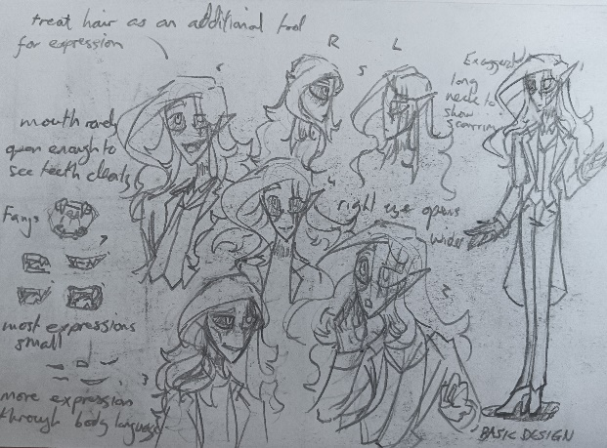
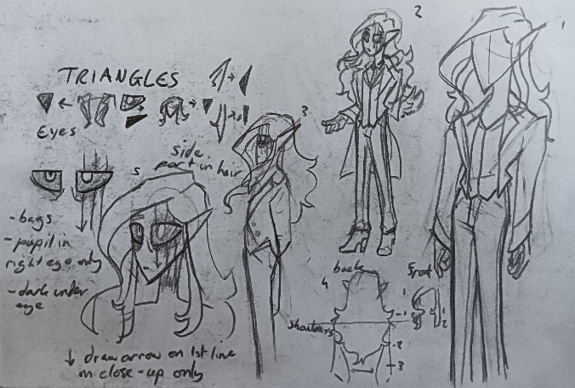
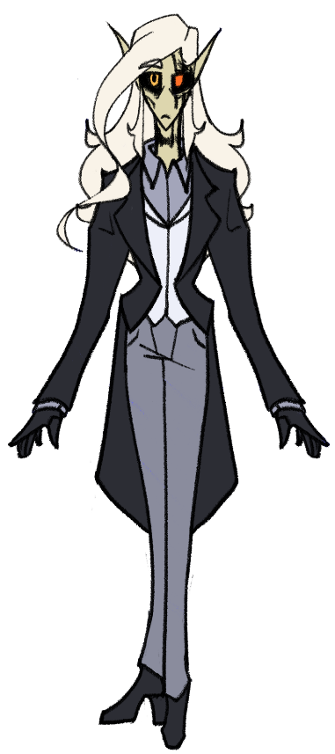
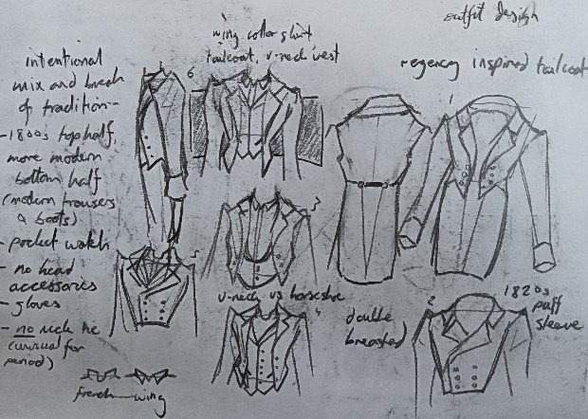
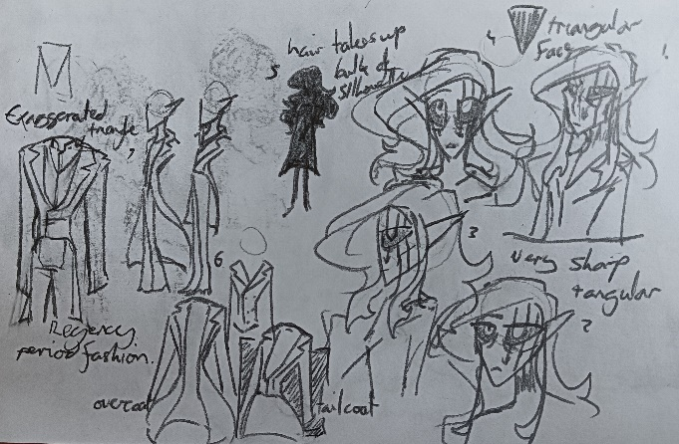

https://www.thebespoketailor.co.uk/the-history-of-the-waistcoat/
https://www.historicalemporium.com/store/mens-trousers.php?&theme=Victorian
https://www.mimimatthews.com/2016/10/03/a-century-of-sartorial-style-a-visual-guide-to-19th-century-menswear/
https://www.pocketwatch.co.uk/how-to-wear-a-pocket-watch
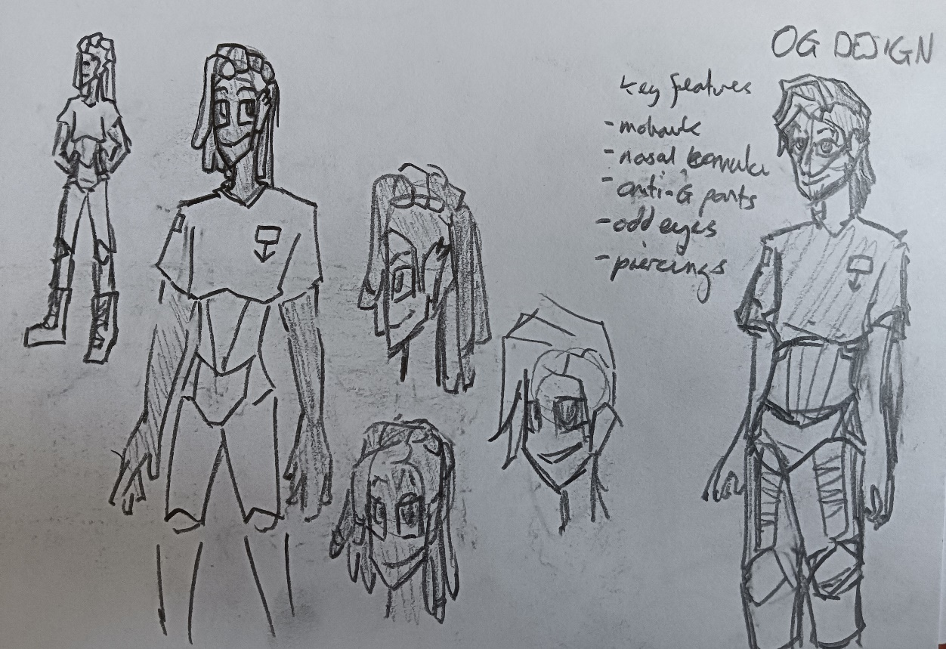
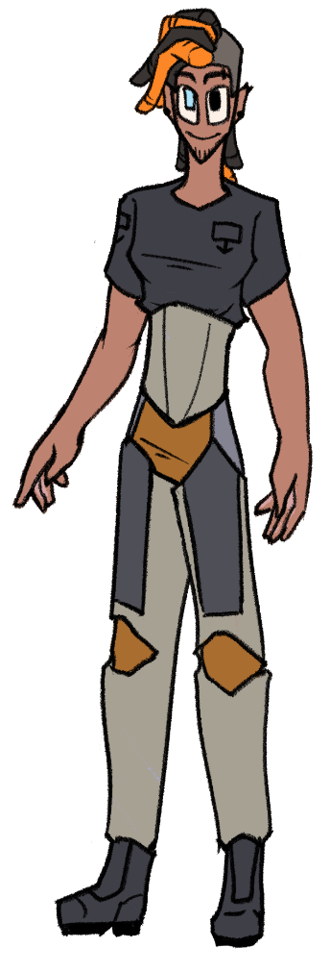
Dec
Character- Declin Stagnata, created by @frequency.n.station (Instagram) and used with permission.

https://www.ebay.co.uk/itm/325444617247?var=0&mkevt=1&mkcid=1&mkrid=710-53481-19255-0&campid=5338749367&toolid=20006&customid=GB_1_325444617247.143933368458~1872793426537-g_EAIaIQobChMI0rKwv4eUggMVOYBQBh3hYQyFEAQYBiABEgJ4zPD_BwE
https://www.youtube.com/watch?v=mV9JAw2oiC4

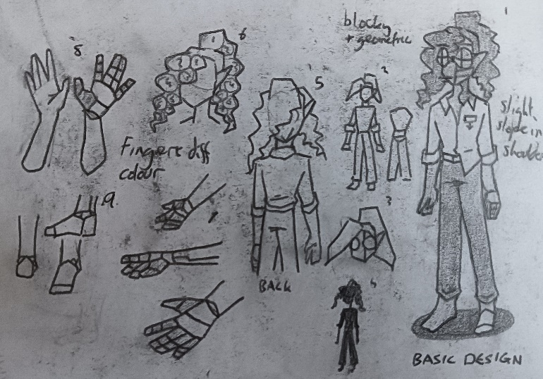
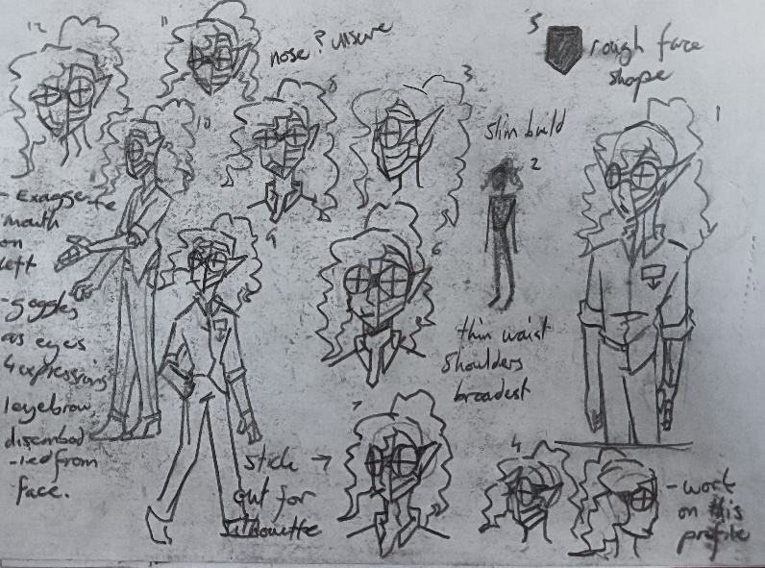
Warren
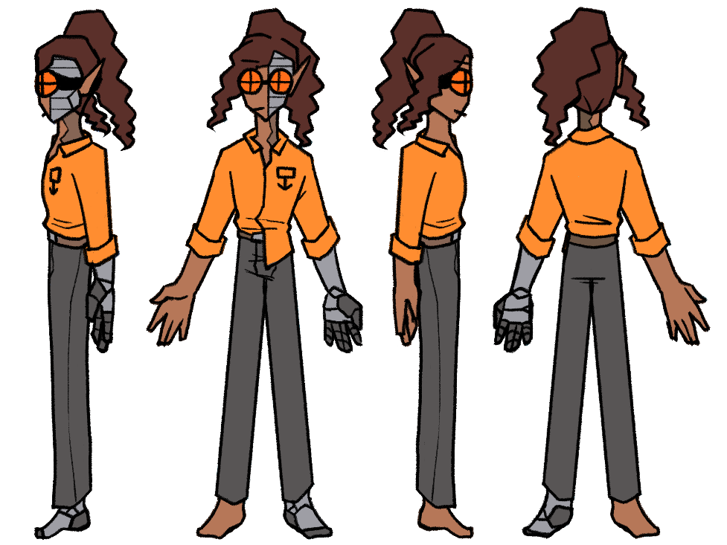
https://propelphysiotherapy.com/amputation/prosthetic-legs-types-of-knee-prosthesis/
https://www.youtube.com/watch?v=U1_NhzIbmVo
https://www.ottobock.com/en-gb/product/3B5-3
https://www.blatchfordmobility.com/en-gb/for-amputees/above-knee-prosthetic-limbs/hydraulic-knees/

Progression Reel Here.

