  Development of an AI-powered Cloud-Based Financial Accounting System for SMEs | Change Makers – Creativity & Value Creation (ACCA5033)  Name of Student :-  Robel Gebregziabher  ID Number 2427640  Submitted To: - Dr .Fahad Ahmad  University of Wales Trinity saint David  March31, 2026

Contents
1: Task 1 – Ideation & Mind Map 2
Section 2: Task 2 – Aim & Objectives 5
Section 3: Task 3 – Research Strategies 6
Section 4: Appendix 8
Section 4: Appendix 8
Appendix A: Pilot Survey Questionnaire 8
Appendix B: Pilot Study Feedback Summary 8
Appendix C: Interview Questions 8
References 11

1: Task 1 – Ideation & Mind Map
Introduction
Creativity and innovation are critical in shaping modern financial technology. Advances in artificial intelligence (AI), cloud computing, and data analytics have transformed how organisations manage financial processes. These technologies allow more efficient, accurate, and scalable solutions for businesses. The mind map developed explores key concepts related to innovation in financial accounting systems and identifies potential project ideas relevant to computing.
https://lucid.app/lucidspark/76fd14a2-4dad-4041-9b3e-7d256014e6e5/edit?viewport_loc=-2246%2C-127%2C3056%2C1464%2C0_0&invitationId=inv_be144136-d4ef-4f6a-80e8-7ffec25f900b
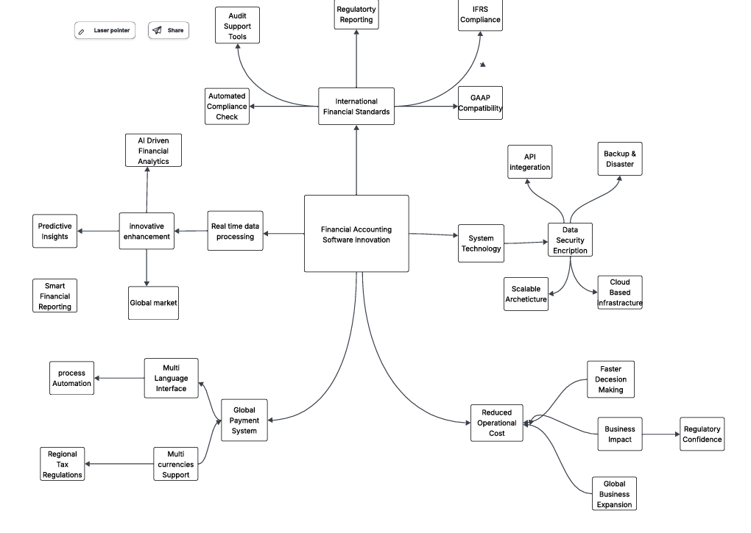

Innovation in Financial Accounting

Innovation drives improvements in accounting systems. Automation is a key area, where AI reduces manual processes and minimises errors. Automated compliance checks and real-time processing enable organisations to operate efficiently and accurately (Laudon & Laudon, 2020).

AI-driven financial analytics provides predictive insights that support decision-making by identifying trends and forecasting outcomes. This reflects the growing reliance on intelligent systems in modern business.

System Technology and Infrastructure

Technological infrastructure is fundamental for developing innovative accounting systems. Cloud-based systems provide scalability and flexibility, allowing SMEs to access tools remotely and reducing dependency on costly on-premise solutions.

Data security is also vital. Financial data is highly sensitive, so encryption and secure access protocols are essential. Backup and disaster recovery mechanisms further enhance system reliability and continuity.

Regulatory and Compliance Requirements

Accounting systems must adhere to standards such as IFRS and GAAP. Automated compliance tools help organisations remain updated with evolving regulations, reducing penalties and ensuring transparency. Regulatory alignment is therefore a key aspect of system innovation.

Global Market Integration

Modern systems must support multi-currency transactions, cross-border payments, and regional tax compliance. Multi-language interfaces enhance accessibility for international users, reflecting the global nature of modern SME operations.

Business Impact and Value Creation

Innovative accounting systems provide tangible business value:

Reduced operational costs
Improved financial transparency
Faster decision-making
Enhanced business growth opportunities

These outcomes highlight how technology-driven innovation contributes to organisational success and wider economic development (Davenport & Ronanki, 2018).

Selected Project Idea

The chosen project is:

“Development of an AI-powered cloud-based financial accounting system for SMEs.”

This project addresses challenges faced by SMEs, including limited resources, manual processes, and compliance difficulties. The proposed system aims to:

Automate financial processes
Provide real-time insights
Improve accuracy and efficiency
Support business growth

Although AI-powered systems offer significant advantages, adoption may be constrained by financial limitations, limited technical expertise, and data security concerns. Over-reliance on automation may reduce human oversight, potentially increasing systemic risks. Therefore, usability, transparency, and affordability must be prioritised for practical and sustainable implementation.

Section 2: Task 2 – Aim & Objectives

Aim

To design and develop an AI-powered cloud-based financial accounting system that improves efficiency, accuracy, and decision-making for SMEs.

Objectives
Investigate current SME accounting challenges including cost, errors, and compliance issues.
Explore AI technologies for automating financial processes and generating predictive insights.
Examine cloud computing benefits in accessibility, scalability, and security.
Design a prototype AI-based accounting system tailored to SME needs.
Evaluate user needs and system usability via surveys and interviews.
Research Philosophy

A pragmatism philosophy is adopted. Pragmatism prioritises practical solutions and supports integration of both qualitative and quantitative data (Saunders et al., 2019). While it may lack the theoretical consistency of positivism, it is suitable for applied computing projects focused on real-world technological solutions.

Research philosophy of the project

This study is based on a pragmatic and problem-oriented research philosophy that aims to address the limitations inherent in contemporary accounting software systems. Existing platforms often show inadequate linguistic adaptability, which restricts their effectiveness in multilingual and globalised business environments. Such limitations highlight the need for more inclusive and context-sensitive technological solutions. Furthermore, although current accounting software includes selected accounting principles, it often lacks full alignment with established accounting theories and internationally recognised standards. This partial integration causes inconsistencies in financial processing and reporting, which undermines the reliability and comparability of financial information. The research also identifies a significant gap in the application of advanced technological innovations, particularly artificial intelligence, within existing systems. The absence of AI-driven functionalities limits the capacity for automated analysis, predictive insights, and improved decision-making. Additionally, the lack of multi-currency support in financial reporting frameworks presents a critical shortcoming, especially in the context of increasingly globalised economic activities. This deficiency leads to financial reports that may be inaccurate, incomplete, and of limited practical value. In response to these challenges, this study adopts a solution-oriented approach to develop a more robust, intelligent, and adaptable accounting system. The proposed framework aims to integrate comprehensive accounting principles, multilingual capabilities, artificial intelligence technologies, and multi-currency functionalities to improve the accuracy, reliability, and global relevance of financial reporting systems.### Financial Accounting Software Innovation

Search Tools & Strategies

Databases: Google Scholar, IEEE Xplore, ScienceDirect, University Library Databases.
Search Strategies: Keyword searches (“AI AND accounting AND SMEs”), Boolean operators, citation tracking, and limiting results to recent publications (last 5–10 years).

Section 3: Task 3 – Research Strategies
Validity, Reliability & Ethics
Validity ensured by designing precise questions and using pilot surveys.
Reliability enhanced through consistent procedures and data triangulation.
Ethical considerations include participant anonymity, consent, and GDPR compliance.
Limitations: Human participant research may introduce bias; sample size may affect generalisability.
Data Collection Methods
Quantitative: Online surveys to measure SME experiences and needs.
Qualitative: Semi-structured interviews to explore user perspectives.
Pilot study conducted to refine questions based on user feedback.
Quantitative & Qualitative Analysis
Quantitative: Descriptive statistics, frequency analysis, trend analysis.
Qualitative: Thematic analysis, coding responses to identify patterns and insights.
Mixed-methods integration strengthens understanding but requires careful analysis to maintain consistency.
Critical Insights

While AI automation offers efficiency, adoption challenges include cost, technical expertise, and data security concerns. Mixed-methods research allows richer insights but increases complexity in analysis.

Conclusion

The mind map demonstrates the strong link between creativity, innovation, and value creation in financial technology. By focusing on AI, cloud computing, and global integration, a viable project has been identified that aligns with current technological trends and addresses real-world SME challenges.

Section 4: Appendix

Section 4: Appendix

Appendix A: Pilot Survey Questionnaire

Appendix B: Pilot Study Feedback Summary
- Participants: 6 SME users
- Feedback: Some terms unclear; survey slightly long; preference for multiple-choice
- Improvements: Simplified language; reduced questions; clarified answers

Appendix C: Interview Questions
- Biggest challenges in financial accounting?
- Current methods of managing financial data?
- Views on AI in accounting?
- Expected features in an AI system?
- Security or cost concerns?
Form Title:

SME Accounting Systems & AI Adoption Survey

Form Description:

This survey aims to understand the challenges faced by SMEs in financial accounting and explore the potential adoption of AI-powered cloud-based accounting systems. All responses are anonymous.

Section 1: Background

Q1. What is your role in the organisation? (Multiple choice)

Owner
Manager
Finance Staff
Other

Q2. What is the size of your business? (Multiple choice)

1–10 employees
11–50 employees
51–250 employees
Section 2: Current Accounting Practices

Q3. What accounting system do you currently use? (Multiple choice)

Manual
Spreadsheet (e.g. Excel)
Accounting software (e.g. Sage, QuickBooks)

Q4. How satisfied are you with your current system? (Linear scale: 1–5)
1 = Very dissatisfied
5 = Very satisfied

Q5. What challenges do you face? (Checkboxes)

Manual errors
Time-consuming processes
High costs
Compliance issues
Lack of real-time data
Section 3: AI & Cloud Systems

Q6. Are you familiar with AI in accounting? (Multiple choice)

Yes
No

Q7. Would you consider using an AI-powered accounting system? (Multiple choice)

Yes
No
Not sure

Q8. What features would be most valuable? (Checkboxes)

Automation
Real-time insights
Fraud detection
Predictive analytics
Section 4: Final Feedback

Q9. What concerns would you have about AI systems? (Short answer)

Q10. Any additional comments?

References
Davenport, T.H. & Ronanki, R. (2018). Artificial intelligence for the real world. Harvard Business Review.
Laudon, K.C. & Laudon, J.P. (2020). Management Information Systems. Pearson.
Bryman, A. (2016). Social Research Methods. Oxford University Press.
Creswell, J.W. (2014). Research Design: Qualitative, Quantitative, and Mixed Methods Approaches.
Saunders, M., Lewis, P. & Thornhill, A. (2019). Research Methods for Business Students. Pearson
- Saunders, M., Lewis, P., & Thornhill, A. (2019). Research Methods for Business Students.
- Creswell, J.W. (2014). Research Design.
- Bryman, A. (2016). Social Research Methods.
- Laudon, K.C., & Laudon, J.P. (2020). Management Information Systems.
- Davenport, T.H., & Ronanki, R. (2018). Harvard Business Review.

