Digital Skills  and Research
Methods
BMSW4003
To identify an Organization and to analyse how this Organization uses modern technology to improve efficiency

Nicoleta Tepes Ghibosu -1921330 Diana-Elena Stanculet-1920967 Maria Maruntelu-1921095
Ana-Maria Barbulescu-1921332
Lavinia Tudor-1921596
Lecturer: Amitave Bamik



Background
of the Organization
Nicoleta Tepes Ghibosu -1921330 Group lider

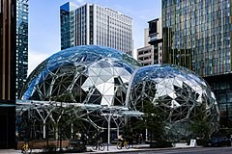

Who are Amazon?

>The world’s largest online retailer and a prominent cloud services provider
>Founded in the garage of Bezo’s rented home in Bellavue,Washington
>In July 1995,the company began service as an online bookstore
>More then 197 million customers around the world
>Is a lider in cloud computing

The Founder
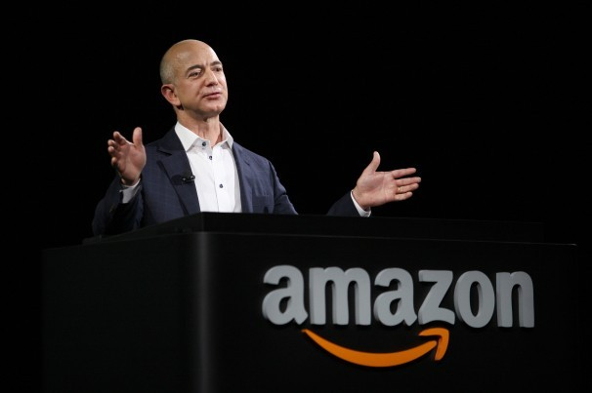

- Amazon was founded by Jeffrey Preston Bezos
>Drew up the Amazon business plan on a road trip from New York to Seatle
>One of the richest people in the world

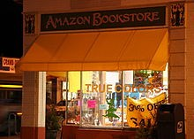
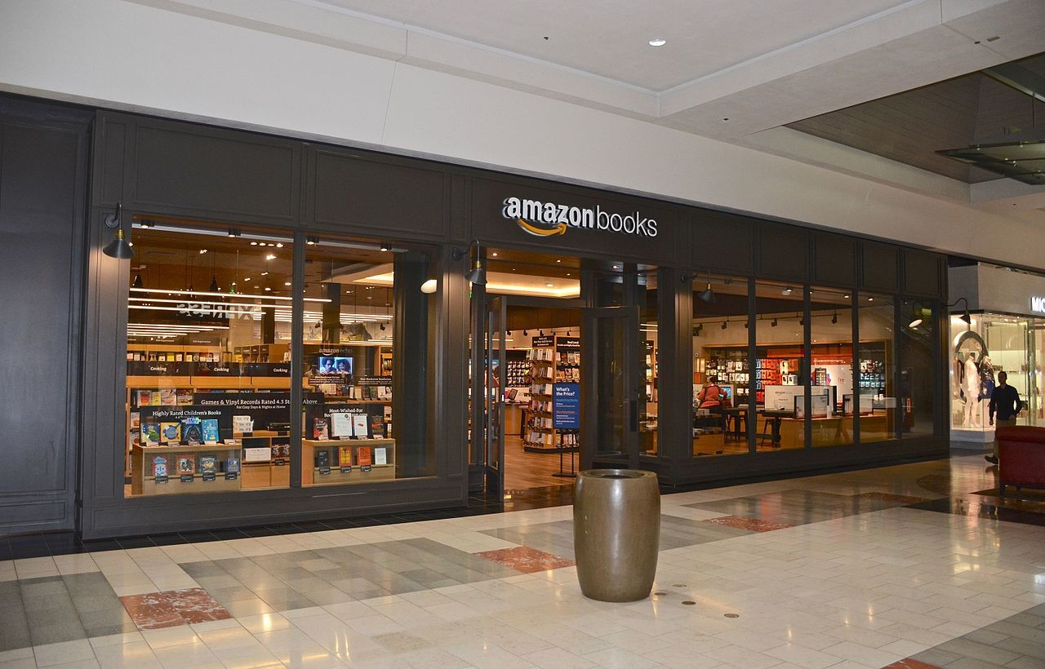
Background
This Photo by Unknown Author is licensed under CC BY-SA

>Began service as an online bookstore
>Was almost named ”Cadabra”
>Jeff Bezos wanted Amazon to be ”an everything store”

Company history
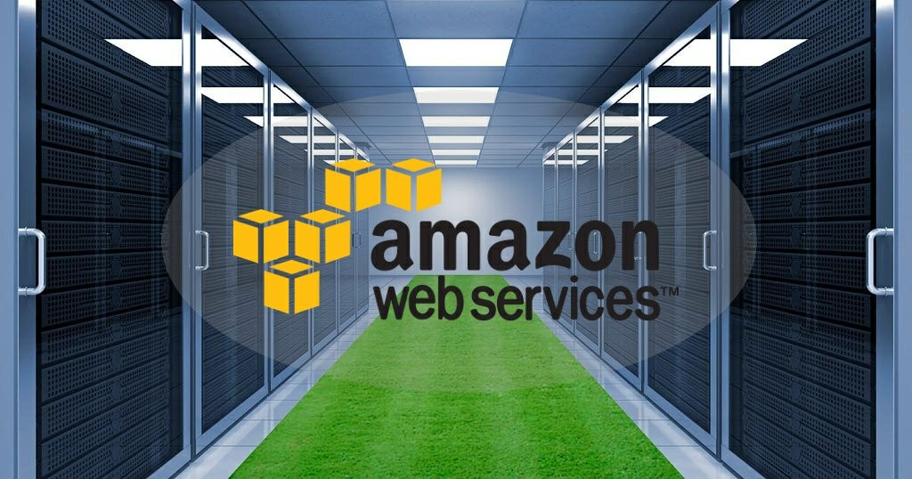

- Amazon go from books to an everything company
- Amazon Web Services
- A modern cloud infrastructure

THE CHALLENGE BEFORE THE INTRODUCTION OF MODERN TECHNOLOGY
ORGANISATION: AMAZON
DIANA ELENA STANCULET
Student ID: 1920967

CHALLENGE(S) BEFORE THE INTRODUCTION OF MODERN TECHNOLOGY
Assistance, the business cases lacked in clarity leading to no specific role of perfection. There was no goal to achieve as a medium of competition thus, the business cases were often on conventional and traditional approaches.
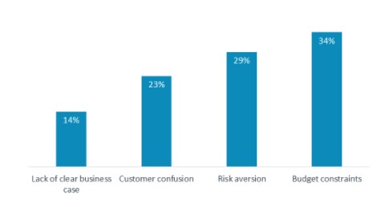

LACK IN GROWTH

◆ LACK IN COMMUNITY DEVELOPMENT: Community development like sustainable approaches were lacking as there were no medium of spreading global awareness.
◆ LESS GLOBAL COMMUNICATION:Export and Import, Fax and Newspaper were the only mode of global communication that relatively hampered competitive trade.
◆ LACK OF COMPETIVE MARKET: Less price discrimination, less comparison of demand and larger organization always became the successful bidders. Lack of Competition lacked in all such distinctive key factors (Chaffey, 2019).
◆ LACK IN MOTIVATION:Motivation was the primary change that lacked as the organization had reduced idea in observation of market trends.

OTH0ER CHALLENGES BEFORE MODERN TECHNOLOGY INTRODUCED

◆ Communication: Fax messages, emails in some countries and letters were only means of business communication lacking instant decision making process.
◆ No robust processes of innovation: Lack in robust ovation leading to no new entrantiin the market. Variety was less and limited.
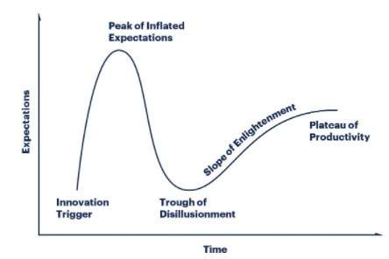

◆ Competitive market:lack of price discrimination led to less substitutes and noprecise openings of new ideas and developments.
◆ Innovationchallenges Successful bidders added no innovation to products.Neither there were adequate ways for new entries in an occupiedmarket.

RISK AVERSION

Risk Aversion often led to no or reduced researches creating less opportunities within market.


RISK AVERSION

◆ Risk averse investor is an investor who prefers lower returns with known risks rather than higher returns with unknown risks (Rosenbaum et al. 2018). In other words, among various investments giving the same return with different level of risks, this investor always prefers the alternative with least interest.
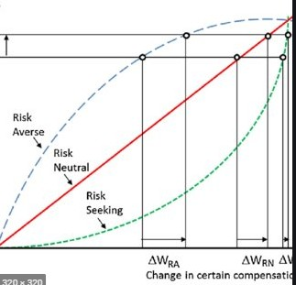

Insights to the modern technology introduced
Maria Maruntelu 1921095

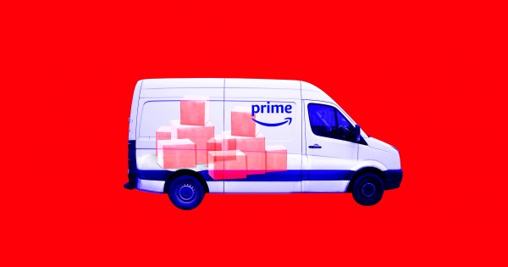

Amazon use advanced transportation
;brings innovation to every area of business they expand .

Invested millions to become the largest online store and made its first delivery by drone in United Kingdom.

The technology has helped company for track the packages safe.

14



- Prime Air service is electric drones that can fly up to 15 miles and delivery packages.

- Customers will fell satisfied receiving the orders in time and safe.

- This will help for special emergency (medical ).

Amazon scout is large enough for small and medium-sized parcels.
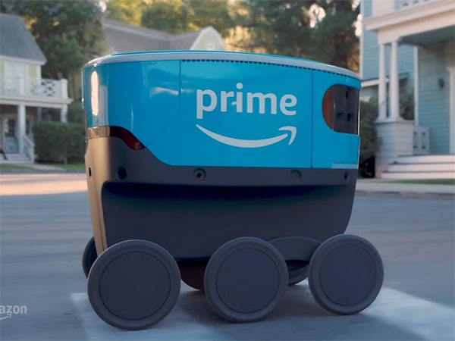

Self-driving machine delivery packages to Amazon Prime Customers.

Amazon spent $775million for warehouse robot in 2012 ,is a mobile robots that could carry shelves of products from workers,

reading barcodes.
16

Amazon has more than 200,000 mobile robots working in warehouse.

  - Amazon Package and Order Tracking

  - Amazon has begun deliveries through a variety carriers.

  - The most important carriers are
:UPS,USPS,FEDEX,DHL,LASERSHIP.

  - The packages are always brought with care and in Time.

  - Tracking is very important and easy way to check the orders.

17

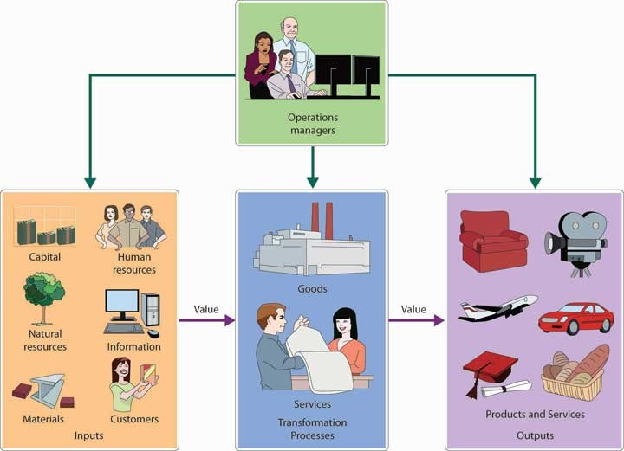

- Command and control system
  - The concept is independent via satellite that monitor routes by software and GPS.

In case of emergency, major incident s or bad weather condition the system gives safer route.

18

THE IMPACT OF THE
TECHNOLOGY INTRODUCED
Ana Maria Barbulescu -1921332

Amazon has led the way from online grocery shopping, gaming, video streaming and Cloud computing to e-readers, on many technological fronts, during the 21st Century.
•
•
•
Most of de products are sold by Amazon;
Various stages of development are working their way with a host of new technologies;
Three of them are just amazing: - Amazon virtual Dash Buttom;
- Amazon Fresh;
- Amazon Fire Tv.

Amazon Virtual Dash Button:
- Dash Button it has appeared in late March 2015 and it has been considered an April Fools’ joke;
    - To clarify that this was real, Amazon had to issue a statement;
    - Amazon prime members could place the Dash Button around the house;
    - It is used as a single function controller;
    - It has the size of a pack of gum;
    - The company sold, at 5 $ each, millions of it.


Amazon Fresh:
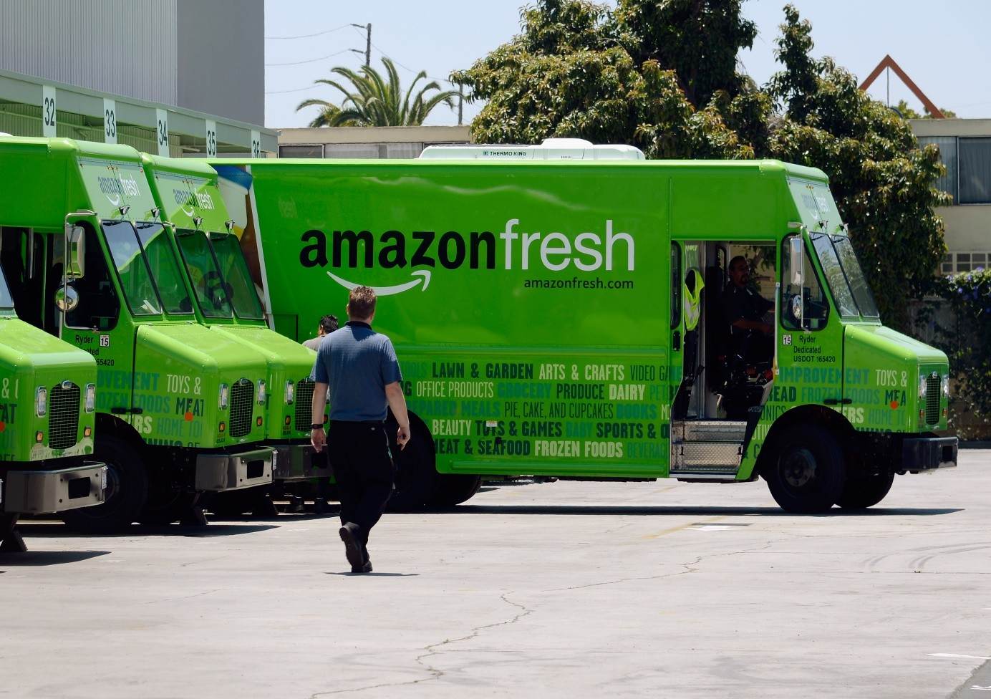

- Only Amazon Prime members can buy online grocery with Amazon Fresh;
- Amazon has been the best to achieve success with this business model;
- It has been launched in Seattle in 2007

Amazon fire TV:


- In 2019 it had more than 34 million active users;
- In the U.S., Amazon’s Fire Tv box had a 28.5% share of the market but 57% of the market for sticks;
- It’s versatility has garnered rave reviews from industry analysts;

Lessons learned from the case study



Presented by:
Lavinia Tudor - 1921596 Lecturer : Amitave Bamik

Lessons learned from the case study
  - Watch the competition closely, but not obsessively;
  - Maintain a hands-on approach to public relations;
  - Live by your mission statement;
  - Have a strategy to handle stubborn competition;
  - Remember Customer Service comes before marketing.
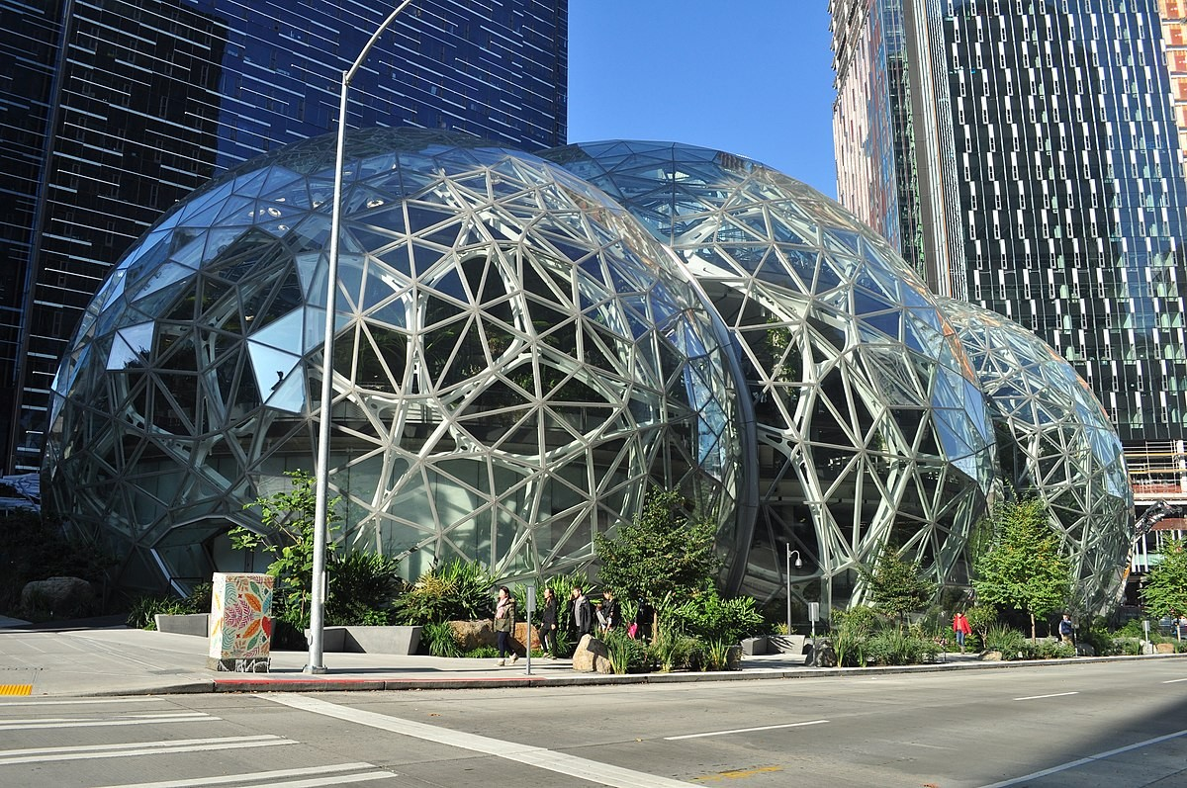

Conclusions
    - Amazon.com is a transnational electronic commerce organization founded in 1994 by Jeff Bezos.
    - Since the time it was established, Amazon.com has acquired five different businesses.
    - The success of this company can be attributed to its low competitive prices and the simplicity of making purchases from anywhere.
    - The growth of sales during the off-season can also be facilitated by introducing a membership facility to offer clients benefits during such times.



Conclusions
- As the company continues to add more products on its website, it risks deteriorating its brand. Microsoft, for example, is well known for computer software products. Imagine if Microsoft decided to diversify and start selling books.This will confuse its customers and put its brand at risk.
- Exploiting foreign markets can expand their customer base.
- Every online business that has achieved its goals attracts rivalry from other players in the market. Therefore, with no particular differential to the increasing competition, potential consumers can shift their loyalties to other brands.

References
  - Annual report 2019,Seatle,Washingyon:Amazon,December,2019
>Amazon.com-History and Facts.Encyclopedia Britannica.Retrieved
January 3,2019
>Amazon Empire:The Rise and Reign of Jeff Bezos,online documentary,2018
>Amazon Prime-Discover all the Benefites
>Jeff Bezos (Tehnology Pioneers)
>Investopia.com/articles/markets-amazing technology
>Rosenbaum,D.,More,E.and Steane,P.,(2018).Planned organizational change management.Journalof Organizational Change Management.
>About amazon.com,(2020) https://www.aboutamazon.com/[Accesed on August 6,2020]

References
>p2pi.org(2020) Path to Purchase Institute MAGAZINE Available from https://p2pi.org/publications[Accessed on August 6,2020]
>Chaffey,D.,(2019).Digital marketing.London:Pearson UK
>https://www.constructionsbusinessowner.com/marketing/5- marketing-lessons-you-can-learn-amazon
>https://ivypanda.com/essays/company-analysis-of amazon-com/

