Preliminary Desk Top Study

  - Proposed Restaurant, Ice Cream Parlour and Manager Apartment
  - Swansea foreshore.

Prepared for:
A.Nantel

Created by:
T. WILLIAMS

Date completed:
November 17th 2020

Table of Contents

1.0 Introduction 3
2.0 Physical Setting 3
3.0 Historical Background 5
4.0 Site Geology 8
5.0 Building Regulations / Codes of Practice 13
6.0 Preliminary Risk Assessment Summary and Recommendations 14
7.0 Permitted uses and restrictions 14
8.0 Approaches and Access to Site 15
9.0 Suitable Foundations Detail 16
10.0 Conclusion 17

1.0 Introduction

This study is being carried out for City and County of Swansea and Marriot Hotels. They have entered into a joint agreement to create a new restaurant, an ice cream parlour and a manager’s apartment on the Swansea foreshore. The proposed site is currently comprised of parts of two different car parks, a cycle path, a storage shed, a walkway and a grassy area with a raise patio seating area.

- The primary objectives of the report are to assess the proposed site through historic background and Geological study.

- To advise based on the historic background, which elements of the proposed site need investigating further and where the greatest risks with the site lay.

- State the Building Regulations / Codes of Practice from which your recommendations are derived.

- State the necessary involvement of local authorities.

- Based on preliminary observations, describe a suitable foundation for the building.

2.0 Physical Setting

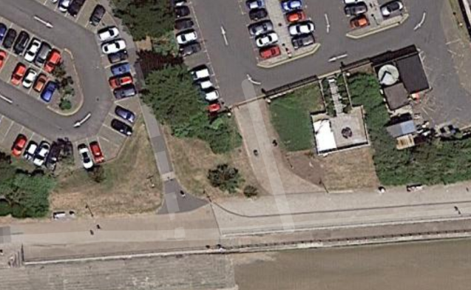
Site Name & Address
Swansea Foreshore Development
Marriot Hotel Car park
Maritime Quarter,
Swansea,
SA1 3SS
National Grid Reference
265403, 192291 (represents central portion of proposed site)
Description of Location
The proposed site is located at the rear of the Marriot Hotel car park.
Site Boundaries
N= Car park
E= Marriot Hotel buildings
S= Swansea cycle path and walkway
W= Swansea civic centre east car park
Site Shape and Development Details
The site is an irregular shape and occupies an area of approximately 2403 square meters. The proposed building will consist of a Gross Internal Area (GIA) at ground floor level of approximately 300 square meters. The ground floor level of the building is to contain the restaurant, the café bar, the ice-cream parlour, a kitchen and food stores etc. The second-floor level is to consist of a staff welfare facility and a self-contained manager’s apartment.
Above Ground Structures
There is a storage facility belonging to the Marriott Hotel to the eastern edge of the proposed site. Also, on the site there is a raised patio with seating area.
Sub-surface Structures and Services
There is a slight chance that relic foundations from historic buildings may be present on site. There is also a possibility of a mixture of current services running below the proposed site to adjacent buildings.
Site History
From looking into the historic research of the area surrounding the proposed site, it is evident the area has had industrial, commercial and residential usage over the years.

3.0 Historical Background

From the early 1900’s to the present day the area surrounding the proposed site has been used for industrial, commercial, residential property and public rights of way.
There was a train engine shed located to the west of the proposed site, which was used to house train engines and remained in use until 1959 (Claret, 2017).
Swansea was heavily bombed in the second world war, the area surrounding the proposed site and nearby docks were targets to be destroyed. “Swansea sustained a three-night blitz on the 19th to the 21st of February 1941. The Luftwaffe using target maps based on aerial reconnaissance photographs, unleashed 1273 high explosive bombs and 56,000 incendiary devices to devastate an area of 41 acres, 857 properties were destroyed and 11,000 properties were damaged. There were 230 people killed and 409 were injured” (anon, 2020).
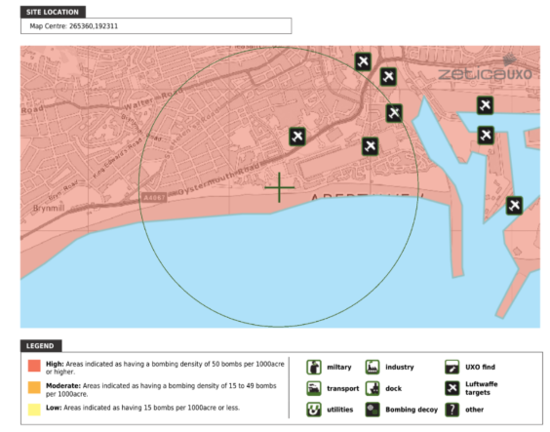
The marina occupies the former south dock which closed in 1969. It lay derelict until it was redeveloped by the local authority in the 1980’s. The old dock re-opened as a marina in 1982 and the city council completed 49 flats near Arethusa Quay. These were to re-house residents of Paxton Street, which was demolished to make way for the new County Hall (Anon., 2000).
In the early 1980’s a few streets of houses to the north of the proposed site were demolished to make way for Swansea County Hall. This was opened in 1982 and re named the civic centre in 2008 (Dalling, 2020).
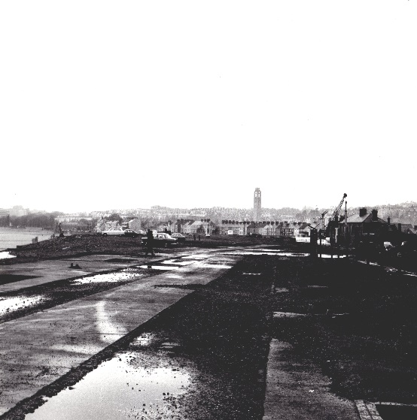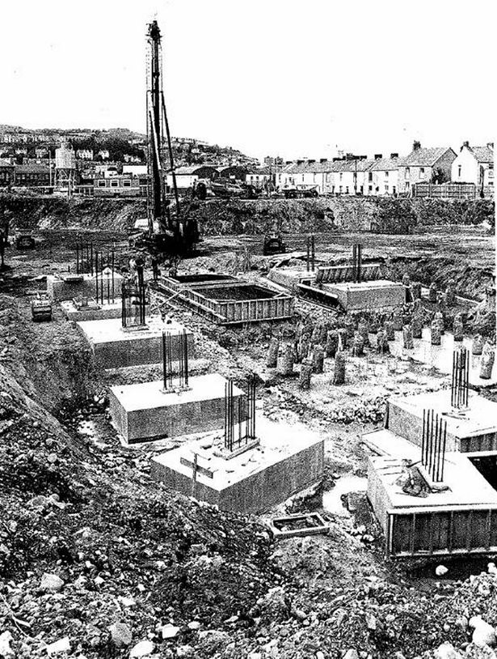

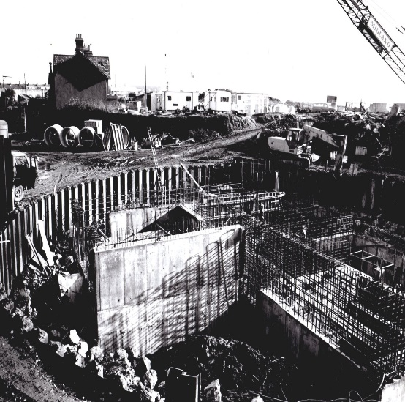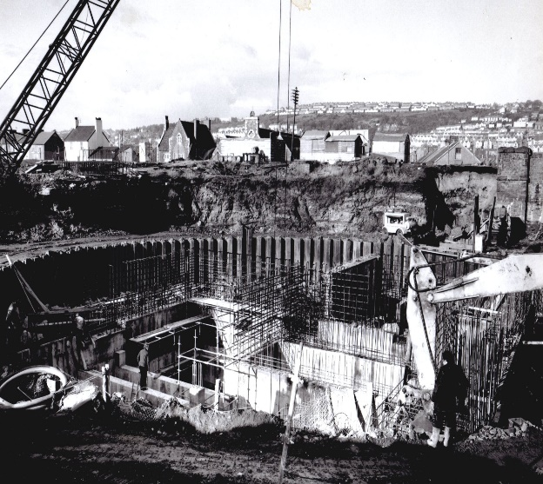
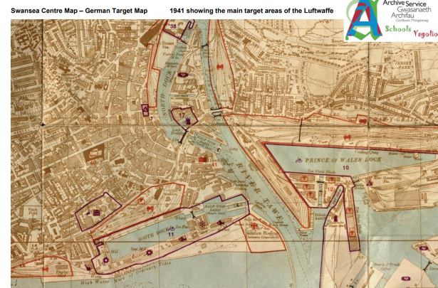
Engine shed west of site. Cannister works east of site.
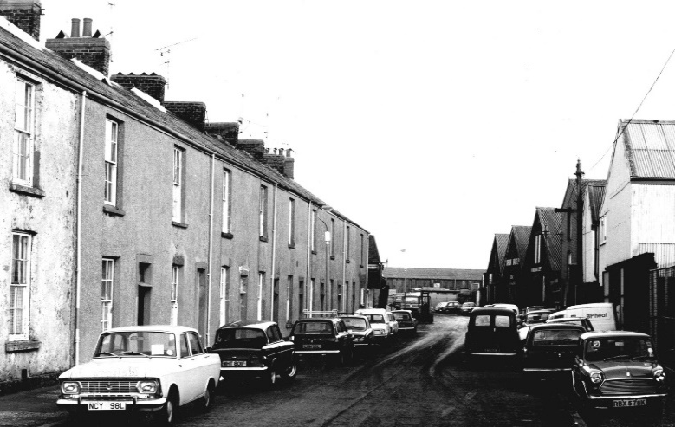
Dunvant Place
The houses pictured were demolished and the Marriot Hotel was built in 1989.

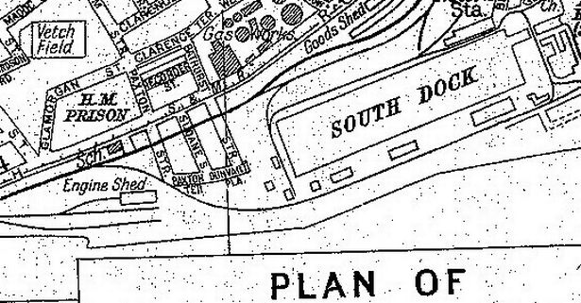

4.0 Site Geology

Information on the Geology of the proposed site has been gathered from records held by the Natural Environment Research Council who conducted the British Geology Survey (BGS). These documents have been reviewed as part of the study:
Geology of Britain viewer 1:50 000 scale.
(BGS) Borehole SS69SE345
Made Ground
The (BGS) Borehole data nearest to the proposed site indicates that there is made ground to a depth of approximately 5 meters containing bricks, ashes, sand and clay (BGS, 2020)
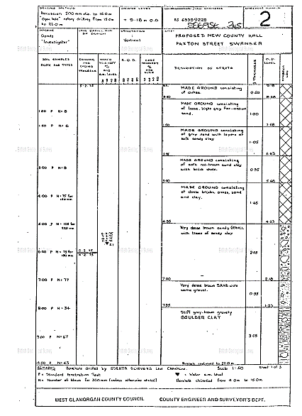
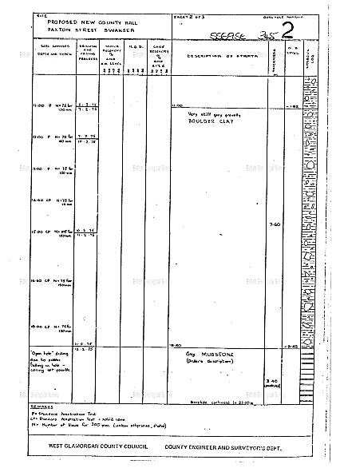

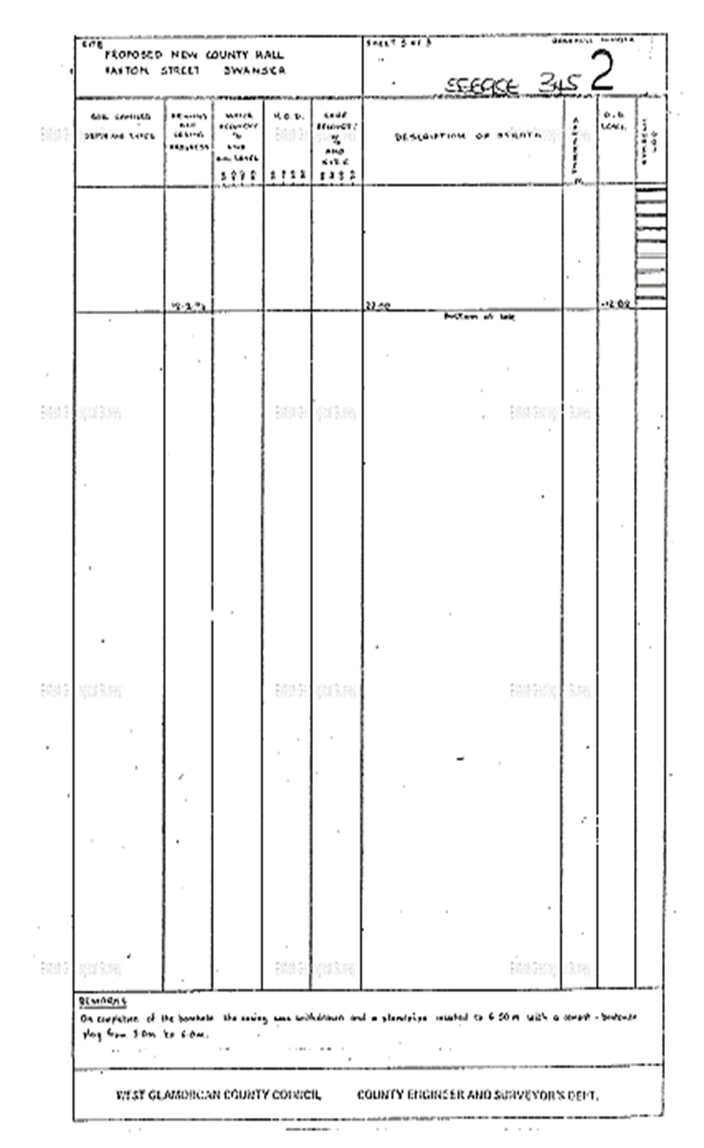
Bedrock Geology
“South Wales Middle Coal Measures Formation - Mudstone, Siltstone and Sandstone. Sedimentary Bedrock formed approximately 310 to 318 million years ago in the Carboniferous Period. Local environment previously dominated by swamps, estuaries and deltas” (BGS, 2020).

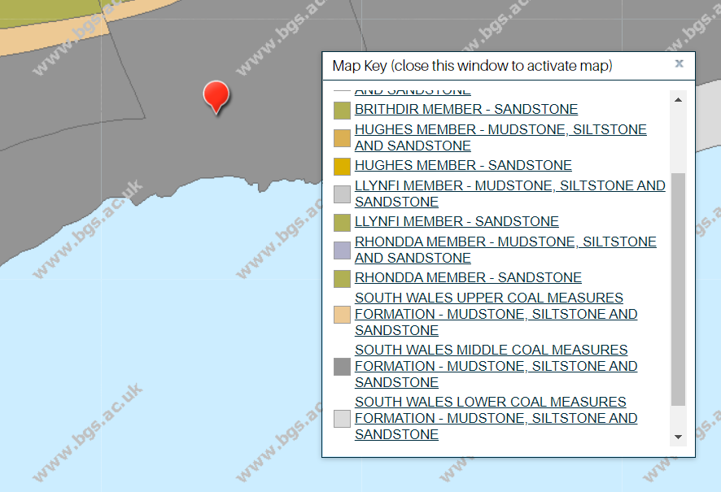

Superficial Deposits
“Blown Sand - Sand. Superficial Deposits formed up to 3 million years ago in the Quaternary Period. Local environment previously dominated by windblown deposits” (BGS, 2020)

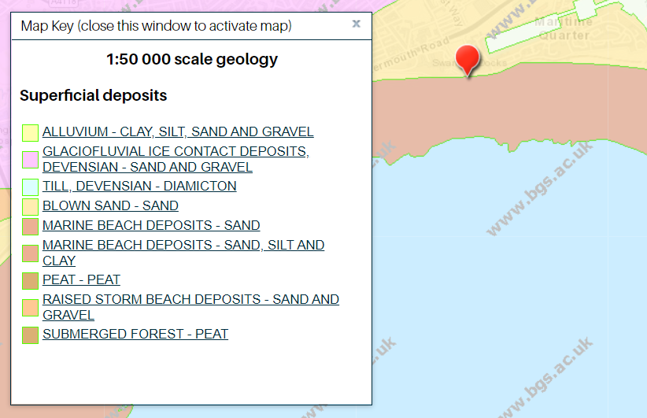
Radon Assessment

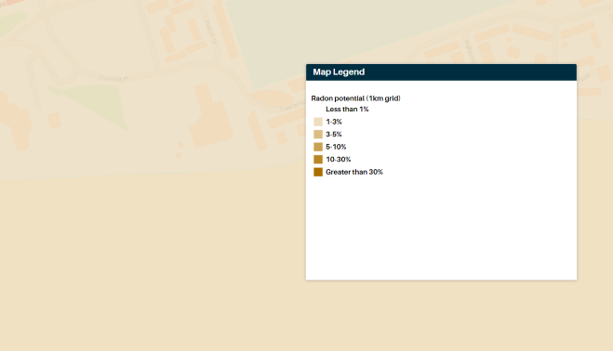
Low risk of Radon in area of the site (BGS, 2020)

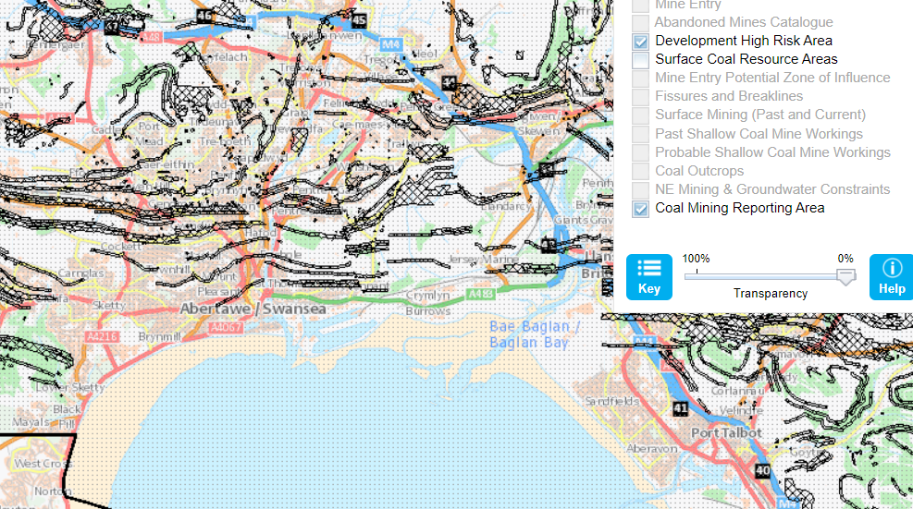

5.0 Building Regulations / Codes of Practice

Code of practice for ground investigations, which helps to assess the suitability of sites for construction operations and civil engineering works BS 5930:1999 Code of practice for site investigations.
BS 8576 provides guidance on the monitoring and sampling of ground gases including volatile organic compounds (VOCs) and permanent gases such as carbon dioxide, methane and oxygen.
BS 10175:2001 Investigation of potentially contaminated sites. Code of practice.
Approved Document A Structure.
Approved Document C Site preparation and resistance to contaminants and moisture.
Approved Document H Drainage and waste disposal.
BS 8002:1994 Code of practice for earth retaining structures. BS 8004:1986 Code of practice for foundations.
BS 8000-1 Workmanship on building sites. Code of practice for excavation and filling [1989].
BS 8000-14 Workmanship on building sites. Code of practice for below ground drainage [1989].
Dead and imposed loads BS 6399-1:1996 Loading for buildings. Code of practice for dead and imposed loads.
Wind loads BS 6399-2:1997 Loading for buildings. Code of practice for wind loads BRE digest 436 Parts 1, 2 and 3 (Brief guidance for using BS 6399-2:1996).
Imposed roof loads BS 6399-3:1998 Loading for buildings. Code of practice for imposed roof loads.
All above (regulations, n.d.)

6.0 Preliminary Risk Assessment Summary and Recommendations

The risk to the public is felt to be low, however as there are public car parks, a walkway and a cycle path running through the proposed site, this will need to be managed accordingly with appropriate risk assessment.
There is a possibility that there could be UXO’s from World War 2, both on the proposed site and in the surrounding area, as Swansea was heavily bombed, detailed further in the historical background.

From review of the historic background above, it is recommended that the contents of the full site investigation, which will need to be carried out by a specialist geotechnical contractor include:

- A full soil investigation should be carried out with an array of bore holes across the site to gain a full ground make up to determine exact foundation necessary. Soil sampling should be conducted alongside to gain insight into the possibility of contamination from the previous uses.

- The possibility of services running below ground through the proposed site will need to be investigated further.

- There is a possibility of access issues. This will need to be further investigated to due to surrounding areas of public use including a public footpath, a cycle path and a carpark.

- Due to the coastal location of the proposed site, various factors such as the possible risk of coastal flooding and strong coastal winds will have to be factored into the full investigation. Scrutinization of historic tidal levels will help aid the investigation when assessing the possibility of coastal flooding.

- From looking at the Coal Authority Map a coal mining report will be needed for the proposed site as it lays within the reporting area.

7.0 Permitted uses and restrictions

“The local Authority will need to be involved in considering proposals for development, where appropriate, enter negotiations to deliver planning obligations under Section 106 of the Town and Country Planning Act 1990. The Council will expect developers to make contributions towards” (Swansea, 2010)

- Improvements to infrastructure, services or community facilities.

- Mitigating measures made necessary by a development.

- Other social, economic or environmental investment to address reasonable identified needs. Provisions should be fairly and reasonably related in scale and in kind to the individual development.

- It is important to convey the changes the development will bring to the area through early engagement with the public. This will include the positive impacts economically, the community benefits and business opportunities this proposed development will bring to the area.

- Duty of care and consideration to any local residents and surrounding businesses during construction is essential for the community and will also be beneficial to the developers. This will assist in the smooth running of the project. This will be done through limiting, as much as practically possible, noise and vibration levels, with minimal disruption to the local community

- Any noisy and impacted related works should be carried out between the hours of 8am and 6pm Monday to Friday, and at no time on Saturday to Sunday and Public Holidays. High impact activities should be carried out between the hours of 9am to noon Monday to Friday and at no time on Saturday to Sunday and Public Holidays.

8.0 Approaches and Access to Proposed Site

Access to the proposed site will be obtained from the main road, A4067 Oystermouth Road and turning on to Dunvant Place. From there either a new access route will need to be created to gain entry to the proposed site, or access can be obtained by entrance through the Marriot Hotel car park. The latter option would require a separate temporary access to the car park for hotel guests.

- Both roads needed to gain access to the proposed site are local authority owned. Oystermouth Road is already under management of traffic lights and so would not require additional control. Appropriate warning and traffic signage to warn of construction site entrance and the presence of construction vehicles in the area may be required, in compliance with Department of Transport legislation. Possible traffic management may be required to allow vehicles to enter and leave the construction site safely.

- There are no access issues with regards to any railway systems.

- With the position of the proposed site being located so close to the river Tawe, there is a possibility that, in the unlikely event of a very high tide, flooding occurring at the site. Tide timings will need to be considered for any coastal investigations to avoid unnecessary disruption to the project.

- Land consisting of vegetation on approach to the site may possibly need to be cleared to gain access, depending on the final decision of site access location. Vegetation on site will have to be cleared for construction.

9.0 Suitable Foundations Detail

Based on the preliminary observations of this study, there is made ground to a depth of approximately five meters. With a further three meters of brown sand with gravel, stiff gravelly boulder clay is reached at approximately eight meters. Which would be a possible bearing layer for the foundations. As the foundations would need to be inserted to a depth of over eight meters to be embedded into the baring layer, this would be classified as a deep foundation as is more than 5m deep. Therefore foundations such as piles would be needed. Piles may be defined as a series of columns inserted or constructed in the ground, to a depth suitable to transfer the load of the structure and external loading. Due to the nature of piles specialist equipment would need to be used on site to construct or insert the piles in the ground. It is possible that smaller diameter replacement piles with reinforced pile caps could be used for these foundations. These could also be joined with reinforced ground beams to link the pile caps together, to transfer the load between piles. This would be determined in the design of the foundations which would allow for extra stresses and strains, from loading of the building from external factors such as environmental pressures of coastal winds and snow.
Pile Cap Binders
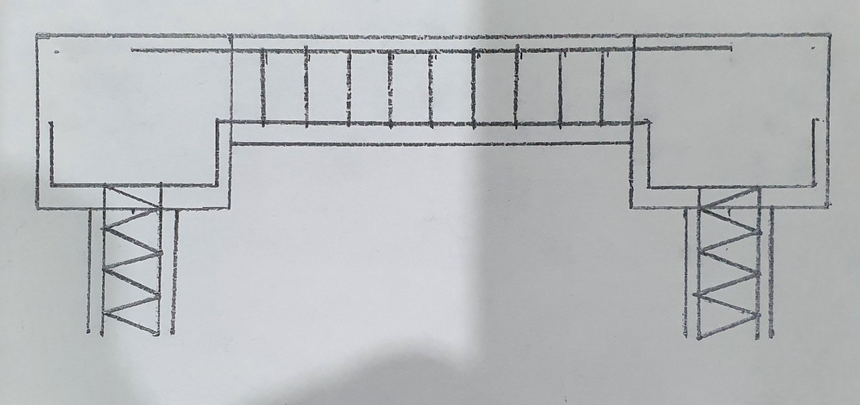
Pile. Ground beam. Pile reinforcement
Main reinforcement bar

10.0 Conclusion

In conclusion, and with addition of supporting documentation aiding in the assessment of the proposed site through historic and geological study, we are able to determine which elements of the site need further investigation and where the greatest risks lay within the proposed site. Ground works such as bore holes and full soil sampling would be needed to determine the ground make up for establishing foundation detail for the proposed build, enabling the safest construction possible.
Through research of the historical background of the proposed site, it is established that there is a risk of UXO’s (unexploded ordinances) within the area due to heavy bombing (having a bombing density of 50 bombs per 1000 acre or higher) of the site and the surrounding area during World War 2. Locating any UXO’s and disposal of such devices would need to be managed appropriately and this would be considered high risk. This is a key element to this investigation and applicable to the proposed site given the significant history.
Early site maps show that from the early 1900’s the surrounding area of the proposed site was developed for industrial, residential and commercial purposes. Also located to the west of the site was a train engine shed, which ceased use in 1959. This was demolished to make way for the present county hall building.
Published records held by the Natural Environment Research Council indicate the presence of a depth of approximately 5 meters of made ground. Research in to the study of Radon assessment indicates low risk of Radon in the area of 1 to 3 percent, meaning no significant control measures would be deemed necessary. A map from The Coal Authority showing the coal mining reporting area indicates a coal mine report would be required to further investigate the possibility of coal mining activities near the proposed site.
It is determined through the study of current site maps of the area, that access to the proposed site will need to be carefully controlled through traffic management and signage. Due to the location of surrounding public areas, the risk to public safety is increased and will need to be factored into the investigation. Working with the appropriate organisations and following building regulations and codes of practice legislation will be needed to ascertain the safest working environment for all construction workers and the general public.
It is deemed that a full site investigation will be required as part of the feasibility stage of this proposed project.

References

Anon., 2000. [Online]
Available at: www.historypoints.org
anon, 2020. [Online]
Available at: www.swanseamuseum.co.uk
anon, 2020. [Online]
Available at: www.swansea.gov.uk
BGS, 2020. [Online]
Available at: www.BGS.ac.uk
Claret, O., 2017. [Online]
Available at: shedbashuk.blogspot.com
Dalling, R., 2020. [Online]
Available at: www.walesonline.co.uk
Greeno, R. C. a. R., 2008. In: Building Construction Handbook. 7th Edition. s.l.:Butterworth Heinemann, p. 229.
regulations, n.d. Construction Information Service. [Online]
Available at: www.ihsmarkit.com
[Accessed 2020].
Swansea, C. a. C. o., 2010. Planning Obligations Supplementary Planning Guidance, Swanse: City and County of Swansea.
swansea, c. a. c. o., 2011. preliminary flood risk assessment , swansea: city and county of swansea .

