Engineering Technical Report

University of Wales Trinity Saint David
Jason Taberner
2404389
BEng, Motorsport Engineering
30/11/2024
Workshop and Practice, ACHA4011
Word Count: 1900 words

Contents
1 Introduction 3
2 Health and safety 4
2.1 Risk Assessment 5
3 Engineers Role in Society 6
4 Problem Solving 7
5 Team Structure 9
6 Personal Development Plan 11
7 Conclusion 13
8 References 14

Introduction
This report aims to explore health and safety, including a risk assessment as well as problem solving in the engineering and academic worlds. This report will also look at engineer’s role in society including research of two organisations that publish a code of conduct for engineers.
Finally, this report will include a personal review in a scenario where teamwork was important and a personal development plan that covers both short- and long-term goals that the author of this report wants to achieve.

Health and safety
This section will cover the health and safety of working in the UWTSD machine shop. It will cover the relevant Health and Safety Legislation as well as the risk level of the activity.
When working in an engineering workshop there are many hazards and so there are safety measures that are required to be in place to protect those in the workshop and those using the machines. The vulnerable areas, hazards, and PPE requirements are displayed in the table below.
Table 1 What PPE for Which Area
Area at risk | Hazard | PPE
Eyes | Flying swarf, dust, projectiles | Safety goggles, face shields
Head and neck | Hair or jewellery entanglement | Hair ties, hair net
Hands and arms | Abrasion, cuts, impact | Sleeves that cover the arm
Feet and legs | Slipping, cuts, falling objects | Steel toe capped safety boots
Health and Safety Executive (2024)
According to The Personal Protective Equipment at Work Regulations (1992), the university is only required to provide PPE to employees of the university. However, it is stated in (The Health and Safety at Work etc. Act [hereafter HSWA],1974), that the employer, in this case UWTSD, is to carry out their work in such a way that it doesn’t put non-employees at risk to their health and safety, as far as is reasonable. Therefore, when students are given the task of operating any of the machines in the workshop, they are required to wear the correct PPE to limit the risk to their health and safety while carrying out the given task.
Due to these requirements of the employer, students are required to wear the correct PPE when carrying out any task in the machine workshop. This means that students are required to always wear steel toecaps in the workshop as there is always a risk of a falling object or swarf on the floor that could cause injury. Students must also wear eye protection when carrying out any machining operations in the workshop to prevent injury to the eyes due to flying swarf. Students are also not allowed to operate machinery without a trained technician in the workshop as this would go directly against the HSWA regulations. This is because the student would be exposed to the risks mentioned previously and the employer would have no way to limit this exposure without a trained technician in the workshop.

Risk Assessment
When working in a machine workshop there are many hazards that need to be evaluated before a task is carried out. Some of these hazards and potential causes are listed below and then inserted into a risk assessment matrix to evaluate the risk of each hazard.
- 1) Entanglement – milling machine, lathe, or pilar drill.
- 2) Crushing – vice jaws, or heavy object falling.
- 3) Cutting – machine cutting tools, hacksaw blades, sharp edges.
- 4) Slips and trips – oil or coolant leaks, discarded personal items i.e. bags or coats.
- 5) Eye injuries – flying swarf, coolant or oil leaks, or tool or part failure.
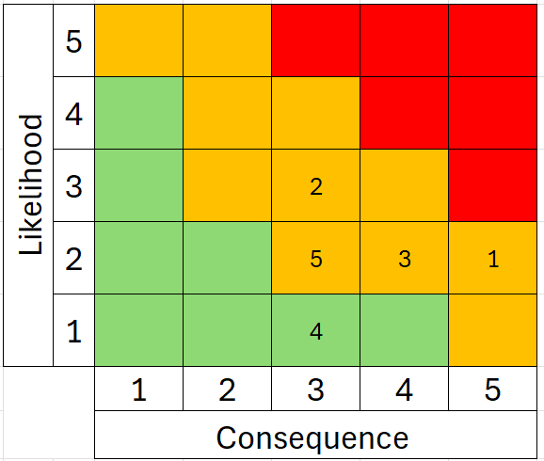
These hazards are backed up by Stony Brook University (2017)
Figure 1-Risk Assessment Matrix

Engineers Role in Society
This section will cover what engineer’s role in society is and what codes of conduct must be followed.
Engineers are held to a high standard because they could cause harm to themselves and others if they do not do their job correctly. Because of this responsibility a statement of ethical principles was published for engineers to follow. This statement says that engineering professionals must protect and if possible, improve natural environments.
The Royal Academy of Engineering and the Engineering Council (2017).
If engineers are to protect natural environments, a key concern when undergoing projects in the automotive and motorsport industries is sustainability. Engineers working in automotive and motorsport need to consider the impact to the environment when carrying out projects, the emissions and impact to natural areas should be evaluated and the impact to the environment should be measured against the positive effects that the completion of the project would have. If the negative effects on the environment are too great it is the engineer’s duty to not let the project go ahead unless it can be reworked to have less of an effect on the environment. One way to reduce the environmental effects is to use sustainable materials and renewable energy sources. Engineers are the people leading the world’s innovation and progress and so sustainability should be one of the main concerns when starting any new project or making breakthroughs in the way the automotive and motorsport industries power vehicles.

Problem Solving
This section will look at problem solving options that engineers can use if they encounter certain issues while developing a new product. These issues are:
- An issue found during development
- An issue found once the product is on the market
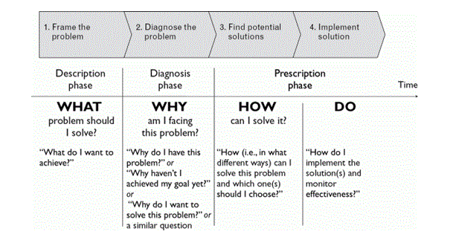
- An issue with the supplier during the production process
Figure 2 4-Step process to problem solving

As shown in figure 2 there is a 4 step process when problem solving and implementing the solution. (Chevallier, 2016, page 28)
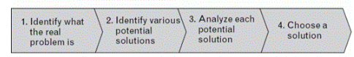
Figure 3 How to find a solution
Figure 3 shows the process once you understand the problem, how to devise and select a solution. (Chevallier, 2016, page 119)

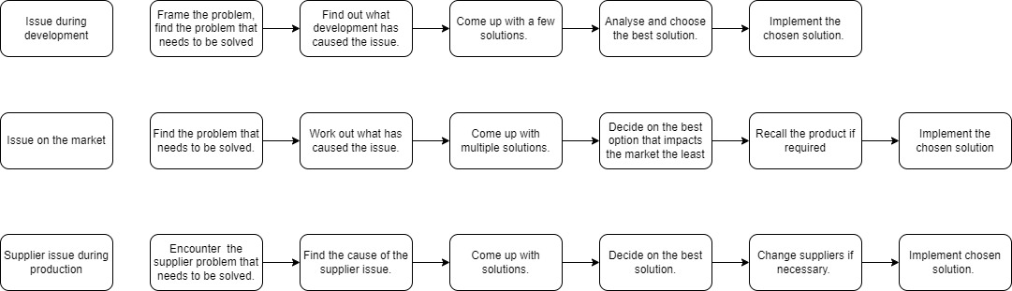
Shown below is a flow diagram to demonstrate how the above apply to each of the aforementioned issues.
Figure 4 Flow diagrams
As shown in figure 4, an issue that is encountered during the development phase is simpler to deal with as the product is not currently on the market and the materials are still being supplied. However, an issue encountered in this phase can still have a big impact on the product.
If the issue is encountered on the market, a product recall might be necessary in order to implement a solution. In 2009 Toyota had to enact a mass recall on their vehicles because of an accelerator pedal issue (Kumar & Schmitz 2011). In this case a product recall was necessary due to the risk the issue posed to the health of others. If the issue was much smaller like the boot light taking too long to turn on, then a solution could be implemented for all future cars of that model.
With a supplier issue, a change in supplier could be necessary. For example, if the current supplier went bankrupt, a change in supplier would be required for the project to continue. However, if the issue was minor such as a certain type of material losing availability, then a solution could be found that uses a different material with more availability.

Team Structure
This section will look at a time that I have worked in a team, it will discuss the team structure that was used by my employer, another team structure that could have been used as well as highlighting the positives and negatives of both structures.
When I worked in a pub the team structure was hierarchical. This team structure is shown below in figure 5.
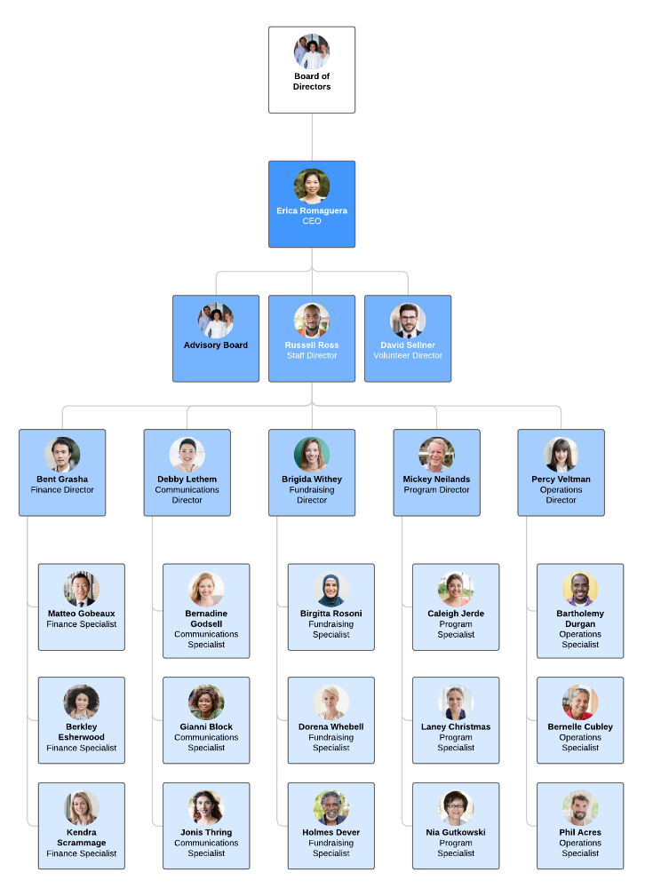
With a hierarchical team structure, it is very easy for each team member to know who to report to, this is because there are clear levels of authority. Team members go to their managers, managers go to the upper management, upper management to the CEO, and the CEO to the board of directors. This team structure also promotes career development as there is a clear-cut path for employees to follow in the ways of promotion. However, with this team structure, those who are at the bottom of the pyramid might feel like they don’t have a voice when it comes to making any decisions, even in the individual branches. When I was working as a bartender, I know I felt that I didn’t have a say in anything and that my ideas weren’t important. Because of this I didn’t share them and instead just let the workplace develop around me without my input.
Figure 5 Hierarchical Team Structure
Lucidchart (2020)
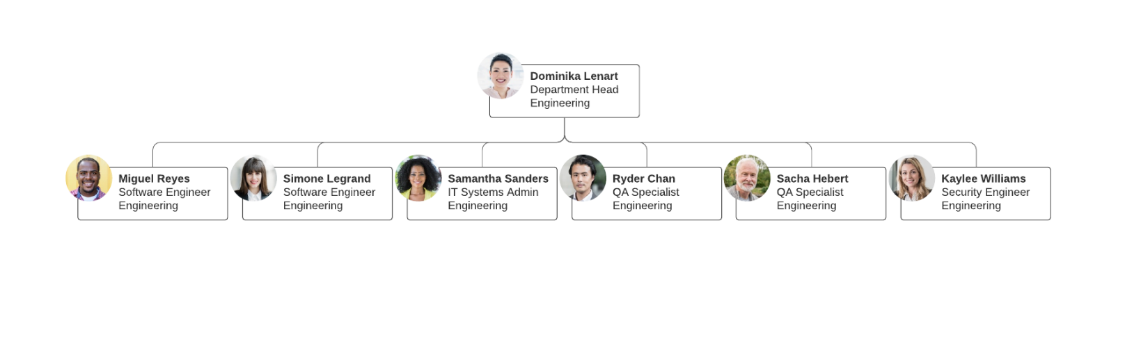
Figure 6 Horizontal or Flat Team Structure
Figure 6 shows a flat team structure, also called a horizontal team structure. This team structure could also be suitable for the pub as you have a head if the team who would be the manager, and then the workers who report to the manager. With a team structure like this, employees would have more responsibility and in turn have more of a voice when it comes to changes in the business. This team structure would also be beneficial as open conversation can be more easily achieved. However, this team structure would be hard to maintain as the business grows. With the pub I worked at being part of a chain it would be hard to use a flat team structure with so many employees. While there is a head of the team, it could also be harder for employees to know who to report to when it comes to smaller issues. If the issue is small, it might not need to go to the head, but there is no one else specifically there to report to for smaller issues.
Lucid chart (2020)
When comparing these team structures, we can see that with the pub being part of a chain, the flat team structure would be much harder to implement and maintain. The hierarchical structure, while potentially creating a space where employees lower down in the pyramid might feel like they are not heard is still more feasible for a larger company.

Personal Development Plan
Name – Jason Taberner
Degree – Motorsport Engineering
Previous Qualifications – BTec Level 3 National Extended Diploma in Engineering
Previous Experience – Bar work in a pub as well as a workshop assistant in an oak framed house construction workshop
Table 2- Personal Development Plan

Long Term Goals (5 to 10 years)
- Get into a job on an F1 team
- Started my own small engineering business where I have the freedom to engineer and design solutions to problems that I consider important and interesting.
- Settled down in a house with a family.

Short Term Goals (0 to 5 years)
- Complete my Motorsport Engineering degree to a high standard.
- Get into a graduate job that is relevant to my studies and that I will have the opportunity to progress in over time.
- Rescue a dog or cat and keep them to support local animal shelters and take care of an animal in need.

Goal | Objective | Resources Required | Measurement | Target Date
Rescue an animal | I will need to be financially stable to look after the pet, as well as have a local animal shelter where I could rescue from. I would then need to choose the pet that I have the facilities to look after and then I can rescue the animal. | A pet friendly place of residence.  The income required to pay for the vet bills, food, etc.  An outdoor space to allow the pet to spend time outside and improve their quality of life. | Successfully adopt a pet from a local shelter | 2028
Graduate job | I will need to perform well in university to be selected for a good graduate job. I will also need to improve my CV to ensure that I stand out among other graduates looking for similar jobs. | Degree in motorsport engineering completed to a high standard. | Successfully apply to and be selected into a graduate job in my chosen engineering field | 2027
Complete degree | I will need to work hard and apply myself to every assignment and exam set over the course of my degree. | YForwm.  The IQ building and resources.  Lecture notes and PowerPoint presentations. | Successfully complete my degree with a Fiest-Class or Upper Second-Class Honours | 2027
F1 team job | I will need to excel in my graduate job to be selected for a role in an F1 team. | A well put together CV.  A good understanding of key engineering principles. | Apply and successfully be chosen for an engineering role on an F1 team. | 2033
Small business | I will need to perform well in my job to be financially stable. I will also need to learn how to advertise my business and sell my services or products online. | The facilities to design and manufacture products.  A website to promote and sell my services/products. | Successfully start my own small business, giving me the ability to tackle the engineering problems I want to. | 2035
Settle down | I will need to save up over the years as well as find an area that is close enough to work and is in a nice area. | The money to put down a deposit.  A good credit score.  A mortgage. | Successfully settle down in a house with my wife and pet that I adopted | 2033

Conclusion
In conclusion, this report has looked at health and safety in an engineering workshop and found through research the relevant legislation that dictates the protocols and PPE requirements for using the machines in the workshop. This report also includes a risk assessment matrix which shows the level of risk of certain hazards that one might encounter in an engineering workshop.
After conducting research, it has been determined in this report that engineers have a duty to uphold certain ethical standards, looking after both people and the environment, as well as staying honest and maintaining integrity in their work. Engineers have a big influence on society and that responsibility should be acknowledged and taken seriously.
When problem solving, the conclusion that has been come to is that engineers should be methodical and not cut corners, there are certain questions that can be asked to help frame the problem and make it easier to develop solutions. In some cases, more dramatic action might be required, but it is important to come up with multiple solutions before implementing one otherwise you have no comparison and could waste both money and time with a lesser solution.
This report has discussed two team structures, one of which has been used in a chosen scenario and one that could also have worked in that same scenario. It has looked at both the pros and the cons of the two team structures and compared them against each other, concluding that the one that was used in the chosen scenario was the better fit.
Finaly this report has included a personal development plan for the author which looks at both short and long term goals as well as the resources required to achieve them. While the goals in the plan might change, they show a general direction for the author and act as something to work towards and achieve in future.

References

Stony Brook University (2017) APPENDIX 1. MACHINE SHOP RISK ASSESSMENT. Available at: https://ehs.stonybrook.edu/programs/laboratory-safety/laboratory-equipment/Machine%20Shop%20Risk%20Assessment.pdf (Accessed on 20/11/24)

Health and Safety at Work Act etc 1974 section 3 Available at: https://www.legislation.gov.uk/ukpga/1974/37/section/3 (Accessed on 22/11/24)

The Personal Protective Equipment at Work Regulations 1992 (SI 1992 No. 2966). Available at: https://www.legislation.gov.uk/uksi/1992/2966/regulation/7 (Accessed on 22/11/24)

Health and Safety Executive (2022) Using personal protective equipment (PPE) to control risks at work. Available at: https://www.hse.gov.uk/ppe/using-the-right-type-of-ppe.htm (Accessed on 22/11/24)

The Royal Academy of Engineering and the Engineering Council (2017) STATEMENT OF ETHICAL PRINCIPLES for the engineering profession. Available at: https://www.engc.org.uk/media/2334/ethical-statement-2017.pdf (Accessed on 23/11/24)

Arnaud Chevallier (2016) Strategic Thinking in Complex Problem Solving. New York: Oxford University Press.

Kumar, S. & Schmitz, S. (2011) ‘Managing recalls in a consumer product supply chain - root cause analysis and measures to mitigate risks’, International Journal of Production Research, 49(1) 235-253
Available at: https://research-ebsco-com.ezproxy.uwtsd.ac.uk/c/onvpsy/viewer/pdf/y4mqqhrylj?route=details

Lucidchart (2020) 10 types of organizational structures (+ org charts for implementation), 2nd of June. Available at: https://www.lucidchart.com/blog/types-of-organizational-structures (Accessed on 29/11/24)

