BMSW4001

ACADEMIC AND EMPLOYABILITY SKILLS

Made by: Denitsa Handzharova- 1916144
Lecturer: Adesewa Ajayi
Executive Summary
This report analyzes the major influencing factors of enhancing Academic and Employability Skills of students. According to the available information the report describes research strategies to facilitate effective study in Higher Education. It also analyzes and describes the Software skills to facilitate effective study in Higher Education. The responsibilities for the students regarding own learning have also been described in the study. It analyzes the various employability skills and their development possibilities. The employability skills have been analyzed through implementing Kolb’s reflective model. The skills have been effectively analyzed and the impact of them also been described in the report.
Table of Contents
1. Introduction 4
2. Research strategies to facilitate effective study in Higher Education 4
3. Software skills to facilitate effective study in Higher Education 5
4. Responsibility of own learning for students 6
5. Development of employability skills such as reflection, time management and presentation skills 6
5.1 Analysis of confidence and competence as effective employees 6
5.2 Kolb's reflective model for effective study 8
5.3 Kolb's reflective model for responsible learning 9
5.4 Kolb's reflective model for time management 10
5.5 Kolb's reflective model for presentation skills 11
6. Conclusion 11
References 12

1. Introduction
Academic and employment skills include critical thinking, adaptability, written and oral communications, creativity, problem-solving, ethics professionalism and more. Several groups and business leaders have worked together to recognize the employability skills for employees success. This report includes research strategies to facilitate effective study in higher education. The software skills that are required to facilitate effective study in higher education are also discussed in this report. Responsibilities of students related to their own learning are also included in this report. A few employability skills such as reflection, time management and presentation skills that can help the students in development are derived in this report.

2. Research strategies to facilitate effective study in Higher Education
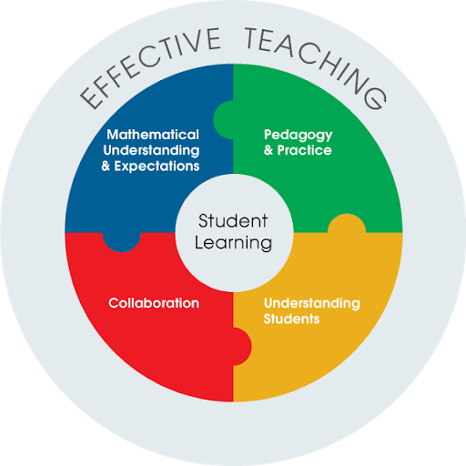
Figure 1: Strategies to facilitate effective study
(Source: Cte.jhu.edu, 2020)
Various research strategies can be used in order to facilitate effective study in higher education. One of them is dual coding as the people can educate themselves by using pictures and words together, it will help them to get an understanding of any topic more clearly. Retrieval practices can also be used as a strategy in order to facilitate effective study in higher education. Since people are incredibly forgetful, they are required to revisit the information and cement them in their thoughts. Spaced practice can help a student to facilitate effective study in Higher education as they will be less stressed in this process (Abas and Imam, 2016). This process can help a student to remember all the pieces of information for a longer period of time. No matter how big or matured the student is they should behave like they are kids and soak all the information that is provided by the teachers as a sponge. They should ask questions regarding every doubt till they are not fully clear about that topic.

3. Software skills to facilitate effective study in Higher Education
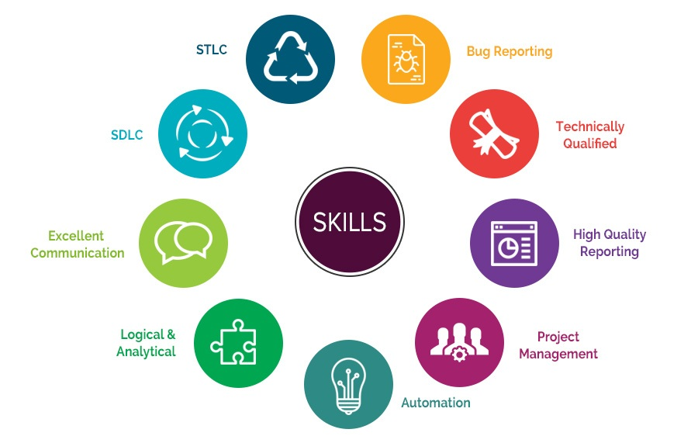
Figure 2: Software skills for employability
(Source: Qltech.com, 2020)
The software skills that can be used in order to facilitate effective study in Higher Education are Microsoft office, Spreadsheets, PowerPoint, Microsoft Access, Web and Social Media skills etc (Okolie et al. 2020). These skills can help any student to get a proper higher education in order to get employment. Microsoft is very important software which can help a student to get employment; it is very much required in any type of office. Spreadsheets are mainly important in Microsoft Excel as this can help to manage all the data and it can also help them to get employment. Students should have access to Microsoft which can help them in information sensitive economy in today’s date. Web and Social Media skills are also very important in order to facilitate effective study in Higher Education (Álamo-Vera et al. 2020). These can help students to stay connected with people and it can also help them any kind of research that is needed for their study.

4. Responsibility of own learning for students
Every student should take their own responsibility for their learning in order to get a higher education. They should make their own decisions regarding their education as they know very well that what is best for them (Paterson, 2017). The parents and teachers should do minimal talking as all the students should respond in a way to get the right approach. This will allow the students to construct the meaning of everything on their own. The students should set their own goals, if they do this then it will allow them to reflect on their goals in a period of time (Biberhofer et al. 2019). They should define their own goals which can help them in learning and they should also make sure that they are getting constructive feedback. They should focus on learning that will help their technological tools in order to help their learning; this will be an added advantage for them.

5. Development of employability skills such as reflection, time management and presentation skills

5.1 Analysis of confidence and competence as effective employees
In order to analyze competence and confidence as effective employees, there are a few ways that can help the managers. The first one is giving their employees a test; it is a quite efficient and traditional way to assess theoretical and technical knowledge of an employee (Kornelakis and Petrakaki, 2020). However, these tests can be conducted in the ‘laboratory’ conditions so that it does not give any precision about if they will be able to use the same knowledge in their real-life or not. The employees can also be asked to get prepared for any self-assessment in form of a questioner or anything else (Daley and Baruah, 2020). They can also get feedback from their teams regarding each other’s performance and see if they are capable of doing a job at a high level. This can test the confidence of an employee and their competence level with other employees of the company.
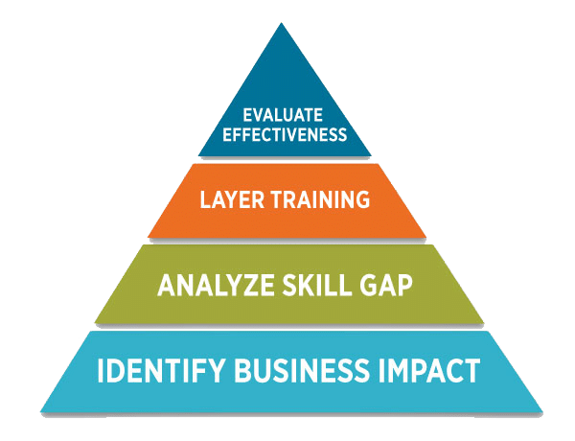
Figure 3: Metrics for confidence analysis of effective employees
(Source: Allencomm.com, 2020)
Confidence and competence of an employee can also be analyzed by putting them in a real situation. Training and assessing skills are the most efficient and effective way to make an employee confident. They should test their confidence by putting them in a situation that not in their favor and watch what they do in that situation (Deeley, 2018). However, if any company’s management is sure about their higher education of their employees so they should put them in real-time situations to challenge and can check their efficiency. They can check their competency level by letting them play business games on various aspects of their lives.

5.2 Kolb's reflective model for effective study
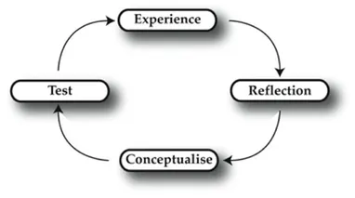
Figure 1: Kolb's Learning Styles and Experiential Learning Cycle
(Source: Simplypsychology.org, 2020)
Effective study plays an instrumental role in the academic and employability skills of a student. According to Kolb’s reflective model, effective study can enable a student to effectively participate in his study and can ultimately increase his employability chances. Kolb’s model theorizes on four primary factors that can influence the learning capabilities of an individual. It is especially effective for effective study and its utilization in the employment capabilities of the students (Akhtar and Hussain, 2019). The basic contributor to this would be having an abstract concept of the literature to be studied. Abstract conceptualism provides the students with an option to reflect on their studies and learn new things regarding it. It enables the students to conduct modification to their existing knowledge and enables them to learn from their experience.
It is the basis of effective study and learning methods that can be massively beneficial for the students in improvising their employment capabilities. Another one of these factors the relative study enables the students to reflect on the newly learned things. Reflective observation is highly recommended for the students as it can massively boost the learning capabilities of an individual. It enables the student to review their studies and omit inconsistencies between their studies. This can also be applied later in their life during employment (Dung and Minh, 2020). It is especially vital to develop adequate employment skills for the students and can highly increase their own learning capabilities. Kolb’s reflective model focuses on concentrated experience for the students in their everyday learning. This enables the students to have experience with their studies and allows them to enhance their academic and employment capabilities. This and active implementation of it in their everyday studies increases the academic capabilities of the students by a lot. It can be highly beneficial for the students can enable them to gain an edge in the modern competitive market.

5.3 Kolb's reflective model for responsible learning
Learning or the method of it plays an instrumental role in the advancement of a student during their employment activities. It can enable them to have an edge over others during employment and it’s highly important for their future development. Implementing Kolb’s reflective model can enable the students to be responsible for their learning activities and can be highly beneficial for them. It can enable them to concentrate during learning activities that will allow for deep learning. It will allow the students to learn and observe from their surroundings and can also enable them to experiment during their studies (Fearon et al. 2020). Having an experimental nature and the ability to learn from it can be a positive perk for a student during employment. This and having a dynamic approach towards learning enables the students to learn effective and essential things from their studies. Active experimentation of the learnings enables the students to have in-depth knowledge regarding the subject an can gain them an edge during interviews.
In-depth knowledge about a subject is considered necessary for most of the employing organizations. One of the most important factors of responsible learning is abstract conceptualism. This enables the students to learn from their mistakes and also allows them to learn from their everyday activities. It is considered a crucial part of learning activity and highly centralized around the idea of effective conceptualism (Fewster-Thuente. and Batteson, 2018). This enables the students to have a reflective idea about their studies. This further enables them to conduct modifications or improvements that are needed. Reflective observation of everyday studies is also highly important for students in their daily activities. It enables the students to review their learnings from study activities and everyday life. This plays a significant part in determining identifying inconsistencies between their learnings and also their everyday activities. It is instrumental for the students to reflect on them for an effective understanding of their studies.

5.4 Kolb's reflective model for time management
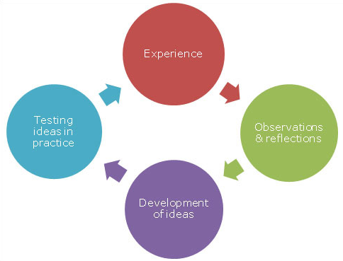
Figure 2: Kolb's reflective model for time management
(Source: Learn.solent.ac.uk, 2020)
The ability to manage time is vital for aspiring students and can also be beneficial later in their life. Employing originations also recognizes this and focusing on measuring the time management capabilities of an employee. Implementation of Kolb’s reflective model can be highly effective for the students in enabling them to effectively manage time and time-related activities (Kornelakis and Petrakaki, 2020). A student should segment his or her daily life into different parts to maximize their own learning capabilities. It also enables them to effectively manage their daily life while maintaining healthy learning activities.
This enables the students to experience different activities and also gives them a chance to experiment with their literary skills. This also enables the students to conceptualize their studies and can provide many learning opportunities. Effective time management is also highly necessary for students during employment (Miniano and Rui, 2020). This enables them to efficiently manage their time and activities. This is also considered a highly important employability skill that can have significant effects on a student and their academic learning.

5.5 Kolb's reflective model for presentation skills
The ability to present one is highly important for students and also their future life. It plays a big part during employment and is considered a major employment skill for the students (Sambell et al. 2020). Kolb’s reflective model is also theorized around the idea of effective presentation skills and its importance for the students. The students should focus on developing their personal ideals and also should reflect on their current ideals and their significance for personal development.
According to Kolb’s reflective model, reflective observational activities enables the students to process their personal activities and can highly influence their presentation skills. Experimenting and the willingness to learn from them can also be beneficial for the students and their character development (Singh and Singh, 2017). This can have significant effects on the presentation skills of the students. Positive growth of these skills can also be highly beneficial for the students in their academic and employability activities.

6. Conclusion
It can be concluded by analyzing this report that this report is regarding academic and employment skills. The research strategies that can be used in order to facilitate effective study in higher education are mentioned in this report. The software skills that can be used to facilitate an effective study in higher education are also suggested in this report. Students own responsibilities in order to facilitate effective study in higher education are also provided. The development of employment skills such as time management, presentation skills and reflections are provided here. An analysis of Kolb's reflective model for an effective study, responsible learning, time management and presentation skills are done in this report.

References
Abas, M.C. and Imam, O.A., 2016. Graduates' Competence on Employability Skills and Job Performance. International Journal of Evaluation and Research in Education, 5(2), pp.119-125.
Akhtar, N. and Hussain, N., 2019. Developing and Testing ERE Cycle in Teaching Communication Courses Using Kolb’s Experiential Learning Theory.
Álamo-Vera, F.R., Hernández-López, L., Ballesteros-Rodríguez, J.L. and Saá-Pérez, D., 2020. Competence Development and Employability Expectations: A Gender Perspective of Mobility Programmes in Higher Education. Administrative Sciences, 10(3), p.74.
Biberhofer, P., Lintner, C., Bernhardt, J. and Rieckmann, M., 2019. Facilitating work performance of sustainability-driven entrepreneurs through higher education: The relevance of competencies, values, worldviews and opportunities. The International Journal of Entrepreneurship and Innovation, 20(1), pp.21-38.
Daley, J. and Baruah, B., 2020. Leadership skills development among engineering students in Higher Education–an analysis of the Russell Group universities in the UK. European Journal of Engineering Education, pp.1-29.
Deeley, S.J., 2018. Using technology to facilitate effective assessment for learning and feedback in higher education. Assessment & Evaluation in Higher Education, 43(3), pp.439-448.
Dung, T.M. and Minh, P.K., 2020. Kolb’s Experiential Learning Model: Teaching The Side-Side-Side Similarity Case Of Two Triangles.
Fearon, C., van Vuuren, W., McLaughlin, H. and Nachmias, S., 2020. Graduate employability, skills development and the UK’s Universities Business Challenge competition: a self-determined learning perspective. Studies in Higher Education, 45(6), pp.1280-1297.
Fewster-Thuente, L. and Batteson, T.J., 2018. Kolb's Experiential Learning Theory as a theoretical underpinning for interprofessional education. Journal of allied health, 47(1), pp.3-8.
Kornelakis, A. and Petrakaki, D., 2020. Embedding employability skills in UK higher education: Between digitalization and marketization. Industry and Higher Education, p.0950422220902978.
Miniano, C.M.B. and Rui, X.Y., 2020. Kolb’s Learning Styles and Managerial Concern for People and Task: A Reflective Measurement Model.
Okolie, U.C., Igwe, P.A., Nwosu, H.E., Eneje, B.C. and Mlanga, S., 2020. Enhancing graduate employability: Why do higher education institutions have problems with teaching generic skills?. Policy Futures in Education, 18(2), pp.294-313.
Paterson, R., 2017. ‘Because sometimes your failures can also teach you certain skills’: Lecturer and student perceptions of employability skills at a transnational university. Qualitative Research in Education, 6(3), pp.241-275.
Sambell, R., Devine, A., Lo, J. and Lawlis, T., 2020. Work-Integrated Learning Builds Student Identification of Employability Skills: Utilizing a Food Literacy Education Strategy. International Journal of Work-Integrated Learning, 21(1), pp.63-87.
Singh, A. and Singh, L.B., 2017. E-learning for employability skills: Students perspective. Procedia computer science, 122, pp.400-406.

