University of Wales Trinity Saint David
Learning in the Digital Era
Module code: ACCA4025
Assignment 1: E-Portfolio
Turnitin Submission Document
Student name: Malik Imran Javaid
Student ID number: 2538963
Course: CertHE Computing Skills for the Workplace
Table of Contents
e-Portfolio 3
Task 1 – Written Summary 4
Essential Skills for Study and Employment 4
Reflection on Turnitin Similarity 5
Self-Assessment (Generic Assessment Criteria) 6
References (Task 1) 6
Task 2 – Mind Map & Academic Poster 7
Mind map 7
Academic poster 7
Task 3 – Automatic Referencing Tool 9
Virtual Collaboration: Building Trust and Communication in Virtual Teams 9
Evidence of RefWorks Use 10
References (Task 3) 12
Task 4 – E-Portfolio Creation and Review 13
Review 13
References (Task 4) 18
Acknowledgement of Generative AI Use 19

e-Portfolio

Link to the online e-portfolio homepage is below
https://aqua-pigeon-321203.hostingersite.com/
This document is submitted to Turnitin as evidence of the work in my online e-portfolio, in case the portfolio cannot be accessed. A screenshot of the home page is shown below, with each task page following.
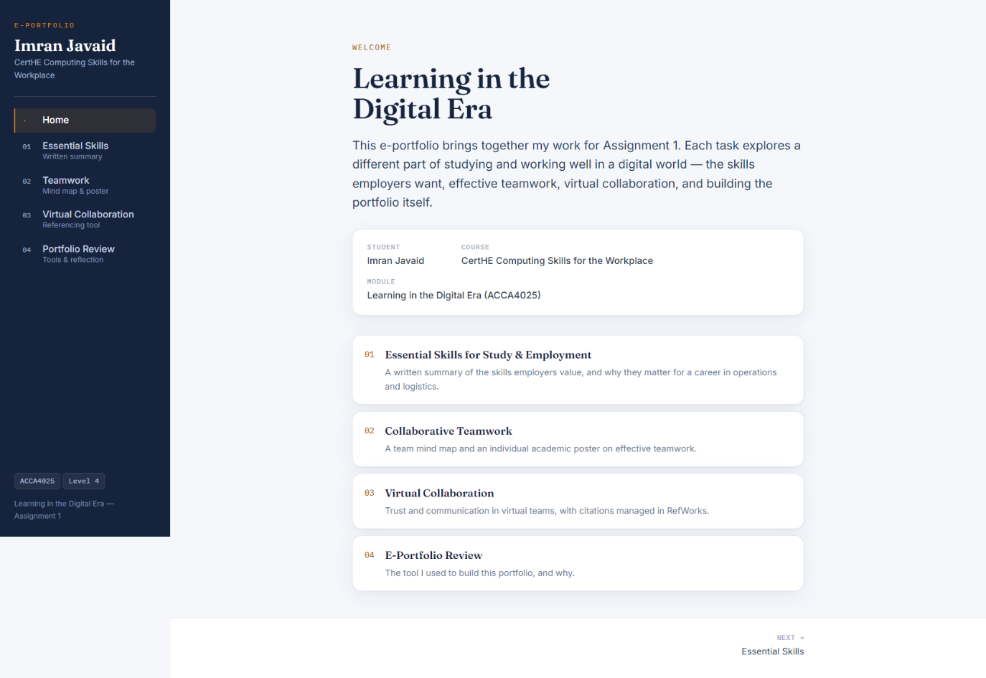
Home page of the e-portfolio.

Task 1 – Written Summary

Essential Skills for Study and Employment
Working in logistics today is completely different from how it used to be. To get ahead, you really need a strong mix of digital know-how and solid people skills. Employers are constantly looking for analytical thinking and tech abilities over almost anything else [2]. If you’re out in the warehouse, knowing how to interpret daily performance data, navigate the WMS, and adjust to new technology is just as crucial as knowing how to physically manage the freight. The tools we use are changing incredibly fast, which means you must be willing to constantly learn and adapt just to keep up [2].
But tech is still only half the job. At the end of the day, strong communication, teamwork, leadership, and self-management are what employers really want to see on the floor [3]. That is exactly how I try to approach my current role as a shift manager. I actively use the management principles from my NVQ Level 5 alongside my IOSH certification to keep my team running smoothly and safely. Being truly employable isn’t just about having a list of certificates, though. It is about deepening your knowledge of working, building a strong professional identity, and having the personal confidence to handle whatever chaos happens during a shift [4].
Building up this specific mix of skills right now is the best way to push my career forward. It guarantees I’ll be ready to lead larger shift teams, make smart choices based on real data, and easily adapt to new tools [1].
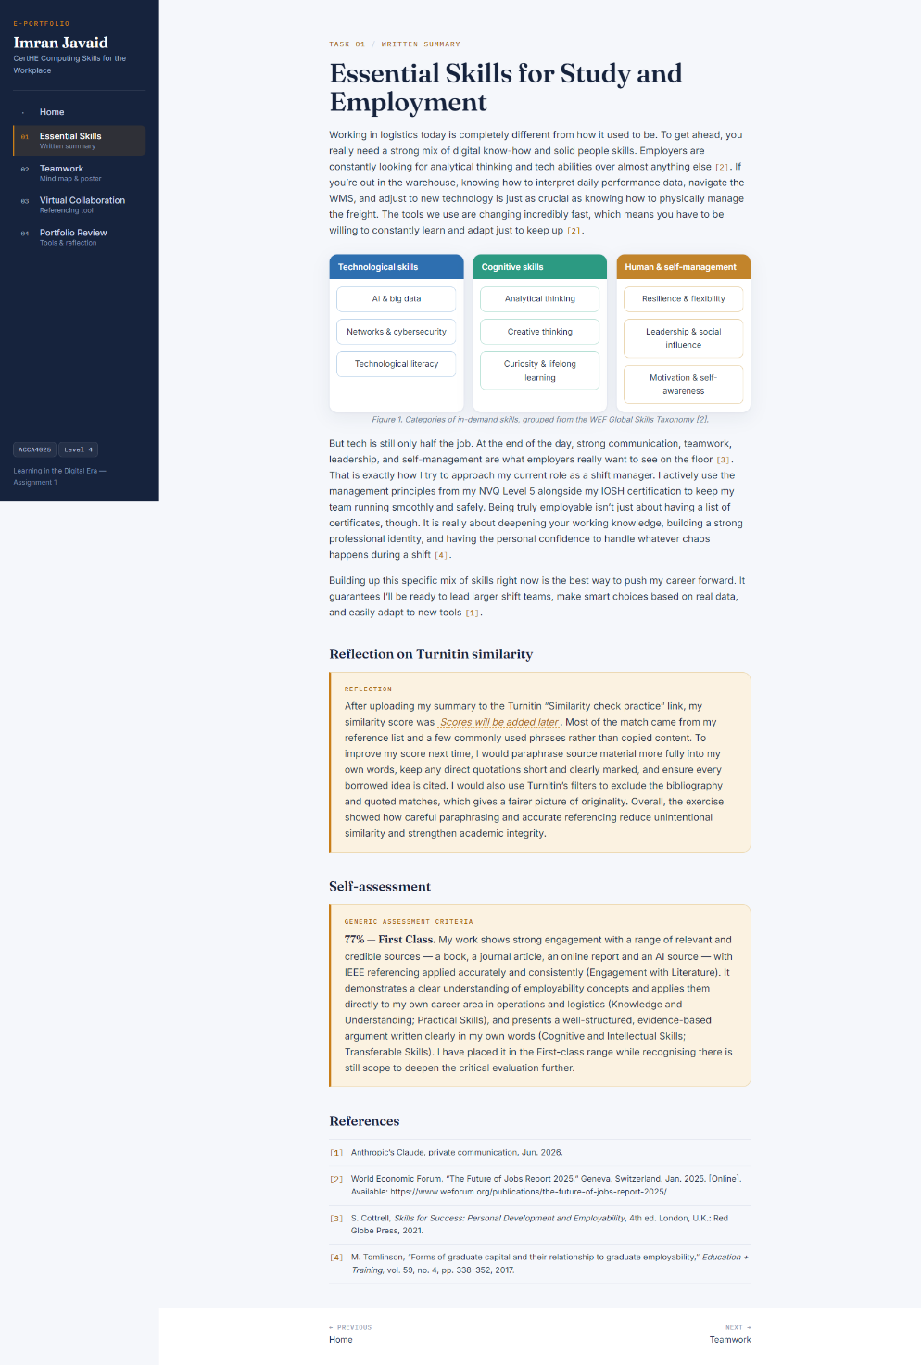
Task 1 page in the e-portfolio (summary, figure, reflection and self-assessment).

Reflection on Turnitin Similarity
After uploading my summary to the Turnitin “Similarity check practice” link, my similarity score was (will be added later) Most of the match came from my reference list and a few commonly used phrases rather than copied content. To improve my score next time, I would paraphrase source material more fully into my own words, keep any direct quotations short and clearly marked, and ensure every borrowed idea is cited. I would also use Turnitin’s filters to exclude the bibliography and quoted matches, which gives a fairer picture of originality. Overall, the exercise showed how careful paraphrasing and accurate referencing reduces unintentional similarity and strengthens academic integrity.

Self-Assessment (Generic Assessment Criteria)
Self-assessed mark: 77% (First Class). Using the Generic Assessment Criteria, my work shows strong engagement with a range of relevant and credible sources — a book, a journal article, an online report and an AI source — with IEEE referencing applied accurately and consistently (Engagement with Literature). It demonstrates a clear understanding of employability concepts and applies them directly to my own career area in operations and logistics (Knowledge and Understanding; Practical Skills), and presents a well-structured, evidence-based argument written clearly in my own words (Cognitive and Intellectual Skills; Transferable Skills). I have placed it in the First-class range while recognizing there is still scoped to deepen the critical evaluation further.

References (Task 1)
[1] Anthropic’s Claude, private communication, Jun. 2026.
[2] World Economic Forum, “The Future of Jobs Report 2025,” Geneva, Switzerland, Jan. 2025. [Online]. Available: https://www.weforum.org/publications/the-future-of-jobs-report-2025/
[3] S. Cottrell, Skills for Success: Personal Development and Employability, 4th ed. London, U.K.: Red Globe Press, 2021.
[4] M. Tomlinson, “Forms of graduate capital and their relationship to graduate employability,” Education + Training, vol. 59, no. 4, pp. 338–352, 2017.

Task 2 – Mind Map & Academic Poster
This task presents a mind map summarizing the key considerations of effective teamwork, and an individual A3 academic poster on why these ideas matter for academic and career success in operations and logistics. The mind map is embedded within the poster, and both are shown below.

Mind map
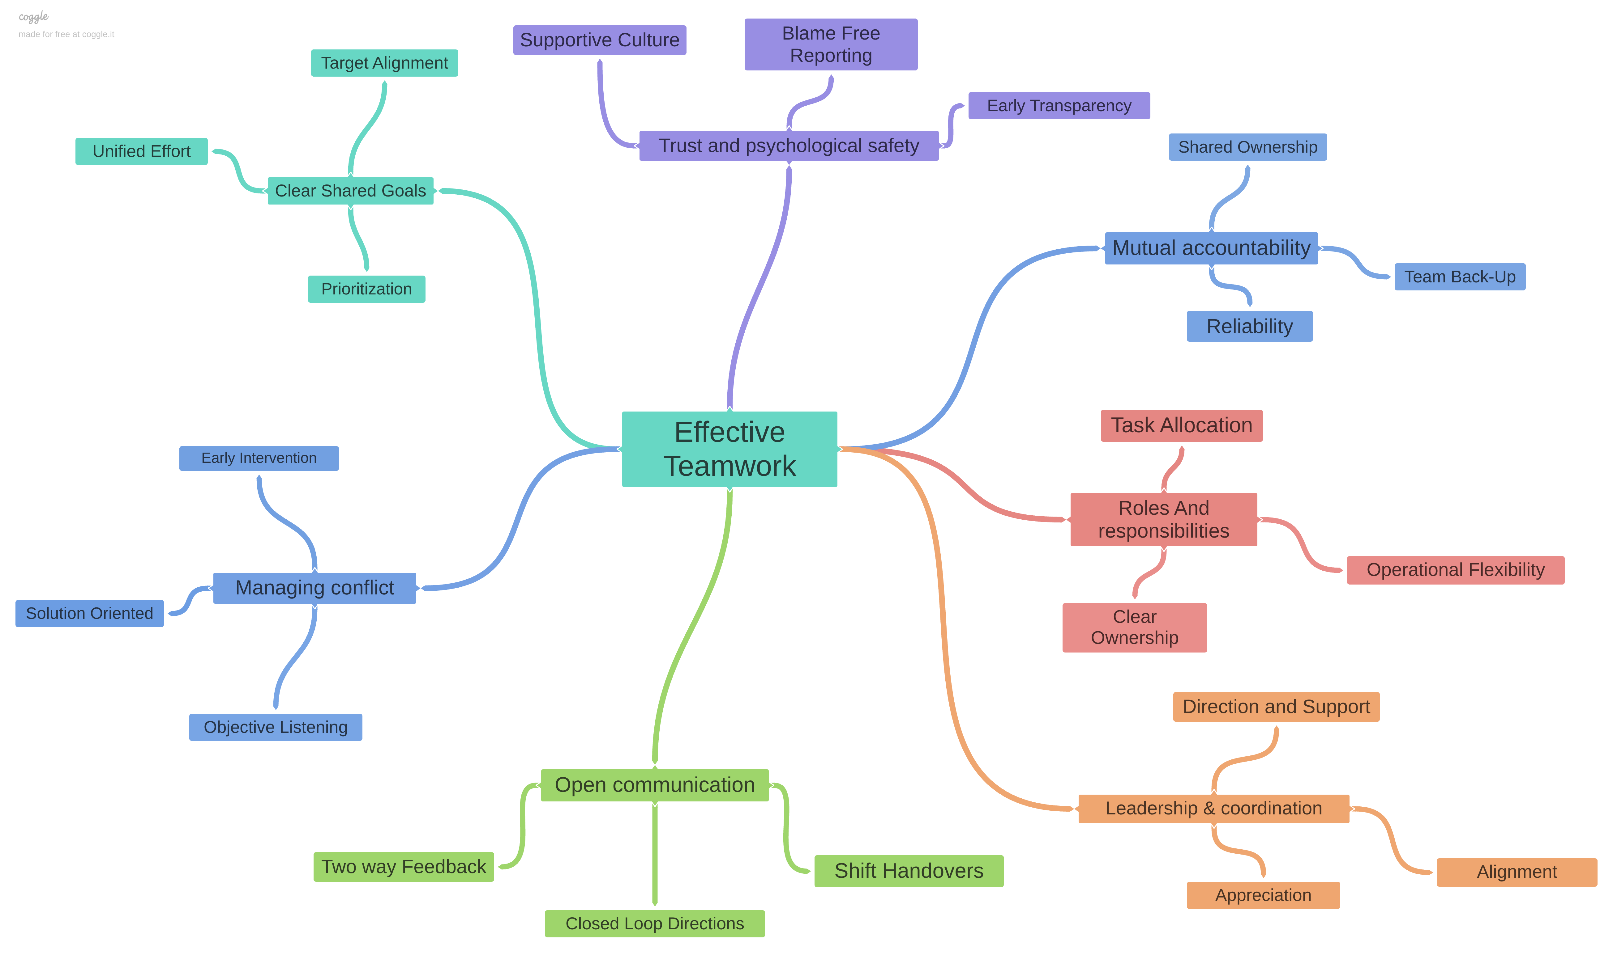
Team mind map (created using Coggle).
View online: https://aqua-pigeon-321203.hostingersite.com/assets/img/mind-map.png

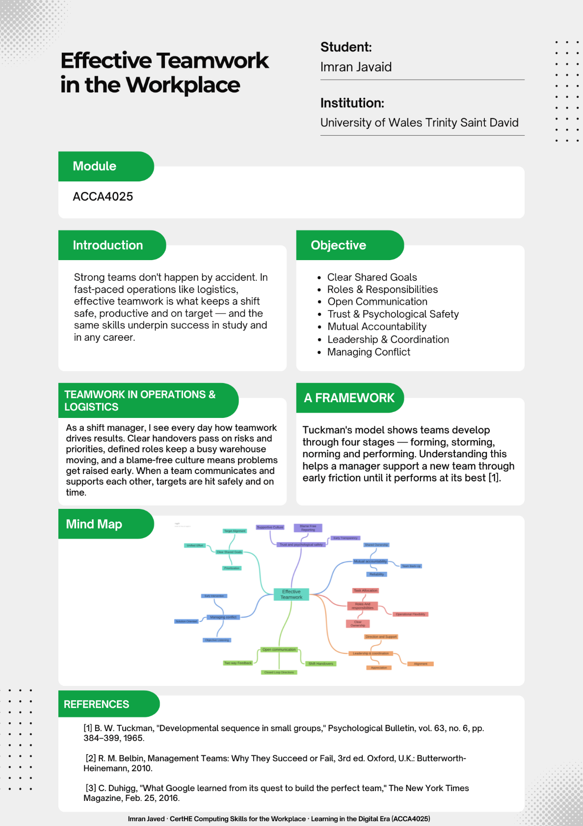
Academic poster

A3 academic poster, with the mind map embedded.
View/download: https://aqua-pigeon-321203.hostingersite.com/assets/img/poster.png
Team members: Imran Javaid, Alex, Natasha and Dave. Tool used: mind map created using Coggle.

Task 3 – Automatic Referencing Tool

Virtual Collaboration: Building Trust and Communication in Virtual Teams
Virtual collaboration is basically about how teams scattered across different sites or working from home manage to connect and build real trust without sitting in the same room. It is a massive deal today because hybrid and remote working setups have completely taken over, making digital tools the absolute backbone of how modern organizations run [3].
When you look at how these groups operate, researchers Jarvenpaa and Leidner point out that virtual teams often form what they call “swift trust” right at the start of a project. The catch is that this initial trust is incredibly fragile. It falls apart fast if people suddenly go dark or if communication becomes patchy and unreliable. On the other hand, teams that communicate proactively reply quickly, and keep their actions predictable manage to maintain that trust and perform way better. It turns out that how you choose to communicate matters just as much as what you are saying [1].
Of course, distance and tech bring plenty of unique headaches. Morrison-Smith and Ruiz note that when you lose out on body language and vocal tones, especially in text-only messages—it becomes much harder to read between the lines or understand someone’s true intent. This constant guesswork slows down decisions and slowly eats away at team trust. Their research highlights a few critical solutions to this problem: setting clear communication rules early on, choosing the right tech tools, strong leadership, and creating a safe environment where people feel comfortable speaking up [2].
Bringing it all together, a few practical habits make virtual teamwork work well. Teams need to set communication ground rules right away, jump on video calls for tricky or sensitive issues, always reply reliably to keep trust alive, and use open platforms so everyone stays in the loop [1], [2].
This connects perfectly with my own day-to-day experience managing people across different warehouse sites and shifting rotas. Figuring out how trust and digital communication interact explains exactly why some long-distance teams thrive while others completely struggle, giving me the clear tools to lead effectively in today’s connected workforce [3].
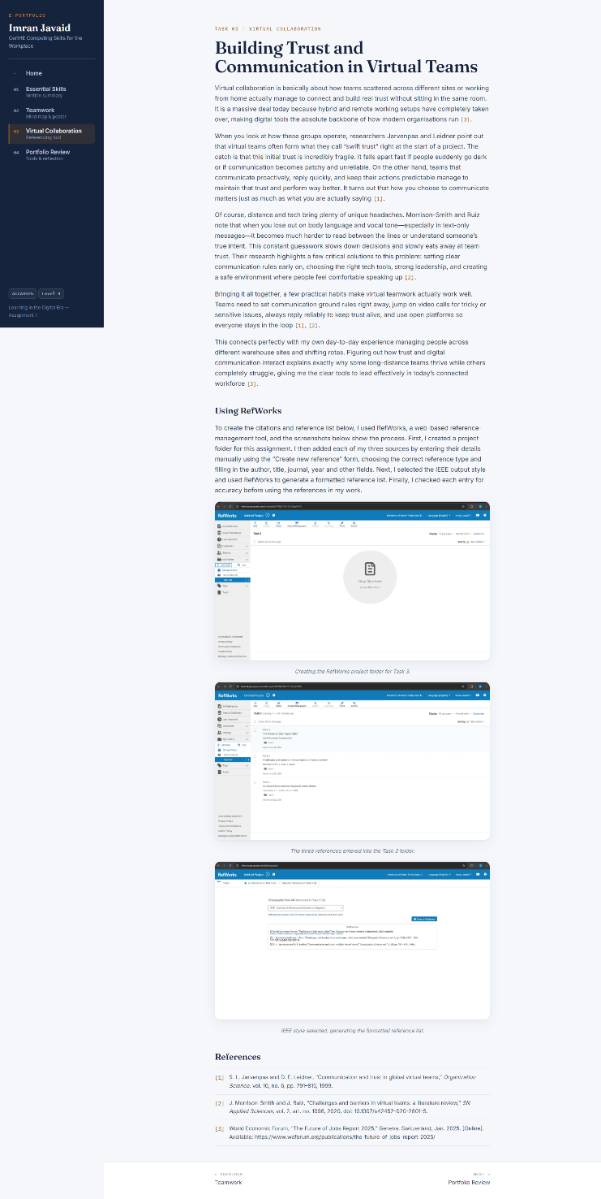
Task 3 page in the e-portfolio.

Evidence of RefWorks Use
To create the citations and reference list above, I used RefWorks, a web-based reference-management tool, and the screenshots below show the process. First, I created a project folder for this assignment. I then added each of my three sources by entering their details manually using the “Create new reference” form, choosing the correct reference type and filling in the author, title, journal, year and other fields. Next, I selected the IEEE output style and used RefWorks to generate a formatted reference list. Finally, I checked each entry for accuracy before using the references in my work.
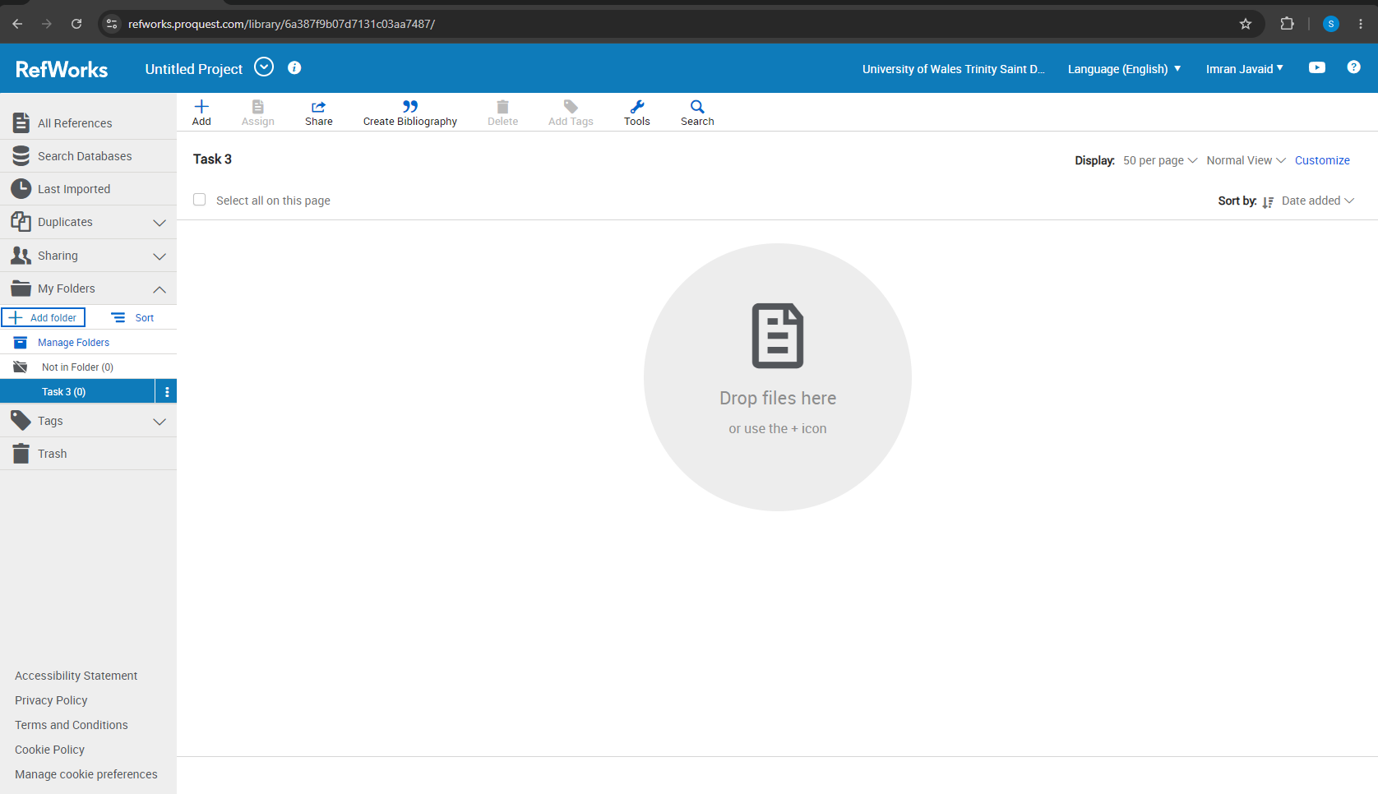
Creating the RefWorks project folder for Task 3.
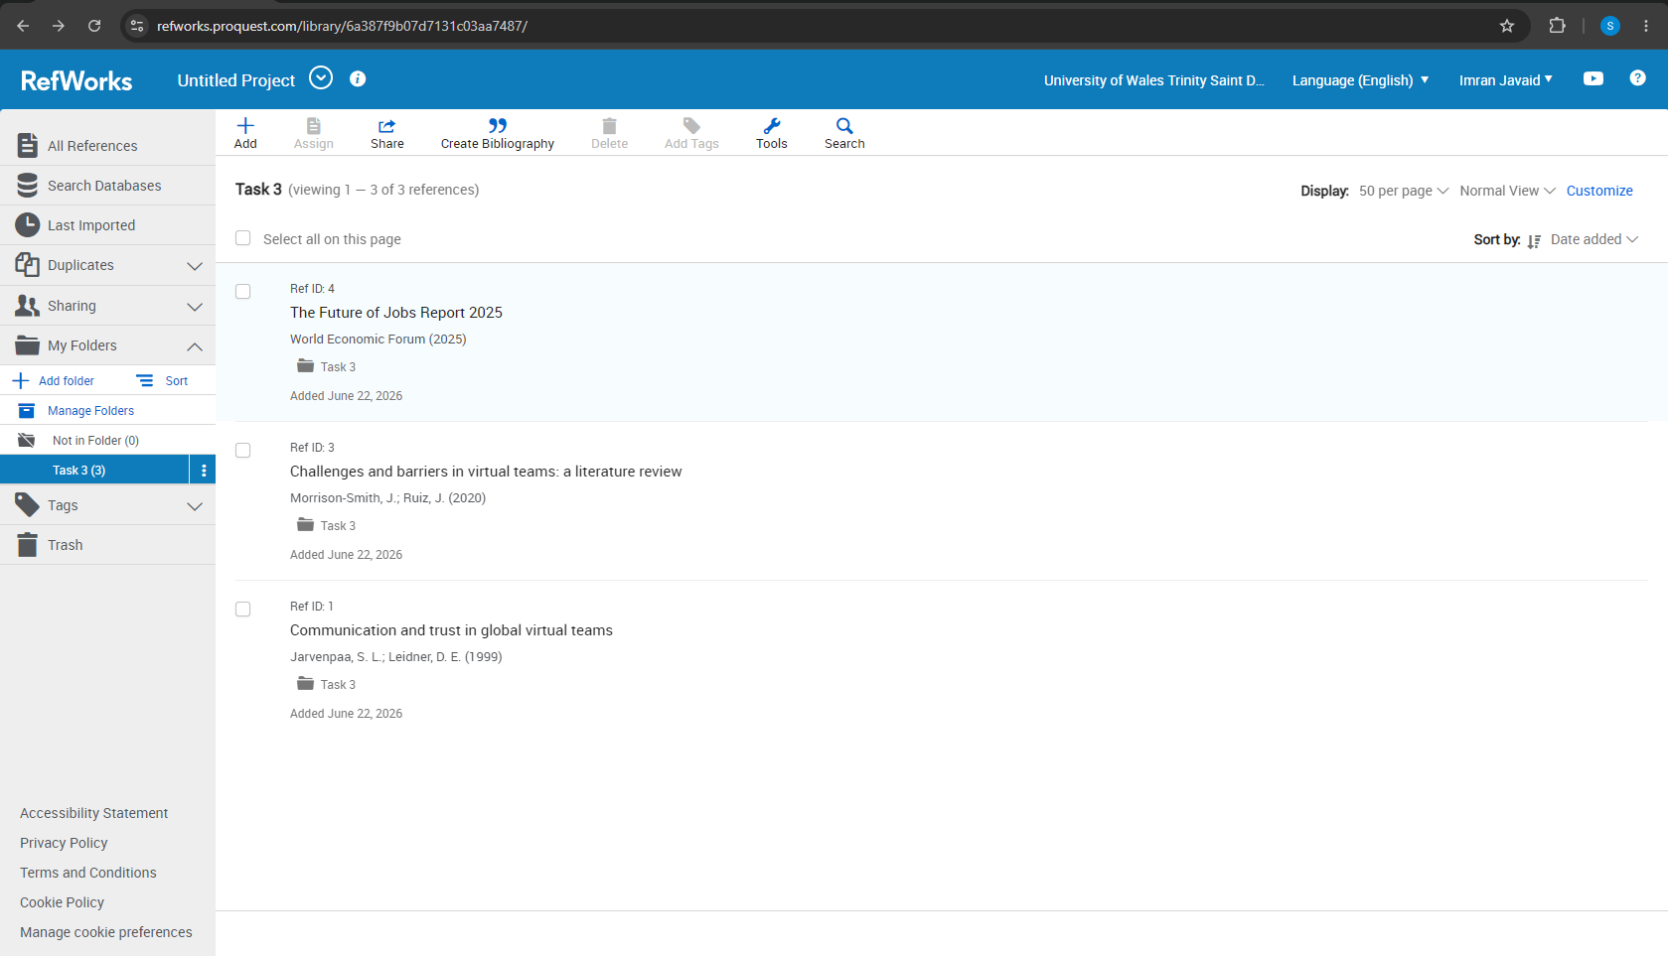
The three references entered into the Task 3 folder.
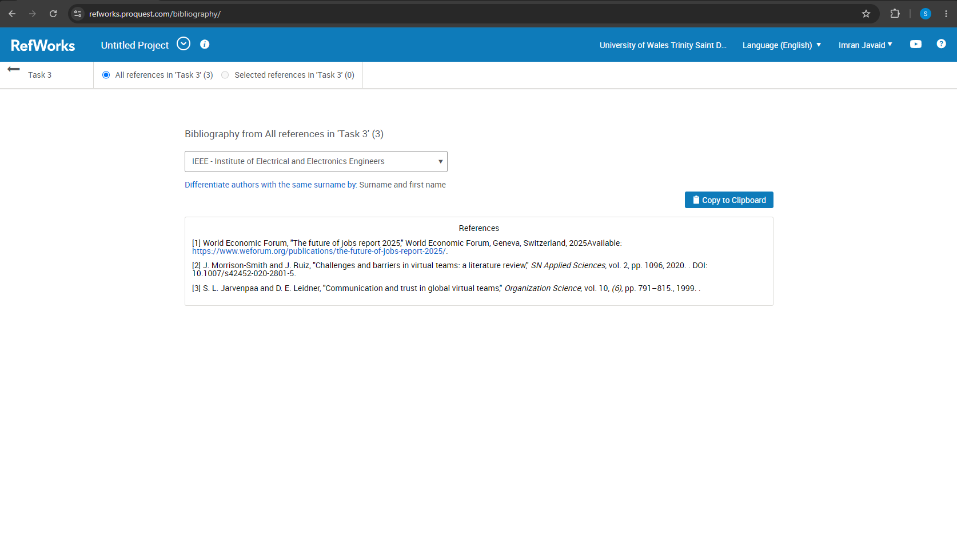
IEEE style selected, generating the formatted reference list.

References (Task 3)
[1] S. L. Jarvenpaa and D. E. Leidner, “Communication and trust in global virtual teams,” Organization Science, vol. 10, no. 6, pp. 791–815, 1999.
[2] J. Morrison-Smith and J. Ruiz, “Challenges and barriers in virtual teams: a literature review,” SN Applied Sciences, vol. 2, art. no. 1096, 2020, doi: 10.1007/s42452-020-2801-5.
[3] World Economic Forum, “The Future of Jobs Report 2025,” Geneva, Switzerland, Jan. 2025. [Online]. Available: https://www.weforum.org/publications/the-future-of-jobs-report-2025/

Task 4 – E-Portfolio Creation and Review

Review
When it came to creating my e-portfolio, I decided to code it from scratch using static HTML and CSS and host it on my own server. I went this route because I wanted total control over the design without getting stuck dealing with platform lock-in from site builders. Plus, a simple static site loads incredibly fast, works perfectly on mobile devices, and leaves me with one clean, professional link to share.
The layout itself is straightforward. I set up a main welcome page that acts as a hub, with direct links pointing to separate pages for each specific task. I also made sure the whole site was fully public. This way, my tutor can just click the link and start reading immediately, without the hassle of logging in or setting up an account.
Putting this project together really highlighted why e-portfolios are so useful. They give you a single place to gather, present, and think about your work, which makes it much easier to show actual proof of your skills to future employers [1]. It isn’t just a digital filing cabinet, though. Keeping an e-portfolio actively encourages you to reflect on what you are doing, making your entire learning journey visible over time rather than just feeling like a blur of assignments [2].
Looking back, building this site was a great exercise. It forced me to properly organize my files, helped me clearly see the progress I’ve made throughout the module, and gave me a polished, easily shareable site that I can use down the line.
Screenshots of each page of the e-portfolio are included below.
Home page.
Task 1 – Essential Skills.
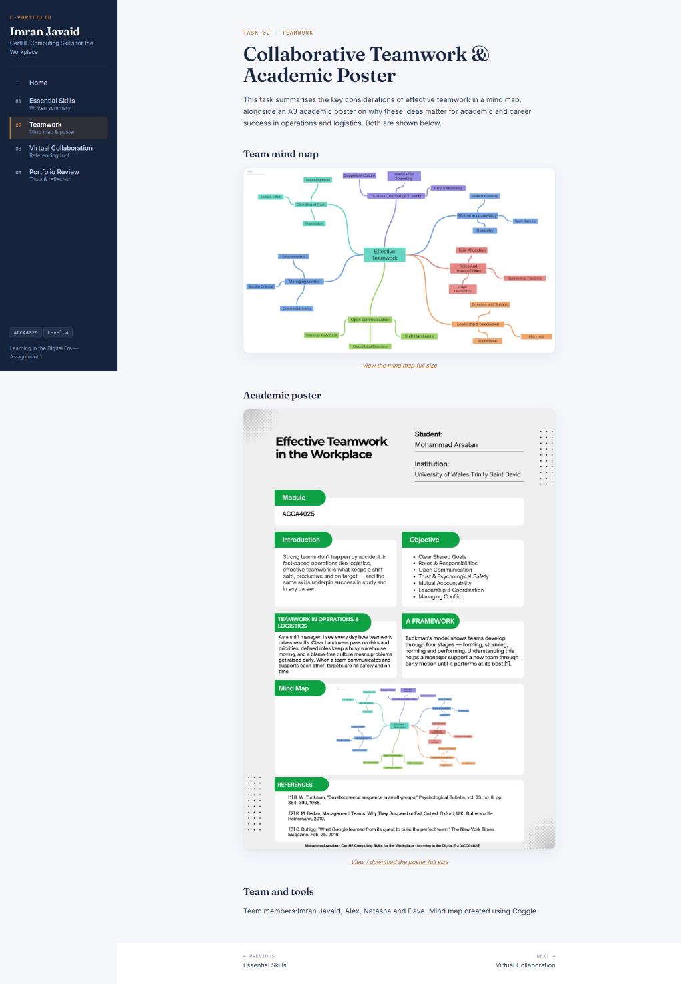
Task 2 – Teamwork.
Task 3 – Virtual Collaboration.
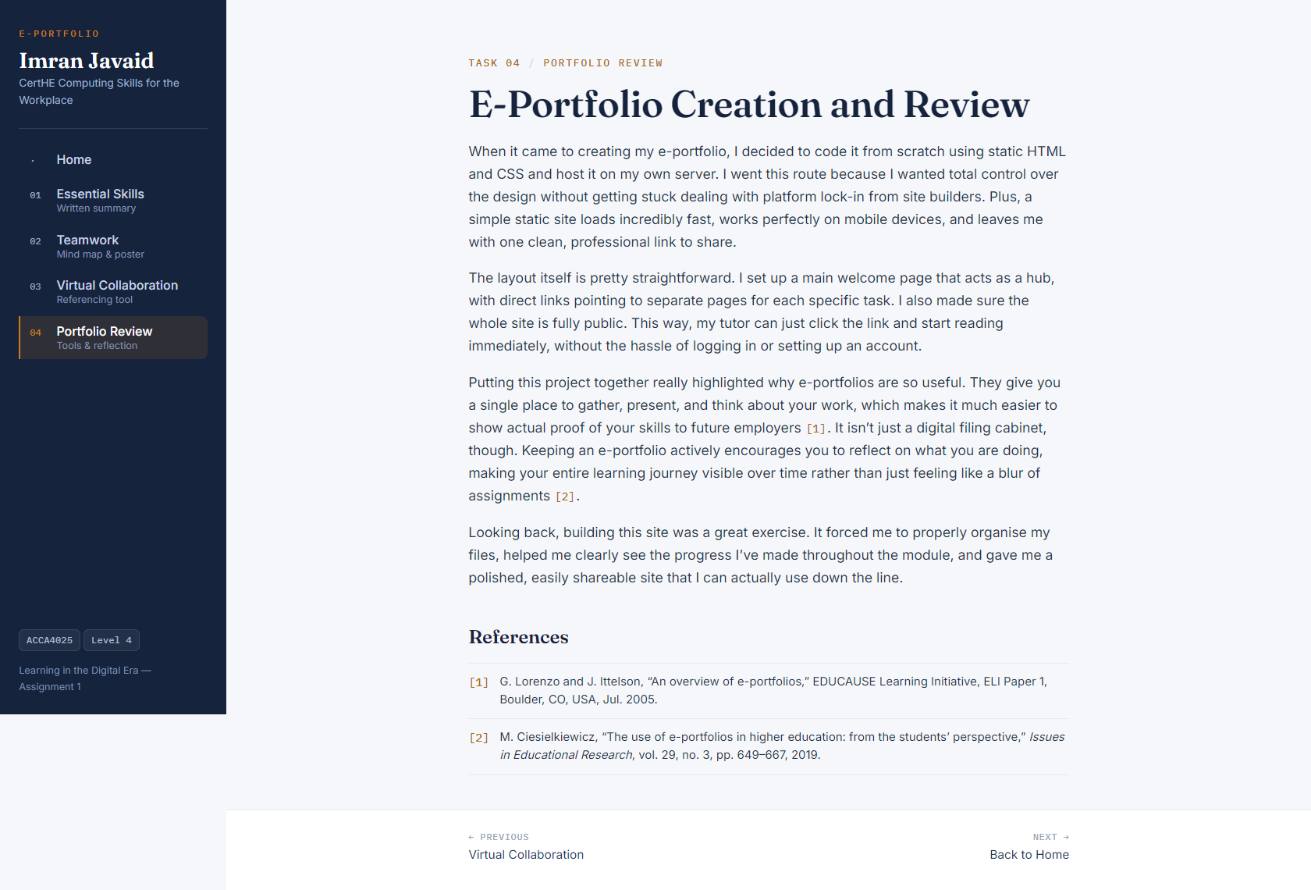
Task 4 – E-Portfolio Review.

References (Task 4)
[1] G. Lorenzo and J. Ittelson, “An overview of e-portfolios,” EDUCAUSE Learning Initiative, ELI Paper 1, Boulder, CO, USA, Jul. 2005.
[2] M. Ciesielkiewicz, “The use of e-portfolios in higher education: from the students’ perspective,” Issues in Educational Research, vol. 29, no. 3, pp. 649–667, 2019.

Acknowledgement of Generative AI Use
In line with the module’s guidance on the use of Generative AI, I acknowledge that I used an AI assistant (Anthropic’s Claude) to support my work on this assignment. I used it to help research the topics and find relevant sources, to create outlines that I then used to plan and write my own answers, and to check the grammar, spelling and clarity of my writing. The written answers for Tasks 1, 3 and 4 are my own words, and I created the Task 2 mind map and poster myself. No AI-generated text was submitted as my answers, and AI is cited as a source [1] in Task 1 in line with the referencing guidance.

