
After a decade of research, Grit has been linked to many adapted outcomes for adolescent’s and the development of school-based interventions for promoting adolescents Grit has been recommended. (“Academic Grit Scale: Psychometric properties and ... - PubMed”) (“Academic Grit Scale: Psychometric properties and ... - PubMed”) However, a reconceptualization of grit and its measurement vital for ​
The future grit research and application.​
The construct of grit, defined as passion for long- term goals, was introduced to help explain why some individuals are driven to​
Maximize their potential. [ Duckworth, Peterson, Matthews, and Kelly, (2007)}. ​
Over the last decade, Grit has received increasing attention not only in empirical research [ Crede, Tynan, and Harms. (“Academic Grit Scale: Psychometric properties and ...”) (“Academic Grit Scale: Psychometric properties and ...”) (2017). ],​
But also, in public and field of Education.​
In day age, the 21st century, everything is gone digital. At my age, I am far behind with this technology, and I had to work very​
Hard to achieve my goal. On this research there a lot of resources to be able to confirm or refute the work of Angela Duckworth. Not only that​
I need to make sure to apply the CRAAP test and DIKW. Whether I agree or disagree!!!! ​
Does Grit work??? In the UK?​
Academic Grit Scale: Psychometric Properties and association with achievement and life satisfaction. [Kelly. N, Christine. K. Malecki​
Journal Homepage: www. Elsevier.com/jschpsyc​



Angela L. Duckworth is an American academic, Psychologist, and a science author. She is married to Jason Duckworth, and they have two (2) daughters namely, Amanda Duckworth, and Lucy Duckworth. Angela L. Duckworth work as an Author, Psychologist, Researcher and an academic. She studies in Oxford University MSc with distinction in Neuroscience,​
PHD in Psychology as a National Science Foundation Graduate Fellow at the University of Pennsylvania. She received an Awards in McArthur Fellowship, and Marshall Scholarship. Angela L. Duckworth has been studying Grit for 15 years, including as part of her Doctoral work. She wrote the books, Thru Grit: Trait level perseverance and for a long term goals predicts effectiveness and retention among novice teachers, The Mechanics of human achievement, Grit: Perseverance and passion for a long term goals, From fantasy to action: Mental contrasting with implementation intentions (MC11) Improves academic performance in children, World-Class Expertise: A development model, The grit effect: Predicting retention in the military and workplace, school, and marriage, More than resisting Temptation: Beneficial Habits mediate the relationship between self- control​
And positive life outcomes, Intelligence is not enough: non-IQ predictors of achievement. These are only some of Angela's book. On Ted Talk she claim that Grit is the power of passion and perseverance. The more girt you have the more likely you are to achieve; Angela says That if you have a higher grit score you are more likely to have a higher academic level of achievement. So, is this true?​
​
​



On these slides I am going to use the CRAAP test to determine is Angela Duckworth claim about Grit is the power of passion and perseverance.​
​
- Currency: There were 25,124,689 viewed Angela Duckworth TED'S TALK GRIT: The power of passion and perseverance. To get that amount​
Of viewers make me believe her credibility. She wrote 10+ books about Grit and has written in the Journal.​
​
- RELEVANT: Relevance!!! Yes..., She is a schoolteacher. She teaches math in seventh grade. An Author, a psychologist, academic, and a ​
Researcher. It is relevant because Grit is about kids and adult behavior challenging settings.​
- Authority: Angela Duckworth prove to be authorities; she holds the New York's best-selling book on Grit. She also Publish in Journal,​
www.elsivier.com​
- Accurate: Is it accurate? Angela Duckworth has been studying Grit for (15) years. She starts studying Kids and adults in challenging settings. ​
Her research team and herself went to west point military academy, The national spelling Bee contest, study newcomer teachers and​
Partners with different companies. And all their results they encounter a prediction of success was Grit. So, I Think Angela Duckworth claim about grit is accurate.​
- Purpose: What is Angela Duckworth Purpose? She is not doing these for her own purpose. She is helping student achieve their​
Long time goal.​
​
I believe that Angela Duckworth claim that the power of passion and perseverance has pass the CRAAP test. It is now time for me to take it to test.​
​
​ 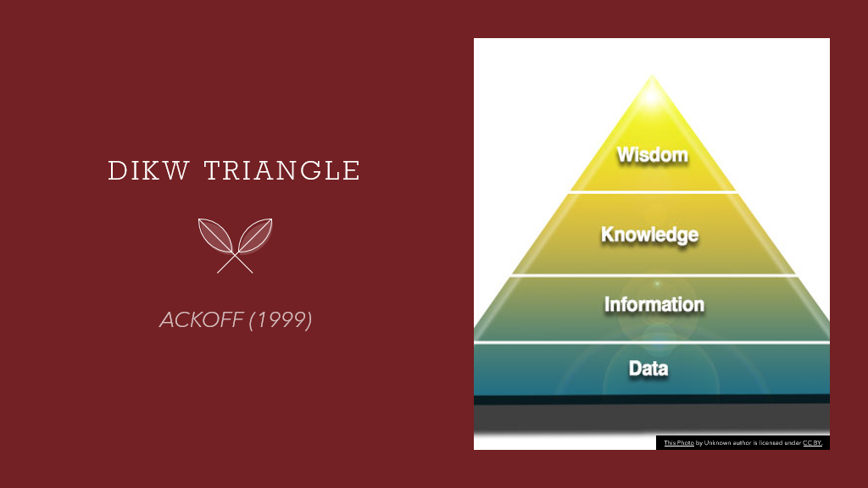

DIKW: From Data to wisdom By Ackoff. R. L (1999) Ackoff Best New York: Wiley and Sons pp170-172​
​
Russell Lincoln Ackoff was an American Organizational Theorist. Born in Philadelphia, Pennsylvania, US on the 12th of February 1919. He was known​
For organizational theory, General Systems theory, and operational speech. He is known as a pioneered system thinker.​
- DATA: The lower level of the pyramid. It does not mean much. It is a list of numbers, words, or symbol. ​
- INFORMATION: The way to move from data to information is to provide meaning, an input.​
- KNOWLEDGE: The way to move from Data to information, Information to knowledge convey by instruction, answer to information.​
- WISDOM: Wisdom deal with values. It involves judgement, evaluation​
Time to apply DIKW...​
​



In this slide I am giving my personal data. My Name is Socorro Alam. I work as a Healthcare assistant in Ashurst Care Home​
In Northampton. I am married. I had three children on my previous partner. I live with my husband in Northampton. My Email address is​
Socorroalam7@gmail.com. During my early years of my life, I was busy working, to earn money to be able to send it to my children and give them good life and Education. Now I manage to bring them over here, and they have their own Degree. It starts me thinking, Time for me to do something for myself. Something that I really want to do. Which is Why I am being here today. Researching on my first assignment after a long time absent in study. Now it is time for my Data make it useful. By taking Angela Duckworth Grit survey.​



Information... Making the Data Useful is to identify my academic level and Grit score. Turning Data to Information. I have done my academic study​
Back home to Philippines. And to be able to identify my academic level, I have used the UK Qualification Comparison Chart. And I can Honestly say That ​
I am Level 3. I graduated my High School in the Philippines and has done one year in University of Philippines studying Criminology. I also took ​
The Grit Score from Angela Duckworth Survey. Which I scored 3.2 and I think looks good for me. Or needs more! ​
And we start making a survey based on what we think is our academic level is by using Microsoft form. And the chart is created.​

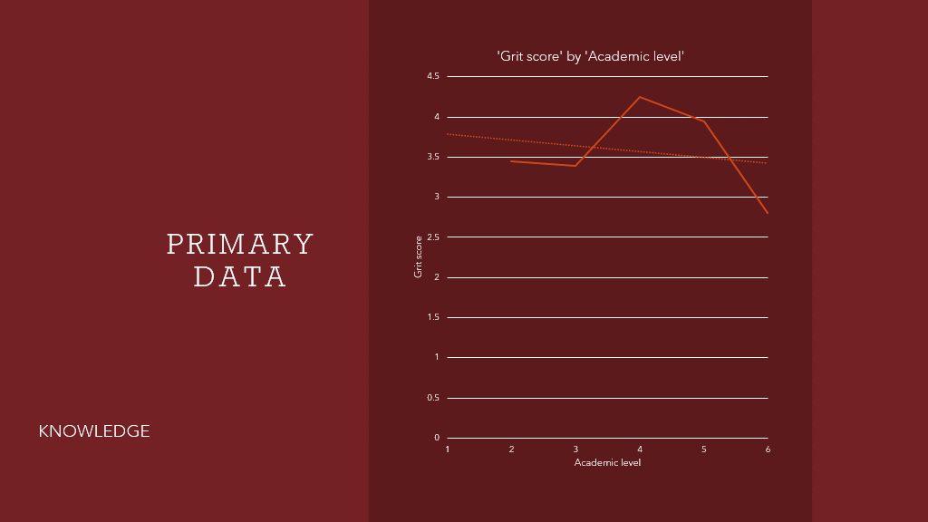
In this slide, we get to learn how to make a chart. I use Microsoft Excel. With the help of Mr. P. Ranson did a survey of the class Grit score and the Academic level which we think is our level. " Academic achievement was assess in (2) ways: Self-reported academic achievement and grade point average, [ De Castella & Byrne, (2015)]. I then collected the class grit score and class academic level into group. [ I did this manually]. Now, I notice ​
That there is an issue with data collected. Some were answered in words instead of numbers. Before we can start the chart, we need to erase those​
Word gathered from survey and change it to number. Word converts to number. And we had to delete the line with word which do not make sense with our chart yet. On the first cell I put all the class academic level in order. Then I collected all our grit score in numerical order and get the average in ​
Each numerical number. To find the average, we click on the next cell available and type = average (then paste the number needed for average and click) the release. The average should come out. I did same with the next one. When it was all finish with average, I can now make a chart. Start with​
Paste all the grit score and the academic level together and press the recommended data. Now, this time we are looking for the scattered line. Then time to click the trend line for comparison. As you can see the trend went down. The Academic level 6 makes our chart go down. I do not think it makes difference if I want to take the academic level 6 is taken out. As you can see, from level 4 it already went down. I find that on this data, Angela​
Duckworth claim about grit did not work.​
​

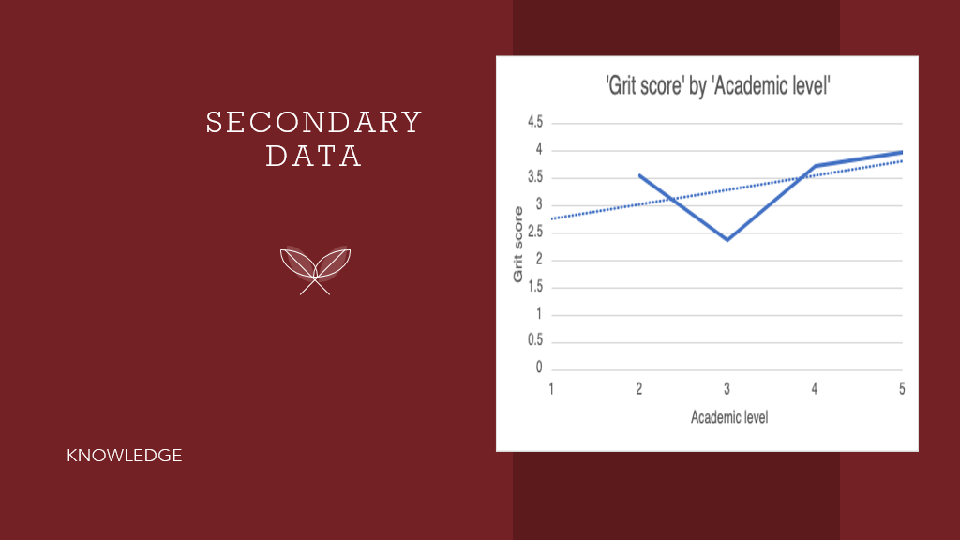

Now on this slide we are using Mr. P. Ranson collected data from University of Wales Trinity Saint David. Which has 175 people who participated.​
Take note!!! This time no issue yet. I sorted the Academic Level and their Grit score manually. Oh dear. Extremely hard to do it manually. Same format, Microsoft Excel used. Collated the data. Grouping (1), (2), (3), (4), (5) academic level. Put in Numerical order, Find the average on each Level. Paste​
And start to make a chart. Do not forget the trending. Now we got the Secondary data. The data look like agreeing to Angela Duckworth Claim in​
Grit.​



LEDGE TO WISDOM​
I found – out that my Primary Data does not agree with Angela Duckworth claimed on Grit. However, The Secondary Data seems to agree.​
There is less Participant in Primary Data compared to Secondary Data which has 175 people who participate in the University of Wales Trinity​
Saint David survey. If only we can get more people to participate in our survey it would be different. Angela survey has 2000 people​
Who participate in her survey?​
Looking back on Angela Duckworth TED's TALK lecture, Angela Duckworth says Carol Dweck growth mindset improve Grit.​
The power of not yet, Gave them a path for the future growth mindset. [ Dweck. C. 17, Dec, (2014). The power of believing that you can improve.​
TED's TALK lecture.​
After learning about Carol Dweck work, I started to reflect on myself on how was struggling with my assignment. Reading various sources, and how many times I change my structure in PowerPoint, rearranging it, making charts, converting my created slides from PowerPoint to Word document,​
Makes me realise I became grittier when I put on my mind that can do this assignment, with a lot of effort and challenging work. And can say​
That I have been applying to myself the work of Carol Dweck and Angela Duckworth. ​
" Wisdom is only attained after a much processing of Data, Information, and Knowledge. (“Assignment 1 - Amelia Hands.docx - CP5806 The DIKW ...”) [Rowley. J. (2007) The wisdom of Hierarchy: Representation of DIKW Hierarchy, (Bangor, Business School, University of Wales, Bangor Gwynedd). Journal of Information Science.​


How can this Content continue!!!​
Have the power of not yet,​
Self – believe,​
Growth mindset applied in daily life.,​
And be GRITTIER.........​
To achieve main goal in life.​



Ackoff.R. L (1999) DIKW from data to wisdom: Best New York: Wiley. J. & Son's pp170-172​
​
Clark. N., Malek. C. K. (2018). Academic girt scale: Psychometric properties & Association with achievement and life satisfaction.​
Journal homepage. www.Elsevier.com/jsnpsyc​
​
Crede., Tynan., and Harms (2017)​
​
Duckworth. A. L. (2013) The power of passion and perseverance. TED's TALK​
​
Duckworth. A. L., Cross. J. J. (2014) Self- control & Grit: Related but separable Determinants of sources. Current directions in Psychological​
Society, 23 (5) 2014 – 10- 01., 319-325​
​
Duckworth. A. L., Quinn. P. D. (2009) Development and validation of the short Grit scale (grit-s). Journal of personality assessment. 91 (2)​
166- 174​
​
De. Castella., Byrne. (2015) Academic achievement was achieved in two ways; Self-reported academic achievement, And Grade point average​
(GPA)​
​
Dweck. C. (2014) The power of believing that you can approve. TED's TALK​
​
Rowley. J. (2007) The wisdom of Hierarchy: Representation of the DIKW Hierarchy. Bangor Business school, University of Wales, Bangor​
Gwynedd. Journal of the Information Science​
​
Wiley. J. New York., and Chichester (1999). Ackoff's Best, His classic writings on management. Vidal., R. V. V. Elsevier B. V (2001)​
​
Winkler. L. E., Duckworth. A., Shulmann. E., Ebeal. S. (2014) The Grit effect: Predicting retention in the military, the workplace,​
School, and Marriage. Frontiers in Psychology. (5) 2014-02-01​
​

