Music Therapist

What is Music Therapy?  Music therapy is the clinical and evidence-based use of music to help people whose lives have been affected by injury, illness or disability, through supporting their psychological, emotional, cognitive, physical, communicative and social needs. (NHS Wales,)2023.  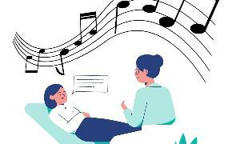 | Music Therapists:  Music Therapists are degree qualified HCPC registered clinicians who work in a wide range of facilities such as hospitals, schools, day centres, care homes, therapy centres, prisons and private practices across the UK.  (British Association of Music Therapy,)2023.  
The Science behind Music Therapy:  Neuroscience:  Research shows that music can have a profound impact on the brain. Music Therapists utilise this knowledge to stimulate areas of the brain through the use of music promoting neuroplasticity,  Research by Cheever et al.,(2018) “ demonstrated improved respiratory control, quality of life, and muscle control associated with swallowing and gait” when music therapy was used as a tool to restore function in the ageing brain.  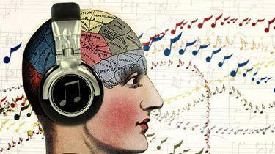  Physiological Science:  Music is able to instigate physiological activity in the body, Pittman & Kridli, (2011) state that “music can cause a decrease in heart rate, respiratory rate and blood pressure”.  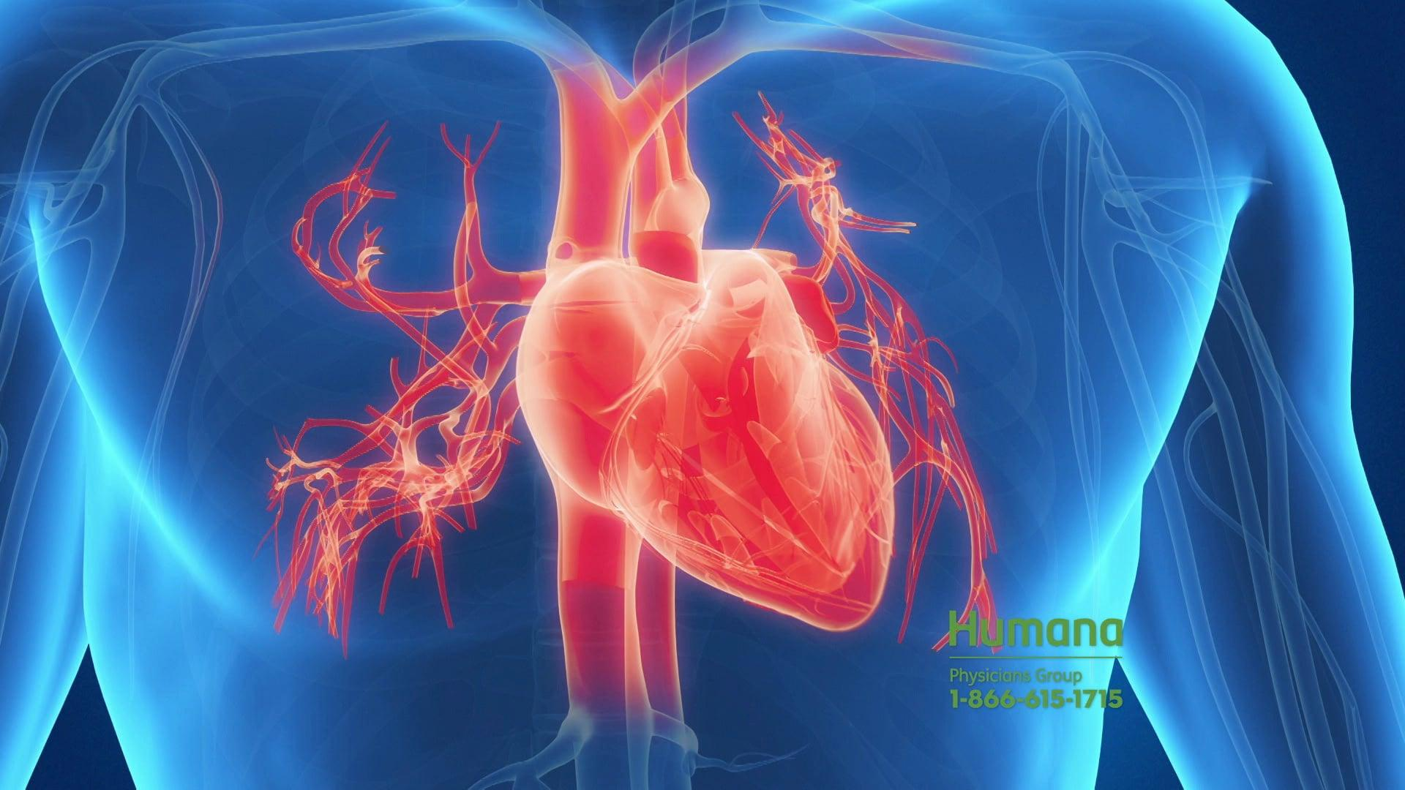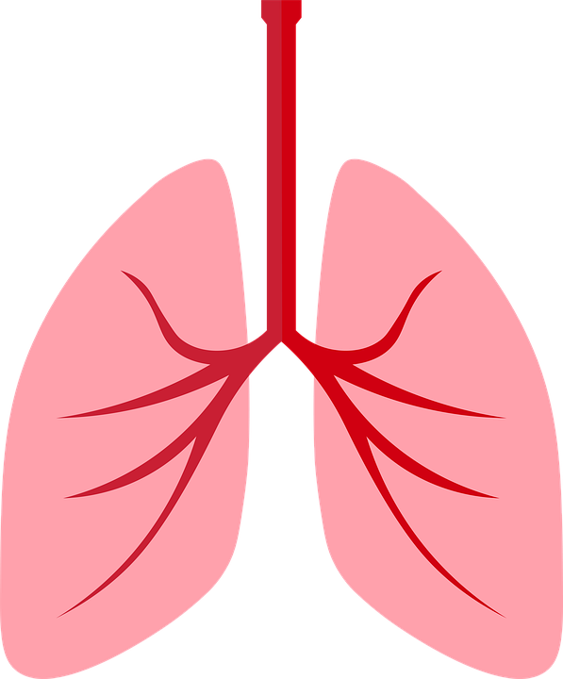 | How science is used in Music Therapy:  Music Therapists use a variety of approaches depending on the needs of the individual being treated, ranging from writing songs, singing, dancing, to just listening to music.  Example 1: Individual suffering with persistent pain.  The Music Therapist would ascertain the individuals preferred genre and then get the individual listen and possibly sing along to the music to elevate the pain, Pepper (2018) explains that “ the brain uses the same pathways to process music as it does pain” leading to limited space for pain messages to be received when listening to music.  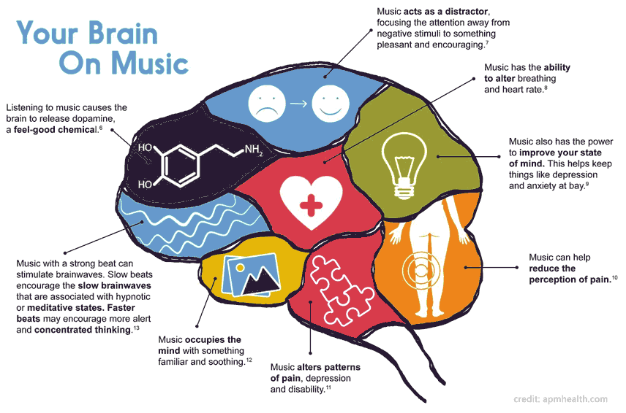  Example 2: Individual suffering with depression  Here the individual will be asked to listen to music and actively play an instrument leading to physical activity, Maratos et al, (2011) tells us that “ the role of physical activity in averting depression and alleviating its effects is well recognised”.  Additionally Klein, (2020) indicates that listening to music leads to the release of “dopamine which is a hormone that makes people feel good and endorphins which induce happy moods”

References:

British Association of Music Therapy (2023) British Association of Music therapy, BAMT. Available at: https://www.bamt.org/music-therapy/what-is-a-music-therapist (Accessed: 16 June 2023).
Cheever, T. et al. (2018) ‘NIH/Kennedy Centre Workshop on music and The brain: Finding harmony’, Neuron, 97(6), pp. 1214–1218. doi:10.1016/j.neuron.2018.02.004.
Klein, A. (2020) Medical News Today [Preprint]. Available at: https://www.medicalnewstoday.com/articles/156433#types (Accessed: 16 June 2023).
Maratos, A., Crawford, M.J. and Procter, S. (2011) ‘Music therapy for depression: It seems to work, but how?’, British Journal of Psychiatry, 199(2), pp. 92–93. doi:10.1192/bjp.bp.110.087494.
NHS Wales (2023) Music therapist, HEIW. Available at: https://heiw.nhs.wales/careers/nhs-wales-careers/roles/allied-health-professionals/music-therapist/ (Accessed: 14 June 2023).
Pepper, L. (2018) The Healing Power of Music, HemAware. Available at: https://hemaware.org/mind-body/healing-power-music (Accessed: 16 June 2023).
Pittman, S. and Kridli, S. (2011a) ‘Music intervention and preoperative anxiety: An integrative review’, International Nursing Review, 58(2), pp. 157–163. doi:10.1111/j.1466-7657.2011.00888.x.

