Module Title: Managing Food & Beverage Operations

Assignment Title: Student Learning Log
Student Name: Anaida Adamache
Student ID:2026381
Module code: BMIH6002
Lecturer Name: Jessica Newport

Table of Contents
Introduction 3
Section 1: Role Reflection 4
Section 2: Development Journey 8
Section 3: Service Improvement Proposal 10
Conclusion 12
References 13

Introduction
My hotel placement was at the Novotel Birmingham Airport, where I worked in the reception area. This property offers food as well as beverage options through its on-site restaurant, bar as well as room service. Accordingly, the menu features British and international dishes such as homemade curries, soups, and udon noodles along with vegetarian and plant-based meals (Accor, 2025). During this learning placement, I aimed to understand and learn work-based key skills. I also hoped to address the issues in the food and beverage department and gain knowledge about management performance. Lastly, I aimed to understand the required performance criteria and technical knowledge to meet the guest standards. On that account, this learning log will highlight my reflection on the experience I have gained during the placement experience. Moreover, my development journey and a service improvement proposal will also be provided here.

Section 1: Role Reflection
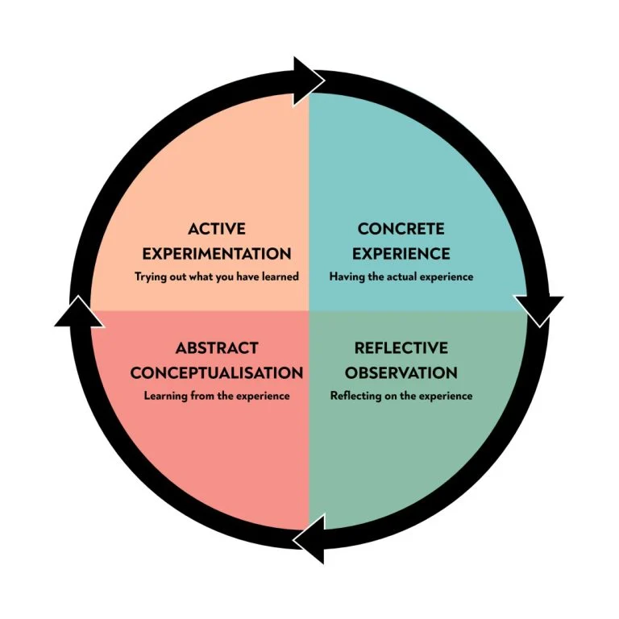
Figure: Kolb’s reflective model
Source: (McLeod, 2025)
Using Kolb’s reflective model to reflect on my experience
Concrete Experience
I have worked at the restaurant area and reception of Novotel Birmingham Airport and catered to the guests who have come to spend their days comfortably. On that account, I have observed the different responsibilities and decision-making processes. Receptionists and front office managers are the key personnel who hold the major responsibilities. The primary guest services that the receptionist offers are check-in and check-out processes, administrative tasks, customer support, interdepartmental coordination and sales retention. I have also noticed that the front office manager manages the reception, ensures smooth operations, resolves issues, manages revenue, reviews report as well as works as a liaison between departments. Additionally, within the restaurant, the guests were served with tasty food with efficient service. As a worker in these department, I have participated in many of these responsibilities. At restaurant area, I have performed duties like clearing tables, maintaining cleanliness, as well as replenishing food items. On the other hand, I have managed basic front-office duties such as checking guests in and out, entering new bookings into the system, and processing payments at reception. Additionally, the decision-making process in this property follows a standard hierarchical model where each worker has their set of responsibilities and they report to their supervisors. However, employees are empowered to solve issues on their own. By working in this area, I have learned that work-related skills such as leadership, problem solving, communication and adaptability are very important.
Reflective observation
While reflecting on my experience, I have acknowledged some inconsistencies in my previous knowledge and learned new things (McLeod, 2025). I have experienced different events where I noticed effective or ineffective supervision and their impact on operations. For instance, I have seen a scene where a guest has complained about poor service which happened due to miscommunication. Due to staff shortage that I have noticed, additional pressure has created and this has caused miscommunication and service inefficiency. Supervisors also failed to manage the occasional pressure at the front office and bar areas due to the staff shortage issue. On that account, this has affected the reputation of the hotel at times. I have understood from this experience that consistent supervision with proper staff allocation is necessary in this particular service field. Another time, when a guest has complained about their coffee being cold, I have handled the guest by politely apologising and ordering new coffee. This has projected my professionalism as well as awareness regarding customers’ needs. Accordingly, I have noticed effective supervision and communication has allowed me to act professionally within my workhour. Reflecting on this experience has made me acknowledge that proper leadership, communication, training, and clear procedures are necessary for getting customer satisfaction.
Abstract Conceptualisation
From my experience, I have understood, along with professional and technical knowledge, soft skills are very necessary in a hotel, including reception. Leadership, problem-solving, communication as well as adaptability are some of the most essential skills that are needed for workers to have to work here. However, previously, I had a misconception that working at reception is solely a desk-based and repetitive task and technologies will eliminate the need for the department. While working here, I have understood that the role and responsibilities involved in this department are dynamic and multilayered, where constant problem-solving and coordination are necessary. On that account, I found that I can easily communicate with others which has helped me in working with teams and coordinating with others. However, I have also noticed that I am slow to adapt to new situations as well as to develop solutions for problems which is an extremely required attribute.
Active Experimentation
With the help of the learning I have earned from this experience, developing an action plan to strengthen my weaknesses such as poor adaptability and problem-solving skills, is necessary.
Action plan
Skills | Ways to achieve | Timeframe
Adaptability | I will develop a growth mindset, learn new skills consistently and develop knowledge about the working field to get accustomed (Sony and Mekoth, 2022). | Within three months
Problem-solving skills | I will develop the habit of getting to know about the problem with more focus and generate different solutions to find out the best one by embracing creativity and brainstorming (Percy, 2024). | Within six months

Section 2: Development Journey
Comparing my current Level 6 placement with the Level 4 experiences
I have developed a new restaurant concept under the Hotel Trinity Hotel and both Greggs and Pine restaurants, where I have worked, were used while writing the student journal in level 4. On that account, Novotel Birmingham Airport is an upscale 4-star hotel, and Hotel Trinity is a budget and independent hotel (Accor, 2025). While Greggs and Pine restaurants are not hotel chains and they fall under the category of budget. Hotel Trinity and Novotel Birmingham Airport focus on classic hotel-based service such as accommodation, dining and others. While the Greggs and Pine restaurant offer standalone dining services (Restaurantpine, 2025). While working at the hotels, I have gained some good experience which includes positive guest experiences, career advancement opportunities as well as team support. However, the extreme work pressure due to lack of staff during some days has made me stressed at times. During my work at the restaurants, I have taken pride in providing excellent service and contributed to a positive guest experience.
Reflecting on the experience of the Level 4 and Level 5 modules
From my experience in Level 4 to the current placement, I have understood that soft skills are very necessary for successful handling of these hotel services. However, I also learnt that the management and decision-making process is different in these places as Novotel Birmingham Airport follows a more hierarchical structure. On that account, Greggs and Pine follow a more functional structure. Consequently, the menu I have designed will be appropriate for Hotel Trinity as with this multifaceted menu, they can easily attract and expand their customer base. On the other hand, the Novotel Birmingham Airport, under the Accor Group, heavily focuses on specific environmental goals. Contrarily, Marriott Hotel’s strategy is broader, encompassing economic opportunities, legal compliance, human rights, and other aspects (Jessen, 2024). Further, greener practices like tiered CSR that combines both environmental and social goals will be useful for these hotels.

Section 3: Service Improvement Proposal
Key area that needs to be improved
Staff shortage at both the reception and the front bar areas creates a huge probability of facing issues in daily operations that leads to service inconsistency (Tripadvisor, 2023). On that account, I can say that customer service inconsistency due to workforce shortage is one of the areas that needs to be improved in my current placement. The firm needs to focus on hiring potential candidates having skills like upselling, handling diverse guest needs and other aspects. I have concluded this aspect after reviewing my placement experiences along with assessing the online reviews and interactions with my colleagues.
Improvement plan
Standardising operating procedures and recruiting new skilled staff
This strategy, through creating clear goals, standardising amenities, establishing communication goals and recruiting new talented staff, will help in improving communication and service and removing pressure from existing staff (Piso, 2022).
Implementing the feedback loop
Gathering feedback on every touchpoint to improve the training process as well as develop training programme for upskilling the new and old staff will also help improve the service consistency (Gîngioveanu Lupulescu et al., 2024).
Empowering and training staff regularly
As the quality of service is dependent on the competencies of staff, providing comprehensive training, empowering and rewarding the old and new staff for better service will help in this aspect (Schwarz, 2025).
The ways through which performance criteria and technical knowledge could be enhanced to meet hotel F&B service standards
Standardised training as well as cognitive apprenticeship can help hospitality companies to gain real-world technical knowledge. Furthermore, performance monitoring, guest feedback and clear standards can also help in boosting the performance criteria to achieve the required F&B service standards (Perez and Apritado, 2022).

Conclusion
Within this learning log, I have reflected on my experience and understood my strengths as well as weaknesses. I have also highlighted my experience to reflect my previous understanding. Along with that, this log has discussed the comparison between my level 4 and my experiences. Lastly, an improvement plan for the area in the F&B operation has also been highlighted here.

References
Accor, (2025). Novotel Birmingham Airport 4 stars. [Online] Available at: https://all.accor.com/hotel/1158/index.en.shtml#:~:text=Novotel%20Birmingham%20Airport%2C%20a%20welcoming,Overnight%20luggage%20holding%20not%20available [Accessed 14 October 2025].
Gîngioveanu Lupulescu, M.G., Dincă, V.M., Taranu, S.D. and Blănuță, B.A., (2024). Data-driven insights from 10,000 reviews: Fostering sustainability through rapid adaptation to guest feedback. Sustainability, 16(7), p.2759.
Jessen, J., (2024). Marriott, Accor & The Lux Collective: Making Hotels Green. [Online] Available at: https://sustainabilitymag.com/articles/marriott-accor-the-lux-collective-making-hotels-green [Accessed 14 October 2024].
McLeod, S., (2025). Kolb’s Learning Styles and Experiential Learning Cycle. [Online] Available at: https://www.simplypsychology.org/learning-kolb.html [Accessed 14 October 2025].
Percy, S., (2024). Stumped? Five Ways To Hone Your Problem-Solving Skills. [Online] Available at: https://www.forbes.com/sites/sallypercy/2024/06/26/stumped-five-ways-to-hone-your-problem-solving-skills/ [Accessed 14 October 2024].
Perez, M.D. and Apritado, J.M.M., (2022). Towards framework development: Exploring the role of skills competencies and service quality to guest experience in food and beverage department of hotels in NCR. International Journal of Research, 10(5), pp.31-46.
Piso, A., (2022). Controlling the clock: Working hours in the UK hotel sector. Research in Hospitality Management, 12(1), pp.1-11.
Restaurantpine, (2025). OUR TEAM. [Online] Available at: https://www.restaurantpine.co.uk/our-team [Accessed 14 October 2025].
Schwarz, L., (2025). How to Improve Hotel Operations: 6 Strategies. [Online] Available at: https://www.netsuite.com/portal/resource/articles/erp/improve-hotel-operations.shtml [Accessed 14 October 2025].
Sony, M. and Mekoth, N., (2022). Employee adaptability skills for Industry 4.0 success: a road map. Production & Manufacturing Research, 10(1), pp.24-41.
Tripadvisor, (2023). Dreadful customer service. [Online] Available at: https://www.tripadvisor.in/ShowUserReviews-g186402-d191977-r930748309-Novotel_Birmingham_Airport-Birmingham_West_Midlands_England.html [Accessed 14 October 2025].

