Hotel Trinity
Healthy and tasty foods at your doorsteps
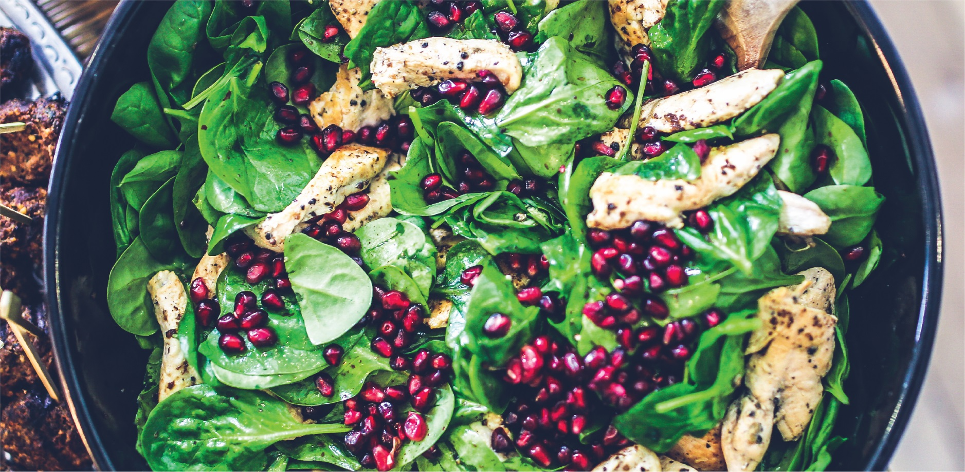
Cabernet Sauvignon (20 minutes for delivery)  Cabernet sauvignon pairs well with steaks, burgers, lamb, and even venison  Because of its rich berry flavors and firm tannins. | 25.00
Chianti (15 minutes for delivery)  Tomato sauces seasoned with fresh herbs combine beautifully with a bottle of  Chianti—both have high acidity, making for a great food and wine match. | 22.00
Malbec (25 minutes for delivery)  With this delectable cherry barbecue sauce smeared over a rack of ribs, Malbec's  fruity character makes it a winner. | 18.00
Merlot (20 minutes for delivery)  It's a fantastic wine for Thanksgiving dinner, and it pairs well with traditional  comfort dishes like mac and cheese. | 20.00
**Food Allergy Notice**
If you have a food allergy or a special dietary requirement, please inform a member of our staff before placing your order.
Beverages: Orange Juice, POP, Lemon juice
Offline order (Through Telephone)

Online Payment (Card, Online Transactions are available)
Contactless delivery: Uber eats, GrubHub, just eat
Hotel Trinity trinity.sweansea@gmail.commailto:Hotel.trinity@gmail.com Open from 10AM to 8PM Baker Street
21/7, 2200
Delivery only, no dine in

