Creativity, Innovation and Value Creation in UK Health and Social Care: A Reflective Portfolio on Campaign Planning, Technology and NHS Leadership

Component 1 Portfolio

- Bsc Health and Social Care
- BMHP5014
- Module: Changemakers: Creativity and Value Creation
- Student Number: 2407750
- Student Name: Mohammed Mobeen Ali
- Tutor Details: Parese Ahmed
- Online Portfolio of Set Exercises
- Submission Date:25th March 2026
Table of Contents
Task 1 – Concept Map: Creativity and Value Creation 3
Task 2 – Self Reflection (Paperclip/Resourcefulness Activity) 5
Task 3 – UK Innovation Case Study: Dementia-Friendly Environments 6
Task 4 – Research Task: Vaccine Hesitancy in the UK 8
Task 5 – Podcast (2-minute recording) 9
Task 6 – NHS Leadership Framework 10
6.1 Summary 10
6.2 Application 10
Task 7 – Reflection Journal Entry 11
References 12

Table of Figure
Figure 1: Concept Map Showing How Creativity Supports Innovation and Value Creation in Health and Social Care 3

Task 1 – Concept Map: Creativity and Value Creation
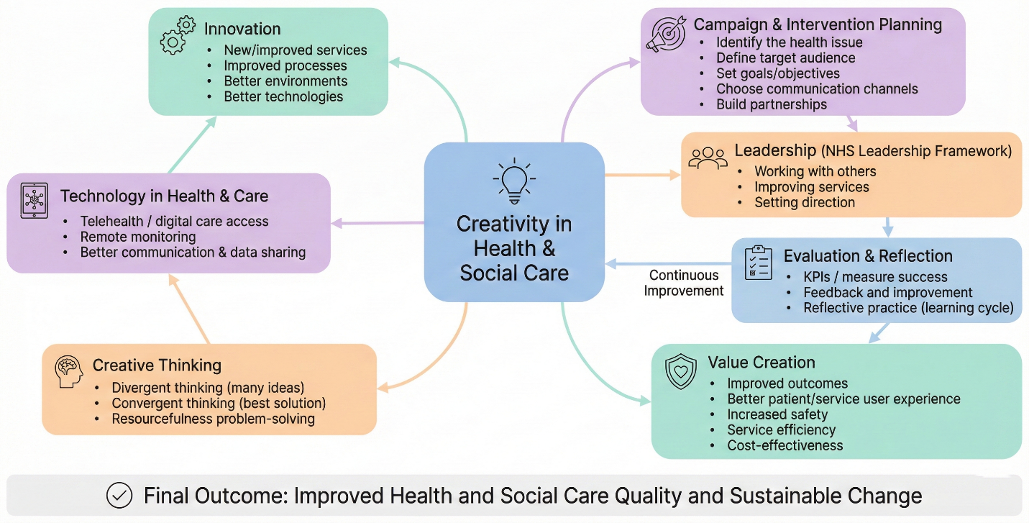
Figure 1: Concept Map Showing How Creativity Supports Innovation and Value Creation in Health and Social Care
Source: Self-Made
The concept map in Figure 1 demonstrates how creativity supports innovation and value creation in health and social care by linking idea generation, structured planning, leadership and evaluation into one improvement pathway. Creativity can be understood as the ability to generate novel and useful ideas to solve problems, which is essential for improving complex systems such as healthcare delivery (Rao, 2010). In health and social care settings, creativity is closely connected to developing new ideas that respond to service user needs and improve the quality of services.
The innovation is motivated by creativity as people and organisations can explore different solutions to problems through creativity and challenge the normal way of doing things, thus creating new methods to deal with current problems (Baker and Hart, 2016). This involves applying divergent mind to come up with different options and convergent mind to choose the best solution that is viable to be put into practice. In the healthcare setting, the process promotes creative advancements like novel care trajectories, reinvented care experience and more attentive interventions that improve the quality of services and user experience.
Creation of value in health and social care can be defined as the creation of outcomes that are of value to the service users and the utilization of resources efficiently, which can be in terms of enhancing safety and satisfaction as well as service efficiency (CIPD, 2022). This is in accordance with the principles of value-based healthcare in that value is determined by the health outcomes whereas the cost is given in terms of the cost of care. Thus, creativity is not a marginal or accidental competence, but an essential innovation driver which helps to bring meaningful service improvements, improve outcomes and enhance health and care systems with better value delivery.

Task 2 – Self Reflection (Paperclip/Resourcefulness Activity)
I applied the Reflective Cycle of Gibbs to the paperclip resourcefulness exercise in which I was presented with a short (limited by time) task of creating as many alternative uses of a simple paperclip as I could envisage. The goal of this task was to build creativity, which entailed rapid creation of ideas and the ability to think flexibly to solve a problem.
At the beginning of the activity, I was a little bit pressured by the time constraint, but I got encouraged as I generated more ideas. This has been an accomplished task since I have managed to come up with several imaginative applications as well as the fact that I had a lot of fun trying to think about a common place item in a different way. Nonetheless, I struggled to go past the most obvious concepts at the start of the work that demonstrated that I occasionally use established familiar patterns of thinking and do not venture beyond them.
Analytically, both convergent and divergent thinking was needed in the task. Divergent thinking assisted me in coming up with numerous potential solutions, like using the paperclip to within the organisation, repair, or make tiny devices, whereas convergent thinking assisted me in choosing the most viable and realistic ones. This is an indication of how creativity aids in the decision-making process since only those solutions that have broad solutions should be generated before narrowing them down to ideas that will be implemented effectively.
Overall, I was able to acquire the information that creativity is not simply a question of imagination but also a question of critical assessment of ideas based on usefulness and situation. Structured brainstorming methods like mind mapping I will employ in future to expand the scope of my ideas. I will also work on being selective in my ideas with the help of the feasibility and impact criteria so that my creative thinking becomes more efficient and effective.

Task 3 – UK Innovation Case Study: Dementia-Friendly Environments
The notion of innovation in health and social care is based on the introduction of new or better approaches, services, or environments that lead to better quality, safety, and service outcomes of people who engage in care (Hind and Moss, 2020). The concept of dementia-friendly environments is a significant innovation in the UK since it recreates care environments to be more inclusive to the needs of people with dementia and enhances their experience of care (Alzheimer’s Society, 2023).
Dementia-friendly environments are those specially created places that are aimed at minimizing confusion and encouraging people with dementia to be independent. This encompasses healthcare settings (including hospitals and care facilities) as well as community settings (including community buildings and public transport zones) (Alzheimer’s Society, 2023). Some commonly used design characteristics are the use of clear signage and signs to find their way, better lighting, colour contrast to aid visual perception, and peaceful or low-stimulation space which eliminates stress. These modifications facilitate orientation, minimize anxiety and make environments easier to move around, especially when one has memory loss and sensations problems.
There is a need to make this innovation since dementia may greatly affect how one understands the world around, identify the places they know, and move freely in buildings. Consequently, patients can develop distress, agitation, and the tendency to become more scared and more exposed to falls or accidents (in particular, in new clinical environments) (NHS, 2023). Dementia-friendly design also coincides with person-centred care whereby the service environment is adjusted to suit the individual instead of the individual having to fit into complex or stressful systems.
Dementia-friendly environments are mainly focused on creativity since it necessitates redesigning spaces in a manner that both ensures clinical safety and comfort, dignity, and familiarity. Rather than adopting a medical intervention-only approach, this innovation employs innovative thinking of design to resolve actual problems by creating practical changes in the environment (Hind and Moss, 2020). The strategy is a display of creative problem solving because employees and planners will need to determine issues faced by users and be able to come up with solutions to enhance lived experience.
Dementia-friendly environments create a value that is important. To service users, these spaces may eliminate anxiety and enhance wellbeing through independence, confidence and comfort in care environments. In the staff, less cluttered arrangements and less chaotic settings can help staff spend less time on distressed patients, repetitive inquiries, or episodes of agitation and enable more effective care delivery (NHS, 2023). On a system level, safer and more accessible environments can help mitigate preventable events like falls, enhance patient flow, and increase the overall quality of services and can assist organisations to provide higher-value care.

Task 4 – Research Task: Vaccine Hesitancy in the UK
The delay of acceptance or refusal to vaccination, even though the vaccination services are available, is known as vaccine hesitancy, and it is a significant public health issue as it may decrease immunisation coverage and contribute to the occurrence of preventable disease outbreaks (MacDonald, 2015). The problem of vaccine hesitancy is still a prevailing issue in the UK context because it has on population protection and the increase of health inequalities between societies.
The dissemination of misinformation and disinformation is one of the major causes of vaccine hesitancy, as false information about vaccines or their efficacy may quickly sway the beliefs of people in online environments (Lockyer et al., 2021). The reluctance is also associated with low motivation to change behaviour as somebody might feel that they do not need to get vaccinated or they have lower priority to prevent when the perceived risk is low. The decisions also can be socially influenced and shaped by norms and peers, individuals tend to use family, friends and community attitudes to judge health behaviours, particularly in cases where there is a lot of uncertainty (MacDonald, 2015). Moreover, the problem of trust and credibility is an important factor since the level of trust in the government, health services, and professional advice can significantly determine the attitude of individuals towards vaccinations as reliable and useful. These are some of the forces that contribute to the formation of complex barrier which influences not only personal decision making but also broader health impacts on the population.
The need of health promotion campaigns and interventions is justified, as it might bring more awareness via messages that are clear and credible to ensure that people know the benefits, and risks of vaccinations correctly (NHS, 2023). Attitude change can also be aided during campaigns by providing information to overcome fear, myth busting and helping people to make informed choices and not judgment and blame. Moreover, social norms can also be affected by the campaigns, which encourage vaccination as a good community behaviour and gain confidence by encouraging the use of trusted local voices.

Task 5 – Podcast (2-minute recording)
5.1 Podcast Title
“Trust the Facts: A Community Campaign to Reduce Vaccine Hesitancy in the UK”
5.2 Podcast Audio
Podcast Label
This 2-minute podcast introduces my proposed UK community health campaign called “Trust the Facts”, designed to reduce vaccine hesitancy. It explains the target audience, the key causes of hesitancy (misinformation and low trust), and how the campaign will use credible messaging and community engagement, with success measured using engagement and uptake indicators.

Task 6 – NHS Leadership Framework

6.1 Summary
The NHS Leadership Framework offers a framework through which leadership behaviours which aid in delivering effective, safe and high-quality healthcare are developed. It also emphasises that leadership is not restricted to top positions but can be exhibited by all individuals throughout services by working together, making decisions that improve and aim to achieve a goal (NHS Leadership Academy, 2011). In this context, at Working with Others, the emphasis is laid on establishing good relationships, effective communication, and engaging stakeholders to reach mutual results. Improving Services focuses on continuous improvement in terms of identifying areas where performance is lacking and then reacting to feedback and employing evidence to improve service quality and efficiency. Setting Direction provides to do with formulating a purpose, establishing realistic goals and leading others towards a common vision. Together, the areas facilitate innovation by making sure that leaders will be able to work in teams, provide a significant change and maintain the improvement in a health and social care environment.

6.2 Application
I will use Working with others to enhance the credibility and trust in my campaign to decrease the prevalence of vaccine hesitancy in the UK through “Trust the Facts” campaign in which I will collaborate with local NHS personnel, pharmacists, community leaders and voluntary organisations to gain more credibility and trust. This collaboration model will facilitate a regularized messaging and promote interaction with the community via online and real-life interaction. To implement Improving Services, I would track response on feedback on service user and stakeholders through short surveys and community session feedback and consequently modify campaign messages and methods of delivery to enhance relevance and effectiveness. That is the significance of results learning and the opportunity to adjust interventions to the requirements of the population. In the case of Setting Direction, I will develop specific objectives like enhancing vaccine confidence and achieving a higher involvement with trusted health information with the assistance of specific metrics like the attendance rates and the use of digital tools. This helps keep the campaign focused, accountable and result-oriented as well as keep the overall objective of the campaign, which is to enhance the behaviour of people about their health.

Task 7 – Reflection Journal Entry
Throughout this module, I got to understand that the ability to be creative is a valuable competency in the development of meaningful improvements in health and social care since it aids in new thinking methods and promotes creative solutions leading to the generation of value among service users. I also realized that value creation does not mean cost minimization, but enhancing results, safety, and experience by means of efficient service delivery. Campaign planning made me realise that it is necessary to have clear objectives, to identify the target audience, to use an appropriate communication channel as well as evaluation methods to determine the success and impact. Secondly, reading about the modern technologies also emphasized the use of digital devices like online communication platforms and health technologies, which may help to achieve access, monitoring, and engagement, yet also necessitate the detailed consideration of equality and trust (Tuten and Solomon, 2017). Lastly, the leadership materials reinforced my ideas that ethical and collaborative leadership is required to manage teams and maintain service enhancement within healthcare settings.
The module has improved my communication abilities because I have become more independent and assertive in communicating ideas and modifying messages to suit various parties. Another skill that enhanced my creativity was practicing the idea generation and choosing practical solutions in carrying out learning activities.
Next, I will continue using reflective practice to evaluate my learning and personal development regularly I will also practice my campaign planning skills by implementing quantifiable KPIs and feedback in enhancing future health interventions and innovations.

References
Alzheimer’s Society (2023) Dementia-friendly communities. Alzheimer’s Society. Available at: https://www.alzheimers.org.uk/
Baker, M.J. and Hart, S. (2016) The Marketing Book. 7th edn. London: Routledge.
CIPD (2022) Effective leadership: A practical guide. London: Chartered Institute of Personnel and Development. Available at: https://www.cipd.co.uk/
Hind, D. and Moss, S. (2020) Entrepreneurship and Innovation in Healthcare and Social Care. London: Routledge.
Lockyer, B., Islam, S., Rahman, A., Dickerson, J., Pickett, K., Sheldon, T., Wright, J., McEachan, R. and Bradford Institute for Health Research COVID-19 Scientific Advisory Group (2021) ‘Understanding COVID-19 misinformation and vaccine hesitancy in context: Findings from a qualitative study involving citizens in Bradford, UK’, Health Expectations, 24(4), pp. 1158–1167.
MacDonald, N.E. (2015) ‘Vaccine hesitancy: Definition, scope and determinants’, Vaccine, 33(34), pp. 4161–4164.
NHS (2023) Dementia: Symptoms and diagnosis. National Health Service. Available at: https://www.nhs.uk/conditions/dementia/
NHS Leadership Academy (2011) Healthcare Leadership Model: The nine dimensions of leadership behaviour. NHS Leadership Academy. Available at: https://www.leadershipacademy.nhs.uk/
Rao, M.S. (2010) Soft Skills: Enhancing Employability – Connecting Campus with Corporate. New Delhi: I.K. International Publishing House.
Tuten, T.L. and Solomon, M.R. (2017) Social Media Marketing. 3rd edn. London: SAGE Publications.

