Learning and Collaboration for Global Citizenship

BMSP4003

Assignment 2

Hannah Kilburn

1805552

Tutor – Alex Bell

Introduction
For this assignment I will be evaluating the digital technologies that are playing a massive role in our everyday lives. I believe that it is hard to escape the way that technology is evolving and how much of our lives are focused around how we use it. All this digital technology, I think is a great way to gather information quickly and to gain access to what we need much faster than we used to. The internet plays a huge role in how we learn and share our experiences online, we have become a generation which now relies on digital technology for learning purposes, entertainment and sharing different experiences. We are now expected to know how to use different technological equipment such as mobile phones, laptops and computers to gain access online and to find out information from different online sites. I think that the idea of using all these technologies is beneficial to us as it provides quicker access to information and we can communicate quickly with other people either to work colleagues, friends or family through different internet platforms. I feel that now technology is always changing and becoming more involved in our lives, the age that we begin to learn these digital technologies is much younger than it used to be as children are taught how to use iPads and laptops to keep up with the changes that technology brings.

Individual and collaborative learning
As an individual we all learn in our own way, we all write in our own way and we all research differently from one another. Each individual has a certain way of writing and a specific learning style that we like to follow. The term “individually” is described by the online dictionary as being “one by one; singly; separately. Personally; in an individual capacity.” (GoogleDictionary, 2019). We all learn in different ways and we each have a style that suits us best when it comes to learning. The individual approach is better for researching and gathering our own information from online sites such as Google. We individually choose information that suits us and the topic we are either writing about or finding information for, this can be used for educational studies or to find out any facts and figures that may interest us. I think we have to have a good balance of both individual and collaborative to succeed and gain new skills.
According to Julie DeNeen we learn by doing tasks individually and we are able to understand different styles by finding out ourselves. We are able to gather our own opinions on certain topics and we can then share our opinions with others to express our own thoughts and feelings. We are able to gain skills from learning on our own and finding our own research and it can be seen that a classroom can be full of distractions and obstacles that may slow down the learning when with others. (DeNeen, 2013)
On the other hand, there is collaborative learning which I believe works well to gain opinions from others and we can gather new information that we may not have been able to find on our own. According to the online dictionary “collaborative” is explained as “produced by or involving two or more parties working together.” (GoogleDictionary, 2019).
We are able to share ideas and opinions with other people so we can have a wider range of knowledge from others such as fellow students, friends, work colleagues and family members. We can share ideas with people we trust and rely on to help us out if we need anything. Working as a group can work well for some and not so well for others. From a personal point of view, I think that working together and sharing ideas works well for me and I enjoy listening and interacting with others. It is very easy to communicate online and use digital technology to talk with others and to share different personal experiences online for others to see. Social media is a huge platform that lets us share and communicate with others very quickly and easy from nearly anywhere in the world. We can access social media such as Facebook, Instagram and snapchat on our phones, tablets and laptops as long as we have an internet connection.
According to Cornell University there are lots of benefits to working collaboratively and in a group with other members. Collaborative doesn’t just have to be one on one it can be with a range of people, whether they are in the same learning group or from another group or even a different university or work place. Working together can develop new skills and improve communication. (CornellUniversity, 2019)

Personal learning approach
From a personal point of view, I think I rely on technology for all sorts of reasons. I find all my research for assignments and other educational purposes, communicating with other students and friends and also to check things going on around the world. All digital technology plays a role in learning as it is such a massive part of our lives today and I think it will possibly take over and everyone will have to learn to use technology at some point in their lives. The digital technology that I use of a daily basis would be different social media sites, google, checking emails and these would all be done from my mobile phone or laptop. I would say that my personal learning approach is definitely technology orientated.
According to recent statistics that Ofcom have provided “Nine in ten people had access to the internet in the home in 2018. The majority (62%) of time spent on the internet was on mobile devices, and mobile advertising made up 45% of online advertising in 2017.” (Ofcom, 2018). There are many devices which are coming more and more popular in recent years. It is also very easy to connect to the internet from outside the home as so many areas have access to WIFI which can be used by the public in shops, café and offices. Digital technology is being seen as changing the world as it goes through a new generation of how we learn and do things. Education is a massive area that has changed as children now are learning through using iPads and computers to type up work instead of handwriting and teachers are using interactive whiteboards to display presentations and new activities. As a student myself, I have to understand technology as all assignments I complete must be handed in online as a digital copy of my work which is then processed through a computer. Kennedi Gubler explain how technology has changed the world and explains that “Online and various technological tools have taken over the education system. Thousands of courses and degrees are available online and have shown to be more effective at times than the traditional classroom”. (Gubler, 2018) There are now all sorts of courses that can be done online for people of all ages and for nearly any subject. Although from a personal perspective I still like the idea of having classroom-based lessons to be able to share with other students and communicate face to face with the tutor instead of over email on a regular basis. The way that I discovered I still enjoy classroom-based lessons is after completing the online forum for four weeks where I only communicated with fellow students and the tutor through emailing each other. I didn’t find this task easy and felt that having class discussions on some of the topics would have been more successful although it gave everyone a chance to express their own opinions on the chosen subject areas.

Strengths and weaknesses of digital technology
There are many strengths and there are also weaknesses which comes from using digital technology. Technology can be very helpful when it comes to researching and finding information that we rely on these days. It can be very quick and easy to access anything we need online. Some of the most helpful things I find when it comes to digital technology is the online library which has many helpful books that we can print off and analyse useful information for certain topics for assignments. Having the online library cuts out the time of travel and finding the book, where as when it is accessible online that time is cut out. Also being able to use google and other search engines helps get answers almost immediately. Social media is another area where we are able to communicate with other students that may be able to give tips and help with any of the tasks we must complete of our course.
There is now improved productivity when it comes to using technology to learn. Programmes such as Microsoft 365 make sure that all sorts of documents can be made and saved safely to all sorts of other devices such as iCloud and One drive which allows us to share our work with other people. Businesses are benefitting greatly from using technology as they can share and communicate with people and organisations all over the world. (Dao, 2018)
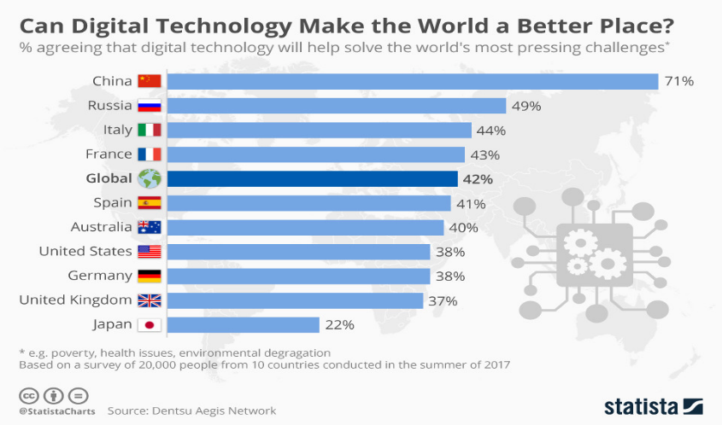
Although with all this new technology being brought out and everything being so accessible to everyone, security is an issue which needs to be thought about. Many people across the world believe that digital technology will help to make the world a better place in the future. These are some of the countries that rank in the top 10 of major economies and they want to help reduce some of the biggest world issues today. (Fleming, 2018)

From a personal point of view, I think that I understand the use of digital technology well and think that it is beneficial to all people with varying backgrounds to work and communicate through digital technology. I am able to communicate with tutors through email and I can use social media to talk to other students.

Advice for new students and conclusion
As technology is such a massive thing in this day, it is important to know and have basic knowledge of up to date technology such as how to use a mobile phone, laptop or tablet. It is also important to make sure that the internet is a place that will help with all kind of research and communication methods that will be needed for the course. It is good to understand how to use different research methods such as Google and the online library. The programme that is constantly used to access all lectures, Turnitin and special links is Moodle. This site is the core to making sure that we have access to all information provided through the lectures and we must upload our assignments through this programme. Having basic knowledge to begin with will make the process much easier in the future. For new students it is good to have a group of friends that can easily be contacted when out of lecture time to share any ideas of to get help with anything that you may not understand. This is where digital technology is great because it is so accessible to anyone and it can be used and developed with any previous experience someone may have. Overall, I think that digital technology is beneficial to everyone and it is very easily accessible. It doesn’t take long to pick up the benefits that comes with easy access to all sort of information and ways to learn. There are so many different apps and programmes that make researching much easier for all kinds of people with all different professions. Digital technology from my point of view is helpful to anyone that needs to use it and it will be how the future is designed. There are many issues in the world that are being researched using different forms of digital technology which are becoming more and more advanced. As time has gone on even from a few years ago, the technology that is available today is far more advanced and far more used than it may have been 10 years ago.

References
CornellUniversity. (2019). Retrieved from https://teaching.cornell.edu/teaching-resources/engaging-students/collaborative-learning
Dao, D. Q. (2018, April). Tech Funnel. Retrieved from https://www.techfunnel.com/information-technology/3-benefits-of-digital-technology-in-business/
DeNeen, J. (2013). Retrieved from opencolleges.edu.au: https://www.opencolleges.edu.au/informed/other/teachers-or-facilitators-10-reasons-why-educators-should-step-out-of-the-way-and-encourage-independent-learning/
Fleming, S. (2018, October). Weforum.org. Retrieved from https://www.weforum.org/agenda/2018/10/digital-distrust-we-re-losing-faith-in-technology-to-solve-the-world-s-problems/
GoogleDictionary. (2019). Retrieved from https://www.google.com/search?ei=QSqiXO_eNeuk1fAPw9OYkA4&q=google+dictionary&oq=google+dicti&gs_l=psy-ab.1.0.35i39j0l9.2505.5618..6760...1.0..3.161.2562.10j16....2..0....1..gws-wiz.....6..0i71j0i67j0i20i263j0i131i67j0i131j0i131i273j0i273j0i10.Ozzeuy5Z1fw#
GoogleDictionary. (2019). Retrieved from https://www.google.com/search?q=google+dictionary&ie=&oe=#dobs=individually
Gubler, K. (2018, June). Inwhatlanguage.com. Retrieved from https://www.inwhatlanguage.com/blog/5-reasons-technology-is-changing-the-world/
Ofcom. (2018). Retrieved from https://www.ofcom.org.uk/__data/assets/pdf_file/0022/117256/CMR-2018-narrative-report.pdf

