
Comprehensive Health Improvement Plan for Bob
BMHP5003_BIRM
Module lead: Raheela Shaikh
Name student: Valentina Isabela BORDEA
Number of student: 2133347



Table of Contents
Introduction 2
Health Questionnaire Analysis 2
Diet 3
Conclusion 7
References 9

Introduction
Bob, a 37 year individual is employed in a typical office setting, which highlights the challenges commonly faced in modern life such as being inactive having imbalanced diets and dealing with constant stress. The purpose of this introduction is to delve into the impact of this lifestyle on Bobs well being and lay the groundwork for recommendations that will be discussed further in this report.
Due to his demanding work schedule and limited opportunities for activity Bob encounters significant health risks. These risks encompass concerns like obesity cardiovascular diseases and other conditions associated with lifestyle choices. His office job requires him to spend hours sitting in front of a computer screen while following an irregular diet consisting mainly of processed foods lacking essential nutrients – all of which worsen these health risks.
Furthermore the stress linked to deadlines and increased work responsibilities can have adverse effects on Bobs eating patterns exercise routines, as well as his mental and emotional state. This sedentary way of living fueled by eating habits and stress has become an increasingly worrisome issue, in todays society.
Henceforth it becomes crucial to analyze and comprehend the intricate nature of Bobs lifestyle so that we can propose effective strategies aimed at improving his overall health and enhancing his quality of life.
This introduction provides a foundation for delving into a thorough examination of the various factors that impact Bobs health. It also lays the groundwork, for discussing recommendations that will be explored further in the report.

Health Questionnaire Analysis
Age: 37 years
Occupation: Office Worker
Smoking Status: Non-smoker
Height: 1.68 m
Weight: 82.5 kg
Diet: High in fats
Physical Exercise Frequency: Regular
Blood Pressure: Normal
Cholesterol Level: Normal
Family History: Heart diseases
BMI: 29.09

Diet
Reducing the fats: Bobs diet plays a role in his overall health and must be taken seriously. Having a diet that's high in fats can pose long term health risks such as obesity and cardiovascular diseases. To ensure Bobs well being and prevent these issues it is essential to address the following factors;
It is crucial to reduce the amount of fats in Bobs diet as recommended by sources like the World Health Organization (2020) and nutrition experts (Brown, 2019; Willett, 2017). They emphasize the significance of lowering consumption especially saturated and trans fats as they can increase the chances of developing cardiovascular diseases (Haskell et al., 2007; Rolls & Barnett 2019).
Saturated fats, which are commonly found in fatty meats and fat dairy products can contribute to cholesterol buildup in arteries that may lead to heart problems (Willett, 2017). On the hand trans fats often present in fast food items and packaged cakes have a known negative impact, on cardiovascular health (Swinburn et al., 2004).
To keep his health in check Bob can improve his diet by replacing unhealthy fats with healthier options like unsaturated vegetable oils and nuts (Haskell et al. 2007). Including omega 3 acid rich fish, such as salmon in his meals can also have a positive impact on his heart health (Willett, 2017).
It's crucial for Bob to carefully read food labels and steer clear of products that contain added trans fats (Rolls & Barnett 2019). Instead he should focus on incorporating nutritious foods, like fruits, vegetables, whole grains and lean proteins into his diet to maintain a healthy cardiovascular system (Swinburn et al., 2004).
Increasing the consumption of fruits: Including fruits and vegetables in ones diet is crucial for maintaining good health and can bring a multitude of benefits to enhance Bobs overall well being. Fresh produce is packed with vitamins, minerals and antioxidants that play a vital role in bolstering the immune system and reducing the likelihood of chronic diseases (Brown, 2019).
Research indicates that incorporating a diet in fruits and vegetables can contribute to lowering blood pressure managing weight effectively and minimizing the risk of heart related ailments (Hu, 2008). Additionally these rich foods also offer advantages for eye health due to their valuable content of vitamin A and antioxidants (Lichtenstein & Russell 2005).
To fully enjoy these advantages it is recommended that Bob diversify his meals by including an assortment of vibrant fruits and vegetables. For instance dark leafy greens like broccoli and spinach are sources of iron and vitamin K (Trichopoulou et al., 2003). Meanwhile orange hued fruits such as carrots and oranges contain nutrients like vitamin C and beta carotene that are vital for maintaining healthy skin as well as supporting the immune system (Brown, 2019).
According to guidelines (Willett, 2017) it is advisable for Bob to aim for at least five servings of fruits and vegetables, per day.
Opting for unprocessed food is the better choice to maximize the health advantages as noted by Cordain et al. In 2005.
When Bob incorporates fruits and vegetables into his diet he can enhance his overall well being and lower the chances of developing chronic illnesses.

Regular physical activity plays a role in Bobs pursuit of a healthy lifestyle. According to the American College of Sports Medicine and the American Heart Association it is crucial for adults to prioritize activity for their overall well being (Haskell et al., 2007). To harness the effects Bob should incorporate exercise into his daily routine.
One of the advantages of engaging in regular physical activity is maintaining a healthy body weight. By burning calories and achieving an energy intake physical exercises can prevent the accumulation of excess body fat (Haskell et al., 2007). Furthermore they have the potential to increase muscle mass boosting metabolism and helping Bob achieve a weight (King et al., 2008).
In addition to its impact, on health regular exercise can also greatly benefit Bobs mental well being. It has been shown to reduce stress levels and alleviate anxiety (Epel et al., 2001). Moreover engaging in activity triggers the release of endorphins – often referred to as "feel good" hormones – which can enhance mood and lower the risk of depression (King et al., 2008).

Bob has options when it comes to choosing suitable types of physical activities. These include walking, running, swimming, cycling or even resistance training.It's crucial for him to select the activities he enjoys the most so that he stays motivated to practice them King et al., 2008). Also incorporating variety into his workout routine can help keep things engaging and inspiring.
For outcomes Bob should seek guidance from a physical activity specialist or a personal trainer in order to create a tailored exercise plan. This plan should take into account Bobs fitness level and gradually increase the intensity of his workouts to avoid strain and reduce the risk of injuries (Hu, 2008).
In summary engaging in activity plays a vital role in maintaining a healthy lifestyle, for Bob and can bring about numerous advantages, both physically and mentally.
Managing Bobs diet involves an element known as portion control. In the book "The Volumetrics Weight Control Plan" authored by Rolls and Barnett (2019) valuable insights are provided regarding eating strategies and being mindful of the quantity of food consumed.

Portion control: The idea behind portion control emphasizes not what we eat but also how much we eat. It's easy to go with portions leading to excessive calorie intake and eventual weight gain (Rolls & Barnett 2019).
"The Volumetrics Weight Control Plan" aims to educate readers, including Bob on identifying portions and effectively managing them. Practical guidance is offered by the authors on dividing food into servings and enjoying favorite snacks without indulging excessively in quantity. The book also imparts knowledge, about calorie and low energy density foods that can fill the stomach satisfying hunger without adding excess calories (Rolls & Barnett 2019).
Additionally the book addresses another aspect; being aware of and listening to ones body signals. For Bob it becomes vital to learn how to recognize when he feels full and avoid overeating as it contributes to maintaining a weight.
Furthermore the book highlights the significance of being mindful while eating, which means taking the time to savor and enjoy each bite than rushing through meals or mindlessly munching in front of the TV. This approach can help reduce the chances of overeating and enhance the eating experience (Rolls & Barnett 2019).
To sum up maintaining a diet and achieving an appropriate body weight for Bob heavily relies on practicing portion control. "The Volumetrics Weight Control Plan" offers a foundation, for comprehending and incorporating this concept into his everyday life.
Avoiding Processed and High-Fat Foods: Its widely recognized that staying away from processed foods and those high in fats is crucial for maintaining a diet. This principle has been extensively. Endorsed by reputable sources that promote the adoption of a healthy lifestyle.
For instance "Eat, Drink and Be Healthy; The Harvard Medical School Guide to Healthy Eating" authored by Willett (2017) provides information about the advantages of healthy eating along with practical suggestions for making good food choices.
Similarly respected works like "Nutrition Through the Life Cycle" by Brown (2019) and "Lifestyle Medicine; A Manual for Clinical Practice" written by Rippe and Angelopoulos (2016) emphasize the significance of avoiding processed foods and high fat options at stages of life and within a medical context.
Moreover the guidelines outlined in the "Guidelines on Physical Activity and Sedentary Behaviour" published by the World Health Organization (2020) underline the connection between an active lifestyle, a healthy diet and steering clear of processed foods as well as those high in fats.

Another factor to consider is being mindful of both content and glycemic index when choosing what we eat. In fact Schulte et al.s book (2015) delves into the notion of addictive foods while highlighting how fat content and glycemic index play a role, in our food preferences.
To sum up it is crucial to steer of processed and high fat foods if you want to stay healthy and avoid gaining extra weight. These books mentioned above offer insights, into comprehending and implementing this principle in our everyday lives.

Conclusion
Maintaining a diet is crucial as highlighted in Willetts book "Eat, Drink and Be Healthy" (2017). It is important to focus on consuming rich foods and avoid processed options that are high in sugar and unhealthy fats. To achieve this Bob should strive for a balanced diet that includes plenty of fruits, vegetables, lean proteins while minimizing the intake of unhealthy food choices.
Regular physical activity is emphasized by the World Health Organizations guidelines on activity and sedentariness (2020). Bob should establish a fitness routine that incorporates both exercises and weight training. This will not help maintain cardiovascular health but also boost metabolism.
Weight management plays a role in preventing and addressing overweight and obesity issues according to Raynor and Champagnes research (2016). Bob should adopt a weight management plan that involves making modifications as well as incorporating regular physical activity into his lifestyle.
It is worth noting that stress can impact habits as revealed by Epel et al.s study (2001). To combat this influence on his eating behavior Bob may find it beneficial to explore stress management techniques, like meditation or yoga. These practices can assist him in controlling the urge to overeat.

Taking care of ones health; For Bob embracing a lifestyle as outlined in the book "Lifestyle Medicine; A Manual for Clinical Practice" by Rippe and Angelopoulos (2016) involves a comprehensive approach that extends beyond just eating right and exercising. It is crucial for Bob to focus on maintaining a balanced diet incorporating insights from the book "Eat, Drink and Be Healthy" by Willett (2017) and engaging in regular physical activity as recommended by Haskell and his colleagues (2007). Managing weight effectively and controlling stress are also aspects to consider following the principles outlined in "The Volumetrics Weight Control Plan" by Rolls and Barnett (2019) and implementing stress reduction techniques highlighted by Epel et al. (2001). This holistic way of life will not enhance Bobs physical and mental well being but will also contribute to preventing long term health issues based on research findings in the fields of nutrition and health.

It is vital to seek guidance from a doctor or nutritionist when aiming to improve your health. They provide personalized advice and tailor recommendations based on needs, such as dietary preferences and medical conditions. Additionally they can conduct health assessments to monitor indicators like cholesterol and blood sugar levels making adjustments to your health plan accordingly. It's also beneficial to work with a trainer or physiotherapist in order to create an effective exercise program. If you struggle with habits like eating consulting a psychologist or behavioral health counselor can be very helpful. Taking this approach not only supports lifestyle changes but also aids in staying motivated and overcoming challenges. By implementing these changes you can significantly enhance your well being reduce the risk of chronic diseases and foster a balanced and healthy lifestyle, in the long run.

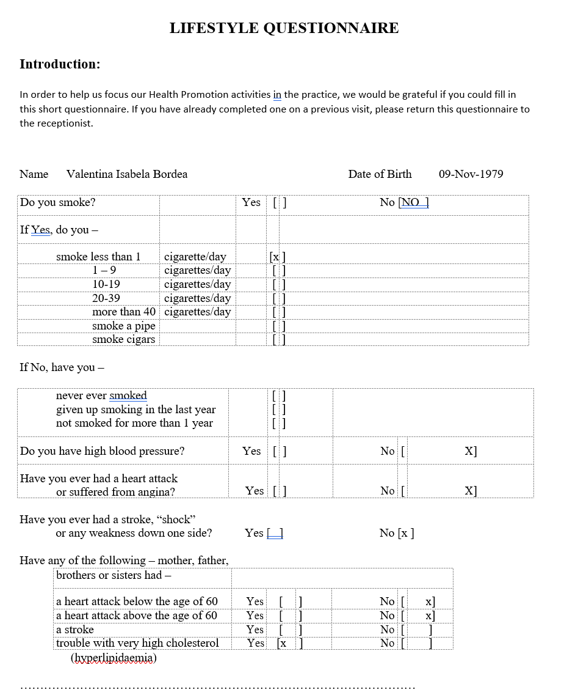

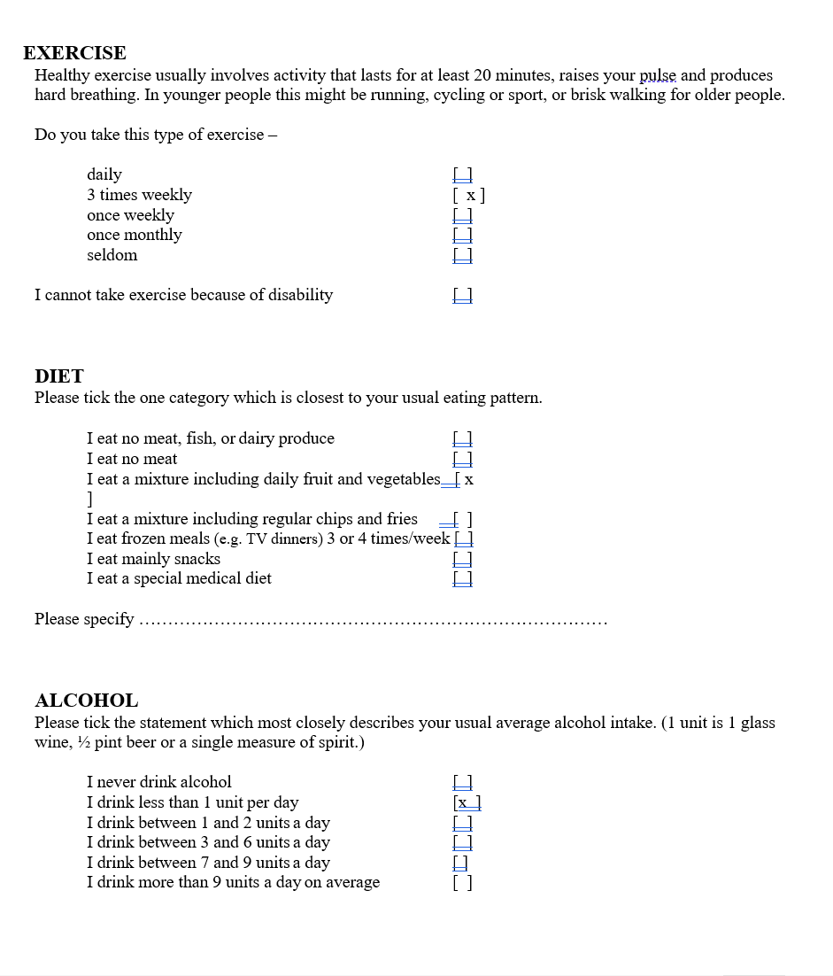

References
- Brown, J.E. (2019). Nutrition Through the Life Cycle. 6th ed. Belmont, CA: Cengage Learning.
- Epel, E., Lapidus, R., McEwen, B., and Brownell, K. (2001). "Stress may add bite to appetite in women: a laboratory study of stress-induced cortisol and eating behavior." Psychoneuroendocrinology, 26(1), pp.37-49.
- Haskell, W.L., Lee, I.M., Pate, R.R., et al. (2007). "Physical activity and public health: updated recommendation for adults from the American College of Sports Medicine and the American Heart Association." Medicine & Science in Sports & Exercise, 39(8), pp.1423-1434.
- Hu, F.B. (2008). Obesity Epidemiology. New York: Oxford University Press.
- King, A.C., Ahn, D.K., Oliveira, B.M., et al. (2008). "Promoting physical activity through hand-held computer technology." American Journal of Preventive Medicine, 34(2), pp.138-142.
- Lichtenstein, A.H., and Russell, R.M. (2005). "Essential nutrients: food or supplements? Where should the emphasis be?" JAMA, 294(3), pp.351-358.
- Pollan, M. (2008). In Defense of Food: An Eater's Manifesto. New York: Penguin Press.
- Raynor, H.A., and Champagne, C.M. (2016). "Position of the Academy of Nutrition and Dietetics: Interventions for the Treatment of Overweight and Obesity in Adults." Journal of the Academy of Nutrition and Dietetics, 116(1), pp.129-147.
- Rippe, J.M., and Angelopoulos, T.J. (2016). Lifestyle Medicine: A Manual for Clinical Practice. Cham: Springer.
- Rolls, B.J., and Barnett, R.A. (2019). The Volumetrics Weight-Control Plan. New York: Harper.
- Schulte, E.M., Avena, N.M., and Gearhardt, A.N. (2015). "Which foods may be addictive? The roles of processing, fat content, and glycemic load." PLoS One, 10(2), e0117959.
- Sisson, M. (2009). The Primal Blueprint. Malibu, CA: Primal Nutrition, Inc.
- Swinburn, B.A., Caterson, I., Seidell, J.C., and James, W.P.T. (2004). "Diet, nutrition and the prevention of excess weight gain and obesity." Public Health Nutrition, 7(1A), pp.123-146.
- Trichopoulou, A., Costacou, T., Bamia, C., and Trichopoulos, D. (2003). "Adherence to a Mediterranean diet and survival in a Greek population." New England Journal of Medicine, 348(26), pp.2599-2608.
- Willett, W. (2017). Eat, Drink, and Be Healthy: The Harvard Medical School Guide to Healthy Eating. New York: Free Press.
- World Health Organization. (2020). Guidelines on Physical Activity and Sedentary Behaviour. Geneva: WHO.

