3/24/2025
University of Wales Trinity Saint David
London campus
Module Name: Data Security and Compliance
Module Code: ACCA 5034
Student Name: Mohamad Bagher Ghotbi Karimi
Student ID: 2422377
Lecturer’s Name: Ayman El Hajjar

09 - Aug - 2026
Assignment

Task 1

The Zero Trust Architecture
A Critical Analysis of its Principles, Implementation Challenges, and Efficacy Compared to Traditional Models

Introduction:
The increasing use of cloud services, remote working, mobile devices, and interconnected systems has reduced the effectiveness of traditional perimeter-based security models. These models generally focus on protecting a trusted internal network, but modern organisations increasingly operate beyond fixed network boundaries [2], [9].
Zero Trust Architecture (ZTA) addresses this challenge by removing implicit trust based on network location. Instead, access to organisational resources is continuously evaluated according to factors such as user identity, device status, and contextual information [1]. Principles including continuous verification, least privilege, and network segmentation can therefore reduce unauthorised access and restrict lateral movement following a compromise.
This report critically evaluates the principles, benefits, and implementation challenges of Zero Trust and compares the approach with traditional security models. The 2017 WannaCry attack on the NHS is used to examine how Zero Trust principles could have limited the impact of ransomware while also demonstrating why fundamental controls such as vulnerability management and software patching remain necessary [16], [17].

Principles of Zero Trust Architecture:
Zero Trust Architecture is based on the principle that no user, device, application, or network connection should be automatically trusted. Instead, access decisions are based on factors such as identity, device condition, user behaviour, and contextual information rather than network location alone [1].
Continuous authentication and authorisation require access to be evaluated throughout a user session rather than relying only on initial login. Suspicious behaviour can trigger additional verification or access restrictions, reducing the risk associated with compromised credentials [1], [6].
Least privilege limits users and systems to the minimum permissions required for their responsibilities. This reduces the potential impact of compromised accounts and insider threats, although permissions must be regularly reviewed as organisational roles change [3], [9].
Micro-segmentation divides networks into smaller security zones and restricts unnecessary communication between systems. If one system is compromised, segmentation can reduce lateral movement and limit an attacker's ability to reach other sensitive resources [1], [8].
Continuous monitoring supports Zero Trust by analysing user, endpoint, and network activity for suspicious behaviour. This improves threat detection but requires appropriate security technologies and skilled personnel [7], [11].
Finally, Zero Trust follows an assume-breach approach. Organisations recognise that attacks cannot always be prevented and therefore focus on limiting access, detecting malicious activity, containing incidents, and reducing their operational impact [10]. These principles are relevant to the NHS WannaCry incident because weaknesses in patching and network segmentation contributed to the rapid spread of ransomware [16]. Least privilege and segmentation could have limited lateral movement, although Zero Trust would not have removed the need for effective vulnerability and patch management [14], [17].

Benefits of Zero Trust Architecture
Zero Trust can strengthen organisational security by removing implicit trust and applying access controls according to identity, device status, and risk [1], [3]. Least-privilege access and micro-segmentation can reduce lateral movement and limit the impact of compromised accounts or devices, while continuous verification and monitoring can improve the detection of suspicious activity [1], [6].
Zero Trust is also better suited to modern environments where employees, cloud services, applications, and devices operate beyond a traditional network perimeter [2], [9]. However, these benefits depend on effective implementation, accurate asset visibility, identity management, and continuous monitoring. Zero Trust should therefore be considered a risk-reduction strategy rather than a complete replacement for other cybersecurity controls [3], [9].

Challenges of Implementing Zero Trust Architecture
Implementing Zero Trust presents technical, financial, and organisational challenges. Legacy systems may not support modern controls such as Multi-Factor Authentication (MFA), Identity and Access Management (IAM), and continuous authentication, requiring costly upgrades or replacement [3], [7]. Implementation also requires investment in identity management, endpoint security, monitoring technologies, employee training, and skilled cybersecurity staff, which can be particularly challenging for organisations with limited resources [9], [11].
Identity and access management is another challenge because Zero Trust requires organisations to maintain accurate information about users, devices, applications, and permissions. As cloud and third-party services increase, maintaining least-privilege access becomes more complex, and excessive permissions can weaken the effectiveness of the model [1], [6].
Zero Trust can also affect usability and organisational culture. Additional authentication and device-verification requirements may be viewed as inconvenient by employees, making communication, training, and management support important for successful adoption [10]. Continuous monitoring also creates privacy considerations because organisations collect information about user, device, and network activity. Monitoring should therefore be managed in accordance with data-protection requirements such as GDPR [20].
Zero Trust should not replace fundamental cybersecurity practices. Vulnerability management, patching, security awareness, business continuity, and incident response remain necessary [2], [10]. This is particularly relevant to WannaCry, where outdated systems and inconsistent patch management contributed to the impact on NHS organisations [16]. Zero Trust controls such as segmentation and least privilege could have limited ransomware propagation, but they would not have removed the need to patch vulnerable systems [14], [17].
Overall, Zero Trust should be treated as a long-term security strategy rather than a single technology project. Its effectiveness depends on an organisation's ability to manage technology, people, identity, and security processes together [3], [6].

Zero Trust Architecture versus Traditional Security Models:
A Critical Evaluation

Traditional security models mainly protect a trusted internal network using controls such as firewalls, VPNs, and intrusion prevention systems. This approach was more suitable when users, applications, and devices were largely located within controlled organisational networks [2]. However, cloud services, hybrid working, mobile devices, and third-party services have reduced the relevance of a clearly defined network perimeter [9], [11].
Zero Trust addresses this limitation by removing implicit trust based on network location. Access decisions instead consider factors such as identity, device status, behaviour, and resource sensitivity [1]. Least-privilege access reduces unnecessary permissions, while micro-segmentation restricts communication between resources and can limit lateral movement following a compromise [1], [3], [8]. Continuous monitoring can also support earlier detection of suspicious user, device, and network activity [7], [11].
A significant difference between the two approaches is therefore how trust is established and maintained. Traditional models can provide greater trust to users and devices once they are operating within the protected network, whereas Zero Trust requires access decisions to consider identity, device condition, context, and the sensitivity of the requested resource [1], [2]. This can provide an important advantage when user credentials or devices are compromised. Successfully passing one security boundary should not automatically provide broad access to internal resources. Least-privilege policies and segmentation can restrict the resources available to a compromised account and reduce opportunities for lateral movement [1], [8].
The effectiveness of Zero Trust is particularly relevant to cloud and hybrid environments. Traditional perimeter controls remain valuable for filtering traffic and protecting network boundaries, but they are less able to represent a modern organisation in which employees, applications, cloud services, and third parties may operate from different locations [2], [9]. Zero Trust addresses this problem by focusing security decisions on access to individual resources rather than assuming that network location itself provides sufficient evidence of trust [1]. However, this advantage depends on accurate identity, device, and asset information. Poor asset visibility or incorrectly configured permissions can reduce the effectiveness of Zero Trust access decisions [3], [7].
However, Zero Trust is not automatically superior in every environment. Implementation can require significant changes to identity management, monitoring, network architecture, legacy systems, and organisational processes, increasing cost and complexity [3], [9]. Continuous verification, MFA, monitoring, and granular access policies can strengthen security but may also increase administrative workload and user friction [3], [7]. Traditional security controls may therefore remain more practical for some legacy systems that cannot easily support modern identity-based controls. A gradual and risk-based transition can be more realistic than attempting to immediately replace an organisation's existing security architecture [9].
Traditional security controls also remain necessary after Zero Trust adoption. Firewalls, endpoint protection, vulnerability management, software patching, and incident response address risks that identity-based access controls cannot eliminate. Zero Trust should therefore strengthen defence-in-depth rather than completely replace traditional security [1], [9]. This is important because an organisation could implement strong authentication and segmentation while remaining vulnerable if critical software weaknesses are not identified and remediated.
WannaCry demonstrates this distinction. Patch-management weaknesses and outdated systems contributed to the impact on NHS organisations [16]. Stronger segmentation and least-privilege controls could have restricted ransomware propagation, but Zero Trust would not have removed the underlying software vulnerability or the need for timely patching [14], [17]. The value of Zero Trust in this situation would therefore have been primarily in reducing the consequences of compromise rather than eliminating the original vulnerability. This demonstrates why its effectiveness should be evaluated alongside vulnerability management, endpoint protection, monitoring, and incident response rather than as an isolated security solution [1], [9].
Overall, Zero Trust is better suited to modern distributed environments because it reduces reliance on network location as evidence of trust and provides more granular control over access to organisational resources. Nevertheless, its effectiveness depends on organisational maturity, system visibility, identity management, monitoring, and fundamental cybersecurity controls. Traditional security remains valuable, particularly for perimeter protection and systems that cannot fully support Zero Trust mechanisms. A layered approach that integrates Zero Trust with appropriate traditional controls therefore provides a more practical and resilient security strategy than treating either model as a complete solution [1], [9].
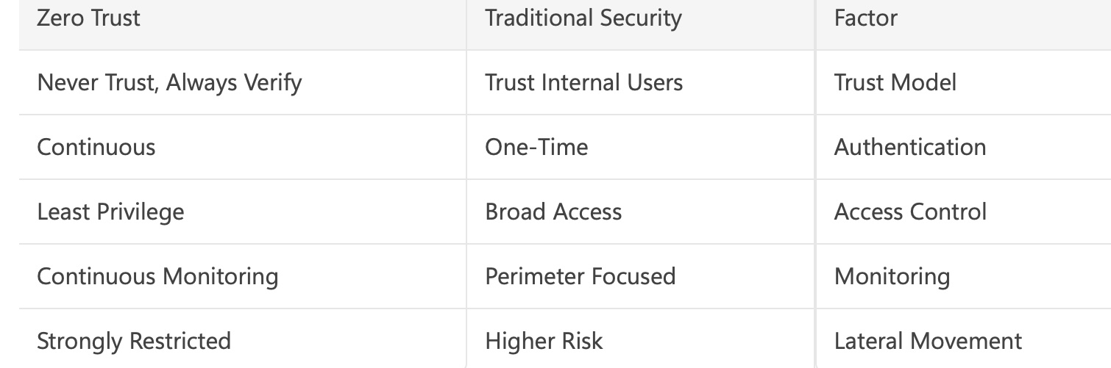

Conclusion:
Zero Trust Architecture provides a more suitable security model for modern environments where cloud services, remote working, mobile devices, and interconnected systems have reduced the effectiveness of traditional network boundaries [1], [2]. Continuous verification, least privilege, micro-segmentation, and monitoring can reduce unauthorised access, restrict lateral movement, and improve the detection of suspicious activity.
However, Zero Trust is not a complete cybersecurity solution. The WannaCry incident demonstrates that segmentation and least-privilege controls could have reduced ransomware propagation, but effective vulnerability management and timely patching would still have been essential [14], [16], [17]. Implementation also requires investment in identity management, monitoring, governance, skilled personnel, and organisational change [9], [10].
Therefore, organisations should not treat Zero Trust as a replacement for traditional security controls. Firewalls, endpoint protection, patch management, and incident response remain important components of defence-in-depth. The most effective approach is to integrate Zero Trust principles with these established controls as part of a layered and risk-based cybersecurity strategy [1], [9]. This provides stronger protection while recognising the operational and financial limitations associated with Zero Trust implementation.

Task 2

Developing a Cybersecurity Programme:
A Case Study of the Equifax Data Breach

Introduction:
Cybersecurity is a strategic business responsibility because security incidents can create financial, operational, regulatory, and reputational consequences. Effective cybersecurity therefore requires organisations to combine technical controls with governance, risk management, incident response, and continuous improvement [10], [11].
The 2017 Equifax data breach demonstrates the consequences of weaknesses in these areas. The incident involved failures in vulnerability remediation, asset visibility, monitoring, and organisational oversight, showing that major breaches can result from weaknesses in both technology and management [13].
This report analyses the Equifax breach and proposes a cybersecurity programme based on clear organisational accountability, measurable security policies, risk management, NIST CSF 2.0, incident response, and appropriate preventive and detective controls. Relevant Zero Trust principles are also considered where they can reduce unauthorised access and lateral movement [1], [10].

Overview of the Equifax Data Breach:
Equifax is a major U.S. consumer credit reporting agency that stores large amounts of sensitive financial and personal information. In 2017, attackers gained unauthorised access to its systems and compromised the personal information of approximately 147 million individuals. The exposed data included names, dates of birth, Social Security numbers, addresses, driving licence information and, in some cases, credit card details [13], [18].
The attackers exploited a known vulnerability in the Apache Struts web application framework. Although a security patch was available before the attack, Equifax failed to apply it to a vulnerable internet-facing application. Attackers were therefore able to access the network and remain undetected for several weeks while collecting sensitive information [13].
The incident resulted in financial, regulatory, and reputational consequences and demonstrated weaknesses beyond the original software vulnerability [11], [13]. Governance, asset visibility, vulnerability management, and security monitoring were also important factors in the scale of the breach. The Equifax case therefore demonstrates how failures in both technical controls and organisational processes can transform a known vulnerability into a major data breach [13].

2.1 Organisational Structure and Accountability:

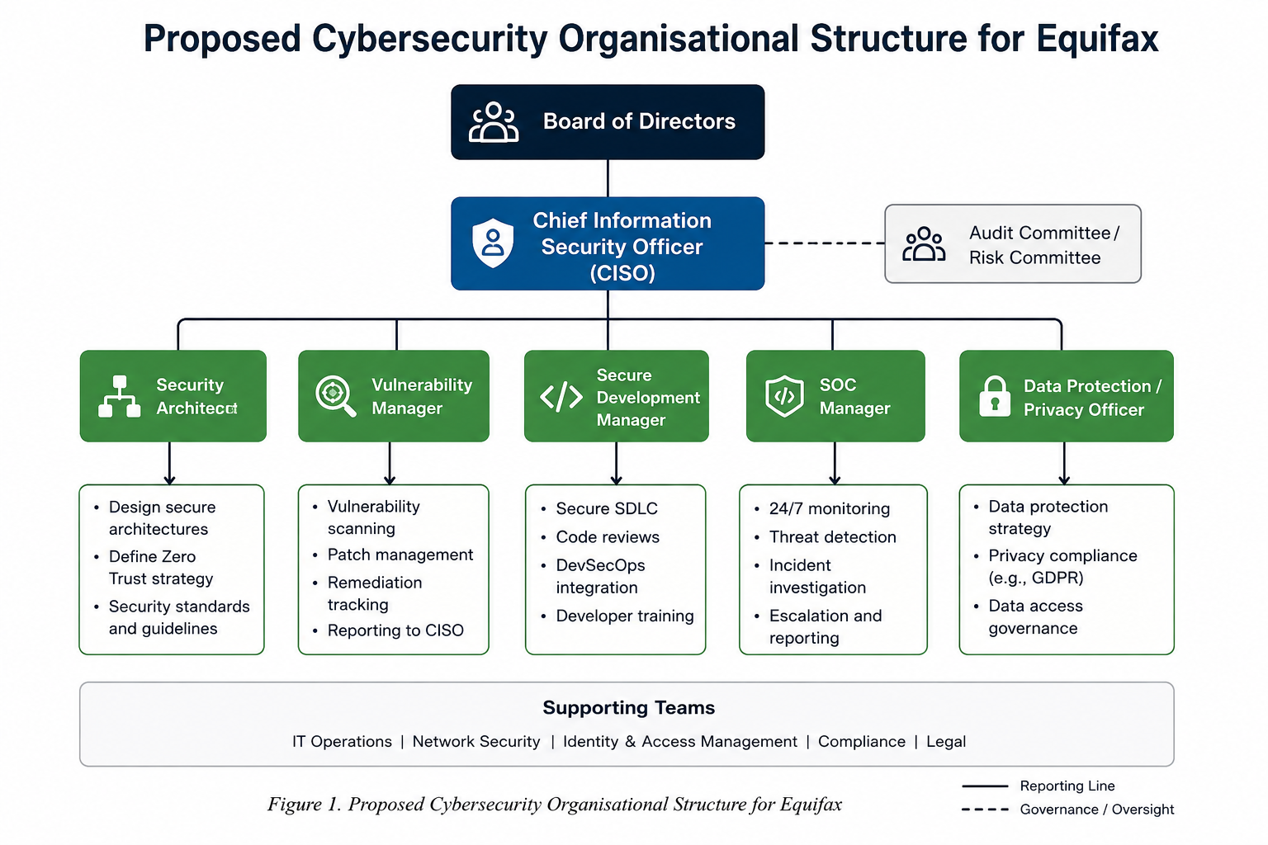
The Equifax breach demonstrated that cybersecurity failures can result from weaknesses in governance and accountability as well as technical controls [13]. The proposed structure therefore establishes clear responsibilities from Board level to operational security teams and aligns with the governance principles of NIST CSF 2.0 [10].

Board of Directors
The Board should provide strategic oversight and regularly review major cyber risks, critical vulnerabilities, significant incidents, and unresolved security issues. Treating cybersecurity as an enterprise risk ensures that its potential effects on business continuity, compliance, financial performance, and customer trust receive appropriate management attention [10].
Chief Information Security Officer (CISO)
The CISO should lead the cybersecurity programme, report significant risks to senior management and the Board, monitor security-control effectiveness, and ensure that unresolved critical issues are escalated. Stronger senior-level visibility could have supported earlier attention to weaknesses associated with the Equifax breach [10], [13].
Security Architect
The Security Architect should ensure that security requirements are incorporated into system and network design. The role should support controls such as least privilege and segmentation and work with vulnerability and development teams to address security weaknesses [1].
Vulnerability Manager
The Vulnerability Manager should oversee vulnerability scanning, patch management, remediation tracking, and escalation of unresolved vulnerabilities. Critical vulnerabilities should have defined owners and remediation deadlines, directly addressing the failure to remediate the known Apache Struts vulnerability involved in the Equifax breach [13].
Secure Development Manager
The Secure Development Manager should integrate security into the software development lifecycle through secure coding, testing, vulnerability assessment, and pre-deployment review. Identified weaknesses should be recorded, prioritised, and addressed with the Security Architect and Vulnerability Manager.
Security Operations Centre (SOC) Manager
The SOC Manager should oversee continuous monitoring, threat detection, incident investigation, and escalation. SIEM and EDR technologies can improve visibility, while serious incidents should be rapidly escalated to the CISO. This is particularly relevant because delayed detection increased attacker access during the Equifax breach [13].
Overall, this structure establishes clear ownership, reporting, and escalation from operational teams to senior management. This supports NIST CSF 2.0 by defining cybersecurity roles, responsibilities, and oversight [10].

2.2 Policies and Procedures:

The Equifax breach demonstrated that security technologies are ineffective if policies are not consistently implemented and monitored. Failure to remediate the Apache Struts vulnerability exposed weaknesses in vulnerability management, patching, asset visibility, and oversight [13], [18]. The proposed programme should therefore establish measurable and auditable policies in these areas.

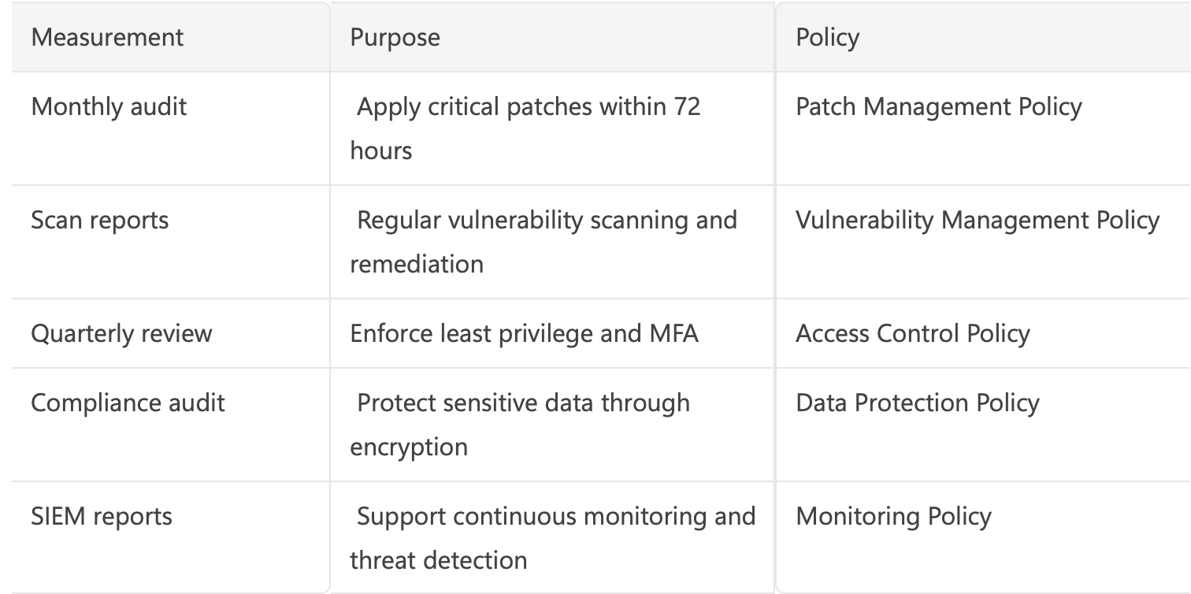

Vulnerability and Patch Management
Regular vulnerability scanning should cover internal, cloud, application, and particularly internet-facing assets. Vulnerabilities should be prioritised according to severity, exposure, data sensitivity, and business impact, with an assigned owner and remediation deadline. Critical vulnerabilities should be escalated when deadlines are missed [13], [18]. Patch management should follow the same risk-based approach. Where a critical patch cannot be deployed on time, the exception, accepted risk, and temporary controls should be documented and approved.
Secure Software Development
Security should be integrated throughout the Software Development Lifecycle (SDLC), including design, coding, testing, and deployment. Security testing and review should identify weaknesses before production, while vulnerabilities discovered during development should be recorded, prioritised, and remediated.
Asset Visibility and Management
Equifax should maintain an accurate inventory of hardware, software, applications, cloud services, and internet-facing systems. Each important asset should have an owner and information about its purpose, software version, and security status. Connecting asset inventories with vulnerability scanning would reduce the risk of systems being missed during patching [13].
Continuous Monitoring
Security logs from critical systems, applications, endpoints, and network devices should be centrally monitored. SIEM and EDR technologies can support detection and investigation of suspicious activity [1], [11]. High-risk alerts should have defined investigation and escalation procedures so that serious incidents rapidly reach the SOC Manager and CISO.
Data Protection and Access Control
Sensitive personal and financial information should be classified and protected according to its risk. Access should follow least-privilege principles, with MFA for important accounts, appropriate encryption, and regular reviews of user permissions [1]. These controls can reduce unnecessary access if an account is compromised.
Measurement and Accountability
Policies should be measured through indicators such as unresolved critical vulnerabilities, patch compliance, asset-inventory coverage, alert investigation, and completion of access reviews. Audit records should provide evidence of compliance, while serious or repeated failures should be escalated to the CISO. This supports the governance and continuous-improvement principles of NIST CSF 2.0 [10].
Overall, these policies connect technical controls with clear ownership, measurement, and escalation. This directly addresses the combination of patching, asset-management, monitoring, and governance weaknesses demonstrated by the Equifax breach [13], [18].

2.3 Governance and Strategic Alignment:

Cybersecurity governance should connect security decisions with organisational objectives and enterprise risk. The Equifax breach demonstrated that weaknesses in governance and operational security can create financial, legal, and reputational consequences [13], [18]. Senior management should therefore understand major cyber risks and ensure that responsibilities, resources, and controls are appropriate.
The proposed programme aligns with NIST Cybersecurity Framework (CSF 2.0), which organises cybersecurity risk management around six functions: Govern, Identify, Protect, Detect, Respond, and Recover [10].

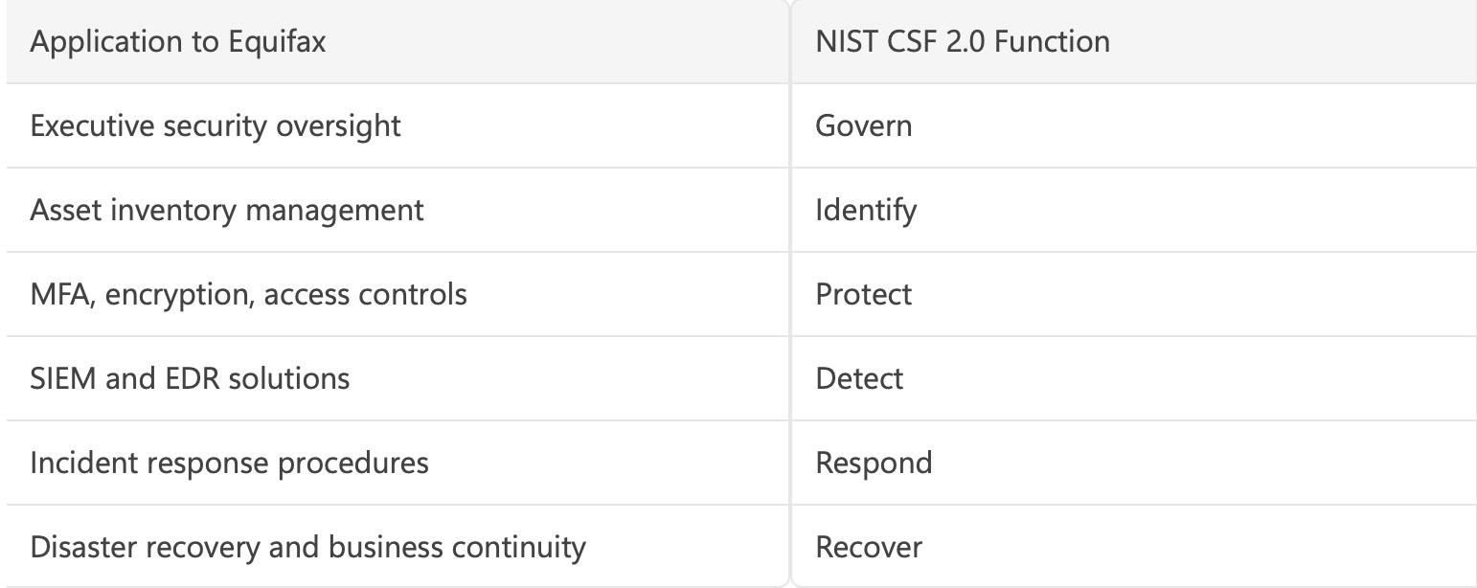

Govern establishes accountability, policies, risk oversight, and management responsibilities. For Equifax, the Board and CISO should ensure that significant vulnerabilities and security risks are identified, reported, and escalated [10].
Identify focuses on understanding assets, vulnerabilities, threats, and risks. Accurate asset inventories and regular vulnerability assessments are particularly important because the Equifax breach involved a vulnerable internet-facing application [13], [18].
Protect applies safeguards such as patch management, MFA, least privilege, encryption, awareness, and network segmentation to reduce the likelihood and impact of incidents [10].
Detect uses monitoring, logging, SIEM, and EDR to identify suspicious activity. Stronger detection could have reduced the time malicious activity remained unnoticed during the Equifax breach [13].
Respond requires documented procedures for escalation, containment, investigation, communication, and notification. Clear responsibilities can help the organisation make faster decisions and reduce operational and reputational damage [10].
Recover supports restoration of systems and business operations through tested backups, disaster recovery, business continuity, and lessons learned after incidents [10].
Together, these functions connect cybersecurity with business continuity, customer trust, regulatory responsibilities, and organisational resilience. However, adopting NIST CSF 2.0 does not automatically create effective security. Its value depends on implementation, accountability, and continuous review. The Equifax breach illustrates this limitation because the availability of a security patch did not prevent compromise when the vulnerable system remained unpatched [13], [18].

2.4 Risk Management and Assessment:

Effective risk management requires organisations to identify important assets, assess threats and vulnerabilities, and prioritise security actions according to likelihood and business impact [10]. The Equifax breach demonstrates the importance of this process because attackers exploited a known vulnerability in an internet-facing application, while weaknesses in patch management and asset visibility increased exposure [13], [18].

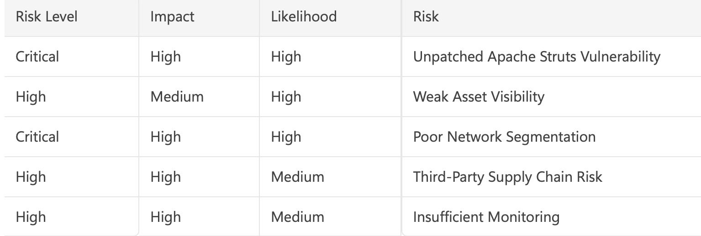

Internet-Facing Assets and Patch Management
Internet-facing systems should receive high priority because they are directly exposed to external threats. Equifax should maintain an accurate inventory of these systems and continuously assess them for vulnerabilities. Critical vulnerabilities should have defined remediation deadlines, and patch deployment should be verified rather than assumed to be successful [13], [18]. Where immediate remediation is not possible, the risk and temporary controls should be formally documented.
Third-Party and Supply-Chain Risk
Third-party software, suppliers, and external services should also be included in risk assessments. Important dependencies should be identified, relevant security advisories monitored, and supplier access to sensitive systems controlled. Supply-chain compromise was not established as the direct cause of the Equifax breach; it is included here as an additional risk within the proposed programme.
Network Segmentation
Network segmentation and least-privilege access can reduce the impact of a successful compromise by restricting unnecessary communication and lateral movement [1]. However, segmentation should complement rather than replace effective vulnerability and patch management.
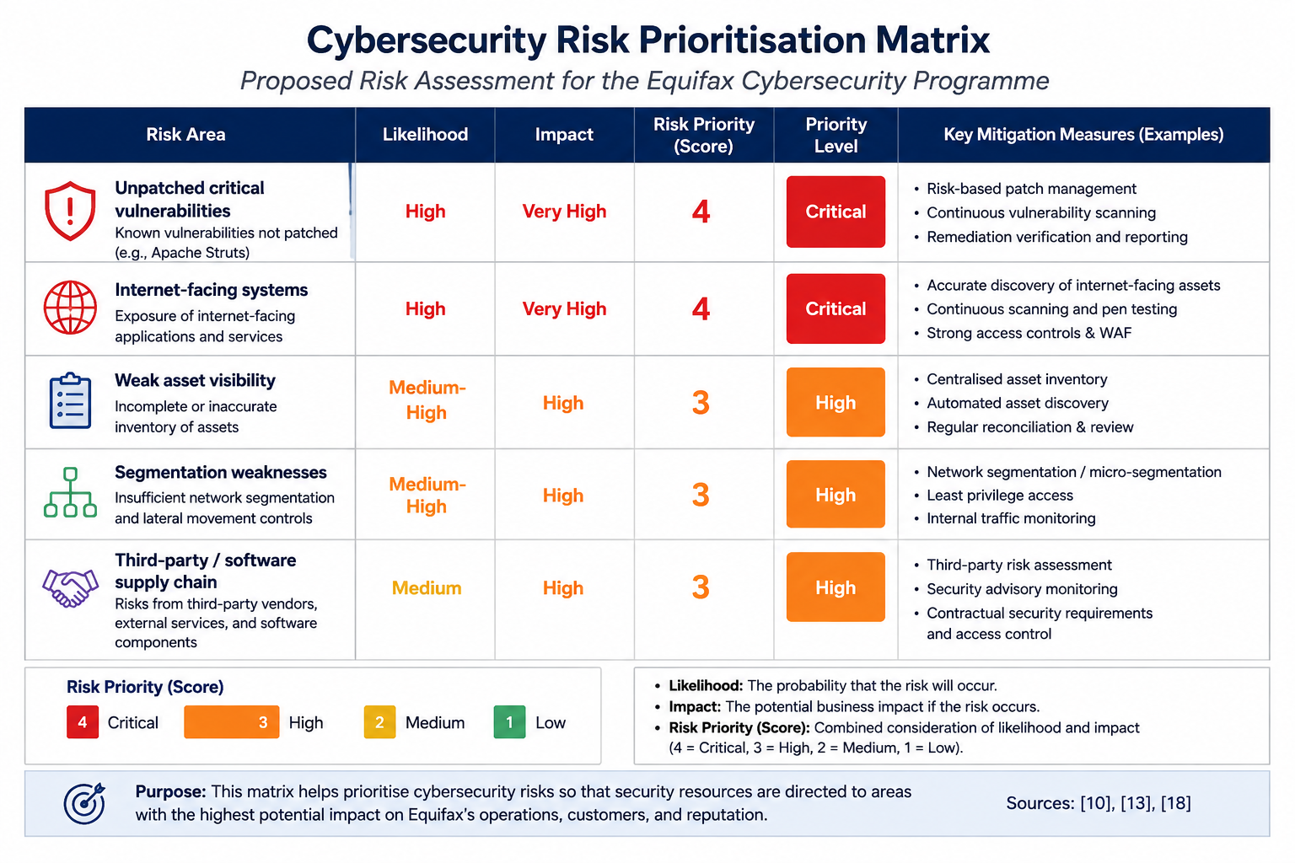
Risk Prioritisation and Mitigation
Risks should be prioritised according to likelihood, business impact, system exposure, data sensitivity, and existing controls [10]. For Equifax, an unpatched critical vulnerability affecting an internet-facing application containing sensitive information should therefore receive the highest priority [13], [18].
The matrix represents a proposed risk assessment, rather than historical ratings assigned by Equifax. It demonstrates how security resources could be prioritised towards risks with the greatest likelihood and potential business impact.
Risk management should be continuous because changes in systems, vulnerabilities, suppliers, and threats can alter organisational exposure. Regular assessment, clear risk ownership, vulnerability monitoring, and management review can help Equifax identify significant risks earlier and prioritise appropriate mitigation [10], [13], [18].

2.5 Compliance, Incident Response and Protection Controls
Compliance and Assurance
Compliance should be treated as an ongoing governance activity rather than a one-time exercise. Equifax should maintain evidence of vulnerability assessments, patching, access reviews, monitoring, incidents, and risk assessments so that security performance can be demonstrated through internal and external audits. Significant compliance failures and unresolved high-risk issues should be escalated to the CISO and senior management, supporting the governance principles of NIST CSF 2.0 [10]. This is particularly important because the Equifax breach demonstrated the consequences of ineffective vulnerability remediation and oversight [13], [18].
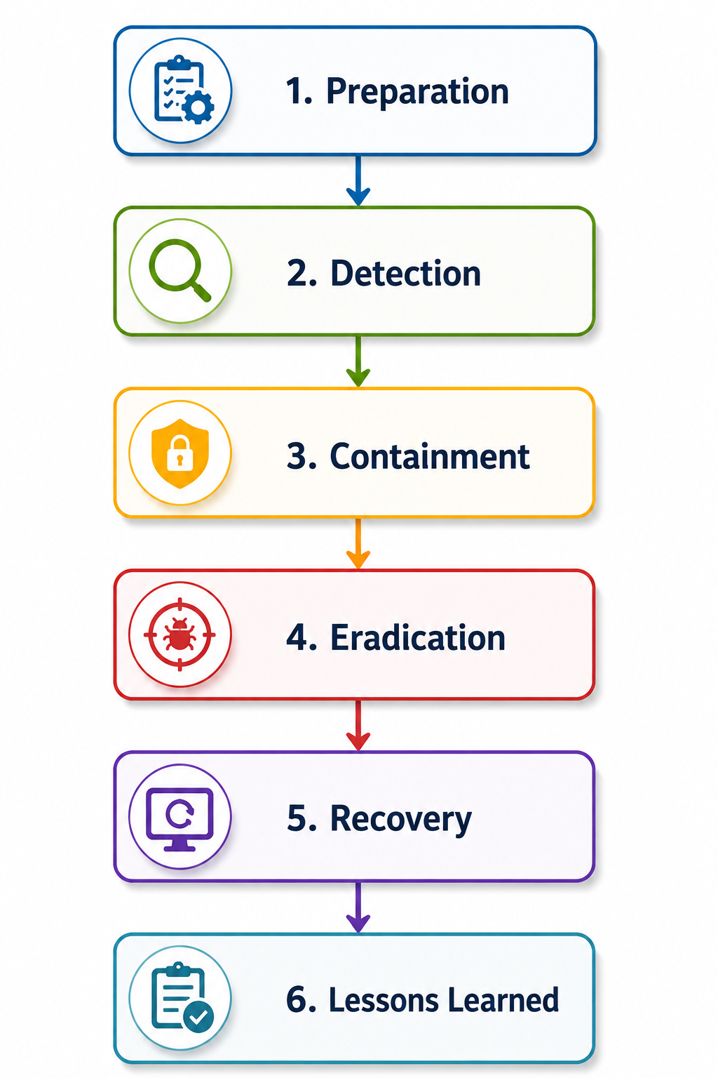
Incident Response.
A documented incident-response process should define responsibilities and escalation across six stages: Preparation, Detection and Analysis, Containment, Eradication, Recovery, and Lessons Learned. Preparation should establish plans, roles, tools, and training; detection should use monitoring, SIEM, and EDR to assess suspicious activity; containment should isolate affected accounts, devices, or systems; eradication should remove malicious activity and remediate vulnerabilities; recovery should safely restore operations; and lessons learned should improve policies, controls, and future risk assessments [10]. Serious incidents involving sensitive information or significant business disruption should be escalated from the SOC Manager to the CISO and senior management.

Preventive and Detective Controls
Preventive controls should include MFA, least privilege, patch management, secure configuration, network segmentation, encryption, and secure software development. Patch management is particularly important because the Equifax breach involved exploitation of a known vulnerability [13], [18]. Detective controls such as centralised logging, SIEM, EDR, vulnerability scanning, and network monitoring should identify suspicious activity and high-risk events for rapid investigation.Centralised monitoring, SIEM, and EDR can reduce attacker dwell time by detecting suspicious activity earlier, while rapid containment can limit data exposure and organisational impact.
Responsive and Automated Controls
Automated responses can improve speed by restricting suspicious accounts, isolating compromised endpoints, blocking malicious activity, and escalating critical alerts. However, high-impact automation should use defined conditions, logging, and human oversight because incorrect actions could disrupt legitimate business operations.
These controls should be linked to identified risks rather than implemented without justification. Vulnerability scanning and patching reduce exposure to known weaknesses; asset management improves visibility; segmentation and least privilege restrict lateral movement; monitoring supports detection; and incident response reduces the impact of successful compromise. This risk-based approach is consistent with NIST CSF 2.0 [10].
Overall, compliance, incident response, and technical controls should operate as connected components of the cybersecurity programme. The Equifax breach demonstrates that individual controls are insufficient when vulnerability remediation, monitoring, and governance processes fail [13], [18].
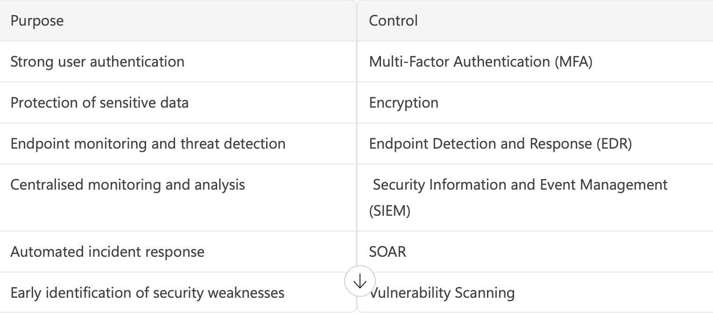

Analysis of the Security Failures:

The Equifax breach was not caused by a single technical failure. Although attackers exploited a known Apache Struts vulnerability, the scale of the incident reflected weaknesses in patch management, asset visibility, monitoring, governance, and risk management [13].
The most significant failure was not the absence of a technical solution, because a security patch was already available. Instead, Equifax failed to ensure that the vulnerable internet-facing system was successfully remediated [13]. This indicates a wider process and accountability problem: identifying a vulnerability provides limited protection if responsibility, remediation deadlines, verification, and escalation are ineffective.
Asset visibility and monitoring weaknesses increased this risk. Organisations cannot reliably patch or protect systems they do not accurately identify, while ineffective monitoring can allow attackers to remain undetected after initial compromise. In the Equifax case, malicious activity continued for several weeks before detection [13].
These failures were therefore interconnected rather than independent. Weak asset visibility affected vulnerability management; ineffective remediation left the application exposed; limited monitoring increased the time available to attackers; and governance weaknesses reduced assurance that critical risks had been addressed [10], [13]. The breach demonstrates why cybersecurity requires coordinated technical controls, clear ownership, verification, and management oversight rather than reliance on individual security technologies.

Critical Evaluation:
The proposed cybersecurity programme could reduce Equifax's exposure to similar incidents, but no framework or technology can eliminate cyber risk. Its effectiveness therefore depends on how consistently security controls are implemented, monitored, and improved.
NIST CSF 2.0 provides a useful structure for governance, risk identification, protection, detection, response, and recovery [10]. Its risk-based approach allows cybersecurity activities to be aligned with organisational priorities. However, adopting a framework does not guarantee effective security. The Equifax breach demonstrates this limitation because a security patch was available, but operational and management processes failed to ensure that the vulnerable system was successfully remediated [13].
Zero Trust can strengthen this approach through continuous verification, least privilege, and segmentation, which can reduce unauthorised access and lateral movement [1], [9]. However, Zero Trust cannot compensate for weaknesses in fundamental practices such as vulnerability and patch management. It can also increase cost and complexity, particularly where organisations operate legacy systems or lack skilled cybersecurity personnel [9], [11].
Therefore, the strongest approach is not to rely on a single framework or technology. Effective cybersecurity requires NIST-based governance and risk management, selected Zero Trust controls, and fundamental practices such as patching, monitoring, and incident response. Continuous management oversight is necessary to ensure that documented security requirements operate effectively in practice.

Recommended Cybersecurity Framework for Equifax:

Based on the weaknesses identified in the Equifax breach, the recommended approach is to combine NIST CSF 2.0 with selected Zero Trust principles. NIST CSF 2.0 provides the overall structure for governance, risk management, protection, detection, response, and recovery, while Zero Trust strengthens access control through continuous verification, least privilege, and segmentation [1], [10].
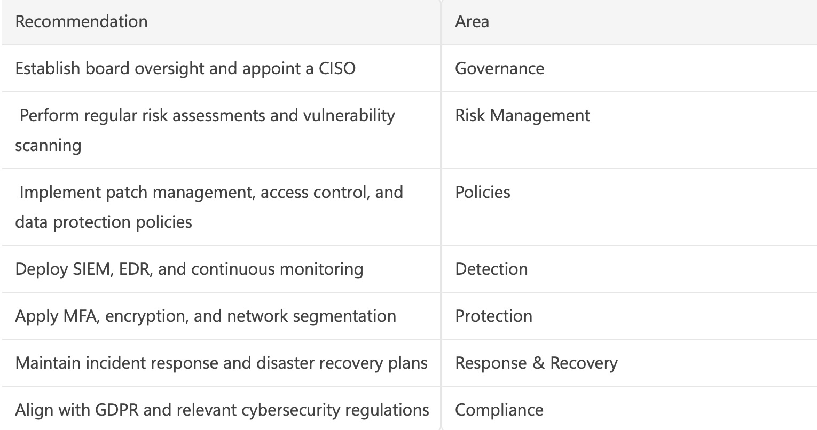

This combination addresses both organisational and technical weaknesses. NIST CSF 2.0 can improve accountability, risk management, asset visibility, and incident response, while Zero Trust can reduce unauthorised access and lateral movement following compromise [1], [9], [10]. However, Zero Trust would not have prevented exploitation of the unpatched Apache Struts vulnerability and must therefore complement effective vulnerability and patch management [13].
Overall, this combined approach provides a balanced response to the governance, operational, and technical weaknesses identified in the Equifax case. Its effectiveness depends on continuous implementation, monitoring, and management oversight rather than simply adopting documented frameworks.

Conclusion:

The Equifax breach demonstrates that major cybersecurity incidents can result from interconnected technical and organisational failures. Weaknesses in vulnerability management, patching, asset visibility, monitoring, and governance allowed a known vulnerability to contribute to a major data breach [13], [18].
The proposed cybersecurity programme addresses these weaknesses through clearer accountability, measurable security policies, continuous risk assessment, monitoring, and structured incident response. NIST CSF 2.0 provides an appropriate framework for integrating governance, identification, protection, detection, response, and recovery activities [10]. Selected Zero Trust principles, particularly least privilege and segmentation, can further reduce unauthorised access and lateral movement [1].
However, frameworks and technologies are only effective when they are consistently implemented and reviewed. The main lesson from the Equifax case is therefore that cybersecurity depends on the integration of people, processes, governance, and technology, supported by continuous monitoring and improvement [10], [13]. This combined approach can strengthen organisational resilience and reduce the likelihood and impact of similar incidents.

References:

[1] S. Rose, O. Borchert, S. Mitchell, and S. Connelly, Zero Trust Architecture, NIST Special Publication 800-207. Gaithersburg, MD, USA: National Institute of Standards and Technology (NIST), Aug. 2020.

[2] N. Nahar, K. Andersson, O. Schelén, and S. Saguna, "Zero Trust Architecture: A Comprehensive Review of Challenges and Applications," IEEE Access, vol. 12, 2024.

[3] C. Itodo and M. Ozer, "Zero Trust Security Models: Opportunities and Challenges for Modern Organisations," Computers & Security, vol. 139, 2024.

[4] Z. Adhami, A. W. Malik, and Z. Anwar, "Security Analysis and Implementation Considerations of Zero Trust Architecture," Computers & Security, vol. 116, 2022.

[5] J. Kindervag, “No More Chewy Centers: The Zero Trust Model of Information Security,” Forrester Research, Cambridge, MA, USA, 2010.

[6] H. Kang, G. Liu, Q. Wang, L. Meng, and J. Liu, "Research on Zero Trust Security Architecture and Its Applications," Entropy, vol. 25, no. 9, 2023.

[7] S. M. Zohaib, S. M. Sajjad, Z. Iqbal, M. Yousaf, and M. Haseeb, "Advances and Challenges in Zero Trust Architecture," Information, vol. 15, no. 3, 2024.

[8] Y. He, D. Huang, L. Chen, and Y. Ni, "Comparative Analysis of Traditional and Zero Trust Security Models," Security and Communication Networks, 2022.

[9] J. Garbis and J. W. Chapman, Zero Trust Security: An Enterprise Guide. Berkeley, CA, USA: Apress, 2021.

[10] National Institute of Standards and Technology (NIST), Cybersecurity Framework (CSF) 2.0. Gaithersburg, MD, USA: NIST, 2024.

[11] IBM Security, Cost of a Data Breach Report 2024. Armonk, NY, USA: IBM Corporation, 2024.

[12] E. Grass, C. Pagel, S. Crowe, and S. Ghafur, "Cyber Resilience in Healthcare Organisations," Journal of the Operational Research Society, 2025.

[13] U.S. Government Accountability Office, Data Protection: Actions Taken by Equifax and Federal Agencies in Response to the 2017 Breach, GAO-18-559. Washington, DC, USA: U.S. Government Accountability Office, 2018.

[14] K. Rajput, A. Darzi, and S. Ghafur, "Digital Health Security and Cyber Resilience in Healthcare Organisations," The Lancet Digital Health, vol. 7, no. 2, 2025.

[15] National Audit Office (NAO), Investigation: WannaCry Cyber Attack and the NHS. London, UK: National Audit Office, 2017.

[16] NHS England, Cyber Security Strategy for Health and Social Care. London, UK: NHS England, 2024.

[17] National Cyber Security Centre (NCSC), Zero Trust Architecture Design Principles. London, UK: NCSC, 2023.

[18] U.S. House Committee on Oversight and Government Reform, The Equifax Data Breach: Majority Staff Report. Washington, DC, USA: U.S. House of Representatives, 2018.

[19] Federal Trade Commission, Equifax Data Breach Settlement. Washington, DC, USA: Federal Trade Commission, 2019. [Online]. Available: https://www.ftc.gov

[20] European Parliament and Council of the European Union, “Regulation (EU) 2016/679 of 27 April 2016 on the protection of natural persons with regard to the processing of personal data and on the free movement of such data (General Data Protection Regulation),” Official Journal of the European Union, vol. L 119, pp. 1–88, May 2016. [Online]. Available: EUR-Lex

