

BMHP6029-Psychopathological Classifications and Provisions

Component 2: Written Assignment (Report)
Student name: Rebeca Daniela Serban
Student number: 2331907
Name of lecturer: Bianca Sanfilippo

Contents
Introduction 3
Classification and Diagnosis: 3
Treatment and Rehabilitation: 4
Pharmacological Treatment 5
Psychological and Psychosocial Interventions 5
Rehabilitation Measures 6
Current Debates and Emerging Issues 6
Debates on Classification 6
Neurodivergence and Reclassification Issues 7
Impact on Practice and Policy 7
Recommendations: 8
1. Strengthen Diagnostic Precision 8
2. Expand Access to Psychosocial and Rehabilitation Services 8
3. Improve Treatment Personalisation 8
4. Integrate Neurodiversity‑Informed Approaches Responsibly 8
5. Enhance Policy and Workforce Capacity 8
6. Promote Research on Bipolar Depression and Mixed States 9
Conclusion 9
References 9

ICD11 Chapter 6:
06 Mental, behavioural or neurodevelopmental disorders
6A60 Bipolar type I disorder
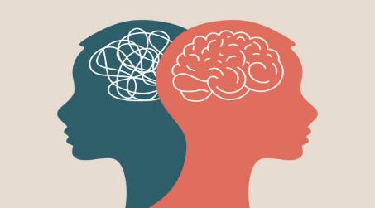

Introduction
Bipolar Type I Disorder is classified in ICD‑11 under Chapter 6: Mental, behavioural, or neurodevelopmental disorders, reflecting its global clinical significance. While this framework provides a structured basis for diagnosis, ongoing debates highlight the difficulty of capturing the full spectrum of mood dysregulation within categorical systems. Characterised by manic and depressive episodes that severely disrupt emotional regulation and functioning, Bipolar I continues to raise questions about diagnostic thresholds, differentiation from related conditions, and the value of biological versus neurodiversity‑informed perspectives. Despite advances in mood stabilisers, psychological therapies, and social interventions, challenges remain in managing bipolar depression, treatment resistance, and long‑term recovery. Inequalities in access to rehabilitation and continuity of care persist across health systems, underscoring gaps between diagnostic recognition and real‑world service provision. Current discussions around classification, neurodivergence, and the reconceptualisation of mood disorders are reshaping both clinical practice and societal understanding. This report critically examines how ICD‑11 informs the diagnosis, treatment, and rehabilitation of Bipolar Type I Disorder, evaluates emerging debates, and offers recommendations to strengthen clinical practice, policy development, and future research (Tan, et all. 2019).
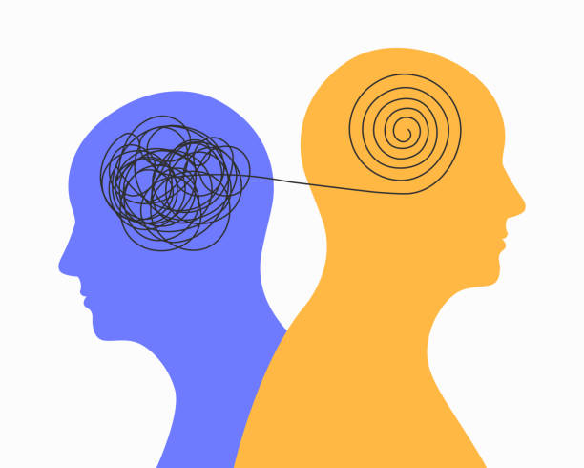

Classification and Diagnosis:
Bipolar Type I Disorder falls under the category of Mood Disorders in Chapter 6: Mental, behavioural, or neurodevelopmental disorders of the International Classification of Diseases, 11th Revision (ICD-11). The term "disorder" is used consistently in ICD-11, indicating a medicalised paradigm that highlights functional impairment, the intensity of symptoms, and the necessity of clinical intervention. Bipolar Type I Disorder is identified by the classification number 6A60, which sets it apart from Cyclothymic Disorder (6A63) and Bipolar Type II Disorder (6A61). The ICD-11's move toward dimensionality is reflected in this hierarchical framework, which acknowledges mood disorders as existing along a spectrum rather than as distinct classifications.
Bipolar Type I Disorder, according to ICD-11, is marked by at least one manic episode, which may be preceded or followed by depressed or hypomanic episodes. The presence of abnormally elevated, expansive, or irritated mood together with increased energy or activity that lasts for at least a week (or necessitates hospitalisation) is emphasised in the diagnostic criteria. Inflated self-esteem, a decreased need for sleep, pressured speech, flight of ideas, distractibility, psychomotor agitation, and participation in high-risk behaviours are further symptoms. These symptoms must significantly hinder functioning, clearly deviate from baseline functionality, and not be caused by drugs or illnesses.
Using structured interviews, longitudinal history, collateral data, and the elimination of differential diagnoses such as schizoaffective disorder, borderline personality disorder, or substance-induced mood disorders, the ICD-11 diagnosis procedure is clinical and phenomenological. Additionally, ICD-11 highlights the significance of periodicity in differentiating chronic mood instability from bipolar illnesses. The terms "disorder," "episode," and "impairment" are biological in nature. ICD-11 makes a more explicit effort to incorporate psychosocial aspects than earlier versions (Nusslock, et all. 2011).
The identification of mixed episodes, in which manic and depressive symptoms co-occur, is a significant change in ICD-11. This is in line with recent studies that demonstrate the prevalence and clinical significance of mixed states, which are frequently linked to increased suicide risk and worse treatment outcomes. ICD-11's more expansive and adaptable criteria are intended to promote diagnostic precision, but detractors contend that this increased inclusivity increases the risk of overdiagnosis, especially in young individuals whose mood instability may be due to psychosocial or developmental causes rather than a chronic mood disorder (Angst, et all. 2005).

Treatment and Rehabilitation:

A multimodal approach to therapy and rehabilitation is emphasised by the classification of 6A60 Bipolar Type I Disorder in ICD-11 Chapter 6: Mental, behavioural, or neurodevelopmental disorders. Instead of prescribing specific drugs, ICD-11 follows international clinical standards that emphasise social rehabilitation, psychological therapies, and pharmacological stability as essential elements of care. Pharmacologically, treatment usually consists of atypical antipsychotics, mood stabilisers (such lithium), and adjuvant medicines for managing acute manic episodes and preventing recurrence. This represents the fundamental treatment goal of ICD-11, which is to stabilise mood dysregulation. The intricacy of bipolar depression, treatment resistance, and the possibility of medication-induced mood swings, however, continue to pose difficulties for physicians, underscoring the shortcomings of a purely biological paradigm.
Pharmacologically, treatment usually consists of atypical antipsychotics, mood stabilisers (such as lithium), and adjuvant medicines for managing acute manic episodes and preventing recurrence. This represents the fundamental treatment goal of ICD-11: to stabilise mood dysregulation. The intricacy of bipolar depression, treatment resistance, and the possibility of medication-induced mood swings, however, continue to pose difficulties for physicians, underscoring the shortcomings of a purely biological paradigm. According to ICD-11, rehabilitation includes social inclusion, occupational functioning, and long-term healing in addition to symptom reduction. However, in reality, bipolar illness rehabilitation services are still uneven within health systems. Many people experience inequities in service delivery, gaps in continuity of care, and restricted access to community-based support—problems that are especially pertinent to chronic and episodic disorders like Bipolar I. Overall, a complete, biopsychosocial approach is supported by ICD-11's classification of 6A60; yet, practical application exposes persistent difficulties in guaranteeing fair, long-lasting, and person-centred rehabilitation (Selb, et all. 2015)

Pharmacological Treatment
Lithium and other mood stabilisers continue to be the gold standard for treating mania and averting relapse. Although lithium's anti-suicidal qualities are well-established, some patients may not find it acceptable due to its limited therapeutic index, requirement for frequent blood testing, and possible adverse effects on the thyroid and kidneys. Although evidence varies by episode type, anticonvulsants (such as valproate, carbamazepine, and lamotrigine) are frequently utilised; for instance, lamotrigine is more helpful for bipolar depression than mania.

The effectiveness of current treatments and incomplete adherence due to side effects, expenses, and the absence of persistent symptoms hinder effective prophylaxis of BD. Access to and support from professional, comprehensive clinical programs is another barrier to long-term treatment of BD. As with most psychiatric diseases, the lack of a clear pathophysiology or aetiology is a key barrier to the development of better, rationally designed pharmaceutical treatments for BD (Baldessarini, et all.2019)

Psychological and Psychosocial Interventions
Psychological therapies play a crucial role in relapse prevention and functional recovery. Evidence‑based approaches include:
-Cognitive Behavioural Therapy (CBT), for controlling mood and preventing relapses
-Psychoeducation, which enhances early detection of relapse symptoms and medication adherence
-Family‑Focused Therapy is very beneficial for youth and adolescents in circumstances with high levels of expressive emotion
-Interpersonal and Social Rhythm Therapy (IPSRT), which maintains circadian cycles and everyday routines.
The psychosocial aspects of bipolar disorder, such as stigma, interpersonal challenges, and interruption at work, are addressed by these interventions (Perich, et all. 2022)

Rehabilitation Measures
ICD-11 defines rehabilitation as a broad term encompassing community integration, occupational recovery, and social functioning. In actuality, rehabilitation could involve:
-Supported employment programmes
-Housing support
-Peer support and recovery colleges
-Crisis planning and relapse prevention
-Lifestyle interventions (sleep hygiene, exercise, substance use reduction)
However, there are substantial regional differences in the availability of rehabilitation services. For instance, community mental health teams in the UK are frequently unable to offer long-term psychosocial assistance, which results in a dependence on medication.
Acute mania can be effectively treated with pharmaceuticals, but bipolar depression is still difficult to treat and causes long-term disability. Treatment resistance, repeated relapses, and cognitive deficits that continue even during euthymic periods are common among patients. A significant obstacle is medication adherence, which is impacted by stigma, side effects, and a lack of understanding during manic episodes.
Psychosocial therapies are successful yet resource-intensive, requiring long-term involvement and qualified doctors. Many patients fall between the gaps between primary care, secondary mental health services, and social care, and rehabilitation options are not always available. Overall, systemic problems like underfunding, a lack of workers, and disjointed care routes limit the effectiveness of treatment (Catalao, et all. 2025)

Current Debates and Emerging Issues

Debates on Classification
The question of whether bipolar illness should be viewed as a spectrum disorder rather than as distinct subtypes is one of the main points of contention. Although research increasingly supports dimensional models that reflect diversity in mood instability, impulsivity, and neurobiological markers, ICD-11 maintains categorical differences (Type I, Type II, Cyclothymia). Rigid classifications, according to critics, may mask individual variations and result in incorrect diagnoses, especially in teenagers whose mood swings may be the result of developmental processes rather than illness.
The overlap between borderline personality disorder (BPD) and bipolar disorder is another topic of discussion. Both include interpersonal challenges, impulsivity, and mood swings. Although ICD-11 emphasises periodicity in bipolar illness against chronic instability in BPD in an effort to make distinctions clear, diagnostic ambiguity still exists. Misdiagnosis can result in improper pharmacological interventions or exclusion from psychological therapy, which has treatment implications (Malhi, et all.2023)

Neurodivergence and Reclassification Issues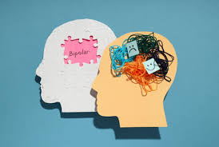
Understanding bipolar disease via a neurodiversity lens, which highlights individual differences in mood management, creativity, and energy and questions the pathologizing language of "disorder," is gaining popularity. Some proponents contend that there is a spectrum of bipolar features and that lived experiences, cultural interpretations, and strengths related to mood variability are not adequately captured by the biological model.
Applying neurodiversity frameworks to bipolar disorder, however, is debatable. Bipolar disorder is characterised by periods of extreme impairment, risk, and loss of autonomy, in contrast to autism or ADHD. Reframing bipolar disease as neurodivergence, according to critics, may reduce clinical risks, make therapy less accessible, or mask the need for protection during manic episodes (Deterding, et all. 2026)

Impact on Practice and Policy
These discussions have an impact on clinical practice by influencing service design, treatment paths, and diagnostic thresholds. For instance:
- Although they run the risk of overdiagnosing, broader diagnostic criteria may improve early detection.
- Although they may facilitate individualised care, dimensional models complicate the requirements for service eligibility.
- Although they may lessen stigma, neurodiversity-informed approaches necessitate a substantial shift in service culture.
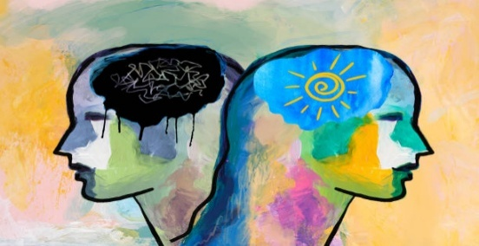
The necessity for integrated care pathways, funding for community services, and professional training in trauma-informed and culturally competent practice are some of the policy consequences (Kozicky, J., et all. 2022)

Recommendations: 

1. Strengthen Diagnostic Precision
To lower misdiagnosis, ICD-11 criteria should be supported by multidisciplinary input, longitudinal monitoring, and systematic evaluation methods. Diagnostic accuracy would be increased with more precise instructions on how to differentiate bipolar disease from personality disorders, trauma-related conditions, and substance-induced mood swings.

2. Expand Access to Psychosocial and Rehabilitation Services
Long-term results would be enhanced by funding community-based rehabilitation, which includes peer support, family interventions, and supported employment. Recovery-oriented models that prioritise social inclusion, strengths, and autonomy should be used by services.

3. Improve Treatment Personalisation
Individualised lifestyle, psychological, and pharmaceutical therapies should all be included in care plans. Practice should incorporate regular monitoring of side effects, physical health, and cognitive performance

4. Integrate Neurodiversity‑Informed Approaches Responsibly
While providing protections for people who are at danger during manic episodes, services should recognise the variety of mood variation experiences. More comprehensive evaluations would be supported by training in trauma-informed and culturally sensitive care.

5. Enhance Policy and Workforce Capacity
Funding for mental health services should be given top priority by policymakers, who should also shorten wait times and increase the number of specialists in the field. Fragmentation would be lessened by integrated care pathways connecting social care, secondary mental health services, and primary care

6. Promote Research on Bipolar Depression and Mixed States
To explain mixed episodes, create effective treatments for bipolar depression, and investigate biomarkers that could aid in tailored medication, further study is required (Goodwin, G.,et all. 2016)

Conclusion

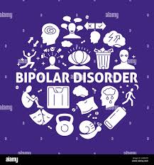
The ICD-11 classification of bipolar type I illness represents a contemporary perspective of mood disorders that prioritises clinical importance, functional impairment, and episodicity. Although the classification offers a precise foundation for diagnosis, there are still difficulties in differentiating bipolar disorder from similar diseases and guaranteeing proper evaluation in a variety of demographics. A multimodal strategy is necessary for treatment and rehabilitation, but access to complete care is restricted by systemic obstacles. The dynamic nature of psychiatric diagnosis and the need for adaptable, person-centred treatments are highlighted by current discussions, especially those around spectrum models, neurodivergence, and reclassification.
Investing in psychosocial treatments, improving diagnostic accuracy, and integrating biological and neurodiversity-informed viewpoints in a balanced way are all necessary to improve outcomes for people with Bipolar Type I Disorder. Long-term healing, social inclusion, and fair access to treatment must be given top priority in future research and policy.

References

Angst, J., & Cassano, G. (2005). The mood spectrum: improving the diagnosis of bipolar disorder. Bipolar Disorders, 7(s4), 4–12. https://doi.org/10.1111/j.1399-5618.2005.00210.x

Baldessarini, R. J., Tondo, L., & Vázquez, G. H. (2019). Pharmacological treatment of adult bipolar disorder. Molecular Psychiatry, 24(2), 198–217. https://doi.org/10.1038/s41380-018-0044-2 ( accessed 27.06.2026)

Catalao, R., Broadbent, M., Ashworth, M., Das-Munshi, J., L. Hatch, S., Hotopf, M., & Dorrington, S. (2025). Access to psychological therapies amongst patients with a mental health diagnosis in primary care: a data linkage study. Social Psychiatry and Psychiatric Epidemiology, 60(9), 2149–2161. https://doi.org/10.1007/s00127-024-02787-y

Deterding, K., Halabi Najjar, R., Roach, A., & Cloyes, K. G. (2026). Neurodivergence Among Nurses in the Workforce: A Scoping Review. Journal of Advanced Nursing. https://doi.org/10.1111/jan.70541

Goodwin, G., Haddad, P., Ferrier, I., Aronson, J., Barnes, T., Cipriani, A., Coghill, D., Fazel, S., Geddes, J., Grunze, H., Holmes, E., Howes, O., Hudson, S., Hunt, N., Jones, I., Macmillan, I., McAllister-Williams, H., Miklowitz, D., Morriss, R., … Young, A. (2016). Evidence-based guidelines for treating bipolar disorder: Revised third edition recommendations from the British Association for Psychopharmacology. Journal of Psychopharmacology (Oxford), 30(6), 495–553. https://doi.org/10.1177/0269881116636545

Kozicky, J., Schaffer, A., Beaulieu, S., McIntosh, D., & Yatham, L. N. (2022). Use of a point‐of‐care web‐based application to enhance adherence to the CANMAT and ISBD 2018 guidelines for the management of bipolar disorder. Bipolar Disorders, 24(4), 392–399. https://doi.org/10.1111/bdi.13136

Malhi, G. S., Bell, E., & Bhui, K. (2023). ICD-11 and bipolar II disorder: so much ado and yet nothing new. British Journal of Psychiatry, 223(2), 345–347. https://doi.org/10.1192/bjp.2023.66

Nusslock, R., & Frank, E. (2011). Subthreshold bipolarity: diagnostic issues and challenges. Bipolar Disorders, 13(7–8), 587–603. https://doi.org/10.1111/j.1399-5618.2011.00957.x

Perich, T., Mitchell, P. B., & Vilus, B. (2022). Stigma in bipolar disorder: A current review of the literature. Australian and New Zealand Journal of Psychiatry, 56(9), 1060–1064. https://doi.org/10.1177/00048674221080708

Selb, M., Kohler, F., Nicol, M., Riberto, M., Stucki, G., Kennedy, C., & Üstün, B. (2015). ICD-11: A comprehensive picture of health, an update on the ICD-ICF joint use initiative. Journal of Rehabilitation Medicine, 47(1), 2–8. https://doi.org/10.2340/16501977-1928

Tan, R., Erim, B., stün, N., & ney, R. (2019). Effects of comorbid personality disorders in bipolar type I disorder patients to disease course. Anadolu Psikiyatri Dergisi, 20(3), 1–244. https://doi.org/10.5455/apd.3721

