

Module Name: Digital Skills for Personal Development and Business Growth
Module Code: (BMSW4008_SWAN)
Assignment Name: Evidence of Learning (E-Portfolio)
Student Name: Mais Bitar
Student Number: 2417052
Lecturer: Philippa Fitzgerald
Deadline: 20th June 2025

Wordcount: 1817

AI Acknowledgement
I confirm that I have not presented any AI generated materials as my own work.
I confirm that I have copies of my drafts, notes, and other resources I used, which I may be asked to provide in evidence.

Contents
Market Research and Website Development Project 4
Introduction 4
Questionnaire Analysis 4
Conclusion 10
Website: 11
Flyer: 12
Logo: 12
Business Card: 12
The Importance of Excel in The Digital Era 13
Introduction 13
Excel and the Digital Era and How it Links to Elevate 13
Conclusion 14
Excel Spreadsheet and Chart: 16
Reference list 17

​​
​
​
​
​
​
​
​
​

Market Research and Website Development Project

Introduction
Tutoring is a form of educational assistance either in small group or one-to-one by qualified tutors to achieve academic success. It helps students to better understand subjects and build confidence (Levy, 2024). Tutoring proved to have steady and more beneficial outcomes compared to parental assistance (Nickow, Oreopoulos and Quan, 2020).
Understanding a business’s target audience helps with developing an effective marketing campaign, ensuring a successful business (Supan, 2023).
At Elevate, a questionnaire was conducted to understand customers’ needs and expectations. Gathering a total of 49 responses provided insights on subject needs, tutoring types, learning modes and pricing. This essay analyses four key questions and explains how they will influence the business idea, website design, and marketing strategy including insights into audience segmentation and Search Engine Optimisation (SEO).

Questionnaire Analysis
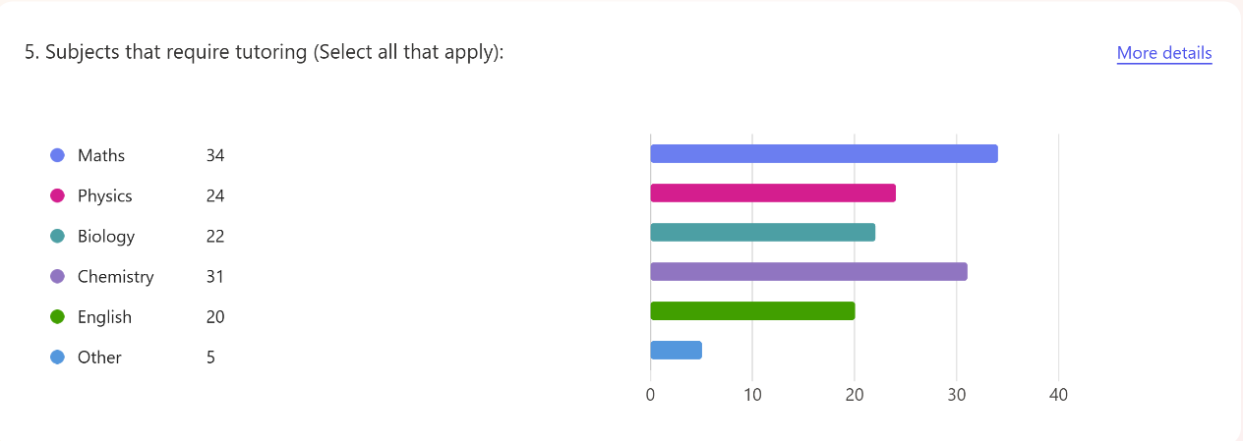
Question 5 (Figure 1) asked about subject needs: Maths (34 responses) and Chemistry (31 responses) were the most required, followed by Physics (24 responses), Biology (22 responses) and English (20 responses), showing a clear demand for STEM subjects, which stands for Science, Technology, Engineering, Mathematics. According to, Chiangpradit (2023), STEM subjects are the most challenging for students due to their highly theoretical content. In particular, Physics and Maths talk about complicated theories that can be challenging to some without guidance and practical applications to real life issues.
Figure 1: subject needs results.
Given this, Elevate will make STEM support the main focus of tutoring services. Experienced tutors will be hired to provide help and support for learners focusing on real-world and practical applications to simplify complex concepts. According to Modiraparambil (2023), a PhD or Master’s does not mean a person is qualified for teaching; teaching requires the person to have academic skills to efficiently pass knowledge.
Elevate’s website will show different services, for GCSE, A-level, and undergraduate students. Strong STEM support will also be promoted as shown in Figure 2.
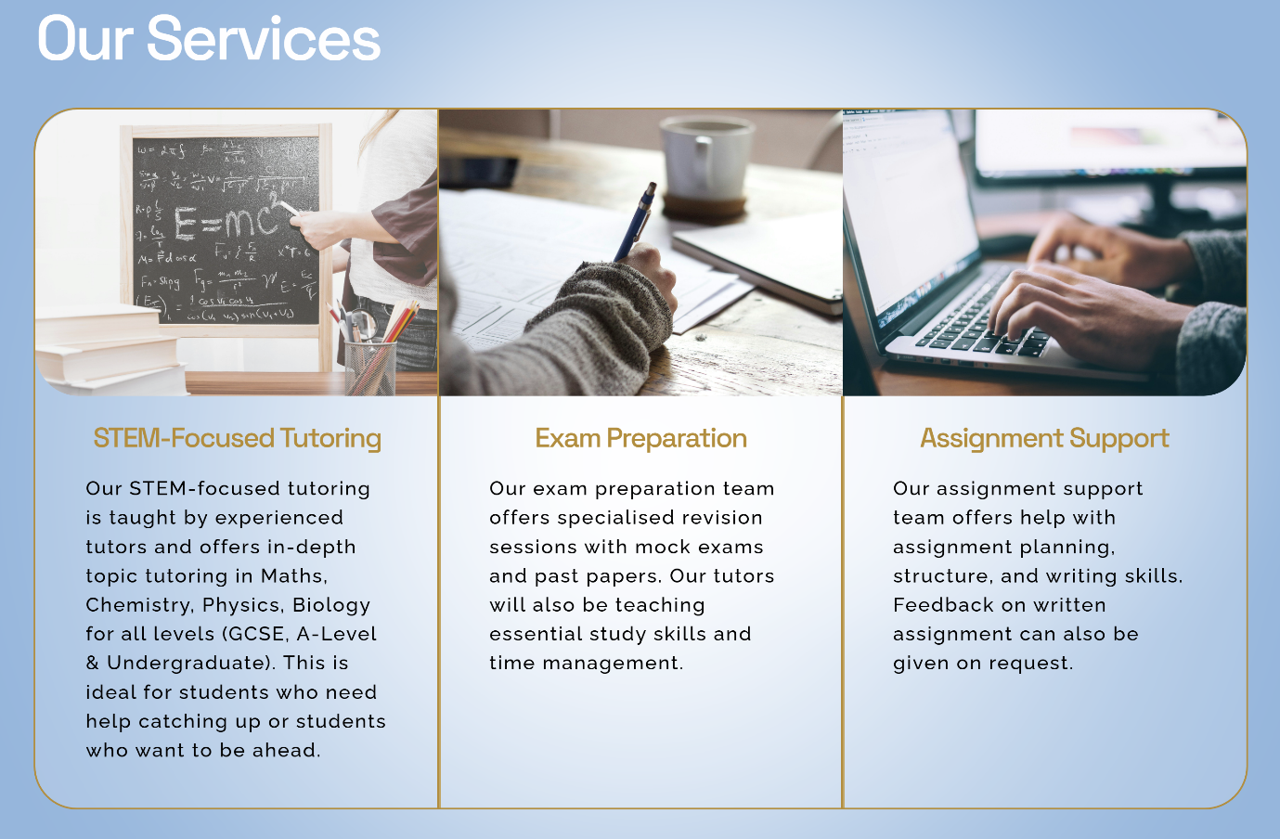
Figure 2: Elevate’s services. (Squarespace, 2025).
Question 6 (Figure 3), asked about the preferred tutoring type: exam preparation scored 49% followed by in-depth topic tutoring scored 33%, and 18% assignment support. This reflects that the majority of students and parents are prioritising exam success and academic improvement. Tittle (2024), highlights the value of good tuition in improving exam results by helping students to understand topics to guarantee good scores. Teachers can also teach students strategies and skills to approach exam questions to improve their grades.

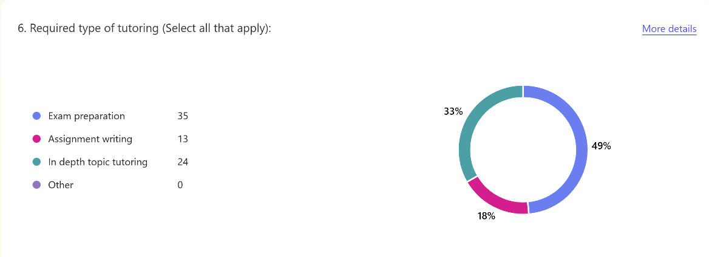

Figure 3: tutoring type results.
In response, Elevate will offer intensive exam preparation sessions including past papers, mock tests nearer to exam times. Students will also be provided with in-depth topic tutoring to understand and grasp subject material. Sessions can be either one-to-one or small group, as shown in Figure 12. According to Education Endowment Foundation (2021), small group and one-to-one tuition are both effective, however, small group tuition can be more suitable for students who cannot afford the price of one-to-one tuition.
Inspirational slogan ‘Rise To Your Potential’ (Figure 4), implemented on the website, flyers, and business card, motivates students to sign-up to the programs.

Figure 4: inspirational slogan and mission. (Squarespace, 2025).
Question 8 (Figure 5) surveyed learning preferences: 76% preferred face-to-face, 14% preferred online and 10% had no preference, which reflected the importance of face-to-face learning. Students see face-to-face better than online or blended learning as the former allows full interactions with tutors, class involvement and group work (Mali and Lim, 2021).
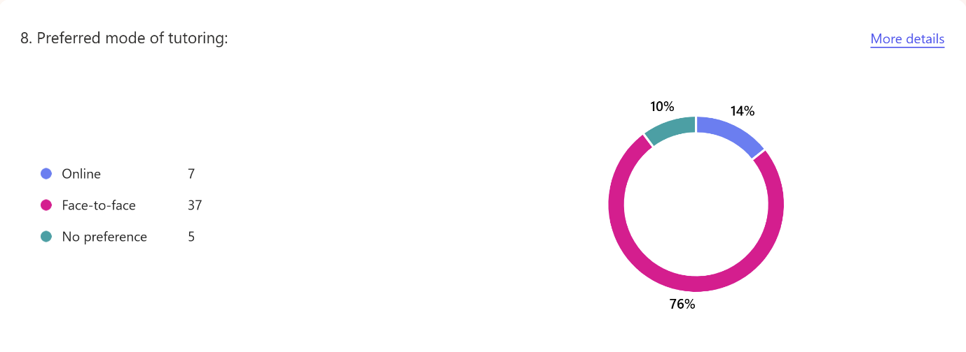
Figure 5: learning preferences results.

Consequently, Elevate will prioritise in-person tutoring in the centre without ignoring online learning. Other options such as the student’s home, or local community centres where there is good demand. This can be discussed through booking free consultation on the website, as shown in Figure 6.
Figure 6: a contact us section.
Question 12 (Figures 7 to 10) inspected pricing options: 54% of respondents can pay between £15 and £25 per hour, 24% could pay between £30 and £40, and 22% preferred to pay between £5 and £12; most people cannot afford, or are not willing to pay a lot of money. According to the research (The Sutton Trust, 2019), students from rich backgrounds have had more access to tutoring than students from poorer backgrounds.
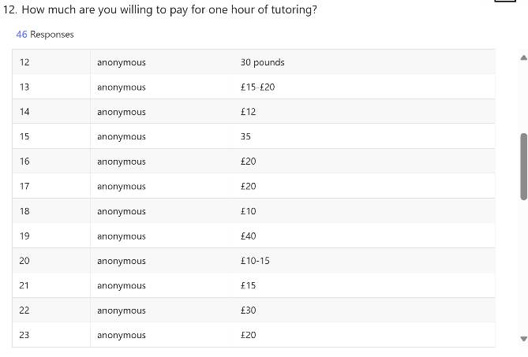
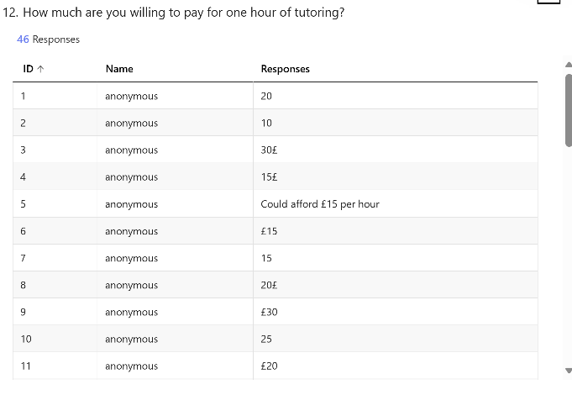

Figure 7: pricing preferences. Figure 8: pricing preferences.

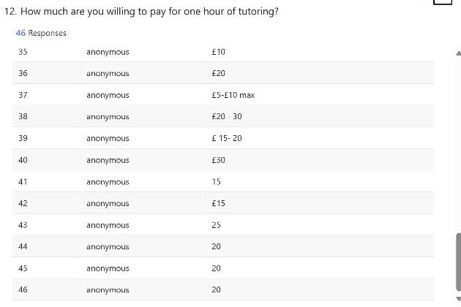
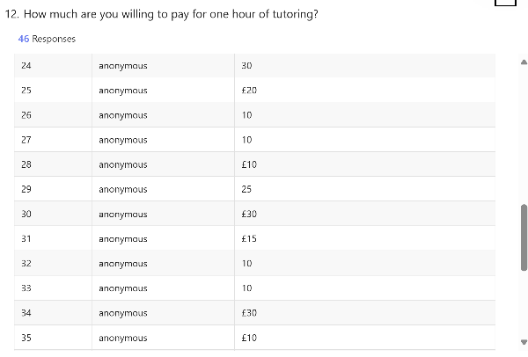

Figure 9: pricing preferences. Figure 10: pricing preferences.

As a result, Elevate will offer flexible pricing and packages; a small group tutoring (up to 3 students) priced at £15 per student per hour for standard sessions and £25 per student per hour for premium sessions; one-to-one standard priced at £25 per hour, and premium (with experienced tutors) priced at £35 per hour. A monthly payment scheme (with lower prices) of £160 per month (£20 per hour twice a week) for one-to-one tutoring and £80 per student per month (£10 per hour twice a week) for small groups will also be offered. This is displayed clearly on the website, allowing users to choose the service they require according to their needs and budget as shown in Figure 12.
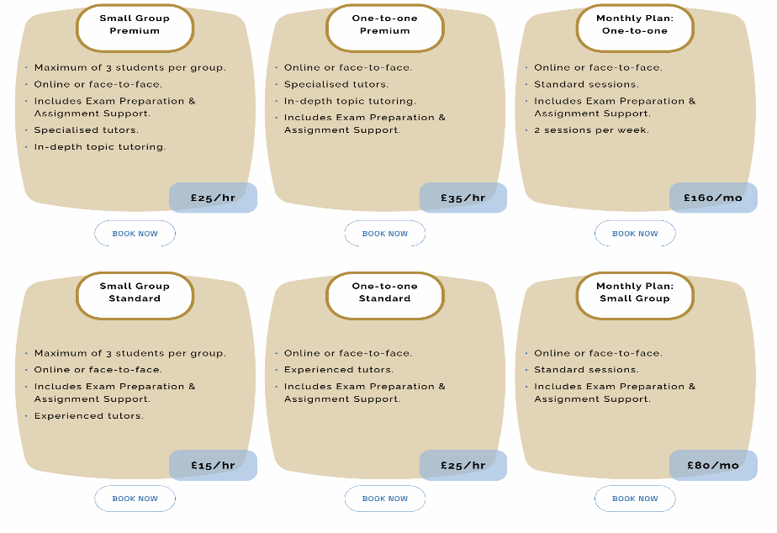

Figure 12: prices and packages.
From the responses, three audience segments are identified:
- STEM students needing support and in-depth tutoring.
- Exam-preparation students needing short term exam success.
- Limited-budget students looking for affordable prices and budget-friendly plans.
These segments meet the customer needs and abilities thereby fostering stronger engagement.
Using SEO, businesses can reach potential customers effectively and affordably. SEO is the key for bringing customers, since the pandemic shifted people to be more online than they ever were. Through SEO, businesses are more visible to customers, making the marketing more impactable on businesses. All of this makes SEO an essential tool for the success of businesses (Hollingsworth, 2024).
To boost search, Elevate’s website includes the following: Elevate is an affordable tutoring centre in Swansea that offers expert one-to-one and group tutoring for GCSE, A-Level and undergraduate students to increase grades, boost confidence and guarantee success in a supportive learning environment. This is shown in Figure 13.
SEO is implemented for the pricing and packages page, and will include: view the affordable pricing plans for one-to-one, small group, and monthly plans. Flexible packages to suit everyone’s needs, goals, and budget. Contact us for a free consultation. This is shown in Figure 14.
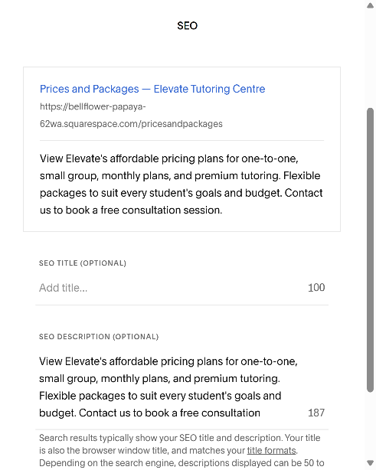
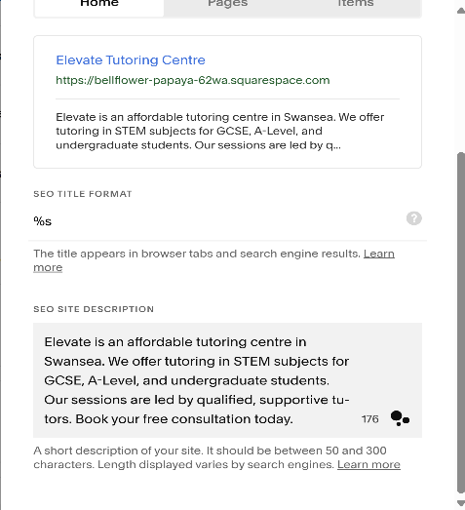

Figure 13: SEO site description. Figure 14: SEO packages and pricings.

Conclusion
Tutoring plays an important role in boosting students’ achievements and confidence (levy, 2024). The questionnaire gave Elevate a clear understanding of the target audience and their needs; the demand for STEM subjects and exam support, the preference for face-to-face learning, and the pricing. The analysis shaped the business model to give top standard, and affordable service. Analysing the target audience’s needs gave Elevate a clear idea of marketing strategy, service offering, and prices. Putting the services in-line with the needs of target audience and using digital marketing tools, Elevate is in the right place to be leader in education support.

Website:
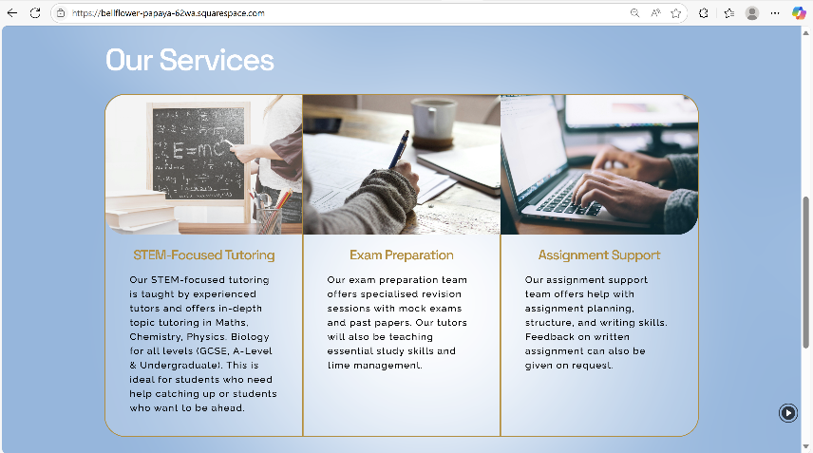
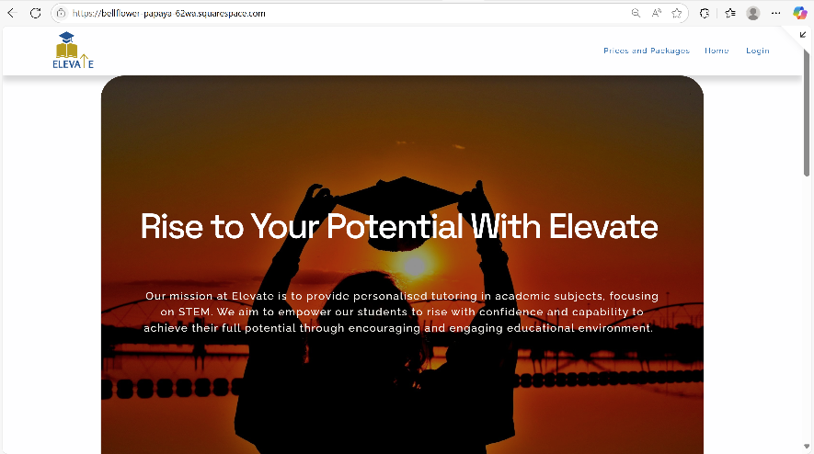
Homepage: (Squarespace, 2025).
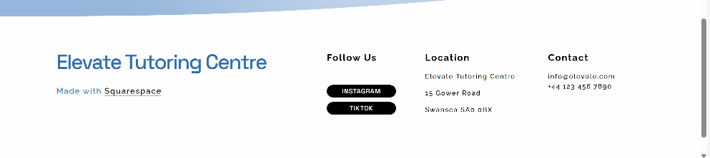

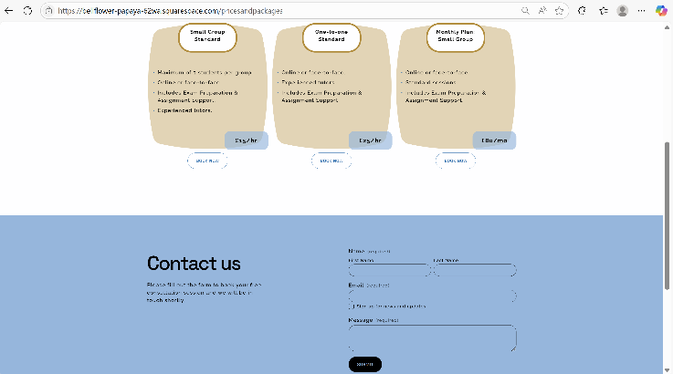
Pricing Page:
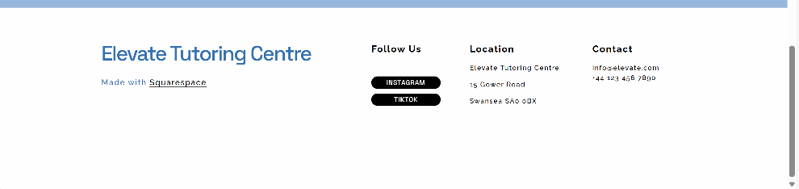
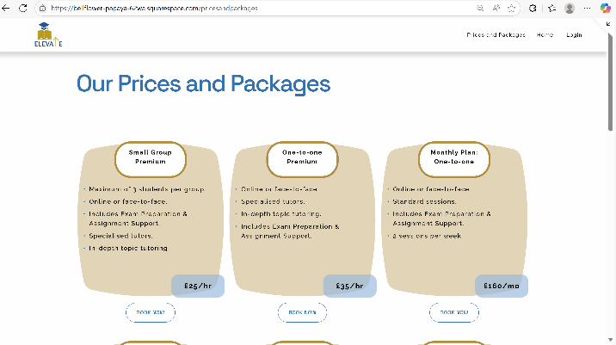

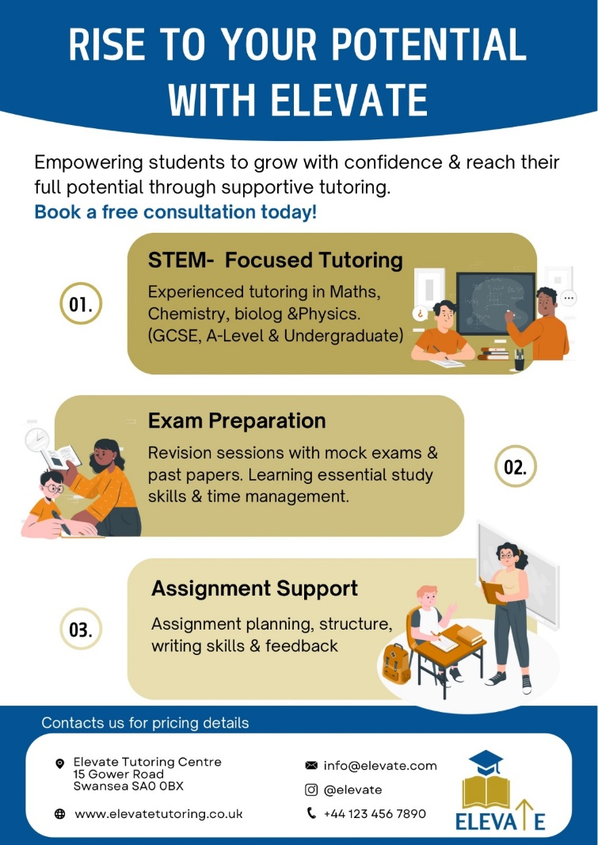
Flyer: (Canva, 2025). Images: (Storyset, 2023).


Logo: (Canva, 2025).


Business Card: (Canva, 2025).

The Importance of Excel in The Digital Era

Introduction
Microsoft excel is a software developed by Microsoft and designed to make spreadsheets to organise and analyse data by using calculations, formulas, graphs, and tables. It also includes Visual Basic as a programming language for applications (Nongo and Nwachukwu, 2021). In today’s world with the increasing use of digital tools, Excel emerges as an essential software for business, research and data management. Despite the huge progress in digital technology, including AI, Excel remains an irreplaceable key skill for those looking for succession and competence (Rosvi .S, 2025). According to Wonder (2021), there are more than 750 million people worldwide who use Microsoft Excel monthly. For Elevate as a growing business, it is essential to use Excel for development and success.

Excel and the Digital Era and How it Links to Elevate
The Digital Era can be defined as a time of significant shift to advanced technology that leads to quicker and self-sufficient production, as well as application of knowledge (Shepherd, 2019). Understanding Excel’s impacts, will help Elevate build a connection with technology and benefit from the knowledge it generates (Shepherd, 2019).
Microsoft Excel still remains essential for businesses, especially in finance departments. Its handling of numbers, organisation of data, continuous updates, and flexibility make it the first choice to use for companies, which explains why it is still relevant in the business world. It is widely known for its simplicity and reliability in data management. Moreover, if Excel is used in conjunction with Power BI, then it is possible for users to filter the data before visualising it. This means that Excel and Power BI complete each other effectively (Charlesworth, 2024). However, according to Raymond (2023), Excel has some drawbacks that lower the effectiveness, such as: Excel’s performance becomes slower with bigger datasets, it has limited features for collaborative work, not enough support for complex analytics, and not enough visualisation tools. Understanding these drawbacks helps businesses with finding more suitable solutions for effective data management and analysis.
In the current world of digitalisation and despite the emergence of new technologies, Excel is still used in business operations and data management, enabling companies to create, analyse, and share data so that decisions are made correctly. With new features like 3D mapping, pivot tables, and integration with Microsoft 365, Excel supports real-time collaboration and decision-making (Tyrer, 2021).
As a developing tutoring centre, Elevate can benefit from using Excel in several ways, such as: financial planning and budgeting, monthly and yearly budgets, cash flow, income and expense tracking, and profit and loss reports. Clear decisions and plans for growth can also be made easily using excel.
Another use is accurate scheduling for several tutors and students. With the help of Excel, weekly schedules can be created for each tutor and students can be put in suitable group sessions and time slots. This way, the Elevate team can prevent double bookings and can update and share schedules easily.
Excel can help Elevate by keeping track of student records such as contact details, subject interest, payments, attendance and progress reports. By using formatting and colour coding, students’ information can be spotted easily, including late payments.
It also helps with marketing analysis by tracking social media interactions and campaigns. By entering marketing metrics and using charts, it is easy to decide which platforms work best and allocate resources accordingly.
In Elevate, Excel will be used to track supplies such as stationary, books and exam papers to ensure that purchases are just what is required.
One of Excel’s biggest benefits is in making strategic decisions; adjustments can be done according to demand especially during peak tutoring times. For instance, more tutors can be hired on hourly basis between May and July if Excel data indicates a significant need for exam preparation at this time.

Conclusion
To conclude, Excel is still an important tool in a wide range of fields from business to research; it is essential for data management and analysis to help in informed decision making. The increased importance of data analysis necessitates that professionals and business decision makers should master Excel not only as a spreadsheet, but also as an intelligent and dynamic platform that aligns well with rising AI tools (Agnese, 2025). Excel is essential for businesses because it is adaptable, flexible, simple and good for analysis. At Elevate, Excel can be used to enhance productivity through financial tracking, student management and marketing analysis. By integrating Excel into its daily operations, Elevate can understand its business better, and offer a higher quality service to its students, and succeed as a business.

Excel Spreadsheet and Chart:

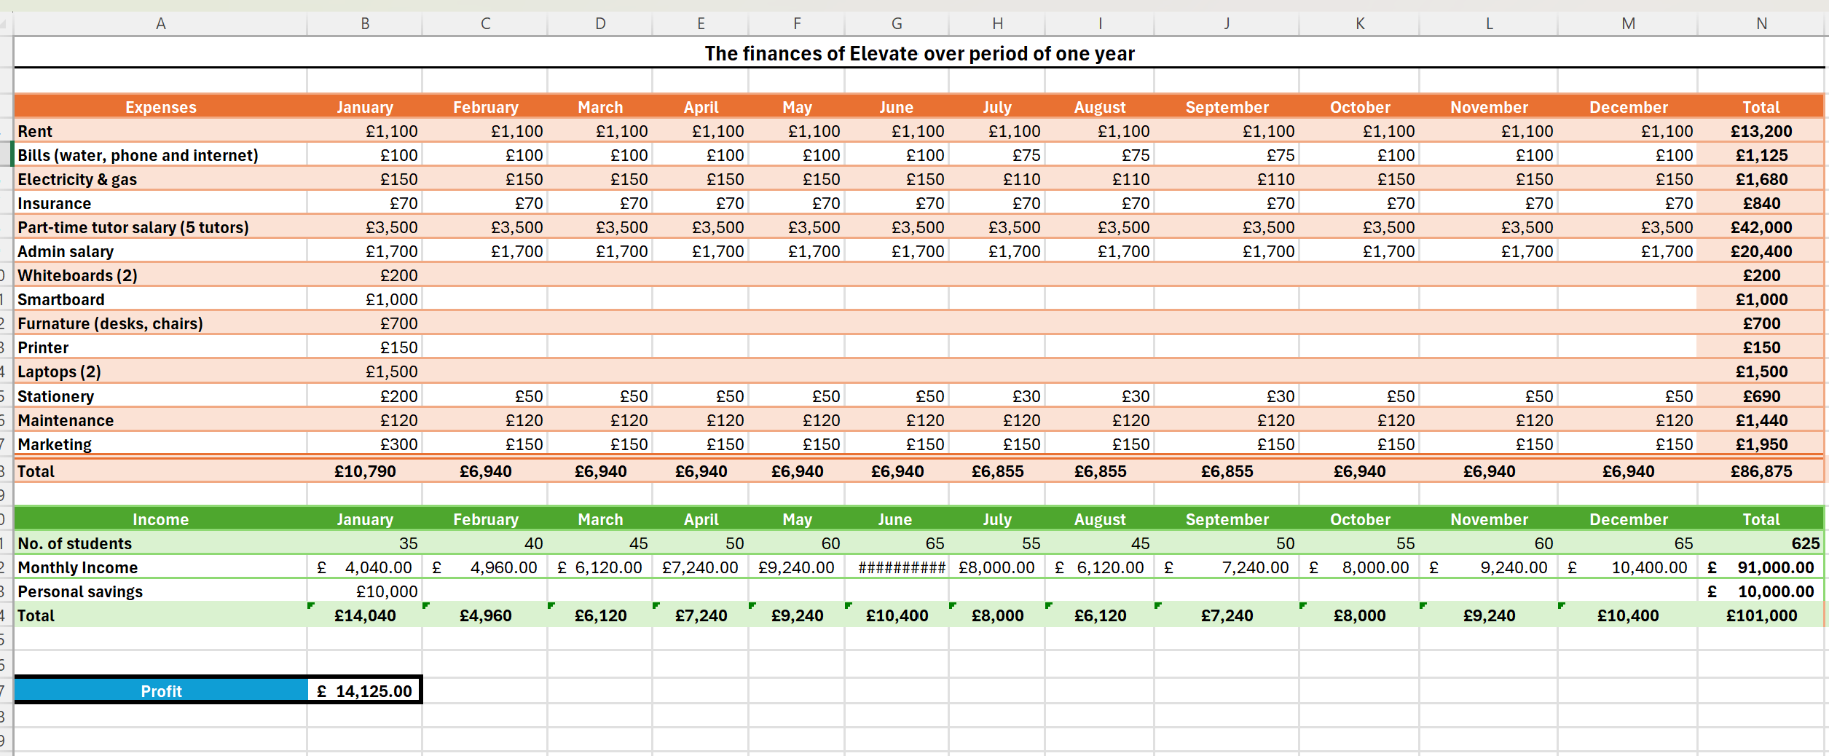
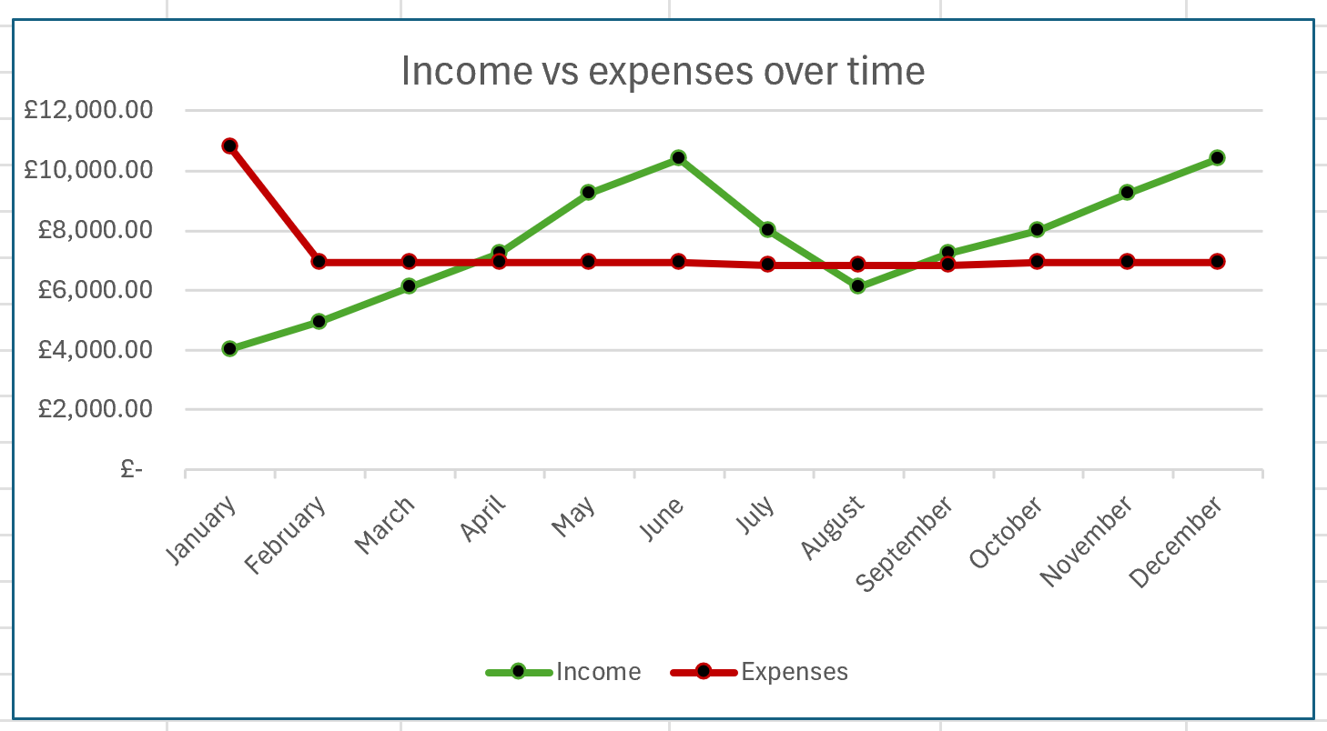

Reference list
Agnese (2025). Is Microsoft Excel Still Relevant in 2025? [online] Ajelix. Available at: https://ajelix.com/excel/microsoft-excel-still-relevant/#conclusion [Accessed 9 Jun. 2025].
Canva (2025). Canva: Visual Suite for Everyone. [online] Canva. Available at: https://www.canva.com/?msockid=2210f48da564633b1277e004a484624b [Accessed 5 Jun. 2025].
Charlesworth, L. (2024). What is Microsoft Excel used for and is it still relevant? [online] Kaplan.co.uk. Available at: https://kaplan.co.uk/blog/is-microsoft-excel-still-relevant [Accessed 7 Jun. 2025].
Chiangpradit, L. (2023). Are STEM Subjects Harder? | STEM Sports. [online] https://stemsports.com/. Available at: https://stemsports.com/are-stem-subjects-harder/ [Accessed 2 Jun. 2025].
Education Endowment Foundation (2021). Small Group Tuition. [online] EEF. Available at: https://educationendowmentfoundation.org.uk/education-evidence/teaching-learning-toolkit/small-group-tuition [Accessed 9 Jun. 2025].
Hollingsworth, S. (2024). 12 Reasons Why Your Business Absolutely Needs SEO. [online] Search Engine Journal. Available at: https://www.searchenginejournal.com/why-seo-is-important-for-business/248101/ [Accessed 9 Jun. 2025].
Levy, A. (2024). The Benefits of Tutoring: Why Personalized Learning Matters. [online] Epee-Education. Available at: https://epee-education.com/the-benefits-of-tutoring-why-personalized-learning-matters/ [Accessed 4 Jun. 2025].
Mali, D. and Lim, H. (2021). How do students perceive face-to-face/blended learning as a result of the Covid-19 pandemic? The International Journal of Management Education, 19(3). doi: https://doi.org/10.1016/j.ijme.2021.100552.
Modiraparambil, H. (2023). The Importance of Teacher Qualifications in Effective Education. [online] www.linkedin.com. Available at: https://www.linkedin.com/pulse/importance-teacher-qualifications-effective-education-modiraparambil [Accessed 9 Jun. 2025].
Nickow, A., Oreopoulos, P. and Quan, V. (2020). The Impressive Effects of Tutoring on PreK-12 Learning: A Systematic Review and Meta-Analysis of the Experimental Evidence. [online] doi: https://doi.org/10.26300/eh0c-pc52.
Nongo, C. and Nwachukwu, P. (2021). Application of Microsoft Excel in Managing Collection Development as Best Practice. In: Australian Academic & Research Libraries . [online] Available at: https://www.researchgate.net/profile/Celina-Nongo-3/publication/355022957_Application_of_Microsoft_Excel_in_Managing_Collection_Development_as_Best_Practice/links/615844674a82eb7cb5e43a6a/Application-of-Microsoft-Excel-in-Managing-Collection-Development-as-Best-Practice.pdf [Accessed 7 Jun. 2025].
Raymond, D. (2023). Top 10 Cons & Disadvantages of Using Microsoft Excel. [online] Articles for Project Managers - The Project Management Network. Available at: https://projectmanagers.net/top-10-cons-disadvantages-of-using-microsoft-excel/ [Accessed 16 Jun. 2025].
Rosvi .S (2025). In a world where technology is evolving rapidly, some tools have managed to stand the test of time. One such tool is Microsoft Excel—one of the oldest spreadsheet applications that continues to be an essential part of businesses, research, and data management. [online] Linkedin.com. Available at: https://www.linkedin.com/pulse/timeless-power-excel-why-still-reigns-digital-age-rosvi-s-xaghc [Accessed 7 Jun. 2025].
Shepherd, J. (2019). What is the Digital Era? Social and Economic Transformation in the Digital Era, pp.1–18. doi: https://doi.org/10.4018/978-1-59140-158-2.ch001.
Squarespace (2025). Squarespace. [online] Squarespace. Available at: https://www.squarespace.com/ [Accessed 6 Jun. 2025].
Storyset (2023). Storyset. [online] Storyset.com. Available at: https://storyset.com/illustration/teacher-student/cuate [Accessed 6 Jun. 2025].
Supan, D. (2023). Best Practices for Content Marketing in 2023 - DigitalMarketer. [online] DigitalMarketer. Available at: https://www.digitalmarketer.com/blog/content-marketing-2023/ [Accessed 4 Jun. 2025].
The Sutton Trust (2019). Private Tuition 2019. [online] Sutton Trust. Available at: https://www.suttontrust.com/our-research/private-tuition-polling-2019/ [Accessed 2 Jun. 2025].
Tittle, L. (2024). Using Tuition to Improve Grades. [online] gcsehelp.co.uk. Available at: https://www.gcsehelp.co.uk/tuition-and-tutoring-using-tuition-to-improve-grades [Accessed 3 Jun. 2025].
Tyrer, M. (2021). The Role of Microsoft Excel in Digital Transformation - Summit... [online] Summit Solutions Training. Available at: https://summitsolutionstraining.co.za/the-role-of-microsoft-excel-in-digital-transformation/ [Accessed 7 Jun. 2025].
Wonder (2021). Number of Google Sheets and Excel Users Worldwide. [online] Wonder. Available at: https://askwonder.com/research/number-google-sheets-users-worldwide-eoskdoxav [Accessed 7 Jun. 2025].

