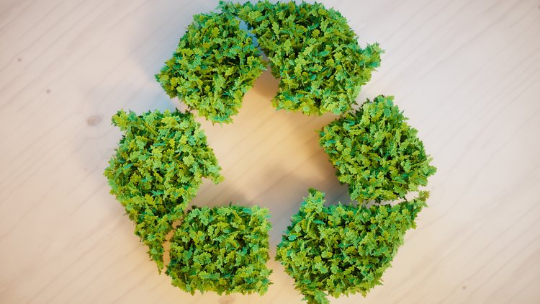

Sustainable Development in the Hospitality Industry

M6X01931_LON
Lecturer Dale Clarke

Erol Asan
1814997
1814997@student.uwtsd.ac.uk

July 2020

Table of contents

Table of Contents…………………………………………………...1
Introduction……………………………………………………….....2
Sustainable Development…......…………………………….……2
Marriott and Sustainable Development………….....…………..3
Requirements for Future Growth…………………….……….....4
Primary Research……………………………….…………....….....5
Major Trends and Issues for Modern Hotels………………......6
Environmental Issues……………………………………………...7
Recommendations…………………………………………......…..8
Conclusion……………………………………………………….…..9
Bibliography…………………………………………………...……10

Introduction

The modern world sees a constant increase in requirements, ranging from technological, to social and political they all are necessities for economic growth. With constant demand for resources, there has been a demonstrated need to reduce consumption of resources and be more sustainable.(Sloan, 2013) states that an understanding of pollutants and its factors is essential for any manager as sustainable practices derived from combating diminished resource levels is better for an organisations future.(Brundtland, 1987) also states that the social, environmental and financial aspects must be balanced and that that is what sustainable development is.

Sustainable Development

In 1987, The World Commision on Environment and Development (WCED, the Brundtland Commision) defined the term ‘’Sustainable Development’’ as ‘’The ability to meet the needs of the present without compromising the ability of future generations to meet their own needs.’’ (WCED, 1987) or simply put creating a business atmosphere where the future needs are protected in the present. (LeBlanc, 2012). Later on UNCED in Rio de Janeiro, 1992 a set of sustainable development goals were set that became the first tools to be used in a new era of sustainable project development, governed by 27 principles that placed humanity above profits. These high level movements lead to even more demonstrations on how mankind can unite against one of the day's biggest problems and face it for a better future.

Marriott and Sustainable Development

According to (Marriott.com, 2020) their approach to their continuous growth exhibited in the recent years, as well as their approach for the present and future is that their obligation is to operate responsibly while they increase their global presence. To that point, from planning stage to finished hotel, sustainability is embedded in their business model.They work together with builders, engineers to create spaces that are friendlier to the environment,and once in place the next step is to find ways with suppliers, vendors, and other business partners to create for the guests that walk through their doors the best blend of hospitality with environmental awareness.
According to the GM of the London Heathrow Marriott ‘’Get a good team together and listen to everyone’s ideas. Don’t be afraid to be imaginative and creative, but above all have fun!’’ (Voss, 2019). The ideas don't just come from the management team or from the corporate head offices, all employees are heard and even when it comes to developmental ideas now voice is left unheard because of the high level of professionalism found inside the organisation.
When it comes to suppliers for Marriott properties around the world, the thinking is to find other businesses that are like-minded when it comes to leading environmental and social practices. Materials and supplies are obtained from local sources, local growers offer fresh produce and animal products ensuring the best foods are served in restaurants with ingredients obtained from eco-friendly farms.
Carbon footprints are kept low by utilizing the newest technologies available, the initial costs may be high but the overall results make Marriott a more attractive venue for people like-minded and socially responsible. Air conditioning units, specialized glazing on windows, recycling techniques as well as water saving products are incorporated from the initial planning stages and there is always room for improvement as shown in 2014 when London Heathrow Marriott went through a general refurbishment that saw changes being put in place besides the aesthetic level, all the way to an overhaul of electric and plumbing to fit the newer guidelines in electrical safety and water management brought by environmental demands in legislature.
In 2018, the Marriott group had managed to get 36% of their properties to a recognized sustainability standard, and 225 properties had a LEED (or equivalent) certification meeting sustainability standards for the hotel industry. Another success was the 185 open adaptive reuse hotels. (Marriott.com, 2018). This high standard of sustainability reflects the importance this hotel group places on sustainable development.
The goals of this organisation are that by the year 2025, all their properties (100%) will reach a sustainability standard with the hope of achieving a LEED certification with active use and consumption rates available online for all to see to demonstrate the positive impact on local sites.

Requirements for Future Growth

(Deloitte, 2014) argues that with the ever-growing population, the Hospitality Industry will face a major need to face sustainability as an issue because of the diminishing resources. Combating pollution will be an important subject and reduction will be a key point that can only be obtained with sustainable business practises.
A financial investment in the beginning of of a project is not enough to be classified as sustainable development, LHM (London Heathrow Marriott) is constantly updating its structure as well as its training both the employees as well as the guest that cross its doorstep, bringing to the spotlight the main issue of our generation, and trying to generate profits and also lower as much as possible its impact on its surrounding environment. For future growth however, it must also invest in newer technologies as well when it comes to SD as each year marks new breakthroughs in the field and being up to date is paramount in further reduction of CO2 levels it is responsible for.
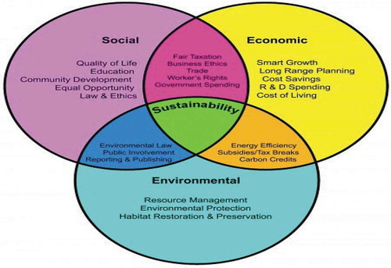

Primary Research

While conducting research for this rapport, the following items were revealed:
According to Front Office Manager of the London Heathrow Marriott, James Lane, the majority of the guests checking in the hotel have business relating stays, with only 23% on average are on holiday, for this hotel situated right next to the busiest airport in the U.K. this is normal, individual guests rarely choose this property on eco-friendly rating alone but the majority are said to admire the implementation of green business practices. In house service reports compiled by guests show that one of the most desired improvements is for the hotel to continue ‘’Green Hotel Improvements’’ 43%. Another aspect that reveals the tendency for the upcoming period is the fact that in the restaurant ‘’Organic’’ food is requested by a growing number of patrons. 33% for 2019 from 18% in 2014.
A major department in any hotel is the Housekeeping Department, this sees constant change as new cleaning supplies are adopted and outside vendors are changed so as to meet the new organisational standards. Drycleaning for this particular hotel is done by an outside company, chosen because of its low environmental impact reports and adapted technologies that reduce within their processes the amount of generated pollution.
A significant improvement on carbon emissions was obtained after the refurbishment of the property in 2014. The reduction was seen with a 12% decrease in energy usage and a 11% reduction in water usage. Another aspect that aided the hotel in recent years was the overhaul of the waste management procedures, and total implementation of recycling methods throughout the property. That led to a reduction in waste material and also positively impacted guests that have appreciated the implementation.
All figures and comments were found in the (London Heathrow Marriott Hotel yearly report, 2018)*

Major Trends and Issues for Modern Hotels

According to (Manaktola and Jauhan, 2007), research shows that people would stay at a hotel that has implemented green practices but they would not pay extra for this fact as it is widely seen as a modern fact of life, and as such is not a luxury. These extra costs in operations are incorporated in general in the rates used by hotels but are not as great as expected. The implementation of measures like water use limitations, and lights that are activated by motion sensors, specialized windows that block out solar heat to thus reduce air conditioning costs save the hotel money overtime so costs are amortized.
There are situations though where integration of green techniques are difficult and issues are observed:
- The lack of a local infrastructure when it comes to waste management especially for recycling.
- Low numbers of local farms that meet the required standards for environmentally safe businesses means that in some cases produce has to be delivered from outside the area.
- No support from local governments in regard to creating programs that reward bio-safe practises and possibly the lack of interest from local businesses to incorporate newer standards.
- Another aspect is the lack of electric car charging stations in a particular area, this aspect does not help the local people want to choose the newer environmentally safe vehicles that would reduce the levels of pollution.

Environmental Issues

There are 3 areas in which a hotel has a negative impact on its local environment. Energy, Waste and Water.
Energy wise, according to (Gossling, 2005), per night, per stay in a hotel the average consumption of energy is 130 MegaJouls, because hotels operate other facilities and occupy a large area that requires heating, electrical power and ventilation systems working continuously. Because of that, per night, a hotel can generate a calculated 20 Kg of CO2.
When it comes to waste, each guest at a hotel generates in average 1 Kg trash per day, accumulated from restaurant food remains, plastics used, drink cans and paper.(Bohdanowicz, 2005)
It is estimated that 15000 cubic meters of water is used per 100 guest nights for a hotel to operate facilities like swimming pools, grounds watering, and maintenance of golf courses, a similar amount would be used by farmers over 3 years.(Holden, 2000)

Recommendations

The most beneficial thing is for the hotel industry to try and adopt as many sustainable practices as possible. Their implementation would reduce a large percentage of pollution solely associated with the Hospitality Industry. It was observed that 25-30% of all waste is associated directly or indirectly to the tourism industry, and the implementation of recycling processes over the years has reduced that amount by half (Bohdanowicz, 2005).
Implementation of any eco-friendly practise in a hotel is a beneficial act, helping stabilyze the environment ,reduce waste, and improve air, water, soil quality is a long-term plus. If such measures are not put in place soon, tourism hotspots will be gravely affected, as in Paris, Tokyo, Rome. In these cities , famous for being points of interest for millions on holiday have seen a surge in pollution over the past decade. News reports can be found explaining how waste quantities have grown in Paris, air quality has gone down in Tokyo and because of increased traffic in Rome, pollution levels are at an all time high. This can also be seen in London, with 5 major airports in close vicinity 30 million people decide to experience its sights yearly. (Gov.uk, 2020).
Implementation of green practices produces financial benefits, as in the long run the costs are significantly lower in operating a green facility as it uses less resources.
- Using local produce reduces transportation pollution associated with the gasses produced by vehicles that transport food across long distances to a hotel.
- The reuse of linens is not limited to a short use life, and change in washing chemicals.
- Building insulation brings down heating/ cooling cost.
- Keeping the building up to code, as governmental regulations , now, are put in place for sustainable business practices.
- Implementing a long term goal list for the property would help, targeting aspects in operational sustainability could produce results.
- Creating a position within the company whose role would be training employees for a more eco approach to avoid waste, also to keep track of modifications in legislation and technology.

Conclusion

In today's market many managerial issues exist that create impediments for people that must make decisions, sustainable practices however should be the first ones approached by any organisation within the Hospitality Sector, because of the large levels of traffic, many supporting branches and secondary businesses it is the largest sector after industry that generates the largest emissions and contributes the most to global warming. By size, placement, volume, level of access all businesses must adopt sustainable practices to ensure a better future.
The focus for the future for a hotel like the London Heathrow Marriott is to try to bring to the table the same requirements that all top tier hotels must have. The biggest trend is sustainable development and it has grown in the last years to become the largest point of focus for investment. With upgrades in sectors that do not meet the standard there can be achieved large profits overtime and investments in the sector will bring in future great observable benefits to local communities and maybe even help sustain international landmarks for other generations to visit.

Bibliography

Bohdanowicz, P., 2005. Sustainable Energy Utilisation. Stockholm: Royal Institute of Technology, Department of Energy Technology.

Brundtland, G.H., Khalid, M., Agnelli, S. and Al-Athel, S., 1987. Our common future.New York.

Cooper, C. and Hall, M., 2010. Contemporary Tourism: An International Approach. Oxford: Goodfellows.

Conrady, R. and Buck, M., 2011. Trends And Issues In Global Tourism 2007. Berlin: Springer.

Deloitte (2014), “Hospitality 2015: game changers or spectators”, available at:www.deloitte.com/assets/Dcom-UnitedKingdom/Local%20Assets/Documents/Industries/THL/uk_thl_Hospitality2015v2.pdf (accessed 3 July 2020).

Gil-Saura, I. and Ruiz, M.E. (2011), “Tools for improving environmental sustainability in the hospitality industry”,CAB Reviews: Perspectives in Agriculture, Veterinary Science,Nutrition and Natural Resources, Vol. 6 No. 13, pp. 1-6.

Gossling, S., Peeter, P. and Scott, D. Consequences of climate policy for international tourist arrivals in developing countries. Third World Quarterly, 29(5), 875-900.

Gov.uk, 2020. Activities In Britain’s Nations And Regions. London: Visit Britain.

Grober, U. and Cunningham, R. (trans) (2012),Sustainability: A Cultural History, Green Books,Cambridge.

Holden, C., 2000. Nutrition And Child Health. London: Baillière Tindall.

Lane, J. (2019). Departmental Overview Discussions
Le Blanc, D.. Development cooperation in the light of sustainable development and the SDGs: Preliminary exploration of the issues, UNDESA: Rio
Marriott (2012), “2011-2012 sustainability report”, available at:www.marriott.com/Multimedia/PDF/CorporateResponsibility/MarriottSustainabilityReport_2011and2012condensed4MB.pdf (accessed 11 July 2020).

Marriott International, 2018. London Heathrow Marriott Yearly Raport 2018. London Heathrow Marriott Yearly report. London.

Manaktola, K. and Jauhan, V. (2007), “Exploring consumer attitudes and behaviour towards green practices in the lodgings industry in India”,International Journal of ContemporaryHospitality Management, Vol. 19 No. 5, pp. 365-377.

O'Neill, S., McLeish, E. and Tuppen, H. (2019). London Heathrow Marriott: forward facing innovation | Green Hotelier. [online] Greenhotelier.org. Available at: https://www.greenhotelier.org/destinations/europe/london-heathrow-marriott-forward-facing-innovation/?fbclid=IwAR12Hc07RrkI7TGxNo0XiHNXkAIevSXbVpCnXtaW7cjT7x2gWTSbB4lXBQM [Accessed 6 July. 2020].
Patel, S. (2019). The Big Interview: Hotel General Managers Paul Davies And Ron Vos. [online] Meadin.com. Available at: https://www.meadin.com/70432.html?fbclid=IwAR0YwKYLUcDBNzTTZCoRQsXaW2d8djuYidpVRlUrYLyzom0JbyjkfbHTRT4 [Accessed 6 July. 2020].
Robson, C., 2011. Real World Research. Oxford: Wiley.
Sloan, P., Legrand, W. and Chen, I.J. (2013),Sustainability in the Hospitality Industry: Principles ofSustainable Operations, Routledge, London.

