

LOCATION: Swansea | LLEOLIAD: abertawe
LEVEL 4 | LEFEL 4
EXAMINATION PERIOD | CYFNOD ARHOLIADAU
July 2022 | Gorffennaf 2022

MODULE CODE: ACDA4006
Electrical & Electronic Principles

TIME: 2 HOURS
answer all questions

Equipment or materials required – Calculator, Formulae Sheet
Adnoddau neu ddefnyddiau sydd eu hangen – Cyfrifiannell, Taflen Fformiwla

6 Questions
Total marks available = 60

ANSWER ALL QUESTIONS

- A 12 V battery has an internal resistance of 3Ω,
  - Calculate the power dissipated by various load resistances and complete the table below.

Load resistance (Ω) | Load power (W)
1 | 9
2 | 11.52
3 | 12
4 | 11.755
5 | 11.25
[10 Marks]

  - Plot a graph of the load power against load resistance
[6 Marks]
Graph showing data from table above. Marks for: Axis labels, Units, Scale, Headings, Axis right way round, Data plotted as per table

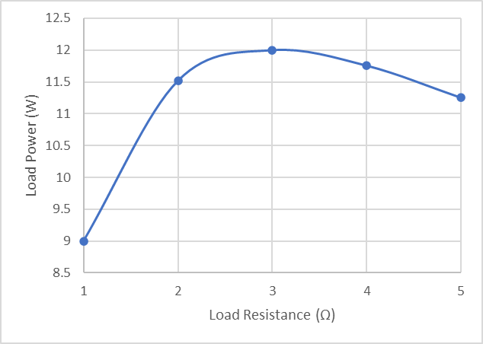

- For the circuit shown in Fig Q2, given R1=1kΩ, R2=470Ω, R3=1.5kΩ, R4=330Ω, R5=560Ω, R6=2.7kΩ, and the battery has a voltage of 9V. Calculate:
  - Total circuit resistance
[4 Marks]
$$R_{T}=1000+\frac{800×1500}{800+1500}+560+2700=4781.74 Ω$$
  - Circuit current
[2 Marks]
$$I=\frac{V}{R}=\frac{9}{4781.74}=1.882 mA$$
  - Total power supplied by the battery
[2 Marks]
$$P=IV=1.882×{10}^{-3}×9=16.938 mW$$
  - Current flowing through R4
[2 Marks]
$$I=1.882×{10}^{-3}×\frac{1500}{800+1500}=1.227 mA$$
  - Power dissipated by R3
[4 Marks]
$$I_{R3}=1.882×{10}^{-3}-1.227×{10}^{-3}=0.655 mA$$
$$P=I^{2}R={(0.655×{10}^{-3})}^{2}×1500=643.538 µW$$
  - R3 is replaced by a 10Ω resistor. What is the new circuit current?
[4 Marks]
$$R_{T}=1000+\frac{800×10}{800+10}+560+2700=4269.877 Ω$$
$$I=\frac{V}{R}=\frac{9}{4269.877}=2.108 mA$$
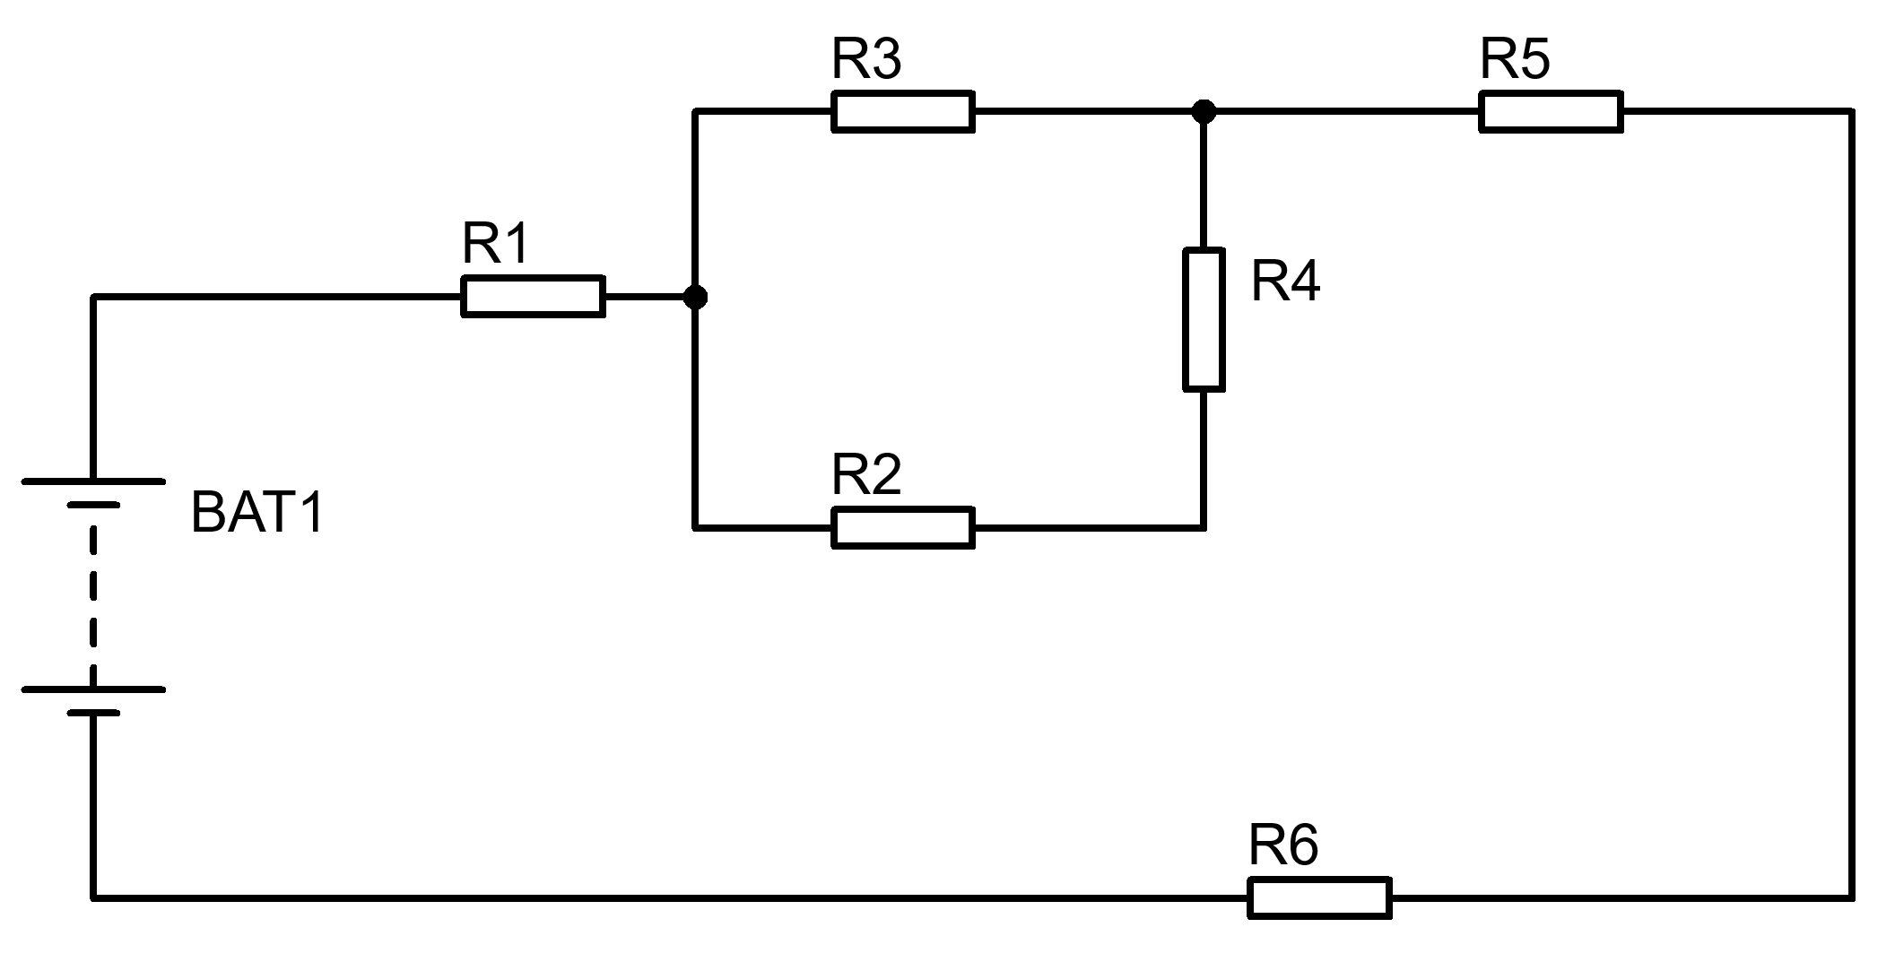
Fig Q2

- For the symmetrical sinusoid shown in Fig Q3 below:
  - Determine its period τ
[1 Mark]
$$τ=\frac{1}{f}=\frac{1}{10000}=100 µs$$
  - Determine its peak-peak voltage.
[1 Mark]
$$V_{pk-pk}=V_{pk}×2=50×2=100 V$$
  - Determine the RMS value of the waveform.
[2 marks]
$$V_{RMS}=V_{pk}×0.707=50×0.707=35.35 V$$
  - Sketch the diagram immediately below and indicate on it any two points between which the PERIOD (T) could be measured
[1 Mark]
Accept any two identical points on consecutive cycles

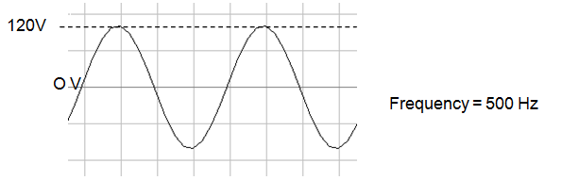
10kHz
50V
Fig Q3

- For the circuit shown in fig Q4, given the resistor is 50Ω, the inductor is 10mH, and the capacitor is 1µF, and the supply is 15V RMS at a frequency of 1500Hz.

Determine the following:

  - Total Impedance
[2 Marks]
$$X_{C}=\frac{1}{2πfC}$$
$$X_{C}=\frac{1}{2×π×1500×1µ}=106.103 Ω$$

$$X_{L}=2πfL$$
$$X_{L}=2×π×1500×0.01=94.248 Ω$$

$$\left|Z\right|=\sqrt{R^{2}+{\left(X_{L}-X_{C}\right)}^{2}}$$

$$\left|Z\right|=\sqrt{{50}^{2}+{\left(94.248-106.103\right)}^{2}}=51.386 Ω$$

  - Total current supplied to the circuit
[2 Marks]
$$I=\frac{V}{Z}=\frac{15}{51.386}=291.908 mA$$
  - Phase difference between the supply voltage and current
[2 Marks]
$$φ=\tan^{-1}{ \frac{X_{T}}{R}}$$
$$φ=\tan^{-1}{ \frac{94.248-106.103}{50}}=-13.339 °$$
  - Voltage across the resistor.
[2 Marks]
$$V=I×R=0.291908×50=14.595 V$$
  - Voltage across the capacitor
[2 Marks]
$$V=I×X_{C}=0.291908×106.103=30.972 V$$
  - Voltage across the inductor
[2 Marks]
$$V=I×X_{L}=0.291908×94.248=27.516 V$$
  - The resonant frequency
[2 Marks]
$$f_{res}=\frac{1}{2π\sqrt{LC}}=\frac{1}{2π\sqrt{0.01×1µ}}=1591.549 Hz$$
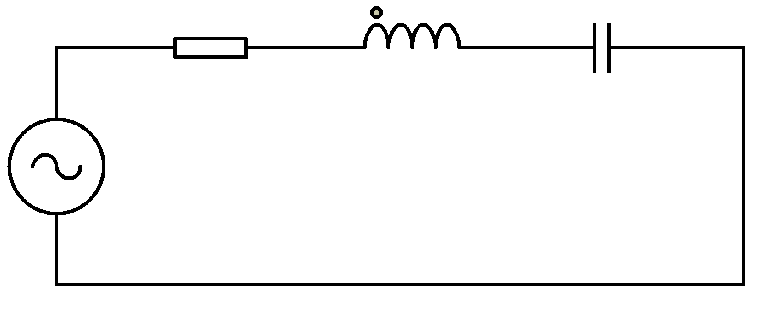
Fig Q4

  - State Kirchhoff’s voltage law
[2 Marks]
The sum of voltages around a closed loop are equal to zero.
  - State Kirchhoff’s current law
[2 Marks]
The sum of currents around a circuit node is equal to zero.

  - Show how 4 diodes can be connected in a circuit to create a DC voltage source from an AC voltage source.
[2 Marks]

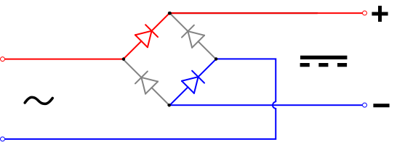
  - What component can be added to this circuit to smooth the DC output voltage?
[1 Mark]

A capacitor can be added to the output of the circuit to smooth the ripple from the DC voltage.
Diwedd/End

Formulae Sheet
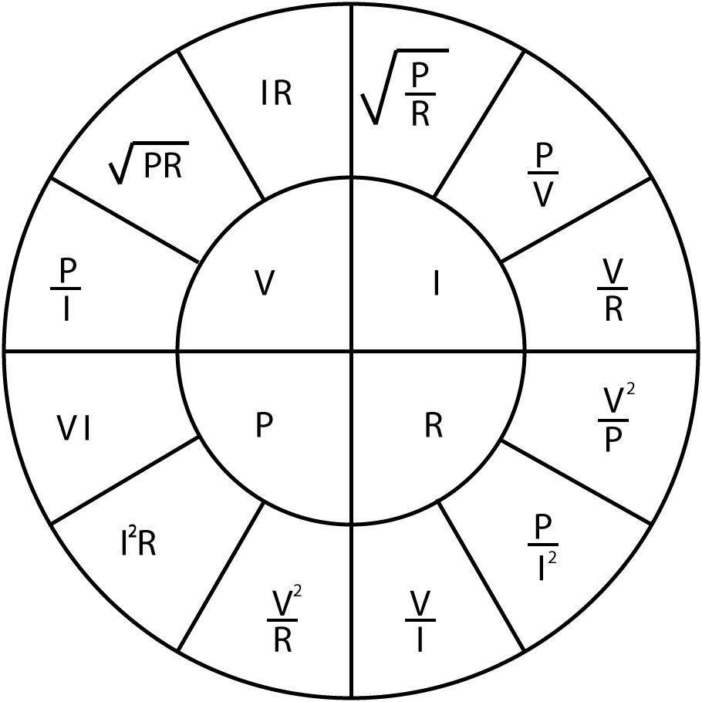 |  | $$R_{T}=R_{1}+R_{2}+…+R_{n}$$  $$\frac{1}{R_{T}}=\frac{1}{R_{1}}+\frac{1}{R_{2}}+…+\frac{1}{R_{n}}$$  $$\frac{1}{C_{T}}=\frac{1}{C_{1}}+\frac{1}{C_{2}}+…+\frac{1}{C_{n}}$$  $$C_{T}=C_{1}+C_{2}+…+C_{n}$$  $$L_{T}=L_{1}+L_{2}+…+L_{n}$$  $$\frac{1}{L_{T}}=\frac{1}{L_{1}}+\frac{1}{L_{2}}+…+\frac{1}{L_{n}}$$ | $$V_{Out}=V_{in}\frac{R_{B}}{R_{A}+R_{B}}$$  $$I=I_{in}\frac{R_{B}}{R_{A}+R_{B}}$$
$$X_{C}=\frac{1}{2πfC}$$
$$X_{C}=-j\frac{1}{ωC}$$

$$X_{L}=2πfL$$
$$X_{L}=jωL$$

$$Z=R+j\left(X_{L}-X_{C}\right)$$  $$\left|Z\right|=\sqrt{R^{2}+{\left(X_{L}-X_{C}\right)}^{2}}$$ | $$ω=2πf$$  $$X_{T}=X_{L}-X_{C}$$ | $$φ=\tan^{-1}{\frac{X_{T}}{R}}$$  $$pf=\cos{φ}$$ | $$f_{res}=\frac{1}{2π\sqrt{LC}}$$
$$V_{C}=V_{s}\left(1-e^{{-t}/τ}\right)$$  $$I_{C}=\frac{V}{R}\left(e^{{-t}/{RC}}\right)$$  $$V_{C}=V_{0}\left(e^{{-t}/τ}\right)$$  $$I_{C}=-\frac{V}{R}\left(e^{{-t}/{RC}}\right)$$  $$τ=RC$$ | $$τ=\frac{L}{R}$$  $$V_{L}=V\left(e^{{-Rt}/L}\right)$$  $$V_{L}=-V\left(e^{{-Rt}/L}\right)$$  $$I_{L}=\frac{V}{R}\left(1-e^{{-Rt}/L}\right)$$  $$I_{L}=\frac{V}{R}\left(e^{{-Rt}/L}\right)$$ | $$f=\frac{1}{2πRC}$$  $$A_{V}=20\log{\frac{V_{out}}{V_{in}}}$$  $$A_{P}=10\log{\frac{P_{out}}{P_{in}}}$$ | $$Q=\frac{X_{L}}{R}$$  $$Q=\frac{X_{C}}{R}$$  $$Q=\frac{f_{R}}{f_{U}-f_{L}}$$  $$Q=\frac{1}{R}\sqrt{\frac{L}{C}}$$
$$E=\frac{1}{2}CV^{2}$$
$$E=\frac{1}{2}LI^{2}$$
$$V_{B} \text{=}\frac{\text{RB2}}{\text{(}\text{RB}\text{1 + }\text{RB}\text{2)}}\text{×} V_{CC}$$  $$V_{E}=V_{B}-0.7$$  $$I_{C}=I_{E}$$  $$V_{C}=V_{CC}-\left(I_{C}×R_{C}\right)$$  $$Av=\frac{v_{c}}{v_{b}}$$  $$V_{E}=10\%V_{CC}$$  $$R_{IN}=\frac{1}{\frac{1}{{RB}_{1}}+\frac{1}{{RB}_{2}}+\frac{1}{\left(h_{FE}×R_{E}\right)}}$$  $$R_{OUT}=R_{C}$$  $$A_{V}≈-\frac{R_{C}}{R_{E}}$$ |  | $$V_{out}=-\frac{R2}{R1}×V_{in}$$  $$V_{out}=\left[1+\frac{R2}{R1}\right]×V_{in}$$  $$V_{out}=\frac{R2}{R1}×\left[V_{2}-V_{1}\right]$$  $$V_{out}=-\frac{R2}{R1}×\left[V_{1}+V_{2}\right]$$  $$V_{out}=-\left[\frac{R}{R1}×V_{1}+\frac{R}{R2}×V_{2}+…+\frac{R}{Rn}×V_{n}\right]$$

Detach this page and place in answer book

Student Number …………………………. Question Number ……………………….



