Assignment 2
Learning in the Digital Era
UNIVERSITY OF WALES TRINITY SAINT DAVID
LONDON CAMPUS
Video Link: https://youtu.be/bNhVDszGik0
Please be sure to give unrestricted access to your video presentation so that your work can be marked by the examiner.
Module Name: Learning in the Digital Era
Module Code: ACCA 4025

Student Name: Alison Sherman Vas
Student ID: 2513127
Group:1

Lecturer’s Name: Koushik Modak

Table of Contents
Introduction 2
Main Body 2
GIBB’s REFLECTIVE MODEL 4
Brief explanation: 5
TASK 1: SELF EVALUATION 5
Brief explanation: 6
TRAITS GAINED FROM THE SELF EVALUATION 6
Brief explanation: 7
Task 2: PROFESSIONAL DEVELOPMENT PLAN 8
Brief explanation: 9
TASK 3: UNIT 4 TOPIC SUMMARY 10
TOPIC 1-LEARNING TO LEARN 10
Brief explanation: 11
CONCLUSION 12
Brief explanation: 13
REFERENCES 14
Task 1 15
Task 3 15
Video link 17

Introduction
I am Alison Vas, and I'm studying at UWTSD. I'm performing a presentation on self–evolution, Professional Development Plan and assigned an overview of the course's topics for my module –learning in the digital era assignment 2.

Main Body
Today I will focus on self-evaluation and self-discovery throughout my presentation. Using the development plan that I learned from my studies at UWTSD and to apply in my workplace and daily life. Experience gain through this Moodle will be explain in detail step by step
Video Link:

Slide 1 COVER PAGE
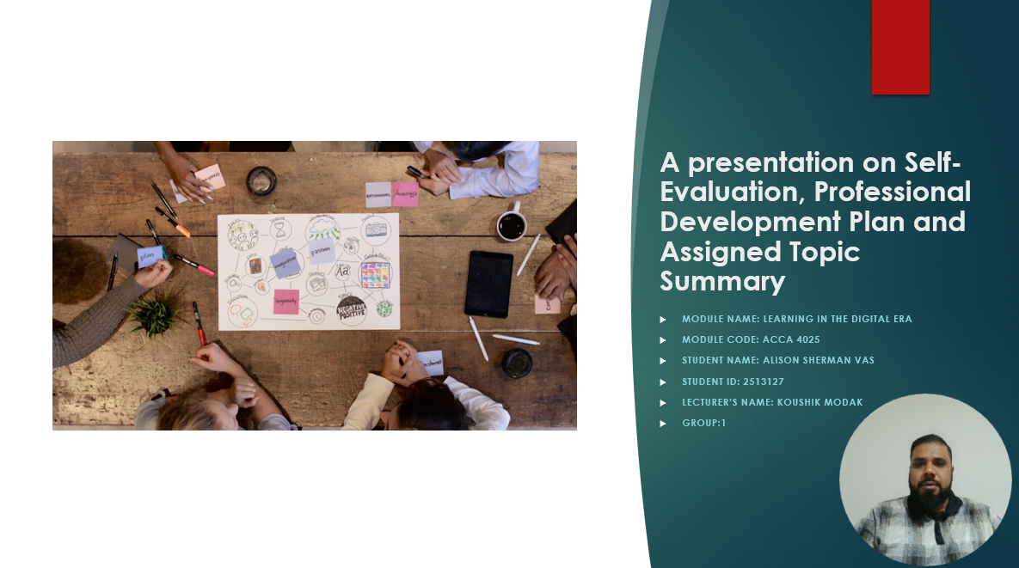

Slide 2 CONTENTS

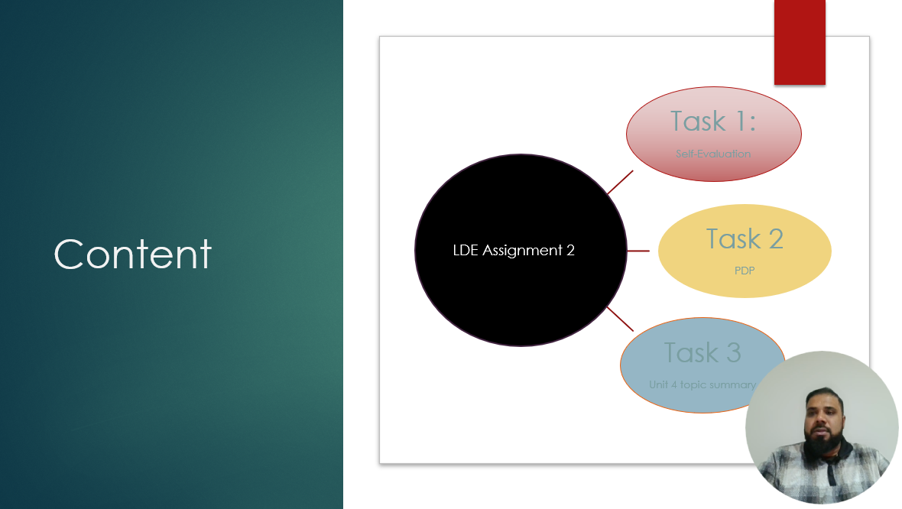
Slide 3 INTRODUCTION


Slide 4 MAIN BODY
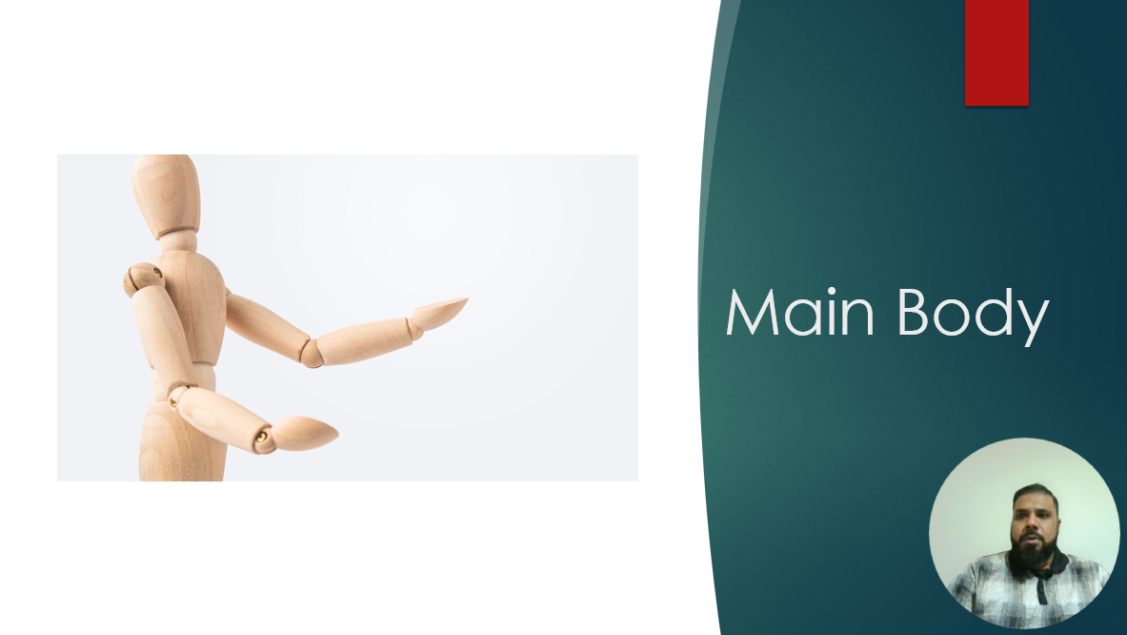

GIBB’s REFLECTIVE MODEL
Slide 5 GIBB’s REFLECTIVE MODEL
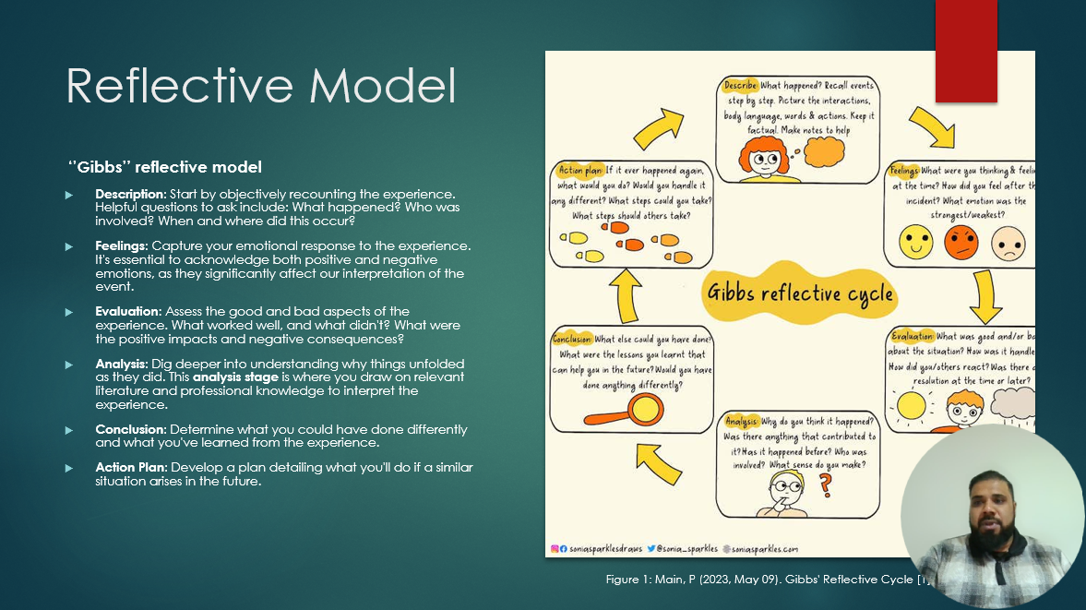

Brief explanation:
A popular framework for organized reflection that aids people in methodically learning from events is Gibbs' Reflective Cycle [1]. Description, Feelings, Evaluation, Analysis, Conclusion, and Action Plan are the six phases of the model. The reflective process is guided by each step, which begins with an objective account of an event, examines emotional reactions, assesses both positive and bad aspects, analyses the causes of results, draws conclusions, and plans future activities [2]. This methodical approach promotes ongoing professional and personal development as well as better knowledge.
I intend to use Gibbs' Model in Assignment 2 by outlining the task I completed, thinking back on my emotional reactions, assessing what worked and what didn't, analysing the causes of these results, coming to conclusions about my learning, and ultimately creating an action plan to sharpen my abilities for upcoming assignments. By ensuring systematic reflection, this approach improves performance and learning.

TASK 1: SELF EVALUATION
Slide 6 TASK 1: SELF EVALUATION
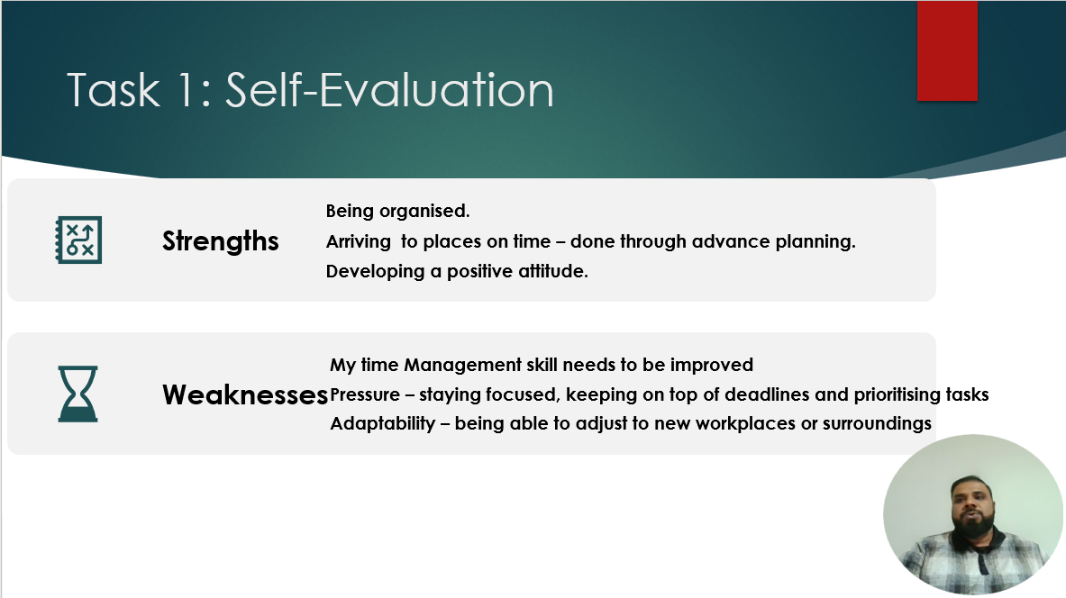

Brief explanation:
One of my main advantages, according to my personal SWOT analysis, is my excellent organizational skills. I routinely meet deadlines and support productivity because I organize my duties ahead of time, efficiently manage my schedule, and make sure I arrive on time. In addition to helping me with my individual work, this organization promotes team productivity and efficient workflow. However, time management is one of my weaknesses. Even though I am well-organized, I occasionally underestimate how long particular chores would take, which can put strain on me when several deadlines fall on the same day. I am actively trying to address this by using tools like planners and reminders to increase my efficiency, setting realistic deadlines, and prioritizing jobs more effectively. I see this as a field that is still being developed, and I am determined to eventually transform it into a strength.

TRAITS GAINED FROM THE SELF EVALUATION
Slide 7 TRAITS GAINED FROM THE SELF EVALUATION
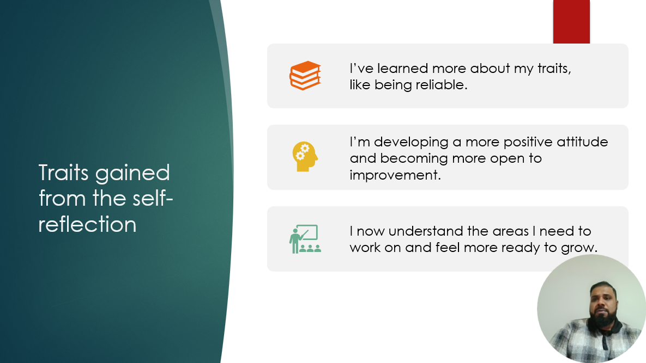
Slide 8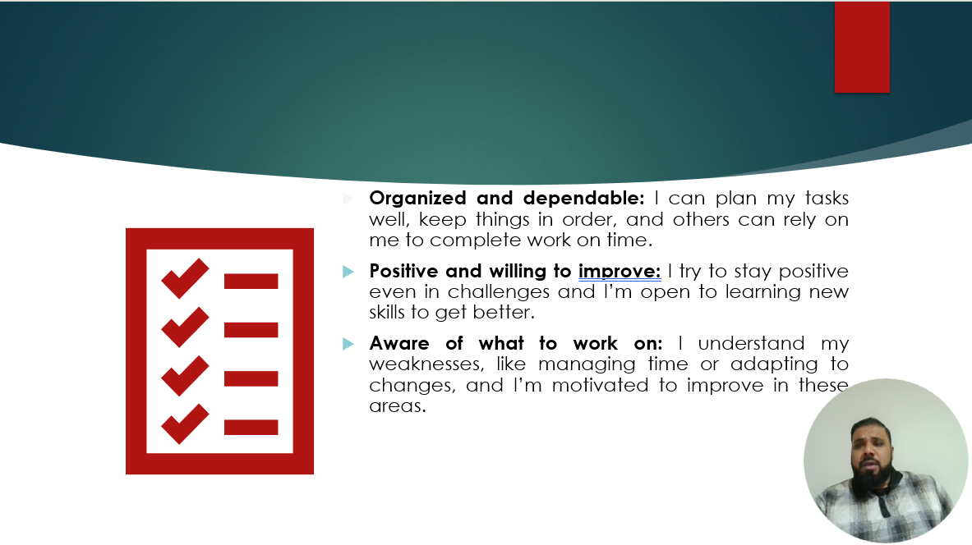

Brief explanation:
Organized and dependable: I can plan my tasks well, keep things in order, and others can rely on me to complete work on time.
Positive and willing to improve: I try to stay positive even in challenges and I am open to learning new skills to get better.
Aware of what to work on: I understand my weaknesses, like managing time or adapting to changes, and I am motivated to improve in these areas.

Task 2: PROFESSIONAL DEVELOPMENT PLAN
Slide 9 PROFESSIONAL DEVELOPMENT PLAN
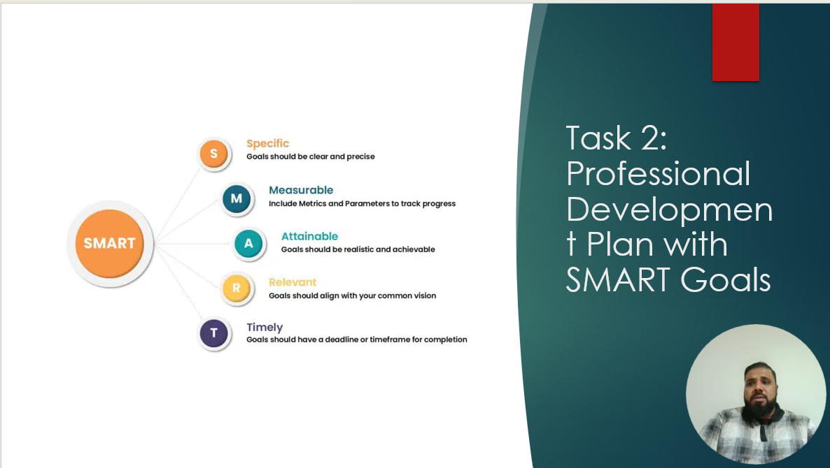

Slide 10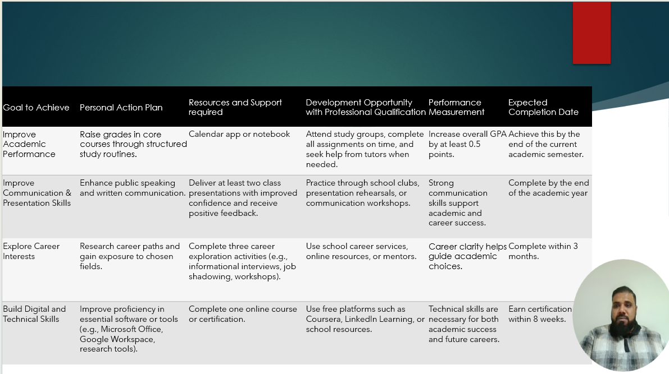

Brief explanation:
The above plan outlines four primary goals to enhance abilities and advance. The goals are to improve academic performance, develop technical skills, learn about various occupations, and enhance communication and presentation. There are specific steps to follow for each aim, such as taking online classes, researching jobs, delivering presentations, and studying on a regular basis. The plan also outlines the resources and help needed, including career services, workshops, and applications. It describes ways to measure success, such as via getting comments or improving grades. Lastly, each goal includes a deadline to help you remain on course and make progress on schedule.

TASK 3: UNIT 4 TOPIC SUMMARY
Slide 11 UNIT 4 TOPIC SUMMARY
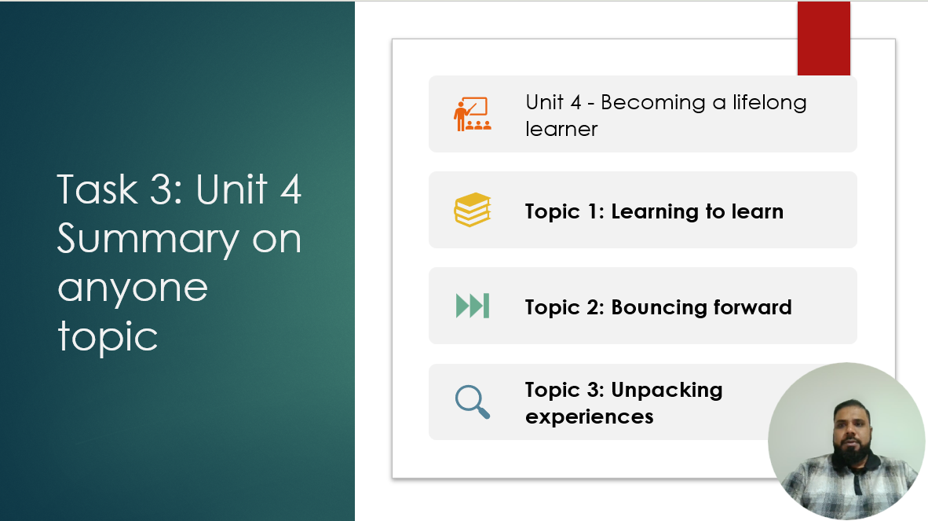
Slide 12
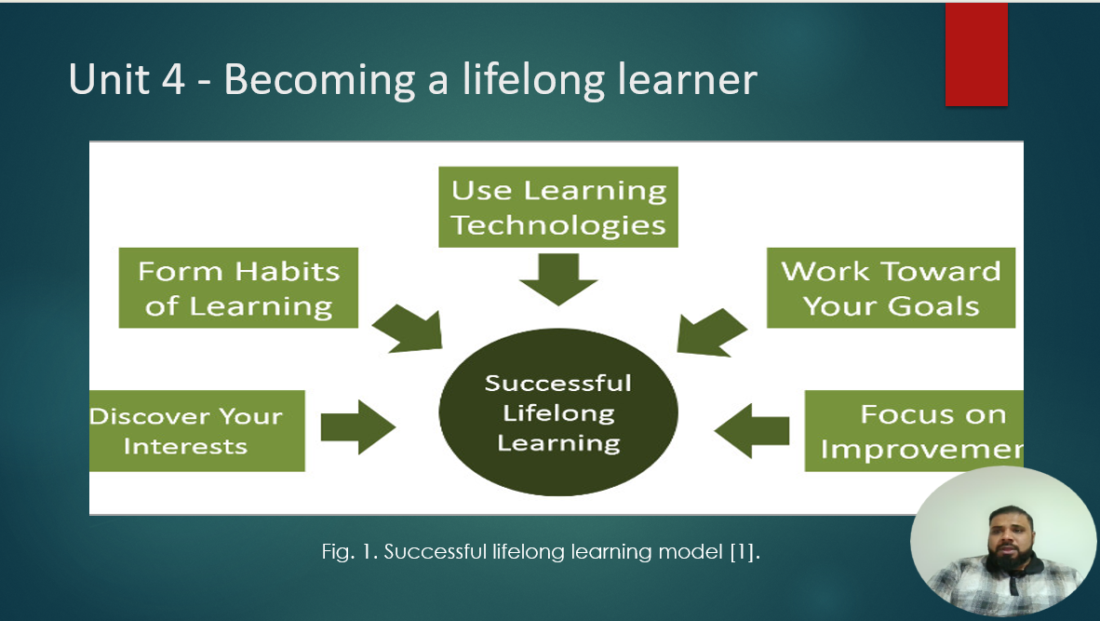

TOPIC 1-LEARNING TO LEARN
Slide 13
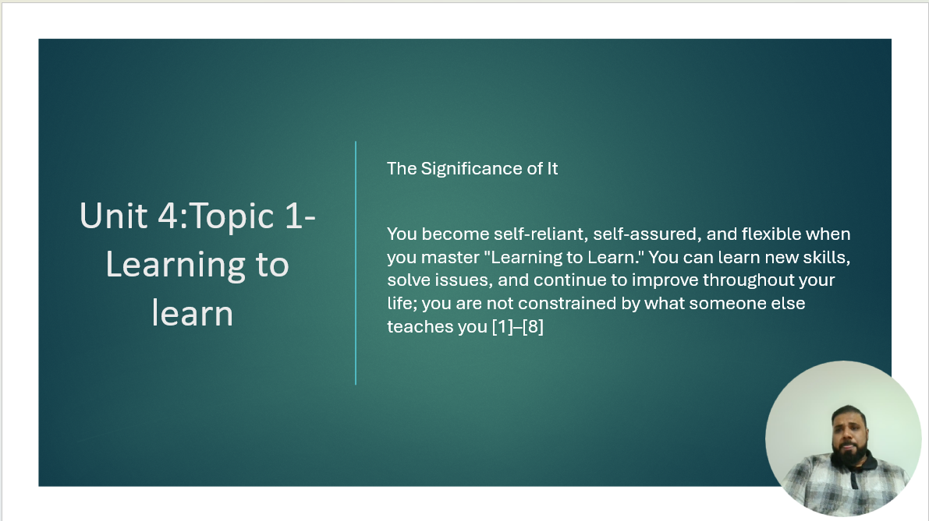

Brief explanation:
Key Ideas & Topics in Learning to Learn
What it is: "Learning to Learn" refers to understanding not just what you learn, but also how you learn. It involves cultivating the abilities, approaches, and mindset necessary to take charge of your education, resolve issues, and adjust to novel circumstances. It is the cornerstone of lifelong learning, to put it briefly [3], [5].
Key Topics/Concepts
Thinking About Thinking (Metacognition)
This is the capacity to reflect on how you think. It entails finding your areas of strength and weakness, preparing how to tackle a task, assessing your comprehension along the way, and changing your approach, as necessary. [7], [3].
Self-Control & Active Learning
Active learning encourages you to interact with the content rather than just read or listen. Engage in dialogue, practice techniques, ask questions, and think back on your work. Claiming self-control keeps you motivated and on course. [6], [4].
Getting Knowledge
Note-taking, summarizing, making mental maps, self-testing, and spaced repetition are all components of your learning arsenal. Learning to learn includes selecting the best approach for the task [5], [7].
Goal setting, Motivation, and Confidence Believing in You
Even when learning becomes difficult, you may persevere if you have clear goals and believe you can learn. Consistent success is powered by motivation [4], [8].
Contemplation & Assessment
After finishing a task, pause to consider what worked and what did not. Over time, this self-review enhances your learning [5], [9].
Flexibility and Lifelong Education
Learning to learn is about adapting your skills to new subjects, jobs, or situations in life, not just for academic purposes. Continuous growth is easier if you are more adept at learning [3].
The Significance of It
You become self-reliant, self-assured, and flexible when you master "Learning to Learn." You can learn new skills, solve issues, and continue to improve throughout your life; you are not constrained by what someone else teaches you [3]– [9].

CONCLUSION
Slide 14 CONCLUSION

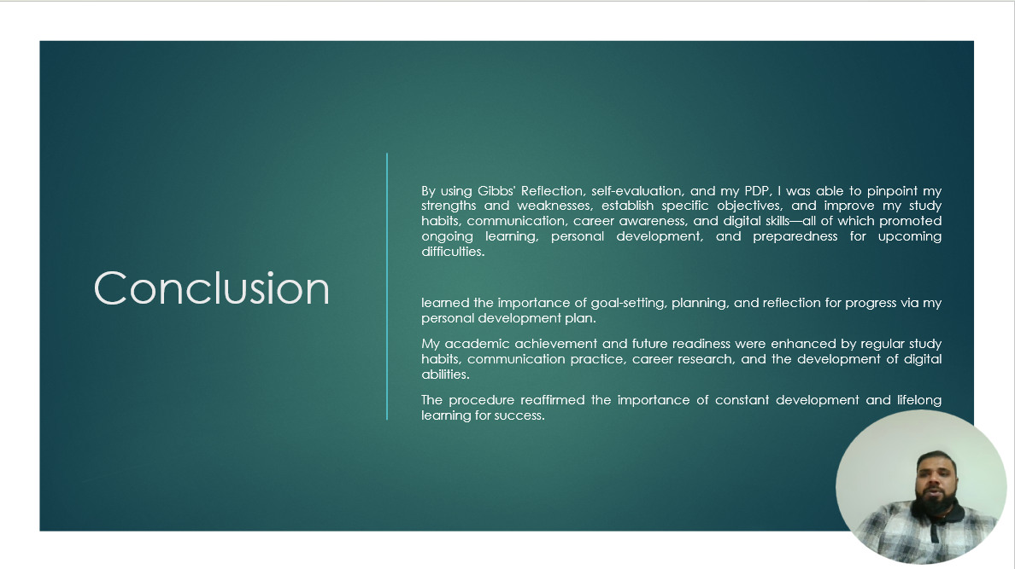

Brief explanation:
What I Discovered
The creation of my Personal Development Plan (PDP) taught me the importance of setting up clear, attainable goals and use research-proven tactics to promote both academic and personal development. I came to see that setting up explicit study schedules and keeping track of my development is consistent with earlier research showing that regular self-regulated learning enhances academic achievement. This reaffirmed how crucial time management, planning, and reflective practice are to my everyday study routines.
I also discovered how crucial presenting and communication abilities are to success in the classroom and in the workplace. I learned that communication is a talent that can be learned and developed via intentional practice by practicing public speaking and getting feedback. This understanding is reinforced by communication competence models that have been studied in the literature.
I learned the value of early career preparation by investigating my job interests. Through taking part in career exploration activities, I became aware of how career development theory emphasizes the use of guidance resources and reflective career decision-making tools to help people better understand their strengths and potential pathways.
Lastly, developing digital and technical skills made it easier for me to see how important they are becoming in today's classrooms and businesses. I discovered by interacting with online courses and platforms that, in line with the recommendations of the global digital skills framework, digital literacy is now seen as a fundamental talent needed in most fields.
Given the circumstances, the PDP process showed me how organized planning, ongoing development, and lifelong learning support academic achievement, personal development, and preparedness for future employment.

REFERENCES
Slide 15 REFERENCES
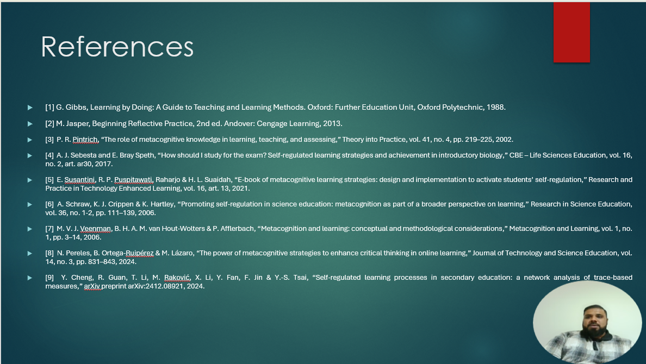
References

Task 1
[1] G. Gibbs, Learning by Doing: A Guide to Teaching and Learning Methods. Oxford: Further Education Unit, Oxford Polytechnic, 1988.
[2] M. Jasper, Beginning Reflective Practice, 2nd ed. Andover: Cengage Learning, 2013.

Task 3
[3] P. R. Pintrich, “The role of metacognitive knowledge in learning, teaching, and assessing,” Theory into Practice, vol. 41, no. 4, pp. 219–225, 2002.
[4] A. J. Sebesta and E. Bray Speth, “How should I study for the exam? Self-regulated learning strategies and achievement in introductory biology,” CBE – Life Sciences Education, vol. 16, no. 2, art. ar30, 2017.
[5] E. Susantini, R. P. Puspitawati, Raharjo & H. L. Suaidah, “E-book of metacognitive learning strategies: design and implementation to activate students’ self-regulation,” Research and Practice in Technology Enhanced Learning, vol. 16, art. 13, 2021.
[6] A. Schraw, K. J. Crippen & K. Hartley, “Promoting self-regulation in science education: metacognition as part of a broader perspective on learning,” Research in Science Education, vol. 36, no. 12, pp. 111–139, 2006.
[7] M. V. J. Veenman, B. H. A. M. van Hout Wolters & P. Afflerbach, “Metacognition and learning: conceptual and methodological considerations,” Metacognition and Learning, vol. 1, no. 1, pp. 3–14, 2006.
[8] N. Pereles, B. Ortega Ruipérez & M. Lázaro, “The power of metacognitive strategies to enhance critical thinking in online learning,” Journal of Technology and Science Education, vol. 14, no. 3, pp. 831–843, 2024.
[9] Y. Cheng, R. Guan, T. Li, M. Raković, X. Li, Y. Fan, F. Jin & Y.-S. Tsai, “Self-regulated learning processes in secondary education: a network analysis of trace-based measures,” arXiv preprint arXiv:2412.08921, 2024.
Slide 16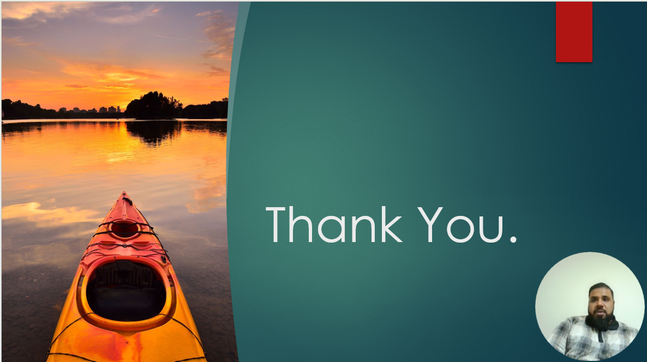
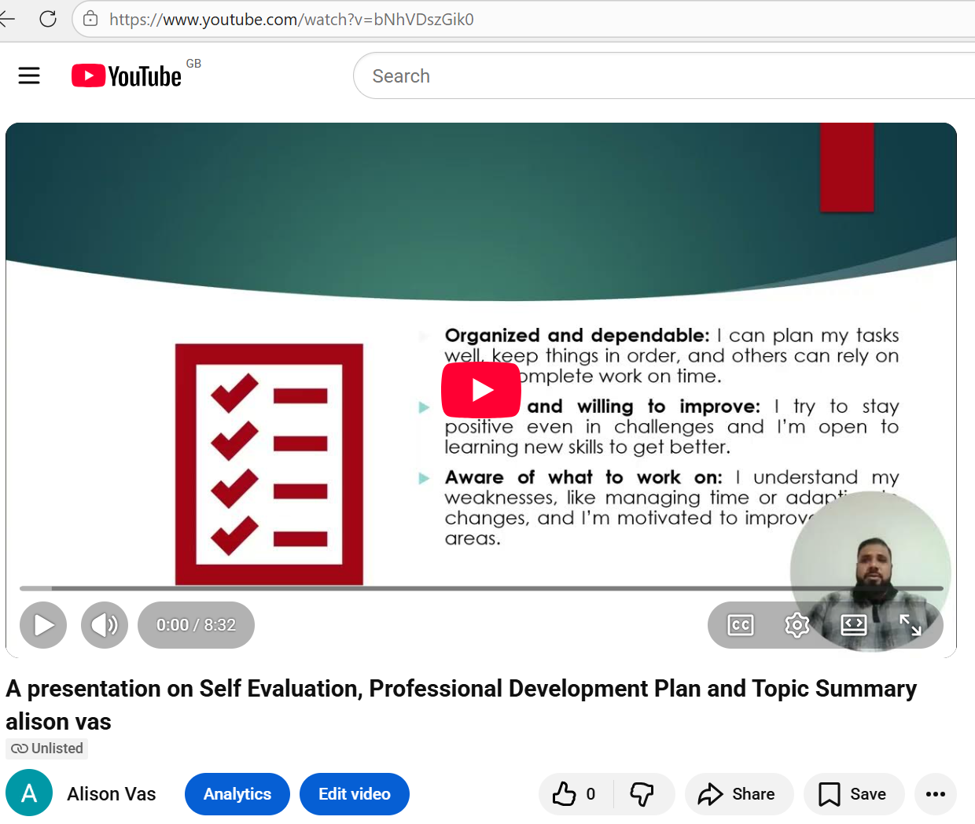

Video link
https://youtu.be/bNhVDszGik0
https://youtu.be/bNhVDszGik0?si=xBjpXomp0XfmPG-Z

