Contemporary Challenges: (Making a Difference (BMTP4010/C)
Assignment 1 – Clyde Carmelo Seisun (2220481)
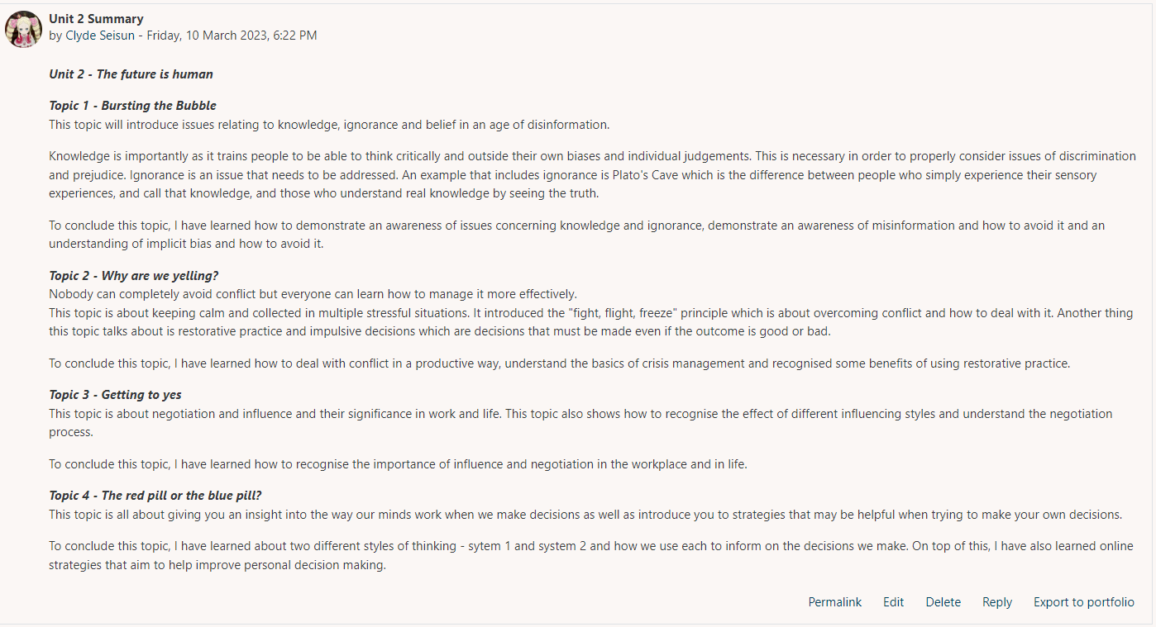
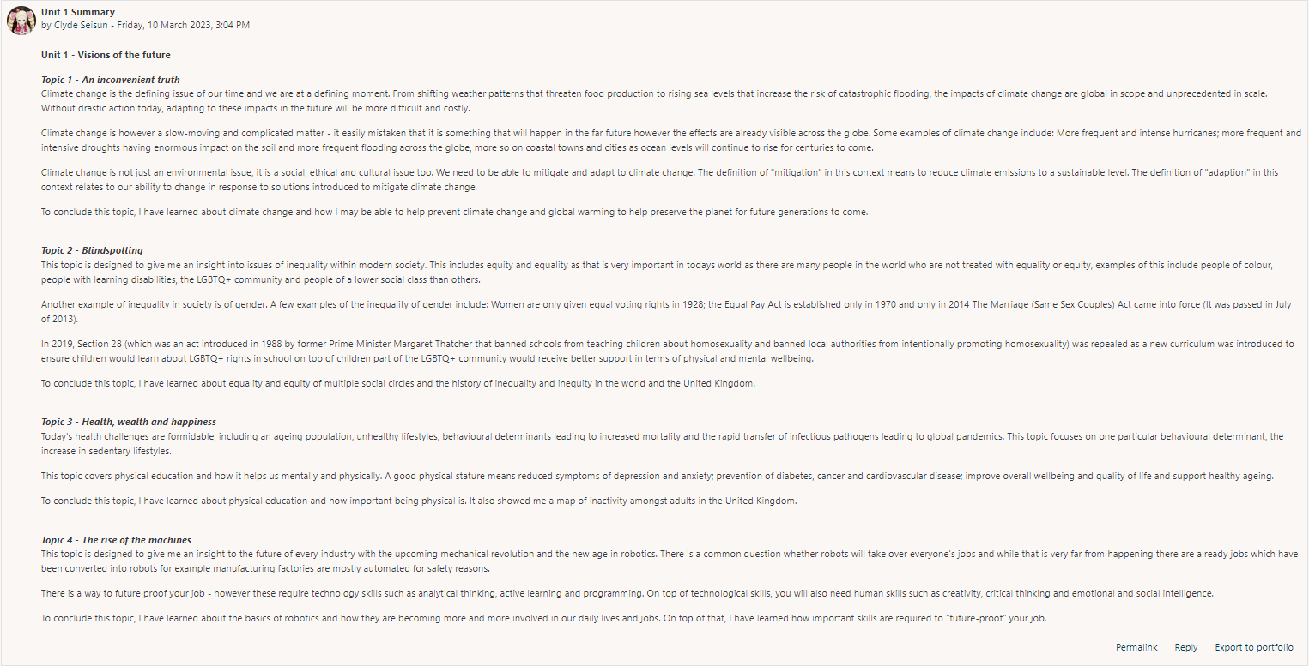

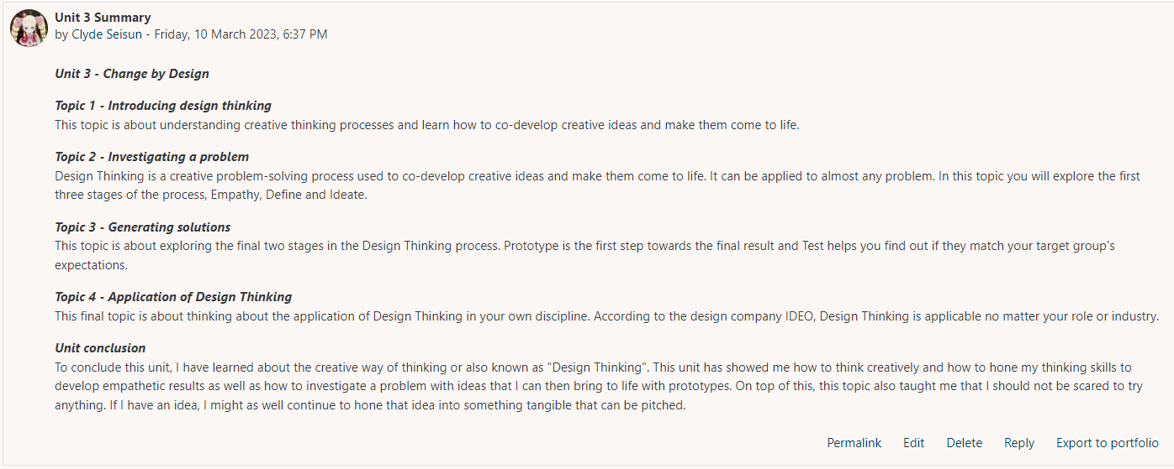

Wordpress Link:
http://www.xashyz.wordpress.com
I have sent you an email with the invitation to see the private blog.

