Catherine Wood
Task 1 word count: 2186
Task 2 Word count: 1259

- Define the term professional and explain what it means to be a ‘people professional’. (AC 1.1)

The term professional can be subjective and interpreted in many ways however, The CIPD (2023) Code of Conduct and Ethics provides people professionals with a set of standards to follow in order to promote professionalism and ethical practice. The CIPD Code of Conduct and Ethics has five key virtues which encompass the main factors to reflect upon in order to act professionally. One of these areas covers the delivery of professional service and competence. The key points of this virtue are:

- Taking responsibility for continuing professional development, skills and knowledge.
- Providing and delivering evidence-based practice.
- Being confident to seek advice when unsure about a certain area of expertise.
- Treating all information sensitively and confidentially.

In addition to the CIPD code of conduct, there are three professional values at the core of the CIPD Profession Map which help drive the purpose of people practice:

- Principles-led
- Evidence-based
- Outcomes-driven

These principles were curated in order to support better decision-making and create meaningful long-term and short-term impact in all aspects of people practice (CIPD, n.d.).

Whilst the CIPD Code of Conduct and Ethics and the Profession Map are key resources for People Practitioners, professionalism and best practice, it is important to consider a persons’ moral and ethical values as these will influence the decisions and actions a person will take (Waite et al., 2021). These decisions can also be influenced by the level of emotional intelligence (EI) a person has. Some of the key components of EI are as self-awareness and self-regulation, which allow someone to act professionally by not allowing their emotions disrupt and impact others (Harvard Professional Development, 2019).

- Explore how the role of a people professional (either a generalist or a particular specialist) is evolving and the priorities this raises for continuing professional development (CPD) (AC 3.1).

Historically, people practitioners’ main priority was to increase the efficiency and productivity of an organisation’s employees in order to increase company profits (Taylor and Woodhams, 2022). In contrast to this, people practice today has developed into a much wider subject where its purpose is to support employees by creating meaningful, valuable jobs and opportunities, whilst also delivering strategic plans that benefit both an organisation and their employees.

However, there are constantly new challenges emerging in today’s world, which highlights the importance of continued professional development (CPD) (Waite et al., 2021). CPD can depend on an individual’s aims and short/long-term goals. CPD can be summarised as a range tools used to support learning and professional development (CIPD, 2021). The CIPD (2022) recommend using the CPD cycle, which includes the following activities:

- Identify: check what skills and knowledge are required to reach short term and long term goals. For example, looking at person specifications for roles you aspire to and seeing what is required for the role.
- Plan: use a timeframe to plan activities, ideally in line with performance reviews.
- Act: use a range of activities to support learning.
- Reflect: helps embed learning, see what is working well and what needs improving.
- Apply: creating strategies and opportunities to apply learning, repeat.
- Share: having discussions and sharing insights with colleagues and other professionals.
- Impact: ideally in measurable outcomes. Reflecting and evaluating what you’ve learned against the goals set.

CPD is advantageous for the individual and organisation because it can help improve staff performance, efficiency and confidence. CPD can also give the organisation more credibility by having staff who hold the latest qualifications (Edwards, 2018).

- Discuss the concept of ‘ethical values’, and how at least three ethical values that you hold personally, impact (or could impact) on your work as a people professional. (AC 1.2)

Having personal ethical principles that align with an organisation’s vision will help to achieve a positive work environment where employees are able to trust and thrive (Waite et al., 2021).

Three values I consider myself to possess are empathy, fairness and justice. In long-term sickness review meetings I make sure I actively listen and make the employee feel comfortable enough to share important details with me regarding their case. I believe it is important to be empathetic as some cases are very sensitive and the way they are handled could have a huge impact on the employee’s engagement. By being empathetic it can also encourage their willingness to return to work, knowing that they will have appropriate support in place.

This also ties in with my strong belief for justice, which is demonstrated in my work when dealing with employees who abuse the long-term sickness policy. These employees can have a negative impact on their colleagues by causing frustration and burnout as they are left to cover the additional workload. It is important for me to gather all the evidence and support the line manager as well as the employee in these cases. My need for justice allows me to look at the facts and act impartially and with fairness, so the most ethical outcome is produced. This can also be applied in situations where a manager isn’t being supportive of a genuine sickness case and are drawing their own conclusions on the situation. Furthermore, this compliments my value for fairness. Not only do I apply this value in sickness reviews, I also feel that this is an important value when it comes to company culture due to it being a key characteristic of inclusion (CIPD, 2022b).

- Explain why it is essential for people professionals to contribute confidently to discussions, and ways of doing this that are (AC 1.3)
- informed
- clear
- engaging.

One of the core behaviours in the CIPD Profession Map is ‘Professional courage and influence’. This core behaviour highlights the importance of using knowledge and evidence to challenge and influence others within an organisation, particularly when faced with ethical dilemmas (CIPD, 2019b). According to the Mind Tools Content Team (n.d.), meetings and discussions should be seen as an opportunity for people practitioners to add value. This can be achieved by providing constructive criticism, challenging view points and offering practical suggestions that are backed up by evidence.

When putting forward an idea, argument or business case, the first thing to consider is which stakeholder group it will be presented to. This will determine what information needs to be shared and how to word the argument in order to engage and persuade that particular group of stakeholders (Taylor and Woodhams, 2022). For example, including research highlighting the cost and productivity advantages for a four day working week when presenting to CEOs. In contrast to this, opting to include the advantages of improved work-life balance would be more persuasive if presenting to employees.

Additionally, it is important to be clear, concise and engaging when presenting the argument. Structuring the case in a way that allows the audience to follow and take on board the key points will support this. According to Indeed (2022) there are five key steps to follow when drawing up an effective argument:

  - Introducing the issue and provide context
  - Present your perspective on the issue
  - Use evidence to support the claim
  - Discuss opposing views and address them
  - Summarise and conclude the argument

This style of presenting an argument is similar to the Aristotelian argument, developed by Greek Philosopher, Aristotle and is used when the aim is to persuade someone to agree with the proposed viewpoint (Long, Minervini and Gladd, 2020).

- Discuss when and how to raise concerns when issues such as organisational policies or leadership approaches conflict with ethical values or legislation. (AC 1.4)

A hypothetical example of leadership conflicting with ethical values could be seen in a situation where a Sales Manager sets their team a target of 20 sales per week, regardless of their working hours. Whilst the Manager may have good intentions for increasing revenue for the company, this could be deemed unfair as it puts part-time employees automatically at a disadvantage. In addition to this, it could result in an indirect discrimination case against the Manger if there are women who work part time because of childcare issues. According to Working Families (2022), this is recognised as ‘childcare disparity’ and can be successfully argued at employment tribunals.

In order to prevent situations where ethical values are conflicting with leadership approaches, there needs to be a culture of trust and good communication between employees and managers. This would give employees the confidence to raise concerns at their earliest opportunity, allowing issues get resolved informally. Furthermore, this would reduce the amount of time and money spent on grievances and tribunals (ACAS, 2020).

In addition to grievance and disciplinary procedures, it is good practice for companies to have a whistleblowing policy. Although there is no legal requirement for a whistleblowing policy, having one helps to promote a safe and fair working environment by reassuring employees to speak up against actions they deem unethical or inappropriate, without being reprimanded for doing so (GOV, 2015). However, it is important to note that a whistleblowing policy only protects employees if their grievance contains issues that have the potential to negatively impact the public. This is defined under the Public Interest Disclosure Act 1998. An example of this is seen in Underwood v Wincanton plc 2015. To summarise this case, a small group of HGV drivers had reported safety issues with some of the company vehicles. Following this, they complained that they had received less overtime opportunities which they felt was due to the safety issues they had reported. This eventually resulted in dismissal which the HGV drivers took to the Employment Tribunal for unfair dismissal. Because there was a public interest aspect to their complaint, the Employment Appeal Tribunal accepted the appeal (CIPD, 2022c).

- Provide a robust argument for ethical people practice that is supported by academic theory and details both the business and human benefits of people at work feeling included, valued and fairly treated. (AC 2.1)

The ethical climate of an organisation can be influenced by the social norms and values of its’ employees. This is why it is important to reward staff for demonstrating and supporting the organisation’s ethical values in order to encourage commitment to these values from all employees (CIPD, 2022c).

In addition to the CIPD (2021a) explaining the influence human behaviour and social norms have on ethics in the workplace, David Rock’s (2008) SCARF theory supports the idea that positive social relationships help staff feel less ‘threatened’ and therefore can help increase collaboration, focus and productivity. Rock (2008) recommends supporting ways of building connections between staff to stimulate the ‘reward’ response in the brain.
Margaret Heffernan (2015) discusses the importance of positive social interactions in the workplace and its impact on productivity. Heffernan highlighted the results of research carried out by MIT, which identified the relationship between high levels of productivity and social connection. The study showed that groups which were diverse, scored highly for social sensitivity, and included more women proved more productive when faced with the same task as groups which lacked in diversity, and had lower scores for social sensitivity, despite scoring highly in other areas such as their IQ. This is supported by Lauricella et al. (2022) who explains that teams with strong connections and trust between members are more likely to engage, exceed their work duties and therefore improve performance and increase productivity. In addition to this, they state that years of academic research show the benefits of social capital including a larger pool of specialist knowledge, more innovation and low staff turnover.

- Drawing on your own or a hypothetical example of providing a people practice solution to meet a particular need or introducing a new policy or initiative, describe:
- strategies for designing the solution/initiative so that it will be inclusive
- strategies for checking that, when in practice, the solution/initiative engages and meets the needs of all those it is aimed at. (AC 2.2)

In line with the Equal Pay Act 1970, men and women should be paid equally for doing the same work (ACAS, 2022). However, whilst there has been some progress over the past 50 years, there is still more to be done. Research from the Office of National Statistics (2022) suggests that women working full-time are still paid 8.3% less than their male colleagues, despite doing same work as them.

In order explore this issue within my organisation, I would carry out internal data analysis on job roles, salary and gender to determine whether there was a gap in pay between men and women. If a gender pay gap was found, I would investigate further into the issue to determine if there are any trends or reasons for the difference in pages. For example, if there were a larger number of women in roles that were typically lower paid on our pay structure i.e. Cleaners, Breakfast Club Assistants, compared to men in these roles, I would investigate further.

I would start my investigation by using an online survey with a mix of qualitative and quantitative questions. This would be communicated via personal emails, work emails, intranet and weekly newsletter to ensure as many female colleagues were able to participate. The aim of this would be to establish the reasons why these women have chosen these roles and whether these reasons are causing potential barriers to progression. The TUC (2022) suggests that there are more women than men working part-time due to childcare duties and as a result, have less opportunities to develop and progress in the workplace and therefore less chances to increase their salaries. In addition to this, the ONS (2022) explains that the hourly pay is usually lower for part-time worker in comparison to full-time workers.

In order to support these women experiencing the gender pay gap and barriers to employment, we could look at adding a childcare costs scheme to give more women the opportunity to progress into full-time roles. In addition to this, Barman (2022) recommends a mentorship programme, where an employee could shadow, discuss career goals and make an action plan with a more senior or experienced employee in the organisation. Sharing this knowledge and skills can help build positive, cross-departmental relationships across the organisation.

If successful, the mentorship programme could be rolled out to all employees in the organisation, no matter what their gender, role or salary is, in order to provide an opportunity to upskill the entire workforce and support career progression. Furthermore, this could benefit the organisation by reducing staff turnover (Taylor and Woodhams, 2022).

TASK 2
ACTIVITY 1

According to Waite et al. (2021) continuing professional development (CPD) enables people to take control over their own career progression, rather than waiting for their employer to offer them learning and development opportunities. CPD gives someone responsibility to self-reflect and highlight areas where they can improve their skills and expand their knowledge. This opportunity also helps to increase their job security in a world where rapid and constant change is a growing threat to many job roles, including People Professional.

In order to accurately answer the CIPD self-assessment, I carried out a SWOT analysis using my job description and person specification to help me reflect upon my strengths and weaknesses in my current role. I chose this analysis tool because it is easy to use and helps to identify key areas CPD (Waite et al., 2021). I also reflected on my recent work projects to draw upon examples of where I have applied the CIPD core behaviours. I put the examples into a table and considered where I had had demonstrated the core behaviours well. Furthermore, this helped highlight what core behaviours I need to seek opportunities to display.
Finally, I gathered anonymised 360 feedback from my colleagues. I chose this technique because it allows for honest comments from a variety of people (Indeed, 2022b).

Activity 2

Communication

This is a key skill in my current role as Assistant HR Officer. In order to work on this activity, I will ask to be observed in meetings by a more experienced colleague. These meetings will be Stage 1 and Stage 2 formal procedures that follow our sickness absence policy and procedure. I will ask for feedback on my verbal communication in the meeting and written communication in the outcome letter.

This should allow me to understand how well I listen to the details of the meeting and whether I display the appropriate amount of empathy due to the sensitive nature of some long-term sickness cases. In addition to this, feedback on my written communication will help me assess my ability to record and relay the information accurately. This is a key part of the sickness procedure because of the possibility of a case getting taken to a tribunal.

Ethical Practice Factsheet

I chose this activity because in my role I am occasionally faced with ethical dilemmas. An example of this is having to take formal action, such as issuing a written warning or terminating a contract of an employee who has genuine reasons for sickness absence. In these cases, the policy and procedure can conflict with my own ethical views therefore, reading the factsheet could help me weigh the ethical conflicts and business needs. The factsheet could also help me find ways of advising managers on how to improve ethical culture within their teams.
Activity 3
Record Name: | Specialist Knowledge
Date: | 12/02/2023
Profession Map Area: | Employee Relations
Type of Reflection: | Course Reflections
Type of Learning Experience: | Attended a Course
Grade: | N/A
Supporting material: | N/A

What did I learn?
I learned:

- Why companies need rules and policies
- Who is responsible for policies being followed
- Who is involved in creating or amending policies
- How policies are communicated

I also learned the correct process to follow for grievances and disciplinary. This included the ACAS Code of Conduct, investigation process, effects to the personal lives on the employee and trade union involvement. These fall under a range of areas of the CIPD Profession Map for example, negative effects on the personal lives of an employee following a suspension before an investigation has concluded them guilt of an offence. This incorporates ethical practice and wellbeing.

What did the learning experience tell me about myself?

The learning experience made me realise that I have the ability to cross reference my knowledge from different policies and procedure, making the link between similarities across them. I also noticed that I am confident in answering questions.

How does this learning experience impact my professional practice and the way I'll approach situations in the future?

I learned best practice in disciplinary and grievances. It particularly made me think about how my actions can have a big impact on the personal lives of people. Whilst I am methodical and process-based in most of my decision making, I will ensure a more human and thoughtful approach to my advice going forward.

What do I need to do next for this learning experience to have a wider positive impact (eg on others, my organisation, the sector, the profession, society)?

Review our current Discuplinary and Grievence procedure to ensure it follows the ACAS Cose of Practice and is fair for employees.

Record Name: | Specialist Knowledge
Date: | 05/12/2022
Profession Map Area: | Wellbeing
Type of Reflection: | Other Reflections
Type of Learning Experience: | Attended an Event
Grade: | N/A
Supporting material: | N/A

What did I learn?

This was a very interesting event about Burnout and Wellbeing in the workplace. I learned about the different reasons for burnout and factors that influence employees’ wellbeing such as the Covid-19 pandemic and cost of living crisis. I also learned about the range of ways an organisation can support employees experiencing burnout and poor wellbeing.

What did the learning experience tell me about myself?

During this event, I realised how interesting I found this area of practice. The event also gave me the chance to meet other people professionals and expand my HR network.

How does this learning experience impact my professional practice and the way I'll approach situations in the future?

Following the event, I have thought about the impact people practitioners have on employees’ wellbeing both in and out of work. I realised that this could be through policies, procedures and line managers who need more support in training and wellbeing.

What do I need to do next for this learning experience to have a wider positive impact (eg on others, my organisation, the sector, the profession, society)?

I need to use the information from this event and evidence-based practice to inform others in my organisation of the impact burnout and wellbeing has on individuals and therefore an organisation. I think a business case should be put forward to provide more targeted training for managers and employees to help them with their own wellbeing and the wellbeing of others.

Record Name: | Specialist Knowledge
Date: | 01/11/2022
Profession Map Area: | People Analytics
Type of Reflection: | Other Reflections
Type of Learning Experience: | Something I’ve done at work
Grade: | N/A
Supporting material: | N/A

What did I learn?

This was an opportunity for me to apply the learning from my first assignment. I analysed the data from a questionnaire completed by new employees in the organisation. The purpose of the questionnaire was to gain insight into the candidate experience throughout the first stage of the employee journey e.g. advertisement, interview, onboarding etc.

What did the learning experience tell me about myself?

That I am capable of data analytics and applying learning from courses to real-life situations.

How does this learning experience impact my professional practice and the way I'll approach situations in the future?

I learned the importance of getting feedback from employees to see how processes can be improved. It also highlighted how different people will experience different issues that may not be thought of by someone else e.g. accessibility issues. This is something I will consider going forward to improve inclusivity in my organisation.

What do I need to do next for this learning experience to have a wider positive impact (eg on others, my organisation, the sector, the profession, society)?

Use the information to improve the candidate journey.

Appendices
Appendix 1

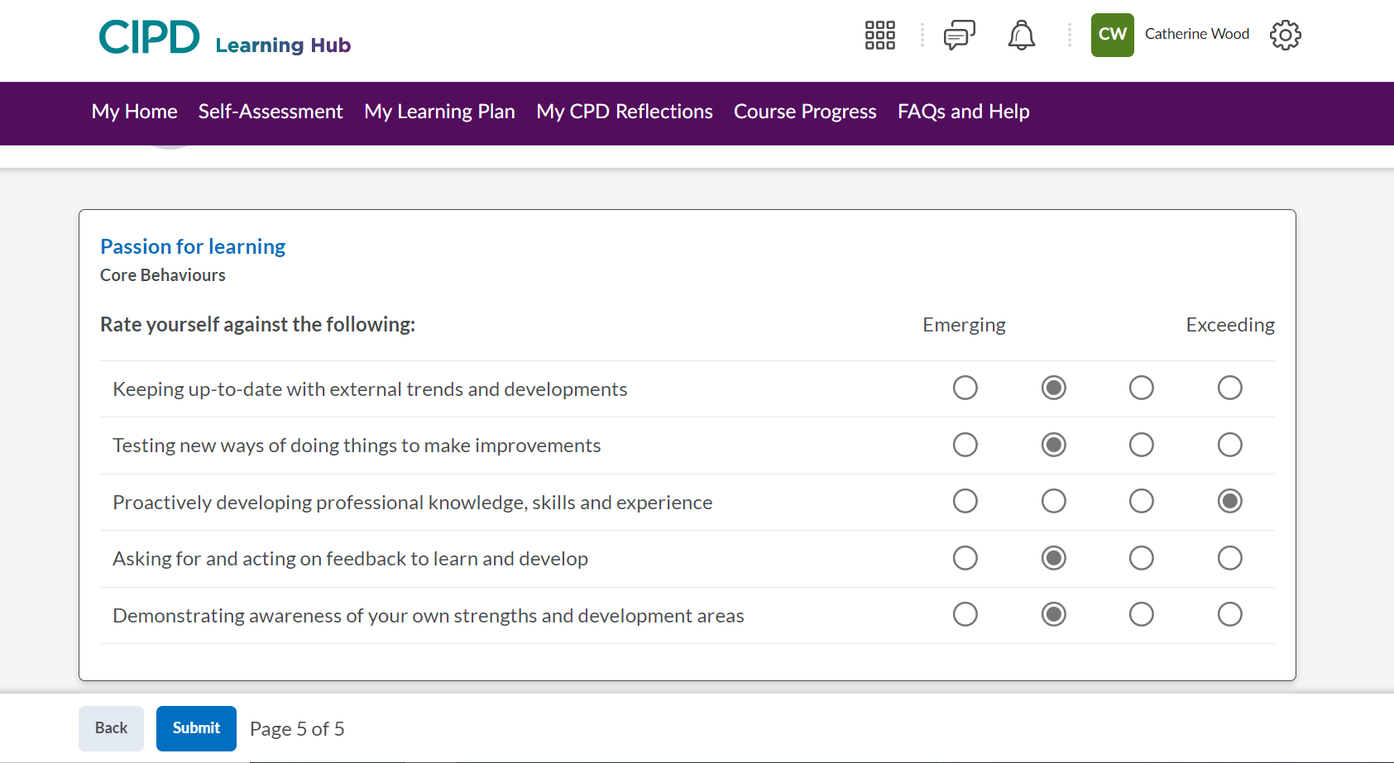

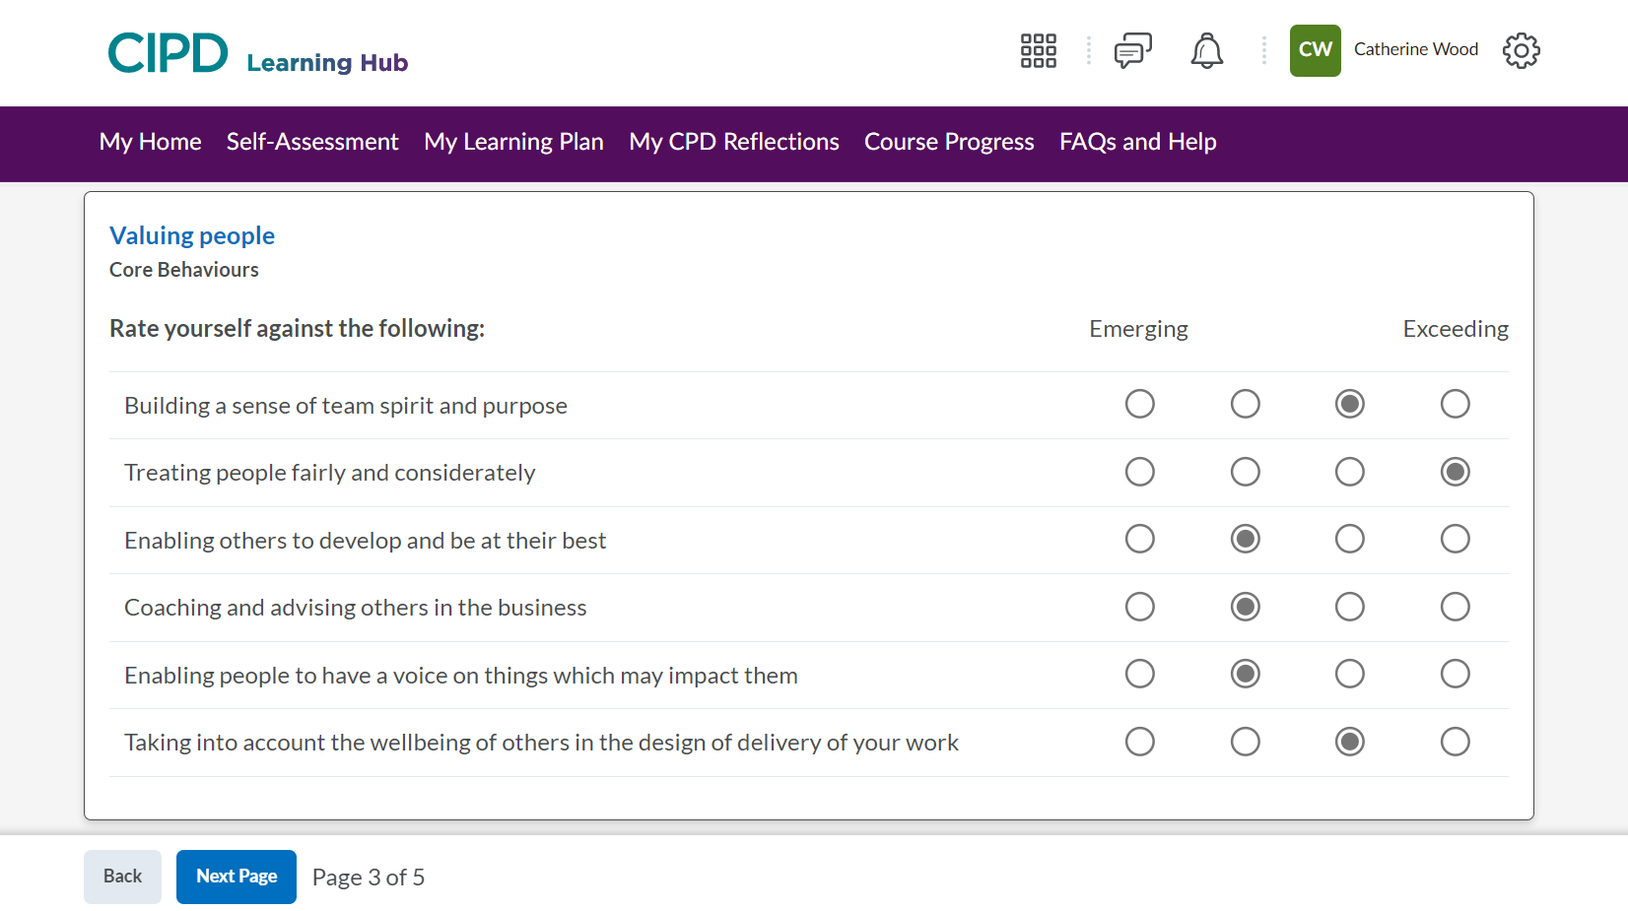

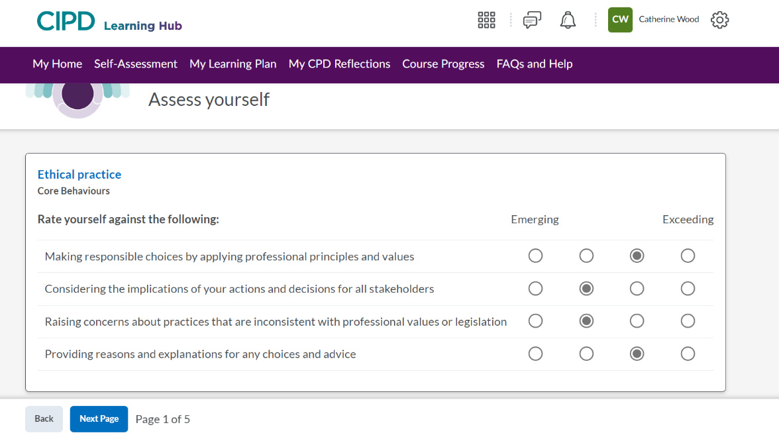
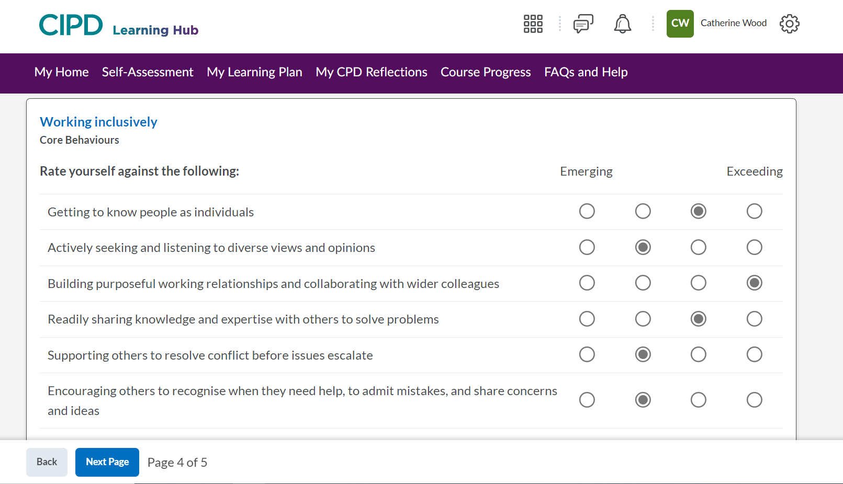

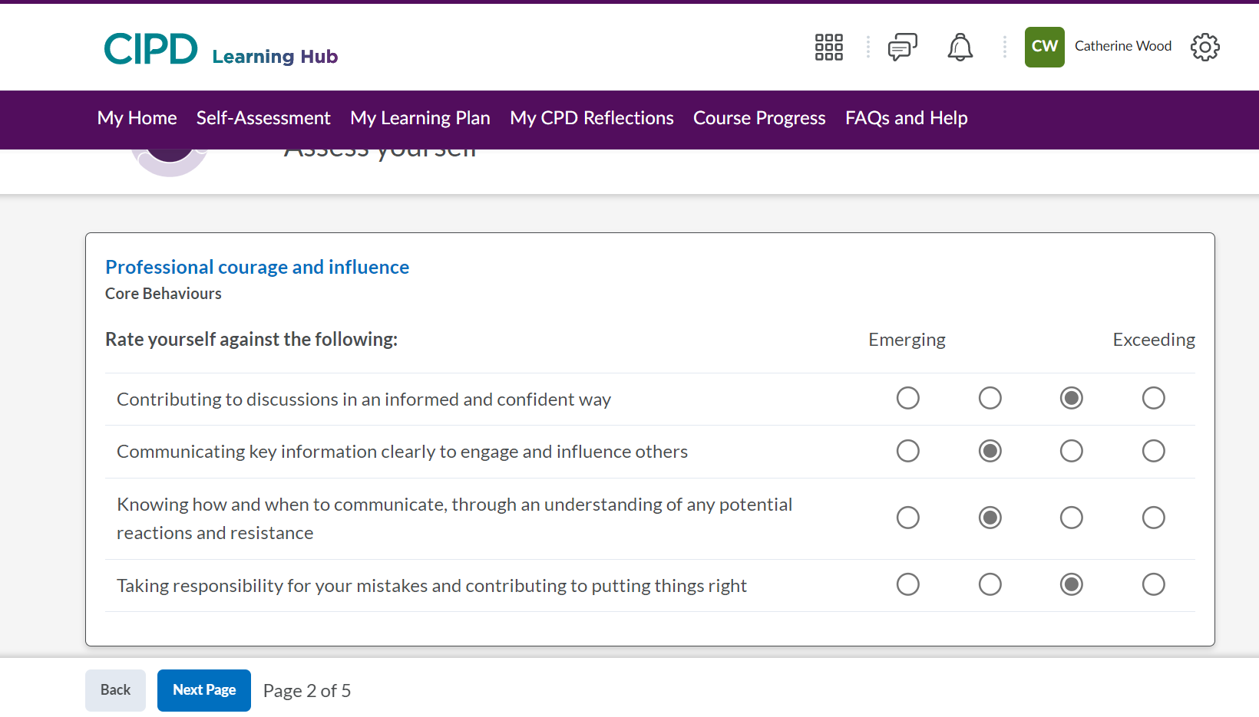

Appendix 2
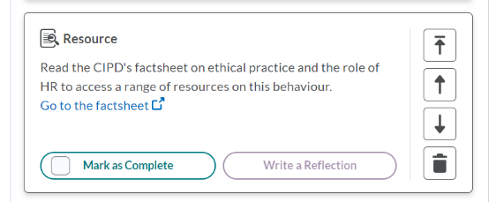
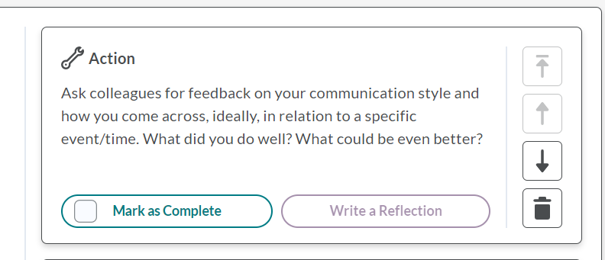

References

ACAS (2020). Acas guide to discipline and grievances at work | Acas. [online] www.acas.org.uk. Available at: https://www.acas.org.uk/acas-guide-to-discipline-and-grievances-at-work [Accessed 7 Mar. 2023].
ACAS (2022). Equal Pay and the Law. [online] Acas. Available at: https://www.acas.org.uk/equal-pay/equal-pay-law [Accessed 10 Mar. 2023].
Barman, D. (2022). Mentoring Women to Reshape the Future. [online] Making Business Matter (MBM). Available at: https://www.makingbusinessmatter.co.uk/mentoring-women/ [Accessed 10 Mar. 2023].
CIPD (2019a). Core purpose | CIPD Profession Map. [online] CIPD Profession for the Future. Available at: https://peopleprofession.cipd.org/profession-map/core-purpose [Accessed 11 Feb. 2023].
CIPD (2019b). Professional courage and influence | CIPD Profession Map. [online] CIPD Profession for the Future. Available at: https://peopleprofession.cipd.org/profession-map/core-behaviours/professional-courage-influence [Accessed 21 Feb. 2023].
CIPD (2021). What is Continuing Professional Development (CPD) | CIPD. [online] CIPD. Available at: https://www.cipd.co.uk/learn/cpd/about [Accessed 19 Feb. 2023].
CIPD (2021a). Learning Theories for the Workplace | Factsheets. [online] CIPD. Available at: https://www.cipd.co.uk/knowledge/strategy/development/learning-theories-factsheet#gref [Accessed 10 Mar. 2023].
CIPD (2021b). What is Continuing Professional Development (CPD) | CIPD. [online] CIPD. Available at: https://www.cipd.co.uk/learn/cpd/about [Accessed 19 Feb. 2023].
CIPD (2022a). CPD Cycle Stages | CIPD. [online] CIPD. Available at: https://www.cipd.co.uk/learn/cpd/cycle [Accessed 19 Feb. 2023].
CIPD (2022b). Diversity and Inclusion in the Workplace | Factsheets | CIPD. [online] CIPD. Available at: https://www.cipd.co.uk/knowledge/fundamentals/relations/diversity/factsheet.
CIPD (2022c). Ethical Practice and the Role of HR | Factsheets | CIPD. [online] CIPD. Available at: https://www.cipd.co.uk/knowledge/culture/ethics/role-hr-factsheet [Accessed 10 Mar. 2023].
CIPD (2022c). Whistleblowing Cases. [online] CIPD. Available at: https://www.cipd.co.uk/knowledge/fundamentals/emp-law/whistleblowing/cases [Accessed 1 Mar. 2023].
CIPD (2023). Code of Conduct and Ethics. [online] Available at: https://www.cipd.co.uk/Images/cipd-code-of-conduct-and-ethics-v2_tcm18-112336.pdf [Accessed 11 Feb. 2023].
CIPD (n.d.). Core purpose | CIPD Profession Map. [online] CIPD Profession for the Future. Available at: https://peopleprofession.cipd.org/profession-map/core-purpose [Accessed 11 Feb. 2023].
CIPD and Peters, R. (2020). Why we call it the people profession. [online] CIPD People Profession. Available at: https://peopleprofession.cipd.org/insights/articles/why-people-profession [Accessed 8 Feb. 2023].
Edwards, N. (2018). Why CPD is Important in an Ever-changing World. [online] MHR. Available at: https://mhrglobal.com/uk/en/blog/why-cpd-is-important-in-an-ever-changing-world [Accessed 19 Feb. 2023].
Gibson, E. (2022). TUC: Women much more likely than men to have flexible work arrangements that lead to loss of hours and pay. [online] www.tuc.org.uk. Available at: https://www.tuc.org.uk/news/tuc-women-much-more-likely-men-have-flexible-work-arrangements-lead-loss-hours-and-pay [Accessed 10 Mar. 2023].
GOV (2015). Guidance for Employers and Code of Practice Whistleblowing: Guidance for Employers. [online] Available at: https://assets.publishing.service.gov.uk/government/uploads/system/uploads/attachment_data/file/415175/bis-15-200-whistleblowing-guidance-for-employers-and-code-of-practice.pdf. [Accessed 10 March 2023].
Harvard Professional Development (2019). How to improve your emotional intelligence. [online] Professional Development | Harvard DCE. Available at: https://professional.dce.harvard.edu/blog/how-to-improve-your-emotional-intelligence/ [Accessed 6 Mar. 2023].
Hayden, D. (2021). Learning Theories for the Workplace | Factsheets. [online] CIPD. Available at: https://www.cipd.co.uk/knowledge/strategy/development/learning-theories-factsheet [Accessed 6 Mar. 2023].
Heffernan, M. (2015). Forget the pecking order at work. [online] www.ted.com. Available at: https://www.ted.com/talks/margaret_heffernan_forget_the_pecking_order_at_work?language=en [Accessed 6 Mar. 2023].
Indeed (2022a). How To Structure An Effective Argument in 5 Steps. [online] Indeed Career Guide. Available at: https://www.indeed.com/career-advice/career-development/how-to-structure-an-argument [Accessed 18 Mar. 2023].
Indeed (2022b). What is 360 feedback? (with examples, benefits and FAQs). [online] Indeed Career Guide. Available at: https://uk.indeed.com/career-advice/career-development/360-feedback [Accessed 13 Mar. 2023].
Kier, L. (2021). Council Post: The Five Ws Of Engaging Communications. [online] Forbes. Available at: https://www.forbes.com/sites/forbescommunicationscouncil/2021/05/12/the-five-ws-of-engaging-communications/?sh=10be21a82dce [Accessed 22 Feb. 2023].
Lauricella, T., Parsons, J., Schaninger, B. and Weddle, B. (2022). Companies need to rebuild connections in the workplace | McKinsey. [online] www.mckinsey.com. Available at: https://www.mckinsey.com/capabilities/people-and-organizational-performance/our-insights/network-effects-how-to-rebuild-social-capital-and-improve-corporate-performance [Accessed 6 Mar. 2023].
Long, L., Minervini, A. and Gladd, J. (2020). Aristotelian (Classical) Argument Model. idaho.pressbooks.pub. [online] Available at: https://idaho.pressbooks.pub/write/chapter/aristotelian-classical-argument/#:~:text=The%20Aristotelian%20or%20classical%20argument%20is%20a%20style [Accessed 22 Feb. 2023].
Mason, G. (2016). The 10 Characteristics of Professionalism. [online] Linkedin.com. Available at: https://www.linkedin.com/pulse/10-characteristics-professionalism-greg/ [Accessed 8 Feb. 2023].
Mind Tools Content Team (n.d.). MindTools | Home. [online] www.mindtools.com. Available at: https://www.mindtools.com/asrnl5c/8-ways-to-add-value-to-meetings [Accessed 21 Feb. 2023].
ONS (2022). Gender pay gap in the UK - Office for National Statistics. [online] www.ons.gov.uk. Available at: https://www.ons.gov.uk/employmentandlabourmarket/peopleinwork/earningsandworkinghours/bulletins/genderpaygapintheuk/2022 [Accessed 10 Mar. 2023].
Taylor, S. and Woodhams, C (2022a) Studying Human Resource Management A Guide to the study, context and practice of hr. 3rd edn. London: KOGAN PAGE.
Waite, K., Beevers, K., Small, N., Tomlinson, K. and Hussain, S. (2021). People practice : a complete guide. London, United Kingdom ; New York, Ny: Kogan Page.
Working Families (2022). Flexible working and the law - a guide for employees. [online] Working Families. Available at: https://workingfamilies.org.uk/articles/flexible-working-and-the-law-a-guide-for-employees/ [Accessed 22 Feb. 2023].

