Employability Skills and Personal Brand for a Career as a Support Worker

Name: Diana Mihaela Briceag
Student Number: 2408209
Module Code: BMHP5015
Module Title: Changemakers: Building your Personal Brand for Sustainable Employment
Assignment title: Assignment (Report)

Introduction
This report examines the Community Healthcare Support Worker position, a Band 3 role within the NHS, as a specific health and social care career I am keen to pursue going forward. The position involves assisting registered nurses with delivering care to patients in the community, supporting people to stay safely in their own homes and helping to lower rates of unplanned hospital admission. My motivation for this role stems from my current employment at Boots, where chasing and processing customer orders has built a solid grounding in customer service and organisational skills and I am now looking to move into a position where I can put these abilities to use directly in caring for people.

Job Advertisement

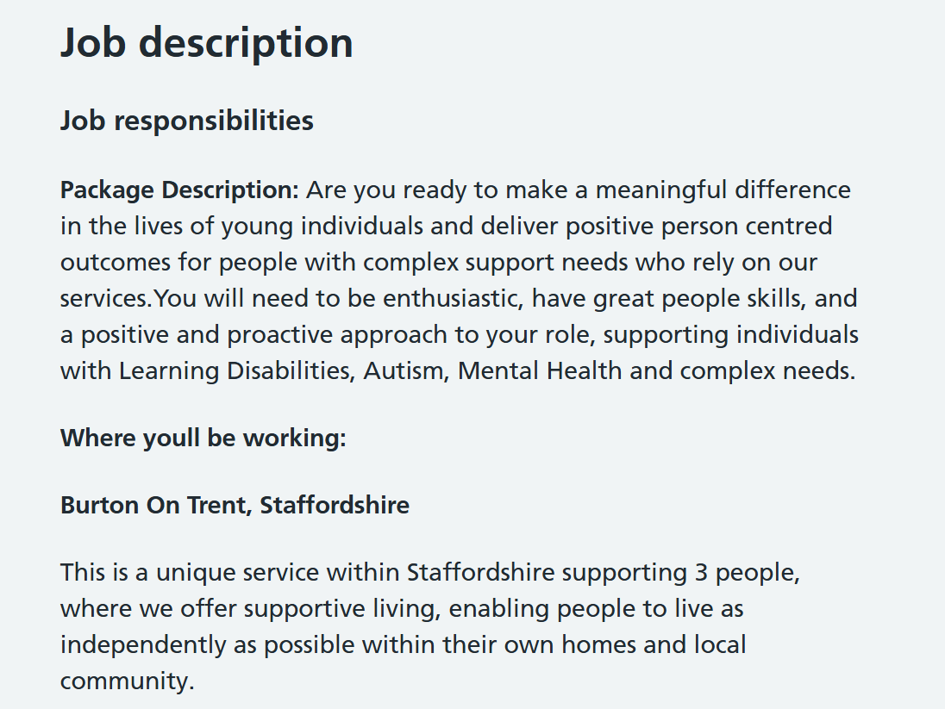
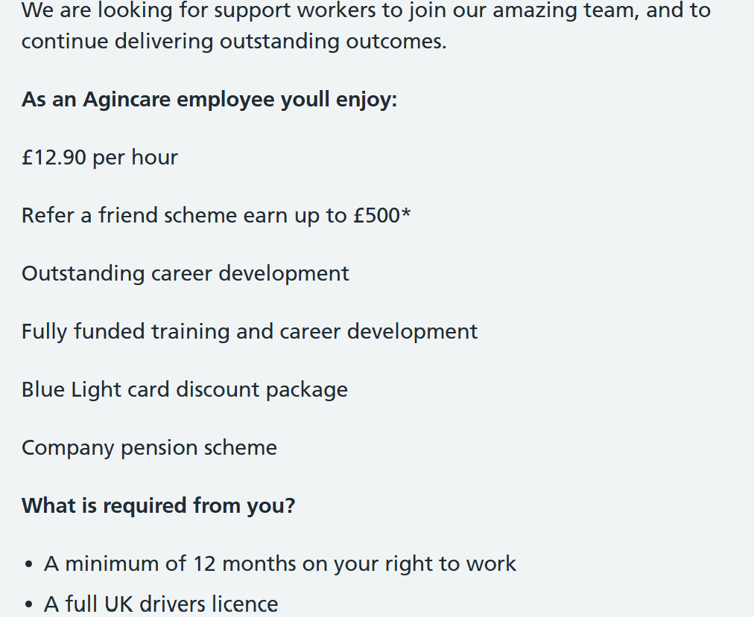
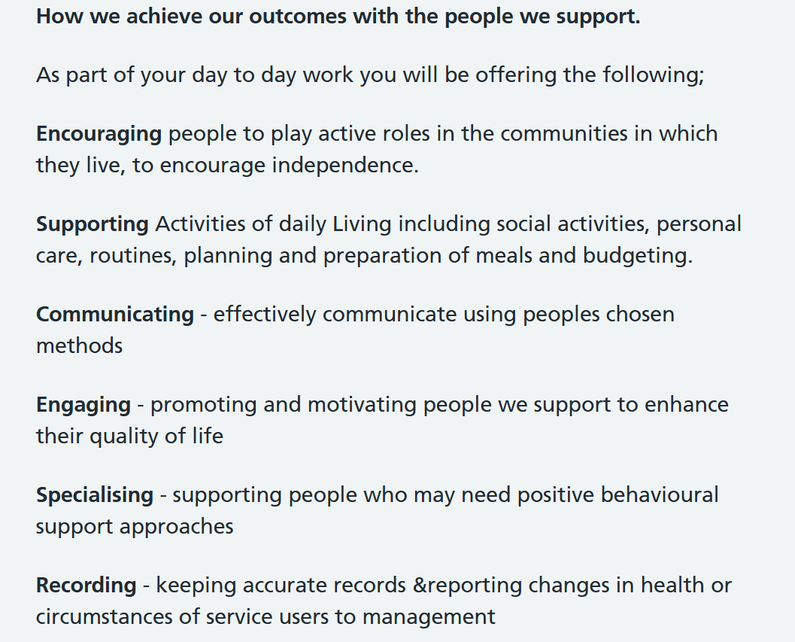

(Agincare, 2026)

Job Role Employability Skills
Several key employability skills emerge from the Agincare advert. Communication stands out as fundamental, since the worker needs to engage with everyone using whatever method suits them best this might involve non-verbal signals, established routines,or communication aids, given that the client group includes people on the Autism spectrum with complex needs. Getting this wrong could leave a person feeling ignored or upset, meaning this skill has a direct impact on care quality (Skills for Care, 2015).
People skills and building relationships are specifically flagged in the advert "great people skills" since earning the trust of the three individuals supported is vital to fostering their independence rather than simply doing things for them, reflecting the sector's wider emphasis on values-based recruitment (Skills for Care, 2024).
Using initiative and working independently are important because the posting explicitly looks for someone able to rely on their "own initiative" alongside working as part of a team. Support workers in a small supported-living environment frequently work solo or with limited oversight during a shift so confident independent decision-making is essential rather than needing constant manager check-ins.
Patience, resilience and a proactive attitude are required since supporting people with Learning Disabilities, Autism, Mental Health needs and complex needs can bring unpredictable behaviours or emotionally charged moments and the advert specifically mentions comfort with positive behavioural support methods, an approach widely promoted across the care sector (Skills for Care, 2015).
Organisation and support with practical life skills assisting with meal planning, budgeting and daily routines demand a methodical, organised worker since these tasks are meant to build the person's independence rather than being completed on their behalf.
Accurate recording and reporting are equally essential, as the worker must log activities properly and flag any changes in a person's health or circumstances to management and missed or inaccurate reporting could delay vital support or medical care and falls short of expected care standards (Care Quality Commission, 2023).
Lastly, flexibility and mobility shown through the requirement for a full UK driving licence, indicate that staff are expected to travel and help people access their local community rather than stay confined to one location

Evaluate Your Own Skills
Self-Assessment: My relevant background comes from my current position at Boots, chasing and processing customer orders. This has given me regular practice communicating clearly, staying organised under pressure, and resolving problems when an order hasn't gone to plan, alongside frequent contact with customers, including some who are elderly or unwell. My BSc in Health and Social Care has also provided theoretical grounding in care values, safeguarding and the needs of people with disabilities, autism and mental health conditions. To assess my own skills objectively, I used a SWOT analysis (Humphrey, 2005) to identify strengths and gaps against the role and applied the Johari Window (Luft and Ingham, 1955) to consider how my communication style comes across to others. I do not currently hold formal certificates in first aid, safeguarding or positive behavioural support, nor have I undertaken paid or voluntary care work and building this experience is the main focus of my action plan below.
Strengths: My most notable strengths are communication, organisation and confidence dealing directly with the public. Chasing customer orders at Boots has taught me to stay calm and clear when someone is upset, while managing several tasks accurately under pressure both aligning with the advert's emphasis on people skills and initiative. I also already hold a full UK driving licence, meeting one of the practical requirements of the role directly. My degree has equipped me with a solid theoretical understanding of supporting people with Learning Disabilities, Autism and Mental Health needs. My unique selling point lies in combining practical customer-service skills with academic knowledge of disability and mental health support.
Areas for Improvement: My most obvious gaps are direct, hands-on experience supporting people with Learning Disabilities, Autism or complex needs, since my role at Boots is customer-facing rather than care-delivery based. I do not yet hold accredited training in positive behavioural support and I have not yet gained experience recording and reporting on someone's health or wellbeing in a professional setting.
Who can help: My course tutor and university careers team can help me benchmark my self-assessment and prepare application materials. My manager at Boots can offer feedback on my communication and problem-solving abilities. Once I gain relevant experience, a supervisor at Agincare could support my development of positive behavioural support skills, while coursemates with care experience could offer peer feedback. I also intend to keep a reflective log using Gibbs' Reflective Cycle (Gibbs, 1988) to turn everyday experiences into clear, evidenced examples of my development.

Create an Action Plan and Timeline
Action Plan: To address the gaps outlined above, I will combine training, hands-on experience and personal growth. This involves undertaking free or affordable online courses covering safeguarding, first aid and positive behavioural support and building direct experience supporting people with Learning Disabilities, Autism or Mental Health needs through voluntary work or a part-time care position using resources such as the National Careers Service (2026) to identify suitable training routes and funded course options available to me locally. I will also maintain a reflective log, updated regularly to convert everyday experiences from Boots and my studies into clear, evidenced examples I can draw on for future job applications and interviews.
The Timeline below is split into short-, medium- and long-term goals across the next five years:
- Short-term (now – 12 months, whilst completing my degree): Complete free online training in safeguarding, first aid and an introductory positive behavioural support course and take on regular voluntary work within a care or disability support setting to gain direct, hands-on experience and request structured feedback from my Boots manager on my communication and problem-solving abilities and act on it visibly to show clear improvement over time; research local charities and organisations supporting people with Learning Disabilities and Autism to identify suitable volunteering opportunities.
- Medium-term (1–3 years, following graduation): Obtain a paid Support Worker position, ideally in supported living, drawing on my degree, driving licence and voluntary experience as supporting evidence; complete an accredited positive behavioural support qualification along with any necessary mandatory training (such as manual handling or medication administration) to meet expected care standards (Care Quality Commission, 2023); establish a solid, well-documented track record of accurate recording and reporting within a professional care environment.
- Long-term (3–5 years): Work towards a Senior Support Worker or Team Leader position, taking on responsibility for supervising newer team members, contributing to individual support plans and mentoring colleagues new to the sector and consider pursuing a recognised qualification such as a Level 3 Diploma in Health and Social Care (Skills for Care, 2024) to underpin this progression and continue developing specialist knowledge in areas such as Autism, Mental Health or complex needs support.
Reviewing this plan every six months alongside my course tutor will let me adapt the timeline should training providers, funding, or the availability of suitable voluntary or paid roles change, keeping the overall plan realistic and responsive rather than fixed.

Building Your Personal Brand
A personal brand for this role should convey reliability, compassion and a genuine commitment to supporting people with Learning Disabilities, Autism and Mental Health needs. I will develop this mainly through a LinkedIn profile (LinkedIn Corporation, 2026) showcasing my Health and Social Care BSc, my customer-facing experience at Boots, and any care-related training or voluntary work, using a consistent, professional tone and where possible, a recommendation from my Boots manager.
Resources: LinkedIn will serve as my main platform, alongside university careers events and networks linked to disability and mental health support organisations such as Skills for Care (2024) and a personal website isn't essential at this stage but could later showcase a portfolio of training certificates and reflective case studies once I have built up relevant experience. I will ensure my online presence (LinkedIn together with a professional email address) matches my CV, while steering clear of personal social media content that might seem at odds with a caring, professional image.
Content: Where suitable, I could post brief reflections on relevant health and social care news, training courses completed or voluntary experiences on LinkedIn, showing ongoing dedication to the field to anyone viewing my profile, while never revealing confidential details about the people I support or customers I've helped.

Promoting Your Professional Identity
CV and Cover Letter: I will shape my CV closely around the main requirements set out in the Agincare advert, applying the STAR technique (Situation, Task, Action, Result) to demonstrate my Boots and academic experience against each point for instance, presenting order-chasing as evidence of organisation, initiative and staying calm and communicative under pressure. My supporting statement for applications will directly mirror the qualities the advert looks for, such as enthusiasm, a positive and proactive attitude, and confidence using positive behavioural support methods, reflecting the values-based approach increasingly used in care sector recruitment (Skills for Care, 2024). I will also ask my course tutor to review a draft before submitting any application, to ensure my language and examples are pitched appropriately for the sector.
Online Presence: I will keep an updated LinkedIn profile (LinkedIn Corporation, 2026) that builds on my CV with a fuller account of my experience and any certificates gained, visible to potential employers. As my care-related experience develops, I could create a simple personal website or digital portfolio to showcase reflective case studies and training evidence, offering employers a richer, more detailed picture of my progress than a CV alone can provide.

Building a Network for Successful Employment
Networking is particularly valuable in health and social care, where vacancies are often filled through word-of-mouth, referrals, or direct contact with an employer and where speaking to people already working in the sector offers more realistic insight than a job advert alone (NHS Health Careers, 2026). Building these connections early increases my chances of hearing about opportunities, gaining honest feedback and securing strong references.
Potential mentors include my current manager at Boots, who can speak to my communication and reliability and university course staff who can support my academic development. Once I begin voluntary work or a part-time care role, a supervisor or senior support worker would offer valuable guidance, particularly around positive behavioural support and working with people with complex needs. Relevant organisations include Skills for Care (2024), local disability and mental health charities in the Burton and Staffordshire area, and my university's alumni network.
Attending local job fairs, university careers events, and open days run by providers such as Agincare would let me speak directly to people working in supported living roles, helping me understand day-to-day realities of the job and refine both my applications and longer-term career plan.

Conclusion
I already have relevant employability skills for a Support Worker role communication, organisation and confidence with the public built through Boots and my Health and Social Care degree, plus a full UK driving licence meeting one practical requirement. My shortfalls, positive behavioural support training and hands-on care experience, are addressable through a five-year action plan combining training, voluntary work and paid experience.
A consistent personal brand across LinkedIn, my CV and my professional network will help convey my genuine commitment to this field despite lacking formal care qualifications currently. This role represents an achievable step from my current background towards direct, person-centred support work, letting me make a real difference while building my career in health and social care.

References
Agincare (2026) Support Worker [Online]. Available at: https://www.jobs.nhs.uk/candidate/jobadvert/L0014-26-1083?country=GB-ENG&keyword=support%20worker&location=DE15%209LT&distance=5&language=en (Accessed: 8 July 2026).
Care Quality Commission (2023) The Fundamental Standards. London: CQC.
Gibbs, G. (1988) Learning by Doing: A Guide to Teaching and Learning Methods. Oxford: Further Education Unit, Oxford Polytechnic.
Health Education England (2014) Values Based Recruitment Framework. Leeds: Health Education England.
Humphrey, A. (2005) 'SWOT Analysis for Management Consulting', SRI Alumni Newsletter. Menlo Park: SRI International.
LinkedIn Corporation (2026) LinkedIn Learning: Building Your Personal Brand [Online]. Available at: https://www.linkedin.com/learning (Accessed: 8 July 2026).
Luft, J. and Ingham, H. (1955) 'The Johari Window, a graphic model of interpersonal awareness', Proceedings of the Western Training Laboratory in Group Development. Los Angeles: UCLA.
National Careers Service (2026) Explore Careers: Support Worker [Online]. Available at: https://nationalcareers.service.gov.uk/job-profiles/support-worker (Accessed: 8 July 2026).
NHS Health Careers (2026) Working in Health and Social Care [Online]. Available at: https://www.healthcareers.nhs.uk (Accessed: 9 July 2026).
Skills for Care (2015) Core Skills Training Framework. Leeds: Skills for Care.
Skills for Care (2024) Values Based Recruitment Toolkit. Leeds: Skills for Care.

