University Of Wales

Trinity Saint David

THE GLOBAL BUSINESS ENVIRONMENT (LCBB4005)

– Assignment 1

Name: Ivan Medarev
Student Number: 1920485
Module Title: The Global Business Environment
Module Lecturer: Dr. Rexon Nting
Assignment Title:
Environmental Analysis of Global Car Industry And Bentley Motors

Table of Contents
Introduction 3
Task 4
Conclusion 13
Reference 14

Introduction
The concept of Business Environment refers to the environmental factors that influence the operations and decision making in the companies at a geographical location. The macro-environment involves political, economical, social and legal elements affecting the company operations, while micro-environment refers to the internal elements like competitiveness, brand image, employee base and revenue of the organisation. This study would discuss the environmental factors affecting the global car industry in context to Bentley Company. Furthermore, this study would also focus on growth opportunities and global issues influencing the Bentley Company.
Bentley Motors Company was established in the year 1919 by Walter Owen Bentley. The company manufactures and sells large number of luxury SUV cars in the global market, with the current headquarters at Crewe, England (bentleycareers.com, 2020).

Task
(a) Explain the major forces shaping the business environment of the car manufacturing industry. In your analysis, you should explain how the industry has changed in the last few years.
The automotive industry has been evolving with the rise in technology and easy availability of resources through maintaining global relationships with stakeholders. The major macro-environmental factors influencing the car industry in UK is being analysed through using PESTLE Analysis.
- Political factors
Brexit: The emergence of Brexit has affected the global companies in automotive industry as trading in Britain requires following separate regulation. Brexit refers to Britain exiting the European Union in 2020 (Sampson, 2017). The car industry have distributors and suppliers in different parts of Europe, therefore, there might be issue in complying with dual legislation for international trading.
- Economical Factors
The economical condition of UK has been stable with a GDP growth of 1.4% in the year 2019 (countryeconomy.com, 2019). Favourable economical condition offered good scope for the car industry to enhance their business of luxury and electronic vehicles. However, the outbreak of Covid-19 in resulted in loss in GDP, with the UK government assuming there might be a fall of 14% GDP, which would be affecting all the business companies (bbc.com, 2020). This would have an adverse effect on the UK economy, and hence affect the sale of luxury cars.
- Social Factors
Popularity of Driving
The demand for passenger cars and luxury vehicles has been increasing with the years, developing the trend of driving. Moreover, the growing population of UK has demand for transportation services, which drives them to purchase personal cars. This enhances the opportunity for car industry to manufacture more vehicles with innovative features.
- Technological Factors
Self-Driving Cars: The technological advancement has benefitted the Car industry to bring innovative features in the luxury cars. The self-driving technology has enables manufacturing autonomous motor and electrical engines in the new cars. As UK stands on the fifth position among 129 nations in the Global Innovation Index, Bentley would be able to access high technological resource, while trading in UK (globalinnovationindex.org, 2020).
Improved Safety: The advance technology has also helped the car industry to add more safety features along with exclusive luxurious appearance of the cars. For instance, Bentley uses the new technology for providing anti-lock brakes, side-impact airbags, electric engines and motors along with automatic lock systems (Coffey and Thornley, 2020).
- Legal Factors
Copyright Issues
The Car industry encounters the issue of Copyright as the car manufacturing companies need to secure and protect their blueprints, innovative designs and the ideas related to new projects through using legal elements like trademark, patent or copyrights. Bentley uses patents and trademarks for protecting their designs and innovative ideas from being copied or stolen by other car companies. The car companies also integrate the Copyright, Designs and Patents Act 1988 for protecting their innovations and designs (legislation.gov.uk, 2020).
- Environmental Factors
Emissions Policies
Apart from assessing the safety factors related to the automotive industry, the UK Government also focuses upon the effect of vehicles on the environment. Almost all types of vehicle are powered by fuels (Petrol and Diesel), which releases high amount of carbon emissions and causes air pollution. Therefore, as per the governmental policies, the car industry need to provide report regarding the statistics and data associated to carbon emission from the vehicles (Favaro, 2020).

SWOT Analysis
Strengths | Weaknesses
- Evolving industry: The car industry is rapidly growing with creating job opportunities and enhancing the global economy.  - Technology and innovation: The emergence of technological resources has enabled manufacturing electrical vehicles.  - Growth and demand shifting to Asian markets has increased global business of the car industry.  - The demand for luxury cars has been beneficial for growth of the car companies like Bentley, Volvo etc. | - Cars recalled: Recalling cars due to technical and functionality issues and non-abidance to governmental policies is a weakness for the car industry.  - Bargaining power of buyers has been a major issue for car companies like Bentley, due to high competition in the market of luxury cars. People have more choices of brands (Bentley et al., 2017).  - Growth rate is being affected by various factors like no entry of cars from other nations and fuel price fluctuations.
Opportunities | Threats
- The leading car manufacturers like Bentley have good scope to enhance their business through designing and launching fuel-efficient vehicles.  - Strategic Alliances between leading companies would be beneficial to create differentiating features.  - Changing lifestyle of the people has led to more demand for luxury cars, which Bentley can analyse and manufacture cars as per customer demand. | - Intense Competition: Large number of car manufacturing companies in the global market increases the competition for Bentley, Volvo, and Mercedes Benz etc.  - Volatility in fuel-prices influences the purchasing behaviour of the customers, hence can reduce growth of the car industry.  - Investment in R & D requires high expenditure, which s a threat to increase profit by the car manufacturers.
Table 1: SWOT Analysis of Automotive Industry for Bentley
The evolution of Car Industry
Technology has been redefining the manufacturing, designing, maintaining and operating of cars since the 20th century. However, much before that technology already played a role in redefining ways for manufacturing engines and using fuels for the car industry. Over the years, technology has supported the engineers to manufacture electric engines, brakes and motors using solar energy. This helped the car companies to replace the combustible engines with hybrid-engines and electric engines that run by electric energy instead of fuel and reducing carbon emission (Nunes et al., 2016).
The leading automotive companies started to invest upon technology to develop innovative features like ‘Autonomous Emergency Brakes’ (AEB) that includes lidar technology, radar and cameras for analysing the roads and prevent collisions (oponeo.co.uk, 2020). The car companies also started integrating software in the luxury cars, for instance Google map for analysing routes. Apart from that the emergence of self-driving cars with speed regulatory system has also enhanced the growth and opportunity of car industry in the global market.
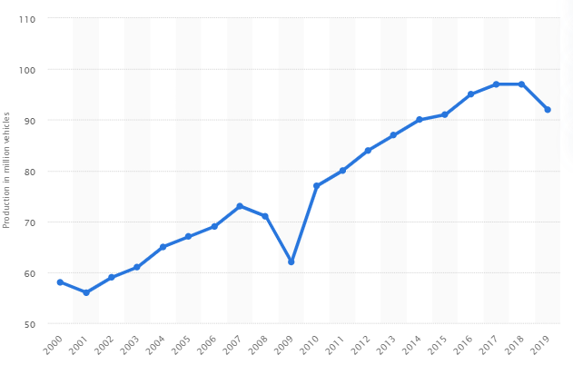
Figure 1: Worldwide production of cars
(Source: Statista.com, 2020)
The automotive industry of UK generated a profit of £82 billion, which contributed £18.6 billion to the nation’s economy in 2019. More than 92 million cars were manufactured worldwide in 2019, depicting rapid growth of the global car industry (Statista.com, 2020)
However, it can be estimated that there would be a fall in sale and production of cars in 2020 due the outbreak of the pandemic disease, Covid-19.
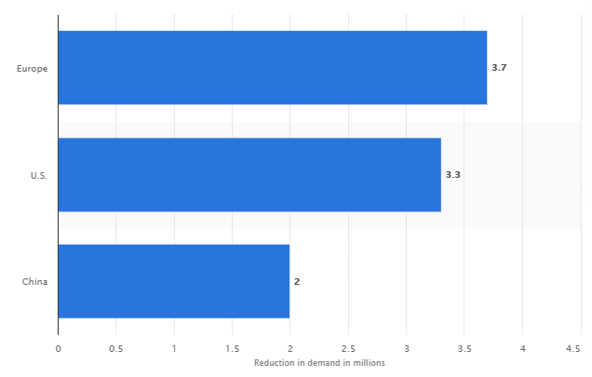
Figure 2: Fall in number of vehicles in 2020
(Source: Statista.com, 2020)
The pandemicCovid-19 resulted in limitation and obstruction in the business operations and supply management for the car companies along with affecting the economy and social condition of the world. This has highly affected and reduces the sale of the car companies in 2020.

(b) Provide a critical assessment of the opportunities and challenges that these forces present and discuss how firms can best position themselves to gain a competitive advantage.
Porter’s Five Force
Threat of new entrants: Low
Manufacturing vehicles with innovative features requires high investment and good financial resources (Musonera and Cagle, 2019). Therefore, it is difficult for new companies to enter the automotive industry and start manufacturing cars, depicting low threats from new entrants for the existing car manufacturers like Bentley.
Bargaining power of suppliers: Low
The suppliers have very low power over the car manufacturers as they need to produce and supply products based on the demand and requirement of the car companies. Moreover, the leading car brands like Bentley, Toyota, Ford and BMW hold high clout as the spare parts and raw materials are available in plenty. Hence, car manufacturers can easily switch supplier teams, enjoying high power over the suppliers.
Bargaining power of car-buyers: Moderately high
The demand of buying vehicles is growing among the people. Corporate companies tend to purchase fleet of cars for business purpose, which also enhances the sale. Hence, the car manufacturers need to assess the demands and purchasing behaviour of the buyers and design and launch cars with features that would fulfil the customer demands. However, the people tend to find the best features in exchange of minimum possible payment. Therefore, there is chance of witching brand by the buyers, which depicts moderate bargaining power of buyers over the car manufacturers.
Threat of substitute products: Low
The substitute to personal vehicles is public transport services like taxis, trains, buses etc. Therefore, the car industry has good scope and opportunity to grow and increase manufacturing cars in Europe and other parts of the world (Huang, 2019). The threat of substitute is quite low for the car industry. However, in context to Bentley in particular, the threat would be high as there are other luxury car brands like Mercedes Benz, Ford and BMW offering highly innovative and luxurious electric cars.
Competitive rivalry: High
The competition among the companies in the automotive industry is high with high exit barriers. Any manufacturer trying to leave or exit the industry would be bearing huge losses. Though the different car brands target different groups and market segment, they often end up overlapping enhancing competition level. Furthermore, the brands also raised the level of competition in context to designs, innovation, rice, safety features, technology and quality of the vehicles.
Product Life Cycle
The companies under the automotive industry can utilise the tool called ‘Product Life Cycle’ for examining the equipments and spare parts supplied by their teams of suppliers.
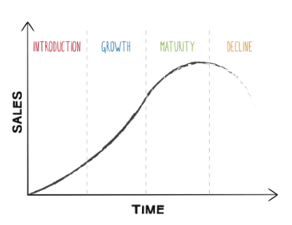
Figure 3: Product life cycle
(Source: Hedberg et al., 2017)
Introduction
This stage involves the car manufacturers creating news and awareness about their latest techniques and designs that would be integrated in their new vehicles. This helps to raise interest level among the buyers and reach out to more targeted people.
Growth
The growth stage refers to enhancing the company’s brand image through developing more awareness campaigns and advertising through effective modes. This highly affects the purchasing behaviour of the interested buyers (Tao et al., 2016). Bentley uses social media and digital platform for creating awareness about their luxury cars with new technology and innovation.
Maturity
The ‘Maturity’ stage comes, when all the promotional activities are completed and the manufacturer has already shared all the important information regarding their latest vehicle model. This stage involves marketing campaigns for increasing the sale of the product and enhancing the customer base.
Decline
The price and popularity of the particular product or vehicle tends to drop in the market in this stage. Often, the manufacturers face the decline phase of a vehicle due to new technology and new models with differentiating features entering the market.
Porters Value chain
The model of Porter’s Value Chain is discussed i context to the Automotive Industrry.
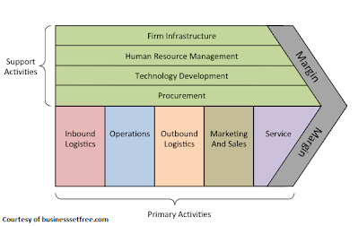
Figure 4: Porter’s Value Chain
(Source: Ruan, 2020)
Inbound Logistics
This refers to getting all the important spare parts and raw materials delivered to the manufacturers by their suppliers. Inbound logistic department in the car manufacturing companies also maintains the inventories. In context to Bentley, the company require different types of devices, machines, technology and spare parts for manufacturing their luxury cars, hence managing the inbound logistics is highly important.
Operations:
The Operation department of the car companies involve their research teams, who are responsible for assembling the spare equipments and manufacturing the cars with innovate features and designs (Simatupang et al., 2017). As Bentley deals in luxury cars, their operational team plays a great part in integrating the technological features like Automated locks, auto-brakes, electric engines etc in the cars.
Outbound Logistics:
This stage involves completion and inspection of the car models with new technology and features followed by delivering them to different venture experts for product analysis. The venture analysers inspect the features and technology and decide the value of the new cars.
Sales and Marketing:
This stage involves market segmentation and positioning of the latest car models in the suitable markets, where they can get maximum buyers. Hence, this stage also involves all kinds of promotional activities by the car manufacturers.
Services:
The success of the automotive industry is highly based upon both product and their services. The car manufacturers need to deal with different factors in respect to services, for instance, post sale services, examining performance of the new vehicles, buyers’ complaints etc. Bentley offers their post sale services through their physical outlets along with 24x7 online chat options for their customers.

Conclusion
The emergence of electric vehicles in the Car industry has been successful through using high technology and innovation. The government prioritises the environmental issues like increasing pollution due to vehicles run by fuels. Therefore, many luxury car companies like Bentley are planning to manufacture electric luxury cars and reduce air pollution. The global car manufacturers encounter low threats from new entrants, suppliers and substitution. Moreover, there is high scope for growth for the car industry, especially for the leading brand like Bentley as they can invest and use the technological resources and develop differentiating features for their luxury cars.

Reference

bbc.com 2020. Bank of England warns of sharp UK recession [Online] Available at: https://www.bbc.com/news/business-52566030 [Accessed: 1 August 2020].
Bentley, G., Bailey, D. and Braithwaite, D., 2017. Resilience, adaptation and survival in industry sectors: remaking and remodelling of the automotive sector. In Creating Resilient Economies. Edward Elgar Publishing.

bentleycareers.com 2020. Official Bentley Careers website | About Bentley [Online] Available at: https://www.bentleycareers.com/en/about.html#:~:text=Inspired%20by%20our%20customers%2C%20we,most%20desirable%20high%20performance%20cars. [Accessed: 1 August 2020].
Coffey, D. and Thornley, C., 2020. Britain’s Car Industry: Policies, Positioning, and Perspectives. In New Frontiers of the Automobile Industry (pp. 137-161). Palgrave Macmillan, Cham.
Favaro, N., 2020. Has the green economy revolutionized the car industry and customers choices? (Bachelor's thesis, Università Ca'Foscari Venezia).

globalinnovationindex.org 2020. Global Innovation Index | Creating Healthy Lives-The Future of Medical Innovation [Online] Available at: https://www.globalinnovationindex.org/Home [Accessed: 2 August 2020].
Hedberg Jr, T.D., Hartman, N.W., Rosche, P. and Fischer, K., 2017. Identified research directions for using manufacturing knowledge earlier in the product life cycle. International journal of production research, 55(3), pp.819-827.
Huang, Y., 2019, December. Strategic Environment Analysis of Logistics Enterprise based on SWOT-PEST-Michael Porter's Five Forces Model--Taking SF Express as an Example. In 2nd International Symposium on Social Science and Management Innovation (SSMI 2019). Atlantis Press.

legislation.gov.uk 2020. Copyright, Designs and Patents Act 1988 [Online] Available at: https://www.legislation.gov.uk/ukpga/1988/48/contents [Accessed: 2 August 2020].
Musonera, E. and Cagle, C., 2019. Electric Car Brand Positioning in the Automotive Industry: Recommendations for Sustainable and Innovative Marketing Strategies. Journal of Strategic Innovation and Sustainability, 14(1).
Nunes, B., Bennett, D. and Shaw, D., 2016. Green operations strategy of a luxury car manufacturer. Technology Analysis & Strategic Management, 28(1), pp.24-39.

oponeo.co.uk 2020. How new technologies have changed the automotive industry » Oponeo.co.uk [Online] Available at: https://www.oponeo.co.uk/blog/how-new-technologies-have-changed-the-automotive-industry [Accessed: 1 August 2020].
Ruan, S., 2020, April. Research on Strategic Cost Management of Enterprises Based on Porter’s Value Chain Model. In Journal of Physics: Conference Series (Vol. 1533, No. 2, p. 022056). IOP Publishing.

Sampson, T., 2017. Brexit: the economics of international disintegration. Journal of Economic perspectives, 31(4), pp.163-84.
Simatupang, T.M., Piboonrungroj, P. and Williams, S.J., 2017. The emergence of value chain thinking. International Journal of value chain management, 8(1), pp.40-57.

statista.com 2020. Auto demand amid COVID-19: reduction by market | Statista [Online] Available at: https://www.statista.com/statistics/379770/vehicles-lost-due-to-auto-plant-stoppages-in-selected-regions/ [Accessed: 1 August 2020].

statista.com 2020. Car production: Number of cars produced worldwide 2018 | Statista [Online] Available at: https://www.statista.com/statistics/262747/worldwide-automobile-production-since-2000/ [Accessed: 1 August 2020].
Tao, F., Wang, Y., Zuo, Y., Yang, H. and Zhang, M., 2016. Internet of Things in product life-cycle energy management. Journal of Industrial Information Integration, 1, pp.26-39.

tradingeconomics.com 2020. United Kingdom GDP Growth Rate | 1955-2020 Data | 2021-2022 Forecast | Calendar [Online] Available at: https://tradingeconomics.com/united-kingdom/gdp-growth [Accessed: 1 August 2020].

