BA Business Management
Management Economics
LCBB5008
Individual Report

Module Leader: Muno Zuwirai

Table of Contents
Introduction 3
Literature Review 4
Project portfolio structuring 4
Importance of Project Portfolio Organization for Organizational Success 5
Business Success 5
Organisational Strategy 6
The Heart of Tesco's Business Model 6
Profit Maximisation and Business Success 7
Impact of Organisational Strategy on the Success of Profit Maximisation 8
Balanced Score Card of Tesco 9
Porter’s Five Forces framework– Tesco: 10
Conclusion 11
Recommendations 11
References 12

REPORT

To: Tesco Executive Committee
From:Business Planning Director
Date:20/10/2023
Subject:Business Report

Introduction
In the project management canon, the goals of business report have been thoroughly outlined. Portfolio value maximisation, aligning the portfolio with the firm's strategy, and balancing projects within the portfolio while considering the firm's resources are the primary objectives. However, several studies have criticised the common practice of treating projects and their success as separate objects for the purposes of analysis and evaluation. Researchers conclude that effective business report requires effective single-project management but is not a sufficient condition for the latter. Measuring an organisation's performance is crucial because it reveals the extent to which the business is successful and the areas where it needs to grow and improve. In any case, a company's performance can be evaluated in terms of its competitive advantage or the attractiveness of its industry. One way businesses can increase their bottom line is by strengthening their competitive advantage by expanding and improving internal resources and capabilities. However, industry attractiveness makes a particular market lucrative; it is created when a company has access to a valuable strategic resource and the capabilities that have traditionally been present in the market. Because of this, the Balanced Scorecard (BSC) framework will be used to evaluate Tesco's success relative to its competitors.

Literature Review
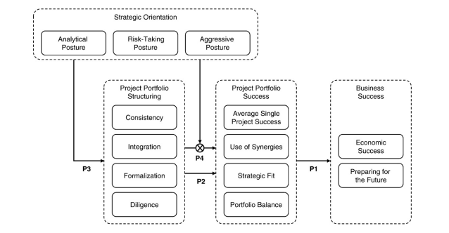
Image 1: Strategic focus, business report, and end results: a theoretical framework

Project portfolio structuring
According to the source, "portfolio selection" can refer to various activities. Depending on the author, "project selection" can mean either the final step in the process or the entire procedure. Project prioritisation can be used in the broadest sense to describe a collection of related endeavours. Others stress the significance of reviewing ongoing projects, while others use the procedure exclusively for new ones. Strategic planning, project assessment, and portfolio selection are ongoing processes that apply to all pending and newly proposed projects that successfully advance business goals without exceeding the budget or other constraints. For clarity, we will refer to this activity going forward as "project portfolio structuring." There is no universally accepted theoretical framework for measuring the degree of portfolio structuring because the process of project portfolio structuring varies from organisation to organisation. As a result, (1) Strategic portfolio analysis evaluates how well a company's projects and programmes fit in with its overall business and corporate goals. (2) The level of formalisation, which looks at the uniform application to all projects, covers topics like project evaluation and portfolio selection. Finally, the constraints within the structuring process can be considered by the degree to which (3) the firm's functions are integrated and (4) due diligence is exercised when selecting the portfolio. The scope of this study does not include an examination of the various tools for evaluating projects that have been the subject of other studies (Martinsuo, 2013).

Importance of Project Portfolio Organization for Organizational Success
Project portfolio structuring entails assessing and ranking potential new projects alongside ongoing initiatives and deciding which to pursue. The success of the project portfolio is directly tied to the projects chosen to receive good management. Portfolio selection has been linked to project success in several studies. Prioritisation is crucial to the success of portfolio management, but experts agree that there is a serious lack of systematic project evaluation and portfolio selection. According to a quantitative, empirical study, successful project portfolios have been shown to have a direct correlation to the portfolios' owners' decision-making processes (Jonas, 2010).

Business Success
For the most part, businesses only use financial metrics to gauge their performance. Models for assessing achievement that considers multiple dimensions, like The Balanced Scorecard, were developed in response to the overwhelming evidence that traditional metrics alone cannot predict a company's long-term viability. Research in the field of project management has therefore suggested looking at business report and its success from various angles, including the project, portfolio, and business levels. This study modifies and employs the project success framework in a portfolio context because there is no widely accepted multi-dimensional model for project portfolios. Researchers claim that when evaluating the success of a project, or a portfolio of projects, one must consider the final product's quality and the project's performance throughout its execution. Since project and product success are integral to the model, there will be no differentiation between the two, as there has been in many previous studies. The first two success dimensions discussed in this research, project efficiency and customer impact, were previously covered by the average single success dimension during the project's execution phase. The third dimension, "business success," and the fourth dimension, "preparing for the future," focus on the project's outcomes and, as a result, analyse the project's immediate and long-term financial effects. Business and corporate success are taken into account by these product-related metrics. Therefore, the portfolio perspective is adopted and adjusted to achieve both short-term (1) economic success and long-term (2) future preparation (Schwalbe, 2009).
Market and business performance make up economic success. This metric measures how the company's project portfolio affects the business. New product success measure in research and writing about product development. Market success is hitting sales goals like market share or volume. These goals are often evaluated based on comparable companies' achievements to account for external factors. Commercial success is measured using ROI, profit, and break even. A study on project success measures examined market and commercial criteria, leading researchers to conclude that the combination of measures depends on the firm's situation and strategy. No one agrees on how to measure market and commercial success in projects or portfolios. The financial success of the firm's project portfolio is measured by comparing the percentage of revenue generated by new products to that of competitors, with and without predecessor products. Compliance with market goals, ROI targets, and amortisation plans is also evaluated. Economic success only matters for product-related projects and portfolios. Portfolios and projects that have a bearing on the organisation's cycle time, yield, quality, etc., can be tracked and evaluated (Schwalbe, 2009).

Organisational Strategy
In the long term, it is necessary for firms to make strategic decisions in order to keep their competitive edge over other companies. Researchers are firm proponents of the concept that company actions may be called strategic if they result in a demonstrable and long-lasting competitive advantage. This idea has gained a lot of traction in recent years (Salter, 2014).
According to the study, optimal business performance requires blending operational efficiency and strategic planning. He also says that to outperform competitors, a business must use methods they don't. Strategic positioning includes variety, needs, and access. Target, Woolworth (Woolco), and K-Mart opened alongside Tesco. Both other retailers failed and filed for bankruptcy, but Target has been successful with Tesco's help. Porter's five forces model explains strategic decision-making. The model outlines the basics of launching a new business, such as supplier bargaining power. While franchising Franklin, he looked for cheaper deals to pass on to customers and profit from volume and bulk purchases. Customers pay less at discount stores. Tesco's expansion has made it a target for new entrants, so it frequently buys up smaller competitors. It is the world's largest retail industry, but Super Target, Walmart, etc. compete fiercely (Larson and Gray, 2014).

The Heart of Tesco's Business Model
Tesco shattered its own sales record with $244.52 billion in 2003, confirming its status as the world's largest company. Mike says Tesco's workforce has grown by 11.256 percent since 2002, when there were 1,283,000 workers. Tesco has a great approach for managing its 4,150 stores worldwide, as seen below. Tesco's thrifty culture, lack of regional offices, and joyful work environment help it beat competitors' prices. The executive staff travels often, and Saturday meetings are usual. These meetings don't have dress rehearsals. Tesco does a great job managing and protecting its most valuable asset, its people. The manager's pay depends on the businesses he controls. Bonuses and salary increases are based on the firm's financial success and individual contributions via promotions. (Foote and Krishnamurthi, 2001).
Tesco employees are not unionised since the company handles their benefits and trains them on them. Tesco offers POS terminals, a store performance measurement system, real-time market research tools, a satellite system, and universal product codes (UPC). Tesco’s goal is to provide cheap pricing on a range of products and services. One of its procurement tactics is aggressive negotiation; others include building relationships with suppliers and centralising purchase and planning. Tesco's profit margin is increased with automated cross docking, pick-to-flight, EDI, and a hub-and-spoke network. Tesco’s model is innovative in many ways: the company has monopolies in some smaller towns; its stores have low rental costs; its prices are set locally; the company is expanding circularly; it sells name-brand and private-label products; it has limited storage space; it has stores within stores; etc. The store manager sets prices, while community members help with merchandising and promotion. Tesco's daily cheap pricing and loyalty programmes enabled by point-of-sale information technology create the store's core components, which increase the company's bottom line via larger volume sales and inspire consumer confidence (Foote and Krishnamurthi, 2001).

Profit Maximisation and Business Success
Success in any business depends on the quality and efficiency of its operations. Only with superior management and efficient control can a company outperform its rivals or competitors in the market and create a difference from the others, attracting customers. A company is more effective than its competitors if it performs its operations at the same level or even better. According to research, Tesco is a master at shaping customers' opinions. Tesco price spin advertising campaigns have been criticised for creating the false impression that the retailer's prices are lower than those of its rivals. Advertising that "we have lower prices than anyone else" and setting a low "opening price point" are two of Tesco effective strategies for luring customers into its stores and keeping them there. The 'opening price point' refers to the store's absolute lowest price, prominently displayed to trick customers into thinking that the rest of the store's prices are lower (Jones and Schilling, 2014).
According to the SWOT analysis, Tesco has the strongest retail brand, the best reputation for value and commitment, and the largest selection of products. It is expanding rapidly in size and geographic reach, having recently merged with another company and acquired several others. Tesco sees significant growth potential in the European and Chinese markets, so it actively pursues merger and acquisition opportunities with market leaders and smaller retailers in those regions. Maintaining Tesco’s position in global markets is a constant source of competition. Being the industry leader on a global scale makes a company susceptible to the economic and political issues facing the country in which it is based. Executives work tirelessly to stay on top of the game by formulating policies and strategies to outperform the competition. Any business in the retail sector faces risks from laziness, imitation, substitutes, and hold-ups. However, Tesco plans to launch several sustainability initiatives to achieve its zero-waste and 100 per cent renewable energy goals (Jones and Schilling, 2014).
Market leader's reputation will suffer from divided public opinion. Technological advances reduce demand for a company's unique offering. Substitution threats can be subtle and sneaky, like when a company decides to meet with store managers via video chat instead of flying across the country. Substations are great for challenging hegemonic competitors. Once dangers are identified and understood, substitution offers solutions. To survive, the company should merge with or substitute for the threat. Customers, suppliers, or complementors with bargaining power gain value, causing contentious negotiations, binding contracts, and vertical integration (Muzumdar, 2014).
With over 2,000 Tesco stores in 16 countries and regions, Tesco has an impressive distribution network. They have over 2 million employees and over 100 million annual customers. If reports that Americans spend $26 million an hour at Tesco are accurate, then it stands to reason that the company is extremely prosperous and well-equipped to deal with competition. Tesco has effectively exhausted its potential for geographic expansion through mergers and acquisitions of smaller businesses. Therefore, Tesco is safe enough to maintain its dominant position in the retail industry thanks to its extensive store network and partnerships with ASDA, Target, and many others (Muzumdar, 2014).

Impact of Organisational Strategy on the Success of Profit Maximisation
There are several reasons for Tesco's hegemony in the UK, including the company's mysterious business model and the successful concealment of its weaknesses from competitors. Tesco’s included deliberate attempts to achieve market dominance in the retail sectors in which it operates. This includes growing the company through international and UK expansion, increasing brand awareness and customer satisfaction and venturing into new retail markets (Moore, 2009).
Any business needs superior resources and skills to succeed. Tesco helps it remain stable during economic downturns. Pereira says the company wants to dominate retail. Consumers trust Tesco’s price strategy. The plan is to buy goods cheaply and sell them for even less, maximising money made from each sale and minimising money spent on goods. Competition is fiercer than ever, so Tesco battles its rivals until it dominates the industry. Tesco wants to expand quickly. Tesco has 13,000 employees, 4000 stores (3000 in the UK), and 100 million weekly customers. Tesco has expanded internationally through mergers and acquisitions, including ASDA. Tesco's extensive retail footprint allows it to affect nearly every community in the UK. Tesco's expansion strategy has fed Europe. Tesco has expanded its international presence by acquiring 122 Woolco stores and 21 Wertkauf locations in the UK, Germany, and Canada. Tesco’s strategy ensures the company will lead the new market and limit competitors. Tesco is the world's largest retailer thanks to its success in several foreign markets (Herman, 2018).
Through careful planning and strategic execution, Tesco has significantly impacted three of the five forces in Porter's model: the threat of new entrants and intense competition from existing firms. To achieve its goal of customer satisfaction, Tesco has relied on selling products under its legal brand, even though these products are often cheaper alternatives. Due to the success of Tesco and other big-box retailers, low-priced chains no longer have a monopoly on the American retail market (Herman, 2018).

Balanced Score Card of Tesco
The Researcher has introduced BSC as a tool for evaluating systems that measure the material (financial) and immaterial assets, like the vision and the mission. There are now four viewpoints available to businesses thanks to BSC's efforts: four perspectives: (i) the customer's, (ii) the company's own processes, and (iii) the company's own development.
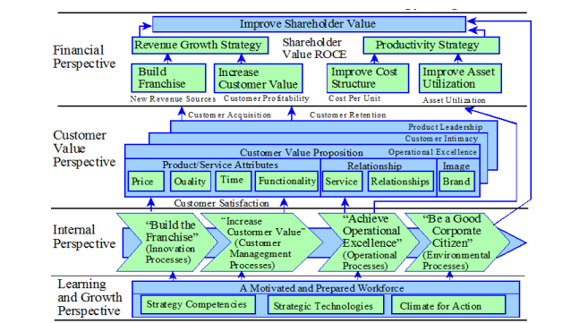
Image 2: Framework for Generic Strategic Management Based on the Balanced Scorecard

There is a hierarchical relationship between the perspectives, with each having its own set of strategy-derived goals that, once met, will help in pursuing the goals of the next perspective in the chain.

Porter’s Five Forces framework– Tesco:
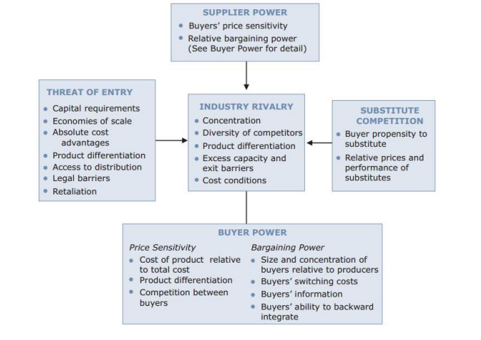
Image 3: The Five Factor Model of Porter
This framework generally examines five types of competitive pressure to gauge the industry's profitability. Each of these competitive forces is influenced by several factors that combine to form the industry's competitive landscape (Warrier, 2016).

Conclusion
In conclusion, this business report investigates how organisational strategy affects the performance of business report. In light of this, the literature on business report was integrated with the strategic orientation concept to form a more comprehensive framework. Four hypotheses were formulated after researching the connection between strategic orientation, project portfolio structuring, and project portfolio success. This included looking at how strategic orientation influenced the connection between the two. A comprehensive conceptual model was proposed by the team in order to shed light on the intricate relationship that exists between strategic focus, business report, and organisational success.

Recommendations
It is considered that Tesco pursues its goals by employing three overarching strategies: the Focus Strategy, the Differentiation Strategy, and the overall cost leadership. Managers put in a lot of effort to make their companies stand out from the competition and pinpoint the factors that convince customers to buy their wares. Therefore, the resources and capabilities that are unique to the firm are critical factors in explaining the firm's performance. The Resource-Based View (RBV) postulates that even highly competitive markets will exhibit heterogeneity due to significant and lasting differences in the resources and capabilities of individual competitors. The company's competence shows in its features and steady performance, much like Tesco’s logistics. Tesco has a solid foundation, and it's staffed with experienced managers and cutting-edge technology (Moore, 2009).

References
Foote, P.S. and Krishnamurthi, M., 2001. Forecasting using data warehousing model: Tesco's experience. The Journal of Business Forecasting, 20(3), p.13.
Herman, B., 2018. Making sustainability work: Best practices in managing and measuring corporate social, environmental and economic impacts. Routledge.
Jonas, D., 2010. Empowering project portfolio managers: How management involvement impacts business report performance. International journal of project management, 28(8), pp.818-831.
Jones, G.R. and Schilling, M.A., 2014. Strategic management: theory: an integrated approach. Cengage Learning.
Larson, E. and Gray, C., 2014. Project Management: The Managerial Process 6e. McGraw Hill.
Martinsuo, M., 2013. Business report in practice and in context. International journal of project management, 31(6), pp.794-803.
Moore, S., 2009. Strategic business report: enabling a productive organisation (Vol. 16). John Wiley & Sons.
Muzumdar, P., 2014. A Study of Business Process: Case Study Approach to PepsiCo. Available at SSRN 2392611.
Salter, A. , 2014. Going underground: Bootlegging and individual innovative performance. Organization Science, 25(5), pp.1287-1305.
Schwalbe, K., 2009. Introduction to project management. Boston: Course Technology Cengage Learning.
Warrier, L., 2016. Mr. Porter and the New World of Increasing Returns to Scale. Journal of Management Research (09725814), 16(1).

