Student Name: Charlie Barriscale

P Number: 2501144

Programme of Study: Graphic Design

Module: ADDA4023 Ways of Perceiving

Task: Curate an exhibition = 1363 words

The Shaping of Type

This exhibition has been curated with the purpose of providing a concentrated and intimate experience that explores the shaping of typography and how it has evolved through the years as well as the impact of specific typographic revolution. As stated by Bringhurst "Typography is the cat of endowing human language with a durable visual form" ( Robert Binghurst, 1992 ). The potential of typography is truly limitless and its ability to grow and expand overtime is what makes it truly fascinating. This tradition of visual language using letterforms can be dated back many of thousands of years.

This exhibition is being presented in a large circular hall with dim lighting. The pieces on display have a warm glow around them and are placed evenly from each other on the walls. This exhibition aims to bring light to the true nature of typography and how it is integrated into everyone's lives even without knowing in some cases. As Tschichold points out "Perfect typography is certainly the most elusive of all arts." ( Jan Tschichold, 1940 ).
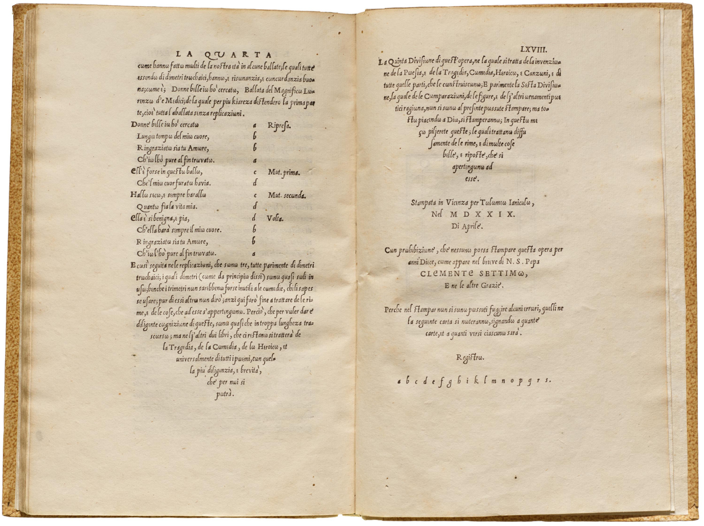

Fig 1, ( Ludovico, 1529, Trissinio: La Poetica )

This piece represents the true longevity and sustain of typography through the years. Text from centuries ago that still display distinctive typographic elements that even some modern typefaces display. This piece allows for the viewer to reflect on the development of typefaces throughout the years and how previous generations of typography has informed the modern era. The piece itself is disruptive and lacks consistent structure. This formation of letters creates a sense of uncertainty that may confused viewers. However, the composition of the type allows for the uniqueness of its design to be appreciated. As written by Dowding "Spacing is the soul of typography." ( Geoffrey Dowding, 1954 ).

While being an older piece of typography there is a certain technical element to its design. The layout of the type is very specialised. This piece clearly displays the aged tradition of typography through the tone of the paper and its unconventional form and use of serifs which are still present in some recent typefaces such as Bodoni Moda. It is also a reflection of Italian literary style and shows how poetry used to be taught.
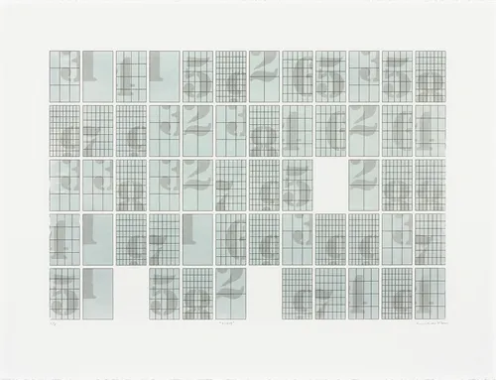

Fig 2, ( Lian Ng, 2011, Serigraphy based on the pi sequence )

This piece is a great example of how typography has become more advanced and technical throughout the years. This grid based work used a uniform structure that is somewhat chaotic. The difference in grid layout throughout the tiles in this piece creates a hectic atmosphere but not in a way that is jarring. There is also a nice consistency within the design because of the way that the numbers are constructed and placed the same in each of their tiles. The overlaying of the numbers and grids create a depth to the piece despite its basic format. The colour palette also adds and intention to the grid and makes you focus on the information and the small details within it. It's lack of vibrancy leaves no room for much of an emotional impact on the viewer but has a thought provoking essence. As Gerstner stated "A typeface is a program for printing text." ( Karl Gerstner, 1964 ).

This piece is also quite interesting due to its lack a a visual hierarchy, with such little variation in colour and size there isn't a way for the viewer to focus on any single component. They are likely to scatter there view instead of viewing it in a specific way. The layout of this typographic piece has a very disruptive effect due to the gaps between the tiles. This adds to the chaotic nature of the design and might create a sense of u comfortable tension in it.
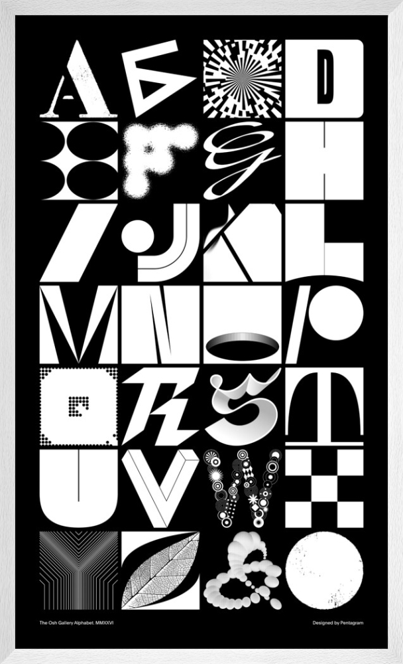

Fig 3, ( Pentagram, 1974, Osh Gallery Alphabet )

This piece is a great display of modern typography and how far it has come. Each letter being unique and different creates a nice contrast with this work. While the letter forms and very abstract it is still contained within a very uniform grid. The colour palette is very basic but this allows for the specific letter designs to stand out. The way that this piece pushed the boundaries and norms of letter formations and design is very interesting and might give the viewer a sense of confusion as some of the design have peculiar features that might be hard to understand at first. These letter forms experiment with various style elements such as geometry, illusion, pattern as well as texture. This typeface is not as much about having a cohesive concept but rather the expression of the letters and how far the boundaries of the typical letter forms can be pushed without straying too far from the original structure. These letter designs also also have visual links to work from the modernism era of design. Each of the letter convey a type of emotion or feeling, as Spiekerman wrote "Type is saying things to us all the time." ( Eric Spiekerman, 1993 ).

It's nice that this piece leaves room for interpretation in its design, not so much what the intended letter is but rather what message each of the letters is trying to express.

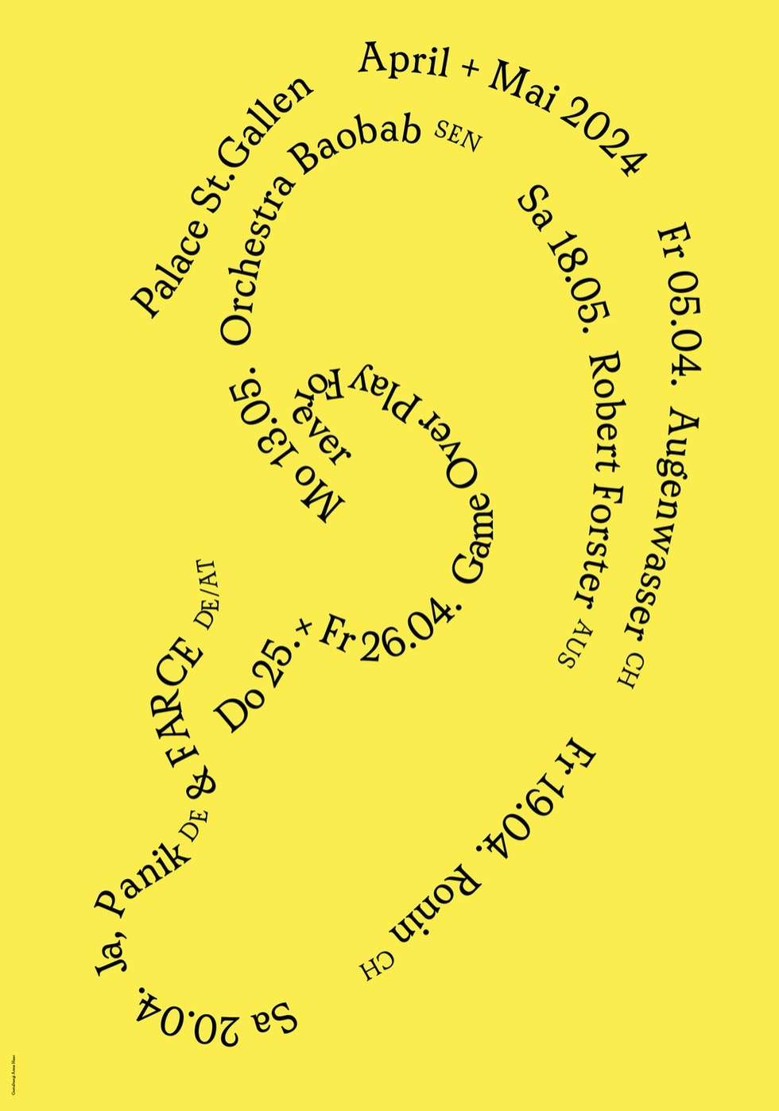
Fig 4, ( Anna Has, 2024 )

This piece is a typography driver poster that has used the text to create a visual. This represents how typography has expanded beyond just the actual text but can also be used to convey something in an image style. While the actual type may not be effectively placed for the viewers convenience, its purpose goes beyond just displaying a message. These experimental layouts have become more popular in modern day graphic design and typography. It has become a playful way of conveying messages with personality in a design. The high contrast of the black and yellow draws viewers in because it is so vibrant.The bright yellow creates a sense of high energy and might infuse the viewer with a feeling of excitement. Ruder says "Reading is a visual event." ( Emil Ruder, 1967 ).

This design in particular lacks any visual hierarchy but it has a natural flow due to the form of the type that allows you to read it smoothly and with order. While the design on the surface depicts an ear, the reason for this might be to symbolise an event that involves music or a speech. While the colour of this graphic is high energy and eye catching, the lack of hierarchy as well as the simplicity of the visual makes the experience of this piece less effective.

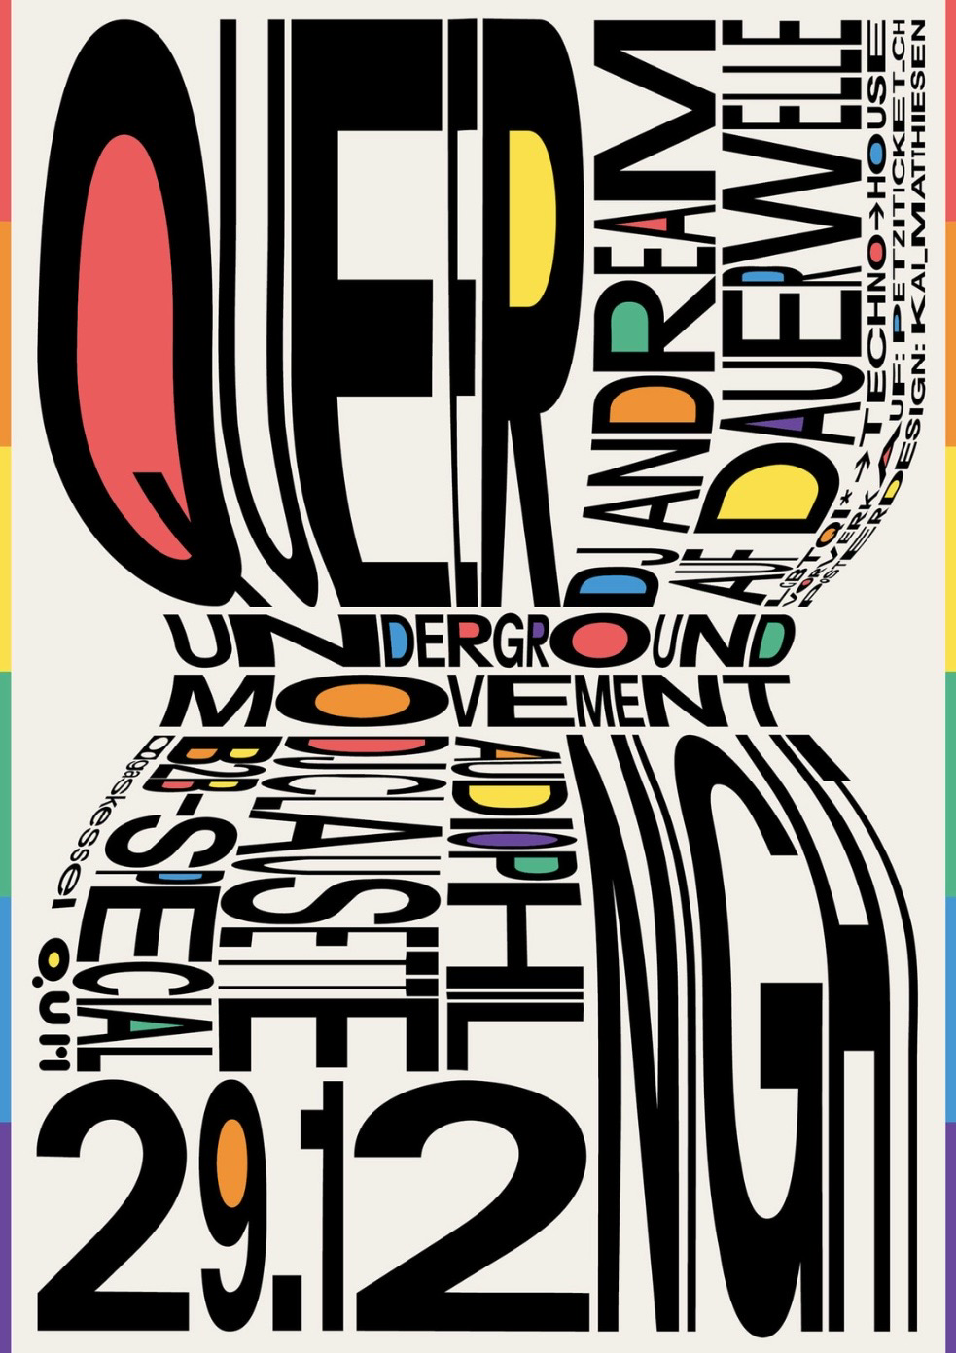
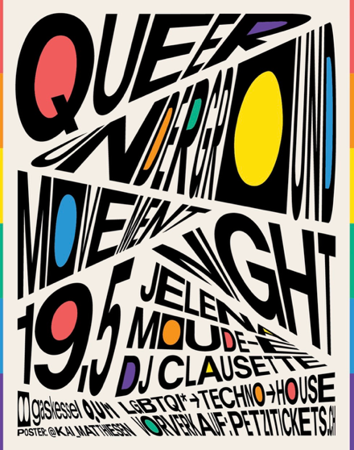

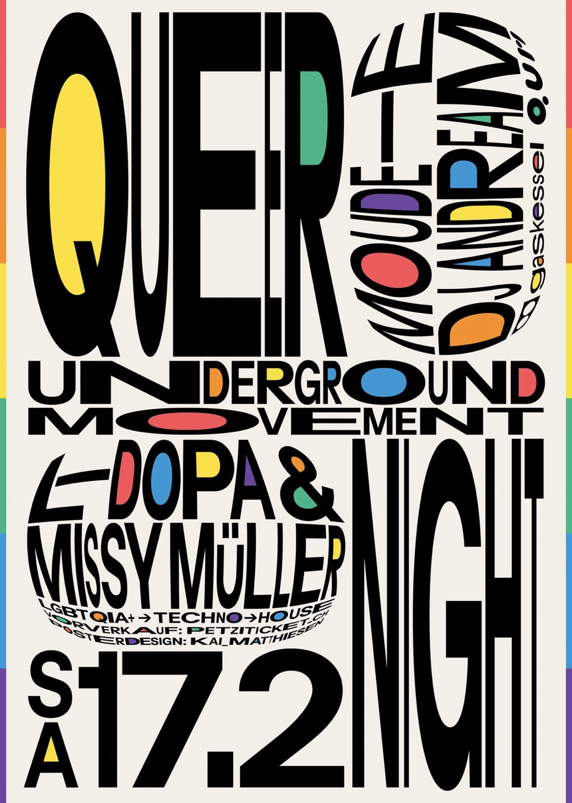

Fig 5, ( Kai Matthiesen, 2023, queer underground movement night party )

This final set of pieces being exhibited are a group of separate posters that were created and design for the promotion of an event. These posters use a range of abstract, warped typography. The posters as a set show the various different ways you can apply
Typography through a single outlet. There is a clear visual hierarchy within these posters that highlight the key information that the designer wanted to draw attention to. Alongside the typography, the rainbow colour scheme has been used to cater to the target audience, th queer community. As a rainbow has been used as a symbol for the LGBTQ community, these colours are a way to draw the attention of people who identify with that community. These posters also have elements that align with post modernist design and typography. This type of design is specifically about breaking down the norms of traditional design and for a poster that is for promoting a 'movement' I think this form of design fits it effectively. The composition of these designs also have a consistent flow through them that allows for viewers to easily read through the information in a structured manner. As Syjuco states,

"Postmodernism was a reaction to modernism. Where modernism was about objectivity, postmodernism was about subjectivity. Where modernism sought a singular truth, postmodernism sought the multiplicity of truths." ( Miguel Syjuco, N/A )

The colour scheme of these designs creates a welcoming atmosphere that viewers would find comfort in and feel like they could find a sense of community through these events. While the designs are very impactful and direct, they aren't necessarily hectic and busy. The composition doesn't distract from the message of the posters.

Overall, I hope that this exhibition is informative and can help viewers understand the importance of typography as well as how it is apart of our everyday life.

Bibliography:

Bringhurst, R. (1992) The Elements of Typographic Style. Vancouver: Hartley & Marks. Available at: https://readings.design/PDF/the_elements_of_typographic_style.pdf
Dowding, G. (1954) Finer Points in the Spacing and Arrangement of Type. London: Wace & Company.
Gerstner, K. (1964) Designing Programmes. Teufen: Arthur Niggli.
Ruder, E. (1967) Typography: A Manual of Design. Teufen: Arthur Niggli.
Spiekermann, E. (1993) Stop Stealing Sheep & Find Out How Type Works. Mountain View, CA: Adobe Press.
Syjuco, M. (n.d.) Postmodernism quote. Available at: https://www.allgreatquotes.com/quote-319888/ (Accessed: 22 April 2026).
Tschichold, J. (1940) The Form of the Book: Essays on the Morality of Good Design. London: Lund Humphries.

List of Figures:

Figure 1, ( Ludovico, 1529, Trissinio: La Poetica ) Available at: https://oa.letterformarchive.org/item?workID=lfa_antiquarianbound_0039&targPic=lfa_antiquarianbound_0039_022.jpg
Figure 2, ( Lian Ng, 2011, Serigraphy based on the pi sequence ) Available at: https://theartling.com/en/artzine/typography-art-artists/?srsltid=AfmBOoo06q43Mm5VYNlXuCCjOGgl2ozJauzXQE4hg5sqrjeEdzQJOaF7
Figure 3, ( Pentagram, 1974, Osh Gallery Alphabet ) Available at: https://www.kingandmcgaw.com/prints/pentagram/osh-gallery-alphabet-474627#474627::frame:880617_glass:770007_media:0
Figure 4, ( Anna Has, 2024 ) Available at: https://www.typographicposters.com/kai-matthiesen
Figure 5, ( Kai Matthiesen, 2023, queer underground movement night party ) Available at: https://www.typographicposters.com/kai-matthiesen

