Rhys Whatty (1900045)

Programming in c
ACCA4017 – Software Development

Contents
Exercise 1: Variable Values 2
Pre-planning 2
Development of the code 2
Testing 4
Exercise 2: Area of a composite shape 6
Pre-planning 6
Development of the code 7
Testing 8
Exercise 3: Storing prices in an array 10
Pre-planning 10
Development of the code 10
Testing 11
Exercise 4: Treasure Hunt Game 13
Pre-planning 13
Development of the code 13
Testing 16
Exercise 5: Checkers Game 21
Pre-planning 21
Development of the code 21
Testing 24
Code Appendices 29
Exercise 1 29
Exercise 2 30
Exercise 3 31
Exercise 4 32
Exercise 5 35

Exercise 1: Variable Values

Pre-planning
When pre-planning all 5 of the codes, notes where taken of what the code would need and what it has been asked to do. A simple pseudocode was then written to fully understand the process of what the code would do and make the development of the code itself easier.

From the notes, the following points were highlighted that would need to be implemented into the code:
- 3 variables will be required, a string variable for the book name, a double variable for the length and an integer variable for the number of products
- Values for the variables will need to be entered by the user when prompted
- All 3 values need to then be outputted by the system
- In terms of validating data, there are no reasonable means of validation the book name
- The length and number of products will need a check to validate that they are not a negative value

With notes written, the following pseudocode was then written to plan out how the code would run:

Insert Book Title
Save data to Book Title variable

Insert Length
If Length < 0 Then display error
Else Save data to Length variable

Insert Number of products
If Number of products < 0 Then display error
Else Save data to Number of products variable

Output all values

Development of the code
After defining the 3 variables, the code first needs the user to input values for these variables. This has been done with the getline command, with a stringstream variable being used for the 2 number-based data types to convert them from a string to a number value (the same stringstream variable will also be used in other exercises).

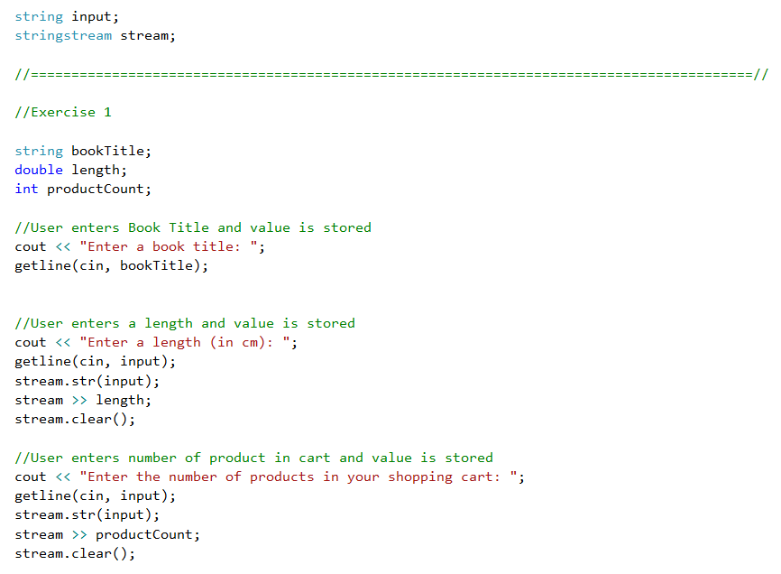

Next the code for outputting the data that the user inputted was added, using 3 cout commands.
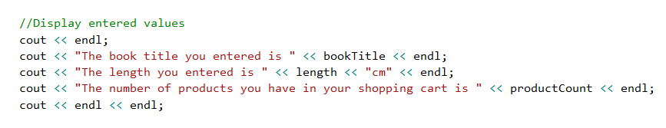

Finally, an If statement was added to the code if the values entered length or productCount were invalid by being less than 0 (being a negative number).
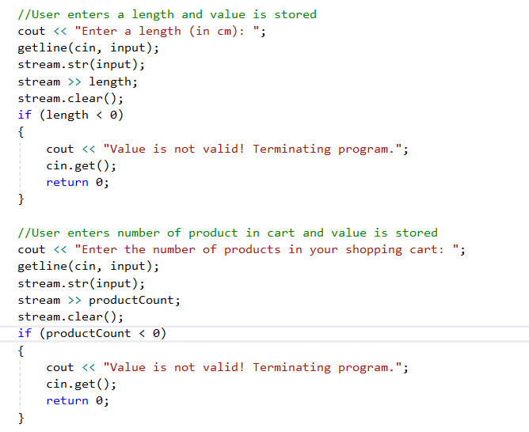

Testing
The first test that was conducted was to confirm that the data was outputted if the numerical variables inputted by the user was equal to 1.
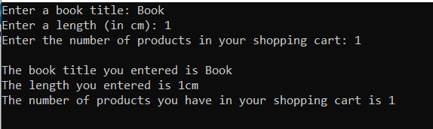
Test successful – Data was correctly outputted as 1.
The second test that was conducted was to confirm that the data was outputted if the numerical variables inputted by the user was equal to 0.
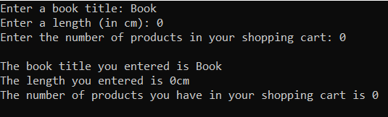
Test successful – Data was correctly outputted as 0.
The third test that was conducted was to confirm that the data was not outputted if the numerical variables inputted by the user was equal to -1.
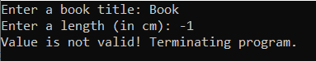
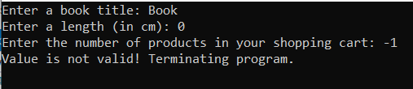
Test Successful – If a negative value was inputted, the code shows an error and terminates the entire program.
The final test that was conducted was to confirm that the data was all successfully outputted if there were no validation errors.
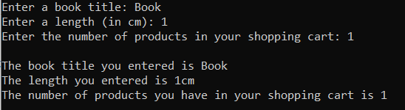
Test Successful – All data was outputted successfully and correctly.

Exercise 2: Area of a composite shape

Pre-planning
When planning for this exercise, the following points were highlighted that would need to be implemented into the code:
- 5 variables would be required, 2 for the height and width of the large rectangle, 2 for the height and width of the box and one for the radius of the circle. A 6th variable can also be used for storing the total area.
- The user will need to enter all lengths for the shapes
- The program needs to be able to compute the area of the size by calculating the area of the large rectangle and subtracting the area of the box and circle (Rectangle/Box Area = height * width, Circle Area = pi * r²)
Although it is not explicitly stated in the brief, I made the assumption that the diameter (2 * radius) of the circle or the height of the box cannot exceed the height of the large rectangle and that the diameter of the circle and the width of the box combined cannot exceed the width of the large rectangle.
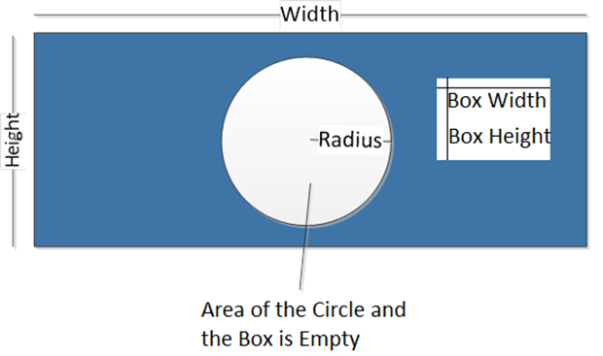

I then proceeded to write the following pseudocode of how the program would run:

User inserts all values of geometric shapes
If Diameter > Rectangle Height or Box Height > Rectangle Height Then Display error
If Diameter + Box Width > Rectangle Width Then Display Error

Area = Rec Height * Rec Width – (Box Height * Box Width) – (pi * radius²)
Output Area

Development of the code
After defining all the variables, including one for the total area, the code for inputting the length values was written using a stringstream variable to convert the inputted data to numeric values.
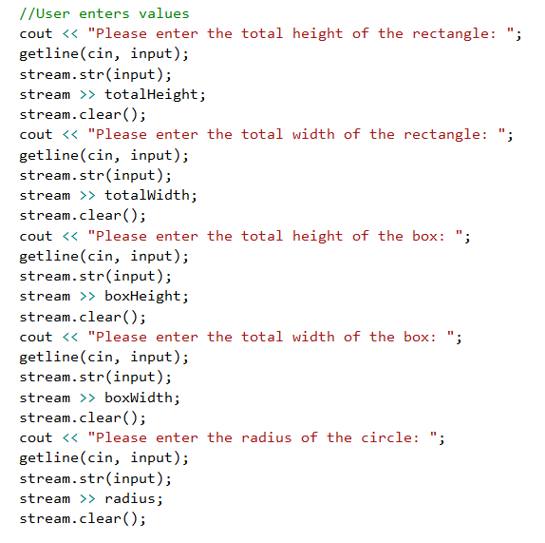

Next, the code for calculating the area and outputting it was written, by saving the value to the Area variable and outputting it with a cout command.
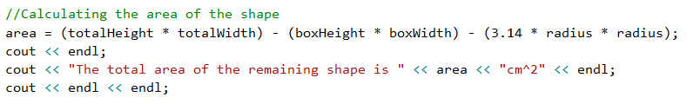

Finally, the code validating the lengths did not exceed one another was added using If commands.
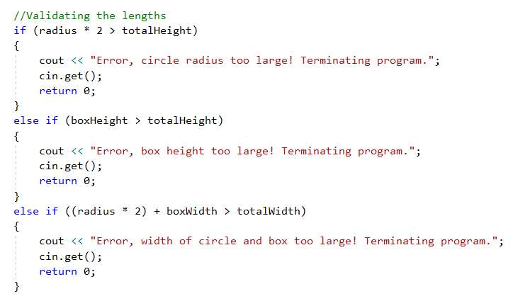

Testing
The first tests that were conducted were to confirm that the data was outputted if the sizes of the inner shapes inputted by the user did not exceed the limitations of the Rectangle. This test should also prove the final point of the data being outputted with no validation errors.
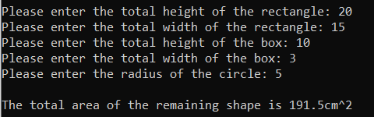
Test Successful – The data was successfully outputted with none of the inner shapes exceeding the limits of the rectangle.
The next tests that were conducted were to confirm that the data was outputted if the sizes of the inner shapes inputted by the user were equal to the limitations of the Rectangle.
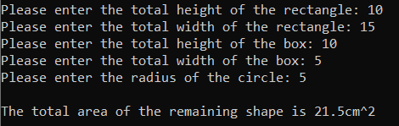
Test Successful – The data was successfully outputted with the lengths of the inner shapes equalling the limits of the rectangle.
The final tests that were conducted were to confirm that the data was not outputted if the sizes of the inner shapes inputted by the user exceeded the limitations of the Rectangle.
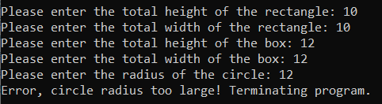
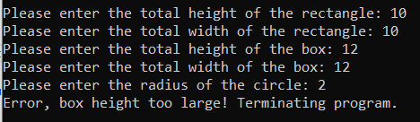
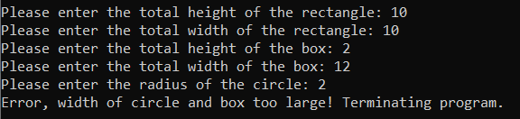
Test Successful – Errors appeared when the sizes of the inner shapes exceeded the size of the Rectangle.

Exercise 3: Storing prices in an array

Pre-planning
When planning for this exercise, the following points were highlighted that would need to be implemented into the code:
- The code would need an array that can store several data entries for the user to input data input (I opted for 5 entries the user needed to input)
- The code will also use 3 variables, one to store the value of the price entered before it is saved into the array, one for storing the total of all prices entered, and an integer counting variable for looping
- The code can use a loop command to have the user insert all the prices
- The code will need to, at the end, output all the entered prices and the total price
- The code also needs to convert the total price to Euros by multiplying it by 1.09 (current GBP to Euro exchange write as of writing this)
I then proceeded to write the following pseudocode of how the program would run:
Start loop
Insert price
Save price to Array
Add price to totalPrice
+1 to Counter
Loop until Counter = 5

Display prices in array
Display totalPrice
Display totalPrice * 1.09

Development of the code
After defining the variables and the Array room for 5 entries, the first part that was coded was the For loop that allowed users to input data, with the counter variable being used as a stand-in for the address number of the Array when saving the value. The code that added the price to the totalPrice is also included in this part.
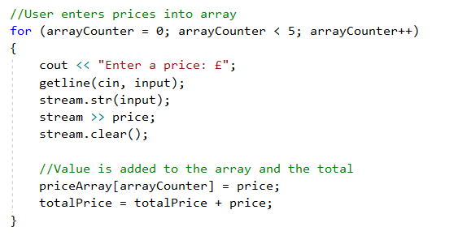

Next, a second For loop was coded to output of all the prices entered by the user, with the Counter having been reset to 0 and being used as a stand-in for the Array Address.
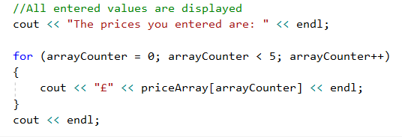

Finally, 2 cout commands were used to output the total Price and the total Price in Euros.
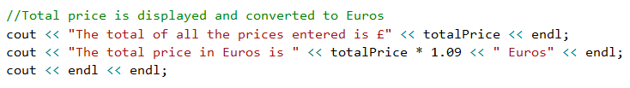

Testing
The first test that was conducted was to confirm that the For loops are correctly intaking the data that is being entered by the user and then outputting it in the order it received the data.
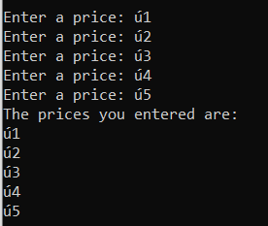
Side note: The console on VS does not support the pound (£) symbol as it is not an ASCII character.
Test Successful – The prices that were entered were outputted correctly and were outputted in the order that they were entered.

The other test that was conducted was to confirm that the total Price and the total in Euros was correctly outputted.
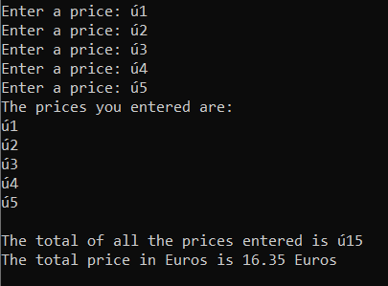
Test Successful – The total values were successfully and correctly outputted and converted to Euros.

Exercise 4: Treasure Hunt Game

Pre-planning
When planning for this exercise, the following points were highlighted that would need to be implemented into the code:
- 6 variables will be needed for the project, a life counter, a correct guess counter, X and Y co-ordinate locators, and 2 more variables used for generating the map.
- 2 2D arrays will also be used, a 7x7 Array to store the map itself, and a 3x2 Array to store the coordinates of the 3 treasures.
- Player 1 will need to enter 3 coordinates for a treasure, which will be stored in an array, that fit within the confines of the map.
- Player 2 will need to be guessing within the confines of the map, and the map will need to be marked where Player 2 has guessed correctly and incorrectly.
- Each incorrect guess will cause a life loss, and once the player is out of lives, the game ends.

I then proceeded to write the following pseudocode of how the code would run:
Player 1 enters 1st coordinates
Coordinates saved to treasureArray
Player 1 enters 2nd coordinates
Coordinates saved to treasureArray
Player 1 enters 3rd coordinates
Coordinates saved to treasureArray

While lives > 0
Player 1 guesses co-ords
If Right Then mark correct
Else Mark incorrect
Lives = lives – 1

If guesses = 3 OR lives = 0
Game ends

Development of the code
After defining variables, the first thing that was coded was generating the map, which included filling the mapArray with hyphens and then displaying the map in the console. Filling the array was simple with a double While loop.
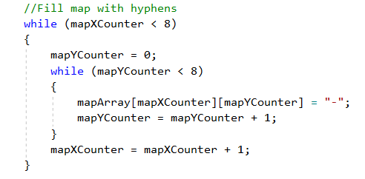
The map took a few trial and errors (see Testing) however a successful map generation was achieved after a couple attempts.
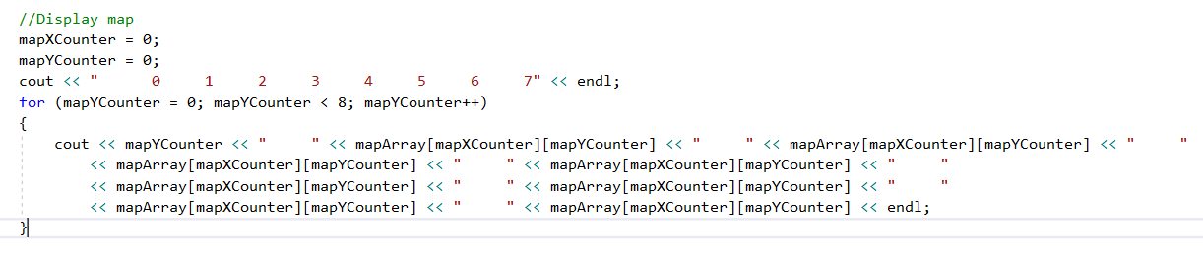
Next, the code to allow Player 1 to input locations of 3 treasures onto the map, by having the user input an X and Y co-ordinate on the board.
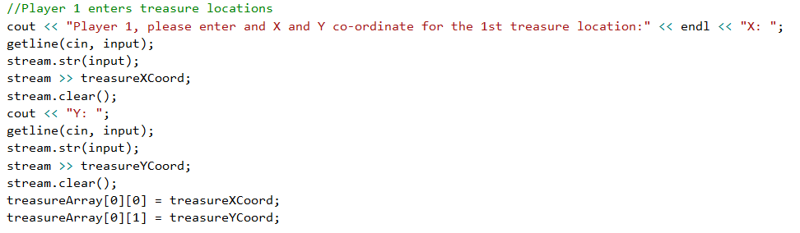
Note: This section of code is repeated 3 times, with each repeat saving to a new section of the array.
Next the code for allowing a user to place a guess was added, with similar code to above.
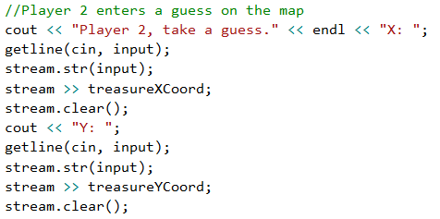
The next bit that was coded was a search through the array to see if the guess matched the locations of any of the treasure.
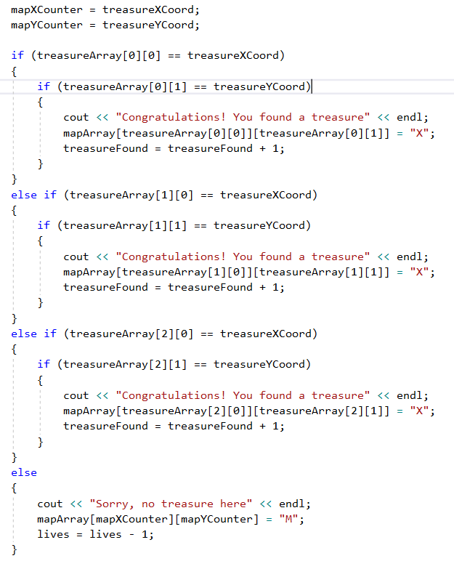
Finally, the code was placed inside a loop set to While (lives > 0) (not pictured) and code to end the game was added to the end.
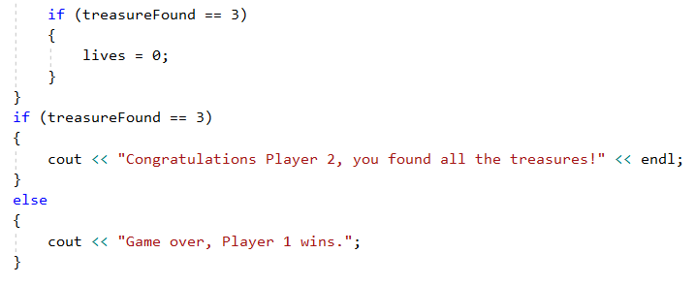

Testing
In the testing, the components that needed to be tested to confirm that they are functioning correctly are:
- That the treasure locations entered by the user do not output if the values are over 7 and display an error
- That a map is generated for player 2 to see
- That the map displays and M (for miss) if the player guesses a wrong location and then loses a life
- That the map displayed an X when the player located a treasure
- That the game ends when all treasures have been found or player runs out of lives

As mentioned in the Development phase, there were several failed attempts at generating the map, including this one: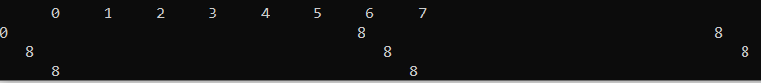
However, after a couple tries, the map looked like this:
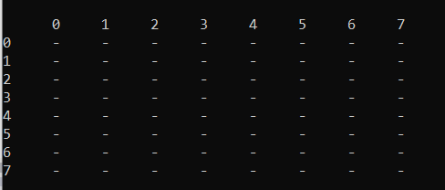
Test Successful – Code can generate a map.
The next test was to see if was successful was if the code doesn’t allow data input and guesses to be made if a co-ordinate is greater than 7.
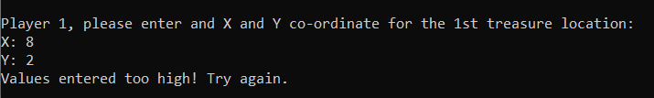
Test Successful – When entering co-ordinates, the code cancels the program if the count is too high. When guessing, the code does not cancel but instead returns to the beginning of the loop.
The next test was to confirm that the board is marked with a correct or incorrect guess after player 2 makes a guess.
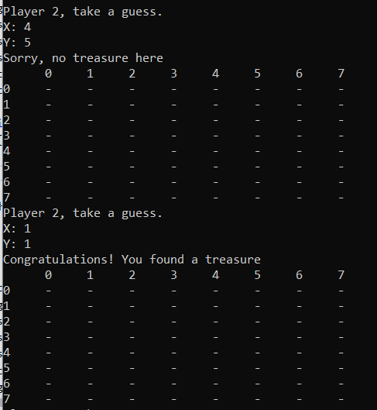
Test failed – The map does not get marked, for either correct or incorrect, when a guess is made.
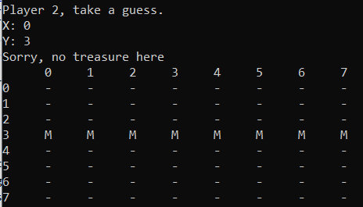
Extension – The code seems to fill in the entire row on the map if the x value that was entered is 0.

The final test was whether the game ended when the player ran out of lives or found all the treasure.
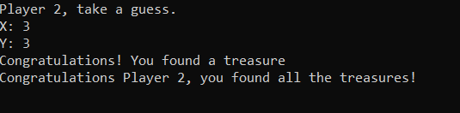
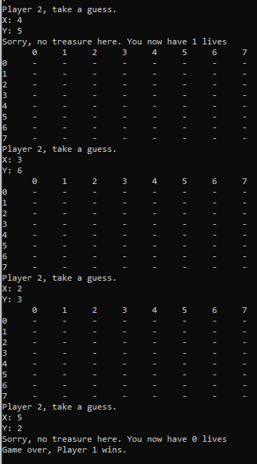
Test half Successful – The game ends correctly if the Player locates the treasures before they run out of lives, but if the player runs out of lives, the game allows 2 more unmassaged rounds to be played before ending.
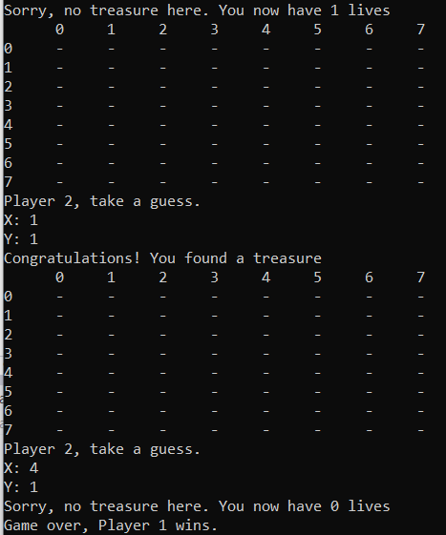
Test successful – After some alterations to the code, the game now ends when the player runs out of lives.

Exercise 5: Checkers Game

Pre-planning
When planning for this exercise, the following points were highlighted that would need to be implemented into the code:
- 4 variables will be needed, 2 counters for general use and a counter tracking the number of pieces the 2 players each have.
- The layout of the board will be stored in an array.
- On each player’s turn, the player will select a piece to move with co-ordinates. The code will then calculate the possible moves the piece can make and display the options as a list.
- Standard pieces can only move forwards, kings can move in all for directions.
- Once a player runs out of lives (all pieces are taken) the game ends.

I then proceeded to write the following pseudocode of how the code would run:
Starting board generated
Player 1 chooses piece to move
Player 1 chooses where to move piece to
If Player 1 takes piece, -1 to Player 2 lives
End turn

Player 2 chooses piece to move
Player 2 chooses where to move piece to
If Player 2 takes piece, -1 to Player 1 lives
End turn

If piece reaches other end of board, make king

Repeat turns until one player runs out of lives (pieces)

Development of the code
After defining variables, the first thing that was coded was generating the board, which first fills in all the board with blank spaces, then places the player pieces.
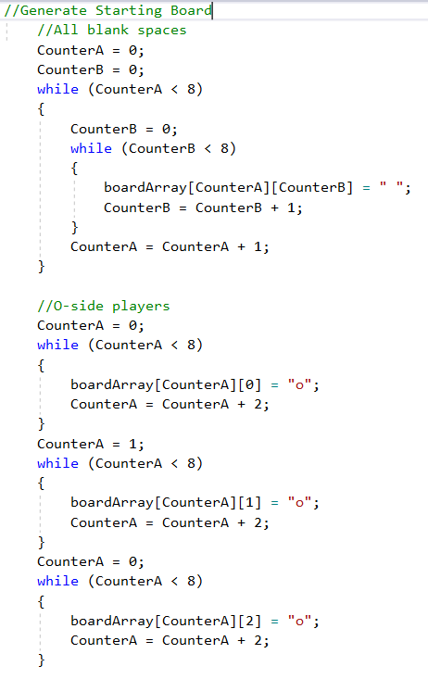
Next the code for displaying the board was coded.
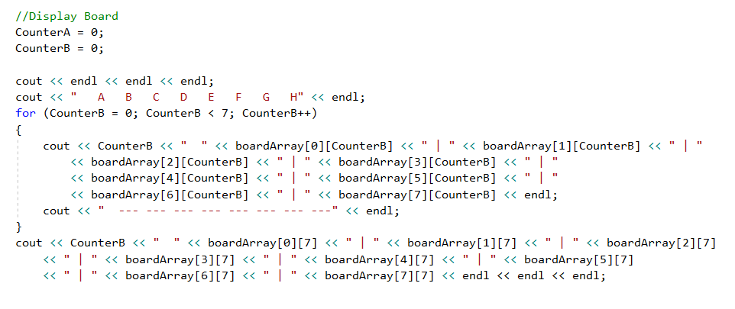
Next the code for the player taking a turn was written. Code like the previous exercise was used to read co-ordinates (with the letter-based co-ordinate being converted into a figure). Then the options for what moves to do were listed.
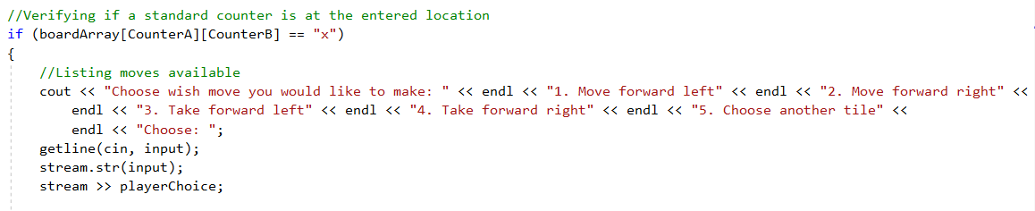
Note: All code involving player turns were duplicated and had figures edited for the second player
Next code using a case function was used for each option of move or taking a piece. If the selected move wasn’t possible, an error appeared and allowed the user to try again.
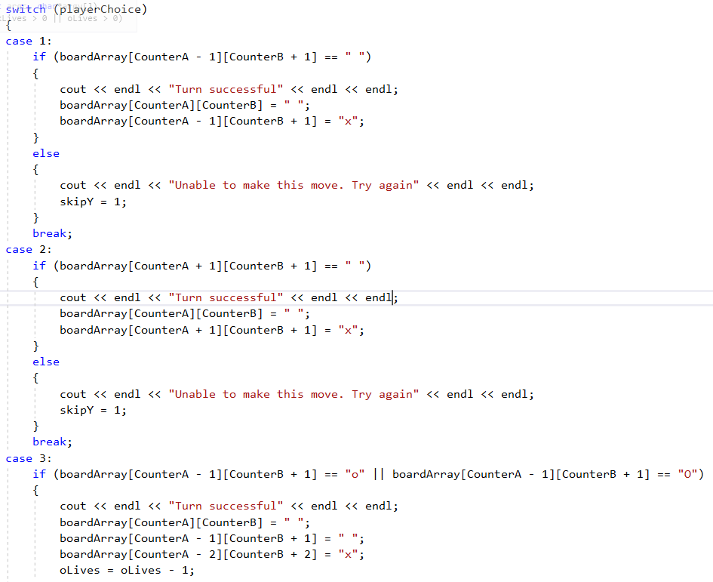
Note: Code for the king players was the same as standard piece code, but had more options for extra moves

Next code for making a player a king was added once they reached the end of the board.
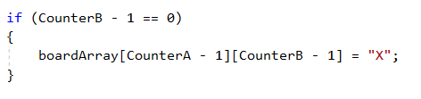
Finally, code for declaring the winner after a player runs out of “lives” (pieces) was written.
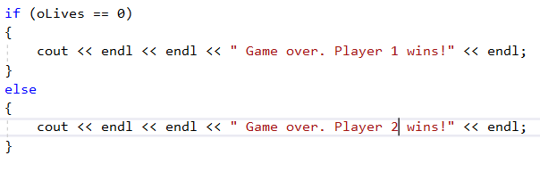

Testing
The first test that was conducted was to confirm that the starting board generated correctly with the Array being filled in correctly.
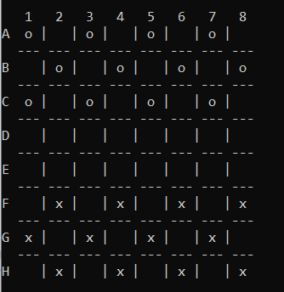
Test Successful – Board generated with all the pieces in the right place.

The next bit of code that was tested was that players can’t enter co-ordinates outside the board boundaries.
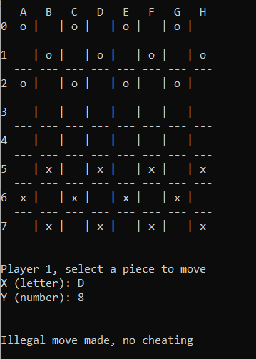
Test successful – Players are warned if they have entered out of bounds co-ordinates.
The next test was to see if players could successfully move their pieces.
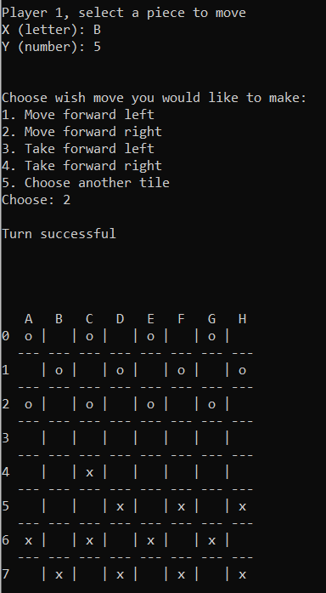
Test Successful – Players can move pieces on the board.
The next test was to see if players could successfully take another player’s piece
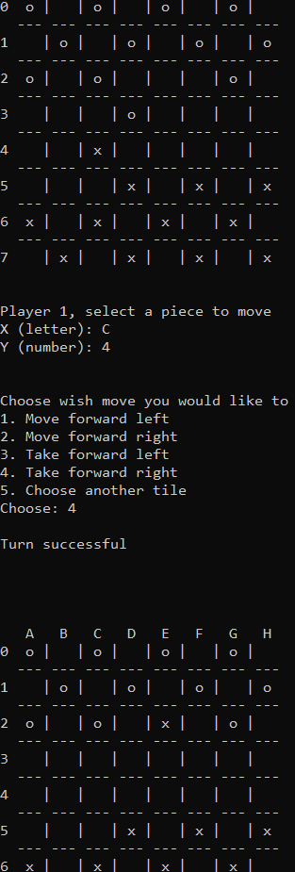
Test Successful – Player was able to jump over and take a player’s piece.
The next test was to see if a player could king their piece when they get to the opposite end of the board.
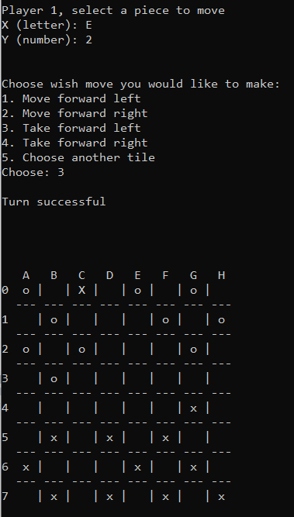
Test Successful – Player becomes a king when they reach the end of the board (indicated by capital letter)

The final test was to see if the game ended when someone ran out pieces and that the game declared a winner.
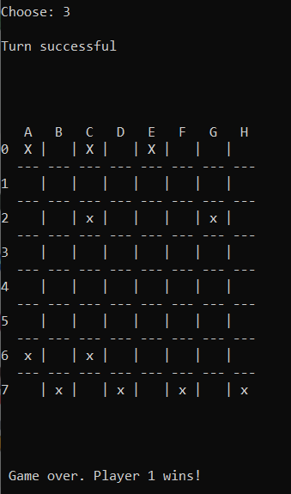
Test Successful – Player declared winner when opponent runs out of pieces.

Code Appendices

#include <string>
#include <iostream>
#include <sstream>

using namespace std;

int main(int argc, char*argv[])
{
string input;
stringstream stream;

//========================================================================//

Exercise 1

string bookTitle;
double length;
int productCount;

//User enters Book Title and value is stored
cout << "Enter a book title: ";
getline(cin, bookTitle);

//User enters a length and value is stored
cout << "Enter a length (in cm): ";
getline(cin, input);
stream.str(input);
stream >> length;
stream.clear();
if (length < 0)
{
cout << "Value is not valid! Terminating program.";
cin.get();
return 0;
}

//User enters number of product in cart and value is stored
cout << "Enter the number of products in your shopping cart: ";
getline(cin, input);
stream.str(input);
stream >> productCount;
stream.clear();
if (productCount < 0)
{
cout << "Value is not valid! Terminating program.";
cin.get();
return 0;
}

//Display entered values
cout << endl;
cout << "The book title you entered is " << bookTitle << endl;
cout << "The length you entered is " << length << "cm" << endl;
cout << "The number of products you have in your shopping cart is " << productCount << endl;
cout << endl << endl;

//========================================================================//

Exercise 2

double totalHeight;
double totalWidth;
double boxHeight;
double boxWidth;
double radius;
double area;

//User enters values
cout << "Please enter the total height of the rectangle: ";
getline(cin, input);
stream.str(input);
stream >> totalHeight;
stream.clear();
cout << "Please enter the total width of the rectangle: ";
getline(cin, input);
stream.str(input);
stream >> totalWidth;
stream.clear();
cout << "Please enter the total height of the box: ";
getline(cin, input);
stream.str(input);
stream >> boxHeight;
stream.clear();
cout << "Please enter the total width of the box: ";
getline(cin, input);
stream.str(input);
stream >> boxWidth;
stream.clear();
cout << "Please enter the radius of the circle: ";
getline(cin, input);
stream.str(input);
stream >> radius;
stream.clear();

//Validating the lengths
if (radius * 2 > totalHeight)
{
cout << "Error, circle radius too large! Terminating program.";
cin.get();
return 0;
}
else if (boxHeight > totalHeight)
{
cout << "Error, box height too large! Terminating program.";
cin.get();
return 0;
}
else if ((radius * 2) + boxWidth > totalWidth)
{
cout << "Error, width of circle and box too large! Terminating program.";
cin.get();
return 0;
}

//Calculating the area of the shape
area = (totalHeight * totalWidth) - (boxHeight * boxWidth) - (3.14 * radius * radius);
cout << endl;
cout << "The total area of the remaining shape is " << area << "cm^2" << endl;
cout << endl << endl;

//========================================================================//

Exercise 3

double price = 0;
double totalPrice = 0;
double priceArray[5];
int arrayCounter = 0;

//User enters prices into array
for (arrayCounter = 0; arrayCounter < 5; arrayCounter++)
{
cout << "Enter a price: £";
getline(cin, input);
stream.str(input);
stream >> price;
stream.clear();

//Value is added to the array and the total
priceArray[arrayCounter] = price;
totalPrice = totalPrice + price;
}

//All entered values are displayed
cout << "The prices you entered are: " << endl;

for (arrayCounter = 0; arrayCounter < 5; arrayCounter++)
{
cout << "£" << priceArray[arrayCounter] << endl;
}
cout << endl;

//Total price is displayed and converted to Euros
cout << "The total of all the prices entered is £" << totalPrice << endl;
cout << "The total price in Euros is " << totalPrice * 1.09 << " Euros" << endl;
cout << endl << endl;

//========================================================================//

Exercise 4

string mapArray[8][8];
int treasureArray[3][2];
int lives = 3;
int treasureFound = 0;
int mapXCounter = 0;
int mapYCounter = 0;
int treasureXCoord;
int treasureYCoord;

//Fill map with hyphens
while (mapXCounter < 8)
{
mapYCounter = 0;
while (mapYCounter < 8)
{
mapArray[mapXCounter][mapYCounter] = "-";
mapYCounter = mapYCounter + 1;
}
mapXCounter = mapXCounter + 1;
}

//Player 1 enters treasure locations
cout << "Player 1, please enter and X and Y co-ordinate for the 1st treasure location:" << endl << "X: ";
getline(cin, input);
stream.str(input);
stream >> treasureXCoord;
stream.clear();
cout << "Y: ";
getline(cin, input);
stream.str(input);
stream >> treasureYCoord;
stream.clear();
treasureArray[0][0] = treasureXCoord;
treasureArray[0][1] = treasureYCoord;
if (treasureXCoord > 7 or treasureYCoord > 7)
{
cout << "Values entered too high! Try again." << endl;
cin.get();
return 0;
}

cout << "Player 1, please enter and X and Y co-ordinate for the 2nd treasure location:" << endl << "X: ";
getline(cin, input);
stream.str(input);
stream >> treasureXCoord;
stream.clear();
cout << "Y: ";
getline(cin, input);
stream.str(input);
stream >> treasureYCoord;
stream.clear();
treasureArray[1][0] = treasureXCoord;
treasureArray[1][1] = treasureYCoord;
if (treasureXCoord > 7 or treasureYCoord > 7)
{
cout << "Values entered too high! Try again." << endl;
cin.get();
return 0;
}

cout << "Player 1, please enter and X and Y co-ordinate for the 3rd treasure location:" << endl << "X: ";
getline(cin, input);
stream.str(input);
stream >> treasureXCoord;
stream.clear();
cout << "Y: ";
getline(cin, input);
stream.str(input);
stream >> treasureYCoord;
stream.clear();
treasureArray[2][0] = treasureXCoord;
treasureArray[2][1] = treasureYCoord;
if (treasureXCoord > 7 or treasureYCoord > 7)
{
cout << "Values entered too high! Try again." << endl;
cin.get();
return 0;
}

//Using endl's to hide the answers inputted by P1
cout << endl << endl << endl << endl << endl << endl << endl << endl << endl << endl << endl << endl
<< endl << endl << endl << endl << endl << endl << endl << endl << endl;

//Game loops until player runs out of lives or finds all treasures
lives = 3;
while (lives > 0)
{
//Display map
mapXCounter = 0;
mapYCounter = 0;
cout << " 0 1 2 3 4 5 6 7" << endl;
for (mapYCounter = 0; mapYCounter < 8; mapYCounter++)
{
cout << mapYCounter << " " << mapArray[mapXCounter][mapYCounter] << " " << mapArray[mapXCounter][mapYCounter] << " "
<< mapArray[mapXCounter][mapYCounter] << " " << mapArray[mapXCounter][mapYCounter] << " "
<< mapArray[mapXCounter][mapYCounter] << " " << mapArray[mapXCounter][mapYCounter] << " "
<< mapArray[mapXCounter][mapYCounter] << " " << mapArray[mapXCounter][mapYCounter] << endl;
mapXCounter = mapXCounter + 1;
}

//Player 2 enters a guess on the map
cout << "Player 2, take a guess." << endl << "X: ";
getline(cin, input);
stream.str(input);
stream >> treasureXCoord;
stream.clear();
cout << "Y: ";
getline(cin, input);
stream.str(input);
stream >> treasureYCoord;
stream.clear();

if (treasureXCoord > 7 || treasureYCoord > 7)
{
cout << "Values entered too high! Try again." << endl;
}
else
{
if (treasureArray[0][0] == treasureXCoord && treasureArray[0][1] == treasureYCoord)
{
cout << "Congratulations! You found a treasure" << endl;
mapArray[treasureXCoord][treasureYCoord] == "X";
treasureFound = treasureFound + 1;
}
else if (treasureArray[1][0] == treasureXCoord && treasureArray[1][1] == treasureYCoord)
{
cout << "Congratulations! You found a treasure" << endl;
mapArray[treasureXCoord][treasureYCoord] == "X";
treasureFound = treasureFound + 1;
}
else if (treasureArray[2][0] == treasureXCoord && treasureArray[2][1] == treasureYCoord)
{
cout << "Congratulations! You found a treasure" << endl;
mapArray[treasureXCoord][treasureYCoord] == "X";
treasureFound = treasureFound + 1;
}
else
{
lives = lives - 1;
cout << "Sorry, no treasure here. You now have "<< lives << " lives" << endl;
mapArray[treasureXCoord][treasureYCoord] == "N";
}
}
if (treasureFound == 3)
{
lives = 0;
}
}

if (treasureFound == 3)
{
cout << "Congratulations Player 2, you found all the treasures!" << endl;
}
else
{
cout << "Game over, Player 1 wins.";
}

cout << endl << endl << endl << endl << endl;
//========================================================================//

Exercise 5
string boardArray[8][8];
string playerXCoord;
int CounterA;
int CounterB;
int xLives = 12;
int oLives = 12;
int skipX = 0;
int skipY = 0;
int playerChoice;

//Generate Starting Board
//All blank spaces
CounterA = 0;
CounterB = 0;
while (CounterA < 8)
{
CounterB = 0;
while (CounterB < 8)
{
boardArray[CounterA][CounterB] = " ";
CounterB = CounterB + 1;
}
CounterA = CounterA + 1;
}

//O-side players
CounterA = 0;
while (CounterA < 8)
{
boardArray[CounterA][0] = "o";
CounterA = CounterA + 2;
}
CounterA = 1;
while (CounterA < 8)
{
boardArray[CounterA][1] = "o";
CounterA = CounterA + 2;
}
CounterA = 0;
while (CounterA < 8)
{
boardArray[CounterA][2] = "o";
CounterA = CounterA + 2;
}

//X-side players
CounterA = 1;
while (CounterA < 8)
{
boardArray[CounterA][5] = "x";
CounterA = CounterA + 2;
}
CounterA = 0;
while (CounterA < 8)
{
boardArray[CounterA][6] = "x";
CounterA = CounterA + 2;
}
CounterA = 1;
while (CounterA < 8)
{
boardArray[CounterA][7] = "x";
CounterA = CounterA + 2;
}

//Display Board
CounterA = 0;
CounterB = 0;

cout << endl << endl << endl;
cout << " A B C D E F G H" << endl;
for (CounterB = 0; CounterB < 7; CounterB++)
{
cout << CounterB << " " << boardArray[0][CounterB] << " | " << boardArray[1][CounterB] << " | "
<< boardArray[2][CounterB] << " | " << boardArray[3][CounterB] << " | "
<< boardArray[4][CounterB] << " | " << boardArray[5][CounterB] << " | "
<< boardArray[6][CounterB] << " | " << boardArray[7][CounterB] << endl;
cout << " --- --- --- --- --- --- --- ---" << endl;
}
cout << CounterB << " " << boardArray[0][7] << " | " << boardArray[1][7] << " | " << boardArray[2][7]
<< " | " << boardArray[3][7] << " | " << boardArray[4][7] << " | " << boardArray[5][7]
<< " | " << boardArray[6][7] << " | " << boardArray[7][7] << endl << endl << endl;

//Player 1 move
while (xLives > 0 || oLives > 0)
{
if (skipX == 0)
{
skipY = 0;
cout << "Player 1, select a piece to move" << endl << "X (letter): ";
getline(cin, playerXCoord);
cout << "Y (number): ";
getline(cin, input);
stream.str(input);
stream >> CounterB;
stream.clear();

//Changing letter Co-ord to an integer value
if (playerXCoord == "A")
{
CounterA = 0;
}
else if (playerXCoord == "B")
{
CounterA = 1;
}
else if (playerXCoord == "C")
{
CounterA = 2;
}
else if (playerXCoord == "D")
{
CounterA = 3;
}
else if (playerXCoord == "E")
{
CounterA = 4;
}
else if (playerXCoord == "F")
{
CounterA = 5;
}
else if (playerXCoord == "G")
{
CounterA = 6;
}
else if (playerXCoord == "H")
{
CounterA = 7;
}
else
{
CounterA = 8;
}

cout << endl << endl;

//Verifying move isn't out of bounds
if (CounterA > 7 || CounterB > 7)
{
cout << "Illegal move made, no cheating" << endl << endl;
skipY = 1;
}

//Verifying if a standard counter is at the entered location
else if (boardArray[CounterA][CounterB] == "x")
{
//Listing moves available
cout << "Choose wish move you would like to make: " << endl << "1. Move forward left" << endl << "2. Move forward right" <<
endl << "3. Take forward left" << endl << "4. Take forward right" << endl << "5. Choose another tile" <<
endl << "Choose: ";
getline(cin, input);
stream.str(input);
stream >> playerChoice;

switch (playerChoice)
{
case 1:
if (boardArray[CounterA - 1][CounterB - 1] == " ")
{
cout << endl << "Turn successful" << endl << endl;
boardArray[CounterA][CounterB] = " ";
boardArray[CounterA - 1][CounterB - 1] = "x";

if (CounterB - 1 == 0)
{
boardArray[CounterA - 1][CounterB - 1] = "X";
}
}
else
{
cout << endl << "Unable to make this move. Try again" << endl << endl;
skipY = 1;
}
break;
case 2:
if (boardArray[CounterA + 1][CounterB - 1] == " ")
{
cout << endl << "Turn successful" << endl << endl;
boardArray[CounterA][CounterB] = " ";
boardArray[CounterA + 1][CounterB - 1] = "x";

if (CounterB - 1 == 0)
{
boardArray[CounterA + 1][CounterB - 1] = "X";
}
}
else
{
cout << endl << "Unable to make this move. Try again" << endl << endl;
skipY = 1;
}
break;
case 3:
if (boardArray[CounterA - 1][CounterB - 1] == "o" || boardArray[CounterA - 1][CounterB - 1] == "O")
{
if (boardArray[CounterA - 2][CounterB - 2] != "x" && boardArray[CounterA - 2][CounterB - 2] != "X")
{
cout << endl << "Turn successful" << endl << endl;
boardArray[CounterA][CounterB] = " ";
boardArray[CounterA - 1][CounterB - 1] = " ";
boardArray[CounterA - 2][CounterB - 2] = "x";
oLives = oLives - 1;

if (CounterB - 2 == 0)
{
boardArray[CounterA - 2][CounterB - 2] = "X";
}
}
}
else
{
cout << endl << "Unable to make this move. Try again" << endl << endl;
skipY = 1;
}
break;
case 4:
if (boardArray[CounterA + 1][CounterB - 1] == "o" || boardArray[CounterA - 1][CounterB - 1] == "O")
{
if (boardArray[CounterA + 2][CounterB - 2] != "x" && boardArray[CounterA + 2][CounterB - 2] != "X")
{
cout << endl << "Turn successful" << endl << endl;
boardArray[CounterA][CounterB] = " ";
boardArray[CounterA + 1][CounterB - 1] = " ";
boardArray[CounterA + 2][CounterB - 2] = "x";
oLives = oLives - 1;

if (CounterB - 2 == 0)
{
boardArray[CounterA + 2][CounterB - 2] = "X";
}
}
}
else
{
cout << endl << "Unable to make this move. Try again" << endl << endl;
skipY = 1;
}
break;
case 5:
cout << endl << endl;
skipY = 1;
break;
default:
cout << endl << "Invalid entry" << endl << endl;
skipY = 1;
break;
}
}
//Verifying if a king counter is at the entered location
else if (boardArray[CounterA][CounterB] == "X")
{
//Listing moves available
cout << "Choose wish move you would like to make: " << endl << "1. Move forward left" << endl << "2. Move forward right" <<
endl << "3. Take forward left" << endl << "4. Take forward right" << endl << "5. Move backwards left" <<
endl << "6. Move backwards right" << endl << "7. Take backwards left" << endl << "8. Take backwards right" <<
endl << "9. Choose another tile" << endl << "Choose: ";
getline(cin, input);
stream.str(input);
stream >> playerChoice;
stream.clear();

switch (playerChoice)
{
case 1:
if (boardArray[CounterA - 1][CounterB - 1] == " ")
{
cout << endl << "Turn successful" << endl << endl;
boardArray[CounterA][CounterB] = " ";
boardArray[CounterA - 1][CounterB - 1] = "X";
}
else
{
cout << endl << "Unable to make this move. Try again" << endl << endl;
skipY = 1;
}
break;
case 2:
if (boardArray[CounterA + 1][CounterB - 1] == " ")
{
cout << endl << "Turn successful" << endl << endl;
boardArray[CounterA][CounterB] = " ";
boardArray[CounterA + 1][CounterB - 1] = "X";
}
else
{
cout << endl << "Unable to make this move. Try again" << endl << endl;
skipY = 1;
}
break;
case 3:
if (boardArray[CounterA - 1][CounterB - 1] == "o" || boardArray[CounterA - 1][CounterB - 1] == "O")
{
if (boardArray[CounterA - 2][CounterB - 2] != "x" && boardArray[CounterA - 2][CounterB - 2] != "X")
{
cout << endl << "Turn successful" << endl << endl;
boardArray[CounterA][CounterB] = " ";
boardArray[CounterA - 1][CounterB - 1] = " ";
boardArray[CounterA - 2][CounterB - 2] = "X";
oLives = oLives - 1;
}
}
else
{
cout << endl << "Unable to make this move. Try again" << endl << endl;
skipY = 1;
}
break;
case 4:
if (boardArray[CounterA + 1][CounterB - 1] == "o" || boardArray[CounterA - 1][CounterB + 1] == "O")
{
if (boardArray[CounterA + 2][CounterB - 2] != "x" && boardArray[CounterA + 2][CounterB - 2] != "X")
{
cout << endl << "Turn successful" << endl << endl;
boardArray[CounterA][CounterB] = " ";
boardArray[CounterA + 1][CounterB - 1] = " ";
boardArray[CounterA + 2][CounterB - 2] = "X";
oLives = oLives - 1;
}
}
else
{
cout << endl << "Unable to make this move. Try again" << endl << endl;
skipY = 1;
}
break;
case 5:
if (boardArray[CounterA - 1][CounterB + 1] == " ")
{
cout << endl << "Turn successful" << endl << endl;
boardArray[CounterA][CounterB] = " ";
boardArray[CounterA - 1][CounterB + 1] = "X";
}
else
{
cout << endl << "Unable to make this move. Try again" << endl << endl;
skipY = 1;
}
break;
case 6:
if (boardArray[CounterA + 1][CounterB + 1] == " ")
{
cout << endl << "Turn successful" << endl << endl;
boardArray[CounterA][CounterB] = " ";
boardArray[CounterA + 1][CounterB + 1] = "X";
}
else
{
cout << endl << "Unable to make this move. Try again" << endl << endl;
skipY = 1;
}
break;
case 7:
if (boardArray[CounterA - 1][CounterB + 1] == "o" || boardArray[CounterA - 1][CounterB + 1] == "O")
{
if (boardArray[CounterA - 2][CounterB + 2] != "x" && boardArray[CounterA - 2][CounterB + 2] != "X")
{
cout << endl << "Turn successful" << endl << endl;
boardArray[CounterA][CounterB] = " ";
boardArray[CounterA - 1][CounterB + 1] = " ";
boardArray[CounterA - 2][CounterB + 2] = "X";
oLives = oLives - 1;
}
}
else
{
cout << endl << "Unable to make this move. Try again" << endl << endl;
skipY = 1;
}
break;
case 8:
if (boardArray[CounterA + 1][CounterB + 1] == "o" || boardArray[CounterA + 1][CounterB + 1] == "O")
{
if (boardArray[CounterA + 2][CounterB + 2] != "x" && boardArray[CounterA + 2][CounterB + 2] != "X")
{
cout << endl << "Turn successful" << endl << endl;
boardArray[CounterA][CounterB] = " ";
boardArray[CounterA - 1][CounterB + 1] = " ";
boardArray[CounterA - 2][CounterB + 2] = "X";
oLives = oLives - 1;
}
}
else
{
cout << endl << "Unable to make this move. Try again" << endl << endl;
skipY = 1;
}
break;
case 9:
cout << endl << endl;
skipY = 1;
break;
default:
cout << endl << "Invalid entry" << endl << endl;
skipY = 1;
break;
}
}
//Resetting the turn if a counter is not at the selected location
else
{
cout << "You don't have a counter here, try again" << endl << endl;
skipY = 1;
}

//Display Board
CounterA = 0;
CounterB = 0;

cout << endl << endl << endl;
cout << " A B C D E F G H" << endl;
for (CounterB = 0; CounterB < 7; CounterB++)
{
cout << CounterB << " " << boardArray[0][CounterB] << " | " << boardArray[1][CounterB] << " | "
<< boardArray[2][CounterB] << " | " << boardArray[3][CounterB] << " | "
<< boardArray[4][CounterB] << " | " << boardArray[5][CounterB] << " | "
<< boardArray[6][CounterB] << " | " << boardArray[7][CounterB] << endl;
cout << " --- --- --- --- --- --- --- ---" << endl;
}
cout << CounterB << " " << boardArray[0][7] << " | " << boardArray[1][7] << " | " << boardArray[2][7]
<< " | " << boardArray[3][7] << " | " << boardArray[4][7] << " | " << boardArray[5][7]
<< " | " << boardArray[6][7] << " | " << boardArray[7][7] << endl << endl << endl;

if (oLives == 0)
{
skipY = 1;
}
}

//Player 2 move
if (skipY == 0)
{
skipX = 0;
cout << "Player 2, select a piece to move" << endl << "X (letter): ";
getline(cin, playerXCoord);
cout << "Y (number): ";
getline(cin, input);
stream.str(input);
stream >> CounterB;
stream.clear();

//Changing letter Co-ord to an integer value
if (playerXCoord == "A")
{
CounterA = 0;
}
else if (playerXCoord == "B")
{
CounterA = 1;
}
else if (playerXCoord == "C")
{
CounterA = 2;
}
else if (playerXCoord == "D")
{
CounterA = 3;
}
else if (playerXCoord == "E")
{
CounterA = 4;
}
else if (playerXCoord == "F")
{
CounterA = 5;
}
else if (playerXCoord == "G")
{
CounterA = 6;
}
else if (playerXCoord == "H")
{
CounterA = 7;
}
else
{
CounterA = 8;
}

cout << endl << endl;

//Verifying move isn't out of bounds
if (CounterA > 7 || CounterB > 7 || CounterA < 0 || CounterB < 0)
{
cout << "Illegal move made, no cheating" << endl << endl;
skipX = 1;
}

//Verifying if a standard counter is at the entered location
if (boardArray[CounterA][CounterB] == "o")
{
//Listing moves available
cout << "Choose wish move you would like to make: " << endl << "1. Move forward right (down and left)" << endl
<< "2. Move forward left (down and right)" << endl << "3. Take forward right (down and left)" << endl
<< "4. Take forward left (down and right)" << endl << "5. Choose another tile" << endl << "Choose: ";
getline(cin, input);
stream.str(input);
stream >> playerChoice;
stream.clear();

switch (playerChoice)
{
case 1:
if (boardArray[CounterA - 1][CounterB + 1] == " ")
{
cout << endl << "Turn successful" << endl << endl;
boardArray[CounterA][CounterB] = " ";
boardArray[CounterA - 1][CounterB + 1] = "o";

if (CounterB + 1 == 7)
{
boardArray[CounterA - 1][CounterB + 1] = "O";
}
}
else
{
cout << endl << "Unable to make this move. Try again" << endl << endl;
skipX = 1;
}
break;
case 2:
if (boardArray[CounterA + 1][CounterB + 1] == " ")
{
cout << endl << "Turn successful" << endl << endl;
boardArray[CounterA][CounterB] = " ";
boardArray[CounterA + 1][CounterB + 1] = "o";

if (CounterB + 1 == 7)
{
boardArray[CounterA + 1][CounterB + 1] = "O";
}
}
else
{
cout << endl << "Unable to make this move. Try again" << endl << endl;
skipX = 1;
}
break;
case 3:
if (boardArray[CounterA - 1][CounterB + 1] == "x" || boardArray[CounterA - 1][CounterB + 1] == "X")
{
if (boardArray[CounterA - 2][CounterB + 2] != "x" && boardArray[CounterA - 2][CounterB + 2] != "X")
{
cout << endl << "Turn successful" << endl << endl;
boardArray[CounterA][CounterB] = " ";
boardArray[CounterA - 1][CounterB + 1] = " ";
boardArray[CounterA - 2][CounterB + 2] = "o";
xLives = xLives - 1;

if (CounterB + 2 == 7)
{
boardArray[CounterA - 2][CounterB + 2] = "O";
}
}
}
else
{
cout << endl << "Unable to make this move. Try again" << endl << endl;
skipX = 1;
}
break;
case 4:
if (boardArray[CounterA + 1][CounterB + 1] == "x" || boardArray[CounterA - 1][CounterB + 1] == "X")
{
if (boardArray[CounterA + 2][CounterB + 2] != "x" && boardArray[CounterA + 2][CounterB + 2] != "X")
{
cout << endl << "Turn successful" << endl << endl;
boardArray[CounterA][CounterB] = " ";
boardArray[CounterA + 1][CounterB + 1] = " ";
boardArray[CounterA + 2][CounterB + 2] = "o";
xLives = xLives - 1;

if (CounterB + 2 == 7)
{
boardArray[CounterA + 2][CounterB + 2] = "O";
}
}
}
else
{
cout << endl << "Unable to make this move. Try again" << endl << endl;
skipX = 1;
}
break;
case 5:
cout << endl << endl;
skipX = 1;
break;
default:
cout << endl << "Invalid entry" << endl << endl;
skipX = 1;
break;
}
}

//Verifying if a king counter is at the entered location
else if (boardArray[CounterA][CounterB] == "O")
{
//Listing moves available
cout << "Choose wish move you would like to make: " << endl << "1. Move forward left" << endl << "2. Move forward right" <<
endl << "3. Take forward left" << endl << "4. Take forward right" << endl << "5. Move backwards left" <<
endl << "6. Move backwards right" << endl << "7. Take backwards left" << endl << "8. Take backwards right" <<
endl << "9. Choose another tile" << endl << "Choose: ";
getline(cin, input);
stream.str(input);
stream >> playerChoice;
stream.clear();

switch (playerChoice)
{
case 1:
if (boardArray[CounterA + 1][CounterB + 1] == " ")
{
cout << endl << "Turn successful" << endl << endl;
boardArray[CounterA][CounterB] = " ";
boardArray[CounterA - 1][CounterB + 1] = "O";
}
else
{
cout << endl << "Unable to make this move. Try again" << endl << endl;
skipX = 1;
}
break;
case 2:
if (boardArray[CounterA + 1][CounterB + 1] == " ")
{
cout << endl << "Turn successful" << endl << endl;
boardArray[CounterA][CounterB] = " ";
boardArray[CounterA + 1][CounterB + 1] = "O";
}
else
{
cout << endl << "Unable to make this move. Try again" << endl << endl;
skipX = 1;
}
break;
case 3:
if (boardArray[CounterA - 1][CounterB + 1] == "x" || boardArray[CounterA - 1][CounterB + 1] == "X")
{
if (boardArray[CounterA - 2][CounterB + 2] != "x" && boardArray[CounterA - 2][CounterB + 2] != "X")
{
cout << endl << "Turn successful" << endl << endl;
boardArray[CounterA][CounterB] = " ";
boardArray[CounterA - 1][CounterB + 1] = " ";
boardArray[CounterA - 2][CounterB + 2] = "O";
xLives = xLives - 1;
}
}
else
{
cout << endl << "Unable to make this move. Try again" << endl << endl;
skipX = 1;
}
break;
case 4:
if (boardArray[CounterA + 1][CounterB + 1] == "x" || boardArray[CounterA + 1][CounterB + 1] == "X")
{
if (boardArray[CounterA + 2][CounterB + 2] != "x" && boardArray[CounterA + 2][CounterB + 2] != "X")
{
cout << endl << "Turn successful" << endl << endl;
boardArray[CounterA][CounterB] = " ";
boardArray[CounterA + 1][CounterB + 1] = " ";
boardArray[CounterA + 2][CounterB + 2] = "O";
xLives = xLives - 1;
}
}
else
{
cout << endl << "Unable to make this move. Try again" << endl << endl;
skipX = 1;
}
break;
case 5:
if (boardArray[CounterA - 1][CounterB - 1] == " ")
{
cout << endl << "Turn successful" << endl << endl;
boardArray[CounterA][CounterB] = " ";
boardArray[CounterA - 1][CounterB - 1] = "O";
}
else
{
cout << endl << "Unable to make this move. Try again" << endl << endl;
skipX = 1;
}
break;
case 6:
if (boardArray[CounterA + 1][CounterB - 1] == " ")
{
cout << endl << "Turn successful" << endl << endl;
boardArray[CounterA][CounterB] = " ";
boardArray[CounterA + 1][CounterB - 1] = "O";
}
else
{
cout << endl << "Unable to make this move. Try again" << endl << endl;
skipX = 1;
}
break;
case 7:
if (boardArray[CounterA - 1][CounterB - 1] == "x" || boardArray[CounterA - 1][CounterB - 1] == "X")
{
if (boardArray[CounterA - 2][CounterB - 2] != "x" && boardArray[CounterA - 2][CounterB - 2] != "X")
{
cout << endl << "Turn successful" << endl << endl;
boardArray[CounterA][CounterB] = " ";
boardArray[CounterA - 1][CounterB - 1] = " ";
boardArray[CounterA - 2][CounterB - 2] = "O";
xLives = xLives - 1;
}
}
else
{
cout << endl << "Unable to make this move. Try again" << endl << endl;
skipX = 1;
}
break;
case 8:
if (boardArray[CounterA - 1][CounterB + 1] == "x" || boardArray[CounterA - 1][CounterB + 1] == "X")
{
if (boardArray[CounterA - 2][CounterB + 2] != "x" && boardArray[CounterA - 2][CounterB + 2] != "X")
{
cout << endl << "Turn successful" << endl << endl;
boardArray[CounterA][CounterB] = " ";
boardArray[CounterA - 1][CounterB + 1] = " ";
boardArray[CounterA - 2][CounterB + 2] = "O";
xLives = xLives - 1;
}
}
else
{
cout << endl << "Unable to make this move. Try again" << endl << endl;
skipX = 1;
}
break;
case 9:
cout << endl << endl;
skipX = 1;
break;
default:
cout << endl << "Invalid entry" << endl << endl;
skipX = 1;
break;
}
}

//Resetting the turn if a counter is not at the selected location
else
{
cout << "You don't have a counter here, try again" << endl << endl;
skipX = 1;
}

//Display Board
CounterA = 0;
CounterB = 0;

cout << endl << endl << endl;
cout << " A B C D E F G H" << endl;
for (CounterB = 0; CounterB < 7; CounterB++)
{
cout << CounterB << " " << boardArray[0][CounterB] << " | " << boardArray[1][CounterB] << " | "
<< boardArray[2][CounterB] << " | " << boardArray[3][CounterB] << " | "
<< boardArray[4][CounterB] << " | " << boardArray[5][CounterB] << " | "
<< boardArray[6][CounterB] << " | " << boardArray[7][CounterB] << endl;
cout << " --- --- --- --- --- --- --- ---" << endl;
}
cout << CounterB << " " << boardArray[0][7] << " | " << boardArray[1][7] << " | " << boardArray[2][7]
<< " | " << boardArray[3][7] << " | " << boardArray[4][7] << " | " << boardArray[5][7]
<< " | " << boardArray[6][7] << " | " << boardArray[7][7] << endl << endl << endl;
}

//Game End conditions
if (oLives == 0)
{
cout << endl << endl << " Game over. Player 1 wins!" << endl;
cin.get();
return 0;
}
else if (xLives == 0)
{
cout << endl << endl << " Game over. Player 2 wins!" << endl;
cin.get();
return 0;
}
}
}

