
Component 1: Design and Implementation of a Relational Database System
Introduction to Web and Database Concepts - ACCA4023

Sadhana Jha


STUDENT NAME: CHRIS ANTWI BOASIAKO
STUDENT NUMBER: 2432249
UNIVERSITY NAME: UWTSD BIRMINGHAM CAMPUS
PROGRAM OF STUDY: CERTHE COMPUTING SKILLS FOR THE WORKPLACE
DATE: 9TH MARCH,2026
January 1, 2026
UNIVERSITY OF WALES TRINITY SAINT DAVID

Contents
TABLE OF CONTENTS:
Scenario Analysis 2
Entity Relationship Diagram (ERD) 2
1. List of attributes and their descriptions 2
2. List of relationships and their meaning. 4
3. ER diagram: 4
Normalization 5
Sample Data Population 7
Query Development 8
Testing and Validation 13
Design Decisions and Future Work 13
1. Design Decisions: 13
2. Future Work: 14
References: 14

Scenario Analysis
This coursework focuses on the design and implementation of a database system to manage information related to medicines, suppliers, customer prescriptions, and sales transactions. The system aims to provide an efficient and structured way of storing, retrieving, and maintaining accurate records to support daily operations. The coursework involves analysing system requirements, designing an appropriate database model, and implementing the database using suitable database management tools. Through this process, the coursework demonstrates the practical application of database design principles in managing real-world pharmaceutical data.

Entity Relationship Diagram (ERD)
Entity-Relationship Diagram (ERD) is an essential tool in the design of databases and in conceptual modelling to help show the entities, their attributes and relationships and offering a systematic way of representing the structure of database. It helps identifies both weak and strong entities as well as showing the distinction between one -to-one, one-to-many and many-to many relationships. [2],[3]

List of attributes and their descriptions
Provide the description of all the attributes and the entities in your ER diagram. Identify the primary keys which they are referring to.
ENTITY 1: MEDICINES
ATTRIBUTE DESCRIPTION
Medicine ID a unique identifier for each medicine.
Name the full name of the medicine.
Category the category of medicine e.g. tablet, capsule.
Strength how strong the medicine is.
Unit Price how much one medicine cost.
Expiry date when the medicine expires.
Stock quantity the quantity of the medicine available in pharmacy.
PRIMARY KEY: Medicine ID
ENTITY 2: SUPPLIERS
ATTRIBUTE DESCRIPTION
Supplier ID a unique identifier of each supplier.
Suppliers name a unique name of each supplier.
Phone number phone number of the supplier.

Email Email contact of the supplier.
Address the location of the supplier.
PRIMARY KEY: Supplier ID
ENTITY 3: CUSTOMER PRESCRIPTIONS
ATTRIBUTE DESCRIPTION
Prescription ID a unique identifier for each prescription.
Prescription date date prescription was issued.
Doctor name doctor who issued the prescription.
Quantity prescribed how many medicines was prescribed.
Customer name the full name of customer.
Date Of Birth month, day, and year of birth of customer.
Phone number contact phone number of customer.
Address where the customer lives.

PRIMARY KEY: Customer Prescription ID
ENTITY 4: SALES TRANSACTIONS
ATTRIBUTE DESCRIPTION
Transaction ID identifies a unique transaction made.
Transaction date date the transaction was made.
Quantity sold how many medicines sold.
Total amount total amount paid.
Payment method how the transaction was made (cash, card)
PRIMARY KEY: Transaction ID

List of relationships and their meaning.
RELATIONSHIP DESCRIPTION
SUPPLY-MEDICINE how medicine is supplied by supplier.
CARDINALITY:
One supplier supplies many medicines. (1:M)
Each medicine is supplied by one supplier. (M:M)
RELATIONSHIP DESCRIPTION
MEDICINE-CUSTOMER PRESCRIPTION What medicine is issued to customer.
CARDINALITY:
One medicine can appear in many prescriptions. (1:M)
Each prescription refers to one medicine. (1:1)
RELATIONSHIP DESCRIPTION
MEDICINE-SALES TRANSACTION how much a medicine cost.
CARDINALITY:
One medicine can be sold in many sales transactions. (1:M)
Each sales transaction involves one medicine. (M:M)
RELATIONSHIP DESCRIPTION
CUSTOMER PRESCRIPTION-SALES how much is paid for a medicine.
TRANSACTION
CARDINALITY:
One prescription can generate one or more sales transactions. (1:M)
Each sales transaction is linked to one prescription. (1:1)

ER diagram:
Provide the screenshot of the ER diagram you have made. Your ER diagram must show all the entities, their attributes, relationships between entities, cardinality and participation constraints.

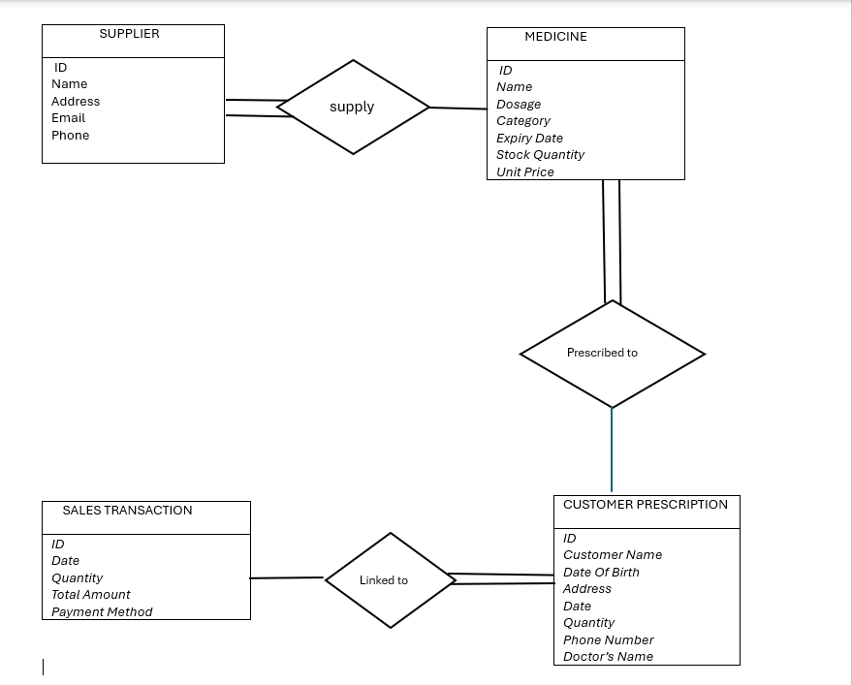

List out all the foreign keys of the entities and the primary keys which they are referring to.

FOREIGN KEYS PRIMARY KEYS THEY ARE REFERRING TO

Supplier ID in medicine referring to supplier ID in suppliers
Medicine ID in customer referring to medicine ID in medicine
prescription
Prescription ID in sales transaction referring to prescription ID in customer
Prescriptions

Normalization

Provide the normalized table for the ER diagram you have made.

(Hint: To provide the normalized table, you will first have to generate relational schema by applying ER to relational schema reduction rules discussed in week 4 and then you have to apply 1NF, 2NF and 3NF on the generated schema)

Database normalization is one of the main principles for Relational Database Model Design and Normalization concept developed to organise data in “relations” or tables following specific rules to minimize data redundancy and consequently improve data consistency by reducing anomalies.[1] The normalization process decomposes relations into smaller, well-structured tables based on functional dependencies, progressively eliminating update, insertions and deletion anomalies through application of Normal Form, First Normal Form (1NF) which eliminates repeating gaps, Second Normal Form (2NF) that removes partial dependencies, Third Normal Form (3NF) eliminating transitive dependencies. This theoretical framework ensures data integrity and storage redundancy. [5]

MEDICINE
ID
Name
Dosage Category
Expiry Date
Stock Quantity
Unit Price

SALE TRANSACTION
ID
Date
Quantity
Total Amount
Payment Method

N
M
Linked to

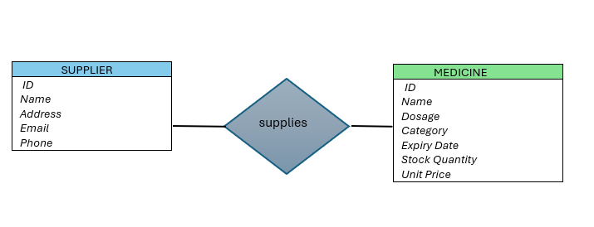
N
M
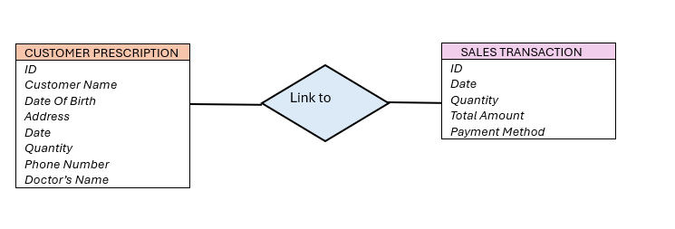
M
1
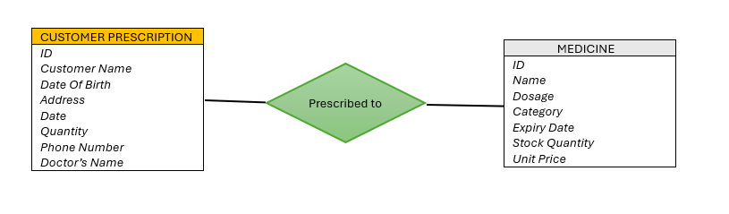
1
M
PresID | Pres  date | Cust  name | Date of  Birth | Address | Phone | Qty | Doctor  name | Med ID
1 | 20/01/  2022 | Nana  Adwoa | 27/06/2005 | 35 Hill Street, Birmingham | 0738902543 | 2 | Dr  Hafiz | 401
2 | 22/10/  2024 | Kofi  Nti | 22/04/2011 | 24 Bull Road, Tamworth | 0783765291 | 1 | Dr Tayo  Sokato | 403
3 | 02/03/  2024 | Kwame  Antwi | 13/01/1970 | 4 Cool  Street  Coventry | 0743567289 | 3 | Dr Sai  Mariana | 402
4 | 11/06/  2023 | Ama  Achiaa | 22/06/1969 | 1 Bart  Street, Kent | 0789654320 | 4 | Dr Kofi  Boadu | 404
5 | 28/02/  2023 | Yaa  Manu | 19/10/1999 | 59 Bee  Road, Nuneton | 0775409876 | 6 | Dr Fifi  Quame | 401

Sample Data Population
Screenshot of the all the tables showing the data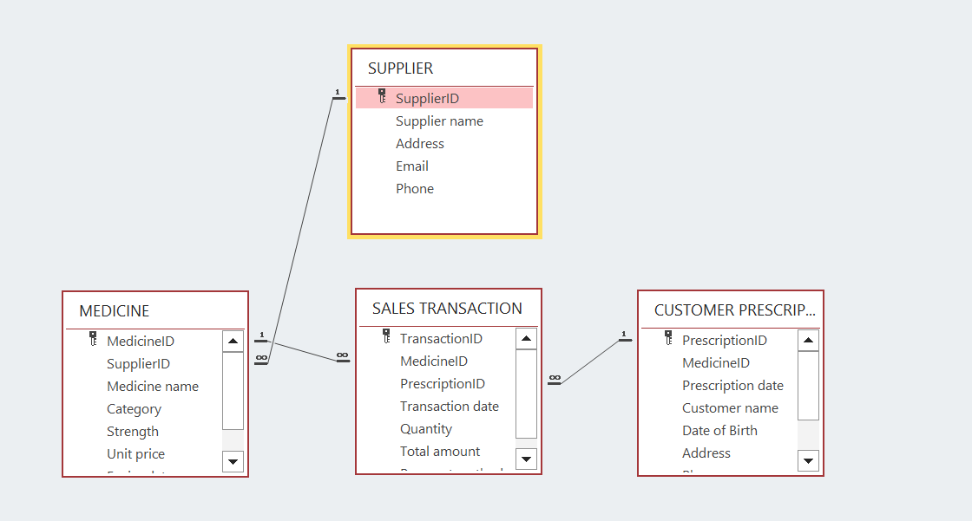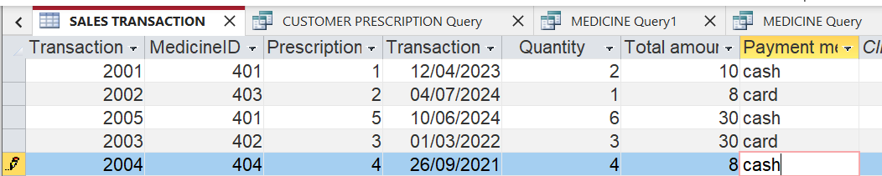

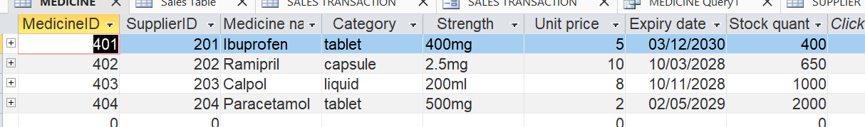
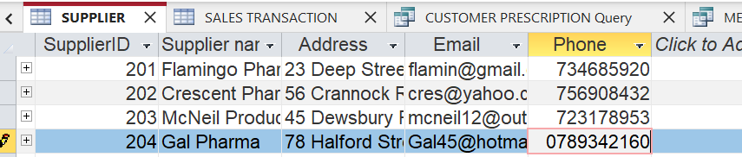
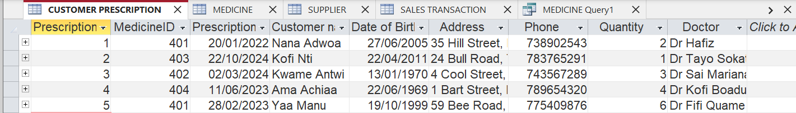

Query Development
Queries in Access serve as a powerful mechanism for data manipulation and reporting where users can retrieve, update, or aggregate data using SQL statements, apply filters and create calculated fields to generate analytical insights. [4] Query optimization represents another critical dimension of database performance engineering where modern Database Management Systems employ sophisticated query optimizers that transform declarative SQL statements into efficient execution plans. [5]

Which query was executed and the screenshot of the results

- What transaction amount was made on 12/04/2023?

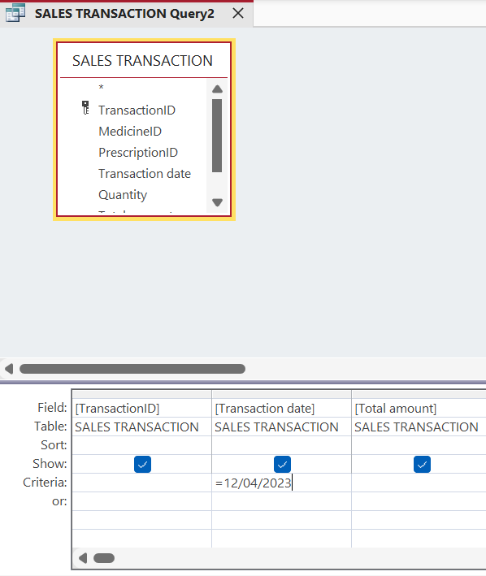

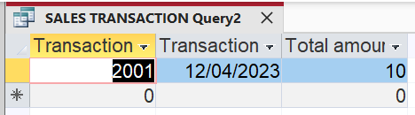

- Which category of medicine was Ibuprofen?
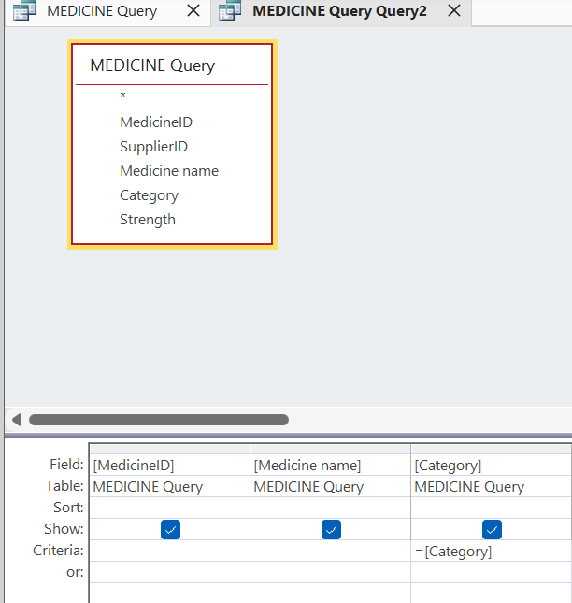

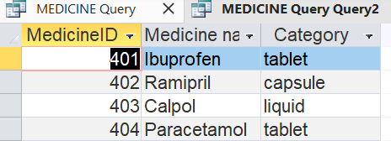

- Which supplier has an ID 204?
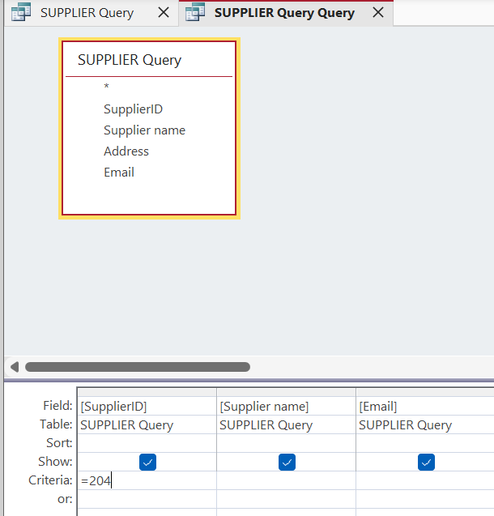

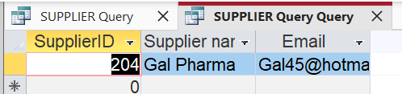

4. What is the name and date of birth of customer with prescription no.2?
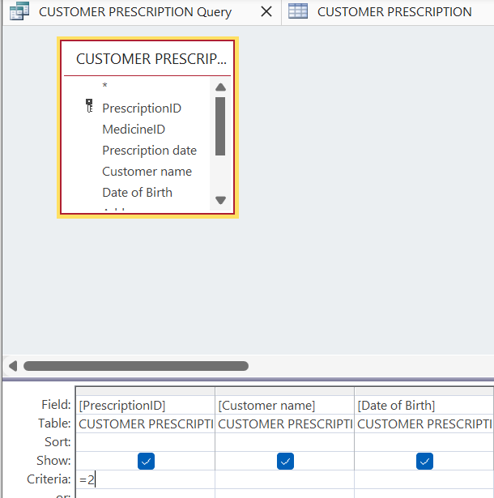

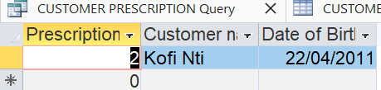

Testing and Validation

Description of how you tested and validated all the functional requirements
The testing and validation were done through the following steps:
- First open the Microsoft Access application.
- Browse in the file where the tables (supplier, customer prescription, medicine, sales transactions) were stored and open one of them e.g. supplier table.
- At the top of the application, click on the Create tab followed by the Query wizard.
- On that window, select (for e.g. supplier table) from the file to see the available fields.
- On the available field, drag the fields you want to run the query using ascending or descending into the query grid and then click on the next button.
- This will lead you to an option whether you want to show the summary or detailed record. Leave it on the detailed option then click on the next button to another window.
- Select the option to modify the query design then click finish. This will display all the results in a special modified table showing all the selected fields that can be changed at any time.
- On the criteria column, insert the functional requirements you want to test and validate.
- Then click on the run button to display the results.
- Do the same to run queries for (customer prescription/medicine/sales transactions) tables. This will help retrieve, filter and analyze data from the tables efficiently.
- To sort data in the query, click on sort row in query design view and then use the ascending or descending.
- To filter data in the queries, use the criteria row to specify conditions for example
- (show only medicines that are tablets).

Design Decisions and Future Work
- Design Decisions: Explaining your design decisions, summarising what you built, and reflecting on any challenges you faced

When designing the pharmacy database system, I focused on creating a simple, clear, normalized, and scalable structure with emphasis on the entities that are primary keys and foreign keys to represent the core operations to ensure referential integrity and to prevent orphan records. The database was designed to prevent reduce data redundancy and repetition of information to align with 3NF. The ER diagram for the pharmacy management system defines the entities that clearly identifies primary keys and foreign keys showing the relationships between the entities.
Some of the challenges faced was how to decide whether a prescription should contain multiple medicines or a sale transaction should contain multiple items. However, I kept the design simple on limited prescriptions to one medicine to make it enough to be clearly understood and implemented.

- Future Work: If you would like to implement any feature in the future
In the future, the system will include inventory restocking records, expiry alerts, and many-to-many relationships for prescriptions and sales. Though it looks simplified in some areas, it provides a solid and scalable foundation that can be implemented into a full enterprise system.

References:

List of reference sources in IEEE format
[1] M. Albarak, R. Bahsoon, I. Ozkaya, and R. Nord, “Managing Technical Debt in Database Normalization,” IEEE transactions on software engineering, vol. 48, no. 3, pp. 755–772, 2022, doi: 10.1109/TSE.2020.3001339.
[2] M. Rahmanian, A. Sami, and Y. Yu, “Challenges and feasibility of multimodal LLMs in ER diagram evaluation,” Cogent Education, vol. 12, no. 1, Nov. 2025, doi: https://doi.org/10.1080/2331186x.2025.2590901.
[3] S. Al-Fedaghi, “Conceptual Entity-Relationship Model: Underneath the Simplicity and Staticity,” 2025, doi: 10.48550/arxiv.2503.06155.
[4] R. Kumar, “Sales and Collection - MS Access Application: A Comprehensive Reporting and Data Management Solution,” Journal Dekstop Application (JDA), vol. 4, no. 2, pp. 58–67, Dec. 2025, doi: https://doi.org/10.59431/jda.v4i2.664.
[5] A. Sahara and S. Ramadhany, Relational Database Design Principles: Normalization , Denormalization and Query Optimization in Data Base management Systems, 2026.

