
Environmental Impacts, Implications and Response to the Pandemic by Companies, Non-Government Organisations or Local Authorities
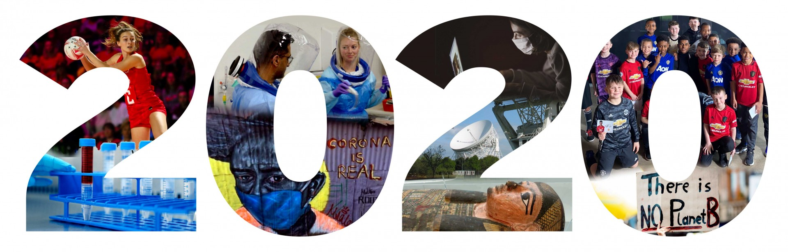
(Credit: The University of Manchester)

By Marie West (1702919)

Contents
Introduction 3
Case Studies: Amazon 3
Amazon’s Response: 4
Case Study: Manufacturing Industry 5
Manufacturing Industry Response 6
Case Study: Surfers Against Sewage 7
Surfers Against Sewages’ Response 8
Conclusion 8
Reference 10
Appendices 13

Introduction
In January 2020 a mysterious virus began to rapidly spread from country to country, by February it was given the name Severe Acute Respiratory Syndrome Coronavirus 2 (SARS-CoV-2) (World Health Organisation, 2021), otherwise known as Covid19. March 23rd 2020 the United Kingdom (UK) was put into lockdown (Government, 2020). By April 2020 46.6% of the population was working from home or remotely (Cameron, 2020). Humans have seen many pandemics throughout history, but Covid19 seems to have taken the world by surprise, and hit the global economy hard (Fuentes and Moder, 2021).
It was a necessity that the population stayed home, however, this is impossible for certain jobs. The response to Covid19 has varied depending on the organisation, business and individuals. While in lockdown the environment appears to have thrived all over the world. While humans were stuck inside the Earth seems to have been looking after itself and ‘healing’; Air pollution levels seemed to improve with approximately 30% drop in Nitrogen Dioxide (NO2) in June 2020 (Kumar et al., 2020), wild animals were reported to be seen in areas that they weren’t normally found in, and the flamingo population has grown ,with them visiting beaches they had not for years (Kumar et al., 2020)- this was just a few positive situations that occurred due to lockdown, but there have been negatives too. Some of the negatives are, loss of life, the global economy will be affected for a long time due to Covid19, increase in organic waste and many other negatives (Kumar et al., 2020). It was a necessity that the population stayed home, however, this is impossible for certain jobs. The response to Covid19 has varied depending on the organisation, business and individuals.
For this report the response to Coivd19, by Amazon, Surfers Against Sewage and the Manufacturing industry will be evaluated alongside what environmental impacts and implications could or have been seen because of the Covid19 Pandemic.

Case Studies: Amazon
Amazon is known for being one of the world’s biggest online retailers and cloud services provider (Wigmore, 2014). Amazon offers a wide range of products and services, such as, electronic books, electronics, cloths etc. (Hall, 2020). In 2019 Amazon announced that they had joined The Climate Pledge, which involved the commitment to reach net zero carbon by 2040 and to only run on renewable energy by 2030 (Amazon, 2020a).
With lockdown enforced due to Covid19, online sales increased by 34.7% since 2019 (Fisher, 2020). Amazon was one of many online shops that sales benefited from Covid19. Amazons net sales increased by 38% in 2020 (Amazon, 2021a); in 2019 the net sale was 280.5 Billion United States (U.S.) Dollars (Amazon, 2021a); by 2020 the net sales went up to 386.1 Billion U.S. Dollars (Amazon, 2021a). Between June 2019 and May 2020 600 million products had been sold through Amazon, approximately 1,200 products per minute (Amazon, 2020b). With the increase in sales there was a need to increase the transport to deliver the products and increase in packaging.
In 2008 Amazon changed their packaging system to be more sustainable (Amazon, 2020a); this change meant that packaging would be ‘Frustration-Free’ (Amazon, 2020a). Frustration-Free meant that the packaging would be easy-to-open, recyclable and to cut down on packaging by using the products original packaging to deliver it in (Amazon, 2020a).
However, a News report from August 2019 states that Amazon was still using branded single-use plastic envelopes (Brignall, 2019). The type of plastic that is used in these envelopes cannot be recycled in many places in the UK (Brignall, 2019). The size and over use of packaging was also in the News report, however, this was put down to the fact that digital software is used to pack the vehicles and is filled to stop the items from sliding around and possible breaking (Gatollari, 2019).
These are not the only issues with Amazon packaging. In 2019 465 million pounds of Amazon plastic packaging was produced, with 22 million pounds being found in freshwater and marine ecosystems (Koop, 2020). A manager of a recycling plant in South Seattle, United States of America, stated that he has seen more Amazon packaging ‘gumming up the machines’ since the Covid19 pandemic start (Long, 2020).
Not only is the Amazon packaging a big environmental problem but their return system is too. In 2019 an undercover investigation was filmed in an Amazon warehouse in France (Parker, 2019); it was found that lorry loads of unused or returned items such as, kitchen equipment, flat-screen televisions and many other items were being sent to dumps or landfill (Parker, 2019), a lot of the items were disposed of incorrectly. Some of the items did not belong to Amazon but small businesses or individuals that use the Amazon platform or their storage system (Parker, 2019). When questioned on their return system in the UK Amazon refused to comment (Parker, 2019). There has been no further update.
With the increase in sales there was a need for more drivers to deliver the products. By the end of 2019 Amazon already had a branded fleet size of 50,000 vehicles (Blanco, 2019). The fleet is made up of 20,000 Amazon branded trailers and 30,000 smaller Amazon branded vehicles (Blanco, 2019). However, Amazon is known to use third-parts to deliver too, this figure is unknown.
In line with their Climate Pledge, Amazon ordered 100,000 electric vehicles to replace their current fleet and is expected to be in force by 2022 (Blanco, 2019). This was done before Covid19.
With a large amount of plastic already being produce by Amazon, there is a possibility that with the increase in sales and the experience of the recycling plant manager; that more plastic will be found in freshwater and marine ecosystem. Along with the packaging the amount of delivers for Amazon on the road could produce more carbon dioxide into the atmosphere.

Amazon’s Response:
Amazon has had few different types of responses to Covid19 such as, donating money, using their own software to help organisations, help with Covid vaccines and testing, along with many other types of assistance (Amazon, 2021b).
Globally Amazon have hired 100,000 full and part time employees and are extending this by an additional 75,000 (Amazon, 2020c) – this increase in employees is due to Covid19 it was done out of the need for more drivers and packers.
To aid countries in Europe Amazon donated 21 Million Euros to support the most affected by Covid19, donated masks to the European Union Public Health Services and provided free content such as, books, music and videos on Amazon devices (Amazon, 2020c). Online STEM classes were also provided for disadvantaged students (Amazon, 2020c).
Amazons Web Services Programme set up a system that collected and analysed data which would allow better allocation of resources (Majerus, 2020). This system was made to help organisations that look after the vulnerable and the homeless to rapidly find housing, help with medication and any other assistants they offer, by allocating resources more efficiently (Majerus, 2020).
Amazon has provided pop-up clinics in the United States of America (USA) to help vaccinate people (Amazon, 2021b). They are using fast-moving response teams to test their employees and anything that they learn is being shared with different organisations (Amazon, 2021b). Their online effects increased to stop price gouging on the website throughout the pandemic (Amazon, 2021b).
Although Amazon has been active with helping others through the pandemic, they have been unable to make strides towards their climate pledge (Hurst, 2020). However, they have been preparing projects to put in place when the world is back to normal (Hurst, 2020). For example, Amazon has been purchasing land in the USA, Australia, Spain, Sweden and other parts of America to build solar farms (Hurst, 2020).

Case Study: Manufacturing Industry
The manufacturing industry has played an important part in the UK’s economy, even though it has declined since the 1970’s (Hennik Research, 2021). In 2019 the manufacturing industry employed 2.7 million people, funds 11% towards gross value added (GVA), 45% of exports come from the manufacturing industry, 69% of business research and development is through the manufacturing industry and gives 13% towards business investments (Hennik Research, 2021).
Berry Global Plastic Manufacturing Company creates packaging and engineering products (Berry Global Inc., 2021a). The Berry Company has 295 locations with 47,000 employers (Berry Global Inc., 2021a).
In 2019 The Berry Company announced that they had put a Sustainability Strategy in place, the goal was to have 10% recyclable packaging on consumers good and encourage the development of renewable materials by 2025 (Berry Global Inc., 2021b).
By the end of 2019 the Berry Company had reprocessed over 135,000 metric tons of polymer waste (Berry Impact Report, 2019). The waste that was collected came from different sources such as, industrial, commercial, agriculture and domestic communities (Berry Impact Report, 2019). When the pandemic started Berry Plastic company started to produce products that safe guarded the population, such as, materials for N95, N99 and surgical masks, Personal Protective Equipment, disinfecting wipes and many more (Berry Global Inc., 2021c). The Berry Global Company is just one of many manufacturers that have been impacted be the Covid19 pandemic.
The manufacturing industry is a complex system of trying to create technology that can increase efficiency and production while also trying to evolve at a rapid rate to be courteous and mindful of the environment (Campbell, 2019). Although they might try, the manufacturing industry does still have an impact on the environment. Such impacts are, air pollution, water pollution, Soil pollution, wildlife destruction and increase risk to human health (Field, 2018).However, many manufacturing companies have taken steps to become more sustainable and have less of an impact on the environment (Bennett, 2019).
In regards to how the manufactory industry has impacted the environment during the pandemic there has not been much of one, why? Because of lockdown; a lot of the companies had to shut down and send their employees home.
In a normal situation the manufacturing industry would be the one to have the impact; however, Covid19 has impacted the manufacturing industry economically. This can be seen when examining the National Statistics from February 2020 to October 2020.
By October 2020 a significant economical impact could be seen on different sectors of the manufacturing industry. For example, repair & maintenance of aircraft and spacecraft’s dropped by 36.3%, manufacturing of weapons and ammunition dropped by 24.8%, manufacturing of aircrafts and spacecraft related machinery dropped by 22.4%, manufacturing of coke and refined petroleum products dropped by 22%, the printing and reproduction of recorded media also dropped by 19% (Stephens et al., 2021) – these large decreases in production was seen in the first 9 months of Covid19.
As mentioned before the UK economy has be hit hard by Covid19, so hard that it is thought that it will cause a worse recession then after World War 2 (Stephens et al., 2021). Although the gross domestic production (GDP) showed a small increase in December 2020 of 1.2%, levels still remained 6.3% below the February 2020 levels (Stephens et al., 2021).
The implications of this economical hit could impact the environment and the UK people. The impact and implication would depend on the type of manufacturing company. For example, Berry Global Plastic has seen and could see further demand of their products as there is a current cardboard shortage (BBC, 2021a). Berry is already environmentally friendly company, there impact to the environment is small and with regards the implication to the environment could be beneficial; with an increase in their product production more funds could be created that would allow more funding to be invested in to make environmentally friendly plastics.
However, a manufacturing company such as an aircraft and spacecraft parts maker could normally impact the environment a lot but due to Covid19 they are producing less than they would, having less of an impact on the environment.
Unfortunately, until the pandemic is over the full impact to the environment will hard to see or understand; and while we can only speculate what the impacts are we still will not able to predict with 100% certainty what will happen.

Manufacturing Industry Response
Every manufacturing company will have responded to Covid19 in their own way but also very similar ways. The government has to impose rules that the public and business would follow, such as to stay at home when possible.
Berry Global Plastic Manufacturing Company has been used as an example in other areas of this report, and only seems appropriate to examine how they responded to Covid19.
Any employee that could work from home was told to do so, this resulted in remote meetings and communicating via email or telephone (Berry Global Inc., 2021d).The company, because of what they produce, had to produce more products as plastic was required to make thing such as facemasks, hand sanitizer bottle, clinical waste sacks etc. (Berry Global Inc., 2021d). This meant that they had to put strict measurements in place to protect their staff, placing tapes on the floor to keep them 2 metres apart, providing personal protective equipment etc. (Berry Global Inc., 2021d).

Case Study: Surfers Against Sewage
Surfers Against Sewage (SAS) is an organisation that first started in 1990’s, it was started because suffers were annoyed with seeing sewage and rubbish in the sea and on the beaches (Surfers Against Sewage, 2021a). Their main mission is to unite communities so that they take action to protect and preserve oceans, beaches, waves and wildlife (Surfers Against Sewage, 2021b). In the 2000’s SAS became a Non-Government organisation (NGO) and given charity status (Surfers Against Sewage, 2021a).
The SAS is slightly different to Amazon has they are an organisation that works to keep the environment clean; with this in mind, there would be little impact from them. However, they clean p areas, this can tell us a little on the positive impact they have.
Surfers Against Sewage participate in many different clean-ups and data collection. Roughly 5,000 items of plastic can be found on UK beaches per mile (Marine Conservation Society, 2016). Plastic pollution is not the only problem that the oceans face; in England and Wales there are approximately 21,462 licensed sewer overflows, which 89% discharge into rivers (Environmental Agency, 2020); this could be linked to why only 14% of the British rivers are at a ‘good Environmental standards’ (European Commission, 2019).
Covid19 has caused many problems but with regards to SAS being able to carry out its normal work such as beach cleans and water quality data collection.
There has been a large amount of Personal Protective Equipment such as, face masks, gloves and face shields, found dumped and littered on the beaches since the pandemic started (BBC, 2020). Not only is the new litter on the beaches becoming a problem but in over areas to reduce plastic had lapsed, for example, during lockdown the 5p payment on plastic bags from supermarkets was stopped when delivering food (BBC, 2020).
Before Covid19 there was a movement to fade out single use-plastic, such as, coffee cups from Greggs, McDonalds, and plastic straw (Surfers Against Sewage, 2020). These types of stagey have been pushed back, halted or taken out of action until further notice.
Due to Covid19 shops like Greggs and McDonalds have and are continuing to refuse to fill the publics reusable carry cup (Cuff, 2020). Scientists have said that it is safety to use this cup again, with the refusal continuing a petition was started with 7,000 signatures (Cuff, 2020); 14 different environmental groups have backed it with such as groups as. Greenpeace, Friends of the Earth and Surfers Against Sewage (Cuff, 2020).
Although these are not the impacts directly by SAS, these changes have concerned them. With the lockdown it has meant that SAS was unable to do their regular beach clean and that the use of single-use plastic again can led to much more litter on the beaches and water ways.
When it comes to environmental implications there is no certainty of knowing what will happen.
Surfers Against Sewage carry out regular beach cleans but with lockdown they have been unable to go out; couple this with the increase us of plastic, it is highly likely that more litter and rubbish will be found on the beaches and in bodies of water around the UK; and many other areas around the global.
Not only are the beaches not receiving their normal care but the bodies of water are not getting the care either. Some studies suggest that Covid19 can be transmitted through untreated sewage, which might not receive the complete or any disinfection treatment when using sewage overflows (Surfers Against Sewage, 2021c). With 89% of the 21,462 licensed sewer overflows licensed to discharge into rivers (Environmental Agency, 2020) this could become a problem – more so if not monitored, SAS are unable to collect data at this time.

Surfers Against Sewages’ Response
The response to Covid19 has had to mainly be online, which started SAS movement towards digital activism. Using the social media website Twitter SAS produced hashtag such as contactless coffee, return to offender, mini-beach clean and waves of optimism (Surfers Against Sewage, 2021d). Contactless coffee was to promote the use of reusable coffee cups, return to offender was to hold the 12 brands responsible for half of the UK’s plastic pollution, mini-beach clean was encouraging people to clean the beaches by themselves while in lock down and waves of optimism was to provide the public with a little project to do while in lockdown, to submit a piece of artwork of their favourite beach (Surfer Against Sewage, 2021e).
With few ways to get information out, the internet and social platforms have become ways to inform others. This type of activism has shown to have had an impact as the environment is being talked about online more.

Conclusion
In Conclusion, the year 2020 has been an interesting one and the pandemic is not over yet. However, there are a few vaccines for Covid19 currently being given to the public, and tops scientists are saying that the virus appears to be slowing down in the UK (BBC, 2021b).
As we can see the pandemic has proven to be beneficial to some and devastating to others. Amazon saw a large increase in profit (Amazon, 2021a) and helped communities that could have suffered throughout the pandemic (Amazon, 2020d); however, the plastic pollution seen in 2019 from Amazon was high and impacted ecosystem (Koop, 2020), could the increase in sales led to a larger number of plastic pollution or less? The impact to the environment of these increased sales and everything associated with it will not be seen until further in the future or until the pandemic is over.
Berry Global Plastic Manufacturing Company has benefited from the pandemic as their plastic has been used more due to the need for masks, face shields and hand sanitiser (Berry Global Inc., 2021c). Although many other manufacturers have seen great loss due to closure or their products not be needed or brought (Stephens et al., 2021). This is one of many reasons contributing to the economic decline in the UK (Stephens et al., 2021) – this can already be seen, and it’s only expected to worsen.
While these over case examples have benefited Surfers Against Sewage has seen little benefit. With lockdown rules enforced SAS has been unable to clean their beaches and collect data from waterway that would monitored be them (Surfers Against Sewage, 2021a). However, they did see a boost in their online audiences as lockdown forced them to be more present then normal on the internet and social media; and many people stuck at home gave an audience that had the time and was willing to know more. Although their impact on the environment was low due to being an organisation that helped to improve it with beach cleans, an impact on the environment in the future could be seen as possible more littler and plastic pollution build up as they have been unable to give the beaches their normal care.
Each of these cases studies environmental impact can been seen in 2019 before the pandemic was in full swing, however, we can only discuss and speculate the implications to the impact on the environment. We will not see the impact until after the pandemic is finished.
At these uncertain times, when many people are living day-to-day, not knowing when life will return to normal, and many good deeds are done by many, the question is, can the good deeds erase or be forgiven for the damage that has been or could be done to the environment?

Reference
Amazon, 2021a. New Release Details. [online] Amazon.com. Available at: <https://ir.aboutamazon.com/news-release/news-release-details/2021/Amazon.com-Announces-Fourth-Quarter-Results/>
Amazon, 2021b. Amazon’s COVID-19 vaccination and testing blog. [Blog] Amazon, Available at: <https://www.aboutamazon.com/news/company-news/amazons-covid-19-blog-updates-on-how-were-responding-to-the-crisis>
Amazon, 2020a. About the Packaging Programme. [online] Amazon.co.uk. Available at: <https://www.amazon.co.uk/gp/help/customer/display.html/ref=hp_left_v4_sib?ie=UTF8&nodeId=201910390>
Amazon, 2020b. Small Business Success in Challenging Times. [PDF] Amazon, p.3. Available at: <https://d39w7f4ix9f5s9.cloudfront.net/4e/f8/33b83b3743628fbd1d5237e1dca6/amazon-uk-smb-report-2020.pdf>
Amazon, 2020c. Amazon’s actions to help employees, communities, and customers affected by COVID-19. [Blog] The Amazon Blog Day One, Available at: <https://blog.aboutamazon.eu/working-at-amazon/amazons-actions-to-help-employees-communities-and-customers-affected-by-covid-19>
BBC, 2021a. Cardboard Shortage Forces Retailers to Box Clever. BBC, [online] Available at: <https://www.bbc.co.uk/news/business-55878062>
BBC, 2021b. Covid: Infections Levelling off in Some Areas –Scientist. BBC, [online] Available at: < https://www.bbc.co.uk/news/uk-55659065#:~:text=The%20coronavirus%20growth%20rate%20is,a%20top%20scientist%20has%20said.&text=On%20Wednesday%2C%20the%20UK%20saw,by%20that%20measure%20to%2084%2C767.>
BBC, 2020. Coronavirus: Pandemic 'Causing New Wave' of Plastic Pollution. BBC, [online] Available at: <https://www.bbc.co.uk/news/uk-england-bristol-53947161>
Bennett, M., 2019. Why More Than Half of UK Businesses are Planning to Increase Spend on Sustainability. The Telegraph, [online] Available at: <https://www.telegraph.co.uk/business/ready-and-enabled/sustainability/increasing-spend/>
Berry Global Inc., 2021a. About Berry. [online] Berry. Available at: <https://www.berryglobal.com/about-us/>
Berry Global Inc., 2021b. Environment. [online] Berry. Available at: <https://www.berryglobal.com/sustainability/environment>
Berry Global Inc., 2021c. Always Advancing To Protect What's Important. [online] Berry. Available at: <https://www.berryglobal.com/covid-19>
Berry Global Inc., 2021d. We're All In This Together. [online] Berry. Available at: <https://www.berryglobal.com/community-support>
Berry Impact Report, 2019. Impact Report 2019. [PDF] Berry Global Inc. Available at: <https://www.berryglobal.com/docs/default-source/sustainability-docs/berry-2019-impact-report-web.pdf>
Blanco, S., 2019. Amazon Buying So Many Commercial Vans, It's a Boom for Mercedes, FCA, and Ford. Car and Driver, [online] Available at: <https://www.caranddriver.com/news/a30295937/amazon-commercial-vans-ford-mercedes-fca/>
Brignall, M., 2019. Amazon under fire for new packaging that cannot be recycled. The Guardian, [online] Available at: <https://www.theguardian.com/technology/2019/aug/20/amazon-under-fire-for-new-packaging-that-cant-be-recycled>
Cameron, A., 2020. Coronavirus and Homeworking in the UK: April 2020. [online] gov.uk. Available at: <https://www.ons.gov.uk/employmentandlabourmarket/peopleinwork/employmentandemployeetypes/bulletins/coronavirusandhomeworkingintheuk/april2020#coronavirus-and-homeworking-in-the-uk-data>
Campbell, F., 2019. Human Factors: The Impact on Industry and The Environment. Intechopen, [online] Available at: <https://www.intechopen.com/books/natural-resources-management-and-biological-sciences/human-factors-the-impact-on-industry-and-the-environment>
Cuff, M., 2020. Reusable Coffee Cups: Many Chains Are still not Accepting Reusables, Despite Experts Insisting There is No Covid-19 Risk. iNews, [online] Available at: <https://inews.co.uk/news/environment/reusable-coffee-cups-pret-a-manger-mcdonalds-caffe-nero-reusables-covid-19-no-risk-581173>
Environment Agency, 2020. Combined Sewer Overflows Explained. [online] Gov.UK. Available at: <https://environmentagency.blog.gov.uk/2020/07/02/combined-sewer-overflows-explained/#:~:text=Combined%20sewer%20overflows%20(CSOs)%20are,from%20flooding%20homes%20and%20businesses.&text=The%20Environment%20Agency%20works%20closely,back%20on%20their%20discharge%20activity.>
European Commission, 2019. The Environmental Implementation Review 2019. [PDF] United Kingdom: European Commission. Available at: <https://ec.europa.eu/environment/eir/pdf/report_uk_en.pdf>
Field, 2018. How Can Factories Affect The Environment. [online] Field.Org.UK. Available at: <http://www.field.org.uk/how-can-factories-affect-the-environment/#:~:text=Factories%20are%20also%20a%20major,the%20environment%20as%20a%20whole>
Fisher, B., 2020. Pandemic Pushes UK Retail Ecommerce Past 30% of Total Retail Sales in 2020. Insider, [online] Available at: <https://www.emarketer.com/content/pandemic-pushes-uk-retail-ecommerce-past-30-of-total-retail-sales-2020>
Fuentes, N. and Moder, I., 2021. The Scarring Effects of Covid-19 on the Global Economy. Voxeu, [online] Available at: <https://voxeu.org/article/scarring-effects-covid-19-global-economy>
Gatollari, M., 2019. This Is Why Amazon Sometimes Packs Small Items In Huge Boxes. Distractify, [online] Available at: <https://www.distractify.com/fyi/2017/12/28/Z1UYuIS/amazon-huge-boxes>
Government, 2020. Prime Minister's Statement on Coronavirus (Covid-19): 23 March 2020. [online] Gov.UK. Available at: <https://www.gov.uk/government/speeches/pm-address-to-the-nation-on-coronavirus-23-march-2020>
Hall, M., 2020. Amazon.com. Britannica, [online] Available at: <https://www.britannica.com/topic/Amazoncom>
Hennik Research, 2021. UK Manufacturing Statistics. [online] The Manufacturer. Available at: <https://www.themanufacturer.com/uk-manufacturing-statistics/>
Hurst, K., 2020. Our progress on The Climate Pledge. [Blog] Amazon, Available at: <https://www.aboutamazon.com/news/sustainability/our-progress-on-the-climate-pledge>
Koop, F., 2020. Amazon’s plastic packaging waste could encircle the globe 500 times. ZME Science, [online] Available at: <https://www.zmescience.com/science/amazons-plastic-packaging-waste-could-encircle-the-globe-500-times/>
Kumar, A., Mella, M. and Dubey, A., 2020. With Corona Outbreak: Nature Started Hitting the Reset Button Globally. Frontiers in Public Health, [online] 8(2296-2565), p.533. Available at: <https://www.frontiersin.org/articles/10.3389/fpubh.2020.569353/full>
Long, K., 2020. Amazon's plastic waste could encircle globe 500 times, report says. Phys.Org, [online] Available at: <https://phys.org/news/2020-12-amazon-plastic-encircle-globe.html>
Majerus, K., 2020. How AWS customers and partners are supporting the homelessness crisis response during COVID-19. [Blog] AWS-Amazon, Available at: https://aws.amazon.com/blogs/publicsector/how-aws-customers-partners-supporting-homelessness-crisis-response-during-covid-19/
Marine Conservation Society, 2016. Latest Press Releases. [online] MCSUK. Available at: <https://www.mcsuk.org/latest/press>
Parker, C., 2019. TRASH AND BURN Inside Amazon’s ‘destruction zones’ where millions of new items it can’t sell are incinerated or dumped in landfill. The Sun, [online] Available at: <https://www.thesun.co.uk/news/9055665/amazon-dumps-millions-items-tvs-kitchen-books-nappies-landfill/>
Stephens, M., Wright, H. and Luckwell, G., 2021. Coronavirus and the Impact on Output in the UK Economy: December 2020. [online] Office for National Statistic. Available at: <https://www.ons.gov.uk/economy/grossdomesticproductgdp/articles/coronavirusandtheimpactonoutputintheukeconomy/december2020>
Surfers Against Sewage, 2021a. SAS History. [online] Surfers Against Sewage. Available at: <https://www.sas.org.uk/about-us/history/>
Surfers Against Sewage, 2021b. Mission & Values. [online] Surfers Agaisnt Sewage. Available at: <https://www.sas.org.uk/about-us/mission-vision/>
Surfers Against Sewage, 2021c. What are the Risks of Covid-19 Transmission from Sewage Discharge. [online] Surfers against Sewage. Available at: <https://www.sas.org.uk/news/campaigns/what-is-the-risks-of-covid-19-transmission-from-sewage-discharge/>
Surfers Against Sewage, 2021d. Return To Offender. [PDF] Available at: <https://www.sas.org.uk/wp-content/uploads/Return-To-Offender-Express-Issue-1-1.pdf>
Surfers Against Sewage. 2021e. Plastic Free in a Time of Covid [online] Surfers Against Sewage. Available at: <https://www.sas.org.uk/news/plastic-free-in-a-time-of-covid/>
Surfers Against Sewage. 2020. What are the Risks of COVID-19 Transmission from Sewage Discharge? [online] Surfers Against Sewage .Available at: <https://www.sas.org.uk/news/campaigns/what-is-the-risks-of-covid-19-transmission-from-sewage-discharge/>
Wigmore, I., 2014. Amazon. [online] Whatls.com. Available at: <https://whatis.techtarget.com/definition/Amazon>
World Health Organisation, 2021. Naming the Coronavirus Disease (Covid-19) and the virus that cause it. [online] World Health Organisation. Available at: <https://www.who.int/emergencies/diseases/novel-coronavirus-2019/technical-guidance/naming-the-coronavirus-disease-(covid-2019)-and-the-virus-that-causes-it#:~:text=The%20International%20Committee%20on%20Taxonomy,two%20viruses%20are%20different>

Appendices
Figure 1. Power Point Presentation: Amazon’s Environmental Impact through the Pandemic.
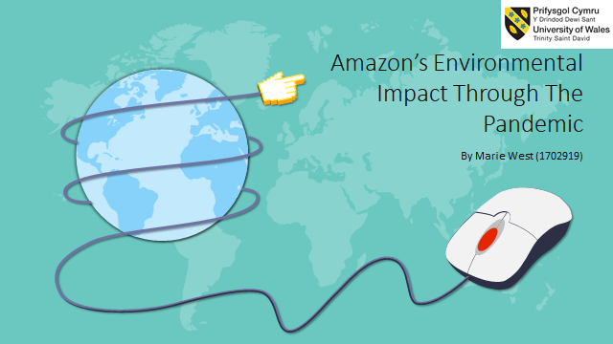
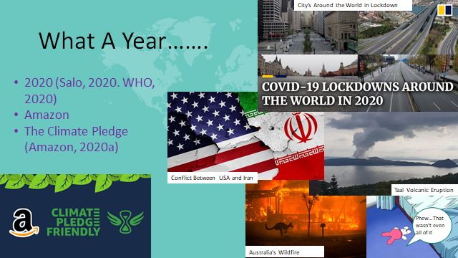
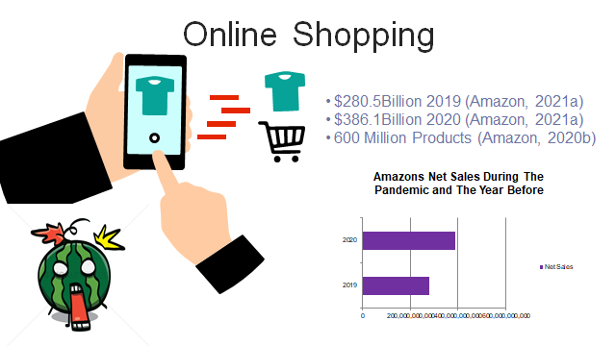
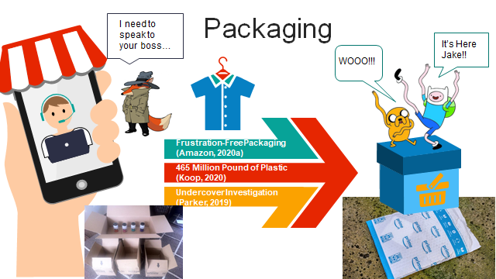
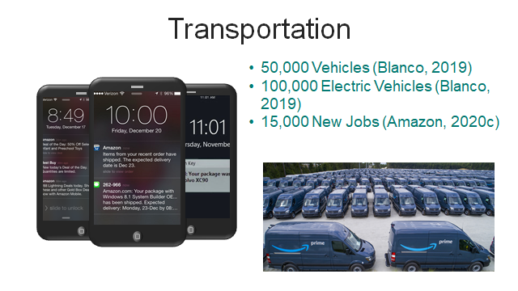
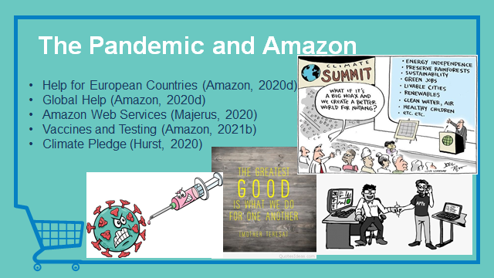
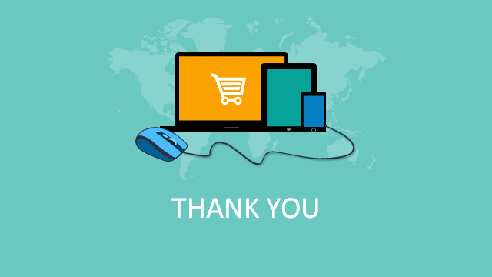
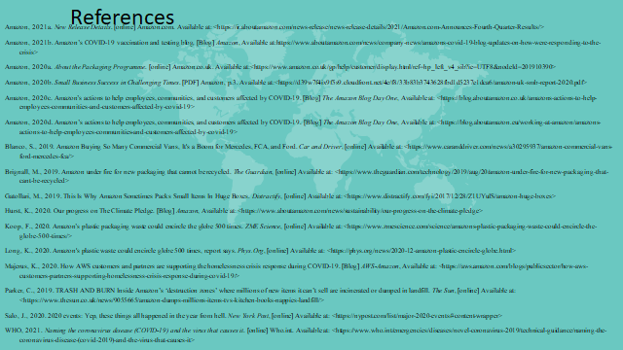
Figure 2. Script to the Power Point Presentation: Amazon’s Environmental Impact Through the Pandemic.
“Introduction
2020 is not going to be forgotten anytime soon. This past year started with devastating wildfires in Australian, Conflict between countries, a Level 4 Volcanic eruption and a mysterious virus (Salo, 2020). By March 2020 the world was in lockdown with a pandemic and the virus was named SARs-Cov-2 (WHO, 2021), otherwise known as Covid19.
Everyone has been impacted by the pandemic in some way. For this presentation I will be discussing how Amazon has dealt with the pandemic in regards to increased online sales, packaging, transport and other positives carried out through the pandemic.
In 2019 Amazon announced The Climate Pledge which involved the commitment to reach net zero carbon by 2040 and to only run on renewable energy by 2030 (Amazon, 2020a).
Online Sales
Amazons net sales increased by 38% in 2020 (Amazon, 2021a).
The net sale in 2019 was 280.5Billion U.S. Dollars but in 2020 net sales went up to 386.1Billion U.S. Dollars (Amazon, 2021a).
Between June 2019 to May 2020 600Million products had been sold through Amazon, roughly 1,200 products per minute (Amazon, 2020b)
Because of the increase in sales it means that transport and packaging is being used more through the pandemic then before.
Packaging
In 2008 Amazon changed their Packaging system to be more sustainable, the change meant Frustration-Free Package, Which would be easy-to-open, recyclable packaging and to cut down on packaging by sending items in their own packaging without additional boxes (Amazon, 2020a)
However, a News report from August 2019 shows that Amazon are still using single-use plastic, branded envelopes that are made from a plastic that very few places in the UK can recycle (Brignall, 2019). The reason for large boxes is due to a software system that will select boxes to fill the vehicle making sure nothing can slide around and break (Gatollari, 2019), it is basically playing Tetris.
465 Million Pounds of plastic packaging was produced by Amazon in 2019 with at least 22million pounds being found in freshwater and marine ecosystems (Koop, 2020). A manager of a recycling plant in South Seattle, USA stated that he has seen more Amazon packaging ‘gumming up the machines’ since the pandemic started (Long, 2020).
There is the return system to consider also, in 2019 a undercover investigation filmed in an Amazon warehouse in France, found that lorry-loads of unused or returned items such as kitchen equipment, flat-screen televisions and many other items were being sent to dumps or landfills; these unused or returns goods will not belong to amazon but businesses or individuals that use their platform and storage system for their business. Amazon refused to comment on the dumping system in the UK. There have been no more updates on whether if this is still happening (Parker, 2019).
Transport
By the end 2019 Amazon had a fleet size of 50,000 vehicles (Blanco, 2019). The fleet is made up of 20,000 amazon-branded trailers and 30,000 smaller amazon-branded vehicles (Blanco, 2019). However, Amazon do outsource to others, these figures are unknown.
Amazon has also ordered 100,000 electric vehicles to replace their current fleet which is expected to be up and running by 2022 (Blanco, 2019).
Because of the increase in online sales Amazon needed more employees so they offered 15,000 new full time or part jobs (Amazon, 2020c). They also enlisted help from Amazon Flex Participants and seasonal employees.
Pandemic and Amazon
So, that is most of the information about how Amazon has dealt with more business in the last year and what environmental implications there could be. However, it is important to also mention what other steps they have taking throughout the pandemic to help others.
To help countries in Europe they donated 21million Euros to support the most affected by Covid19, donated mask to European Union Public health services and providing free content such as books, music and videos on Amazon devices (Amazon, 2020d).
Globally they have hired 100,000 full and part time employees and are extending this by additional 75,000. They are providing disadvantaged Students with online STEM classes (Amazon, 2020d).
Amazons Web Services programme has also helped to set up a system that collects and analysis data, which then allows better allocation of resources; this was set up to help organisations that look after the vulnerable and the homeless to rapidly find housing, help with medication or many other things (Majerus, 2020).
Amazon is also helping with vaccines and testing. For example, they have been aiding in pop-up clinics in the USA to help vaccinate people. They are using a fast-moving response team to give test to their employees and anything that they learn is being shared with different organisations (Amazon, 2021b). They also upped their online effects to stop price gouging on the website throughout the pandemic (Amazon, 2021b).
Although they haven’t been able to keep up with their climate pledge due to the pandemic they have taken steps, there are many projects in place and being worked on to aid in their climate goals. For example, buying land for solar farms in USA, Australia, Spain, Sweden and other parts of America (Hurst, 2020).”

Figure 3. The Summary Sheet for the student Led seminar and the findings of the seminar.
“Summary Sheet for Amazon’s Environmental Impact through the Pandemic by Marie West (1702919)
The year 2020 has be a rough year for everyone over the world. Covid19 has led to a worldwide lockdown with many countries returning to a lockdown after a few months, it has also left many economies in ruins (World Bank, 2020); with many shops in retail unable to open for the foreseeable future and many more shops to close their doors for good.
Although shops are not currently open in many places in the United Kingdom (UK) is has not stopped the UK people from spending their money.
Online shopping sales have increased by 34.7% since 2019 (Fisher, 2020), with an expected expenditure of approximately 141.33 Billion Great British Pounds (£) on online shops (Fisher, 2020).
One of the online giants saw a large increase in their sales; Amazon had a 38% net sale increase in 2020, receiving 386.1 Billion U.S. Dollars ($) (Amazon, 2021a). Although Amazon had a relatively good year in regards to sales they were unable to make much progress towards their Climate Pledge.
With an increase in sales this has led to an increase in packaging and transport to deliver the products. Amazon was reported to have previously changed the type of package they used back in the early 2000’s (Amazon,2020a); This packaging was meant to be Frustration-Free which meant it would be easy-to-open, recyclable and cut back on over use of packaging (Amazon, 2020a). However, news report and online comments have shown amazon using branded single-use plastic envelope which few places in the UK can recycle (Brignall, 2019).
In 2019 Amazon produced 465 million pounds of plastic packaging, with 22 million pound found in freshwater and marine ecosystems (Koop, 2020). A United States of America (USA) recycling plant has reported to have received so much Amazon packaging since the pandemic started that it is ‘Gumming up the machines’ (Long, 2020).
With increase sales comes the need to increase delivery vehicles; at the end of 2019 Amazons Fleet size consisted of 20,000 amazon-branded trailers and 30,000 smaller amazon-branded vehicles (Blanco, 2019). With such a large fleet size and their Climate Pledge Amazon placed an order for 100,000 electric vehicles to replace their current one (Blanco, 2019).
With Amazon sales’ increasing the use of plastic is expected to have risen and more transport is being used, which will add fossil fuels to the atmosphere; this is going against their Climate Pledge and many goals of the United Nations to improve the environment.
Although Amazon is expected to have a larger impact on the environment in 2020, they have done some good deeds to help many people through the pandemic.
They Donated 21 Million Euros to European Countries provided free content such as books, music and videos on Amazon devices, increased global jobs by 175,000, provided disadvantaged students with online STEM classes, used their Amazon Web Services programme to help organisations care for the vulnerable and homeless.
These are just few things that they have done. Which brings a question to mind; can good deeds erase or forgive the damage to the environment?”
Figure 4. Summary Sheet on the Findings of the Student Led Seminar on Amazon’s Environmental Impact through the pandemic.
Summary Sheet on the Findings of the Student Led Seminar on Amazon’s Environmental Impact through the Pandemic by Marie West (1702919)
After presenting the Powerpoint and giving participants the facts, such as:
- Amazons net sales increased by 38% in 2020 (Amazon, 2021a). The net sale in 2019 was 280.5Billion U.S. Dollars but in 2020 net sales went up to 386.1Billion U.S. Dollars (Amazon, 2021a).
- In 2008 Amazon changed their Packaging system to be more sustainable, the change meant Frustration-Free Package, Which would be easy-to-open, recyclable packaging and to cut down on packaging.
- August 2019 shows that Amazon are still using single-use plastic, branded envelopes that are made from a plastic that very few places in the UK can recycle (Brignall, 2019).
- 465 Million Pounds of plastic packaging was produced by Amazon in 2019 with at least 22million pounds being found in freshwater and marine ecosystems (Koop, 2020).
- Amazon had a fleet size of 50,000 vehicles (Blanco, 2019).
- Europe they donated 21million Euros to support the most affected by Covid19, donated mask to European Union Public health services and providing free content such as books, music and videos on Amazon devices (Amazon, 2020d).
- Globally they have hired 100,000 full and part time employees and are extending this by additional 75,000. They are providing disadvantaged Students with online STEM classes (Amazon, 2020d).
- Amazons Web Services programme has also helped to set up a system that collects and analysis data, which then allows better allocation of resources; this was set up to help organisations that look after the vulnerable and the homeless to rapidly find housing, help with medication or many other things (Majerus, 2020).
These were a few points of information given.
One topic of the discussions that took place was that a lot of the participant and the presenter use Amazon a lot – so would it be hypercritical to be opposing them? While this question was asked a counter argument was made, that they had committed to a Climate Pledge and years previously said they would change their packaging to be user friendly and environmentally friendly –that we hold them to a higher standard as the pledge to do the above and that they were a larger enough company that could do it.
This then led in to discussion on the packaging that they use. Larger boxes than need for the items or product inside while also using packaging that could not be recycled in many places in the UK. Although they use a computer software system that packs the items and vehicles, as stated above- in 2008 they were meant to change their packaging, this led to another question ‘should they have not changed this system to be more environmentally friends in 2008?’.
Overall many agreed that the impact on the environment was shocking, especially in regards to how much of Amazon plastic was found in freshwater and marine ecosystems. But, many could agree that the use of Amazon in lockdown was somewhat essential for many. Another point that was discussed was the amount of money that had be put in to Amazon yet they do not pay taxes in many countries, this could put a strain on many economies in the world.

