Live Events Project (BMTP5021): The Feel-Good Health and Wellness Event

Learner Name: Alyssa-Marie Stoneman (2401974)

Lecturer Name: Deborah Jenkins

Event Plan Report

1. Event Overview
Event Name: The Feel-Good Health & Wellness Fayre
Event Type: Wellness Fayre
Concept & Theme: The overall theme of this event is to nourish, restore and glow within yourself, to take some time to invest in yourself and take part in some incredible immersive guided classes like Pilates or yoga. We have opted for the colour scheme of green, beige, white and gold to symbolise healing and growth with the green, clarity and purity with the white, grounding and natural living with beige and with the elements of gold to symbolise vitality and overall positive energy (Robinson, 2017). The concept is to have local businesses in and around Swansea to come down, set up a stall to display their products, goods or services in order to reach an audience of students, staff and general public. We want to bring together a common of like-minded people who are either in to or want to explore the wellness industry.
Target Audience: We are targeting an audience of university and college students aged 18 or above, despite the specific age demographic, the event is open to all. We are also looking to target staff members within the university, and members of the public who may be looking for ways to relax outside of work or other commitments.

2. Timing, Location & Programme
Date & Time: Tuesday 17th March 2026 10am – 4pm
Venue: University of Wales Trinity St David IM Building, Swansea Waterfront, Trinity Waterfront, Swansea SA1 8EW
Event Programme: Live Events Project (BMTP5021) – Deborah Jenkins Module Lead
Registration & Welcome Speech – From 10am onwards (guests can arrive any time between 10am and 4pm) welcome speech done as guests walk in.
Key Activities/Sessions – Stalls will be set up from 8am ready for the event to start at 10am, stall holders will be there all day for guests to check out. Immersive room timings starts from 1pm – 4:30pm in timed intervals. There is a total of 5 sessions ranging from 1 hour sessions to half hour sessions. We have Angelic Glow Qi Gong starting off at 1 pm, at 2pm-2:30pm we have secured Susannah Hollett Crystals, 2:30pm-3pm we have Mellon Theatre Arts demonstrating Pilates, at 3pm we have Jemma Joel doing a life coaching session and to finish off we have Ian Standen doing a yoga session from 3:30pm-4:30pm.
Breaks & Networking – No Scheduled Breaks, Networking to be done during free time.
Closing & Wrap-up – To wrap up the event, we have marketed that the stalls/Fayre will end at 4pm and that the final immersive class will finish at 4:30pm. 2 members of the group will ensure to let final guests know that the event is ending and we will ensure to thank all attendees for coming to the event when we commence the raffle draw. As they leave also we will all make sure to make the effort to thank everyone and wish them a safe journey home.

3. Aim and Objectives
Overall Aim: The main goal of this event is to focus on holistic wellbeing, drive community engagement and market the wellness industry and tactics to interested individuals or groups who are looking to get into caring for their health and wellbeing.
Objectives:
Objective 1- Is to promote Health and Wellbeing awareness
Objective 2- Connect university students with excellent support services
Objective 3- Encourage healthier lifestyle choices

4. Project Planning Techniques (Including EMBOK Framework)
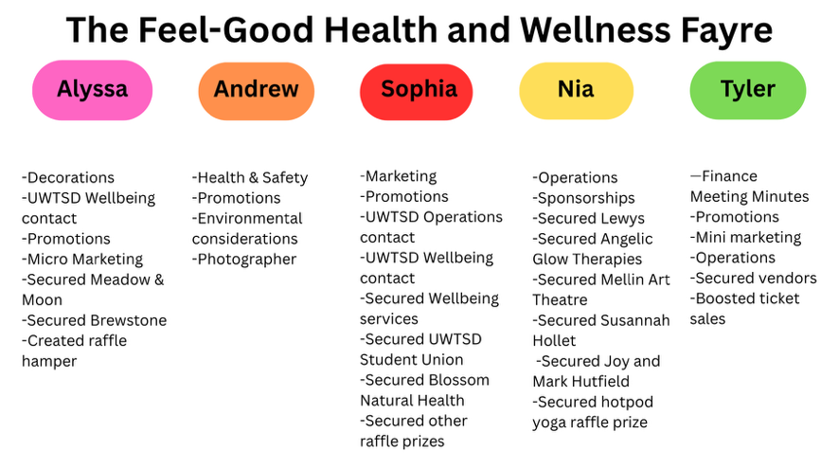
Work Breakdown Structure (WBS):
(ProjectManager, 2022)

Gantt Chart: Gantt Chart did not get sent across in time for submission.

Running Order:
8am- Arrive at Uni to help vendors bring stuff in and begin set up and decorations
9am- Aim to finalise decorations
9:30am- Morning brief
10am- Event starts (vendors available from 10am – 4pm)
12pm-12:30pm- Raffle draw
1pm-2pm- Qi Gong class in Immersive Room
2pm-2:30pm- Susannah Hollett Crystals class in Immersive Room
2:30pm-3pm- MTA Pilates class in Immersive Room
3pm-3:30pm- Jemma Joel Life Coaching class in Immersive Room
3:30pm-4:30pm- Ian Standen Yoga class in Immersive Room
4:30pm-5pm- Event clean up
5pm- Event debrief

EMBOK Domains:
(EMBOK, 2019)
Administration: The planning for the event has been discussed within a WhatsApp group chat between the event organisers, we have allocated specific roles to each individual with specific jobs for the day to ensure that every section of the event is covered (e.g. overseeing, ticketing, set up, vendor locations etc). General coordination for the event has all been planned by the UWTSD Operations team by getting information about where to put tables and the layout of the event.
Design: The overall event theme is based off of nature, relaxation and calming colours as previously discussed. The decorations stick to the colour theming, we have exciting elements to add in such as St Patrick’s Day bunting and tinsel as our event will fall on that exact day, we also have some beautiful floral garlands to create the outdoorsy atmosphere that many people connect to wellness and relaxation. There is technical entertainment with the immersive room guided classes from industry professionals, these are completely voluntary however we will be sure to push the attendees to at least take a look, join the classes and speak to the mentors holding the experiences. Our branding is perfect for this event, our logo incorporates elements of yoga/pilates, matcha’s and coffees and healthy eating as well as displaying relaxation and exercise.
Marketing: To market our event, we are going to mock up promotional messages to send to followers closer to the event date if ticket sales have not reached a huge number, we also have the sponsorship from UWTSD Wellbeing team so they can also help with sharing and posting about the event as they themselves are attending and will be conducting a survey for university male student’s mental health. We will measure audience engagement by tracking the follower count, likes on posts, comments and shares as well as reposts.
Operations: All operations side of things have been covered by Sophia and UWTSD Operations Team. Venue setup is most efficient in the IM building in a ‘U Shape’ as this will eliminate potential risks that will be brought up in the risk assessment, ensures easy navigation and will puss attendee to business engagement. It will also make sure that the entrance to the building is not crowded as students will still need to attend classes within the building on the day. Overall safety of the event is ultimately in the hands of us event organisers, all legal and regulatory licensing are in the name of University of Wales Trinity St David so us as event organisers and students will need to ensure that guests are acting in an orderly manner, if anything were to escalate or get out of hand, we have on site university security at had in order to aid us.
Risk Management: Identifying, assessing, and mitigating risks- Risks such as slips or trips from crowded walkways, allergic reactions to food samples, and minor injuries during fitness demonstrations. To mitigate these risks, ensure clear walkways, provide proper signage, check food ingredients for allergens, and have qualified instructors supervise activities. Additionally, having first aid available and trained staff on-site helps ensure any incidents are handled quickly and safely.

5. Market Research & Target Audience
Market Segments: Main consumers of Wellness Events are predominantly Gen Z and Millennial Women. However, now in recent years it is said that a broad range of age’s in both men and women are significantly growing at fast rates. As of 2025, Gen Z men and women are more interested in taking care of their health and wellbeing more than ever before (Pione (et al., 2025). The different consumer groups for our specific event will be marketed to students in university, staff members, members of the public and customers of local vendors we will be brining in.
Competitor Analysis: A major current competitor to our wellness Fayre is the Lush Wellness Hour that is happening exactly 10 days on from our event date. The Lush Wellness Hour involves massage classes, breath work and meditation (LUSH, 2026). Lush is a UK company hugely popular and known for their handmade soaps, bath bombs and other cosmetic and self care products (Lush, 2025), this could be insanely detrimental for our event as consumers may not want to spend money on 2 similar wellness marketed events which are just a matter of days away from each other.
Consumer Preferences: Event participants are increasingly looking for holistic wellness experiences that support their mental, physical, and emotional health, rather than focusing only on exercise. Today’s attendees also seek personalised, high-quality, and authentic activities that provide practical insights or tools they can easily incorporate into their everyday lives (Pione et al., 2025b).

6. Event Marketing Plan
Marketing Channels: Our main marketing channel is social media. We have created an Instagram page under the title of @feelgoodwellness.events, so far this is seeming to be very beneficial. Within the first day of posting we gained 5 ticket sales. We have massaged 2 influencers – Liam Gleed who has a TikTok following of 30.8k people and Rebecca Francis-Davies who is a Labour Candidate for the 2026 Welsh Senedd. So far Rebecca has shared our event page, reposted an image that we have posted marketing the event and has shown interest in attending our event. Liam on the other hand has not yet responded to our message we have sent across. All event organisers have also made the efforts to share the page and ticket links around on our personal account and also sent messages to friends and family. With me personally (Alyssa) I have share the most on my personal account and immediate family members have also shared around the event and concept along with the ticket link on their Facebook pages and Instagram Page’s. I have also printed off informative flyers and put them up in my student accommodation and handed some out in my home town of Newport.
Promotional Timeline: Marketing activities such as posts and promotional messages will take place weekly and, on the lead, up to the event will be posted daily to keep customer and follower engagement. The marketing posts will be put on the event Instagram page and shared by all of us on our personal accounts to reach the wider audiences.

Key Messages & Branding: We will communicate the event in a calming, holistic and engaging way, by making eye catching images using creative tools like Canva and Adobe Express. Sticking with the branding of green, beige, white and gold elements it will engage audiences by providing a fresh and unique visual environment that not many individuals will typically see in their day to day lives. Event being marketing at the moment such as festivals, concerts and competitors are typically using much more harsh and darker colour elements like reds, yellows, blues and pinks. The key messages we are displaying are investing in yourself, exploring different styles of health and wellness and also showing that we are providing a safe and comfortable environment to connect with others and find your style of investing in yourself.
Sponsorship: Sponsorship for this event has kindly been provided to us by UWTSD Wellbeing Hub, they have kindly offered to pay the expenses for the decorations, university course specific hoodies we will be wearing as a uniform and they have also offered to pay for a roll up/stand up banner to have at the event for photo opportunities, future use and to also provide engagement within the event. We are so lucky to have a great university specific team who are willing to support us in every way they can.

7. Budget & Financial Plan (From Tyler)
Projected Income: Ticket sales are the main point of incline for our event, Tickets are priced at £5 per person, and this price also includes the raffle ticket. As a team, we collectively aimed to sell 50 tickets, which would generate £250 in total revenue (not including Eventbrite fees).
Expected Expenditure: The raffle hamper is coming to be the main heavy cost of our event, we have spent £58.59 on the items all together. The hamper will be given away as the raffle prize during the event.
Venue and Equipment: The event is being held on University of Wales Trinity St David campus at the IM Building, so there has been no venue costs.
Marketing and Promotion: We have no marketing or promotion costs as we are using the free tool of Instagram to market our event to the public. The UWTSD Wellbeing Team have been extremely helpful in covering the costs for the event banner which will also be used for marketing.
Staffing & Security: We again have no outgoing costs for staffing and security; we have Level 4 Tourism and Events Management students helping us out on the day of the event with UWTSD security being on site prepared to help us when needed.
Catering & Logistics: N/A (not necessary for our event type)
Miscellaneous: N/A (any extra costs will be no more than £5)

External Suppliers:

• UWTSD Student Union
• UWTSD Wellbeing Service
• Blossom Natural Health
• Brewstone Cafe
• Lewys (author & surfing advisor)
• Angelic Glow Therapies
• Susannah Hollet
• Melin Theatre Arts
• Joy Hutfield Transformation Coach
• Mark Hutfield Mind in Motion Coach
- Meadow and Moon

Budget Report: ‘A budget report has been created to keep track of income and spending throughout the event planning process.’

8. Risk Management & Health & Safety (From Andrew)
Risk Assessment:
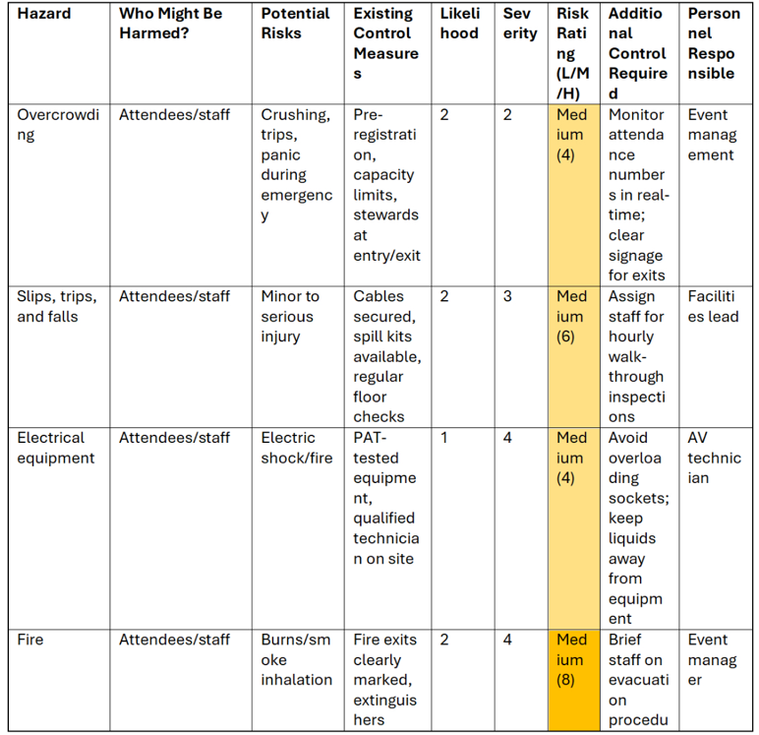

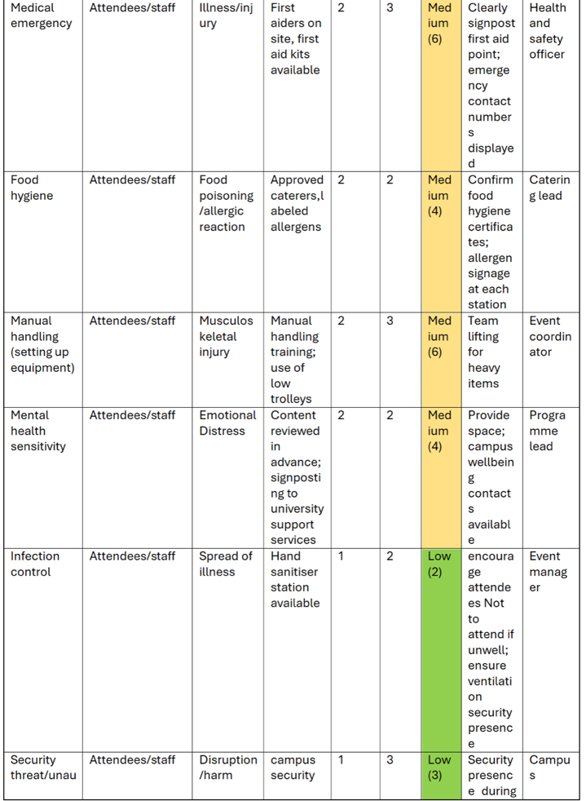
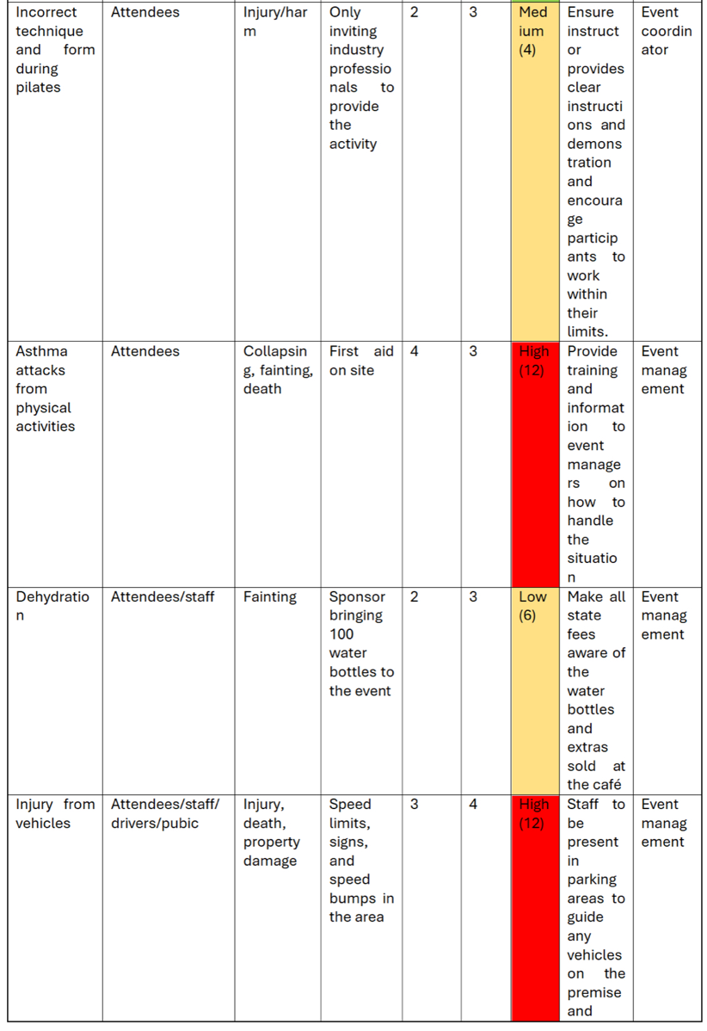

Health & Safety Measures: First aid kits are available on site with clear signage to show the nearest one. There are members of staff who are also first aid trained. Security is also provided by the university and are available on site if needed. For crowd control, the IM Building is extremely spacious and also has plenty of room to accommodate all vendors and up to 50 attendees.
Legal Requirements: No legal requirements needed, UWTSD hold all necessary.
Public Liability Insurance: UWTSD are holders of this licence
Required Licences: Temporary Event Notice (TEN Licence) held by UWTSD and Local Authorities Licences are also held by UWTSD.
Emergency Plan: If the unfortunate event of a necessary evacuation, no responsibility would be on us as university students, all emergency exits are clearly highlighted within the building.

9. Contingency Planning
Alternative Venue: The Dylan Thomas Centre- Function Room
Weather Contingencies: Ensure that grit is on roads if possible icy conditions, market bad weather conditions on social media and wish people safe journeys and mention to not attend if it is not going to be safe enough, ensure to recognise if high UV index occurs to tell people to bring appropriate gear such as sun cream, sun hats and water.
Key Supplier Failures: Ensure we has standby substitutes of a similar market background
Crisis Communication Plan: We need to plan out clear communication channels between ourselves and our interested customers, we also need to be sure to clearly respond to queries we may be sent by Instagram follower or possible vendor opportunities. We also need to have clear honesty with possible event attendees and let them know whether or not we know a piece of crucial information to eliminate or reduce poor feedback. A crisis plan must also be in place from the Health and Safety Manager in case of last-minute cancellations, safety concerns or bad publicity that may come about when marketing the event.

10. Evaluation Strategy
Post-Event Surveys: We will use Google Forms as a feedback collection tool as it is a pre-laid out and formatted survey tool that automatically collects and analyses data clearly for your future use. We can generate a QR code to display on the day of the event and urge attendees to share their experiences through the survey, if we do not manage to gauge a response from every attendee we will have their emails through Eventbrite which is the website we have used to push ticket sales, so if all else failed we can email them from the event email address and ask them to submit a response.
Key Performance Indicators (KPIs): Key metrics for measuring success will be based on ticket sales, Instagram engagement and analytics and general interest on the Instagram page.
Attendance Measuring: We will ensure to make a note of how many tickets have been sold, track how many people attend and are on site and be sure to closely observe overall engagement with social media posts such as likes, shares and comments.
Debrief Meeting: To ensure a clear and effective review of the entire event, all event organisers must ensure to be completely honest with both peers and the module lead. This will easily help with the review write up when the event has come to an end and also is still ethical and relevant.

11. Sustainability & Event Legacy
Sustainability Considerations: Some things we have taken into consideration when planning this event have been making sure to properly recycle and discard of all litter that makes itself apparent before, during and after the event, I have also made sure to carefully select decorations that could be used for future events and that are also recyclable and not overly damaging to the environment. We will also urge attendees to walk to the event if possible, to cut CO2 emissions as much as possible as well as ensuring businesses attending the event as stall holders have sustainable values.
New Economics & Legacy: Our event contributes to long-term benefits by displaying long term uses and take-home solutions on how to manage your health, wellbeing and mindfulness. Economic impacts create temporary employment opportunities for event staff, organisers, and suppliers.
Event Impacts: Positive environmental impacts of our event are that it encourages positive sustainable and healthy practices such as displaying mindfulness and ways to care for you. It also raises awareness about environmental health topics which include clean living and green-wellness products. Negative impacts include carbon emissions from event attendees and vendors as well as increasing energy and water consumption at the venue.
Pocial impacts of our event encourage community engagement and social interaction between guests, attendees and vendors whilst also improving the publics awareness on physical and mental health. Negative social impacts could be the possibility that vendors charging a high amount for their products or even potential misinformation that has been spread.

12. Key Areas of Managing Event Operations
Staff Rota:
Staff: | Jobs: | Timings:
Alyssa Stoneman (Me) | Marketing, promotions, decorating, vendor set up, check in, way finding. | Monday (16th)- 5pm-5:30pm  Tuesday (17th)- 8am-5pm
Andrew Jones | Health and Safety, decorating, way-finding | Monday (16th)- 5pm-5:30pm  Tuesday (17th)- 8am-5pm
Nia Mugford | Decorating, overseeing event, Immersive room rep | Monday (16th)- 5pm-5:30pm  Tuesday (17th)-
Tyler- Belle Condon | Decorating, check in, escort to immersive room, financial manager | Monday (16th)- 5pm-5:30pm  Tuesday (17th)- 8am-5pm
Sophia Rabaiotti | Morning brief, decorating, photography | Monday (16th)- 5pm-5:30pm  Tuesday (17th)- 8am-5pm
Riley Tippett- Volunteer | Decorating, vendor set up | Monday (16th)- 5pm-5:30pm  Tuesday (17th)- 8am-9am
Poppy- Volunteer | Decorating | Monday (16th)-5pm- 5:30pm  Tuesday (17th)- 8am-9am
Ethan- Volunteer | Decorating, vendor set up | Monday (16th)- 5pm-5:30pm  Tuesday (17th)- 8am-9am
Lily Lewis- Volunteer | Decorating | Monday (16th)- 5pm-5:30pm  Tuesday (17th)- 8am-9am

Logistics & On-Site Management: Event organisers main mode of transport includes walking and road vehicles. Stall holders main mode of transport include road vehicle. Parking onsite for attendees (must register their car for free parking within 30 min of arriving). Nia Mugford and Andrew Jones manage crowd control and overseeing. Technical set up (decorations, helping vendors bring in equipment and setting up tables and other items vendors may need assistance with) are to be controlled and monitored by all event organisers and event volunteers.
Stakeholder Coordination: The main communication from us event organisers to the vendors has been through email and Instagram Direct Messages. These are efficient ways of communication because of the professional setting within emailing systems and there is a complete written and kept record of the conversations, it is also effective by ensuring we remain a formal and organised communication method. Whereas, Instagram direct message is a less formal environment yet it also gets recognised by businesses and marketing individuals as they won’t typically receive messages from student-led organisations so it will catch their eye. Still ensuring we remain a professional manner, it is extremely helpful to pre-write a message to send across to businesses. With this can come informal drops in conversations by using slang and adapting a more ‘friendly’ level of communication than keeping the formal tone. Another method that will be used is communication over Microsoft Teams, this is an easy platform for all to access, the conversations can be recorded and it also kept that formal setting. To contact appropriate authorities, in this case being the university management, operations, wellbeing and catering teams, we will opt for using emails as their contacts are easy to find and this also keeps all contact and confidential information within the university area. Using emails to contact university individuals not only will get our name and contacts out there to higher up staff members for future possible employment or networking but is an ethical approach out of respect for their rules and policies as well as legal licensing.

13. Division of Work & Responsibilities
Meeting Minutes: Tyler-Belle Condon- no meeting minutes were recorded as we kept a consistent record of conversations through a WhatsApp group chat. Busy schedules couldn’t allow for all to organise face-to-face meetings.
Email Correspondence: Sophia Rabaiotti, Tyler-Belle Condon, Nia Mugford, Alyssa Stoneman (promoting and contacting vendors through emailing systems)
All emails and Instagram accounts of confirmed vendors:
- Mhutfield@live.co.uk
- Joyhut@hitmail.com
- Rebecca.patrick@uwtsd.ac.uk
- Angelicglowtherapies@hotmail.com
- Beautifulearth41@hotmail.com
- N.owens@uwtsd.ac.uk
- Meadowandmoonuk@gmail.com
- @brewstone_uplands
- Info@blossom-natural-health.com
- Mellintheatrearts@yahoo.co.uk
Task Assignments:
Alyssa- Decorations, Promotions, Marketing (partial)
Tyler- Finance, Spreadsheet, Meeting Minutes, Promotions
Andrew- Team Leader, Health and Safety
Sophia- Marketing, Promotions
Nia- Operations Manager, Promotions
Coordinator: Alyssa, Tyler, Sophia~ Ensuring overall project direction and leadership
Shaper: Alyssa, Nia, Tyler, Sophia~ Driving progress and keeping the team focused
Plant: Alyssa
Monitor Evaluator: Tyler, Sophia, Nia ~ Assessing ideas critically and ensuring quality
Implementer: Alyssa, Nia, Tyler, Sophia, Andrew~ Turning plans into actionable steps
Completer Finisher: Alyssa ~ Ensuring all details are perfected
Resource Investigator: Alyssa, Sophia, Nia, Tyler ~ Seeking external opportunities and connections
Team-worker: Sophia, Nia, ~ Promoting harmony and collaboration within the team
Specialist: Sophia, Nia~ Providing in-depth knowledge in key areas
________________________________________

Reference List:
EMBOK (2019). EMBOK - Event Management Body of Knowledge - EMBOK Model. [online] Embok.org. Available at: https://www.embok.org/index.php/embok-model [Accessed 11 Mar. 2026].
LUSH (2026). LUSH Swansea | Wellness Hour. [online] Eventbrite. Available at: https://www.eventbrite.co.uk/e/lush-swansea-wellness-hour-tickets-1982697246838?aff=ebdiglgoogleliveevents&source=ecat [Accessed 12 Mar. 2026].
Lush (2025). Who we are. [online] weare.lush.com. Available at: https://weare.lush.com/lush-life/our-company/who-we-are/ [Accessed 12 Mar. 2026].
Pione, A., Medalsy, J., Weaver, K., Callaghan, S. and Rickert, S. (2025a). The $2 trillion global wellness market gets a millennial and Gen Z glow-up. [online] McKinsey & Company. Available at: https://www.mckinsey.com/industries/consumer-packaged-goods/our-insights/future-of-wellness-trends [Accessed 12 Mar. 2026].
Pione, A., Medalsy, J., Weaver, K., Callaghan, S. and Rickert, S. (2025b). The $2 trillion global wellness market gets a millennial and Gen Z glow-up. [online] McKinsey & Company. Available at: https://www.mckinsey.com/industries/consumer-packaged-goods/our-insights/future-of-wellness-trends# [Accessed 12 Mar. 2026].
ProjectManager (2022). Work Breakdown Structure (WBS): the Ultimate Guide. [online] ProjectManager. Available at: https://www.projectmanager.com/guides/work-breakdown-structure [Accessed 12 Mar. 2026].
Robinson, J. (2017). Colour semiotics and what they mean in other cultures. [online] Buzz. Available at: https://buzzwordcreative.co.uk/colour-semiotics-and-what-they-mean-in-other-cultures/ [Accessed 10 Mar. 2026].

