2.3 Different types of religion, divergent viabilities

Within the broad framework of the declining social significance of religious belief and practice we have explored two modifications of secularization theory. Martin pioneered examination of socio-cultural variables, demonstrating that the former proximity to power of a state-sponsored church and the readiness with which it had tolerated alternative forms of religion both contributed to the relative degree of secularization in different Western European countries, both Protestant and Catholic. Davie further demonstrated, particularly through the complex interrelation of believing and belonging, that three dimensions of religious decline – public significance, church attendance and personal religious beliefs - require separate and nuanced rather than homogenised analysis, since they will not necessarily decline in parallel and to the same degree. The processes of secularization are thus complexified, and become descriptive of specific particularities of religion and society in the context of modernity rather than universally prescriptive.

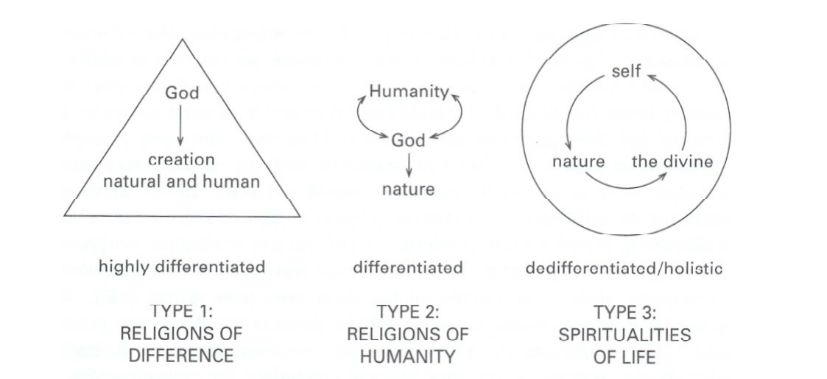

The spectrum of religion in modern times (Woodhead and Heelas: 2000, 3)

Woodhead and Heelas add a further layer of sophistication by identifying different types of religion – irrespective of the particular religion under consideration. They argue that the relative viability of different religious groupings can be predicted depending on their position among these ideal types. Among their students, these categories have become known as the ‘triangle and the blob’.

Type 1 religions emphasise the transcendent otherness of God. These include traditional Catholicism, Orthodoxy, Reformed Protestantism, Fundamentalism and Islam. Calvin’s introductory comments to The Institutes are a prime example of this approach: he states a twofold focus of study, namely God and Man, but the divine is elevated as transcendent purity even as the human is brought low, or even decried, in terms of total depravity. Type 2 religions emphasise the proximity of God and humanity. Liberal Protestantism operates in these terms, which at their most heterodox agree with Feuerbach that the essence of theology is anthropology.
Here the study of God collapses into the study - and indeed the elevation - of humanity. Type 2 religions have tended to work on the assumption that they serve the survival of religion by making religion more credible, stripped of superstition and transcendent superfluities. Type 3 religions bring the natural order fully into the equation of the spiritual, in a this-worldly holistic sensibility. New Age spiritualities very obviously correspond with this category (Heelas: 1996).
Woodhead and Heelas further complexify their analysis by proposing that the first two types operate in both a traditional and an experiential form. They observe that the non-experiential forms of religion, both type 1 and type 2, do least well in contemporary Western culture. This reflects liberalism’s critique of the
increasing implausibility of pre-critical religion, and yet also indicates the unexpected failure of liberalism to construct a credible and accessible form of contemporary religion. Statistically, there is a direct correlation between the proportion of liberals in a denomination and the rate of decline of church attendance. The two most successful forms are type 3, representing the rising tide of New Age experimentation, and also the ‘experiential religions of difference’, among which charismatic and Pentecostal Christianity enjoy global prominence.
Heelas and Woodhead conclude that Pentecostal growth has been unable to offset
the decline in non-experiential Christianity. Moreover, they find that non-experiential religions of humanity are often the most averse to any articulation of religious experience. (This, of course, is not the case with Professor Paul Badham, a leading liberal Anglican and scholar of religious experience, who retired from Lampeter in 2007.) In a later study (Heelas et al.: 2005), Heelas and Woodhead cite Charles Taylor’s emphasis upon Western culture’s ‘massive subjective turn’ (Taylor: 1992). This subjectivity functions in two dimensions. First, the authority of the individual in religious matters has become so elevated that ‘what seems right to me’ (‘epistemological individualism’) is determinative of religious validity. Priests and gurus have diminishing influence. Second, personal experience has been elevated as a primary category of authentic religion.

Although Heelas and Woodhead’s account identifies five forms of religion, the subjective turn may point towards a more decisive distinction. It could be that experiential religion finds niche markets in contemporary Europe, whether the outward form is New Age, Christian or something else. These experiential religions may have more in common than their subjectivity and relative success; this is an area that requires further research. What is clear is that subjectivized religion is capable of enduring, even in the relatively secularized culture of Western Europe. It is perhaps too early to say whether this represents a nostalgic last redoubt for religion or the beginnings of a cultural turn against the ‘iron cage’ of secularity. Nonetheless, this unmistakable degree of resurgent religion and spirituality has
been by no means capable of counterbalancing the decline of religion evidenced in
mainstream, institutional Christianity. The discriminations that Heelas and Woodhead make appear to indicate new mutations or experiments in religion, but at the margins of a broadly secularized culture.

Scroll down for graph!


