ACBA 5004
GEOTECHNICS & FOUNDATION ENGINEERING
Lonye Browne (2114209)
UWTSD

Table of Contents
Sieve Analysis 2
Introduction 2
Aim 2
Apparatus 2
Apparatus Set Up 2
Method 3
Results and Calculations 3
Analysis/ Discussion 5
Conclusion 6
Sources of Error 6
Limitations 6
Atterberg Limit Tests 7
Introduction 7
Aim 7
Apparatus 7
Apparatus Set Up 7
Method 8
Results and Calculations 9
Analysis/Discussion 11
Conclusion 12
Sources of Error 12
Limitations 12
Constant Head 13
Introduction 13
Aim 13
Apparatus 13
Apparatus Set Up 13
Method 14
Results and Calculations 14
Analysis/Discussion 15
Conclusion 16
Sources of Error 16
Limitations 16
References 17

Sieve Analysis

Introduction: Sieve analysis or particle size analysis is a test done to determine the distribution of particles by size within a sample soil. The soil sample is vibrated and passed through a stack of sieves to obtain the different weights of the soil sample that remained on each sieve size. The data obtained from the test is then plotted on a graph to obtain information about the texture of the soil sample. Sieve analysis is important in construction and engineering for concrete design mixes, to determine the performance of soils and for foundation analysis. This test is conducted in accordance with BS 812-103.

Aim: To determine the texture of a soil sample using sieve analysis.

Apparatus: scale, scale pan, scoop, tray, plastic cover, brushes, sieves, vibration machine, fasteners for the sieves, mechanical shaker, soil sample.

Apparatus Set Up:
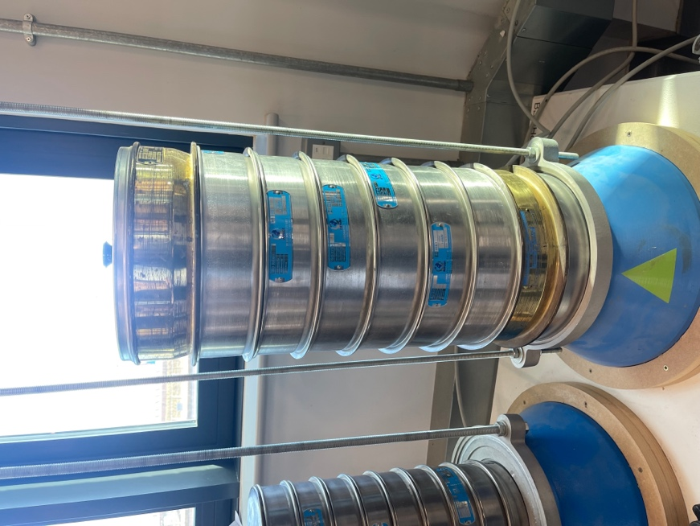
Fig 1. Photo showing apparatus set up for Sieve Analysis Test.
(Author, 2023)

Method: The sample was put in the oven at 120°C for twenty-four hours (before the experiment) to dry. The sieves were organised in a stack from largest (at the top) to smallest (at the bottom). The sieve sizes were then recorded in a table. The scale pan was weighed then the scale was zeroed. The soil sample was divided into quarters, and 1kg was approximated. The approximated 1kg soil sample was placed in the scale pan, weighed, and recorded. The soil sample was gently poured into the stack, then it was secured to the vibration machine by tightening the fasteners. The mechanical shaker was set to two minutes, and the sample was vibrated. After the two-minute period, the vibration automatically stopped, and the fasteners and lid were removed. The first sieve was carefully removed and slowly emptied into a tray with a plastic cover, and then the sieve was brushed to remove any stuck particles. The plastic cover was folded in half, and the soil from the first sieve was transferred to the scale pan. The soil from the first sieve was weighed and recorded in the table with the corresponding sieve size. This process was repeated for the remaining seven sieves and the pan at the bottom of the sieves.

Results and Calculations:
The sample soil weighed 1000g
Sieve Size (mm) | Mass (g) | % On sieve | % Passing
2 | 12.53 | 1.253 | 98.647
1.6 | 20.27 | 2.027 | 96.62
1 | 57.14 | 5.714 | 90.906
500 µm | 186.07 | 18.607 | 72.299
250 µm | 587.79 | 58.779 | 13.520
125 µm | 83.76 | 8.376 | 5.144
80 µm | 22.67 | 2.267 | 2.877
63 µm | 2.71 | 0.271 | 2.606
The pan | 26.06 | 2.606
Fig 2. Table showing results for particle size distribution test

There was 1.253% of gravel
96.041 of sand
And 2.606% of silt and or clay
There was a loss of 0.1% of the soil sample

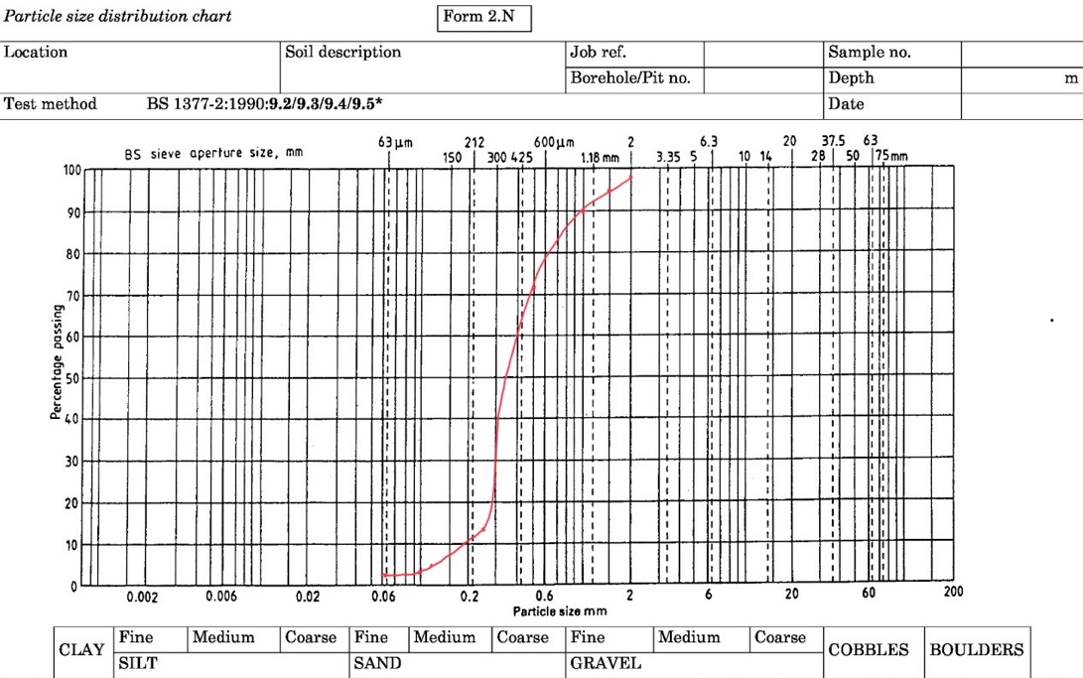
Fig 3. Graph showing the particle size distribution chart of the soil sample.
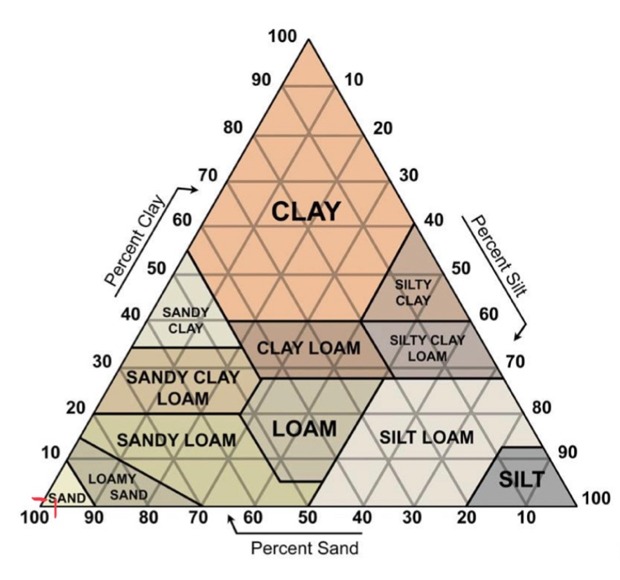
Fig 4. Triangular graph of soil texture for the soil sample.

Analysis/ Discussion: Soil texture is said to be the single most important physical property of the soil. Determining the soil texture of a sample can provide information about the water flow potential, water holding capacity, fertility potential, and suitability based on its bearing capacity. Aggregates are categorized as gravel, sand, silt, and clay based on their size. In this experiment and based on the sieves used, gravel is 2mm +, Sand is less than 2mm but more than 63μ, silt is 63μ, and clays are less than 63μ. Using Figure 2, it was calculated that the soil sample is made up of 1.253% of gravel, 96.04% of sand, and 2.606% of silts and possibly clays. The sieve size and percentage passing from Figure 2 were used to plot the Figure 3 graph. Figure 3, the particle size distribution chart shows that the soil sample is uniformly graded. Uniformly graded means that almost all the particles in the sample are around the same size and shape, with little to no variation in size. Figure 4 is a triangular graph of soil texture, the percentage of sand is marked at 96.04% at the bottom left-hand side, and the percentage of clay is marked nearby at 2.606%. These markings on the diagram tell that the soil sample is classified as sand.

Conclusion: The soil sample was determined to be a uniformly graded sand based on the particle size distribution chart and the triangular graph of soil texture.

Sources of Error: Experimenters failed to check sieves for any stuck stones before beginning the lab and tried to remove all particles that were stuck, which could have resulted in weight gain.

Limitations: It was impossible to remove some of the stuck particles from the sieve, which may have resulted in weight loss.

Atterberg Limit Tests

Introduction: The Atterberg limit test was first carried out by a Swedish scientist, Albert Atterberg. It is a soil classification test used in geotechnical engineering to determine the plasticity characteristics of fine-grained soils. The test measures the water content and finds the boundaries at which soils change from a plastic state to a liquid state, and from a plastic state to a semi-solid state. The Atterberg limit test is essential in structural engineering in the early stages of design. It ensures that a soil performs as expected as drastic changes in moisture can cause settling in the structure. This test is carried out in accordance with BS 1377: Part 2: 1990.

Aim: To determine the liquid limit, plastic limit and plasticity index of a clay sample.

Apparatus: scale, the soil sample, mixing bowl, water, squeeze bottle, spatula, seven small containers, liquid limit device, grooving tool, extra soil, glass plate, and glass rod.

Apparatus Set Up:
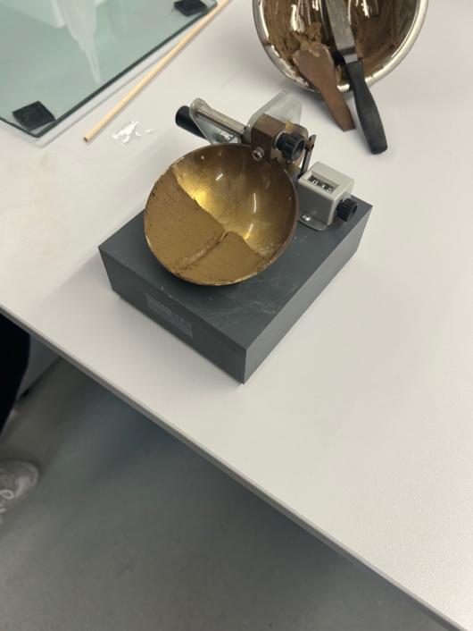
Fig 5. Picture showing apparatus set up for Atterberg Limit Test.
(Author, 2023)

Method: Liquid Limit: Four containers were chosen and labelled LL1, LL2, LL3, and LL4. Each container was weighed, and the weight was recorded. The sample soil was placed in a metal mixing bowl. Small amounts of water were added to the soil sample using a squeeze bottle and it was thoroughly mixed with a spatula. Water was continuously added and mixed in until a clay-like/smooth consistency was achieved. The sample should feel spreadable, caution was taken to not add too much water at first. After the right consistency was achieved, the sample was spread as evenly and flatly as possible on the cup bowl of the liquid limit device using the spatula. It was ensured that there were no air bubbles or gaps, and if there was any excess on the spatula it was returned to the mixing bowl. Using the grooving tool, the experimenter’s hand was held steady and only the wrist was gently flicked forward to cut through the sample. It was ensured that there was a clean line and that the base of the cup bowl was seen. The counter on the liquid limit device was set to zero. The handle was cranked at a steady rate of two drops per second, to lift and drop the cup bowl. The bowl was lifted and dropped until the gap was closed. The number of blows it took to close the gap was recorded. A slice of the sample was removed from the cup bowl and placed in the container labelled LL1. The container LL1 (+ sample) was weighed, and the weight was recorded. The sample remaining in the cup bowl was returned to the mixing bowl. This process (from the step of adding water) was repeated for the other three samples (LL2, LL3, and LL4), gradually increasing the moisture content so that the number of blows required to close the gap was less each time. All four samples were put in the oven to dry for twenty-four hours.
Plastic Limit: Three containers were chosen and labelled PL1, PL2, and PL3. Each container was weighed, and the weight was recorded. The remaining sample in the mixing bowl (from the Liquid Limit test) was used for this test. Extra soil was added to the mixing bowl in small amounts and mixed in. As more soil was added to the mixture, it was kneaded into a big ball. A piece of the sample about 10g in weight was picked off and rolled into a ball. The ball was put down on the glass plate, next to the glass rod. The ball was then gently rolled by hand out to be a cylinder, similar in diameter to the glass rod. The sample was rolled by hand to be half its size in diameter until it crumbled/ broke. When rolling out, it was important not to exert pressure on the sample and to keep a steady hand; this was done to ensure that the sample crumbled due to lack of moisture and not applied force. After the crumbling occurred, one of the two pieces was put into the container labelled PL1. PL1 (+ sample) was weighed, and the weight was recorded. The other piece was returned to the mixing bowl and re-kneaded into the sample. These steps (from separating about 10g of sample) were repeated for two other samples (PL2 and PL3). All three samples were then put in the oven to dry for twenty-four hours.

Results and Calculations:
 | 1 | 2 | 3 | 4 |  | 5 | 6 | 7
Type of Test | LL | LL | LL | LL |  | PL | PL | PL
Container Number | LL1 | LL2 | LL3 | LL4 |  | PL1 | PL2 | PL3
Wt of wet soil + cont (g) | 16.23 | 12.78 | 13 | 11.04 |  | 7.14 | 6.71 | 6.73
Wt of dry soil + cont (g) | 13.24 | 10.60 | 10.69 | 9.13 |  | 6.66 | 6.29 | 6.30
Wt of container (g) | 4.76 | 4.76 | 4.69 | 4.69 |  | 4.74 | 4.74 | 4.70
Wt of moisture (g) | 2.99 | 2.18 | 2.31 | 1.91 |  | 0.48 | 0.42 | 0.43
Wt of dry soil (g) | 8.48 | 5.84 | 6 | 4.44 |  | 1.92 | 1.55 | 1.60
Moisture content (%) | 35.25 | 37.33 | 38.5 | 43.018 |  | 25 | 27.097 | 26.875
Number of blows | 74 | 41 | 25 | 14
Avg moisture cont (%) |  |  |  |  |  | 26.324
Fig 6. Table showing the Liquid and Plastic Limit Determination.

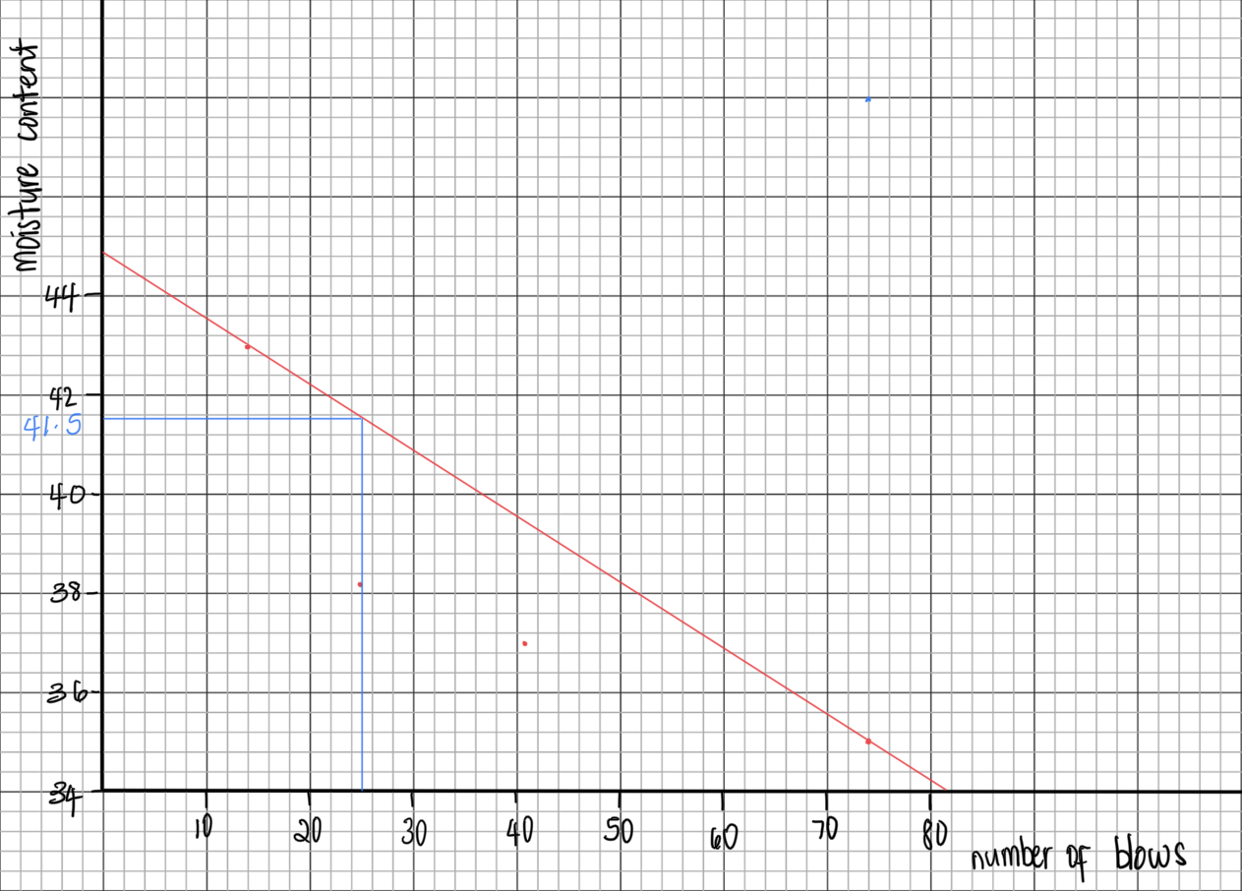
Fig 7. Graph showing the Liquid Limit percentage of the sample soil.

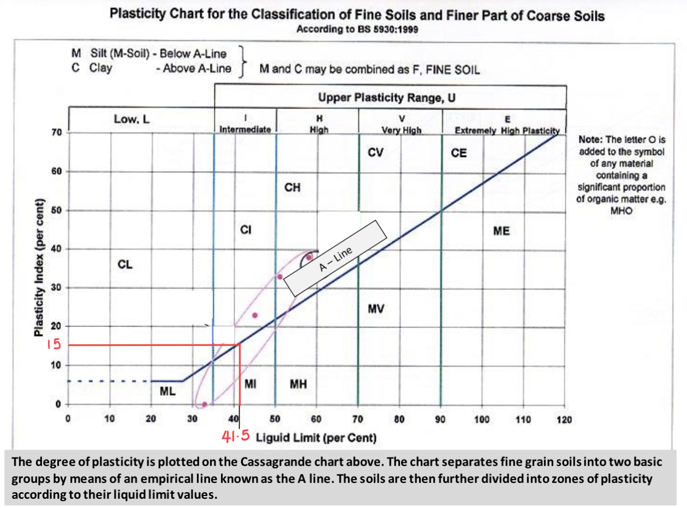
Fig 8. Graph showing the plasticity index percentage of the soil sample.

Liquid Limit = 41.50%
Plastic Limit = 26.324%
Plasticity Index = 15.176%

Analysis/Discussion: The Atterberg limit test is also known as the soil consistency test. In engineering, the consistency of a soil will determine its suitability under loads such as compressive, shear and consolidative (vertical). The liquid limit refers to the water content above which soil acts as a liquid; the soil has a soft consistency. The plastic limit is the lowest water content at which soil behaves like a plastic material; the soil has a stiff consistency. The plasticity index is the range between the liquid limit and the plastic limit; having a consistency between soft and stiff. Figure 6 is a table with all the raw data and calculations; for liquid limit, it shows that as the moisture content percentage increases, the number of blows decreases. Figure 6 also shows that the plastic limit is 26.324%. In Figure 7, a graph of the number of blows against moisture content is plotted to attain the liquid limit percentage. The liquid limit is taken at twenty-five blows and the value is 41.50%. Figure 8 is the plasticity index chart; it shows that the liquid limit and the plasticity index are directly proportional. The liquid limit is marked out at 41.50% percentage, which has a corresponding plasticity index of 15%. This value can also be achieved by finding the difference between the liquid limit and the plastic limit, which is 15.176%. From Figure 8, the plasticity index was above the A-line, indicating that is clay and it is classed in the intermediate plasticity range. Liquid limits and plastic limits play an important role in determining the stability of a slope as increasing water content can decrease the stability of a slope. If the moisture content percentage exceeds the plastic limit percentage, the slope will begin to deform. For example, The Holbeck Hall Hotel, Scarborough, North Yorkshire in June 1993. This was a structure situated on a clifftop sitting on ground/ soil made of clay, sand, and gravel. The area experienced a period of high rainfall, and then a large section of the cliff beneath the structure collapsed. The results of the geotechnical investigation stated that the moisture content of the ground exceeded the plastic limit which caused a loss in cohesion and shear strength of the underlying soil/ground. This incident highlights the importance of conducting Atterberg limit tests in the early design stages and continuing to monitor and maintain the geotechnical aspects of a completed construction project.

Conclusion: The clay sample had a plastic limit of 26.324%, a liquid limit of 41.50%, and a plasticity index of 15.176%.

Sources of Error: Failure to maintain two drops per second when conducting the liquid limit. For the plastic limit, failure to roll the clay out to the correct diameter, as it was eyeballed/estimated.

Limitations: The counter for the liquid limit device was sometimes stuck in between two numbers, causing the experimenter to drop the sample once more.

Constant Head

Introduction: The Constant Head experiment is conducted to test the hydraulic conductivity and permeability of soils. It measures how easily water can flow through a sample. These tests are carried out with soils such as sand and gravel. It forces water through the sample and the permeability is calculated using Darcy’s Law. This test is important in engineering and construction to better understand groundwater flow. This test is conducted in accordance with BS EN ISO 22282-2-:2018.

Aim: To determine the coefficient permeability (rate of flow of water) of a soil sample.

Apparatus: measuring cylinder, timer, balancing tank, control valve, permeameter, supply to permeameter, manometer tubes, soil sample, water supply, vernier caliper, and stool

Apparatus Set Up:
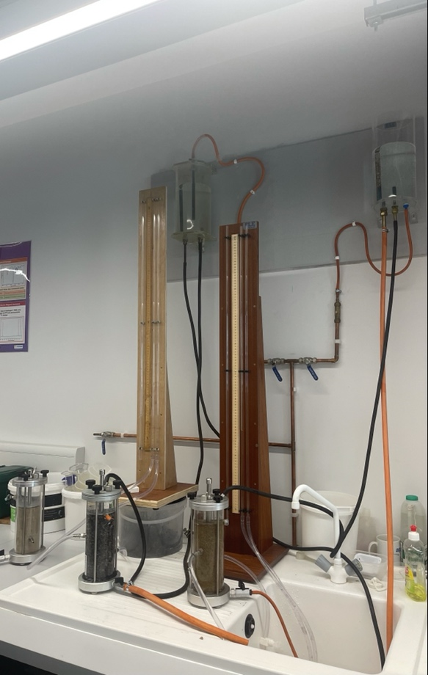
Fig 9. Photo showing apparatus set up for Constant Head test.
(Author, 2023)

Method: The soil sample was already set up in the permeameter by the lab technician. The diameter of the permeameter was measured using a vernier caliper and the measurement was recorded; this was done twice more, and the average diameter was calculated. A common point was chosen (the table), and then the ruler was placed parallel to the permeameter. The height was measured from the table to the midpoint of the opening (where the hoses would be attached) and recorded; this was repeated for the second opening. The difference between those two points was calculated to find the length of flow. The permeameter was then connected to the supply. The valve was opened to establish the constant head difference. The two levels of water were observed and recorded, and then the difference in head was calculated. A stool was then placed near the table to rest the measuring cylinder on to create a levelled surface and to maintain the same flow. A timer was set for thirty seconds. The experimenter placed a finger over the end of the hose. The hose was placed to drain into the measuring cylinder. A count down from three was done, and then simultaneously, the timer was started, and the experimenter removed their finger from the end of the hose. Another countdown from three was done (when three seconds were left on the timer), and then the experimenter covered the end of the hose and removed it from the measuring cylinder when the timer went off. The measuring cylinder was read at eye level, and it was recorded. The pressure was normalised before each drain, and then the process of draining the water in the measuring cylinder was repeated twice. The readings were taken and recorded, and then the average of the three was found.

Results and Calculations:

Diameter of the vessel:
- 79.30mm
- 79.20mm
- 79.40mm
Avg = 79.30mm = 0.0793m

Length of Flow:
- 74mm
- 144mm
Difference = 70mm = 0.07m

Water levels:
- 29mm
- 70mm
Difference in head = 41mm = 0.041m

Measuring Cylinder readings:
- 145ml
- 145ml
- 145ml
Avg = 145ml = 145 x10⁻⁶ m³

Coefficient of Permeability Equation
K = Coefficient of Permeability
Q = Flow over time
L = Length of the flow line
A = Area of flow. (A = Π x r²)
h = Hydraulic head difference
t = Time in seconds

$K=\frac{Q x L}{A x h x t}$

K = 145 x10⁻⁶ x 0.07 = 1.671 x10⁻³ m/s
( Π x 0.03965²) x 0.041 x 30

Analysis/Discussion: Permeability is known as the measure of the rate of flow of water through a soil due to the existence of voids. The degree of permeability is identified by the coefficient of permeability (K). The coefficient of permeability is found by using the equation $K=\frac{Q x L}{A x h x t}$ where,
K = Coefficient of Permeability
Q = Flow over time
L = Length of the flow line
A = Area of flow. (A = Π x r²)
h = Hydraulic head difference
t = Time in seconds.
K is expressed in meters per second (m/s). The values of K are influenced by pore size, grain size, cohesiveness, and the viscosity of the fluid. The value of K varies for different soils, ranging from 1m/s to 10⁻¹⁰m/s. Some of these values are shown below in Figure 10.

Soil type | K value | Degree of Permeability
Clean gravels | 10⁻¹ - 10² | High
Clean sands  Gravel- sand mixtures | 10⁻⁴ – 10⁻² | Medium
Very fine sands  Silts and silty clays | 10⁻⁶ – 10⁻⁵ | Low
Clay silts  Unfissured clay | 10⁻⁷ – 10⁻⁹ | Very low
Fig 10. Table showing values of K and their corresponding soil type and degree of permeability.

For this experiment, K was calculated to be 1.671 x10⁻³ m/s. This value classifies the soil sample as a gravel-sand mixture, with a medium degree of permeability. This result was consistent with visual observations of the soil sample.

Conclusion: The coefficient of permeability was calculated to be 1.671 x10⁻³ m/s, and the soil sample was classified as a gravel-sand mixture with a medium degree of permeability.

Sources of Error: Experimenters only conducted the test for thirty seconds for each test, rather than conducting the test for three different lengths of time, and then averaging the values obtained for the coefficient of K.

Limitations: The lab is an uncontrolled environment; therefore it is unlikely that the temperature remained constant for all three tests, which could have affected the results.

References
ASH, 2023-last update, Well Graded Aggregate, Gap Graded Aggregate, Uniformly Graded & Open Graded Aggregate. Available: https://civilengineersforum.com/well-graded-gap-graded-uniformly-graded-open-graded-aggregate/ [April 2nd, 2023].
ATKINSON, J., 2007. The Mechanics of Soils and Foundations . 2nd edn. London: Taylor and Francis.
BACKUS, B., 2023-last update, Atterberg Limits: A Quick Reference Guide. Available: https://www.globalgilson.com/blog/atterberg-limits-a-quick-reference-guide#:~:text=Atterberg%20limits%20tests%20establish%20the,%2C%20plastic%2C%20and%20liquid%20states. [March 22nd, 2023].
HEISNAM BIDYASHWARI, RAMAWADH SINGH KUSHWAHA, MAIREMBAM CHANDRA and MOIRANGTHEM OKENDRO, 2017. Physical Properties of Soil and Its Implication to Slope Stability of Nungbi Khunou, NH-150, Manipur . International Journal of Geosciences, 8(11),.
KALIAKIN, V.N., 2017. Chapter 2 - Example Problems Related to Soil Identification and Classification. In: V.N. KALIAKIN, ed, Soil Mechanics. Butterworth-Heinemann, pp. 51-92.
Permeability of Soil by Constant Head Permeameter - Objectives & Procedure2023-last update. Available: https://theconstructor.org/geotechnical/soil-permeability-test-constant-head/2993/ [April 18th, 2023].
Soil Permeability Experiment Unconsolidated Undrained (UU) Triaxial2023-last update. Available: https://www.studocu.com/en-gb/document/university-of-wolverhampton/geotechnical-analysis/laboratory-report-constant-head-permeability/3455316 [April 18th, 2023].

