University of Wales Trinity Saint David
Wales Institute of Science & Art



Materials Testing and Sustainability of Composites for Motorsport & Automotive Industries
Automotive Materials & Sustainability

Aaron Lilly
2314260
29/03/2026

Table of Contents
Introduction 3
Literature Review 3
Aluminium 4
Carbon Fibre Reinforced Polymer (CFRP) 4
Kevlar (Aramid Fibre Composites) 4
Natural Fibre Composites (Flax) 4
Sustainability Analysis 5
Introduction 5
Raw Material Extraction 6
Carbon Fibre 6
Aluminium 6
Kevlar 6
Flax Composite 7
Raw Material Extraction – Analysis 7
Manufacturing Process 8
Use Phase 9
End of Life Phase 9
Legislation / Future Trends 10
Experimental Testing 11
Testing Methodology 11
Results 11
Analysis of Material Behaviour 12
Comparison of Mechanical Properties 14
Effect of Material Structure and Composition 15
Material Test Validation 15
Discussion of Anomalies and Data Reliability 15
Sources of Error and Limitations 16
Summary of Findings 16
Recommendations 17
Reference list 18

Figure List

Figure 1: Lifecycle Analysis Graphic 7
Figure 2- Carbon fiber production cost from the PAN based precurser.(Khayyam et al.) 7
Figure 3: (A) Energy demand for raw material extraction (MJ/kg) (B) CO₂ emissions for raw material extraction (kg CO₂/kg) 9
Figure 4 – Stress Strain Curves of each Material Sample 14
Figure 5 UTS Comparison 15
Figure 6 Young's Modulus Comparison 15

Introduction
Composite materials are widely used in automotive, motorcycle, and motorsport industries due to their high strength-to-weight ratios and performance benefits, making them ideal for applications where weight reduction is critical. In motorsport, material selection plays a key role in achieving optimal performance.
However, increasing environmental concerns and evolving legislation have made sustainability an important consideration. The production, use, and disposal of composites, particularly carbon fibre, can have significant environmental impacts, creating a challenge in balancing performance with sustainability.
This report evaluates the mechanical performance and sustainability of selected materials through literature review, experimental testing, and lifecycle analysis.

Literature Review
Composite materials are widely utilised in automotive and motorsport engineering due to their ability to provide high strength and stiffness while maintaining low weight. These materials typically consist of a reinforcement phase, such as fibres, embedded within a polymer matrix, allowing their mechanical properties to be tailored for specific applications (Mallick, 2007). Compared to conventional metallic materials, composites offer improved specific strength and stiffness, making them particularly advantageous in performance-driven industries.
Aluminium
Aluminium has traditionally been used as a benchmark material in automotive and motorcycle engineering due to its favourable strength-to-weight ratio, corrosion resistance, and high recyclability. Aluminium alloys are commonly used in chassis, engine components, and structural parts where a balance between weight, strength, and cost is required. However, despite its advantages, aluminium generally exhibits lower stiffness compared to fibre-reinforced composites, limiting its application in high-performance motorsport structures where maximum rigidity is required (Ashby, 2011).
Carbon Fibre Reinforced Polymer (CFRP)
Carbon fibre reinforced polymer (CFRP) is widely used in high-performance motorsport due to its exceptional strength-to-weight and stiffness-to-weight ratios. Its anisotropic nature allows fibre orientation to be optimised for directional load-bearing. Fibre architecture influences behaviour, with woven fibres offering improved damage tolerance and non-woven or unidirectional fibres providing higher stiffness (Campbell, 2010).
The matrix also plays a key role; epoxy resins provide strong bonding and mechanical performance, while bio-based resins offer reduced environmental impact with slightly lower properties (Pickering et al., 2016). CFRP is used in applications such as Formula 1 monocoques and motorcycle structures, where weight reduction is critical. However, it exhibits brittle failure and limited damage tolerance, which must be considered in safety-critical applications.

Kevlar (Aramid Fibre Composites)
Kevlar, an aramid fibre composite, is known for its high toughness and impact resistance. Unlike carbon fibre, which fails in a brittle manner, Kevlar absorbs energy, making it suitable for impact protection in applications such as crash structures and protective panels. However, its lower compressive strength limits use in primary load-bearing structures where stiffness and buckling resistance are critical (Mallick, 2007). In motorsport, Kevlar is often combined with carbon fibre to improve impact resistance while maintaining structural performance.
Natural Fibre Composites (Flax)
Natural fibre composites, such as flax, have gained attention due to their environmental benefits. Flax fibres are renewable, require less production energy, and produce lower carbon emissions than synthetic fibres (Pickering et al., 2016). Although they exhibit lower stiffness and strength than carbon fibre, they are suitable for non-structural applications such as body panels and interior components. The use of bio-based resins further enhances sustainability. However, variability in fibre properties and moisture sensitivity remain key limitations.
Recent developments in recycled carbon fibre (rCF) and thermoplastic composites aim to improve recyclability while maintaining acceptable performance, reflecting industry efforts to reduce environmental impact.
Material selection therefore involves trade-offs: carbon fibre provides the highest performance but with high environmental cost, aluminium offers recyclability but lower stiffness, and natural fibre composites present a more sustainable option with reduced mechanical capability.

Sustainability Analysis
Sustainability in composite materials must be evaluated across the full lifecycle rather than a single stage. In high-performance industries such as automotive and motorsport engineering, materials that deliver performance benefits may also carry significant environmental costs, requiring a lifecycle-based assessment.
This section evaluates sustainability across four stages: raw material extraction, manufacturing, use phase, and end-of-life. Raw material extraction considers resource origin and renewability, while manufacturing assesses energy use, emissions, and waste. The use phase examines the impact of material properties, particularly weight reduction, on operational efficiency. End-of-life considers recyclability, reuse potential, and disposal impacts.
This approach enables a balanced assessment of environmental impact alongside performance in motorsport, automotive, and motorcycle applications.

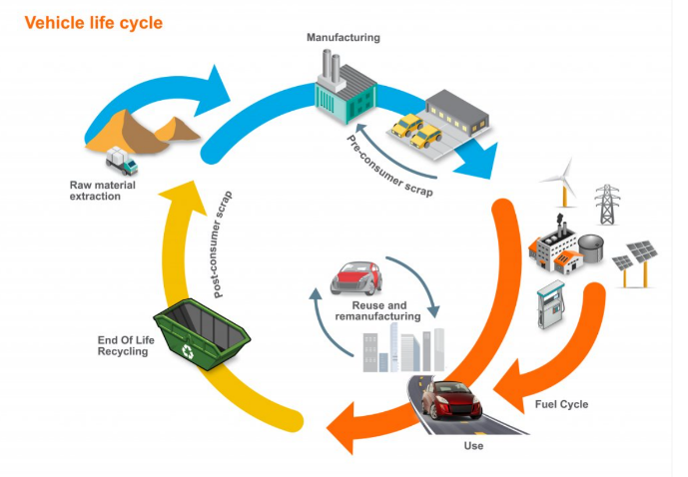
Figure 1: Lifecycle Analysis Graphic

Raw Material Extraction

Carbon Fibre
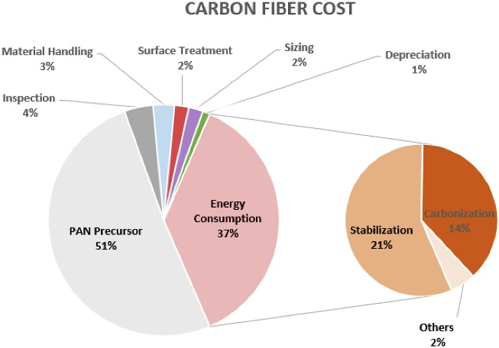
Carbon fibre is produced primarily from polyacrylonitrile (PAN), a petroleum-derived precursor, making it inherently dependent on non-renewable resources. The production process is highly energy intensive, involving multiple high-temperature stages including stabilisation and carbonisation. Reported energy demands for carbon fibre production typically range between approximately 200–600 MJ/kg, with associated carbon emissions of around 20–30 kg CO₂ per kilogram of material (Meng, 2017; Das, 2011). These values are significantly higher than those of conventional engineering materials, highlighting the substantial environmental impact of carbon fibre at the raw material extraction and production stage. This high energy demand is largely attributed to the continuous thermal processing required to convert polymer precursors into high-performance carbon fibres.
Figure 2- Carbon fiber production cost from the PAN based precurser.(Khayyam et al.)

Figure Two further illustrates the environmental burden associated with carbon fibre production, showing that energy consumption accounts for approximately 37% of total production costs, while the PAN precursor, derived from petroleum, contributes over 50%. This highlights the significant reliance on both energy-intensive processing and non-renewable raw materials, reinforcing the high environmental impact of carbon fibre at the production stage.

Aluminium
Aluminium is produced from bauxite ore through the energy-intensive Bayer and Hall–Héroult processes. Primary production typically requires 150–200 MJ/kg, with associated emissions of 8–12 kg CO₂/kg (Ashby, 2011; International Aluminium Institute, 2021).
Despite this, aluminium offers strong sustainability advantages due to its high recyclability. Recycled aluminium requires up to 95% less energy than primary production, making it more environmentally favourable over its lifecycle compared to many composite materials (International Aluminium Institute, 2021).

Kevlar
Kevlar, an aramid fibre composite, is produced from petroleum-derived polymers through a series of chemical and thermal processing stages, including polymerisation and solvent spinning. As a result, it is reliant on non-renewable resources and exhibits a relatively high environmental impact compared to natural fibre composites. Reported energy demands for aramid fibre production are typically in the range of 150–250 MJ/kg, with associated carbon emissions of approximately 10–20 kg CO₂ per kilogram of material (Das, 2011; PlasticsEurope, 2014). While these values are lower than those associated with carbon fibre production, they remain significantly higher than renewable alternatives, reflecting the energy-intensive nature of synthetic fibre manufacturing.

Flax Composite
Flax fibre composites offer a more sustainable alternative to synthetic materials, as they are derived from renewable resources and require significantly lower production energy (10–50 MJ/kg) with emissions of approximately 1–5 kg CO₂/kg (Pickering et al., 2016; Yan et al., 2014). Additionally, flax absorbs carbon dioxide during growth, further reducing its environmental impact.
However, limitations such as variability in properties, moisture sensitivity, and lower mechanical performance compared to carbon fibre restrict their use to non-structural or secondary applications in motorsport and automotive engineering.

Raw Material Extraction – Analysis
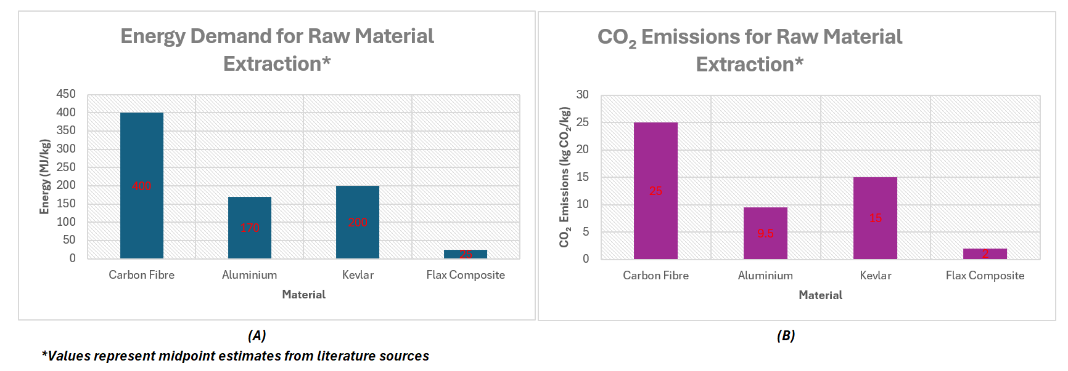
Figure 3: (A) Energy demand for raw material extraction (MJ/kg)
(B) CO₂ emissions for raw material extraction (kg CO₂/kg)
Figures 3 (A) and (B) present the energy demand and carbon emissions associated with raw material extraction. A clear trend shows that high-performance synthetic materials have significantly higher environmental impacts than natural fibre composites.
Carbon fibre exhibits the highest impact (~400 MJ/kg, ~25 kg CO₂/kg) due to energy-intensive thermal processing. Kevlar follows (~200 MJ/kg, ~15 kg CO₂/kg), reflecting similarly demanding synthetic production. Aluminium shows a moderate impact (~170 MJ/kg, ~9.5 kg CO₂/kg), partially offset by its recyclability.
Flax composites demonstrate the lowest impact (~25 MJ/kg, ~2 kg CO₂/kg), owing to their renewable origin and lower processing requirements.
Overall, a clear trade-off exists between performance and sustainability: carbon fibre provides superior mechanical properties at high environmental cost, whereas flax offers a more sustainable but lower-performance alternative. This highlights the fundamental trade-off between mechanical performance and environmental impact in material selection in automotive and motorsport engineering.

Manufacturing Process
CFRP manufacturing is highly energy-intensive, relying on autoclave curing and high-temperature resin processing with long cycle times. As shown in Figure 2, energy accounts for approximately 37% of total carbon fibre production cost, with the petroleum-based PAN precursor contributing over 50%; prepreg layup also generates significant offcut waste. Aluminium and Kevlar similarly require considerable energy input, though aluminium benefits from efficient scrap recycling during processing. Natural fibre composites such as flax require significantly less energy, particularly when combined with low-temperature curing and bio-based resins, and generate less hazardous waste. Overall, the manufacturing stage reinforces the pattern seen in raw material extraction, where high-performance synthetic materials incur greater environmental costs.

Use Phase
The use phase provides a contrasting perspective, as the lightweight properties of composite materials can reduce overall environmental impact during operation. In automotive and motorsport applications, reduced vehicle mass improves fuel efficiency, lowers energy consumption, and decreases emissions over the vehicle’s lifespan.
Carbon fibre composites, despite high production emissions, offer significant weight savings compared to aluminium, improving performance and efficiency. This can partially offset their environmental impact during use.
Natural fibre composites, such as flax, also contribute to weight reduction while offering improved sustainability during earlier lifecycle stages. Aluminium, although heavier, still provides efficiency benefits compared to steel but does not match the lightweight advantages of composites.
Overall, the use phase highlights the importance of lifecycle analysis, as materials with higher production impacts may provide environmental benefits through improved operational efficiency.

End of Life Phase
The end-of-life stage presents a key sustainability challenge for composite materials due to thermoset matrices that cannot be remelted or easily recycled.
Carbon fibre reinforced polymer (CFRP) is typically disposed of via landfill or incineration, as its resin limits material recovery. Recycling methods such as pyrolysis and solvolysis exist but are not widely adopted. However, recycled carbon fibre (rCF) can reduce emissions by up to 90–95% compared to virgin material (Pickering et al., 2016; Oliveux et al., 2015).
Kevlar faces similar issues, as aramid fibres are difficult to recycle and are often downcycled or incinerated.
In contrast, aluminium offers excellent recyclability, retaining properties indefinitely and requiring only ~5% of the energy of primary production (International Aluminium Institute, 2021).
Natural fibre composites, such as flax, offer improved environmental performance due to their renewable origin and partial biodegradability, although thermoset matrices limit full degradation.
Overall, carbon fibre presents significant end-of-life limitations, whereas aluminium and natural fibre composites offer more favourable outcomes, reinforcing the importance of material selection.

Legislation / Future Trends
Sustainability in the automotive and motorsport industries is increasingly shaped by legislation and regulatory frameworks. In the automotive sector, policies such as the UK End-of-Life Vehicles (ELV) guidance promote recyclability and responsible material disposal to reduce lifecycle impact (UK Government, 2023). Emissions targets and net-zero commitments are also driving the adoption of lightweight and more sustainable materials.
In motorsport, governing bodies such as the FIA and FIM have introduced strategies to reduce carbon emissions and promote sustainable practices. The FIA’s net-zero target for 2030 highlights increasing pressure to balance performance with environmental responsibility (FIA, 2020). However, reliance on high-performance materials such as carbon fibre remains a challenge due to high production emissions and limited recyclability.
Future developments focus on recycled carbon fibre, bio-based resins, and thermoplastic composites, which improve recyclability while maintaining performance.

Experimental Testing

Testing Methodology
Tensile testing was conducted on composite and metallic materials using a Denison testing machine, following standard procedures aligned with ASTM D3039 and ASTM E8 (ASTM, 2017; ASTM, 2024)., in the Engineering Science Laboratory, following standard safety procedures (Composite Testing Plan, 2026).
Materials included aluminium as a baseline and fibre-reinforced composites using carbon and flax with epoxy and bio-resins, in both woven (twill) and non-woven forms.
Specimens were produced via resin infusion. Woven samples consisted of three 200 g/m² plies (600 g total) at 45° orientations, while non-woven samples used a single 300 g/m² layer. Mesh was added at specimen ends to aid gripping (Composite Testing Plan, 2026).
Specimen dimensions were measured using digital callipers to determine cross-sectional area. Samples were mounted in the grips of a Denison tensile testing machine, and strain was measured using an extensometer to ensure accurate elastic region data. Load and displacement data were recorded and exported for stress–strain analysis. From this, Young’s modulus, UTS, yield strength (Rp0.2), and break stress were determined using standard relationships (σ = F/A, ε = ΔL/L₀).
Although two tests per material were conducted initially, a larger cohort dataset (~20 tests per material) was used to improve reliability (Composite Testing Plan, 2026).

Results
The results obtained from tensile testing are presented in Tables 1 and 2.
Table 1 , Individual Tensile Test Results
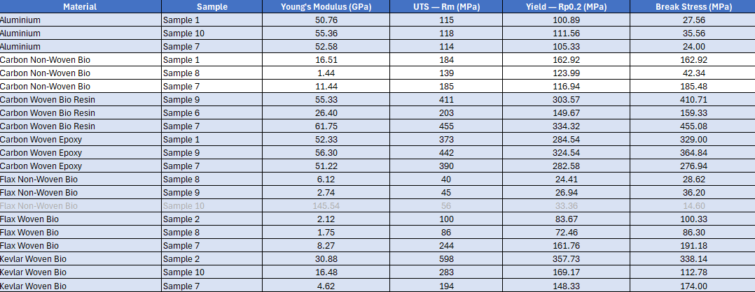

Table 2, Average Material Test Results
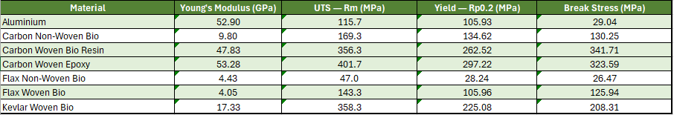

Aluminium samples exhibited consistent behaviour, with an average Young’s modulus of approximately 52.9 GPa and UTS values around 115.7 MPa. Carbon fibre composites, particularly woven epoxy systems, demonstrated significantly higher strength, with average UTS values of approximately 401.7 MPa.
Natural fibre composites, including flax-based materials, exhibited lower stiffness and strength compared to synthetic composites. Kevlar composites demonstrated high tensile strength (358.3 MPa) but comparatively lower stiffness than carbon fibre.

Analysis of Material Behaviour
The stress–strain curves shown in Figure 4 highlight clear differences in material behaviour.
In this report, a screenshot of all graphs will be shown over one page figure.
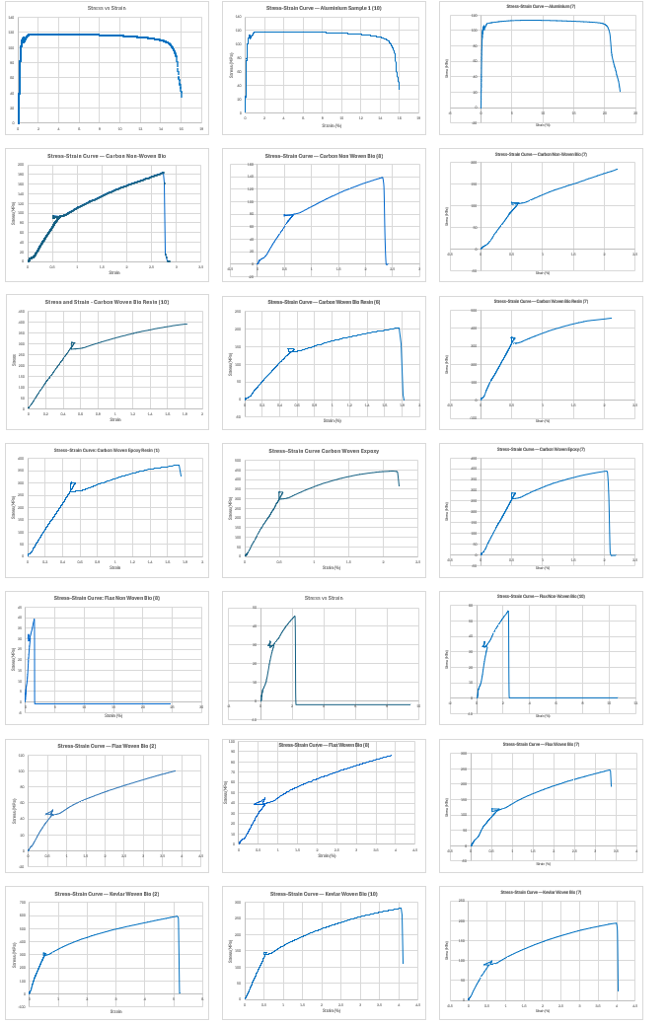
Figure 4 – Stress Strain Curves of each Material Sample
Aluminium exhibits a linear elastic region followed by yielding and significant plastic deformation prior to failure, characteristic of ductile behaviour associated with dislocation movement and energy absorption. In contrast, carbon fibre composites exhibit linear elastic behaviour followed by abrupt failure, characteristic of brittle fracture due to limited plastic deformation and fibre-dominated load carrying (Callister and Rethwisch, 2020).
Flax-based composites exhibit significantly lower stiffness and more gradual failure behaviour, reflecting reduced load transfer efficiency and the inherent variability of natural fibres. Kevlar composites demonstrate high tensile strength with moderate stiffness, consistent with their typical use in applications requiring impact resistance rather than maximum rigidity.

Comparison of Mechanical Properties
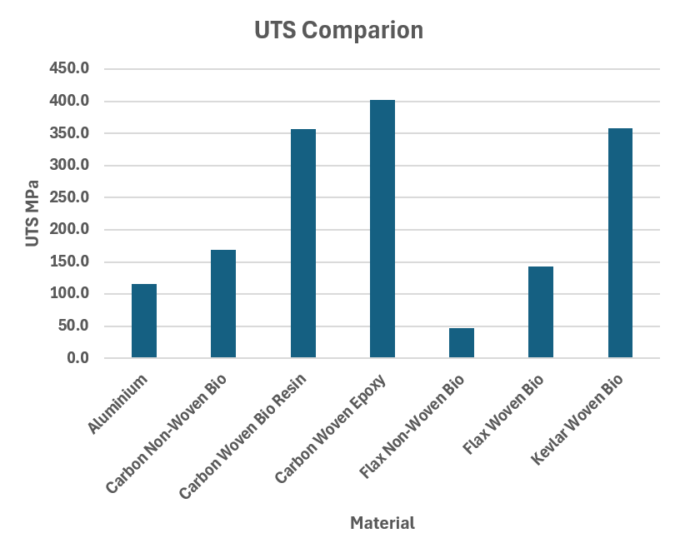
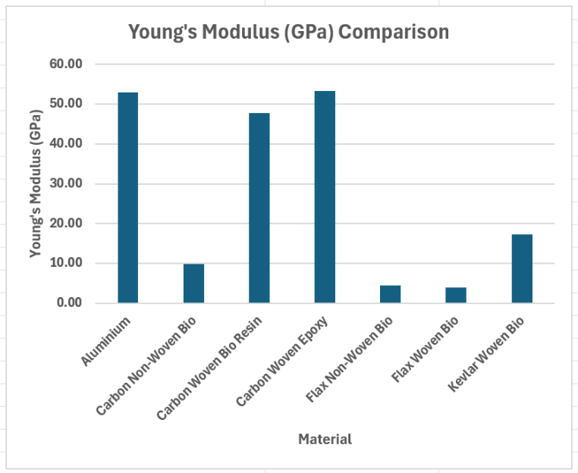
The comparative performance of the materials is illustrated in Figures 5 and 6.
Figure 5 UTS Comparison
Figure 6 Young's Modulus Comparison

As shown in Figure 6, aluminium, carbon woven epoxy, and carbon woven bio-resin exhibit similar stiffness values (~48–53 GPa). In contrast, carbon non-woven materials demonstrate significantly lower stiffness (~9.8 GPa), highlighting the importance of fibre alignment in determining mechanical performance.
Figure 5 shows that carbon woven epoxy exhibits the highest ultimate tensile strength (~401.7 MPa), followed by carbon woven bio-resin and Kevlar composites. Aluminium demonstrates significantly lower strength (~115.7 MPa), while flax-based composites show reduced performance, particularly in non-woven configurations (~47 MPa).

Effect of Material Structure and Composition
The results demonstrate the significant influence of fibre architecture and resin system on mechanical performance.
Woven composites exhibit higher stiffness and strength compared to non-woven materials due to improved fibre alignment and more efficient load transfer. In contrast, non-woven materials contain randomly oriented fibres, which reduces their ability to carry load effectively (Callister and Rethwisch, 2020).
The effect of resin system is also evident, with epoxy-based composites outperforming bio-resin systems. This is likely due to improved fibre–matrix bonding and more effective stress transfer within the composite structure.
Additionally, the 45° ply orientation used in the composite layups reduces stiffness in the primary loading direction, as fibres are not aligned with the applied load. This results in lower effective modulus compared to unidirectional composites.

Material Test Validation
The experimental results were compared with published data to assess their validity.
Aluminium typically exhibits a Young’s modulus of approximately 70 GPa (Callister and Rethwisch, 2020), whereas the measured value in this study (~52.9 GPa) is lower. This discrepancy may be attributed to experimental limitations such as inaccuracies in strain measurement or sample preparation.
Carbon fibre composites are reported to exhibit stiffness values in the range of 70–150 GPa depending on fibre orientation and matrix system (Callister and Rethwisch, 2020). The measured values (~48–53 GPa) fall below this range, which is consistent with the use of 45° ply orientations that reduce stiffness in the loading direction.
Flax fibre composites typically exhibit lower stiffness, generally within the range of 10–50 GPa. Following the removal of an anomalous data point, the corrected Young’s modulus for flax non-woven material (~4.4 GPa) reflects the expected lower stiffness of natural fibre composites.
Overall, while some deviations from literature values are observed, the general trends in material behaviour are consistent with established material properties.

Discussion of Anomalies and Data Reliability
An anomalous result was identified within the flax non-woven dataset, where one sample produced a Young’s modulus of approximately 145 GPa. This value is significantly higher than expected and is not representative of typical flax composite behaviour, indicating probable measurement or data acquisition error.
This data point was excluded from the average calculation, as it is likely the result of experimental error. Potential causes include incorrect identification of the linear elastic region of the stress–strain curve, inaccuracies in strain measurement, or errors in data acquisition.
Variability in the dataset can also be attributed to the inherent nature of composite materials, particularly non-woven structures, which are subject to inconsistencies in fibre orientation, resin distribution, and manufacturing quality.

Sources of Error and Limitations
Several factors may have influenced the accuracy of the experimental results. strain measurement represents a significant source of uncertainty, particularly where extensometer accuracy or calibration may influence elastic region determination, as small errors in displacement measurement can lead to large variations in calculated Young’s modulus.
Additional sources of error include misalignment of samples within the testing machine, slippage at the grips, and variations in specimen geometry. Composite materials, particularly natural fibre systems, are inherently variable and may exhibit significant differences between samples.
Furthermore, limitations in testing conditions and equipment precision may have contributed to deviations from expected material behaviour.

Summary of Findings
The experimental results demonstrate clear differences in mechanical performance between the tested materials. Carbon fibre composites exhibited the highest strength and stiffness, particularly in woven epoxy configurations, while aluminium provided consistent and moderate mechanical properties.
Natural fibre composites exhibited lower mechanical performance but may offer advantages in terms of sustainability. Kevlar composites demonstrated high tensile strength with moderate stiffness, making them suitable for applications requiring impact resistance.

Recommendations
Based on the experimental findings and sustainability analysis, a balanced material selection strategy is recommended, considering both performance and regulatory requirements.
Carbon fibre composites, particularly woven epoxy systems, should be used in high-performance structural applications due to their high strength-to-weight ratio, with experimental results showing the highest tensile strength (~401 MPa). However, high energy demand and limited recyclability present sustainability challenges (FIA, 2024; UK Government, 2023).
Natural fibre composites, such as flax, are suitable for non-structural components where lower performance is acceptable, offering environmental benefits due to their renewable origin and lower emissions (Pickering et al., 2016), aligning with sustainability initiatives (FIM, 2024).
Kevlar is appropriate for impact-resistant applications but is limited by petroleum-based production and recyclability issues.
A hybrid material strategy is recommended, integrating high-performance composites in load-critical regions and sustainable materials in secondary structures, combining carbon fibre in critical areas with sustainable materials in secondary components to balance performance and environmental impact, supporting net-zero targets (FIA, 2024; Formula 1, 2025).
Future work should focus on bio-resins and recycling technologies, such as recycled carbon fibre, to improve sustainability without compromising performance.

Reference list
ASTM (2017) ASTM D3039/D3039M-17: Standard Test Method for Tensile Properties of Polymer Matrix Composite Materials. ASTM International.
ASTM (2024) ASTM E8/E8M-24: Standard Test Methods for Tension Testing of Metallic Materials. ASTM International.
Callister, W.D. and Rethwisch, D.G. (2020). Materials science and engineering : an introduction. 10th ed. Hoboken, Nj Wiley.
Das, S. (2011). Life cycle assessment of carbon fiber-reinforced polymer composites | Request PDF. [online] ResearchGate. Available at: https://www.researchgate.net/publication/225438257_Life_cycle_assessment_of_carbon_fiber-reinforced_polymer_composites.
Environment Agency (2023). End of life vehicles (ELVs): appropriate measures for permitted facilities. [online] GOV.UK. Available at: https://www.gov.uk/guidance/end-of-life-vehicles-appropriate-measures-for-permitted-facilities [Accessed 23 Apr. 2026].
European Aluminium. (2022). A low carbon footprint - European Aluminium. [online] Available at: https://european-aluminium.eu/projets/a-low-carbon-footprint.
FIA (2021). FIA ENVIRONMENTAL STRATEGY 2020-2030 SUMMARY FIA ENVIRONMENT & SUSTAINABILITY COMMISSION. [online] Available at: https://purposedriven-admin.fia.com/sites/default/files/2021-10/FIA%20environmental%20strategy.pdf.
FIA (2024). Federation Internationale de l’Automobile. [online] Federation Internationale de l’Automobile. Available at: https://www.fia.com/.
FIM (2023). FIM ENVIRONMENTAL CODE 2023. [online] Available at: https://www.fim-moto.com/fileadmin/user_upload/Documents/2023/65.620.01_En.pdf [Accessed 30 Mar. 2026].
Formula1.com. (2025). Formula 1 reduced carbon footprint by 26% by end of 2024. [online] Available at: https://www.formula1.com/en/latest/article/formula-1-on-track-to-be-net-zero-by-2030-with-26-reduction-in-carbon.4p2vZMDrgDu6lVHLvOcLPy.
International Aluminium Institute. (2024a). Aluminium recycling saves 95% of the energy needed for primary aluminium production - International Aluminium Institute. [online] Available at: https://international-aluminium.org/landing/aluminium-recycling-saves-95-of-the-energy-needed-for-primary-aluminium-production.
International Aluminium Institute. (2024b). As well as aluminium recycling, saving 95% of the energy needed for primary aluminium production, the recycling process saves a similar percentage in greenhouse gas emissions - International Aluminium Institute. [online] Available at: https://international-aluminium.org/landing/as-well-as-aluminium-recycling-saving-95-of-the-energy-needed-for-primary-aluminium-production-the-recycling-process-saves-a-similar-percentage-in-greenhouse-gas-emissions.
International Aluminium Institute. (2025). Aluminium Carbon Footprint FAQs - International Aluminium Institute. [online] Available at: https://international-aluminium.org/landing/aluminium-carbon-footprint-faqs/?utm_source=chatgpt.com.
Khayyam, H., Naebe, M., Milani, A.S., Fakhrhoseini, S.M., Date, A., Shabani, B., Atkiss, S., Ramakrishna, S., Fox, B. and Jazar, R.N. (2021). Improving energy efficiency of carbon fiber manufacturing through waste heat recovery: A circular economy approach with machine learning. Energy, 225, p.120113. doi:https://doi.org/10.1016/j.energy.2021.120113.
Office for Product Safety and Standards (2015). Regulations: end-of-life vehicles (ELVs). [online] GOV.UK. Available at: https://www.gov.uk/guidance/elv.
Oliveux, G., Dandy, L.O. and Leeke, G.A. (2015). Current status of recycling of fibre reinforced polymers: Review of technologies, reuse and resulting properties. Progress in Materials Science, 72, pp.61–99. doi:https://doi.org/10.1016/j.pmatsci.2015.01.004.
Pickering, K.L., Efendy, M.G.A. and Le, T.M. (2016). A review of recent developments in natural fibre composites and their mechanical performance. Composites Part A: Applied Science and Manufacturing, [online] 83, pp.98–112. doi:https://doi.org/10.1016/j.compositesa.2015.08.038.
Plastics Europe. (n.d.). Eco-profiles set • Plastics Europe. [online] Available at: https://plasticseurope.org/sustainability/circularity/life-cycle-thinking/eco-profiles-set/.
Tudor, K. (2026). Composite Testing Plan.
www.fim-moto.com. (n.d.). Home | FIM. [online] Available at: https://www.fim-moto.com/en/.
Yan, L., Chouw, N. and Jayaraman, K. (2014). Flax fibre and its composites – A review. Composites Part B: Engineering, [online] 56, pp.296–317. doi:https://doi.org/10.1016/j.compositesb.2013.08.014.

