

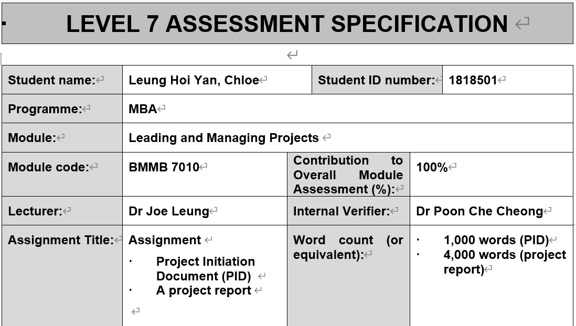
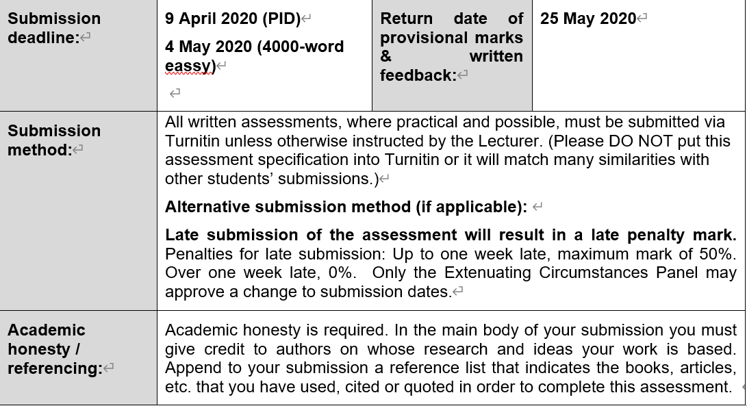



The essence of this project entails the development of a 90-day action plan that would facilitate restructuring and re-position of RHB Hong Kong.

Executive Summary

Restructuring and re-positioning the company refers to a corporate task that entails the improvisation of the business operations in a firm. Both exercises are aimed at reviving business operations in a financially declining situation or increasing the value of an already well-performing business. With the massive losses experienced by the RHB Hong Kong, the operation has been rendered unviable and hence making the company unable to continue with its business operations. This project will determine the various areas of the company operations that may benefit from restructuring and re-positioning of the company. This paper will also encompass the analysis of the strengths and weaknesses faced by the company both internally and externally.

Table of Contents
Page
Executive Summary 2
Table of Contents 3
- Introduction 4 - 5
- Company Background 6 - 7
- Project Objectives and Scopes 8 - 9
- Findings – Analysis 10 - 15
- Discussion – Restructure and Re-position plan 16 - 20
- Implementation 21 - 22
- Recommendations 23 - 25
- Conclusion 26 - 27
- Reference 28 - 30

- Introduction

RHB Hong Kong Limited is a member of the RHB Group of companies. It is a company that deals with trading derivatives, stock brokerage, capital raising, and investment advisory services. The company has also incorporated investment banking together with other related services in its operational portfolio. The overall success or failure of a business depends on the decision-making processes by the company executive. In some instances, restructuring and re-positioning may be the most viable options to prevent bankruptcy or shut down of the company. Restructuring refers to the reorganization of the operational, ownership, and the legal framework of the company to enhance profitability and suite the present needs of the company (Denis &Shome, 427, 2005). Changes in the company ownership and ownership structure, such as amalgamation and mergers, may also call for restructuring (Bowmanand Singh, 5, 1993). Sometimes a firm may need to change or expand its target market. Re-positioning of the company is associated with the rebranding of services provided by the company (Kaikati, 479, 2003). It entails the implementation of significant changes in the perception of company products to broaden the target market.

RHB Hong Kong has been experiencing losses resulting from the challenging operating broking environment in Hong Kong. The enormous losses suffered by a company make it unviable and hence unable to continue with its business operations (Kang and Shivdasani, 31, 1997). The Hong Kong environment has dramatically been affected by instabilities in the local economy accompanied by the sluggishness in the global economy, causing the small to medium-size brokerage companies to be kicked out of business.

- Company Background

RHB Hong Kong Limited (RHBHK) became a member of the RHB Group after being acquired by the RHB Capital Berhad in November 2012.The company provides stock broking services, capital raising, investment consultancy services, and derivatives trading services. RHBHK has a competitive advantage over other companies operating in the region since it capitalizes on strong support from the RHB Group, which is the leading banking group in South Asia. Part of this success is also attributed to the strategic graphical location in the regional financial market. RHB Asset Management Limited is a subsidiary of the RHBHK that deal with the regulation of properties and assets and providing security advice. The company also provides portfolio management services to individuals, corporate clients, and institutions. Since the company has a vast experience in the region in terms of investment skills to deal with maximization of client investment returns. RHB (China) Investment Advisory Company is an associate of the RHBHK, which deals with the provision of the business and investment consultancy services. These services are essential in investment projects, forming of mergers and acquisitions, and providing advice on international markets.

RHB wealth Management Hong Kong Limited is a subsidiary of RHBHK offers advice to clients depending on their financial objectives to enable the clients to attain their goals. Some of the services and products provided by RHB Wealth Hong Kong Limited include professionally managed funds, portfolio management services, and insurance schemes. RHB Capital Hong Kong Limited is a subsidiary of the RHBHK that specializes in the banking sector. It comprises experts in the investment banking industry who provide services ranging from corporate restructuring advisory, regulatory compliance, and miscellaneous financial advisory, a capital raising in both primary and secondary markets, initial public offering, and restructuring advisory services. The company also comprises of the RHB Securities Hong Kong Limited, which as a member of The Stock Exchange of Hong Kong Limited. It is involved in regulated dealing in securities and providing advisory services. Other activities include brokerage services in markets both within Hong Kong and overseas. The organization has an online platform that enables the client to trade securities through the internet. These platforms present a second alternative through which clients can still place orders and contact brokers on matters of securities.

- Project Objectives and Scopes

Objectives of the project:
- To evaluate the factors that contribute to the occurrence and prevalence of the severe brokerage environment that affects financial institutions.
- To determine the measures employed by financial institutions in other regions and their effectiveness in mitigating the adverse impact associated with brokering.
- To assess the internal and external viability of the measures identified and their applicability in RHB Hong Kong.
- To develop various strategies that would guarantee the sustainability of RHB Hong Kong's operations amidst the intensely competitive environment.

Project deliverables are the results of the project. Any project has both inputs and outputs. Deliverables include project reports, project plans that the stakeholders stand to benefit at the end of the implementation of the project plan. The product and services listed as project deliverables are presented to the company executive and stakeholders in the form of paperwork to evaluate the progress up to the completion of the project (Lin et al., 659, 2006). Deliverables vary according to the stakeholder’s requirements and specifications of the project. It is the interest of the stakeholders that the deliverables complete the project to the end and evaluate the performance against the project expectations. The project manager will present the deliverables to the clients and the stakeholders through the project report. Deliverables for this project will illustrate how the plan for restructuring and re-positioning of RHBHK will illustrate how work is proceeding, show which departments will participate in the restructuring and re-positioning process, and lastly, outline any room for improvements before and after closure.

The project will encompass various factors, such as the source of funding, cost, deadlines, and goals of the project. This project will depend on external financing, given that the RHBHK Company is on the verge of collapsing. Both individual and corporate institutions will be invited to invest in the process of restructuring and re-positioning. Most significant contributors to the funding, especially among the corporate institutions, can lead to mergers. The donor company, therefore, takes over part of the company operations or offers technical assistance to ensure the company recovers (Whittington, n.p, 2014). The deadline for completion of every task will be stipulated in the plan, and the task must be completed as per the plan. The responsibilities of every team member must be cleared, including how the tasks assigned will be completed, verified, and approved.

- Findings – Analysis

SWOT Analysis
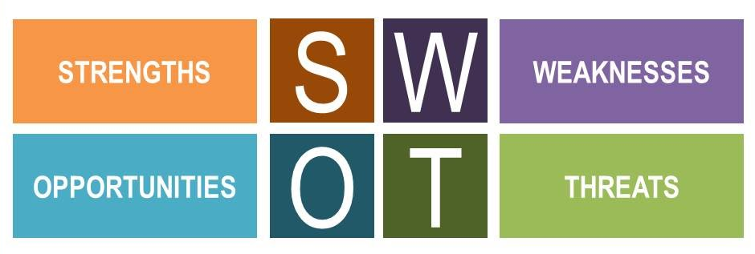
SWOT analysis is a tool for analyzing RHBHK company operations. It is a method of study that focuses on strengths, weaknesses, opportunities, and threats affecting the operations of the company. RHBHK is among the most successful firms dealing in the banking investment sector in South Asia. The company is, however, faced with high losses due to risks posed by the local Hong Kong economy and changes in the global market, leaving the company hanging in the balance. The company is now facing a risk of wind up hence requiring corporate strategies such as re-positioning and restructuring to continue doing business. This project will utilize the SWOT analysis tool that will entail carefully studying all the departments, operations, strategic planning, marketing departments within the organization. The SWOT analysis is represented in a two by two matrix, otherwise known as the SWOT matrix. SWOT matrix is structured basing on both external and internal operations of RHBHK Company. Internal strategic factor affecting RHBHK Company is represented by either strengths or weaknesses, while opportunities and threats represent the external strategic factors. SWOT matrix will help in the process of isolating the threats and weaknesses and developing the best ways of countering them using the opportunities and strengths.

Strengths possessed by RHBHK include its prowess in the banking sector in South Asia compared to other companies in the same business. Secondly, the company enjoys support from the RHB Group, a multinational corporation that boasts the best experts in the investment banking industry. RHBHK also has highly skilled employees who have a vast experience in corporate financing and consultancy. Having significantly invested in the training of its employees, RHBHK ensures that every employee maximizes their output for the success of the company. The company has also invested heavily in the loyalty of its workforce by giving them paid leaves, good salary, and other forms of motivation. It is essential to develop strategies that would guarantee the sustainability of the firm (Schaltegger et al., 99, 2012). Rigorous training and practices in the company encourage innovation among the staff, which a key strength for any organization. RHBHK also has an online, operational platform from where a client can trade securities, get advisory services from experts, and also present inquiries. The online platform, therefore, promotes a good relationship between the clients and the brokers. The company also has a working operation network all over South Asia courtesy to the robust brand portfolio developed through advertisement and marketing of the company product and services.

Weakness in SWOT analysis refers to the areas of RHBHK’s operations that are not up to standards hence causing the business to flop. It is indispensable to highpoint areas of weakness in the company’s system for it to maneuver ways to capitalize and convert the same weaknesses to strengths. Inaccuracy and inefficiency in the company financial planning is the central area of weakness, the current-asset ratio, and the current-liquid ration of RHBHK imply that the company is failing in terms of financial planning. Secondly, the advancement in technology is another area of weakness. The vast customer base and expansion of operations is not possible without the use of more advanced methods of technology. Low funds pumped into the research and development is another reason why the company is failing terribly. RHBHK always needs to channel more funds to research to enable the company to remain ahead of its competitors.

Opportunities in SWOT analysis refers to factors in the company’s eternal environment that promotes the performance of the company. RHBHK has a stable cash flow that enables the company to open a newer venture through creating new projects or investments. The availability of bank reserves for a company implies more significant financial muscle and hence the company’s ability to invest more in product development. Recent trends in the behavior of clients present an excellent opportunity for a company to change tactics, such as assuming modern methods of pricing services and products. It helps the company come up with ways that suit the contemporary market, such as the RHBHK online trading platform. RHBHK engages in the formulation of new environmental policies leveling the playground for all participants in the market. The South Asia region still has plenty of expansion space for RHBHK to make it possible for the company always to add the customer base and make more profits.

The most serious threat faced by RHBHK is the competition from the rival banking and investment companies in the region. Over the last decade, there has an increase in the number of entrants in the market, making the playing field stiffer. Challenging operating broking environment in Hong Kong has been a problem for companies such as RHBHK operating in the zone. Most companies in the banking and investment industry have adopted more advance levels of technology (Kitson &Michie, n.p., 2000), posing a significant danger to the operation of RHNHK in most parts of Asia. Variation in the liability law is another threat facing RHBHK. Since RHBHK is a multinational corporation, the liability laws may change from one nation to another, which may lead to adversely affecting business. To counter this threat, the company must develop different policies to suit the requirements of each market, which is not always an easy process. Lastly, the danger in ever-changing client behavior is a direct risk. The inability to provide right products and services to clients makes them defect to better service providers.

Blue Ocean Strategy

Blue Ocean strategy is a business approach that supports businesses to venture into the uncontested marketplace instead of struggling with vicious competition. The theory posits that companies are better of coming up with ways to colonize untenured markets than competing with other companies (Mi, 1, 2015). The theory analogizes the new unvented markets as the “Blue Oceans” and the already flooded market with competitors as “Red Oceans." The Blue Ocean strategy, therefore, emphasizes pursuing low costs and high product differentiation, making competition less relevant in the process.

Applying the Blue Ocean strategy in the situation of the RHBHK Company implies that it will be advisable for the company to desist from the highly competitive market. The company is therefore required to look for greener pastures outside the competitive zones. The goal for this strategy will not need to defeat the competitors but rather to render the competition irrelevant in the process. Since Hong Kong and the surrounding environment has been the center of operation for RHBHK, it would be prudent for the company to reinvent itself by expanding to the other areas of Asia and the world. RHBHK will, first, adopt fair pricing to eliminate losses that accrue from low pricing caused by competition. Secondly, RHBHK should ensure it minimizes operations in the highly competitive areas and instead concentrates more on the less competitive trade zones. Lastly, the company should develop a newer product that has never been offered in the industry, making them unique. Implementing these three strategies will enable the company to establish a new value curve through reconstructing buyer value elements. Overcrowding in the banking and investment markets is a significant problem and is being accelerated by imitation of products and services. The best way to cope up with imitation is to make a Blue Ocean shift whereby a company creates its own Blue Ocean.

- Discussion – Restructure and Re-position Plan

- Restructure Plan

Downsizing staff
Downsizing of staff is the most common strategy of a corporate restructuring plan, which entails laying off a certain number of employees at the same time to save funds. Corporate downsizing is normally attributed to an attempt by the company to lower the cost of operation. Corporate mergers or acquisition of a company by another company can also be a reason for corporate downsizing. Lastly, the company might be forced to downsize its workforce due to economic falters. Given the situation of the RHBHK, downsizing might the probable cause of action to ensure the company remains operational. Downsizing will ensure the company to maximize efficiency and increase profits (Kim et al., 1209, 2011).

The process of downsizing a very fragile exercise and can cause a huge disruption on the business if it is handled carefully. Downsizing requires an utmost degree of reactiveness, which entails considering the long-term goal and problems. The key factors are to consider while downsizing is company vision and plan, transparency, empathy, and employee sacrifices. Employees with key responsibilities in the company must be maintained to ensure a smooth transition of company operations.

Change of Business Plan/Model
The current business model of RHBHK is under siege due to both internal and external forces threatening to crumble the business operations. It is, therefore, high time for the company to adopt a newer business model. The company has failed in enacting commensurate changes and how the organization should operate. A new revenue stream, target market, and products and services will bolster the company in terms of profitability by a notch high (Casadesus-Masanell and Ricart, 201, 2010.).

The company should adopt a new technique of converting from creating an intensive enterprise to implementing mass rendering of services to clients. Under this technique, the senior management will formulate the plan, and the juniors will implement it. The company operations are focused more on preparation, not planning. Although the company requires projections, especially on costs and revenues, it is crucial to think about methods of capturing value and delivering. Combining create, deliver, and capture value elements compel a company to experience faster growth (Gilson, n.p, 2010). RHBHK needs to focus more on creating a minimally, viable product to maximize profitability.

Advancement in technology
Technological advancements have a substantial impact on the banking and investment industry. Artificial intelligence is both an advantage and a disadvantage in the banking sector. The use of the most recent technology by competitors is likely to render the business obsolete (Brockhoff et al., 27, 1999). RHBHK, therefore, needs to adopt newer technological methods to ensure it remains at par with competitors. The use of technical methods is also associated with low staffing hence providing the company saves on cost while maximizing profits. Modern telecommunications and computer-aided designs enable small players to compete favorably with giant companies since it creates a level playing field. The structural framework of an economy is quickly changing courtesy of the technological changes (Iskander et al., 44, 1999). Even mature sectors such as banking, insurance, and investment are striving to stay up to date with developments in technology to remain competitive.

If RHBHK employs the latest technology in its operations, there is no doubt that the company will have a comparative advantage compared to its competitors. The innovation pace is very rapid, and as such, firms should do what it takes to remain at par with current trends.

- Re-position Plan

Focus on IPO Business
Initial Public offering enables a company to sell its stocks to the public to raise capital funding to run its operations (Jain &Kini, 1699, 1994). Initial Public offering is a corporate re-positioning strategy in which RHBHK will raise capital by selling its stocks to the public. The individuals interested in the shares of the companies will purchase securities on the stock market. In return, RHBHK will get funding to run their operations and maximize efficiency and profits.

Asset Management
Asset refers to the process of directing all or part of the client portfolio for investment purposes. The main aim of asset management is the maximization of output (Denis & Kruse, 392, 2000). RHBHK must be keen on which investments to invest in and which not to invest in. Risk mitigation must be the goal in every venture to avoid losses. Rebranding or modifying asset management as a product offer disadvantageous to the company (Petburikul, 155, 2009).

Wealth Management (Insurance) Business
Wealth management is a financial advisory service outstanding in addressing financial considerations of wealthy clients. RHBHK being a service provider dealing with this product ensures the outcomes of their clients remain positive. Positive results start with hiring an experienced workforce with vast knowledge and skill on financial disciplines. This service is essential for affluent individuals with a wide array of business goals and needs.

- Implementations

In order to implement the reorganization changes on RHB Hong Kong, the following 5 steps of a 90-day action plan will be taken:

Planning
The first step in the reorganization will be planning. At this stage, the project sponsors will be identified. The implementation team consisting of different employees from the organization will also be identified. Phases which will be involved in the reorganization project will also be mapped out. Budgeting for the project will be done at this stage. Planning will be done in a 10 days period from the time the project is launched.

Collection of employees input
The views and opinions of employees and other stakeholders involved in the project will be collected. This will help to improve the process and address any issues that employees may have. Meetings and surveys aimed at collecting employees’ input will be done starting from the fifth day after the project launch and over a 20 days period.

Change management
Employees will receive training regarding new roles. Communications about what to expect after reorganization will also be made to employees. Employees who may show resistance to change and those who may be negatively affected by the changes will also be identified and counselled accordingly. Change management will be done over a 20 days period.

Process migration
Old business processes will be replaced with the new and acquired processes. At this stage, Layoffs will be done and employees whose roles will have been changed will start working by their new roles. Process migration will be done over a 20 days period.

Monitoring
The team tasked with overseeing the project will monitor the changes in order to identify any problems that may arise. Encountered problems should be immediately raised and solutions to fix the problem sought. Monitoring will be done for 20 days.

- Recommendations

Corporate Restructuring
The advantages of corporate restructuring include reduced cost of operation, improved communication, improved decision-making process, and efficiency, and increased operation (Gibbs, 52, 1993). Disadvantages of restructuring include loss of skilled workforce due to downsizing (Jensen & Zajac, 509, 2004), decline in productivity, employee training expenses, poor worker morale, and time of adjustment.

Suggested methods are as below:
- Restructure downsizing is the probable cause of action to ensure the company remains operational.
- A combination of creating, deliver, and capture value elements will compel RHBHK, company to experience faster growth.
- RHBHK should focus more on creating minimally, viable products to maximize profitability.
- RHBHK should adopt newer technological methods to ensure it remains on par with competitors.
- Through employing the latest technology in its operations, RHBHK Company will have a comparative advantage compared to its competitors.

Corporate Re-position
Advantages of re-position include changing the market’s perceptions of an offering so that it can compete more effectively in RHBHK present market or in other target segments. Disadvantages of re-positioning include loss of existing sales, competition reaction brought out by how the product will be understood by clients and, change in perception as a result of improved understanding of the product in the market (Vilppo, n.p, 2010).

Suggested methods are as below:
- RHBHK should sell its stocks to the public to raise capital funding to run its operations.
- RHBHK should be keen on which investments to venture in and which not to invest through making risk mitigation the primary goal.
- RHBHK should hire an experienced workforce with vast knowledge and skill in financial disciplines to ensure positive results in Wealth management.

Therefore, the company has to determine the goals and principles of restructuring and repositioning; to adhere to the principles of scale efficiency, profitability, complete industrial chain and sustainable development during the integration process; to determine the superior business involved in each business reorganization; and to select the star business and cash cow business to enter the scope of business integration. After introducing the business integration plan, it is necessary to improve the organizational structure and management model.

For the financial impact of RHB HK, in short term, this will have a certain impact on the company's overall operations. However, it solves the problems that still exist in the business operation process, rejuvenates existing assets, and shifts the focus to IPO, wealth management and asset management business, thereby enhancing the comprehensive strength and profitability of RHB HK and enhancing the company’s self-operating ability, and improve the self-worth of operators. Save resources by reducing the size and obtain additional income from profitable business.

- Conclusion

The overall success or failure of a business depends on the decisions made by the company executive to prevent bankruptcy or shut down, restructuring and re-positioning may, in some instances, be the only viable option. Restructuring is the reorganization of the operational, ownership, and the legal framework of the company. Re-positioning refers to the significant changes in the perception of company products to broaden the target market. Corporate restructuring and re-positioning are aimed at reviving business operations is a financially declining situation or increasing the value of an already well-performing business. RHBHK being a company facing corporate challenges needs restructuring and re-positioning. Deliverables in this project include reports and plans that the stakeholders stand to benefit at the end of the implementation of the project 90-day plan. SWOT and the Blue Ocean Strategy are the two methods used to analyze the situation of RHB Hong Kong. Strengths include company prowess in the banking sector, support from the RHB Group, highly skilled employees, availability of the online platform, and rigorous training. Weaknesses include Inaccuracy and inefficiency in financial planning, technological advancement, and failure to invest in research and development. Opportunities include trends in the clients' behavior, formulation of new environmental policies, and stable cash flow. Threats include competition, challenging operating broking environment in Hong Kong, advanced technology, changes in liability laws, and change in client behavior.

According to the Blue Ocean Strategy analysis, RHBHK Company should desist from the highly competitive market by concentrating on low costs and high product differentiation, making the competition irrelevant. Corporate downsizing will ensure a more economical price of operation. Downsizing is generally as a result of economic falters, corporate mergers or acquisition of a company and reducing operation cost. Changing the business model will allow RHBHK companies to adopt a new business model. Technological advancements will enable RHBHK to compete favorably in the market. Initial Public offering allows a company to sell its stocks to the public to raise capital funding to run its operations. Asset management and wealth management are aimed at attaining a positive result.

- References

- Bowman, E.H., and Singh, H., 1993. Corporate restructuring: Reconfiguring the firm. Strategic Management Journal, 14(S1), pp.5-14.
- Brockhoff, K., Chakrabarti, A.K., and Kirchgeorg, M., 1999. Corporate strategies in environmental management. Research-Technology Management, 42(4), pp.26-30.
- Casadesus-Masanell, R. and Ricart, J.E., 2010. From strategy to business models and onto tactics. Long range planning, 43(2-3), pp.195-215.
- Denis, D.K. and Shome, D.K., 2005. An empirical investigation of corporate asset downsizing. Journal of Corporate Finance, 11(3), pp.427-448.
- Denis, D.J. and Kruse, T.A., 2000. Managerial discipline and corporate restructuring following performance declines. Journal of Financial Economics, 55(3), pp.391-424.
- Gibbs, P.A., 1993. Determinants of corporate restructuring: The relative importance of corporate governance, takeover threat, and free cash flow. Strategic Management Journal, 14(S1), pp.51-68.
- Gilson, S.C., 2010. Creating value through corporate restructuring: Case studies in bankruptcies, buyouts, and breakups (Vol. 544). John Wiley & Sons.
- Jain, B.A. and Kini, O., 1994. The post‐issue operating performance of IPO firms. The journal of finance, 49(5), pp.1699-1726.
- Iskander, M., Meyerman, G., Gray, D.F. and Hagan, S., 1999. Corporate restructuring and governance in East Asia. Finance and Development, 36, pp.42-45.
- Jensen, M. and Zajac, E.J., 2004. Corporate elites and corporate strategy: How demographic preferences and structural position shape the scope of the firm. Strategic Management Journal, 25(6), pp.507-524.
- Kaikati, J.G., 2003. Lessons from Accenture's 3Rs: rebranding, restructuring and re-positioning. Journal of Product and Brand Management, 12(7), pp.477-490.
- Kang, J.K. and Shivdasani, A., 1997. Corporate restructuring during performance declines in Japan. Journal of Financial economics, 46(1), pp.29-65.
- Kim, K.H., Jeon, B.J., Jung, H.S., Lu, W. and Jones, J., 2011. Effective employment brand equity through sustainable competitive advantage, marketing strategy, and corporate image. Journal of Business Research, 64(11), pp.1207-1211.
- Kitson, M. and Michie, J., 2000. The political economy of competitiveness: essays on employment, public policy and corporate performance (Vol. 3). Psychology Press.
- Lin, B., Lee, Z.H. and Peterson, R., 2006. An analytical approach for making management decisions concerning corporate restructuring. Managerial and Decision Economics, 27(8), pp.655-666.
- Mi, J., 2015. Blue ocean strategy. Wiley Encyclopedia of Management, pp.1-1.
- Petburikul, K., 2009. The impact of corporate rebranding on brand equity and firm performance. RU International Journal, 3(1), pp.155-172.
- Schaltegger, S., Lüdeke-Freund, F. and Hansen, E.G., 2012. Business cases for sustainability: the role of business model innovation for corporate sustainability. International journal of innovation and sustainable development, 6(2), pp.95-119.
- Vilppo, T.M., 2010. Corporate brand re-positioning with CSR as the differentiating factor: A study on consumer perceptions.
- Whittington, R., 2014. Corporate Strategies in Recession and Recovery (Routledge Revivals): Social Structure and Strategic Choice. Routledge.

