Impact of Employee training and development on organisational productivity within UK hospitality industry after Brexit: a case of study Marriot International Inc.

Proposal
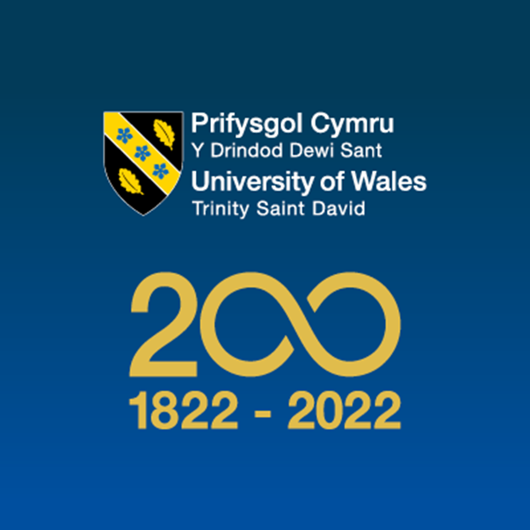
Student’s Name: Plamen Peev
Student’s number: 1815104

Table of Contents

Abstract 2
Introduction 2
Problem Statement 3
Objectives 4
Literature Review 4
Methodology 6
Conclusion 7
Timeline 7
References 8
Appendixes 10

Abstract
In any company or sector, training is a crucial component of the human resources development programme. Equally, its significance in the tourist industry is expanding daily, and we cannot undervalue it. Most of the research has provided a thorough understanding of the efficiency of training and development in the hotel or tourist industries. While development is learning that goes beyond today's job and has a more long-term emphasis in the viewpoint of the job orientation in the hospitality industry, training is an activity that is aimed to give learners the information and skill development that is needed for the job. The relevance of training and development in the tourist industry is highlighted in the current study report.

Introduction
Training is the process of obtaining new knowledge, skills, and abilities by an employee in accordance with the requirements for competencies that are necessary for the effective performance of the assigned labour functions under vocational training programmes and additional professional programmes, considering the specifics of the activity (Choi , et al., 2019). Training is the most useful tool through which management can create a culture that will contribute to the successful achievement of organisational goals and high productivity. The need for the professional development of personnel is due to the acceleration of scientific and technological progress. According to Garavan (2012), talent development focuses on the planning, selection, and implementation of development programmes for the whole talent pool. Evaluation of the knowledge of employees, as well as the conduct of educational activities, are planned and systematic. So, at present, the activities for the development of personnel and their professional adaptation are becoming increasingly important and make ever higher demands on the level of qualifications, knowledge, skills, and abilities of employees at various levels (Waqanimaravu & Arasanmi, 2020).
The knowledge, skills, and abilities that were relevant yesterday have become insufficient today, and tomorrow they may lose their significance, including in the digital economy. Thus, personnel development is one of the most relevant elements of the personnel management system - this is a complete range of measures aimed at optimising the professional qualities of each employee. The system of training and development is a complex continuous process of improving the knowledge, skills, and abilities of personnel using a set of organisational and economic measures, including training, advanced training, internships, and stimulating professional potential, as well as improving the work of personnel using rotation methods and changing job responsibilities (Johnson, et al., 2019). Productivity is a key factor that defines the success of an organisation, and in the modern world, increased productivity can be achieved through the enhanced training of employees to achieve organisational goals.
The present study considers the case of Marriott Inc. hotels in the UK to evaluate the strategies and development programmes provided by the HR departments according to their needs based on employee skills and knowledge. Marriott International is a well-known player in the hospitality industry with an increased focus on improving organisational effectiveness and productivity. The study aims to examine the impact of training and development on organisational performance after the UK voted to leave the European Union in 2016 (GOV.UK, 2016). The HR operations of Marriott International are related to employee development and its impact on organisational performance. The study will consider an innovative approach to training and development as an initiative-taking strategy that is consistent with the company's goals and the current economic environment. The problem statement, objectives, literature review, and data collection will all be examined in the proposal.

Problem Statement
The hospitality industry in the UK faced several challenges that influenced the availability of the right talent and workforce during the past few years, including Brexit and the COVID-19 crisis. The hotel industry in the country requires skilled labour and staff with specific skills to conduct organisational operations. At present, the UK market is facing a labour shortage that seriously affects the hotel business, and the UK market is highly competitive (Appendix 1). To overcome the challenge of labour shortages and growing business requirements in the hospitality industry, organisations need to focus on the existing workforce and gain a competitive advantage through the training and development of employees (Cabral & Chiappetta Jabbour, 2020).Employee productivity is a critical factor that defines the overall performance of the business. For example, companies gain a competitive edge when they develop a labour force that is more efficient than that of their rivals and staff efficiency may help businesses stand out from the competition, cut expenses, and increase profitability (Feng, et al., 2022). The present study addresses the problem by analysing the impact of employee development and training on organisational productivity.

Objectives
The objective of the study is to assess the importance of development and training programmes in the hospitality sector. Organizational development is the point of reference for the positive impacts of employee training and development. The primary objective of the study is to access the training and development programmes of Marriott International UK, after Brexit and its impact on organisational progress. To achieve the primary objective, the following are the secondary objectives.
- Knowledge of employees' training and development, and how it can improve employees’ productivity and performance.
- The importance of employee training and development in the hospitality industry.
- The HR strategies and procedures of Marriott International UK to train their employees after Brexit.
- The role of employee training in the success of Marriott International UK, after Brexit.
- To access, how the employees’ training and development will help the hospitality industry cope with the labour shortage after Brexit.
- To investigate how employee training and development can help motivate employees to achieve organisational goals.

Literature Review
A study conducted by the American Society for the Advancement of Training and Development shows that in the 1990s, economic growth due to the increase in the training of workers was 2.1%, due to population growth was 0.4%, and due to an increase in capital by 0.5% (Farrington, et al., 2018). Altogether, in the United States, the improvement in the quality of the labour force accounted for 14% of the increase in national income (Farrington, et al., 2018). According to a variety of data that Malik gathered, the tourism industry should create training programmes that align with its commercial aims or objectives (Malik, 2018). Innovative, growing, and developing businesses that place a high value on knowledge and competencies are more willing to accept training and development as a necessary tool (Baum, 2019). The learning and development function is incorporated with the HR department in bigger organisations such as Marriott International, Hilton and Accor. According to CIPD (2020), learning and development (L&D) are either a specialist function or job inside the HR department (29%) or are a part of generalist HR operations (16%). At the same time, the involvement of employees in the learning process in the UK is high. Employers train more, and usually highly skilled, workers. In 2019, 16.5 million employees were trained by employers, which is fairly like the 16.4 million recorded in 2017. The percentage of the workforce that is trained, however, has decreased from 62% in 2017 to 60% in 2019, because of a 4% rise in the overall workforce between 2017 and 2019 (Winterbotham, et al., 2020). The smallest share of those trained is in agriculture and fisheries—about 4%. The highest rate is demonstrated by firms engaged in tourism and hospitality activities—42.5%. Enterprises whose main activity is mining, manufacturing, and production and distribution of gas and water train 22-23% of their employees (Farrington, et al., 2018).
Employee training and development are critical in communicating to employees the main meaning and need for organisational operations—in explaining their essence and obtaining support for innovations from management and ordinary workers (Waqanimaravu & Arasanmi, 2020). On-the-job training and the development of personnel have a positive effect on the quality of the performance of duties by employees (Johnson, et al., 2019). The lack of employee training and development results in several consequences, including decreased efficiency, motivational factors, and the risk of moral obsolescence of employees' knowledge. The decreased efficiency of the company's internal processes is especially evident when integration training is abandoned (Malik, 2018). A sharp rejection of training is a strong motivating factor. It can cause the outflow of the most qualified personnel. There is a risk of moral obsolescence of employees' knowledge, which in turn will affect the efficiency of their work (Baum, 2019).
The main roles in increasing the income of the organisation are played by an increase in the number of personnel as well as a change in the shares of departments in the company. It should be said that two factors influenced the decrease in labour productivity in the organisation as a whole: a decrease in output in departments and unfavourable structural shifts between departments. Due to changes in the headcount structure between departments of the organization, the negative impact of the factors mentioned above on the dynamics of labour productivity was mitigated (Jawabreh, et al., 2020).
Managers of many organisations have already realised that weaknesses in the system of personnel management lead to inefficient business conduct and ethical problems. In this regard, large companies around the world are experimenting, seeking to enrich the process of individual learning by experience and to place staff in such a way that the skills of workers correspond to their personal needs and the needs of the business. In other words, there is a gradual replacement of the philosophy of the personnel policy “person for work” with “work for a person” (Cabral & Chiappetta Jabbour, 2020).The legislation provides for mandatory training and advanced training for only certain categories of workers. Periodic refresher courses should be taken by managers, hotel workers, and others (Cabral & Chiappetta Jabbour, 2020).
A corporate culture contributes to the formation and development of personnel as well as the development and improvement of the personnel management subsystem. Motivating employees through the impact on higher needs can only be cultivated in companies with a high corporate culture, operating in a rapidly changing environment, and focused on constantly satisfying growing market needs (Nwaeke & Obiekwe, 2017). Managers can deliberately build important connections into training programmes and daily assistance to subordinates at work. Continuous maintenance of the level of professionalism is important for organisations, especially in times of crisis. The training and development of the workforce in the hospitality industry is a continuous process that is based on personal experience and learning human behaviours to entertain the customers. For the development of employees, organisations use educational programmes that depend on the specifics of the organisation and the specific position (Waqanimaravu & Arasanmi, 2020). It is necessary to train the staff in something without which the company will not be able to work effectively (training in sales, products, est.) (Nwaeke & Obiekwe, 2017).

Methodology
The present research will be based on both primary and secondary data collected and analysed to answer the research questions. The primary data (quantitative data) will be collected through online surveys from a targeted group of people to gather data regarding their opinions, behaviour, or knowledge, whereas the secondary data (qualitative data) will be collected through literature research and articles. Qualitative and quantitative data gathered will help conduct the research to reach the right conclusions. The study will be based on a mixed research strategy that employs both qualitative and quantitative data techniques that will complement each other. Primary data is far more dependable than secondary data since it often contains up-to-date information and is acquired directly from the original source. The literature research (qualitative data) will focus on the impact of employee training and development on organisational performance. The employee’s performance and its evaluation systems will also be discussed in the literature section. The literature will highlight the need for employees in the hospitality industry to receive training and development. The literature will also cover the impact of Brexit on the overall hospitality industry in the United Kingdom and its implications for employee development, training, and organisational productivity. By collecting primary and secondary data, we will have the ability to observe the gaps between practices and theories.
The primary data will be collected through a survey questionnaire of employees, managers and representatives of the organisation working in the field of hospitality. The questionnaire survey will be shared online with the chosen participants, and the responses will be analysed for the evaluation the results. They will be designed to answer the research questions and will be aligned with the study objectives. The data screening and processing process will be analysed to make sure that the collected data is valid, authentic, and can be used for testing hypotheses. The result of the primary data will be compared with the secondary data for validation and analysis. The final data will be subjected to data sheets to analyse the trends over time. The data will use descriptive statistics to present and analyse the data; this process will help plot results in a presentable format. The data collection process is purely research-based, and the researcher will not ask for personal information. If provided by the respondent, it will not be shared with the third party for any use. The study also has certain limitations, as it is based on the UK’s hospitality industry, so it cannot be used for any other region across the globe. The study covers random participants, the larger sample size may increase the validity of the results extracted. Overall, the research employees both qualitative and quantitative methods of data collection, and descriptive statistics to interpret this data to evaluate the results.

Conclusion
Training and development are an essential part of business growth. The present report proposes a study to analyse the impact of employee training and development on the overall productivity of the organization. It is concluded that productivity is significantly influenced by employee development and behaviour at the work. The study considers the case of Marriott International Hotels to evaluate the effectiveness of employee training and development to improve productivity.

Timeline

 | Week 1-2 | Week 3-4 | Week 5-6 | Week 7-8 | Week 9-10 | Week 11-12 | Week 13-14 | Week 15-16
Choosing Topic and problem identification
Literature review
Secondary data collection
Primary data collection
Data screening and cleaning
Comparative data analysis
Results formulation
Conclusion

References
Baum, T., 2019. Does the hospitality industry need or deserve talent?. International journal of contemporary hospitality management, 31(10), pp. 3823-3837.
Cabral, C. & Chiappetta Jabbour, C. J., 2020. Understanding the human side of green hospitality management. International journal of hospitality management, Volume 88, p. 102389.
Choi , H.-M., Kim, W. G., Kim, Y. J. & Agmapisarn, C., 2019. Hotel environmental management initiative (HEMI) scale development. International Journal of hospitality management, Volume 77, pp. 562-572.
CIPD, 2020. Learning and skills at work 2020: Mind the gap: time for learning in the UK. [Online]
Available at: https://www.cipd.co.uk/Images/learning-skills-work-report-1_tcm18-79434.pdf
[Accessed 30 June 2022].
Farrington, T., Antony, J. & O’Gorman, K. D., 2018. Continuous improvement methodologies and practices in hospitality and tourism. International journal of contemporary hospitality management, 30(1), pp. 581-600.
Feng, Z., Hardin, W. G. & Wu, Z., 2022. Employee productivity and REIT performance. Real estate economics, 50(1), pp. 59-88.
Garavan, T. N., Carbery, R. & Rock, A., 2012. Mapping talent development: definition, scope and architecture. European Journal of Training and Development; Limerick, 36(1), pp. 5-24.
GOV.UK, 2016. EU referendum. [Online]
Available at: https://www.gov.uk/government/topical-events/eu-referendum
[Accessed 14 July 2022].
Hutton, G., 2022. Hospitality industry and Covid19. [Online]
Available at: https://researchbriefings.files.parliament.uk/documents/CBP-9111/CBP-9111.pdf
[Accessed 12 July 2022].
Jawabreh, O., Masa'deh, R., Mahmoud, R. & Hamasha, S. A., 2020. Factors influencing the employees service performances in hospitality industry case study AQBA five stars hotel. Geo Journal of Tourism and Geosites, 29(2), pp. 649-661.
Johnson, K. R., Huang, T. & Doyle, A., 2019. European Journal of Training and Development. European Journal of Training and Development, 43(9), pp. 821-841.
Malik, S., 2018. Importance of Training and Development in Tourism. International Refereed Journal of Reviews and Research, 6(1), pp. 11-19.
Nwaeke, L. I. & Obiekwe, O., 2017. IMPACT OF MANPOWER TRAINING AND DEVELOPMENT ON ORGANIZATIONAL PRODUCTIVITY AND PERFORMANCE A THEORETICAL REVIEW. European Journal of Business and Management , 9(4), pp. 153-159.
Waqanimaravu, M. & Arasanmi, C. N., 2020. Employee training and service quality in the hospitality industry. Journal of foodservice business research, 23(3), pp. 216-227.
Winterbotham, M. et al., 2020. Employer Skills Survey 2019: Training and Workforce Development. [Online]
Available at: https://assets.publishing.service.gov.uk/government/uploads/system/uploads/attachment_data/file/936487/ESS_2019_Training_and_Workforce_Development_Report_Nov20.pdf
[Accessed 30 June 2022].

Appendixes

Appendix 1: Vacancies for hospitality jobs are record high.
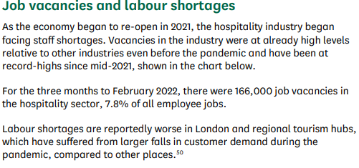
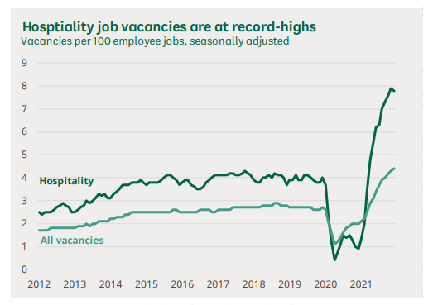
Source: (Hutton, 2022)

