Electronics 1
ACDA4004
Designing an Automatic Traffic Light Controller for a T- Junction Road.
Student ID: 2214461(Owen Wild)
Word Count:2250

Contents
Figures 2
Abstract 3
Introduction 3
Background research 4
Traffic lights circuit and code 5
Flowchart 7
Software listing 8
Simulation and testing 8
Results 10
Conclusion 11
References 12
Appendixes 13

Figures
Figure 1 - Circuit overview. 5
Figure 2 – initializing the pins. 6
Figure 3 - setting up the traffics lights in a do loop. 6
Figure 4 - setting up the traffic lights. 7
Figure 5 - Flowchart 8
Figure 6 - Test 1. 9
Figure 7 - Test 2. 9
Figure 8 - Test 3. 10
Figure 9 - Test 4. 10
Figure 10 - Pic pin overview. [1] 13
Figure 11 - Decimal to hexadecimal values 13

Abstract
This assignment is based around a PIC16F877A to control a T- junction that is controlled by three traffic lights and three counters. Test and simulations were done using proteus and mikro C. The outcome of these test where that their needs to be improvement as the system didn’t work as efficiently as it should do. Also, major heath and safety aspect of the traffic light-controlled T-junction have been identified within the system. Recommendations of how to improve the safety of all road use is state in the concludes for further work devolvement. Pleases note this assignment is to show the use of embedder C and how a pic can control a system. So not to create a real-life traffic system.

Introduction
This assignment shows how embedder C can be utilised to control a traffic light system which is coded and used by a micro controller. The components that were used is a PIC16F877A, traffic lights, seven segment display and LEDs. The coding was done in Mikro C using the language of embedded C. The code was then saved as a Hex file and uploaded to the pic in proteus. Background research was done to identify the right pic that was suitable to run the code and traffic light system. Another aspect of the background research was on the traffic lights designs and law that are associated with a T-junction in the UK. Testing and simulations was done on the T- junction to show if any faults has occurred and if it complies with UK law and legalisation. The conclusion has recommendations of further work that will enable this traffic light-controlled T- junction perform better.

Background research

The PIC16F877A is a 40 pin Microcontroller chip that is part of the pic 16 family a diagram can be found in the appendix of the pic. Some key features that the PIC16F877A has is 8k of Flash programable memory, 256 bytes of EEPEROM, analogy comparators, 368 bytes of memory and five input and output ports [1]. EEPROM (electrically erasable programmable read-only memory) is a type of RAM that can be reprogramed and erased repeatedly [2].
Microcontrollers are small device that has lots of factuality’s and can be use in lots of applications. Microcontrollers contain features like: CPU, RAM, clock, DAC, I/O, ADC and ROM. All these can be programmed to do different things. CPU (central processing unit) preforms Arithmetic, Logic and Data Transfer operations this with the arithmetic logic unit and the control unit. Memory consisted of ROM and RAM that is within the microcontroller. The memory is where date can be stored so can be read and written to as well. I/O (input and output) theses counites of the pins that are on the chip. Theses pin can be change in the code of what their functionality is whether it is an input or out pin or has a more specific function like ADC or a DAC pin. Timing is important within the microcontroller as it is sync to the clock pules. Additionally, a watchdog timer can be used as a reference point as this can’t be change. Applications off trimming use is if it has multiple clock pules to control different output devises or plus width modulation can be done [3].
The traffic lights operations in a certain sequence outline in UK law and the highway code. The sequence starts off with red where this signal means you must stop at the stop line on the road. The next light change is red and amber, the combinations of these light means the same as a red light where you mast stop until a green light shows. The main different is that it also means prepare to go as the next light change is green. A green light represent that you may pass the light but extra care must be taken when driving through the junction. If you are turning at the light either left or right you must give way to pedestrians who are crossing. Finally, the last stage of the traffic light sequence is amber. This means stop also unless you are pass the stop line before it changes or if you are going at speed and cannot stop before the stop line [4].
Pedestrian’s must adhere to rule 21 of the highway codes for this type of crossing. The rule states how a pedestrian must act at a set of traffic light. When the pedestrian light is red they must wait at the side of the road. When a green light appears, it is safe for pedestrians to cross the road, but care must be taken crossing the road as road use may disobey the traffic lights. Finally, when the pedestrian light starts blinking pedestrians must not start crossing as the light will change for the road users shortly. If pedestrians are on the crosswalk the must not stop or turn back they must contain to cross the road safely [5].
Cyclists have their own rules and regulations when it comes to the road. Rule 73 of the highway code states that cyclist must position themselves in the centre of lane the need when at a junction. If there is no specific cyclist facilitates like small traffic lights at head level that adhere to cyclist, which act like normal traffic light but on cyclist can use them. If this is not at the junction cyclist must obey motor vehicles rules 170 to 190 [6].

Laws around using the road specifically for road junction are set out in rules 170 to 183 of the highway code. Rule 170 is a very import rule that relates to all junctions as road uses must watch out for cyclist, pedestrians, motorcyclist and powered wheelchair/mobility scooters as these will be on the road as well. Pedestrians have the right of way when the are crossing the road as road users must wait to allow them to cross. The rule also states you must remain behind cyclist, horse riders’ motorcycles when waiting to turn at a junction. Rule 171 states you must stop behind the stop line so these lines need to be incorporated. Also rule 175 is specify for traffic light-controlled junctions where you must top at the stop line unless the light is green. Rule 176 you must not cross the stop line if the traffic light is any colour other than green. If the traffic light does not work it must be treated as an unmarked junction [7].

Addition as a pedestrian crossing is added and is controlled by traffic light rules 191 to 199 are in effect on this traffic light-controlled T-junction. Rule 191 is a very imported rules as road users must not park or stop on the cross walk or overtake a moving or stopped vehicle near the crossing. Rule 192 is similar to rule 191 where the cross walk should be kept clear as could for pedestrians to cross. Rules 194 and 198 state that pedestrians must be given plenty of time to cross the crosswalk and to allow pedestrians that are still on the crosswalk to count to cross with any hazard or danger to them [7].

Traffic lights circuit and code

Figure 1 shows the T- junction set up with proteus that consist of three traffic lights, six seven segment displays, PIC16F877A and six pedestrian lights. These are laid out in a T-junction like position

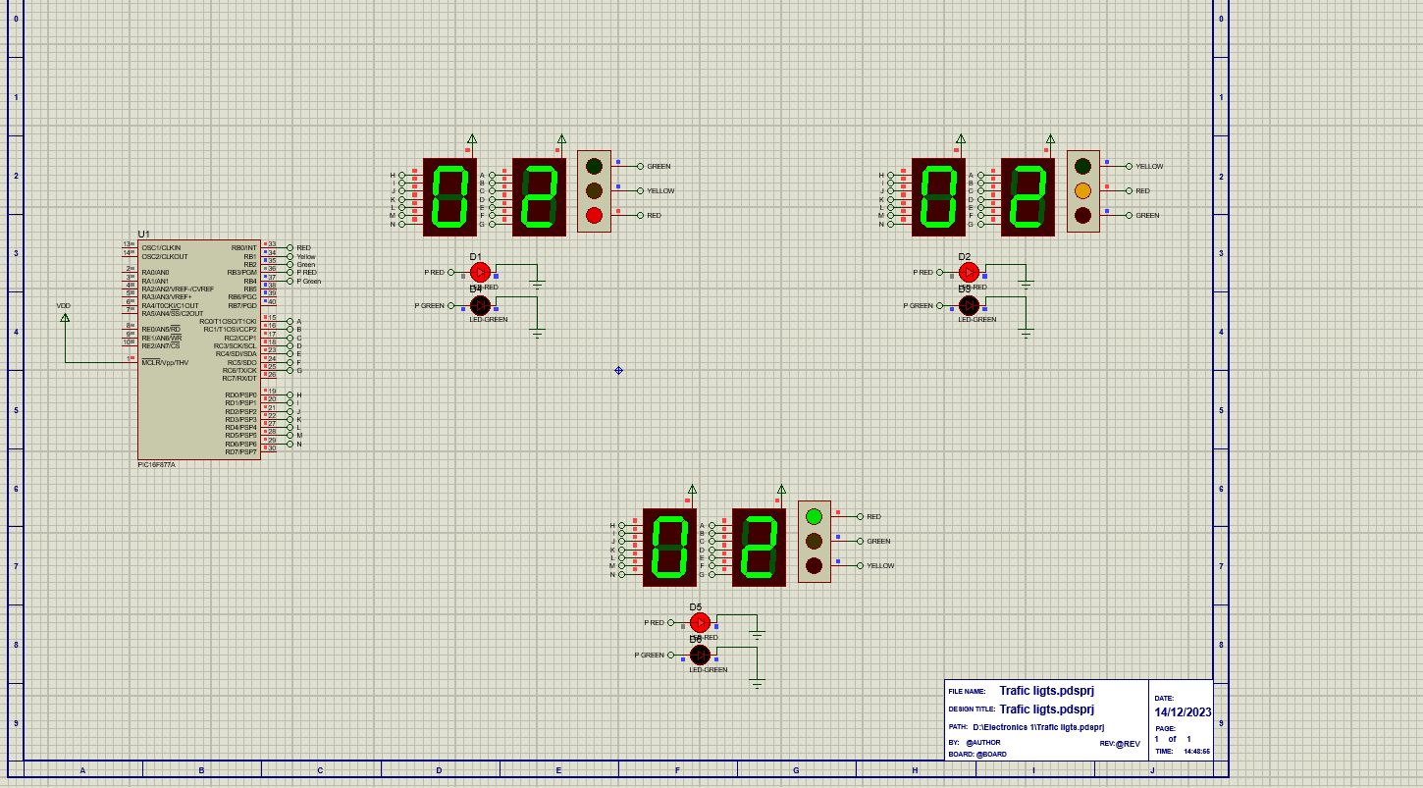
Figure 1 - Circuit overview.
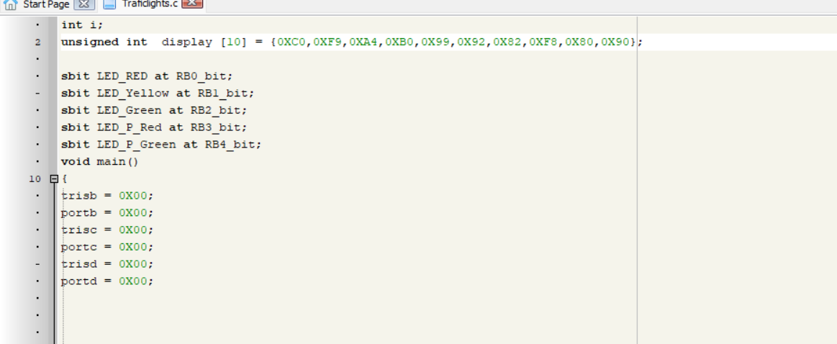
Figure 2 – initializing the pins.
Figure 2 shows the initialisation of the code for the pic to control the T-junction. This is done by setting up the ports to be able to do matrixes by setting up the ports and tristate registers. This will enable fewer pins to be use. Calculations were also done to convert decimal values to hexadecimal values so the pic could read them. Calculations are in the Appendixes

Figure 3 and 4 show the Do loop in void main of the code. This aspect off the code is for the light and counting up sequences. How this works is by setting the counter to display 0 at first then counting up to forty. Each section in the do loop represents ten seconds where a specific traffic light on and if the pedestrian is red or green. There is an individual counter that count from zero to ten in each section to allow for the ten second stages. There are four stages that the Do loop must cycle through before it resets. This is show by the counter resetting to zero and cycling though the sequences again.

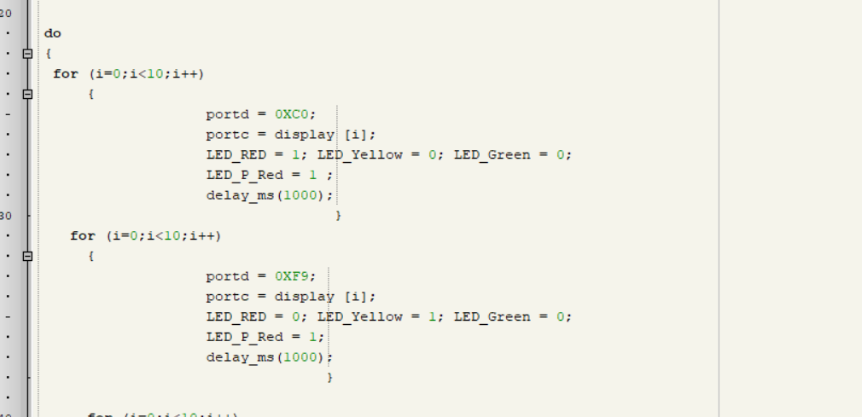
Figure 3 - setting up the traffics lights in a do loop.
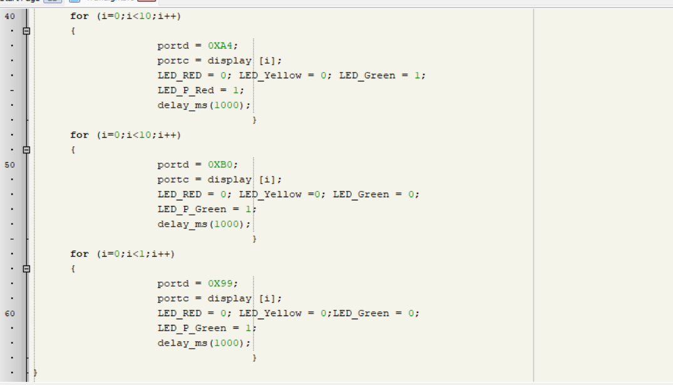
Figure 4 - setting up the traffic lights.

Flowchart

The flowchart shows the process of how the T-junction works. The T- junction works on a time bases that every ten seconds the lights change to allow traffic to flow in another direction. The last ten seconds is set aside for pedestrians to cross the road safely.

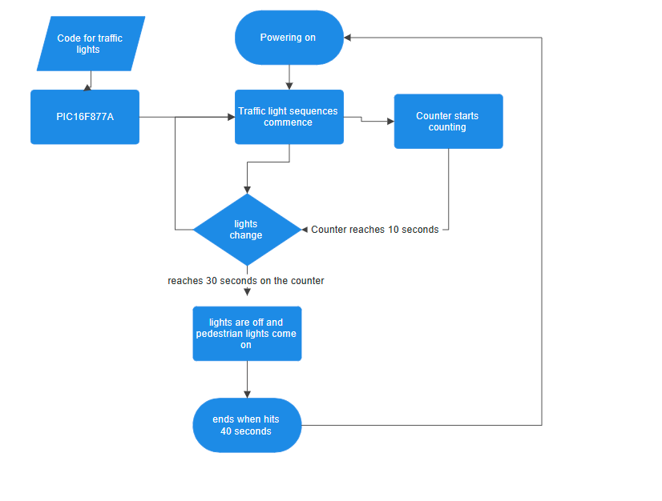
Figure 5 - Flowchart

Software listing

The software that is used in this assignment is proteus and micro C. Proteus is used to simulate the traffic lights and the counting system from the code. Mikro C is use for the code section to make the traffics lights work

Simulation and testing

Simulations were done as show in figures 6 to 9. Each figure depicts a different sequence of events ever ten seconds.
Testing is important as it will show any errors that occur whilst running the traffic light sequence. How testing was done on this set up is by debugging the code to see if any errors were picked up. If errors were pick up they easily rectified. Another test was done on proteus, this was a visual to see if the counter counted up correctly. Furthermore, the visual test checked all the lights to make sure they are all in the right sequences and order that is on each stage of the counting up.

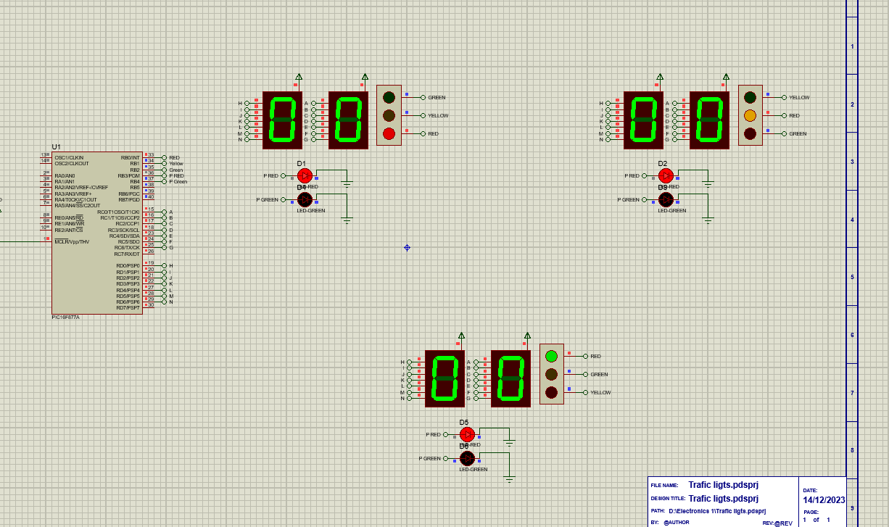
Figure 6 - Test 1.

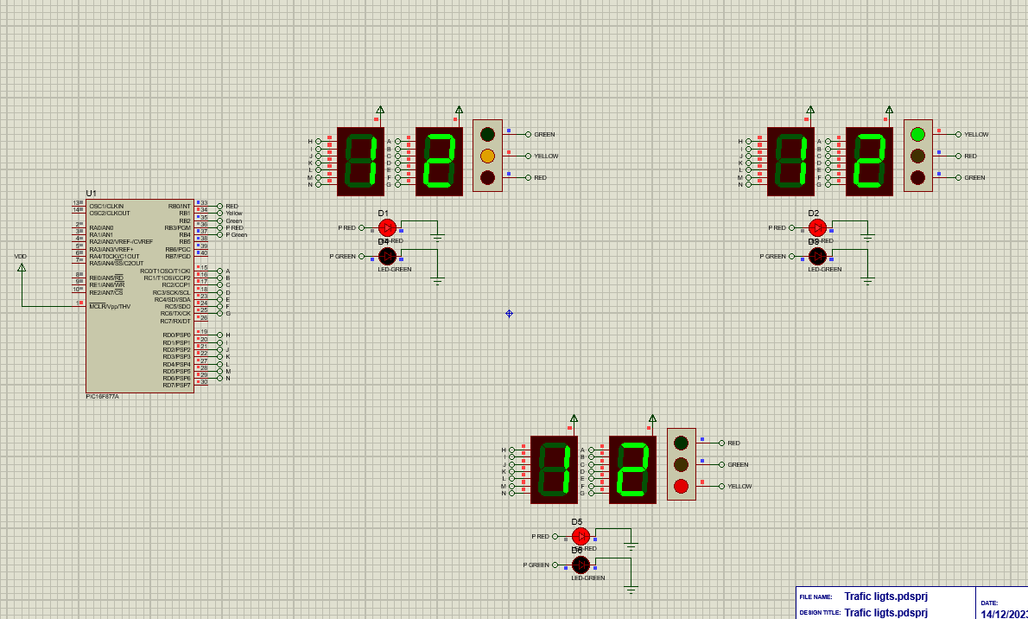
Figure 7 - Test 2.

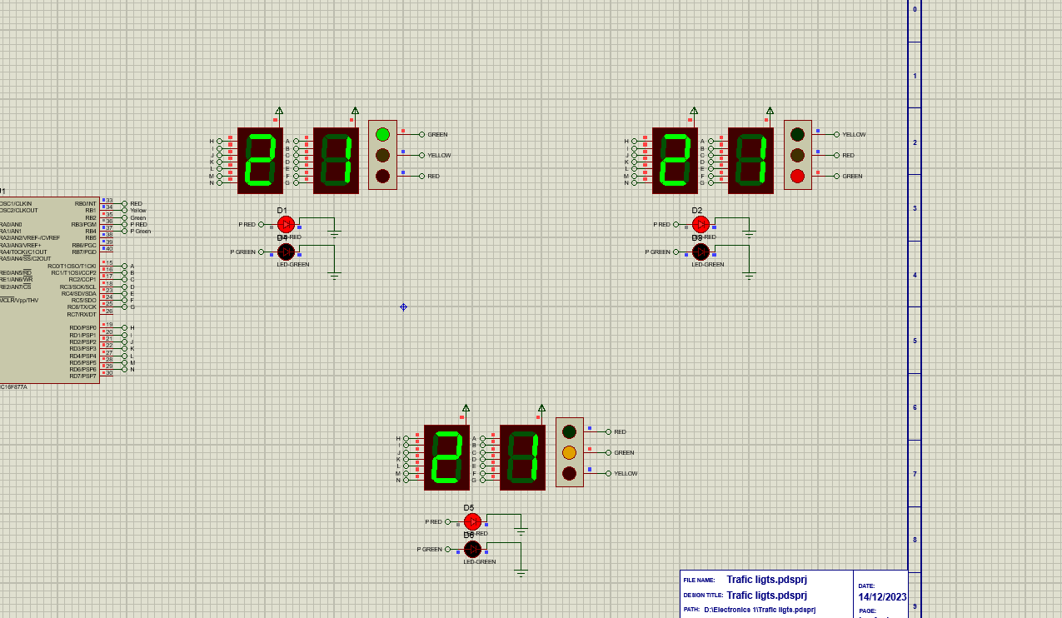
Figure 8 - Test 3.
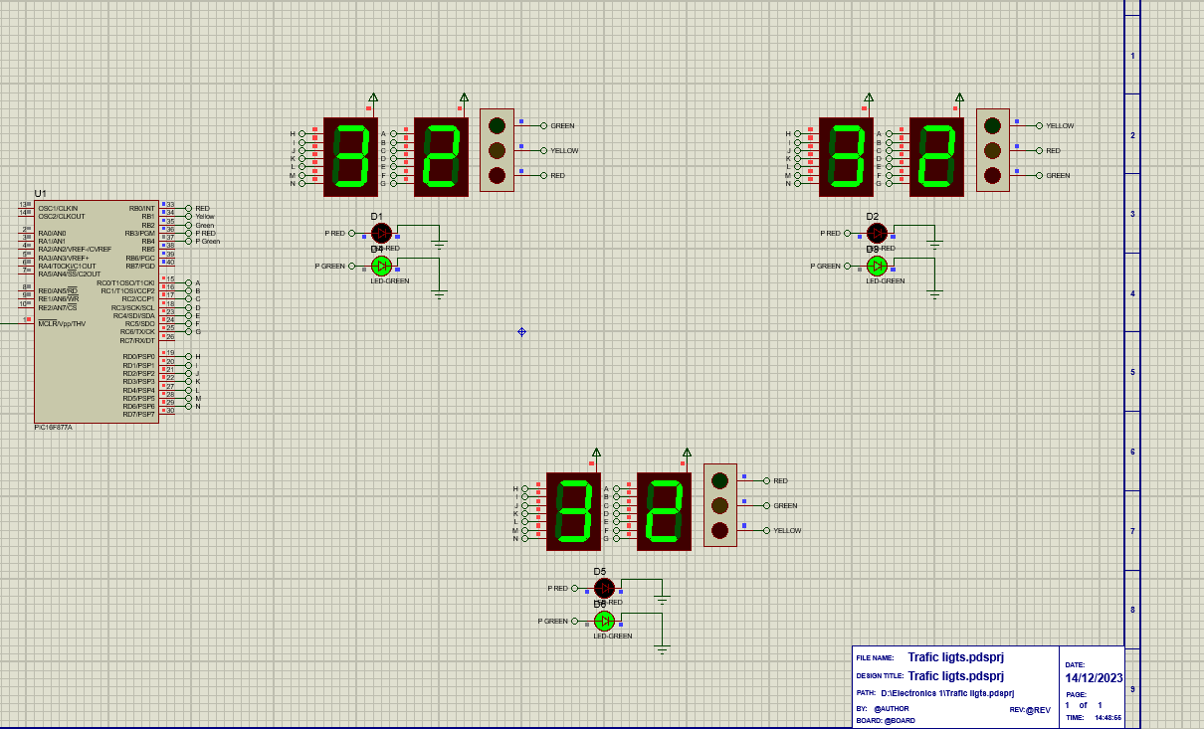
Figure 9 - Test 4.

Results
The results of this project are it work as a T-junction that follows UK law and legislation and has a counting systems that count from 0 to 40. It also has a pedestrian light that stays red until 30 seconds has passed then turns green for 10 to allow pedestrians to cross safely. This fulfils the assignment brief.

Conclusion

In Conclusion the T-junction traffic lights system work as a sufficient way to allow traffic to flow on the junction smoothly and for pedestrians to cross. The assignment gives a brief over look about the type of microcontroller that is being used to control this system. Details of the laws and legislation that surrounds this type has been looked at and has been implement to accordance to UK law. Embedder C is used as it’s a sufficient coding language that works with the microcontroller to do both software and hardware applications on this system.
Testing of this system was done to make sure that it works visually and met the assignment brief. Further testing can be done by making this system on bread bored to see it working in real life situation. Another way is to change the traffic light types were some will have a pedestrian light integrated in with the traffic light system or added a filter light to allow smoother traffic flow and cause less congestion.
Supplementary work can be done on this system to improve it efficient by coding the traffic light to show red instead of being off when pedestrians are crossing. This will limit confuses from the road use and will make it safe for pedestrians to cross as it limits the possibility that road user will move from all directs all at once. Additional making the traffic light show red and amber at the same time this will make it comply with UK law and legalisation as there is a set way a traffic light must work.
Alternatively, another way of improve this system would be to make the seven-segments display a fourteen-segment display. This make reading the display easier for road users to know when the light is about to change.
Making this into a crossroad would further develop the code and the system to show a more complex way of using embedded C and the pic. This is because there will be more things to control.
Further work can be done to improver the systems is to designed the T-junction with all the lights, counters, road and road marking. This will help aid a visually representation of the T-junction to be able to identify any errors within the system. Additionally, will help UK law and legislations as this help with the designing of it.
Finally, all the recommendations stated to further develop the traffic light system will greatly improve the system. When these improvements are implemented the safety of all road use will improve as the traffic light will off clearer direction for road uses. This will greatly reduce the risk of accidents and fatalities.

References

[1] | Microchip Technology Inc, “Digikey,” January 2021. [Online]. Available: https://ww1.microchip.com/downloads/en/DeviceDoc/39582C.pdf. [Accessed 17 12 2023].
[2] | R. Awati, “EEPROM (electrically erasable programmable read-only memory),” techtarget, 05 2022. [Online]. Available: https://www.techtarget.com/whatis/definition/EEPROM-electrically-erasable-programmable-read-only-memory. [Accessed 17 12 2023].
[3] | Electronicshub, “Basics of Microcontrollers – History, Structure and Applications,” Electronicshub, 13 11 2017. [Online]. Available: https://www.electronicshub.org/microcontrollers-basics-structure-applications/. [Accessed 17 12 2023].
[4] | Department for Transport, “Light signals controlling traffic,” 17 09 2023. [Online]. Available: https://assets.publishing.service.gov.uk/media/560aa3f9e5274a036900001c/the-highway-code-light-signals-controlling-traffic.pdf. [Accessed 17 12 2023].
[5] | Department for Transport, “Rules for pedestrians,” 17 09 2023. [Online]. Available: https://www.gov.uk/guidance/the-highway-code/rules-for-pedestrians-1-to-35. [Accessed 17 12 2023].
[6] | Department for Transport, “Rules for cyclists,” 17 09 2023. [Online]. Available: https://www.gov.uk/guidance/the-highway-code/rules-for-cyclists-59-to-82. [Accessed 17 12 2023].
[7] | Department for Transport, “Using the road,” Department for Transport, 17 09 2023. [Online]. Available: https://www.gov.uk/guidance/the-highway-code/using-the-road-159-to-203. [Accessed 17 12 2023].

Appendixes

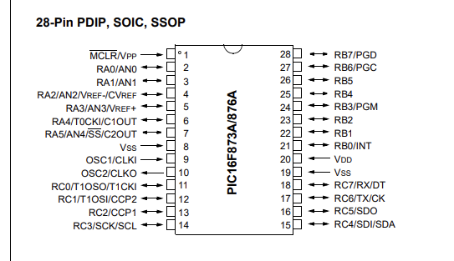
Figure 10 - Pic pin overview. [1]

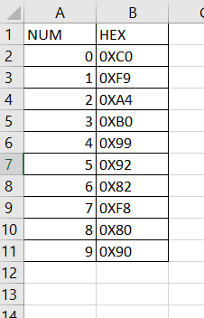
Figure 11 - Decimal to hexadecimal values

