

Cover Page

Name: Sherelle Mclean
Student Number: 2407059
Module: Changemakers: Creativity and Value Creation
Module Code: BMHP5014
Lecturer: Raheela Shaikh
Assignment Title: Component 2: Written Assignment (Report)

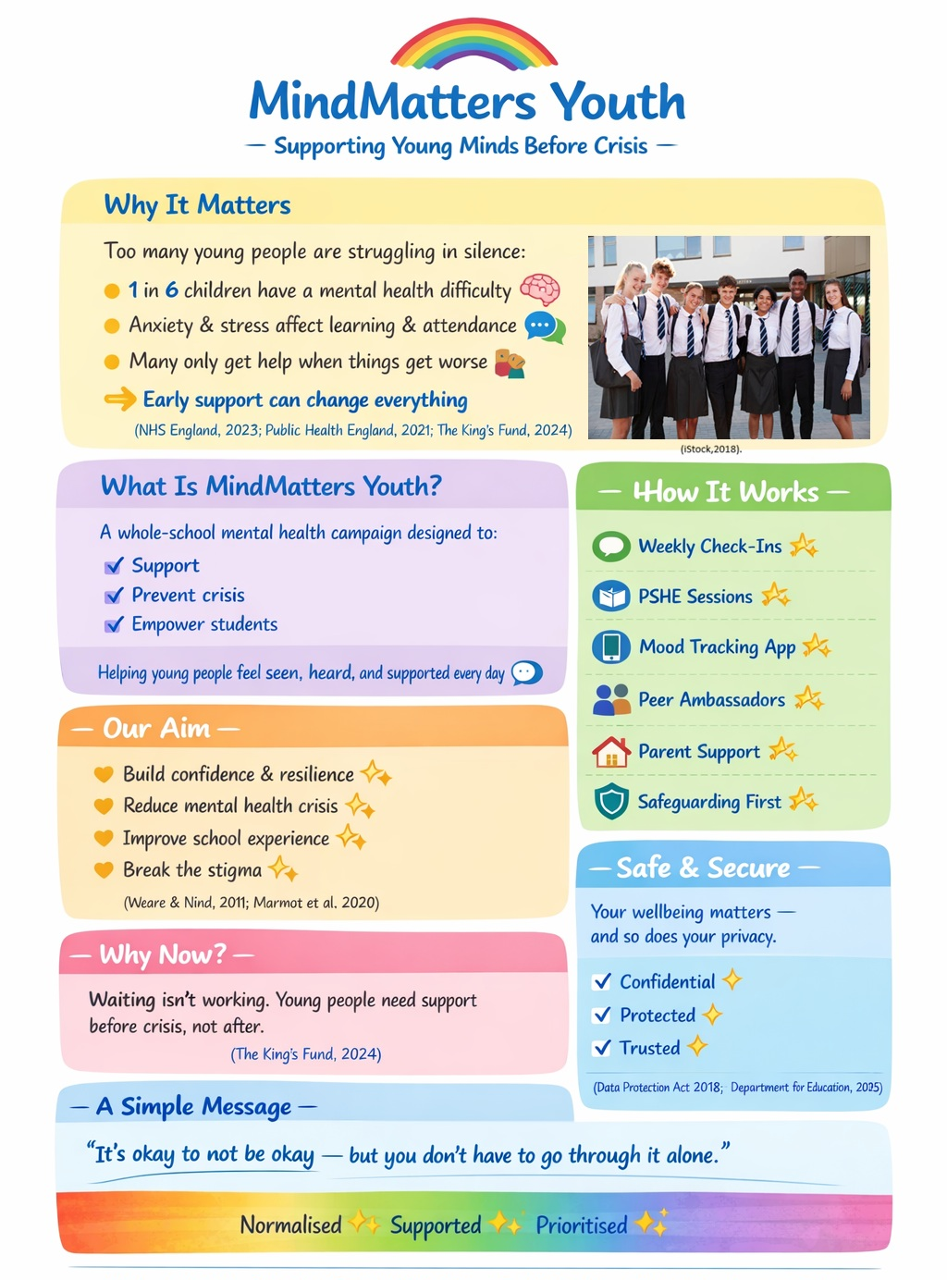

MindMatters Youth

Introduction
I am proposing the implementation of MindMatters Youth, a whole-school mental health campaign designed to protect, support, and empower secondary school students aged 11–16 before their difficulties escalate into crisis.
Across England, too many young people sit in classrooms while silently experiencing anxiety, low mood, or emotional overwhelm. One in six children aged 7–16 has a probable mental health disorder (NHS England, 2023), with prevalence increasing during the secondary school years due to academic pressure, friendships, identity development, and digital exposure (NHS England, 2023; Ofcom, 2023). Despite national policy commitments to early intervention, many pupils only access support once symptoms become severe (The King’s Fund, 2024). This reactive approach is neither sustainable nor equitable.
Mental health difficulties significantly impact educational outcomes. Anxiety and depression affect concentration and motivation, contributing to reduced attainment and increased absenteeism (Public Health England, 2021). Emotional distress may present as withdrawal, irritability or disruptive behaviour, increasing safeguarding concerns and exclusions (Public Health England, 2021). Evidence also shows that 50% of lifetime mental health conditions emerge before the age of 14 (NHS England, 2019). Positioning secondary schools as critical environments for early intervention.
Although policies such as the Department for Education’s Green Paper (Department for Education, 2017) and the NHS Long Term Plan (NHS England, 2019) promote early intervention and whole-school approaches, more recent guidance highlights that implementation remains inconsistent despite continued national rollout and policy updates (Department for Education, 2025). I believe we must move beyond policy intention to visible, practical change within schools. MindMatters Youth offer that change.

How the Campaign Works
MindMatters Youth embeds emotional wellbeing into everyday school life through six interconnected components.
Weekly wellbeing check-ins during tutor time encourage emotional reflection and early identification of concerns. Whole-school social and emotional learning approaches are linked to improved resilience and academic outcomes (Weare and Nind, 2011).
Curriculum-integrated awareness sessions within PSHE lessons address topics such as anxiety, exam stress and online pressures using discussion-based and creative approaches that enhance engagement (Clift and Camic, 2018).
A digital mood tracking platform allows students to privately monitor their emotions and access coping strategies. Given high levels of adolescent digital engagement, this approach increases accessibility and supports early intervention (Ofcom, 2023).
Peer mental health ambassadors reduce stigma and encourage help-seeking behaviours, with evidence showing that peer-led initiatives can improve openness around mental health (Mental Health Foundation, 2022).
Parent and community engagement is supported through workshops and digital resources, strengthening the link between home and school.
Safeguarding integration ensures all disclosures are managed in line with statutory guidance (Department for Education, 2025).
Together, these elements create a layered prevention model operating at both universal and targeted levels.

Implementation Plan
The campaign will be introduced through a structured four-phase approach.
Phase 1 focuses on co-design and planning, including student involvement, leadership approval, safeguarding alignment, and collaboration with NHS Mental Health Support Teams.
Phase 2 introduces a pilot within one year group, supported by staff training, student ambassador preparation and baseline data collection on wellbeing, attendance, and safeguarding indicators.
Phase 3 evaluates the pilot through quantitative and qualitative analysis, enabling refinement based on stakeholder feedback.
Phase 4 expands the programme to a whole-school rollout, supported by a dedicated awareness campaign to embed the initiative into school culture.
This phased approach ensures the programme is manageable, adaptable and evidence informed.

Target Demographic and Expected Impact
MindMatters Youth primarily targets students aged 11–16, particularly those in disadvantaged or high-need areas. Teachers, pastoral staff, and families are secondary beneficiaries.
School-based mental health interventions are shown to improve emotional literacy, resilience, and self-efficacy among young people (Weare and Nind, 2011). Expected outcomes include improved coping skills, reduced escalation to crisis services, increased staff confidence, and a more positive peer culture around mental health.
By providing universal access within schools, the programme helps address health inequalities and ensures support is accessible regardless of socioeconomic background (Marmot et al., 2020).

Technology Integration
Technology is a core element of MindMatters Youth. The optional wellbeing app allows students to engage privately while tracking emotional patterns over time. Aggregated data help schools identify trends and evaluate programme effectiveness without compromising confidentiality.
All digital processes will comply with legal and ethical standards for data protection ( Data Protection Act,2018). , alongside safeguarding requirements ( Department for Education,2025). This ensures both accessibility and safety for all users.
However, while digital tools increase accessibility, they may not engage all students equally, particularly those experiencing digital fatigue or limited access outside school, highlighting the importance of blended approaches (Ofcom, 2023).

Regulations, Value and Feasibility
The campaign aligns with key policies including the Green Paper (Department for Education, 2017), the NHS Long Term Plan (NHS England, 2019) and whole-school wellbeing frameworks (Public Health England, 2021). It supports prevention priorities and contributes to reducing long-term demand on specialist services (Marmot et al., 2020).
Financially, the model is feasible as it integrates within existing school structures such as PSHE and tutor time. However, research highlights that the success of whole-school approaches depends heavily on leadership commitment and staff engagement (Weare and Nind, 2011).
Potential barriers include staff workload and stigma, which remain significant challenges. While these can be mitigated through training and phased implementation, their impact should not be underestimated, as workforce pressures are a known limitation in school-based mental health provision (Public Health England, 2021).

Evaluation
MindMatters Youth is grounded in strong evidence and policy alignment, but its effectiveness will depend on consistent implementation. Whole-school approaches can improve wellbeing outcomes, although impact varies depending on school culture and staff engagement (Weare and Nind, 2011).
A key strength is its preventive focus, which aligns with public health priorities and has the potential to reduce long-term service demand, although measurable impact may take time to be evidenced in practice (Marmot et al., 2020).
Limitations include potential inequalities in digital engagement and ongoing staff workload pressures (Ofcom, 2023; Public Health England, 2021). Despite this, the phased approach, student involvement, and peer-led elements enhance sustainability and feasibility, making the campaign a realistic and impactful strategy.

Conclusion and Call to Action
MindMatters Youth represents not only a practical intervention but a necessary cultural shift in how schools respond to mental health. It ensures that students feel seen, supported, and able to seek help early.
I am seeking support to pilot this campaign within a secondary school in partnership with NHS services and local authorities. With appropriate evaluation, it has the potential to become a scalable, evidence based model for early intervention.
By investing in prevention now, we can reduce future pressures on services, improve educational outcomes, and protect the wellbeing of the next generation.

Reference List
Clift, S. and Camic, P.M. (eds.), 2018. Oxford textbook of creative arts, health, and wellbeing: International perspectives on practice, policy and research. Oxford: Oxford University Press.
Data Protection Act 2018.(2018) Data Protection Act 2018. London: HMSO. Available at: https://www.legislation.gov.uk/ukpga/2018/12/contents ( Accessed 17 February 2026).
Department for Education (2017) Transforming children and young people’s mental health provision: a Green Paper. London: DfE. Available at : https://assets.publishing.service.gov.uk/government/uploads/system/uploads/attachment_data/file/664855/Transforming_children_and_young_people_s_mental_health_provision.pdf ( Accessed 17 February 2026).
Department for Education (2025) Keeping children safe in education. London: DfE. Available at:https://assets.publishing.service.gov.uk/media/68add931969253904d155860/Keeping_children_safe_in_education_from_1_September_2025.pdf( Accessed 17 February 2026).
iStock (2018).Portrait Of Smiling Male And Female High School Students Wearing Uniform Outside College Building stock photo. Available at:https://www.istockphoto.com/photo/portrait-of-smiling-male-and-female-high-school-students-wearing-uniform-outside-gm1047533030-280194391 ( Accessed 17 February 2026).
Marmot, M., Allen, J., Boyce, T., Goldblatt, P. and Morrison, J., 2020. Health equity in England: the Marmot review 10 years on. London: UCL Institute of Health Equity. Available at: https://www.instituteofhealthequity.org/resources-reports/marmot-review-10-years-on/the-marmot-review-10-years-on-full-report.pdf (Accessed 17 February 2026).
Mental Health Foundation (2022) Prevention in mind: Mental health and prevention. London: Mental Health Foundation. Available at: https://www.mentalhealth.org.uk/sites/default/files/2024-01/MHF_PEP_Peer-Educator-Handbook.pdf ( Accessed 17 February 2026 ).
NHS England (2019) The NHS long term plan. London: NHS England. Available at: https://webarchive.nationalarchives.gov.uk/ukgwa/20230418155402/https:/www.longtermplan.nhs.uk/publication/nhs-long-term-plan/ ( Accessed 17 February 2026 ).
NHS England (2023) Mental health of children and young people in England, 2023. NHS England. Available at: https://digital.nhs.uk/data-and-information/publications/statistical/mental-health-of-children-and-young-people-in-england/2023-wave-4-follow-up# ( Accessed 17 February 2026 ).
Ofcom (2023) Children and parents: Media use and attitudes report 2023. London: Ofcom. Available at: https://www.ofcom.org.uk/siteassets/resources/documents/research-and-data/media-literacy-research/children/childrens-media-use-and-attitudes-2023/childrens-media-use-and-attitudes-report-2023.pdf?v=329412 ( Accessed 17 February 2026).
Public Health England (2021) Promoting children and young people’s emotional health and wellbeing. London: PHE. Available at: https://assets.publishing.service.gov.uk/media/614cc965d3bf7f718518029c/Promoting_children_and_young_people_s_mental_health_and_wellbeing.pdf promoting children and young people’s mental health and wellbeing ( Accessed 17 February 2026).
The King’s Fund (2024) Mental health 360. Available at: https://www.kingsfund.org.uk/insight-and-analysis/long-reads/mental-health-360 ( Accessed 17 February 2026).
Weare, K. and Nind, M., 2011. ‘Mental health promotion and problem prevention in schools: What does the evidence say?’, Health Promotion International, pp. 29–69.

