Lampeter: A Picture Essay
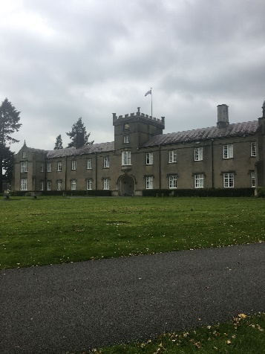
We start our journey at the university campus, as many other journeys start, standing in front of the old building and looking onto the [Georgian] architecture. Anthropologically the building can be seen as imposing, encroaching on the otherwise peaceful atmosphere of its surroundings, I would even suggest that it was created in such a way to express the sophistication of university. In 1822 it was not a common thing for those of lower classes to go to higher education, especially in a traditional farming society such as Lampeter, so to place a prestigious university right near the middle of town sets the president that it is not for the locals. The grand entrance to a courtyard, past water pumps turned into water fountains, engraved stones and circled by Tudor roses- the very foundations of the university insights a “us and them” attitude, we the scholars and them the workers. The campus being raised up on a slight incline from the rest of the village also emphasises that it is almost superior than the rest of the town.

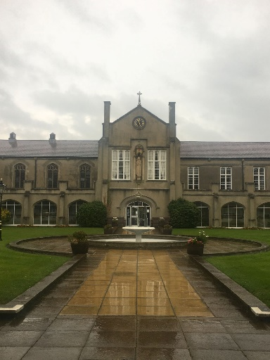
However, looking at the university, it is not a negative scar scratched onto the landscape of an otherwise beautiful village. The culture of Lampeter is enhanced by its edition, the new people filing in and out of the grounds, different cultures and religions circling through the town only adds to its allure as a place that is generally accepting of change and diversity. The new shops added to the town centre builds on Lampeter’s economy and the in and outgoing university students keeps places such as takeaways, family owned bakeries and independent shops open. Additionally, the motte and bailey placed near the back of the old building shows that there was a belief in historical preservation when it was constructed, this not only relates to anthropology but also the archaeological integrity of the people who built it. Rather than destroying it and levelling the ground in the name of study the architect worked with it, allowing past history to be displayed and cherished by the students that would attend and by the local community. The preservation of bygone history can be seen as a promise to the society that it was placed in that it was not here to upturn their lives and change their everyday, instead it was here to boost it, to build upon the past and its heritage without destroying what was already there.
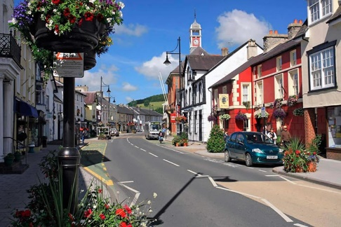

As we move into the town we are witness to the hustle and bustle of ordinary life, the way each person interacts and their natural rhythm we seem to find as humans. Culturally Lampeter is the home of older, more independent and more fantastical shops, ranging from little craft shops like the snail of happiness to the big chains such as Sainsburys and Co-op. In this town there are multiple cultures that find places to share their differences through their cuisines; traditional fish and chip shops, Indian restaurants, Italian cafes and more are all integrated into the commonplace of Lampeter. The very houses that many of shops now reside have stayed similar if not exact to their construction, Lampeter not only feeds on this new age of diversity but also keeps its legacy alight by using the same foundations. From an archaeological perspective, the use of the same buildings could not only show the date of the buildings but also show the probable hints of the old owners, possibly the way they cheaply patched the hole in the wallpaper or how they replaced their carpet by adding a new layer rather than ripping the old one out. Original buildings, despite modern moderations, could also show the ways building were conducted, the codes they followed, the patterns or the lack there of.
Figure 1

Something that also caught my eye when exploring the town was the use of barber poles, anthropologically the symbol has its origins in the middle ages- during the time when barbers were not only the local hairdressers but also the local surgeon for simple surgeries. It intrigued me as it shows that, as a culture, no matter how old the symbol may be it will always mean the same thing. The idea that our society may change and human behaviour is constantly adapting to our new digitalised world, yet, we have held onto the tangible history of our past.
Figure 2
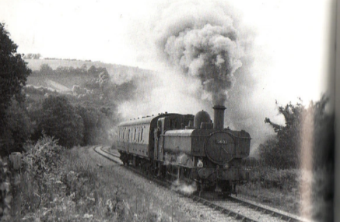

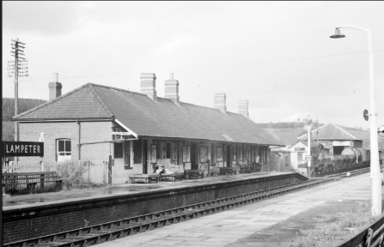
One of the most interesting things to discover in Lampeter is the closed down train station that connected the North to the South. The divide created by the bankruptcy of the company and the cut of the line not only had cultural effects but also shows how the seemingly little town had an important role in Welsh transport- being the train that most would get from Aberystwyth to Carmarthen. The line of trees that now stand in its footsteps highlights the trains importance towards the community, historically the train was used during the second world war for 330 evacuees and only six decades later was just used for milk transportation. It’s fascinating switch in function doesn’t devalue its importance, rather it connects it more to the part Lampeter played in fighting and protecting the people of the UK. Therefore, the proud soldier standing atop of the stone on the war memorial doesn’t just represent the brave men and women to fight on the front lines, it also represents the men and women that opened their homes to welcome the vulnerable and shielded them from the world.
Figure 4
Figure 3

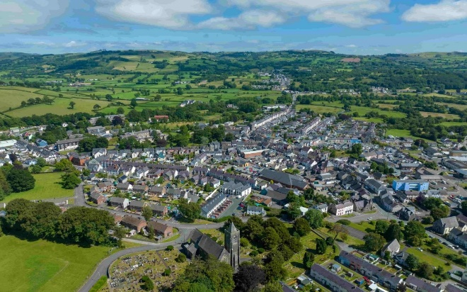
Figure 5
Lampeter, I believe, is an excellent demonstration of the idea that history is all around us. History seeps out of Lampeter and my disciplines of archaeology and anthropology thrive here, the culture of Wales that is present in ever corner of the town to the archaeological findings that are emphasized through agriculture. These fields bond together to show that it doesn’t take travelling miles to find something that reflects your interests, rather its where you look more than where you go.

Biography:
Figure 1: Discoverceredigion.wales. (2024). Lampeter - market town and gateway to Ceredigion - Discover Ceredigion. [online] Available at: https://www.discoverceredigion.wales/areas-of-ceredigion/cambrian-mountains/communities-of-the-cambrian-mountains/lampeter/ [Accessed 12 Oct. 2024].
Figure 2: gillette. (2020). The Barber’s Pole: A Bloody History | Gillette UK. [online] Available at: https://gillette.co.uk/blog/how-to-shave/the-barbers-pole-bloody-history/ [Accessed 12 Oct. 2024].
Figure 3: D, J. (2011). Some Early Lines – Carmarthen, Lampeter and Aberystwyth Line. [online] Chasewaterstuff’s Railway & Canal Blog. Available at: https://chasewaterstuff.wordpress.com/2011/12/16/some-early-lines-carmarthen-lampeter-and-aberystwyth-line/ [Accessed 12 Oct. 2024].
Figure 4: Nolan, I. (2024). Lampeter Station, 13 Nov 1963. [online] Flickr. Available at: https://www.flickr.com/photos/31890193@N08/14263694891 [Accessed 12 Oct. 2024].
Figure 5: Morgan & Davies. (2019). Lampeter. [online] Available at: https://www.morgananddavies.co.uk/lampeter#/ [Accessed 12 Oct. 2024].

