(AC 1.1)

Employee voice links closely with engagement and can be defined as ‘the way people communicate their views to their employer and influence matters that affect them at work’ (Young, 2024).Engagement can be defined as the ‘process of encouraging people to be interested in the work of an organisation’(Cambridge Dictionary, 2024) and is usually stimulated when employees are motivated to achieve high performance levels and feel that their voice is being heard.
With rapid advancements in technology, approaches to employee voice and engagement have become more centred around digital platforms such as Microsoft Teams or Slack. These enable global communication and provide areas for ‘24/7 feedback’ (CIPD, 2023) and collaboration. A good example of this is Pulse surveys, where data can be collected companywide in one go or collaboration via communities on platforms such as Yammer. However, there is the risk that these platforms could be used to replace meetings that should be person to person, leading to ‘digital fatigue’ (Young, 2021), which could decrease engagement. It is important that the use of online platforms does not slip into this area, or there could be adverse effects.
Closely linking with this, there has also been a rise in remote working since the COVID-19 pandemic, with ‘44%’ (Tuhey, 2024) of people in the UK having the ability to do so. This has presented significant risk for burnout and over engagement as the expectations begin to increase leading to an ‘always on’ (CIPD, 2022) culture being created. However, it is important to note that there are some positives to remote working, with employees who work remotely 40-60% of the time being linked with the greatest benefits to both the ‘organisation and to individuals in terms of engagement, connectedness and perceived support’ (Stone et al., 2018) likely due to the flexibility and balance remote working offers employees.
Despite this, there has also been an increase in the importance of speak up methods such as encouraging active listening or open meetings which has bred a switch to direct employee voice from indirect. Employees are encouraged to speak openly and give feedback to their managers and other people within the business as employee voice is now not limited to ‘in-person office-based mechanisms’ (Young, 2024).

(AC 1.2)

Employee involvement and employee participation differ in many ways. Beginning with the definitions, employee involvement can be defined as when management introduces practices directly with employees to gain their ideas and co-operation (Boxall & Purcell, 2022), whereas employee participation can be defined as when employees participate in organisational decision making through their representatives (Marchington et al., 2016).

In terms of the level and depth of decision making, participation offers a deeper engagement, where employees can actively influence and shape decisions that are made (Indeed, 2024). In comparison to this, employee involvement is typically more surface level as only suggestions and ideas are gathered and given here (Wilkinson et al., 2010). The way in which these are carried out also differs, with involvement usually being captured via surveys or focus groups covering a specific project or area versus participation occurring through union negotiations or work councils covering broader strategic and operational matters.

Linking this with utilitarianism and pluralism, it shows how both employee participation and involvement can enable relationship building. Utilitarianism can be defined as an ‘obligation for businesses to do what they can to act in a way that maximises happiness and minimises suffering’ (MacDonald & Marcoux, 2022).

Therefore, by fostering employee involvement and participation in decision making it promotes a sense of belonging and common purpose, by involving employees in discussions and ensuring everyone is aligned and working towards one collective goal whilst being united.
Pluralism can be defined as divergent groups with different interests. Usually ‘each of these groups will be attempting to gain the maximum advantage from the employment relationship’ (University of Hertfordshire, 2017). Employee involvement and participation aim to acknowledge and incorporate diverse viewpoints in decision-making by respecting different interests, ultimately striving to reach a balanced decision. It is clear that both theories aim to build trust, increase communication and promote collaboration and can have a direct positive impact on intrinsic motivation.

(AC 1.3)

There are a wide range of employee voice tools, however three main ones include surveys, suggestion boxes and focus groups. which have been evaluated below:

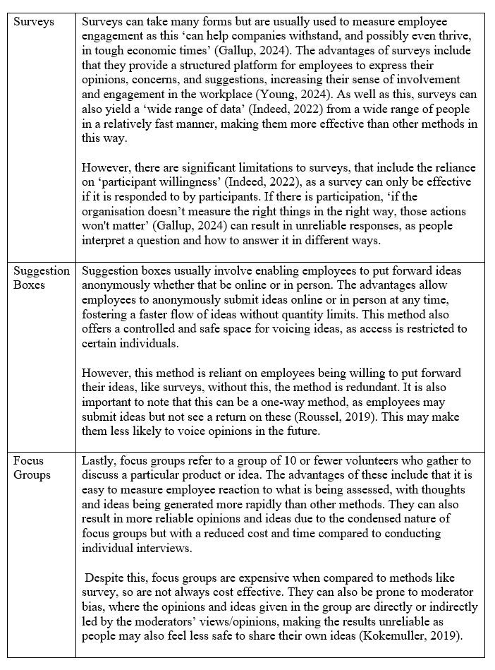
Figure 1: Shows three employee voice tools

Surveys are widely used to measure employee engagement and ‘can help companies withstand, and possibly even thrive, in tough economic times’ (Gallup, 2024). They allow employees to share opinions, increasing involvement and yielding diverse data quickly (Young, 2024; Indeed, 2022). However, surveys rely on participant willingness and accurate measurement; otherwise, they may yield unreliable responses (Gallup, 2024).

Suggestion boxes offer anonymity and unrestricted idea flow, fostering a safe space for feedback. Yet, like surveys, their effectiveness depends on employee participation, and the one-way nature might deter future contributions (Roussel, 2019).

Lastly, focus groups, which refers to a group of 10 or fewer volunteers who gather to discuss a particular product or idea provide rapid, reliable feedback at lower costs than individual interviews. However, they are more expensive than surveys and can be influenced by moderator bias, which may affect the authenticity of the feedback (Kokemuller, 2019).

Two There are many approaches to driving engagement such as employee recognition programmes and career development programmes. can be seen below: Employee recognition programs, like "Employee of the Month" awards, align with Maslow's Hierarchy of Needs (1943), addressing employees' esteem needs and boosting motivation and engagement. SalesForce reports that such recognition improves morale, productivity, and reduces turnover (SalesForce, 2019). However, maintaining consistency across departments can be challenging, potentially leading to perceptions of bias (CIPD, 2020).

Career development programs allow employees to track and enhance their skills, aligning with Herzberg's Two-Factor Theory (1959), which identifies career growth as a key motivator that can lead to higher job satisfaction and engagement. Deloitte’s "Greenhouse" initiative exemplifies this approach, providing an innovative space that applies design thinking, behavioural economics, and group dynamics to solve business challenges, thus enhancing employee engagement and retention and maintaining a motivated workforce (Deloitte, 2018).

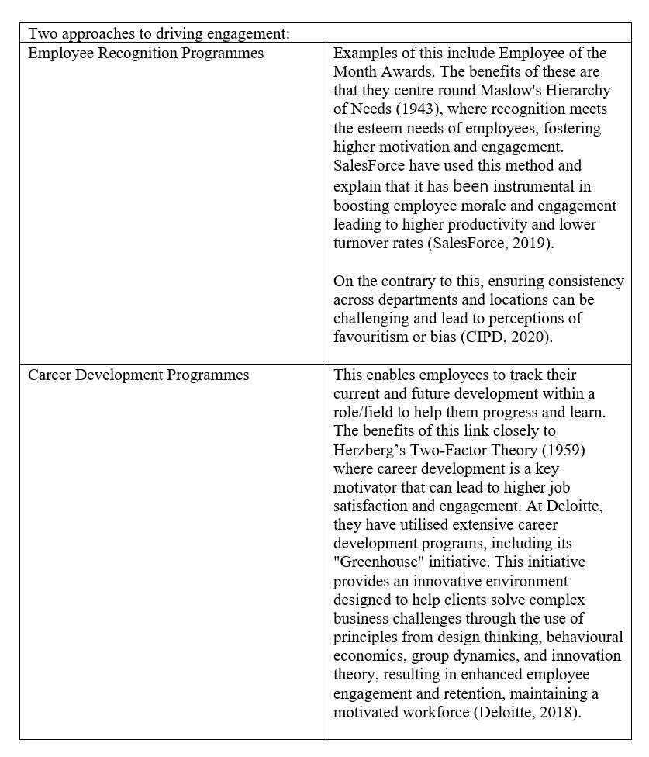
Figure 2: Shows two approaches to driving engagement

(AC 1.4)
Employee voice is defined as ‘the way people communicate their views to their employer and influence matters that affect them at work’ (Young, 2024). Organisational performance refers to the "actual output or results of an organisation against the goals or objectives set" (CMI, 2024).
The relationship between employee voice and organisational performance is significant. Employee voice allows employees to shape organisational practices and work-related issues (Wilkinson et al., 2020). It also helps in forming better working relationships (Young, 2024), fostering a positive working environment. When employees feel heard, respected, and valued, their job satisfaction and performance increase, which, in turn, enhances organisational performance (Young, 2024). Forbes reports that such employees are 4.6 times more likely to produce their best work (Sinclair, 2022). Without employee voice, engagement levels in terms of wellbeing, commitment, and innovation decrease dramatically (CIPD, 2024).
A case study of NMCN, a building company, highlights the positive impact of focusing on employee voice. By implementing leadership briefings with open communication, they stimulated new ideas and engagement, which positively affected organisational performance (CIPD, 2021). However, the benefits of employee voice depend on its quality. Boxall and Purcell (2016) emphasise that the effectiveness of employee voice varies based on its implementation. The NMCN case study also indicates that employee voice channels can be misused by disgruntled employees to complain, potentially creating negativity (CIPD, 2021).
Additionally, there is a risk of employee silence, where employees withhold their opinions due to fear of negative judgment from senior employees (CIPD, 2021). Some argue that most organisations are designed to produce profit for owners, not to provide a platform for employee voice (Dundon et al., 2017). Incorporating employee voice can complicate decision-making processes, potentially slowing down business operations and affecting overall performance.
In summary, while employee voice can enhance organisational performance by improving job satisfaction and engagement, its effectiveness largely depends on the quality and implementation of the voice mechanisms.
(AC 1.5)

Better working lives can be defined as ‘a fulfilling working life, job satisfaction and achieving individual potential’ (TUC, 2010). The concept aims to ensure good work, fair work and decent work are in place. Good work is ‘fundamental to individual well-being, supports a fair society, and creates motivated workers, productive organisations and a strong economy’ (CIPD, 2023).

There are seven dimensions to good work (CIPD, 2023), which include:
- Pay and benefits: Related to feelings regarding pay and employee benefits that are received.
- Contracts: Such as job security and the contract type given to employees.
- Work-life balance: The working hours and flexibility of the role as well as the time it takes to commute to the job.
- Job design: The workload a job role brings as well as the autonomy levels within the role.
- Relationships at work: The social support and quality of people management at the organisation.
- Employee voice: The availability of channels and opportunities for to express this as well as the responsiveness to this.
- Health and wellbeing: The positive and negative impacts on physical and mental health due to the role and the ability for an employee to feel psychologically safe within the organisation.

There are multiple metrics one can use to assess job quality and good work, a few of which include surveys (such as the CIPD Good Work Survey), regular one-to-ones with employees to gauge feedback and key performance indicators (KPI) which measure the output and quality of work produced by employees.

Finally, ways to initiate good work can include but aren’t limited to, ensuring that your organisation offers flexible working options such as compressed hours or hybrid working as there should be a higher focus on productivity than the hours worked by employees. Another method is to regularly review employee workload to ensure employees can take regular breaks and use their holiday entitlement. As well as this, people professionals and managers within the organisation should develop strong interpersonal relationships to aid psychological safety and trust (CIPD, 2023).

(AC 2.1)

Organisational conflict refers to ‘different types of disagreement between employees or departments in an organisation, and how these affect its activities’ (Cambridge Dictionary, 2024) and can take many forms, but is usually employee organised conflict like ‘strikes’ (Edwards, 2003), where employees will stop working to protest conditions such as pay. Whereas misbehaviour refers ‘bad behaviour, or behaviour that breaks a rule’(Cambridge Dictionary, 2024) to and takes the form of unorganised conflict such as fraud or ‘bullying’ (Edwards, 2003).

Informal conflict arises spontaneously and can result in conflict arising from ‘everyday actions’ (Thomas & Kilmann, 1974), misunderstandings or differing opinions whereas formal conflict is often recognised and managed internally through processes and procedures and can take the form of encouraged debates or different leadership styles (De Dreu & Van Vianen, 2001).

(AC 2.2)

Official action refers to activities that are organised and sanctioned by a trade union, where the ‘union has followed all the legal rules’ (ACAS, 2024). This usually occurs in furtherance of a trade dispute which concerns issues such as working conditions or pay and must be supported by a recognised by a trade union. With official action, a formal ‘ballot’ (Taylor, 2010) will be conducted so that union members can vote whether they wish to proceed with the action or not, with any action taken being in line with relevant legislation. With official action, employees are protected against forms of retribution such as dismissal (CIPD, 2024).

Unofficial action refers to activities that are ‘not sanctioned by the union’ (CIPD, 2024) and are unlawful. This usually arises spontaneously when employees act independently of a trade union in response to immediate grievances, known as ‘wildcat action’ (Gilligan & Marsden, 2022). An example of unofficial action would be a spontaneous walk out, where employees “down tools” and stop working in order to protest. With unofficial action, employees are not protected under the same legal frameworks as they are with official action, meaning they may face consequences for their actions such as disciplinary action or dismissal (CIPD, 2024).

(AC 2.3)

In terms of conflict and industrial sanction, there has been multiple trends emerging. More recently, there has been a switch in the length of strikes from longer to shorter. However, data from the ONS (2023) shows that now there are more working days lost and more employees involved in strikes than previously, with industrial action typically involving critical groups of employees to maximise disruption. These strikes are also more strategically planned to cause disruption, such as the rail ‘strikes’ (National Rail, 2024), that disrupted travel nationally to make a stand.

However, the impact of strikes can be seen to be more easily mitigated with rise in popularity and ease of working from home, which means if there is disruption to travel services, employees can still work and not be as affected by this. As well as this, the dates for planned strikes may be readily available like with the national rail, who post their ‘industrial action dates’ (National Rail, 2024), meaning organisations and employees can work around these dates to limit the negative effects these strikes may cause. Linking to this, there has been a rise in organisations trying to obtain legal ‘injunctions’ (Arthur, 2022) to try and prevent industrial action such as strikes occurring to mitigate any and all disruption any potential industrial action could present.

As well as this, there has also been a shift in workplace conflict from collective to individual conflict. This can be shown by an increase in individual grievances and disputes rather than collective actions. Factors contributing to this trend include the rise of individual employment rights, changes in the structure of the workforce, and the decline of union density in some sectors (Colling, 2023). This could be linked to the prominence and increased use of internal policies such as grievance or disciplinary policies, that enable issues to be solved within the organisation instead of growing bigger to include more employees and requiring legal action (CIPD, 2020).

(AC 2.4)

During a dispute a third-party conciliation involves a third party (the conciliator) who helps the disputing parties to reach a mutually acceptable agreement by proposing solutions and explaining the law and regulations. Conciliation is commonly used in both individual and collective employment disputes to settle claims before they proceed to an employment tribunal. This process is beneficial in reducing the costs and time associated with legal proceedings and often results in amicable settlements (ACAS, 2024).

Mediation is a voluntary process where a neutral third party (the mediator) assists the disputing parties in negotiating a resolution. The mediator facilitates communication and promotes understanding but does not impose a solution like with conciliation. Mediation is often used to mend and maintain employment relationships by addressing conflicts in a collaborative manner (Bingham, 2023). Mediation aims to restore and maintain employment relationships by addressing underlying issues and fostering a cooperative environment.

Arbitration involves a neutral third party (the arbitrator) who listens to both sides and then makes a binding decision to resolve the dispute. These decisions are legally binding and enforceable in court, but they generally cannot be appealed, making arbitration final. This process is more formal than mediation and conciliation and can resemble a court proceeding, making it particularly useful when a final and enforceable resolution is needed. Arbitration is mostly used when parties agree in advance to abide by the arbitrator’s decision, which is often seen in collective bargaining agreements and individual employment contracts (ACAS, 2024).

(AC 3.1)

A dismissal may be unfair if an employee worked for their employer for at least 2 years, which is highlighted by the ‘Employment Rights Act 1996’ (GOV.UK, 1996). Reasons for unfair dismissal can vary but some have been highlighted below (ACAS, 2024):

- there was no fair reason for the dismissal i.e. someone was dismissed for partaking in industrial action such as a strike.
- the reason was not enough to justify dismissing them i.e. an employee was 2 minutes late to work once.
- the employer did not follow a fair procedure i.e. an investigation was not conducted before dismissing the employee.

As well as ERA 1996, there is also the Employment Act 2002, which introduces statutory disciplinary and grievance policies and procedures, this used alongside the ACAS Code of Practice on Disciplinary and Grievance Procedures is particularly important to ensure a fair and reasonable procedure takes place. While not legally binding, tribunals take its provisions into account when determining the fairness of dismissals (ACAS, 2024). If this is followed, there is a reduced likelihood that an organisation will face legal action and fines due to this.

A fair dismissal can be broken down into two sections, those being capability and misconduct. Capability refers to ‘performance’ and an example could be an inability to perform the work a role requires. Capability can be used in the instance of illness where an employee can no longer perform their role as contracted to. Misconduct refers to ‘unacceptable or inappropriate behaviour’ which can range from minor infractions (ordinary misconduct) to severe breaches of conduct (gross misconduct) (Lewis & Sargeant, 2023), for example, stealing from the company or physical abuse.

Formal hearings and warnings should follow a structured process, including an investigation to gather facts and evidence regarding the issue, a formal Hearing to allow the employee to present their case with a right to be accompanied by another colleague or Trade Union Representative (ACAS, 2014). Finally, the outcome which could be a warning or dismissal, however, common practice is to issue formal warnings where appropriate before dismissal, particularly in cases of ordinary misconduct or capability issues (ACAS, 2024).

(AC 3.2)

Employee grievances can be defined as ‘a formal way for an employee to raise a problem or complaint to their employer’ (ACAS, 2024). These grievances can be individual, put forward by one employee or collective, put forward by groups of employees.

There are many causes of employee grievances, however the key ones include poor management, which can present itself as a lack of communication or poor policy execution. This can often lead to ‘dissatisfaction among employees’ (Mullins, 2016, p. 539) as they may feel that they are being treated unfairly or not being heard. Linking closely with this, when employees believe that rules or policies are unfair or discriminatory they are more likely to ‘file grievances’ (Robbins & Judge, 2018, p. 409)

As well as this, organisations who fail to demonstrate flexibility may see more grievances raised. For example, failing to accommodate employees' needs for ‘flexible working hours or remote work options’ (CIPD, 2022). Couple this with excessive and unachievable workloads also creates discontent with ‘one in five employees’ stating they want to leave their current job in the next six months to escape overworking due to the stress and discontent this situation brings.

Another prevalent issue that can cause employee grievances is workplace bullying and harassment. Any company that experiences such issues is likely to have grievances raised as these behaviours cause offence, upset and discontent. As well as this, ‘harassment is unlawful under the Equality Act 2010’ (GOV.UK, 2024).

There are also other issues that lead to employee grievances such as pay grading issues, directly related to the level or pay or grading of roles and working conditions, with poor working conditions, such as inadequate facilities, safety concerns, or uncomfortable environments, being common sources of grievances also (Armstrong & Taylor, 2020, p. 567).

(AC 3.3)

There are multiple skills required for effective grievance and discipline-handling procedures. These can include but aren’t limited to, active listening which involves not just hearing, but also understanding others' thoughts and feelings, facilitating problem-solving and reducing tensions (Gallo, 2024).

Questioning skills are key in disciplinary procedures for clarifying issues and gathering detailed information, allowing accused employees to present their defense (Peninsula HR, 2024).

Investigation skills involve systematically collecting facts like emails or CCTV records to ensure objective decision-making by minimizing bias (ACAS, 2024).

Mediating skills focus on facilitating dialogue between conflicting parties, helping them reach a mutually acceptable resolution without assigning blame, thereby encouraging open communication and maintaining relationships (ACAS, 2024).
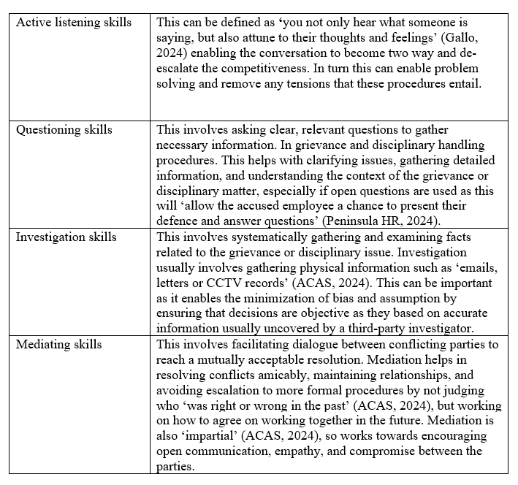
Figure 3: Shows the skills required for effective grievance and disciplinary handling.

(AC 3.4)

Handling grievances effectively is crucial and can mitigate many issues that may have developed if not handled properly. Such as employees feeling compelled to seek legal redress due to poor handling of a grievance. This can result in costly and time-consuming litigation such as employment tribunals, which can be avoided through proactive grievance management (Lewis & Sargeant, 2019).

As well as this, the way grievances are handled can significantly affect the reputation of both the organisation and the individuals involved, as there should be a structured policy and ‘fair procedure’ (Suff, 2023) to ensure the parties involved are treated in a fair manner, leaving less risk for any decision made to be unjust/ incorrect. If managed poorly, grievances can lead to negative publicity and damage both the organisation’s and individual’s reputations, potentially affecting the organisation’s ability to attract and retain talent (Armstrong & Taylor, 2020) and the individuals ability to maintain healthy work relationships or find employment elsewhere.

The positives of handling grievances effectively are plentiful, including increased ‘employee satisfaction and engagement’ (Webnyay, 2023), as employees feel psychologically safe knowing they will be treated in a fair manner following fair processes. Linking to this, conflict prevention is another benefit as this will give individuals the space to be heard and voice their opinion within a structured process that can be controlled, reducing the risk of workplace arguments between employees. Lastly, legal compliance and a ‘positive organisational reputation’ (Webnyay, 2023) also arise, as individuals will feel encouraged to work and support an organisation that treats employees with dignity and is compliant with the law.

Effectively handling grievances is crucial for preventing issues like costly and time-consuming litigation, including employment tribunals, which often arise from poor grievance management (Lewis & Sargeant, 2019).

A structured policy and fair procedure are essential to ensure that grievances are addressed justly, reducing the likelihood of unjust decisions and preserving the reputation of both the organisation and the individuals involved (Suff, 2023). Poor handling can lead to negative publicity, damaging the organisation’s brand and affecting its ability to attract and retain talent, while also harming the individuals' career prospects and work relationships (Armstrong & Taylor, 2020).

The benefits of effective grievance management include increased employee satisfaction and engagement, as employees feel secure knowing they will be treated fairly and their concerns will be heard. This psychological safety fosters a positive work environment and reduces the likelihood of workplace conflicts (Webnyay, 2023). Additionally, it ensures legal compliance, avoiding potential penalties and lawsuits, and enhances the organisation's reputation as a fair and respectful employer, which is attractive to both current and prospective employees (Webnyay, 2023).

(AC 4.1)
Collective employment law, governed by the Trade Union and Labour Relations (Consolidation) Act 1992 (TULRCA), regulates interactions between employers, employees, and their representatives during collective bargaining and industrial action. One significant provision is statutory recognition agreements, where ‘a trade union has successfully applied to the Central Arbitration Committee (CAC)’ (Farrar, 2021) for recognition if not granted by the employer. This process requires support from at least 10% of workers in the bargaining unit, with a majority likely to favour recognition, confirmed by a ballot where 40% of eligible workers must vote in favour (TULRCA, 1992).
As well as this, employers must disclose pertinent information to trade unions to facilitate effective collective bargaining under TULRCA, though confidential business or legally protected information may be withheld. This ensures negotiations balance transparency with business interests. These collective agreements, while generally not enforceable in themselves, can be integrated into individual employment contracts to achieve legal standing. This practice acknowledges the practical implementation of negotiated terms, ensuring clarity and enforceability where explicitly agreed upon (Wedderburn et al.,2023).
Official industrial action, sanctioned by unions through a secret ballot, mandates at least seven days' notice to employers before commencement. Participants in official action are legally protected from dismissal, unlike those involved in unofficial action (Daniels, 2022). An example of this is picketing, which is permitted near workplaces during disputes. This is regulated and follows ACAS guidelines to maintain peace and respect for employer and public rights. The ACAS Code of Practice on Picketing provides detailed standards for lawful conduct (ACAS, 2024).

(AC 4.2)

Employee representation within organisation can take various forms, both union and non-union. Union forms of employee representation include joint negotiation committees, which is a formal structure that enables union representatives and management to negotiate collective agreements. Typically have substantial power due to their ability to negotiate binding terms on pay, working conditions, and other employment issues (Kersley et al., 2006). Unlike with non-union forms of employee representation, ‘they’re able to propose rule changes themselves’ (USS, 2024), and can approve any rule changes suggested giving them a higher level of control and power.

In comparison, non-union employee representation includes work councils which ‘applies to anybody that represents the interests of employees, which an employer must inform and consult with on issues affecting their organisation’ (Personnel Today, 2008) but is not carried out by a union body. These councils or committees do have some degree of power due to the law granting them specific rights and responsibilities, however this is more influence rather than making decisions as a body itself. Less powerful forms include employee forums, which is a space where employers can discuss ‘any important workplace matters with their employees’ (ACAS, 2024) which is usually used to gather ideas or consult with employees, rather than have the employees make a decision.
To summarise, while union-based bodies like joint negotiation committees have significant negotiating power and can engage in collective bargaining, non-union bodies like employee forums, and works councils usually have a more advisory role with varying degrees of influence over organisational decision making.
(AC 4.3)

Collective bargaining (CB) is the ‘official process by which trade unions negotiate with employers, on behalf of their members’ (TUC, 2024). One of the primary purposes of collective bargaining is that it enables the joint determination of rules by providing a space for collaboration between management and employee representatives to establish terms and conditions of employment that are collectively agreed on to reflect both parties’ interests (Towers, 1997).

As well as this, collective bargaining also ensures that there is structure through which workplace policies and practices are regulated and controlled. This industrial governance that CB provides can aid better labour relations and foster a more ‘harmonious workplace’(ACAS,2024) by ensuring that the process is fair and aligned from start to finish. Linking closely to this, CB also enables constructive negotiation and compromise to work towards a balanced outcome, rather than a one-sided decision.

CB is usually used to form an agreement regarding either substantive or procedural terms. Substantive agreements cover employment terms such as benefits or wages, whereas procedural agreements cover processes and policies such as dispute resolution mechanisms. Employees may couple CB with industrial action like strikes to ensure a specific decision is reached (Clegg,1976) or to show solidarity as a collective when negotiation via CB may not be going the favoured way. In some cases, partnership agreements may also be utilised to operate as a contract between the employer and the union, and ‘authorise the union to negotiate on pay and working conditions on behalf of its members’(CIPD, 2024).

Works Cited:

ACAS (2024) Acas Guides on Trade Union and employee representation, Acas. Available at: https://www.acas.org.uk/acas-guides-on-trade-union-and-employee-representation (Accessed: 22 June 2024).
ACAS (2024) Arbitration, Acas. Available at: https://www.acas.org.uk/arbitration (Accessed: 11 July 2024).
ACAS (2024) Informing and consulting at work - formal ice agreements, Acas. Available at: https://www.acas.org.uk/formal-ice-agreements#:~:text=It’s%20useful%20for%20employers%20to,to%20inform%20and%20consult%20them. (Accessed: 22 June 2024).
ACAS (2024) How the process works - early conciliation, Acas. Available at: https://www.acas.org.uk/early-conciliation/how-early-conciliation-works (Accessed: 03 June 2024).
ACAS (2024) The law on industrial action - strikes and industrial action, Acas. Available at: https://www.acas.org.uk/strikes-and-industrial-action#:~:text=Official%20industrial%20action%20is%20when,protected%20by%20industrial%20action%20law. (Accessed: 31 May 2024).
ACAS (2024) Acas Code of practice on disciplinary and grievance procedures, Acas. Available at: https://www.acas.org.uk/acas-code-of-practice-on-disciplinary-and-grievance-procedures (Accessed: 04 June 2024).
ACAS (2024) Step 3: Carrying out an investigation - investigations at work, Acas. Available at: https://www.acas.org.uk/investigations-for-discipline-and-grievance-step-by-step/step-3-carrying-out-an-investigation (Accessed: 10 June 2024).
ACAS (2014) Trade union representation in the Workplace. Available at: https://www.acas.org.uk/sites/default/files/2021-03/trade-union-representation-in-the-workplace.pdf (Accessed: 10 July 2024).
ACAS (2024) Unfair dismissal - dismissals, Acas. Available at: https://www.acas.org.uk/dismissals/unfair-dismissal (Accessed: 04 June 2024).
ACAS (2024) What mediation is and how it can help - mediation at work, Acas. Available at: https://www.acas.org.uk/mediation (Accessed: 10 June 2024).
Armstrong, M. (2020) Armstrong's Handbook of Human Resource Management Practice. 15th edn. London: Kogan Page.
Arthur, R. (2022) Industrial action on the rise: Why Collective Strength Matters, HR Magazine. Available at: https://www.hrmagazine.co.uk/content/comment/industrial-action-on-the-rise-why-collective-strength-matters/ (Accessed: 03 June 2024).
Boxall, P.F. and Purcell, J. (2022) Strategy and Human Resource Management. London: Bloomsbury Academic.
Bingham, L. B. (2023). Mediation in Employment Disputes: An Overview. Journal of Conflict
Resolution, 67(2), 301-320.

Cambridge Dictionary (2024) Engagement | English meaning - cambridge dictionary, Cambridge Dictionary. Available at: https://dictionary.cambridge.org/dictionary/english/engagement (Accessed: 09 July 2024).
Cambridge Dictionary (2024a) Misbehaviour | English meaning - cambridge dictionary, Cambridge Dictionary. Available at: https://dictionary.cambridge.org/dictionary/english/misbehaviour (Accessed: 31 May 2024).
Cambridge Dictionary (2024b) Organizational conflict - cambridge english dictionary, Cambridge Dictionary. Available at: https://dictionary.cambridge.org/dictionary/english/organizational-conflict (Accessed: 31 May 2024).
Cambridge Dictionary (2024) Engagement | English meaning - cambridge dictionary, Cambridge Dictionary. Available at: https://dictionary.cambridge.org/dictionary/english/engagement (Accessed: 09 July 2024).
CIPD (2024) Working with Trade Unions, CIPD. Available at: https://www.cipd.org/uk/knowledge/guides/working-trade-unions/ (Accessed: 31 May 2024).
CIPD (2022) Health and Wellbeing at work 2022: Survey report. Available at: https://www.cipd.org/globalassets/media/knowledge/knowledge-hub/guides/health-wellbeing-work-report-2022_tcm18-108440.pdf (Accessed: 26 May 2024).
CIPD (2023) Technology use in employee voice, CIPD. Available at: https://www.cipd.org/uk/knowledge/guides/technology-use-in-employee-voice/ (Accessed: 26 May 2024).
CIPD (2021) Talking about voice: NMCN, CIPD. Available at: https://www.cipd.org/uk/knowledge/case-studies/nmcn/ (Accessed: 27 May 2024).
CIPD (2023) CIPD good work index 2023: Survey report, CIPD Good Work Index 2023. Available at: https://www.cipd.org/globalassets/media/knowledge/knowledge-hub/reports/2023-pdfs/2023-good-work-index-report-8407.pdf (Accessed: 27 May 2024).
CIPD (2020) Managing conflict in the modern workplace. Available at: https://www.cipd.org/globalassets/media/knowledge/knowledge-hub/reports/managing-conflict-in-the-workplace-2_tcm18-70655.pdf (Accessed: 03 June 2024).
Clegg, H. A. (1976). Trade Unionism Under Collective Bargaining: A Theory Based on Comparisons of Six Countries. Basil Blackwell.
CMI (2024) Organisational performance, CMI. Available at: https://www.managers.org.uk/education-and-learning/professional-standards/organisational-performance/ (Accessed: 26 May 2024).
Colling, T. (2023). Employment Relations: Critical Perspectives on Work and Employment.
Management Review, 20(3), 255-270.

Daniels, K. (2022) Introduction to employment law: fundamentals for HR and business
students. Sixth edition. London: Kogan Page Limited.

Deloitte (2018) Deloitte Greenhouse: A Bold Approach to Innovation and Problem Solving.
[online] Available at:
https://www2.deloitte.com/us/en/pages/about-deloitte/articles/deloitte-greenhouse-business.html (Accessed 26 May 2024).

De Dreu, C. K. W., & Van Vianen, A. E. M. (2001). Managing relationship conflict and the
effectiveness of organizational teams. Journal of Organizational Behavior, 22(3), 309-328.

Edwards, P. (2003). Industrial Relations: Theory and Practice. 2nd ed. Oxford: Blackwell.

Farrar, C. (2021) Statutory recognition for Trade Unions: Human Rights Challenges to the recognition process, Statutory recognition for trade unions: human rights challenges. Available at: https://www.farrer.co.uk/news-and-insights/blogs/statutory-recognition-for-trade-unions-human-rights-challenges-to-the-recognition-process/ (Accessed: 17 June 2024).
Gallo, A. (2024) What is active listening?, Harvard Business Review. Available at: https://hbr.org/2024/01/what-is-active-listening (Accessed: 10 June 2024).
Gallup (2024) The benefits of employee engagement, Gallup.com. Available at: https://www.gallup.com/workplace/236927/employee-engagement-drives-growth.aspx#:~:text=By%20intentionally%20focusing%20on%20measuring,%2D%2D%20in%20tough%20economic%20times. (Accessed: 10 July 2024).
Gilligan, E. and Marsden, T. (2022) Industrial action: Things to consider, Home. Available at: https://www.peoplemanagement.co.uk/article/1794325/industrial-action-things-consider (Accessed: 31 May 2024).
GOV.UK (1996) Employment rights act 1996, Legislation.gov.uk. Available at: https://www.legislation.gov.uk/ukpga/1996/18/contents#:~:text=Employment%20Rights%20Act%201996%20is,force%20at%20a%20future%20date. (Accessed: 04 June 2024).
GOV.UK (2024) Workplace bullying and harassment, GOV.UK. Available at: https://www.gov.uk/workplace-bullying-and-harassment (Accessed: 10 June 2024).
Herzberg, F (1959) The Motivation to Work. New York: John Wiley & Sons.
Indeed (2022) Guide to survey methods: Definition, types and advantages | indeed.com. Available at: https://www.indeed.com/career-advice/career-development/survey-method (Accessed: 26 May 2024).
Indeed (2024) What is employee participation and why is it important? Available at: https://uk.indeed.com/career-advice/career-development/employee-participation (Accessed: 10 July 2024).
Kersley, B., Alpin, C., Forth, J., Bryson, A., Bewley, H., Dix, G., & Oxenbridge, S. (2006). Inside the Workplace: Findings from the 2004 Workplace Employment Relations Survey. Routledge. Accessed from: https://www.academia.edu/72644285/Inside_the_Workplace_Findings_from_the_2004_Workplace_Employment_Relations_Survey_By_Barbara_Kersley_Carmen_Alpin_John_Forth_Alex_Bryson_Helen_Bewley_Gill_Dix_and_Sarah_Oxenbridge (Accessed 11 July 2024)
Kokemuller, N. (2019) The advantages of a focus group as a method for gathering data for customers, Small Business - Chron.com. Available at: https://smallbusiness.chron.com/advantages-focus-group-method-gathering-data-customers-17759.html (Accessed: 26 May 2024).
Lewis, D., & Sargeant, M. (2023). Essentials of Employment Law. Pearson.
MacDonald, C. and Marcoux, A. (2022) Ethical theory: Utilitarianism, The Concise Encyclopedia of Business Ethics. Available at: https://conciseencyclopedia.org/entries/ethical-theory-utilitarianism/ (Accessed: 26 May 2024).
Marchington, M. et al. (2016) Human Resource Management at work. London: Chartered Institute of Personnel and Development.
Maslow, A.H (1943) A theory of human motivation. Psychological Review, 50(4), pp.370-
396. Accessed at: https://psycnet.apa.org/record/1943-03751-001 (Accessed: 22 June 2024)
Mullins,L.J.(2016)ManagementandOrganisationalBehaviour.11thedn.Harlow:Pearson.Accessedat:https:/nibmehub.com/opacservice/pdf/read/Management%20&%20Organisational%20Behaviour.pdf (Accessed: 22 June 2024)
National Rail (2024) Industrial action, National Rail. Available at: https://www.nationalrail.co.uk/travel-information/industrial-action/ (Accessed: 03 June 2024).
Personnel Today (2008) Works councils: Serious business, Personnel Today. Available at: https://www.personneltoday.com/hr/works-councils-serious-business/ (Accessed: 22 June 2024).
Peters, R. (2024) Psychological contract, CIPD. Available at: https://www.cipd.org/uk/knowledge/factsheets/psychological-factsheet/ (Accessed: 26 May 2024).
Roussel, J. (2019) The Pros and cons of moving your employee suggestion box online, The Pros and Cons of Moving Your Employee Suggestion Box Online. Available at: https://blog.kainexus.com/improvement-disciplines/suggestion-box/the-pros-and-cons-of-moving-your-employee-suggestion-box-online (Accessed: 26 May 2024).
Sinclair, S. (2022) Employee voice: This is why it’s so important, Employee Engagement App. Available at: https://www.talkfreely.com/blog/employee-voice (Accessed: 27 May 2024).
Salesforce, 2019. Employee Recognition Program. Available
at: https://www.salesforce.com/blog/employee-recognition/ (Accessed 26 May 2024).
Stone, C., Horan, S. and Flaxman, P. (2018) What does the future hold? Investigating the benefits and challenges of agile and remote working. Available at: https://www.cipd.org/globalassets/media/comms/get-involved/events/investigating-the-benefits-and-challenges-of-agile-and-remote-working_tcm18-57296.pdf (Accessed: 10 July 2024).
Suff, R. (2023) Discipline and grievance at work: Factsheets, CIPD. Available at: https://www.cipd.org/uk/knowledge/factsheets/discipline-factsheet/ (Accessed: 17 June 2024).
Thomas, K. W., & Kilmann, R. H. (1974). The Thomas-Kilmann Conflict Mode Instrument.
Tuxedo, NY: Xicom. Accessed at: https://psycnet.apa.org/doiLanding?doi=10.1037%2Ft02326-000 (Accessed: 17 June 2024)
Towers, B. (1997). The Representation Gap: Change and Reform in the British and American Workplace. Oxford University Press. Available at: https://books.google.co.uk/books/about/The_Representation_Gap.html?id=o9ebXESOGuIC&redir_esc=y (Accessed: 17 June 2024)
TUC (2024) Collective bargaining, TUC. Available at: https://www.tuc.org.uk/workplace-guidance/organising-and-bargaining/collective-bargaining (Accessed: 22 June 2024).
TUC (2010) Good work – and how to achieve it, Good Work. Available at: https://www.tuc.org.uk/sites/default/files/extras/goodwork.pdf (Accessed: 27 May 2024).
Tuhey, J. (2024) What is hybrid working? A guide to the future of work, PeopleHR. Available at: https://www.peoplehr.com/en-gb/resources/blog/what-is-hybrid-working/#:~:text=As%20of%202023%2C%2044%25%20of,to%20drop%20any%20time%20soon. (Accessed: 26 May 2024).
University of Hertfordshire (2017) MANAGING THE EMPLOYMENT RELATIONSHIP. Available at: https://uhra.herts.ac.uk/bitstream/handle/2299/19968/Accepted_Manuscript.pdf?sequence=1 (Accessed: 26 May 2024).
USS (2024) Joint Negotiating Committee, USS. Available at: https://www.uss.co.uk/about-us/how-were-governed/joint-negotiating-committee#:~:text=The%20Joint%20Negotiating%20Committee%20(JNC,the%20Advisory%20Committee%20may%20suggest. (Accessed: 22 June 2024).
Webnyay (2023) The benefits of having a robust grievance management system in your organization, Medium. Available at: https://disputeresolution.medium.com/the-benefits-of-having-a-robust-grievance-management-system-in-your-organization-c4a1498325bb#:~:text=The%20benefits%20of%20effective%20grievance%20management%20include%20increased%20employee%20satisfaction,and%20a%20positive%20organizational%20reputation. (Accessed: 17 June 2024).
Wedderburn, K.W. and Davies, P.L. (2023) ‘COLLECTIVE BARGAINING AND EMPLOYMENT LAW’, in Employment Grievances and Disputes Procedures in Britain. 1st edn. United States: University of California Press, pp. 42–54. Available at: https://doi.org/10.1525/9780520323179-004.
Wilkinson A., Sun J. M., K Mowbray P.(2020). Employee voice in the Asia Pacific. Asia Pacific Journal of Human Resources, 58(4), 471–484.
Young, J. (2024) Employee voice, CIPD. Available at: https://www.cipd.org/uk/knowledge/factsheets/voice-factsheet/ (Accessed: 26 May 2024).
Young, J. (2024) Employee engagement & motivation: Factsheets, CIPD. Available at: https://www.cipd.org/uk/knowledge/factsheets/engagement-factsheet/ (Accessed: 11 July 2024).
Young, J. (2021) Prioritising wellbeing in an ‘always on’ digital age, CIPD. Available at: https://www.cipd.org/uk/views-and-insights/thought-leadership/the-world-of-work/wellbeing-digital-age/#:~:text=Key%20points,other%20studies%20find%20no%20link. (Accessed: 11 July 2024).

