Network Operating Systems and Services

Worksheet 1: Building a virtual LAN using type 2 hypervisor management software.

Author: Kallum Gordon
Prepared for: Nitheesh Kaliyamurthy & Lee Cobley

20th February 2021

Table of Contents
Network Operating Systems and Services 1
1.0 Worksheet 1 Task 1: VM creation and Operating System installations 3
1.1 Worksheet 1 Task 2: Virtual Network Configurations 14
2.0 Observational tasks: 26
3.0 References 27

1.0 Worksheet 1 Task 1: VM creation and Operating System installations
To download VirtualBox their website was visited and the 6.1.18 64bit Windows hosts build was selected and installed. [1]
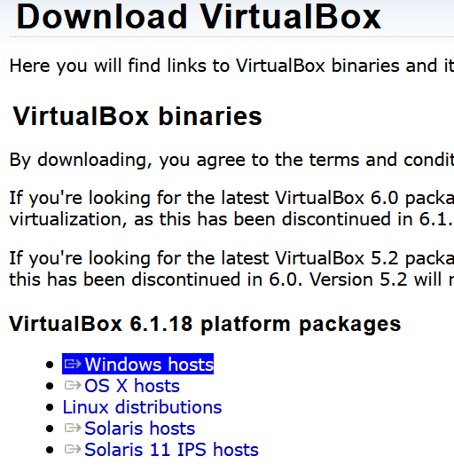

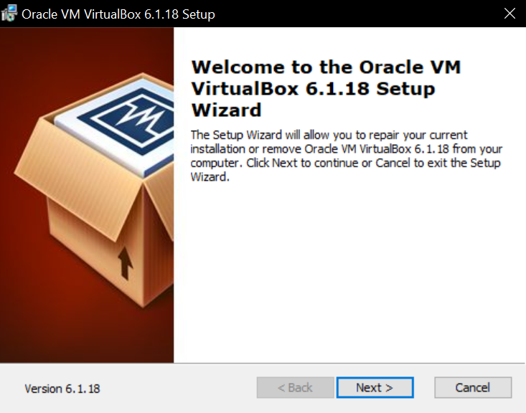
VirtualBox has been set up on the F drive. This drive has adequate space to store future machines without any fuss.

VirtualBox is now set up and is ready for Virtual Machines to be installed using it.
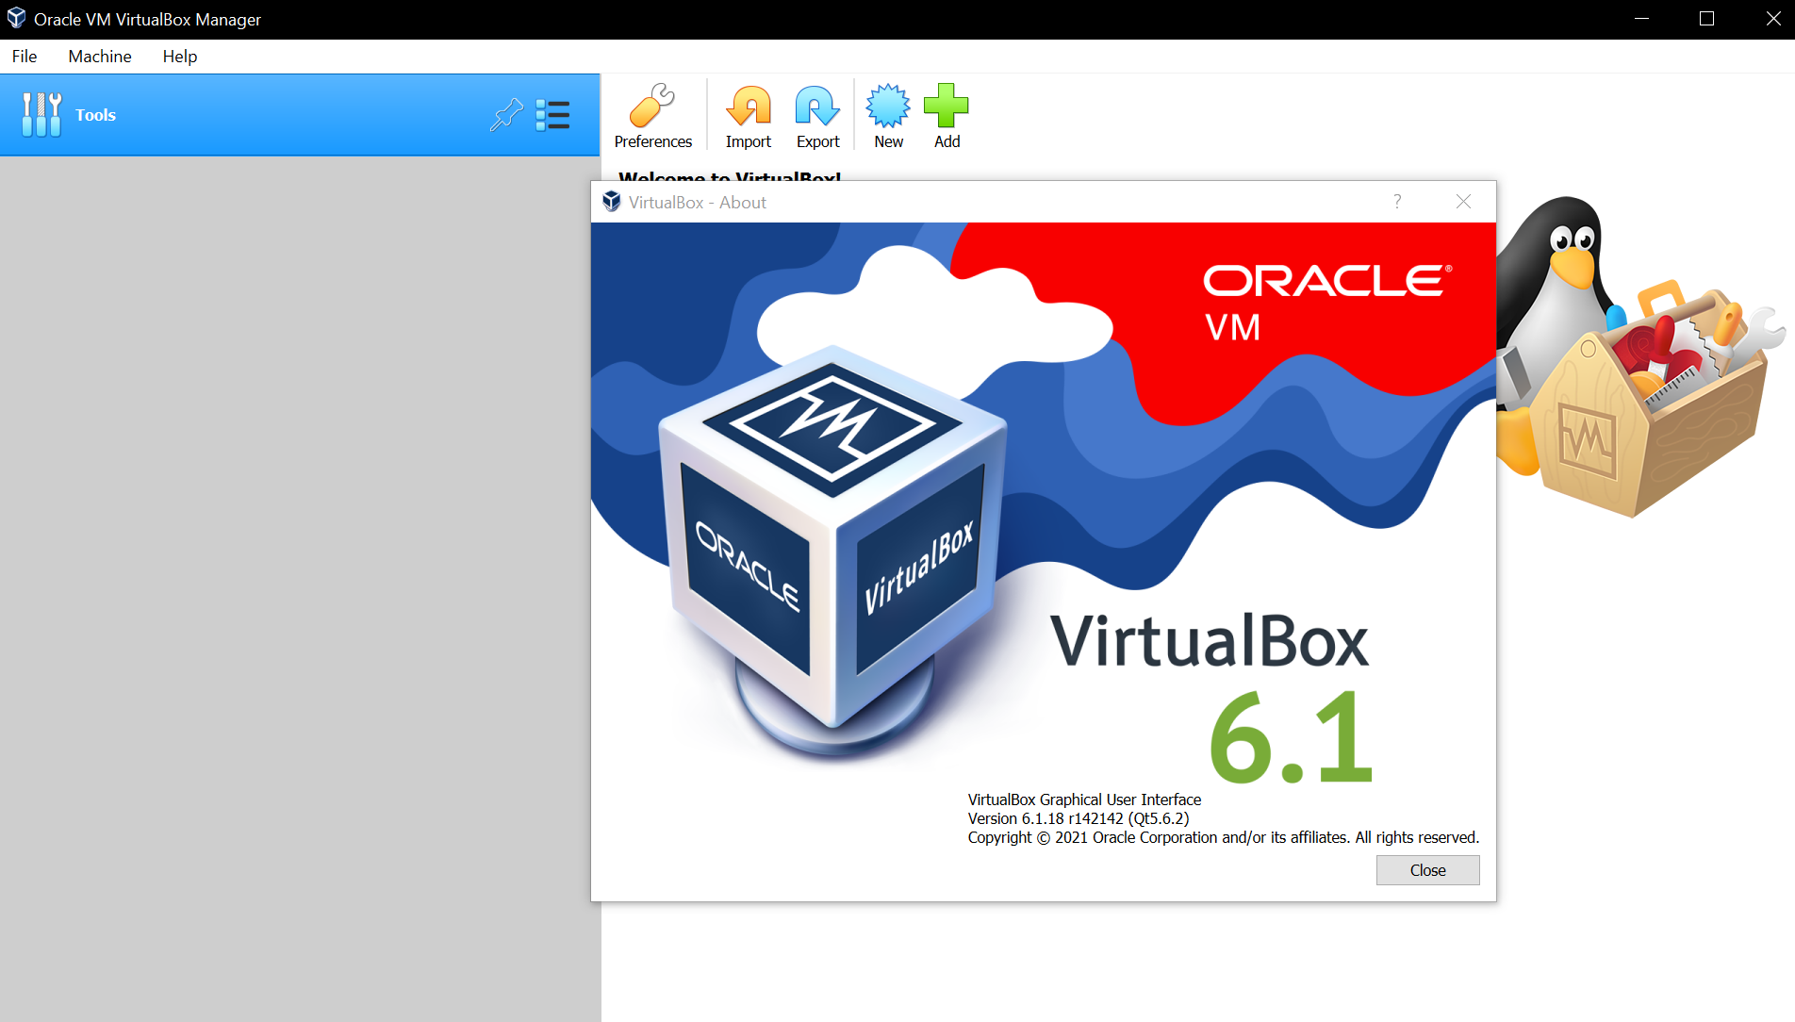

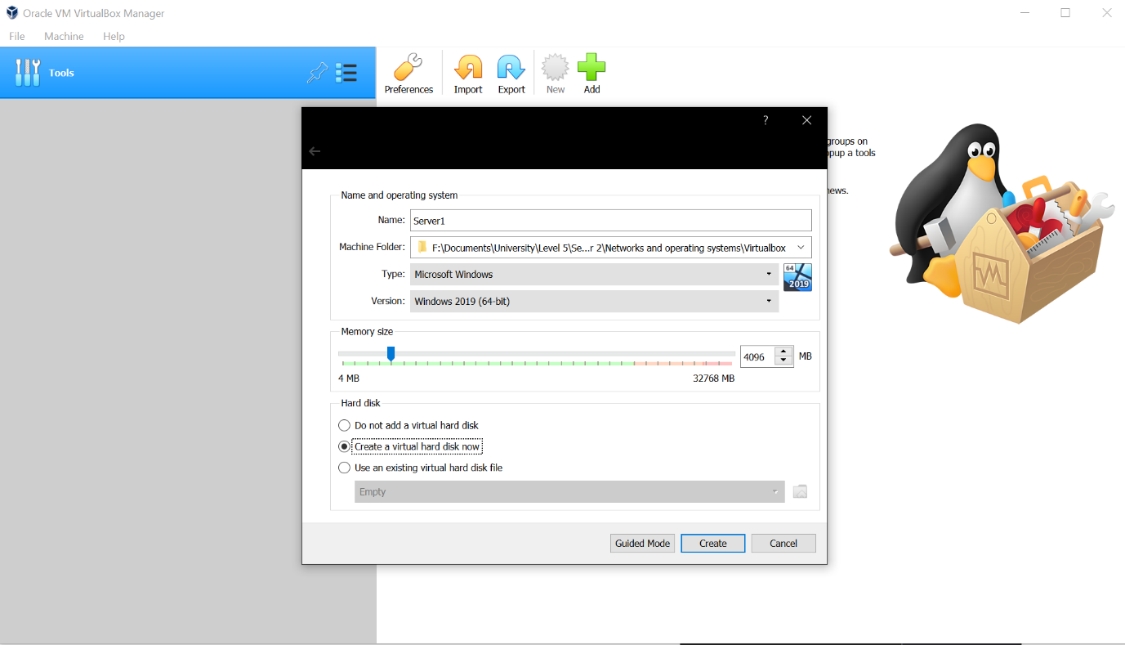
Two servers and two clients will now be set up. The process is near identical for each one so one example will be used but the small differences between server setup and client setup will be documented. The *new* button is clicked and the server is named “Server1”. Windows 2019 64bit has been selected as the version to ensure Windows Server 2019 is set up on the server. The adequate amount of RAM (4096MB, 4GB) has been selected so the machine runs smoothly for what it needs to do. The only difference to the worksheet that has been made is the Virtual Machines have been set up on F drive rather than C drive as C drive doesn’t have enough space as it stores the main Operating System on this machine.

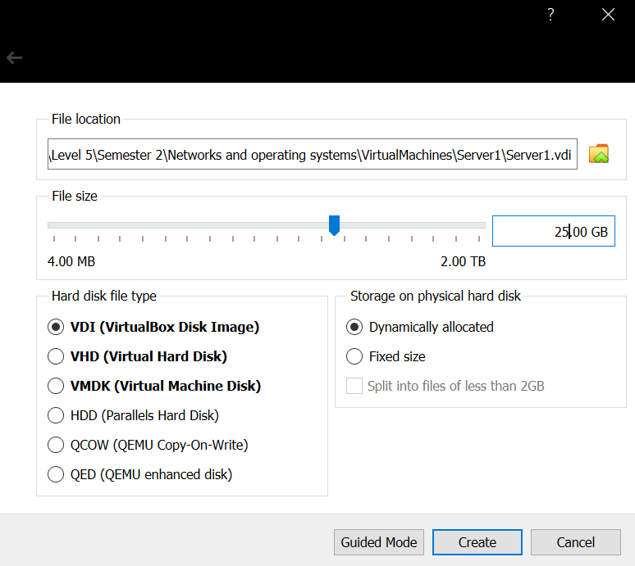
The file location remains the same, VirtualBox Disk Image is selected, the storage on hard disk is set to dynamically allocated, and the file size has been modified from 50GB to 25GB as this should be sufficient to store the OS and networks created within it.

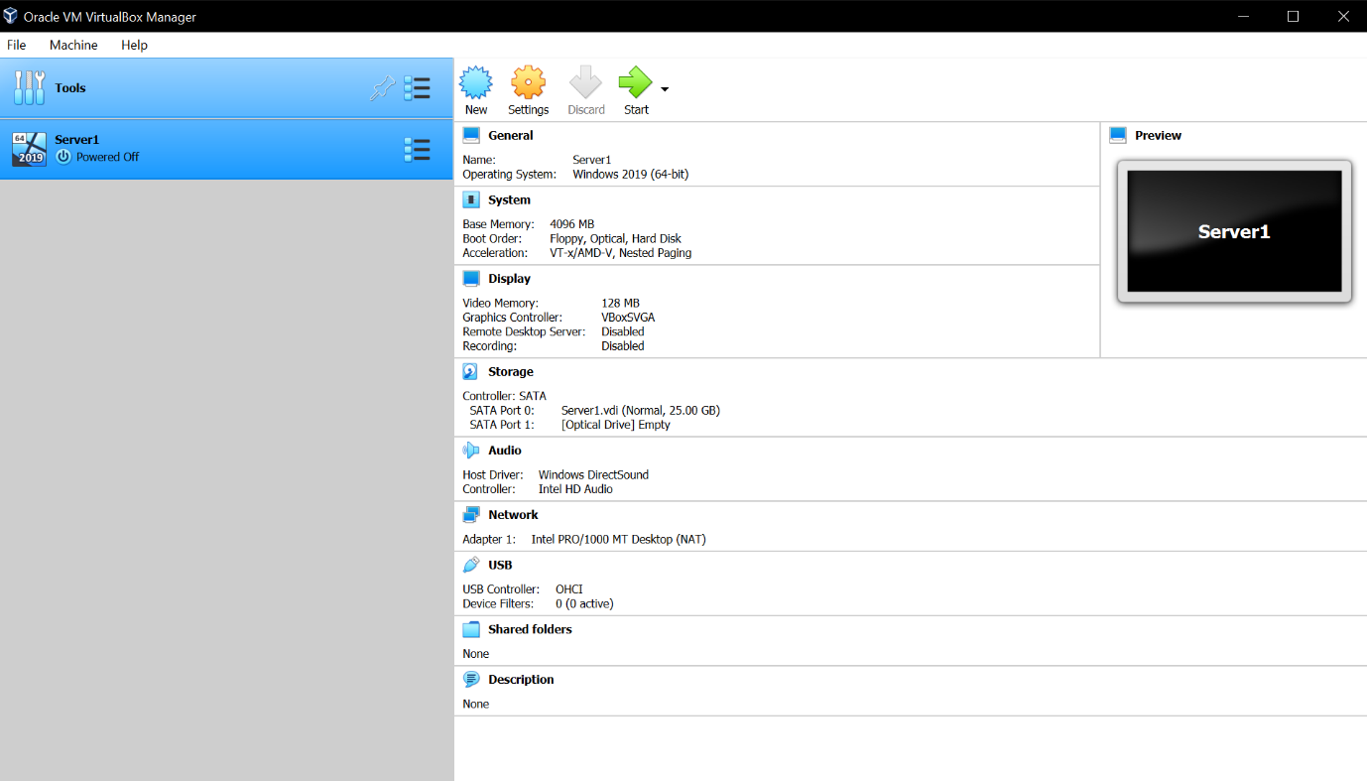
The creation of Server1 is now complete and the same will be done for Server2, Client1, and Client2.

The difference for the Clients is that Windows 10 is the Operating System selected rather than Windows Server 2019. This is because Clients would be running Windows 10 for everyday use rather than software designed to develop servers. The HDD space is also lowered to 20GB for each Client.
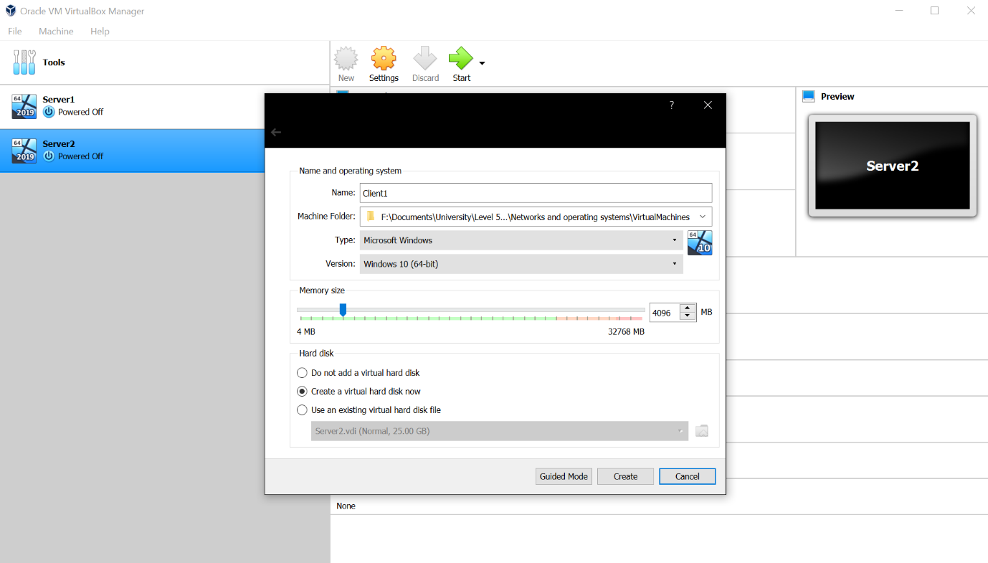

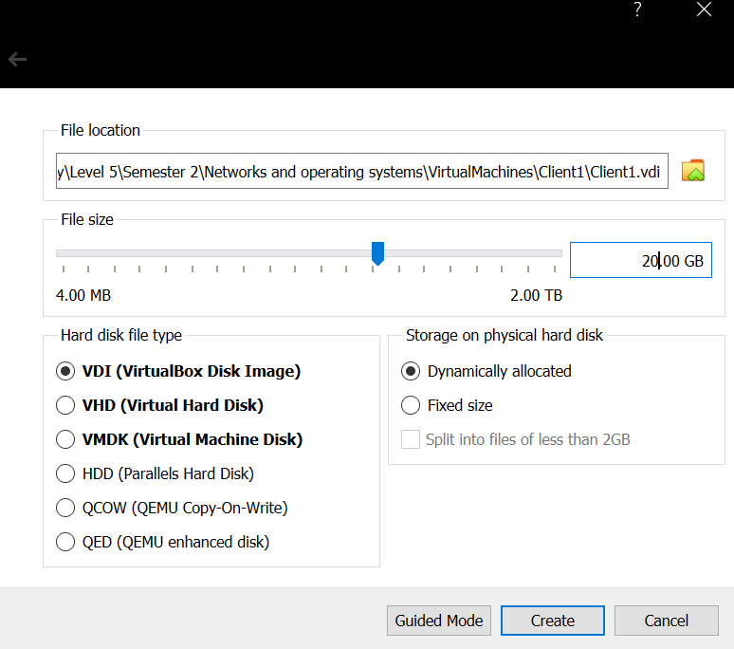

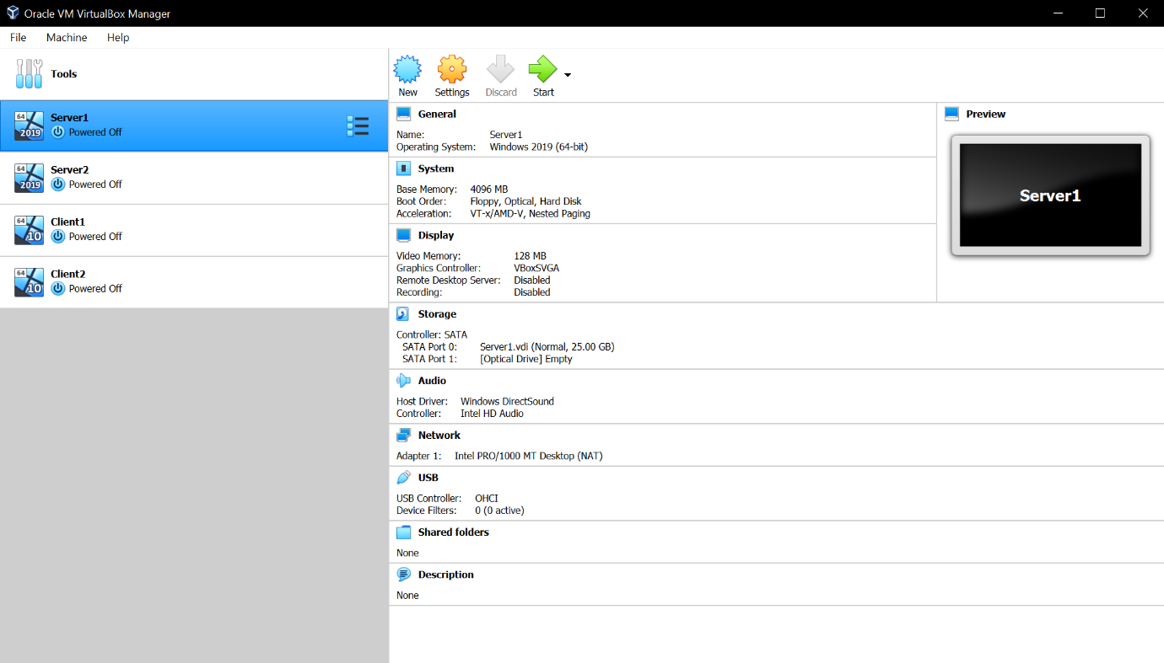
Each Server and Client is now set up and ready for Operating System installation.

Operating System installation will be documented for Server1 and Client 1. Server1’s settings have been selected and the iso of Windows Server 19 has been selected as the disk file (obtained via Microsoft Azure) [2]. The same has been done for Server2.
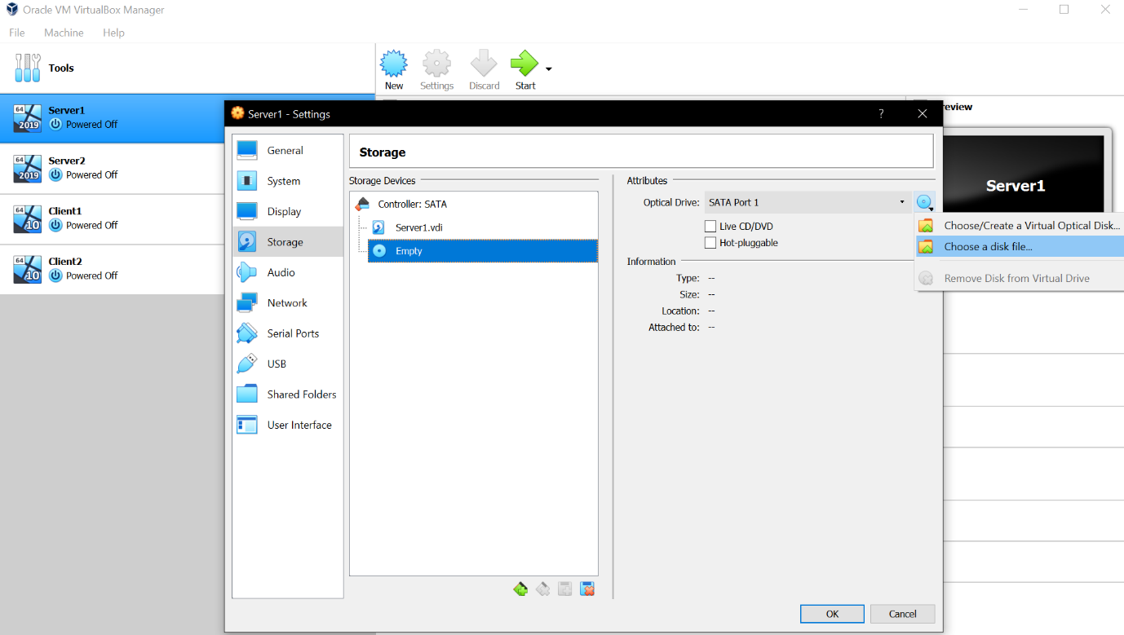

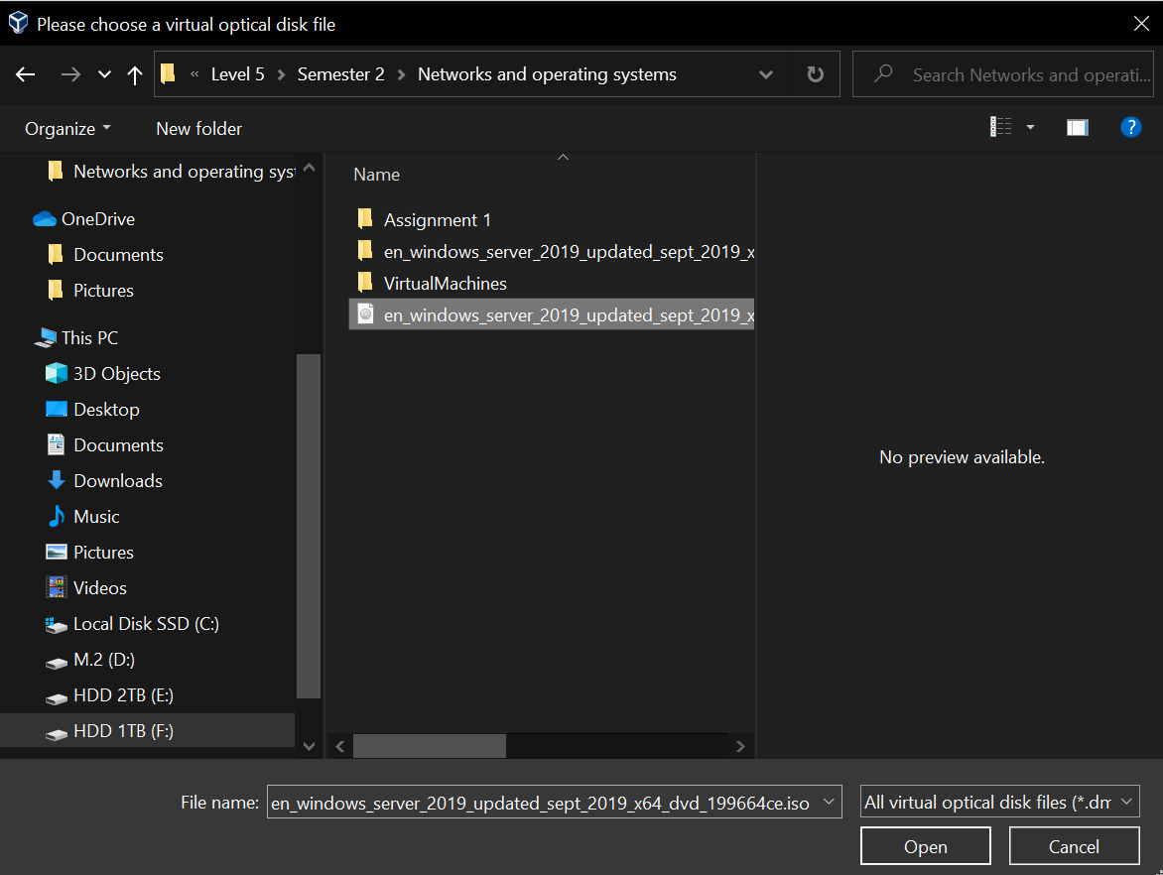

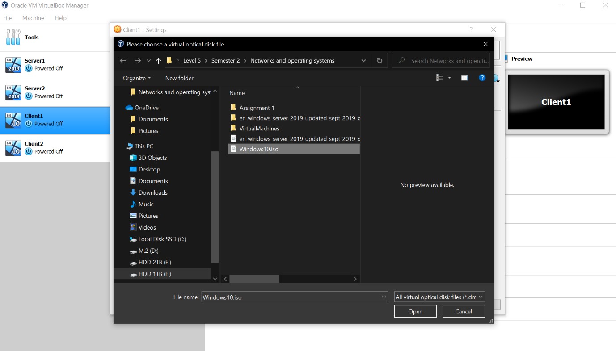
For Client1 and Client2 Windows 10 (Downloaded from the Microsoft website) [3] has been selected as the disk file.

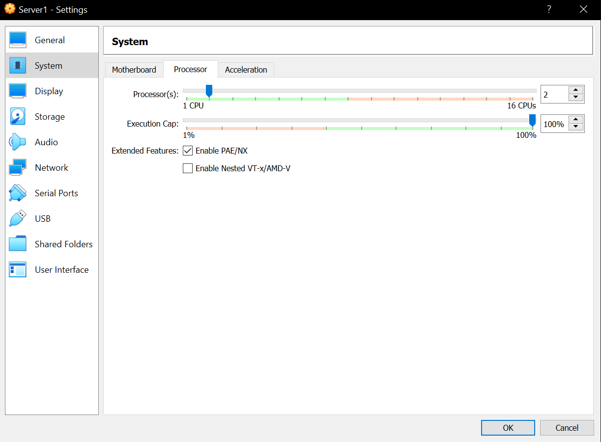
Before the OS’ are installed, optimisation will first be performed. Even if optimisation isn’t strictly necessary on a PC with extremely good specifications, it can still save resources, use less power, and ensures the VM runs as smoothly as possible for a good user experience. This will be done on each Server and Client but will be demonstrated on Server1. The settings button is clicked, then the system category, then the processor tab. Then enable PAE/NX is turned on. More CPU threads have also been allocated. This will be experimented with and 2 may increase to 4 if necessary.

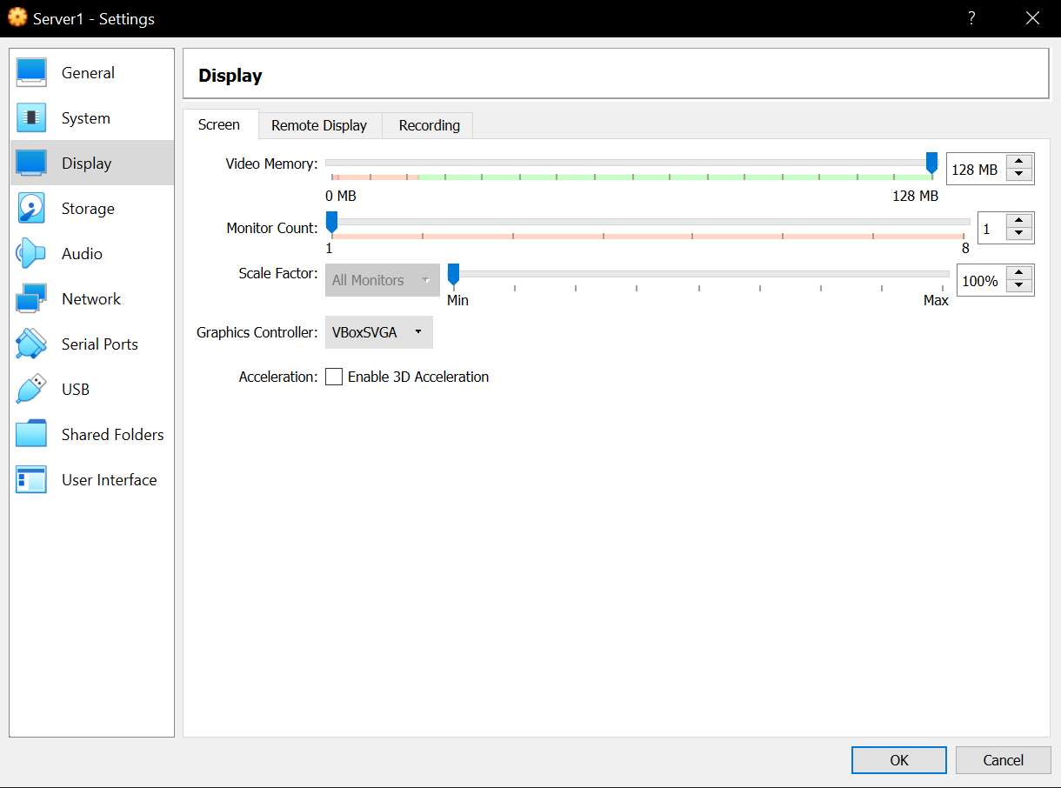
Next, the maximum display memory is selected by navigating to the display category and increasing the video memory.

The Operating Systems will now be installed. Double clicking each VM will automatically start the setup as the installation disk has been virtually inserted. The general Windows settings are set up such as date and time, and language, “I don’t have a product key” is also selected.
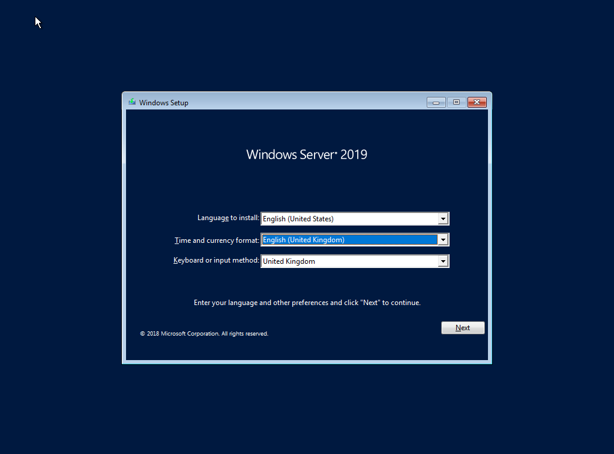

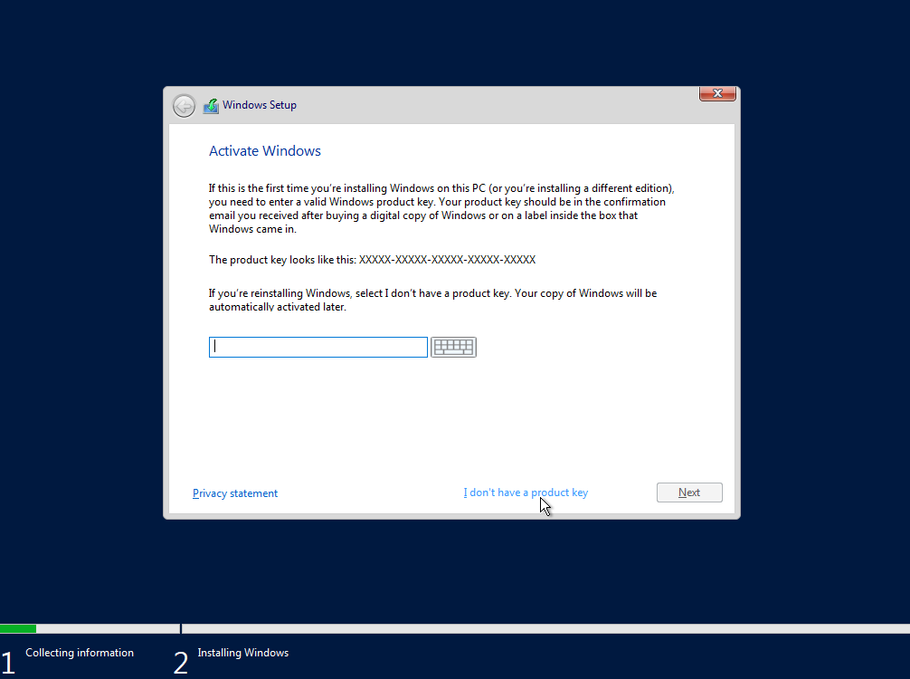

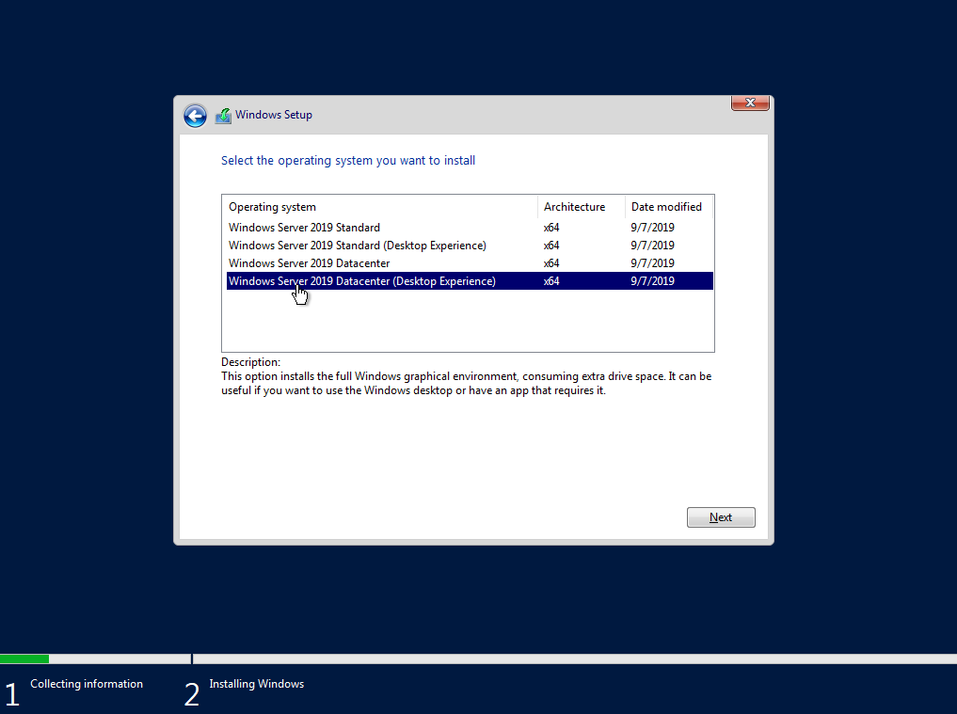
It has been ensured that Windows Server 2019 Datacenter (Desktop Experience) was selected for the servers.

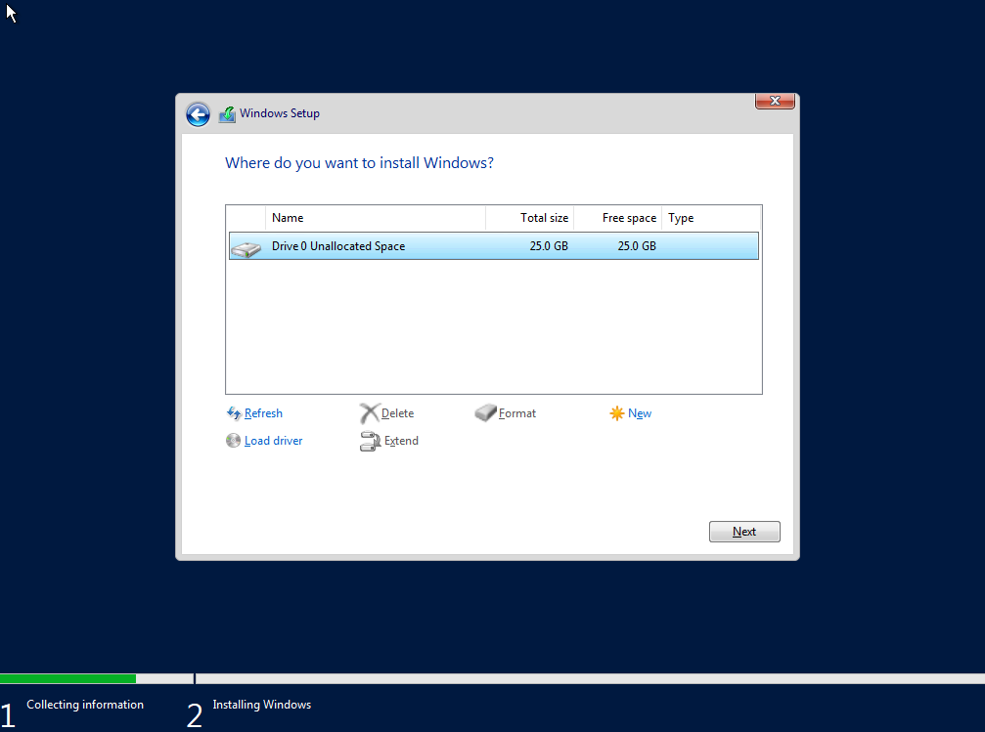
The disk drive set up to be 25GB is available, showing that the prior setup worked as expected.

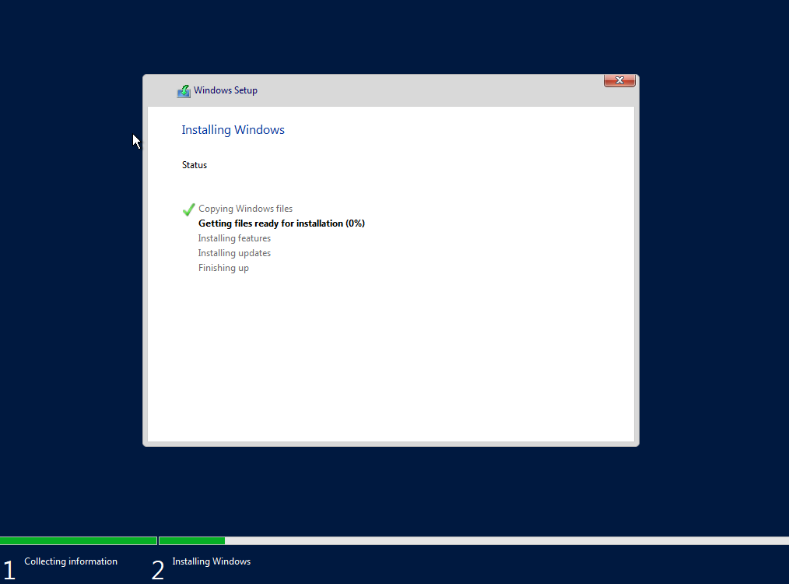

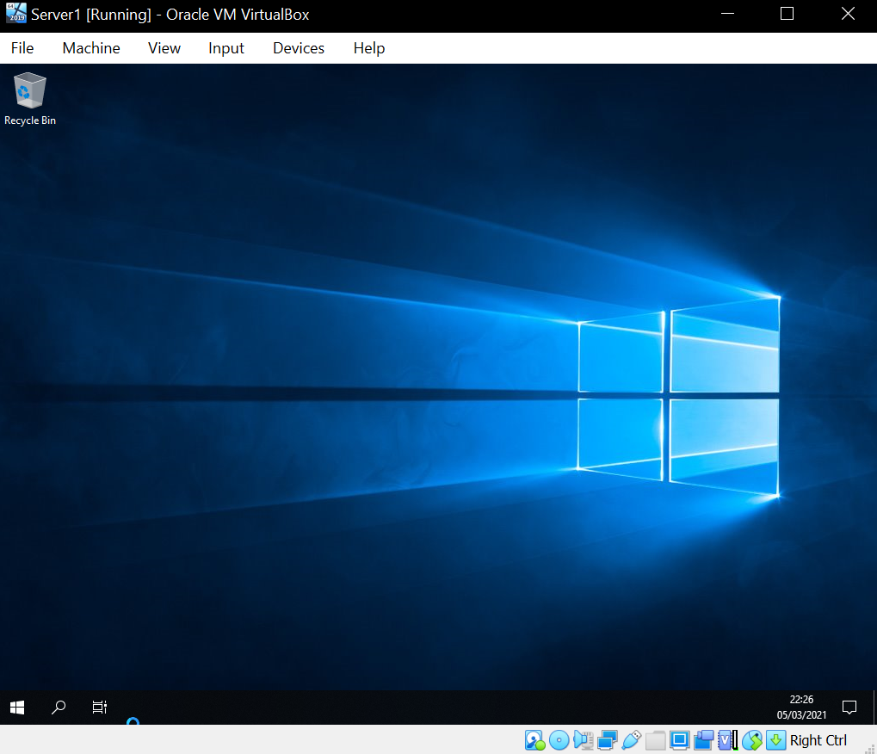
Once setup finished the password was set to P@ssw0rd as instructed, and the machine was logged into.

This process was followed for Server 2. Except for Clients 1 and 2 Windows 10 was installed rather than Windows Server 2019. Windows 10 Education N edition was chosen as it allows for features like group policy without installing bloatware such as Skype.
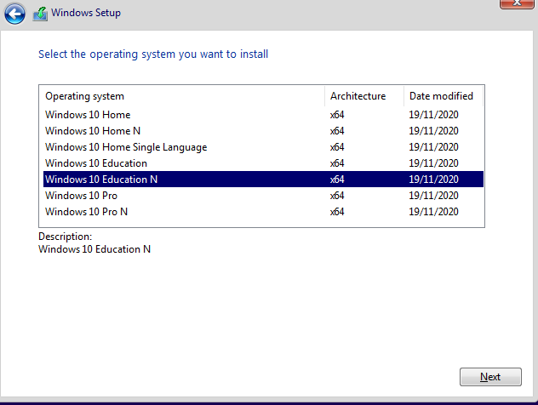
For the clients, Windows 10 Education N was installed.

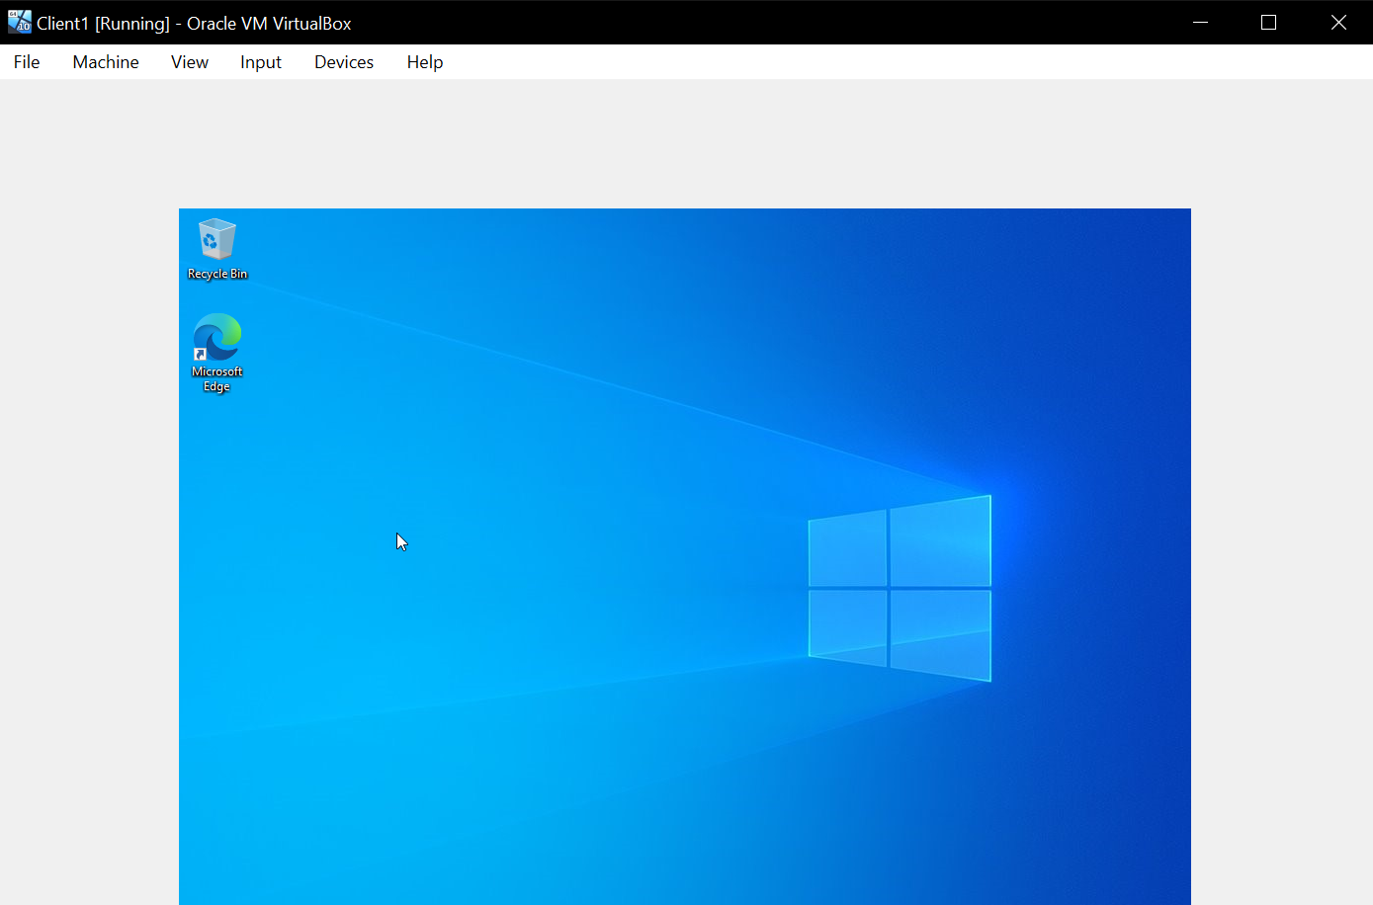
Each machine is now fully set up and ready to progress to the next part of worksheet 1.

1.1 Worksheet 1 Task 2: Virtual Network Configurations
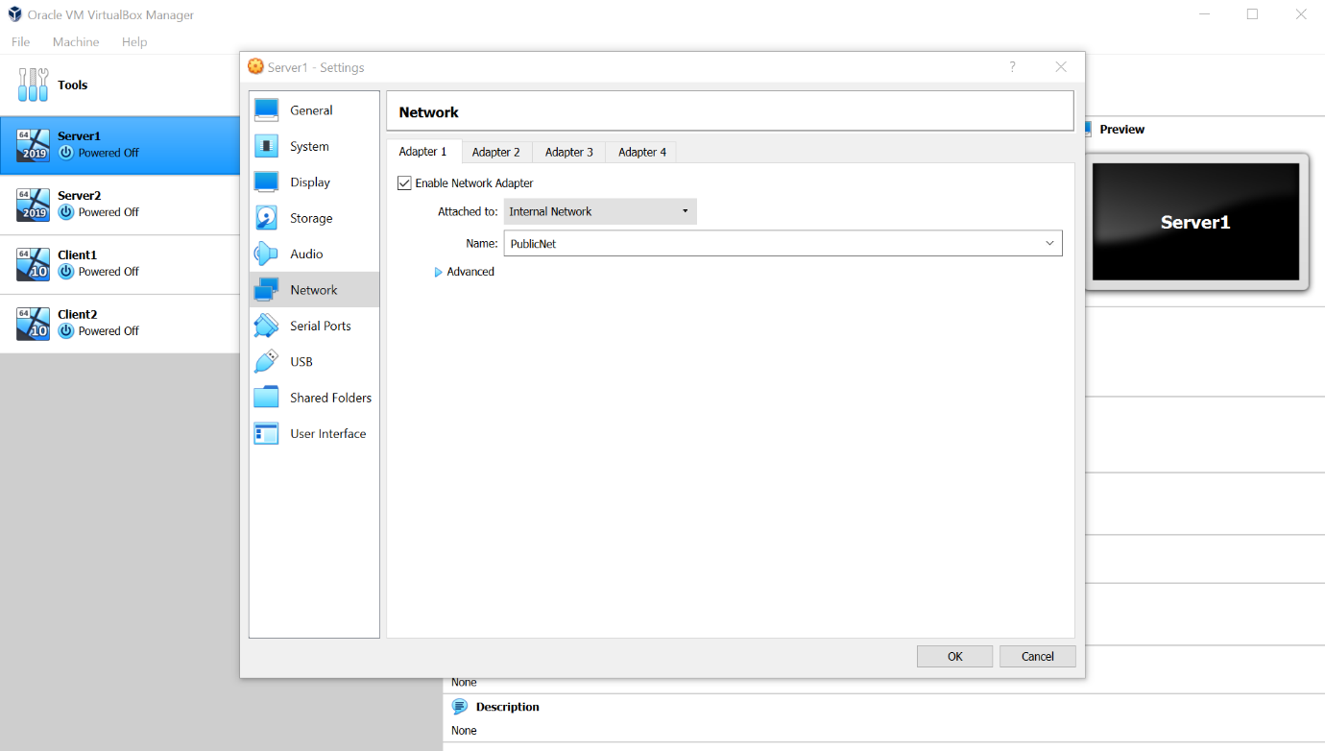
A virtual network, switch, and LAN will now be created. The settings of server 1 is selected. The aim is to configure the server to follow Figure A provided in worksheet 1 by configuring the IP addresses of the servers. To do this adapter 1 is selected and changed from ‘NAT’ to Internal Network’. This is then named ‘PublicNet’.

Server 1 is then booted up and the network connection is renamed to ‘PublicNet’. This has been done by accessing the control panel, selecting ‘view network status and tasks’ and then ‘change adapter settings’. An icon can be observed called ‘ethernet’ and once this is accessed ‘rename connection’ is clicked on and it is renamed to ‘PublicNet’.
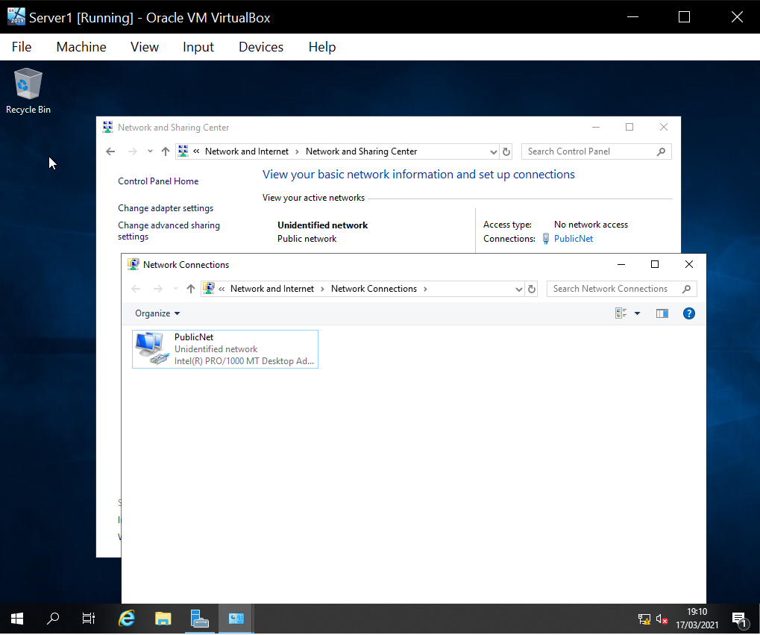

Next, the IP address is assigned by right clicking the recently renamed connection and selecting properties. Internet protocol version 4 was right clicked and the correct IP address was entered which automatically updated the subnet mask.
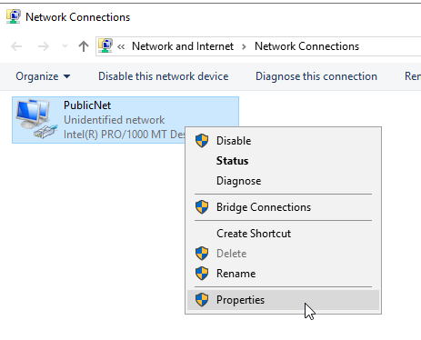

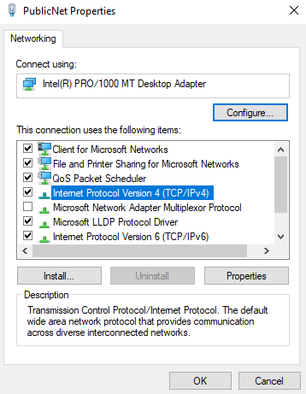

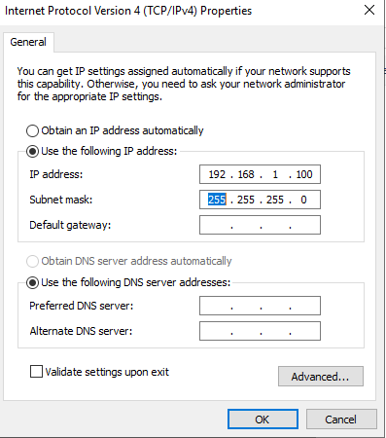

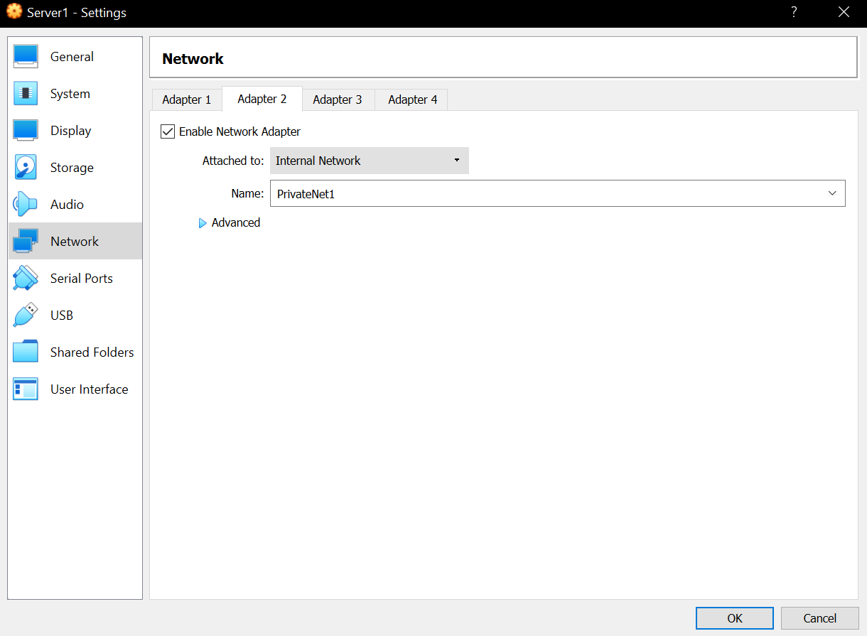
The second adapter was then configured by enabling the adapter and again switching it from ‘Not Attached’ to ‘Internal Networking’. It was then named ‘PrivateNet1’.

Server 1 was then launched again and following the previous instructions the new connection was renamed to ‘PrivateNet1’
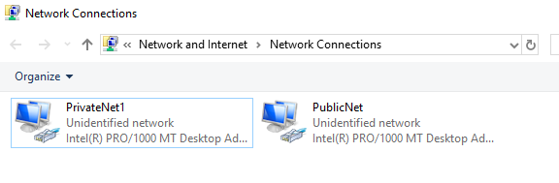

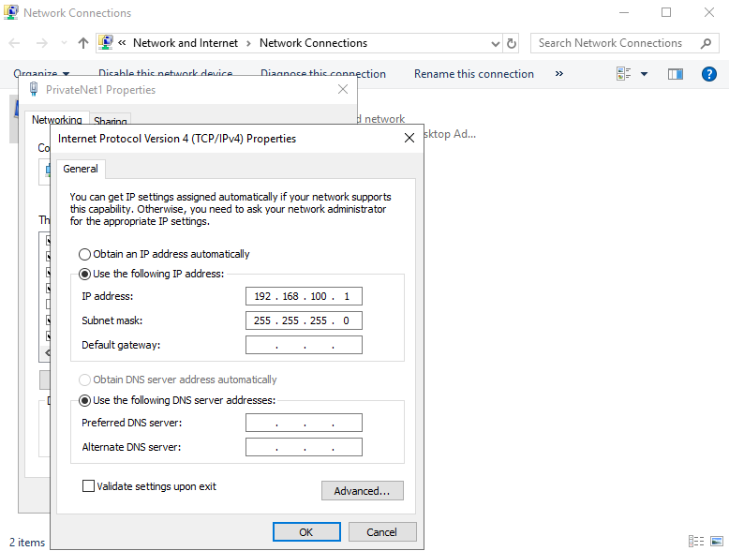
The IP was then set.

After server 1 was set up, client 1 was set up. Client 1’s settings were accessed, and it was confirmed that client 1’s adapter was set up as ‘PrivateNet1’. Client 1 was then booted up.
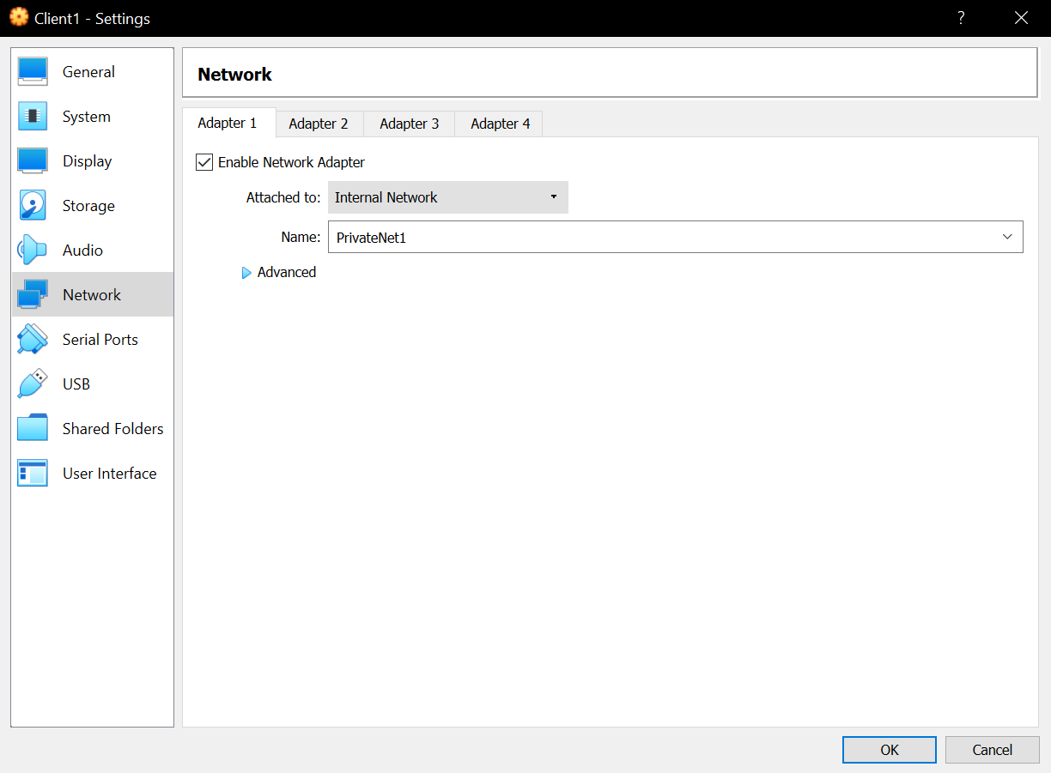

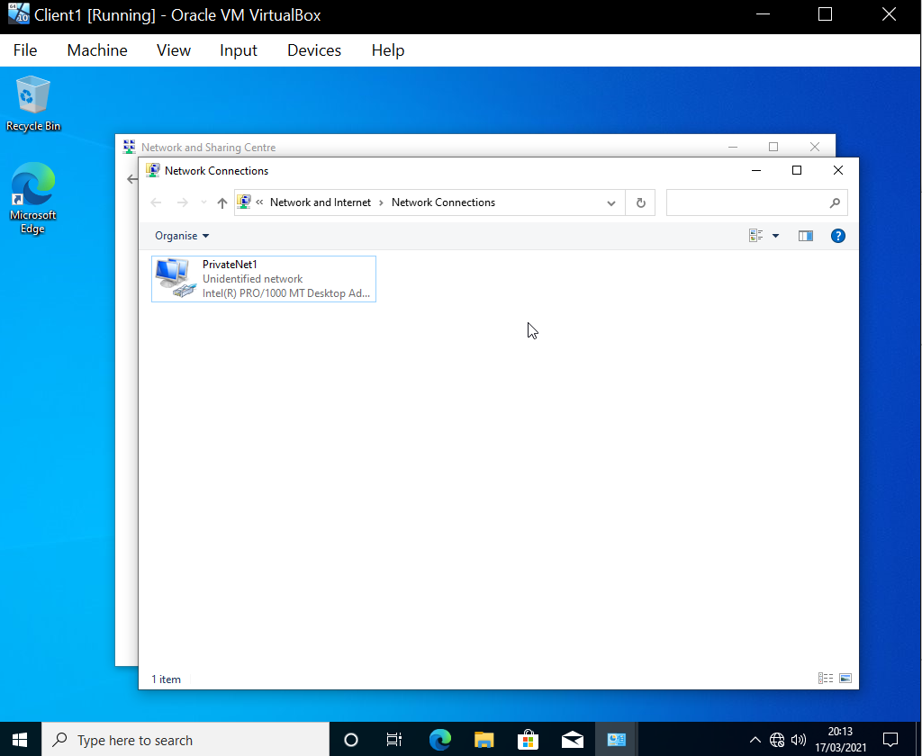
Client 1’s network connection was renamed to ‘PrivateNet1’ and an IP was assigned.

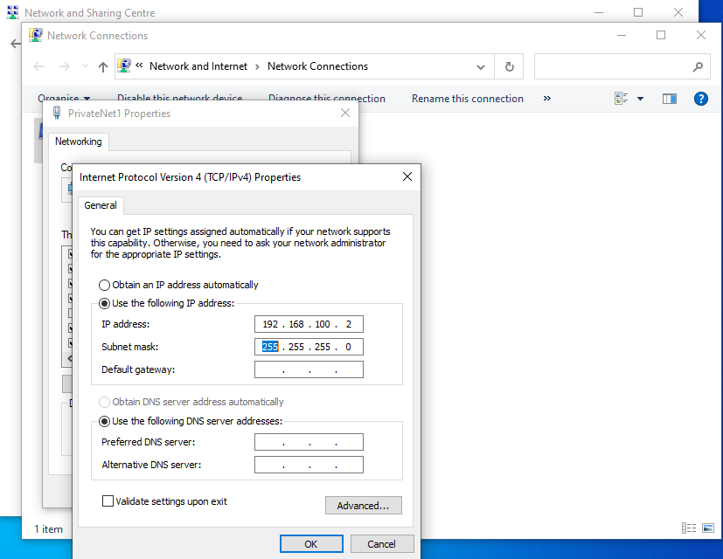

The same was then done for Server 2 and Client 2 except with some slight differences such as the IP addresses differ slightly for Server 2, Server 2 uses a different adapter name, and client 2 is connected to PrivateNet2.
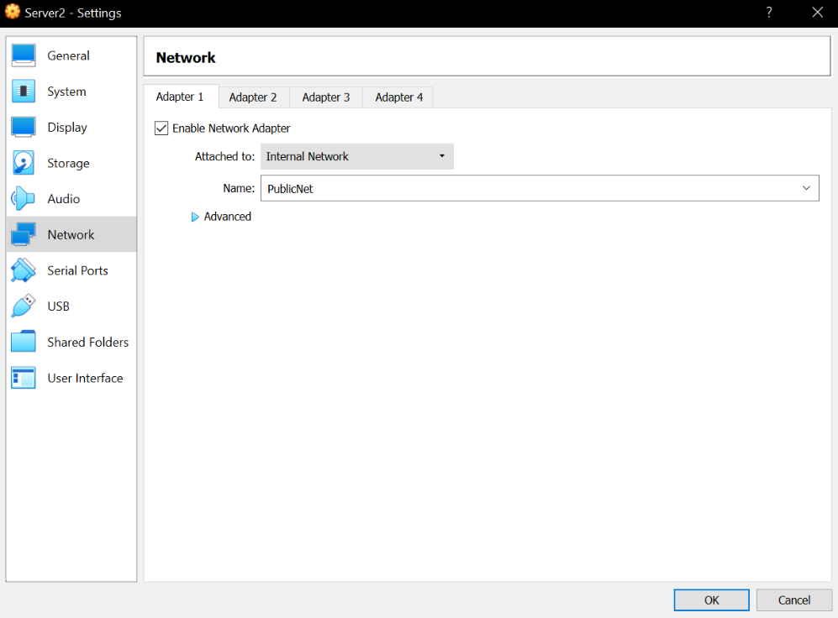
Server 2:

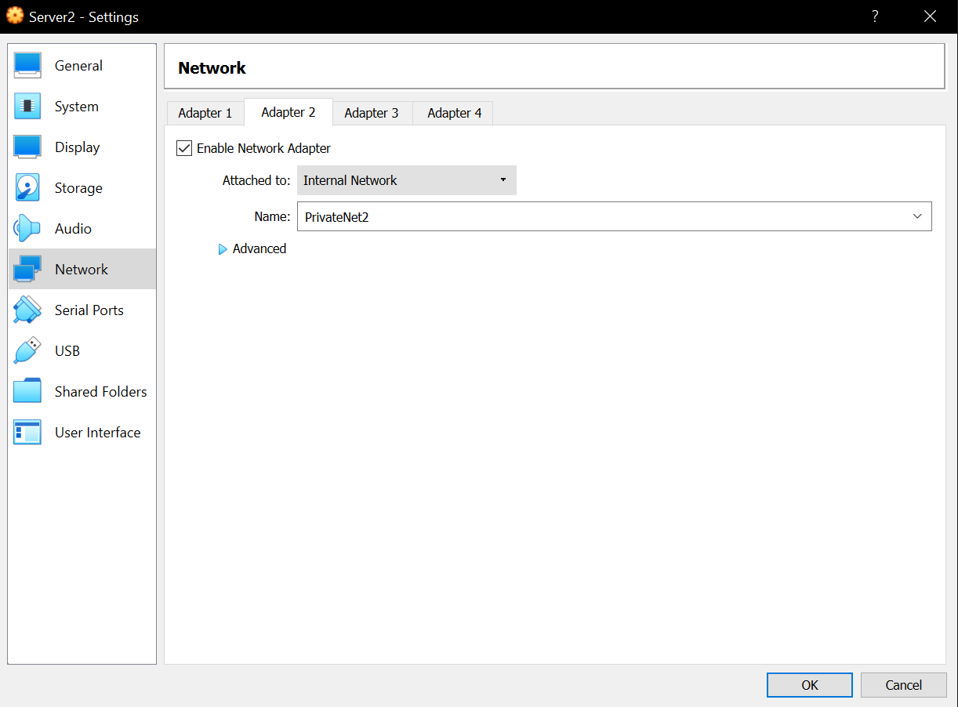

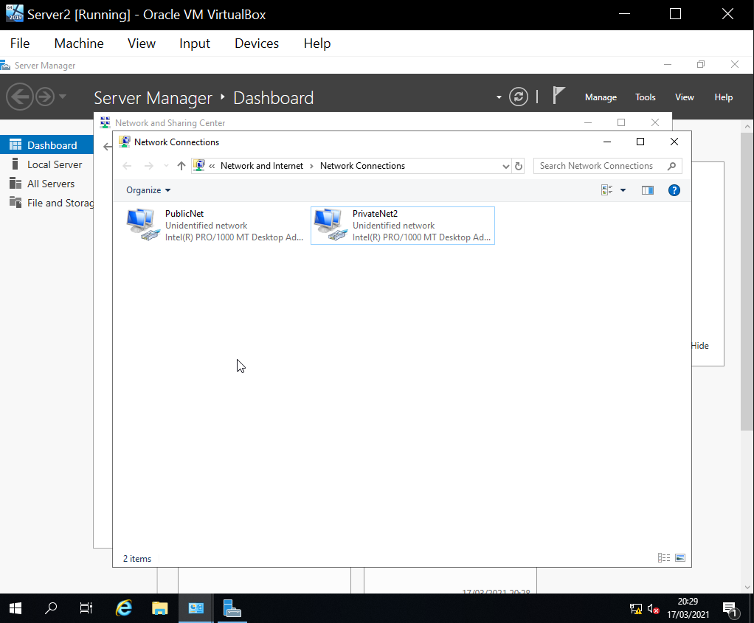

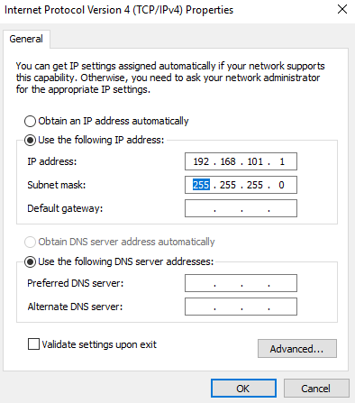
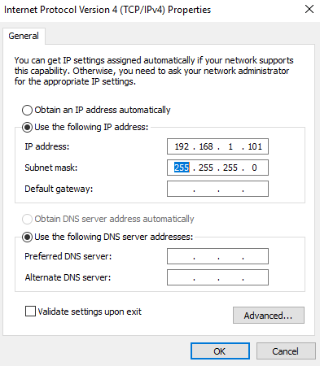

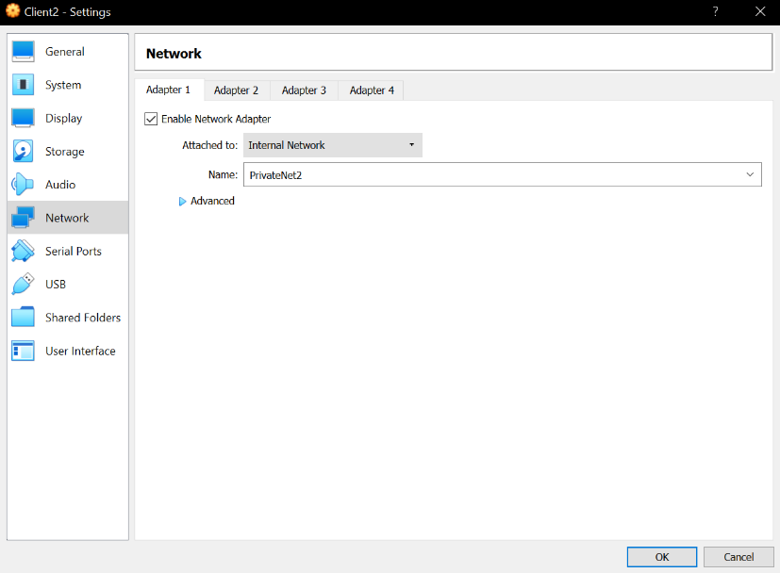
Client 2:

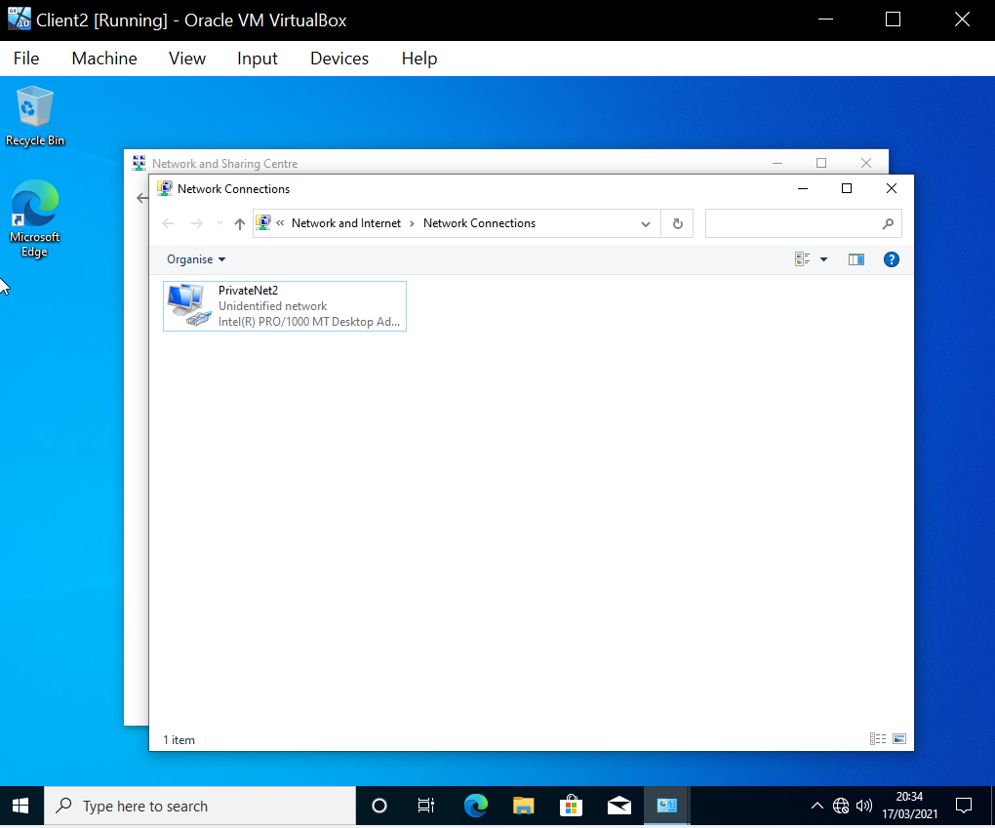

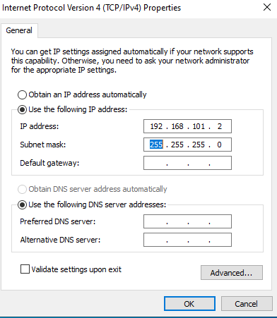

After this was completed, both Server 1 and Client 1 were simultaneously booted and the firewall for both was disabled to prevent the ping attempt from being blocked by said firewalls. To do this, the control panel was accessed, then ‘System and Security’, and under ‘Windows Firewall’ the option ‘Check Firewall Status’ was selected.
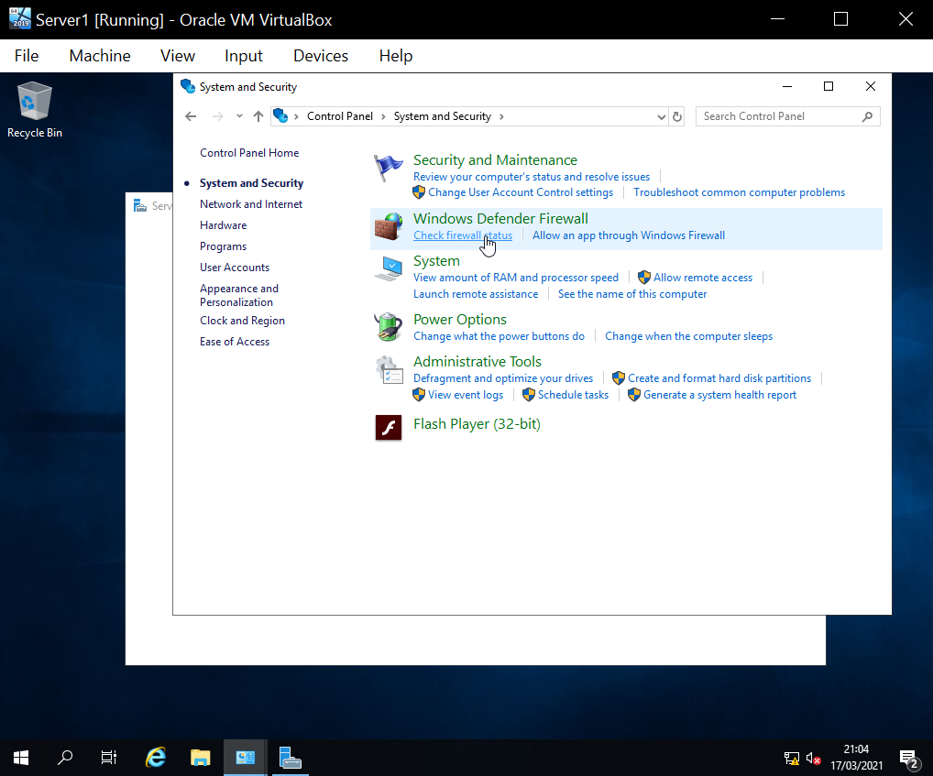

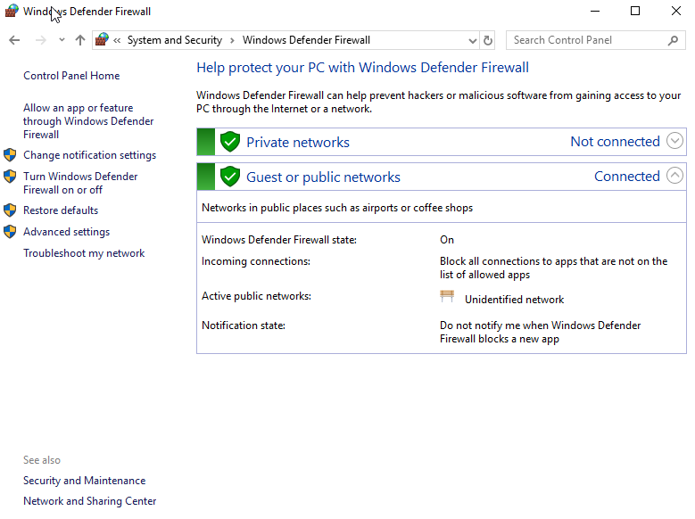

Then ‘Turn Windows Defender Firewall on or off was selected, and the radio button to turn the Firewall off both on a private network and public network was selected.
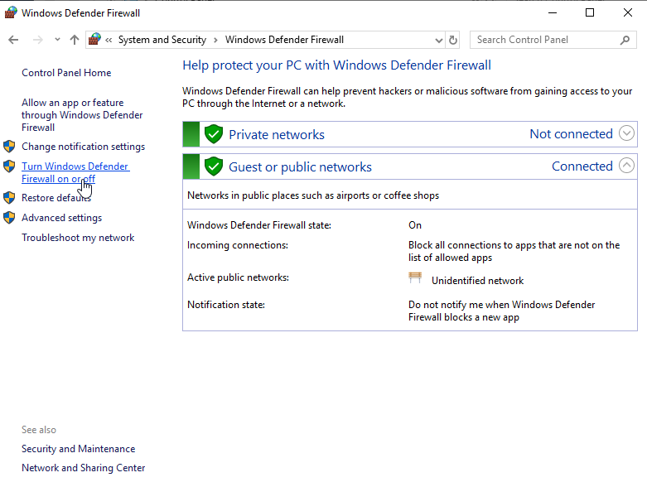

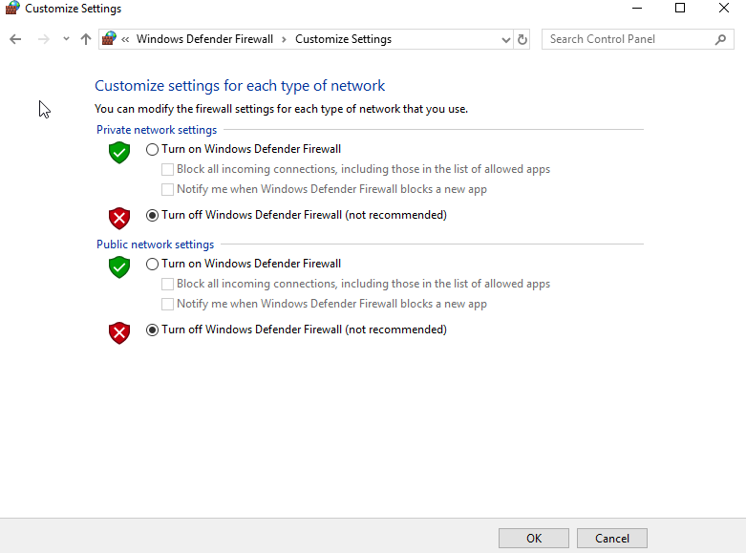

This process was repeated on Client 1.

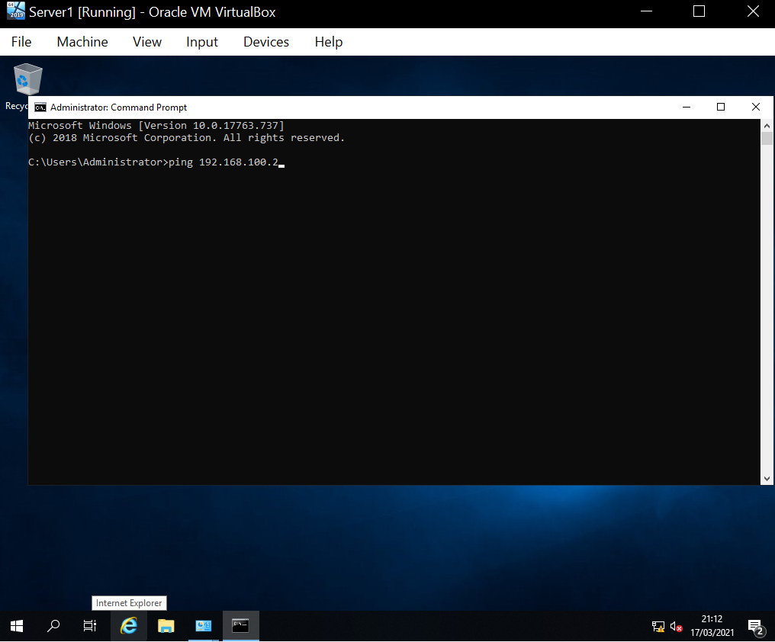
Once the Firewall was disabled a ping was initiated between Server 1 and Client 1. This was done by opening the command prompt and typing ‘ping 192.168.100.2’.

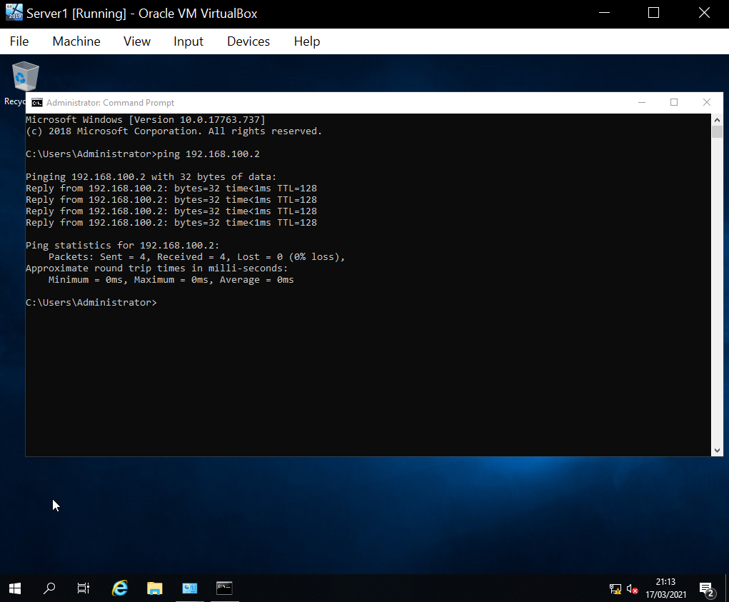
The ping was successful. This was the response:

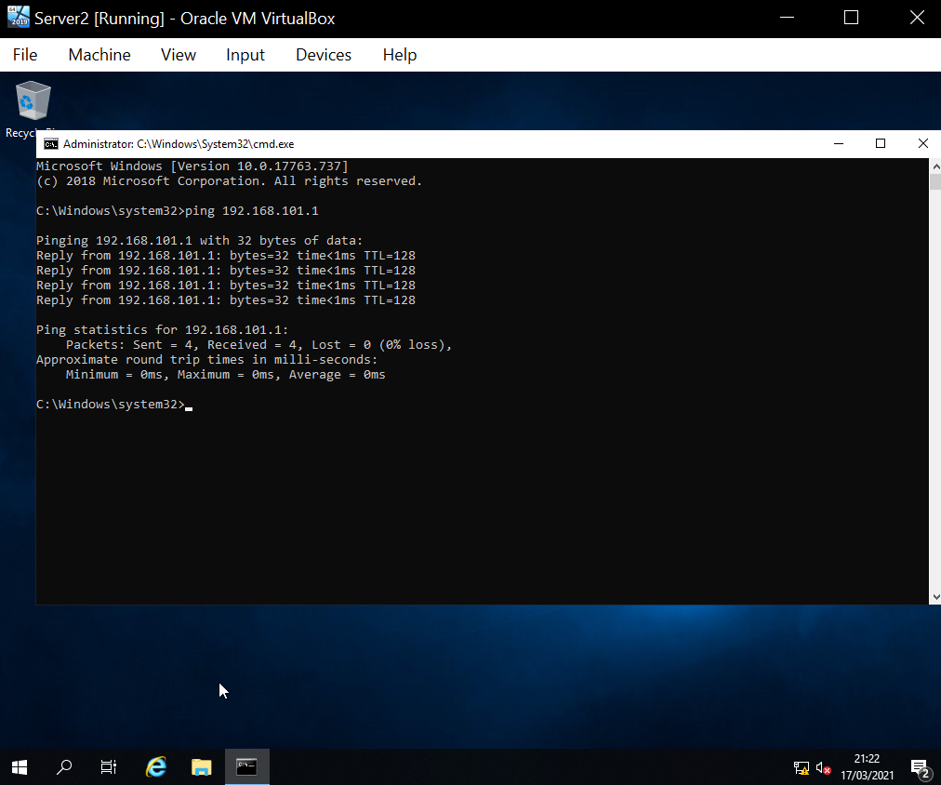
This process was repeated between Server 2 and Client 2 on PrivateNet2 by using the command ‘ping 192.168.101.1’. It was successful and this was the response:

2.0 Observational tasks:
3 a) Describe the main differences between Type 1 and Type 2 Hypervisors. Identify benefits and drawbacks of both and provide some example Vendors.
A hypervisor is the software that creates and runs virtual machines. They allow a computer to share its resources to run multiple virtual machines at the same time your own machine is running. A type 1 hypervisor (also known as “bare metal”) runs directly on the host’s hardware and acts as a lightweight OS. These are secure as they are contained safely away from the actual operating system, allowing tests that could usually break the system such as testing malware and working out a way to detect and detain them. A type 2 hypervisor (also known as “hosted”) runs as software on an operating system, like any other of a computers programs. This means that additional operating systems can be installed on top of the hypervisor at the cost of a higher latency. [4]
3 b) What is the significance of the subnet mask in IPv4 addressing?
A subnet divides a network into two or more networks which defines “which part of the IP address belongs to the device and which part belongs to the network”. [5]
3 c) Cloud computing has revolutionised the way that enterprise networks are hosted. Describe the use of cloud computing including its benefits and drawbacks and identify example vendors within the industry.
Cloud computing is utilized to provide on-demand availability of a computer systems resources remotely, especially to store data externally or use a computers power. This has been especially prevalent between 2020-2021 to allow remote working from home to those who need to access an organisations servers or those who do not have machines capable of producing the work required for their course or job. [6]
3 d) Give an in-detail description about the different terminologies and its purposes(like (not limited to) Ping, Server Management, Firewall, PAE/NX, OOBE etc) you came across during the Task 1 and Task 2. Compare your list of terminologies in the aspect of their operations/functionality with other Network Operating Systems.(For example: If you select Windows Firewall and describe the operations/functionality of Windows Server 2019 Firewall, you have to compare these features with the operations/functionality of other Network Operating Systems like Linux, Mac)
Virtual machine: A virtual machine is the emulation of a computer system, it allows you to contain an operating system separate to your own machine that runs off your machine’s resources.
IP: IP means Internet Protocol and is assigned to each device connected to a computer network. It is a unique identifier for the host and provides the location of the host in a network.
Ping: This is a signal sent from one machine to another which requests a response. This ensures that the host is available and measures how long a response takes.
Server management: This is the process of monitoring and maintaining servers so that they operate at an acceptable performance level.
Firewalls: A firewall is a form of network security that monitors incoming and outgoing network traffic and permits or blocks data packets based on a predefined set of rules.
PAE/NX: Physical Address Extension (PAE) enables an x86 processor to access more than 4GB of RAM. Whereas No-eXecute (NX) refers to “a processor feature that allows memory pages to be marked as non-executable.” [7]
OOBE: Out-of-box experience is when the end-user starts using a product for the first time. This means that all of the settings are presumably set to default and the user can customise them during the setup screen. [8]

3.0 References

[1] | VirtualBox, “Download VirtualBox,” VirtualBox, [Online]. Available: https://www.virtualbox.org/wiki/Downloads. [Accessed 20th February 2021].
[2] | Microsoft , “Welcome to Azure!,” Microsoft, [Online]. Available: https://portal.azure.com/?Microsoft_Azure_Education_correlationId=78e47025-2079-4743-a773-9cec4e7d5e6f#home. [Accessed 20th February 2021].
[3] | Microsoft, “Download Windows 10,” Microsoft, [Online]. Available: https://www.microsoft.com/en-gb/software-download/windows10. [Accessed 20th February 2021].
[4] | vmware, “What is a hypervisor?,” vmware, [Online]. Available: https://www.vmware.com/topics/glossary/content/hypervisor. [Accessed 25th February 2021].
[5] | AVINetworks, “Subnet Mask Definition,” AVINetworks, [Online]. Available: https://avinetworks.com/glossary/subnet-mask/. [Accessed 25th February 2021].
[6] | Microsoft, “What is cloud computing?,” Microsoft, [Online]. Available: https://azure.microsoft.com/en-gb/overview/what-is-cloud-computing/. [Accessed 26th February 2021].
[7] | windows-driver-content et al., “PAE/NX/SSE2 Support Requirement Guide for Windows 8,” Microsoft, 5th February 2017. [Online]. Available: https://docs.microsoft.com/en-us/windows-hardware/manufacture/desktop/paenxsse2-support-requirement-guide-for-windows-8. [Accessed 26th February 2021].
[8] | windows-driver-content et al., “Customize the Out of Box Experience (OOBE),” Microsoft , 9th July 2018. [Online]. Available: https://docs.microsoft.com/en-us/windows-hardware/customize/desktop/customize-oobe. [Accessed 26th February 2021].

