Nicola Louise Bragg – 1910223
BMSP4004 – Generating Business Data and Analysis
Lecturer – Roisin Mullins

A Report into Microsoft Access Database for business



Contents
- Executive Summary
- Introduction
- The Purpose and Function of Information Systems/Microsoft Access Database
- The importance of Information Systems/Databases within Business
- Designing a database
- The Sustainability Leadership Consultancy – Part 1
- Structure and Practice
- Sustainability Leadership Consultancy (SustainableLC)
- Design of Database
- The Sustainability Leadership Consultancy – Part 2
- Assignment Tasks
- Conclusion
- References
- Appendix
Executive Summary
Computer based information systems started to appear within the 1950’s. During this time the sole focus was efficiently processing, this was due to the unreliability of computers as well as the need for applications to be set up through machine/assembly code, seeing that there was no industry software available at the time. Now with the advancement within environment, and technology flourishing the goal of these systems concern “the social, economic, and technological changes taking place in the … functioning of enterprises” (Hoffer, George & Valacich, 2011, pp.6: Ziemba & Wielki, 2016, pp.134). See Appendix 1 for a timeline of system types.
Introduction
This report is based on The Sustainability Leadership Consultancy Database developed within Microsoft Access for the BA Business and Management course in Trinity St.Davids University Carmarthen Campus. The Objective is to clarify the purpose and function of Databases as well as the importance of this software within Business, taking into consideration the design which will lead onto a step by step creation of The Sustainability Leadership Consultancy Database.
The Purpose and Function of Information Systems/Microsoft Access Database
A technological view at an information system is that it is a set of interconnected components/data information that can be collected and/or retrieved, processed, stored, and distributed to aid control/organisation and decision making within an establishment. See Appendix 2 for a diagram of the interdependence between organisations and information systems. See Appendix 3 for systems in organisations, furthermore, see Appendix 4 for information systems in organisations. Significant types of systems are; Transaction processing systems, Management information systems, Decision support systems and Executive support systems (Laudon & Laudon, 2014: Mullins, 2020).
Microsoft Access has various tools incorporated in the structure to increase ease of work flow these tools consist of; tables that store the information, queries that find and retrieve data needed for the user, forms which add and/or view data along with updating data in the tables, and reports, these analyse data whilst allowing the information to be printed in a specific design (Microsoft, 2020). Other tools that may be used are macros and modules.
A table holds data specific to one type, information categories are inserted within the fields which then allows the records to be inserted into the columns. “Each record can be uniquely identified through a primary key field” (Staffordshire University, 2007).
A query is an object within access “to view, analyse or modify data.” It allows the user to present fields and records in a certain order. When a query runs, it retrieves data based on criteria selected in the design phase. Queries are generally used as a basis for “reports, displayed in forms, or used to create other queries” (CAT, 2020). Commonly known as ‘dynaset’ records (Mullins, 2020).
Forms link to one or many tables, they administer a simple “interface for accessing, editing and creating records” (Staffordshire University, 2008).
Reports allow the user to print records; this could be done simply by printing a table however not all the information the user desires may be available therefore, auto reports can be created (Staffordshire University, 2007).
Macros automate tasks, like modules they can be used in forms and reports, or control by adding functionality. “Macros are created by choosing from a list of macro actions, whereas modules are written in Visual Basic for Applications” (Mullins, 2020).
To bring data together from different tables to create forms, queries, and reports, relationships must be used. These relationships allow the user to make links between tables to automatically generate the information wanted without the need of filling in or retrieving the data again, as it is taken from the original origin (Microsoft, 2020).
These objects/tool will be explained in more depth relating to The Sustainability Leadership Consultancy Database.
The importance of Information Systems/Databases within Business
Nowadays businesses are trying to implement new strategies to increase value and encourage profitability as well as efficiency. If an information system is assembled and enforced to a high standard throughout this should strengthen the company’s ability, and initiative to problem solve challenges short and/or long term that arise in management and organisation in the business environment. Characteristics of those issues tend to comply with data security/privacy, data volume, data format, data cost, data integrity, data accuracy and data timeliness (Laudon et al., 2014: Mullins, 2020).
Designing a database
This is the first step of the systems development life cycle, in which the user and developer distinguish a set understanding of how the system will operate.
The designs purpose adheres to five points, one; entering the data into stable structures (normalised tables) over time these records tend not to change. Two; creating a logical database design that echo actual requirements generated by data in the forms and reports. Three; relates to the physical database design. Four; “translate a relational database model into a technical file and database design that balances several performance factors.” Five; data storage technologies, choose one that will “efficiently, accurately and securely process database activities.”
The logical design process follows four steps; each known user interface needs a developed logical data model for the application using normalization principles. View integration: combining the data from all user interface into one solid model. “Translating the conceptual E-R data model for the application or enterprise, developed without explicit consideration of specific user interfaces, into normalised data requirements.” Lastly compare the E-R model along with the consolidated logical database design and select the final logical database model.
The databases physical design follows four guidelines these proceed from the logical database design steps. Firstly, choosing the storage format for each attribute, the format can maximise data quality and minimise storage space. Next, physical records are grouped into attributes from the logical database model. Secondary memory (hard disks) help information to be backed up, arranged, stored, retrieved as well as protected from errors found within the database if any occur. Lastly, to make data access more efficient appropriate media and structures for storing should be used. “The primary structure used today to make access to data more rapid is key indexes on unique and nonunique keys” (Hoffer, et al., 2011, pp.311-316).
The Sustainability Leadership Consultancy
Part 1 reads the instructions provided to start the development of the database whilst Part 2 covers the additional assignment tasks to finish the database model.
Part 1
Structure and Practice
The Access Application was opened, the Northwind database (provided by the university) located and opened, a display box regarding security measures enabled by clicking the ‘enable this content.’ Among doing so this allowed the user to access the content, next a login box appeared where an employee’s name could be entered to access the actual database. A navigation pane can be seen with the access objects available to select, situated vertically to the left-hand side. Along with the ribbon situated above horizontally which like other Microsoft applications is designed with commands to order the application to perform. Towards the top left is the design view and the datasheet view, this allows the user to view the data in different formats. To get comfortable with the system’ processes, tasks were enforced to become more user friendly. These consisted of filtering through records to find specific answers (Mullins, 2020). See Appendix 4 for task results.
Sustainability Leadership Consultancy (SustainableLC)
“A small software consultancy company which designs and delivers training courses relating to all aspects of leadership.” They anticipated organisational needs as their platform (Excel) grew difficult to extract/insert correct up to date information when needed therefore an upgrade to Access was desired to “assist with the day to day management of data and administration” (Mullins, 2020).
Design of database
The designs purpose evolved around these points;
“The courses available at the consultancy, personnel records for each consultant, records for each client/company, details of up-to-date course and client bookings, up-to-date course costs, the invoice reports which need to be raised each month and built in calculations, c.v. reports for each consultant, and the SustainableLC company contracts various consultants who teach one course only, cost of course is calculated according to attendees, number of consultants and duration of course” (Mullins, 2020).
Next an entity relationship diagram had to be created which identifies the entities within a business and the relationships between them (Mullins, 2020). The answers are as followed; names of each entity are – Consultants, Course Details, Session, Booking and Client Company. The attributes associated are Consultants: Personnel number, Family name, Given name, Office number, Phone, Extension, Software experience, Job title, Job description, Contract details, Photograph, Consultant client work history, Years training experience. Course Details: Course code, Course title, Course description. Session: Counter, Booking number, Personnel number, Course code, Teaching room, Date time course run, Duration of course (hrs). Booking: Booking number, Date, Company code. Client Company: Company code, Company name, Address 1, Address 2, Address 3. The primary keys are determined in bold above. The foreign keys are determined by an infinity symbol in the ERD; Personnel number, Course code and Booking number in the Session entity along with Company code in the Booking entity.
Now information can have several relationships these being; “One-to-one – each row in one table is linked (or related) to a single row in another table using a “key” column. One-to-many – Each row in one table is linked (or related) to one, or more, rows in another table using a “key” column. Many-to-many – One, or more, rows in one table is linked (or related) to one, or more, rows in another table using a “key” column” (Lafler, 2017). Four one-to-many relationships have been found and the main relationship was with the session table, this is because by generating a session entity linked to the booking entity it allowed for many records for each booking, otherwise without this it would result in a many-to-many relationship as many consultants can be booked onto many courses, for many clients.
A new Microsoft Access database could be started and saved under the name SustainableLC1. It is important to save, and close objects open within databases regularly as they can corrupt if too many commands take place. Data was then entered through tables created for each entity. This was done by selecting the table object and adding the field name (the data’s identified name), data type (the kind of data/value which will be inserted), properties (the format to which it is shown size, colour, number, amount (additions may also be changed in the lookup box)), and description (short description of the field, useful for operators in relation to forms. Examples of this are Field name; ‘Booking Number’, Data type would be ‘Number’ and Description; ‘Each booking entry will be assigned a new booking number’. The primary key can be applied at this point by clicking the small grey box situated to the left-hand side of the field name, once operating a small key like object will appear (this is also seen in the relationship tool). This is a repetitive process that must be handled with precision otherwise errors could evolve further into the development process, this was experienced first handed when the database in creation became corrupt and starting again was the only was to ensure data protection, quality and accuracy.
An example of how to set up relationships; select the database ‘relationship’ tool within the ribbon bar then ‘show table’ from menu, source the appropriate tables and click ‘open’ this brings them onto an open space, from there a field can be dragged by mouse onto another table. A dialogue box appears with relationships which can be made, in this box ‘enforce referential integrity’ should be ticked, one-to-many option secured and created.
Records were now entered in each of the tables within the datasheet view.
Next forms had to be created to ease input of records for the user. Forms which can be used are single column (entries are depicted in one column each entry on a separate line), tabular (row/column format, displays multiple at one time), main/sub (main form including sub form within it), and graph (provides a graph). Access is encoded with a wizard which can also help design more simple forms (Mullins, 2020). To initiate the process a table must be selected then form selected from the create menu, ensure you are on the design sheet, then add existing fields warranting all required ones are selected. Upon the form, properties could be entered by right clicking the form header, access creates the possibility of good physical appearance for the user. The course label was changed to size 30, Font to Times New Roman, Text; centered, Background; light grey, Outlines; Black. These were the design specifics chosen as the client SustainableLC is wanting information quickly and effectively so will not concern over appearance, but it must still be eye friendly as employees may be using this database over long periods of time. Save and close the form. Securing that the form works a record was entered and saved which occurred no problems. The main/sub form was developed by selecting the session subform and dragging it into the Booking form in the design view (Mullins, 2020).
Queries are needed for answers in relation to organisation of data questions within business. An example is “Give me a list of all employees with salary >15,000” or “to find out how many clients are based in England.” An explanation is “sort the course codes into descending order” to meet these objectives navigate to ‘create’ then click ‘query design’ add the course table and close box. Double click the title bar of the table and drag all fields onto the QBE grid. The QBE grid allows the user to sort, show or criteria information. For this scenario ‘descending’ was selected from the sort box. The query is then viewed and sent to run. File save and query complete.
SustainableLC also wanted a resume for each consultant, these were formatted through the report tool so they could be printed and looked over by hand, this concept may be used within meetings of a business, or for employing/promoting more staff. Report is selected from the create menu, all fields are added from the consultant table. These are then arranged in a sensible order for the user to comprehend. The rest of the properties follow suit with how a form is created. Extra abbreviations and criteria’s that were used in this process were abǀ boxes the first one in the footer with =page entered; this automatically generates page numbers when printing. In the second abǀ box =date() was entered, this generates the current date.
Part 2
Assignment Tasks
This part is filled with evidence regarding individual assignment work. Firstly, inserting two new fields into the Consultant Table, their properties, and five new records:
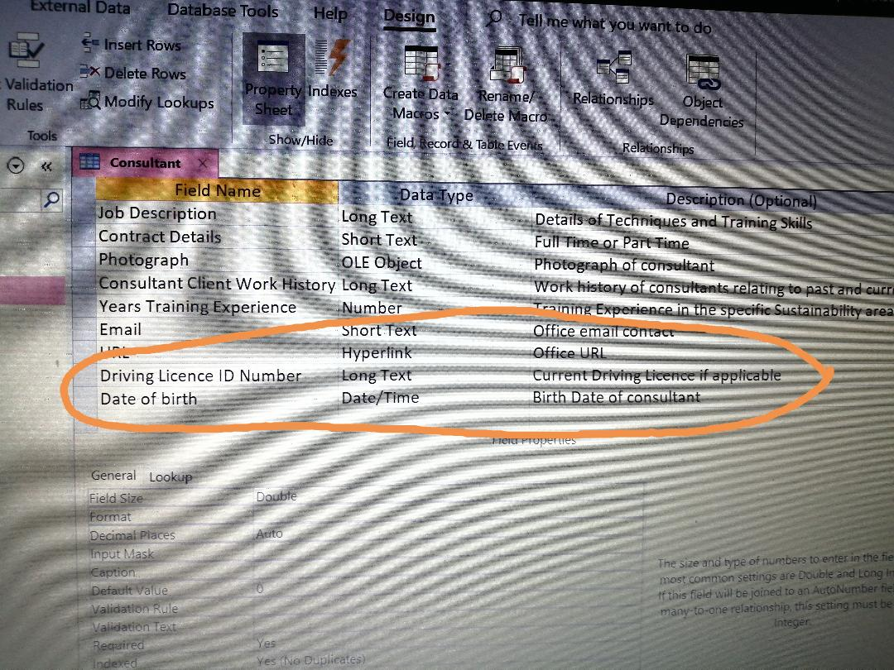
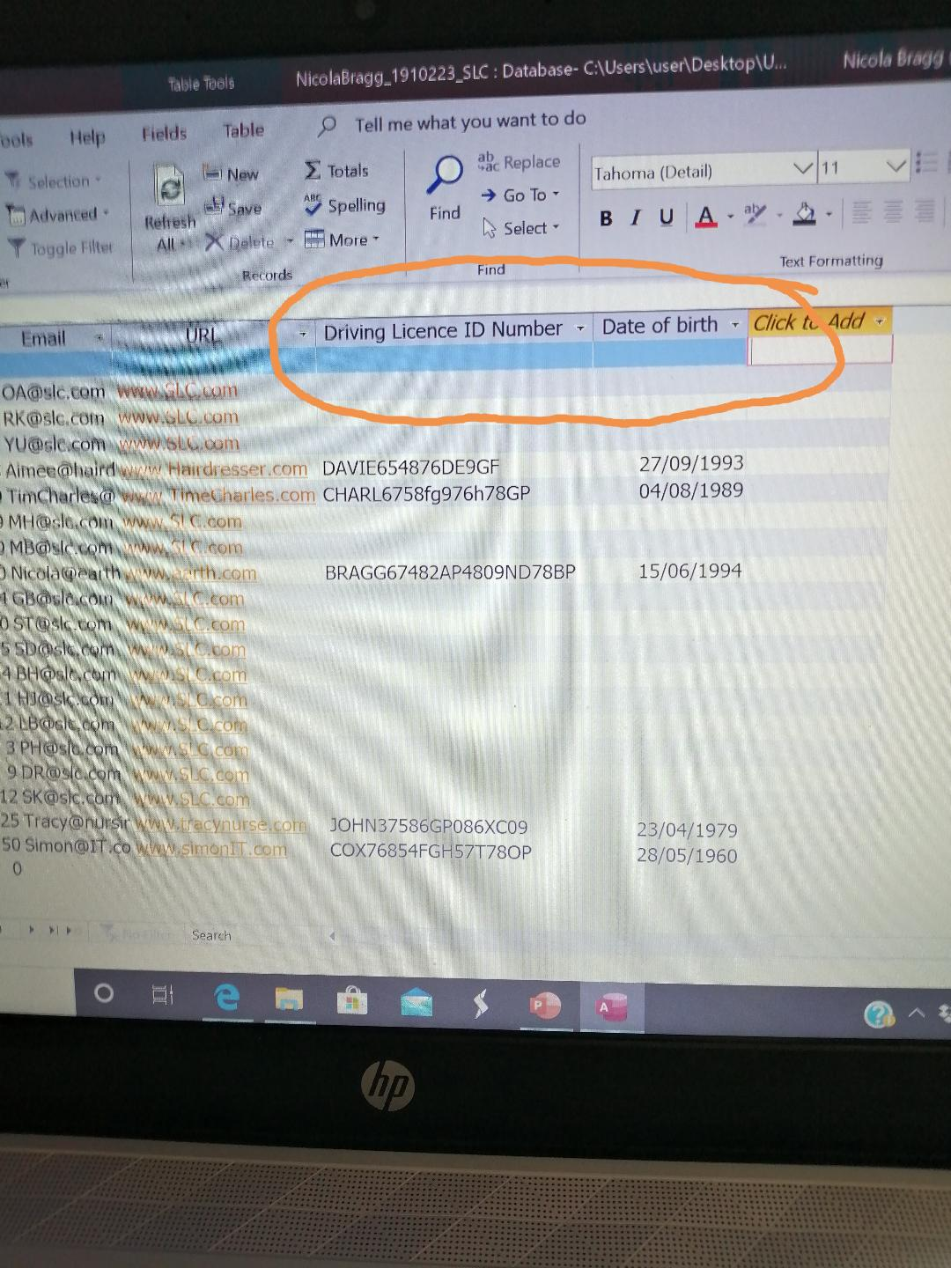

Insert one new field in the Client Company Table, their properties, and five new records:
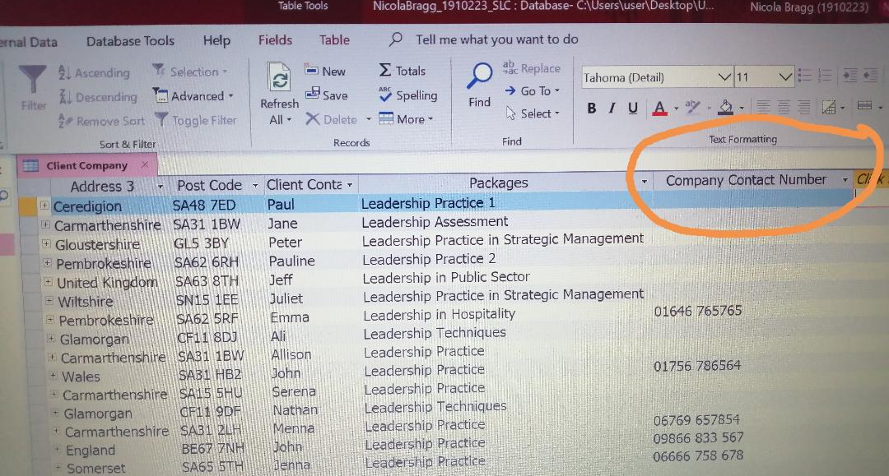
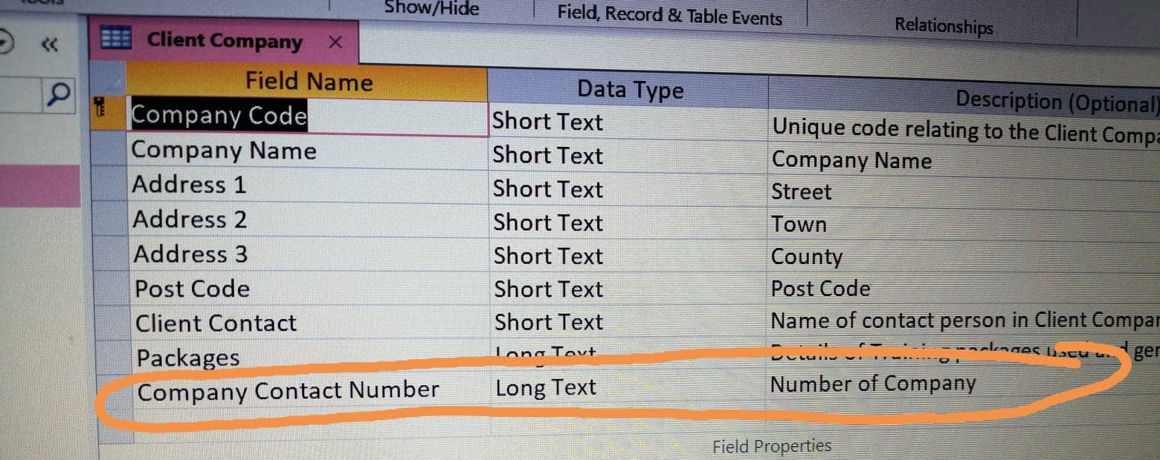
Insert two new fields in the Course Booking Tables, their properties and five new records: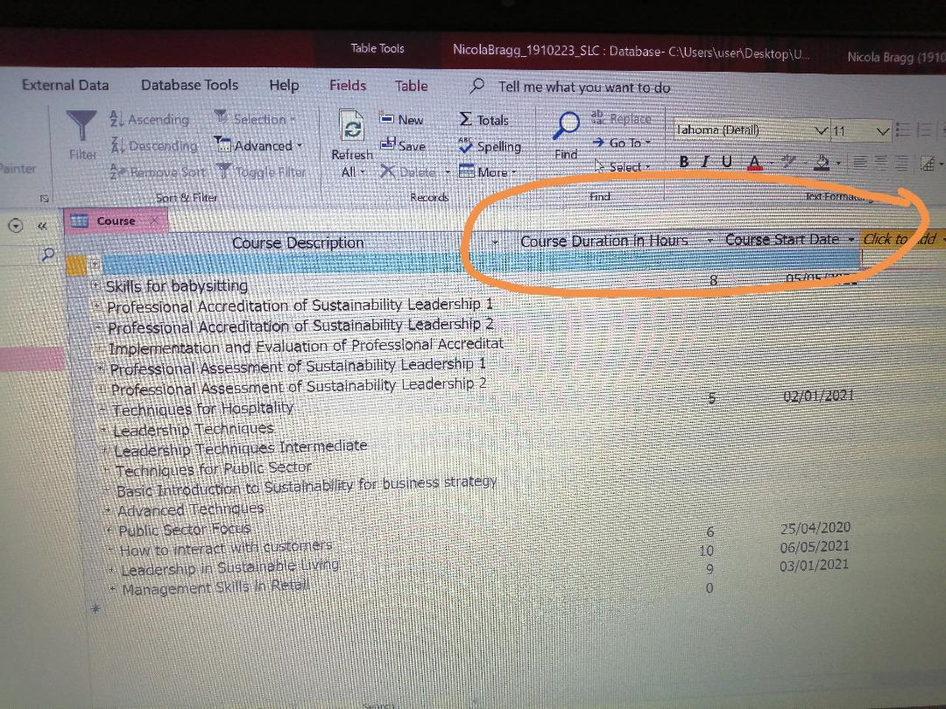

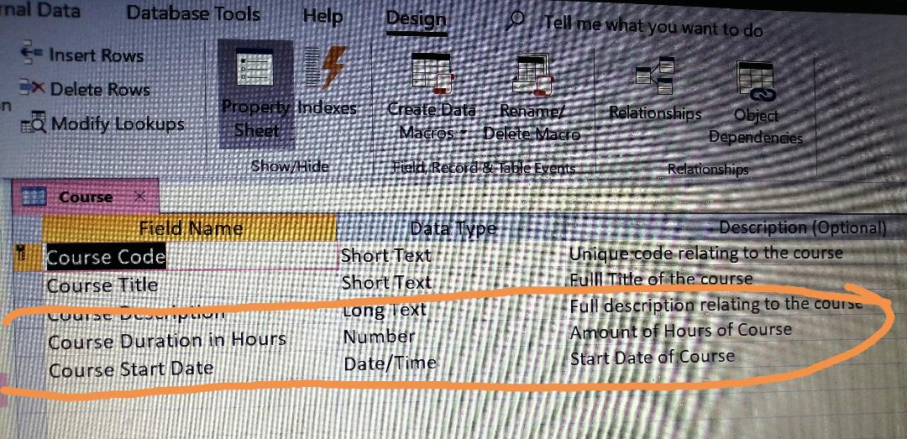
Creating a new course booking:
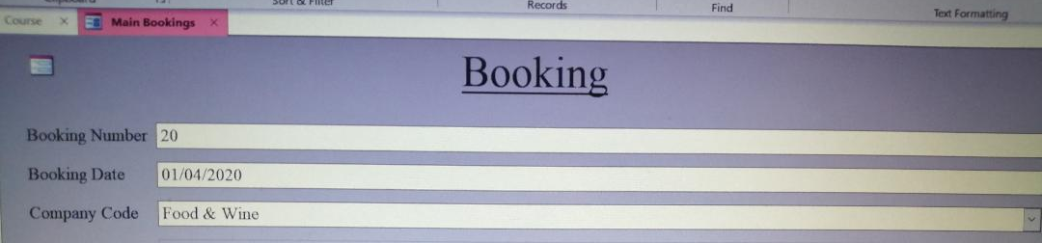
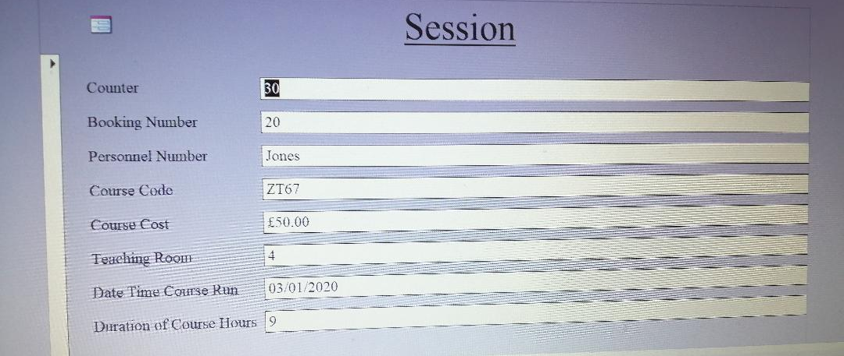Creating one additional form:
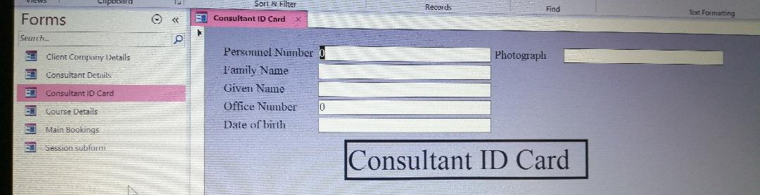
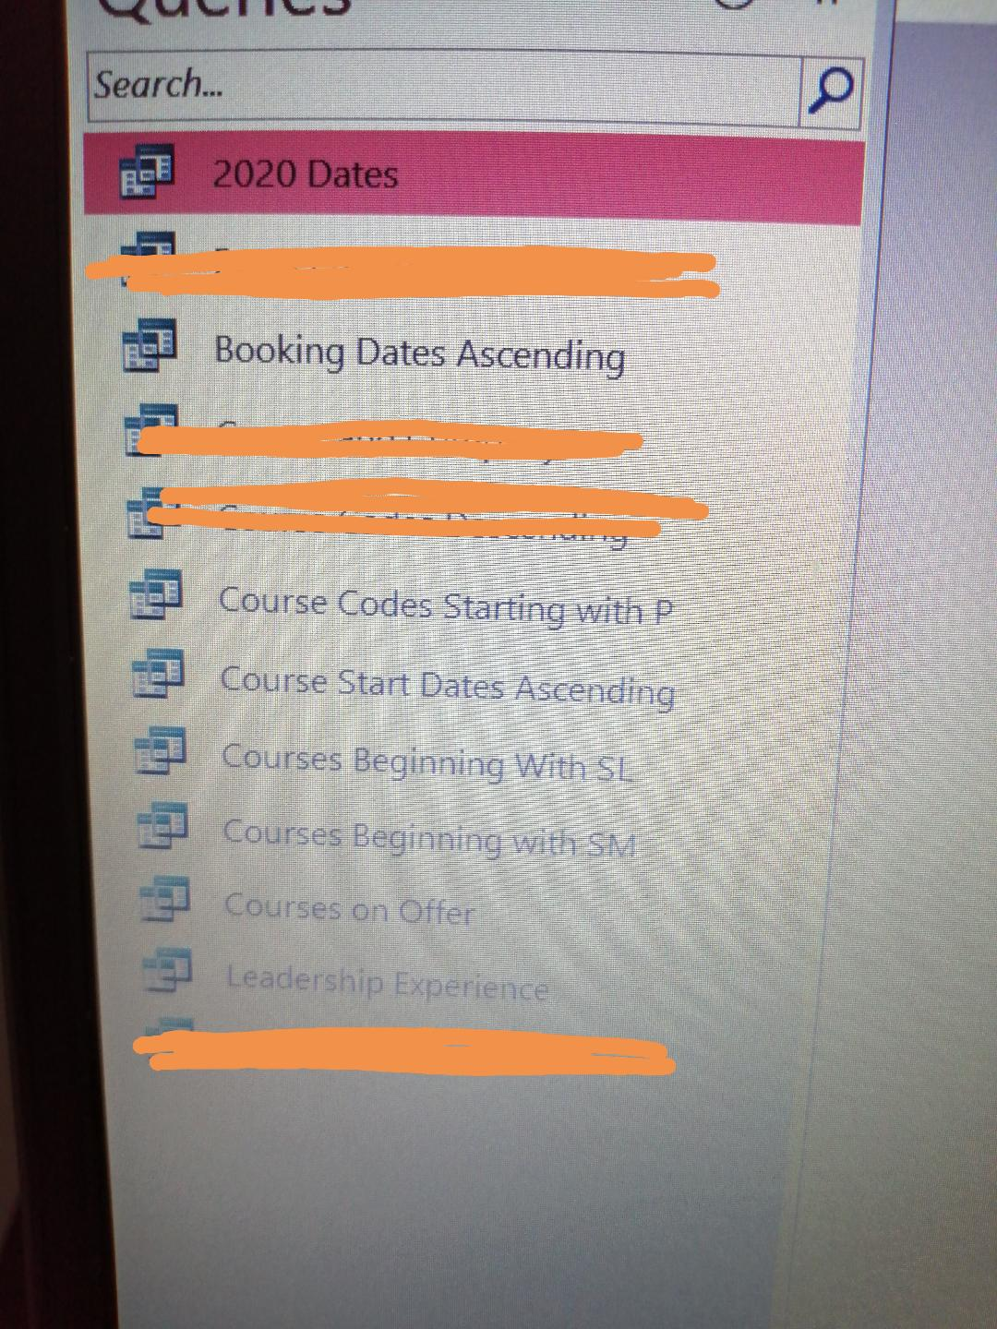
Three additional Queries:
7 extra queries were completed some with similar sort criteria and others with different.

Creating a second report:
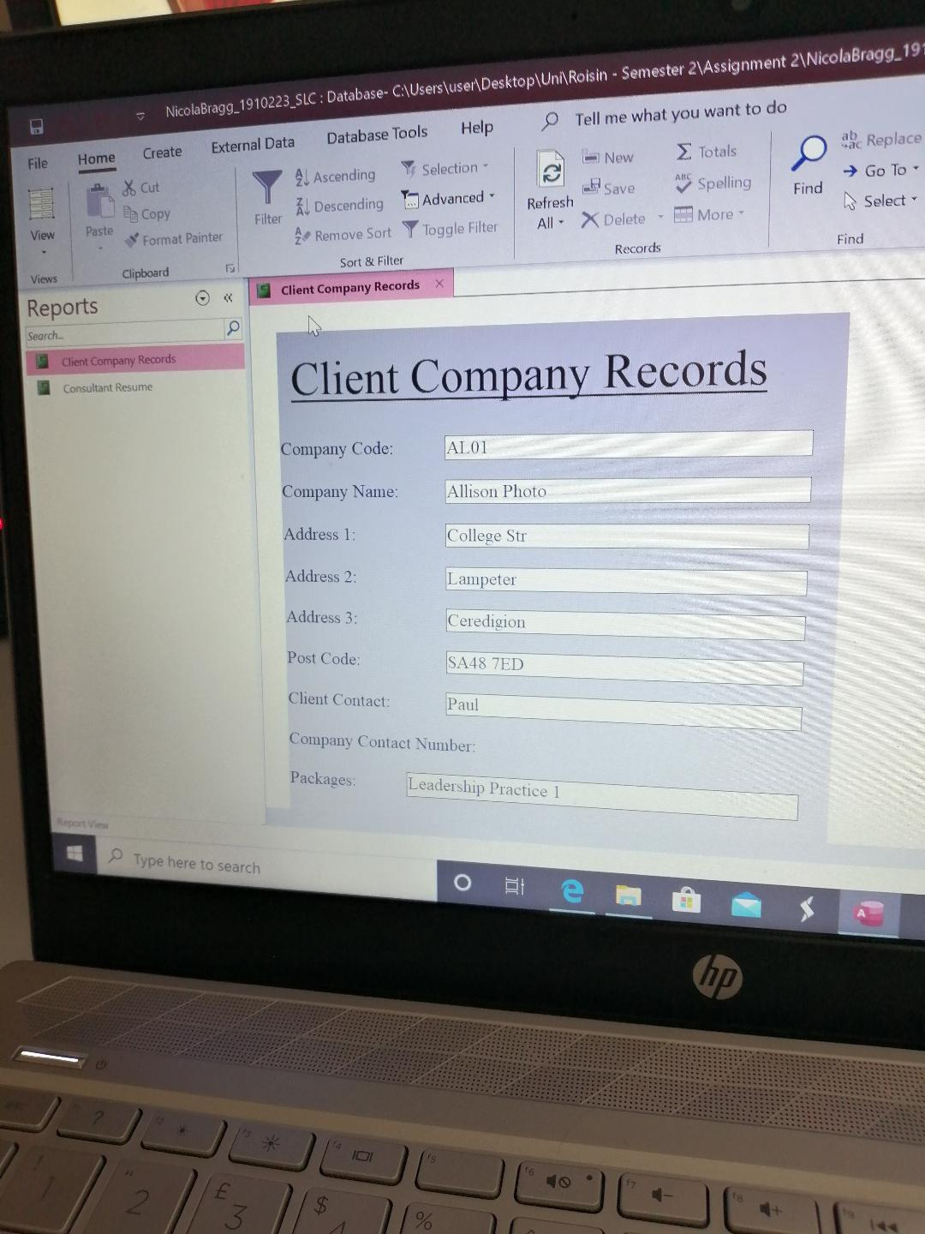
Saving and converting into a zip file:
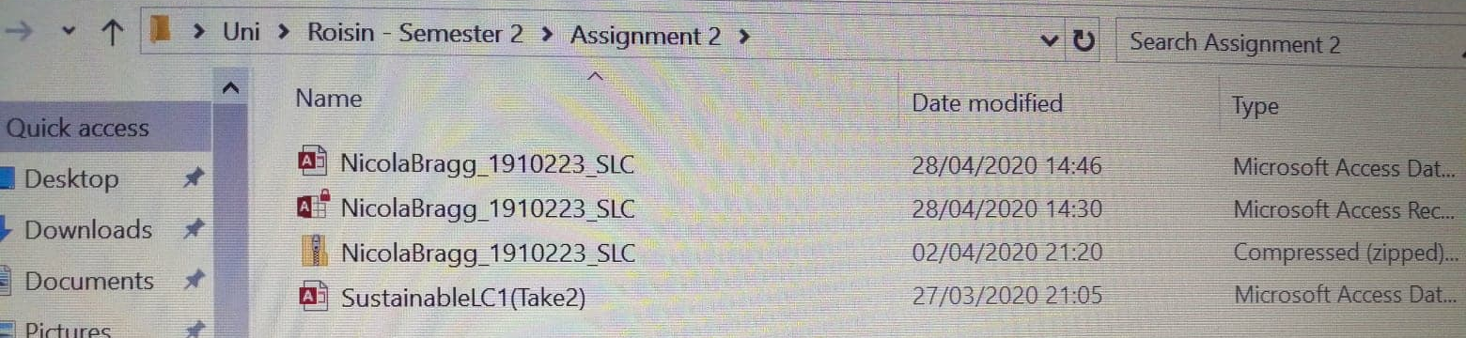
Conclusion
The knowledge retained from developing skills for Microsoft Access have improved dramatically. Theories that are understood relate to: database history, purpose and function of information systems, the need for databases within business, and designing the system. Software commands which are understood: navigation pane, ribbon, security measures, objects (Tables (adding/removing fields, data types, properties), Forms (and types of), Queries, Reports, Macros, Modules), datasheet/design views, entities, attributes, primary keys, foreign keys, ERD’s, relationships (and their types), and post/pre-design of a database. The SustainableLC company now has a database which is more efficient, easy to manoeuvre and simple for inserting/extracting data this will help with the day-to-day running of administration for the staff therefore should result in greater productivity, organisation, protection and privacy of data information processed.
Reference list
Computer Applications Training (2020). Access Queries
Available at: https://lib2.colostate.edu/images/cat/Access_Queries.pdf (Accessed on: 04 April 2020)
Hoffer, J., George, J., Valacich, J. (2011). Modern Systems Analysis and Design (7th ed, pp.6,
311-316.). U.S.A: Pearson Education Inc.
Lafler, K. (2017). One-to-One, One-to-Many, and Many-to-Many Joins Using PROC SQL
Available at: https://www.lexjansen.com/wuss/2017/124_Final_Paper_PDF.pdf (Accessed on 08 April 2020)
Laudon, K., Laudon, J. (2014). Management and Information Systems – Managing the
Digital Firm. U.S.A: Pearson
Microsoft Office. (2020). Learn the structure of an Access Database
Available at: https://support.office.com/en-gb/article/learn-the-structure-of-an-access-database-001a5c05-3fea-48f1-90a0-cccaa57ba4af (Accessed on: 01 April 2020)
Mullins, R. (2020). Semester 2 – Week 1: Introduction to access practical lesson 1
Available at: https://moodle.uwtsd.ac.uk/course/view.php?id=3564 (Accessed on: 01 April 2020)
Mullins, R. (2020). Semester 2 – Week 3: Practice Task – Paper Exercise
Available at: https://moodle.uwtsd.ac.uk/course/view.php?id=3564 (Accessed on 01 April 2020)
Staffordshire University (2008). Creating Forms in Microsoft Access 2008
Available at: https://www.staffs.ac.uk/images/user166_access_forms_tcm68-28841.pdf (Accessed on: 06 April 2020)
Staffordshire University (2007). Producing Reports in Microsoft Access 2007
Available at: https://www.staffs.ac.uk/images/user167_access_reports_tcm68-28842.pdf (Accessed on: 08 April 2020)
Staffordshire University (2007). Creating Tables in Microsoft Access 2007
Available at: https://www.staffs.ac.uk/images/user164_access_tables_tcm68-28392.pdf (Accessed on: 06 April 2020)
Ziemba, E., Wielki, J. (2016). Towards a Sustainable Information Society: Business in the
Sustainable Information Society (pp.134)

Appendix 1:
Timeline of System Types
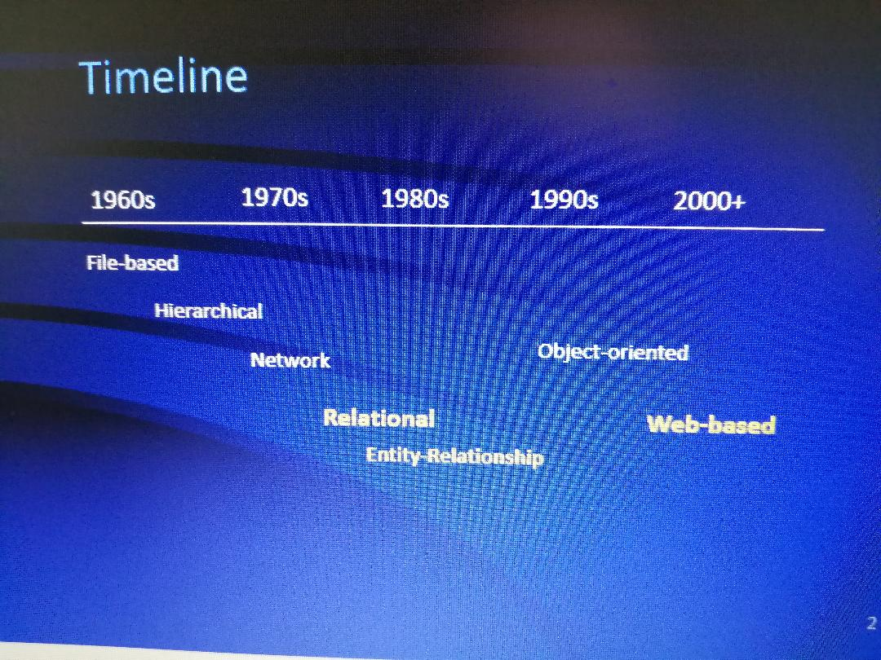
(Mullins, 2020) [Semester 2 – Week 2 – powerpoint – slide 2]
Available at: https://moodle.uwtsd.ac.uk/course/view.php?id=3564

Appendix 2:
Diagram of the Interdependence Between Organisations and Information Systems
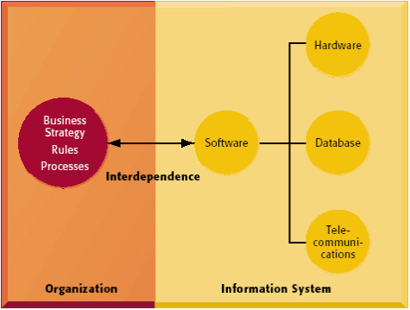

Aavailable at: Laudon, K., Laudon, J. (2014). Management and Information Systems – Managing the Digital Firm. U.S.A: Pearson
Appendix 3:
Diagram of Major Types of Systems in Organisations
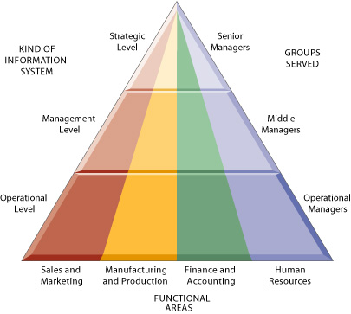

Appendix 4: Task results
Available at: Laudon, K., Laudon, J. (2014). Management and Information Systems – Managing the Digital Firm. U.S.A: Pearson
Appendix 4:
BMSP4004: Generating Business Data and Analysis – Week 2 Tasks
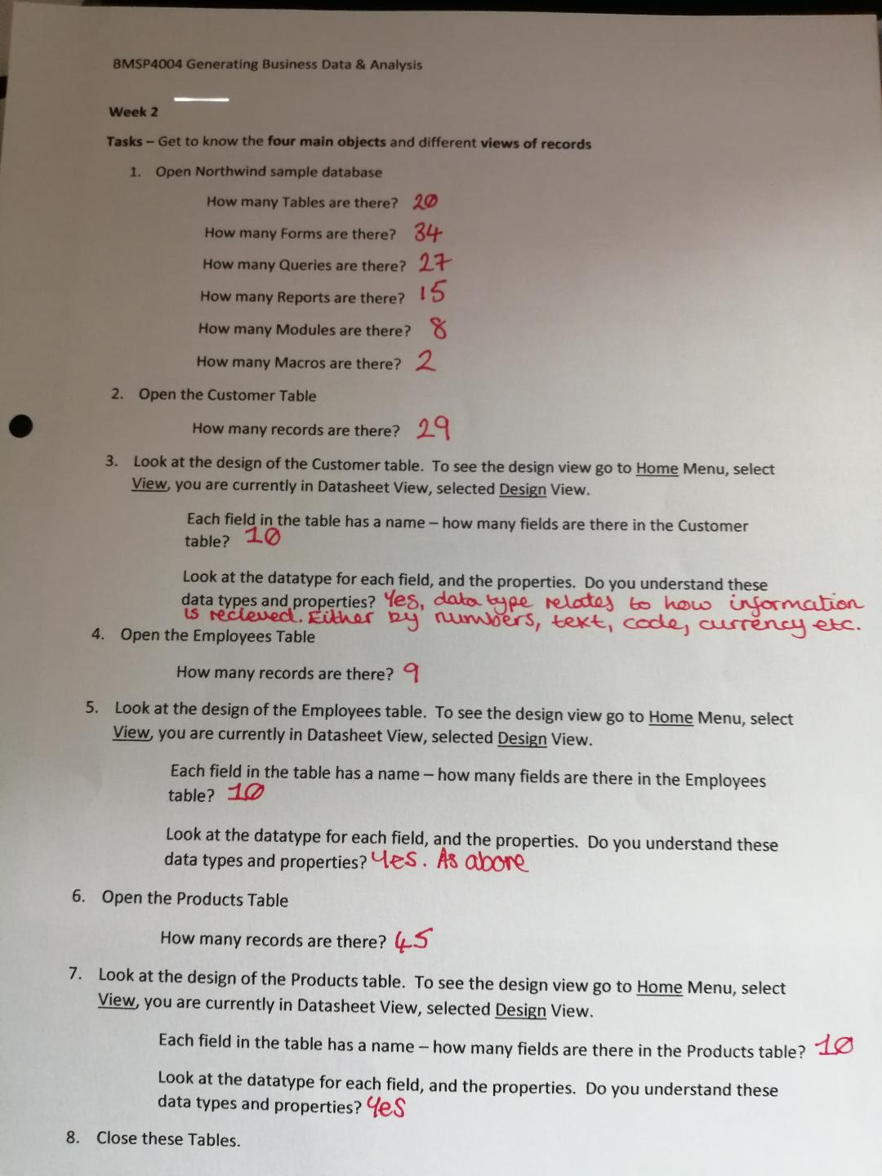
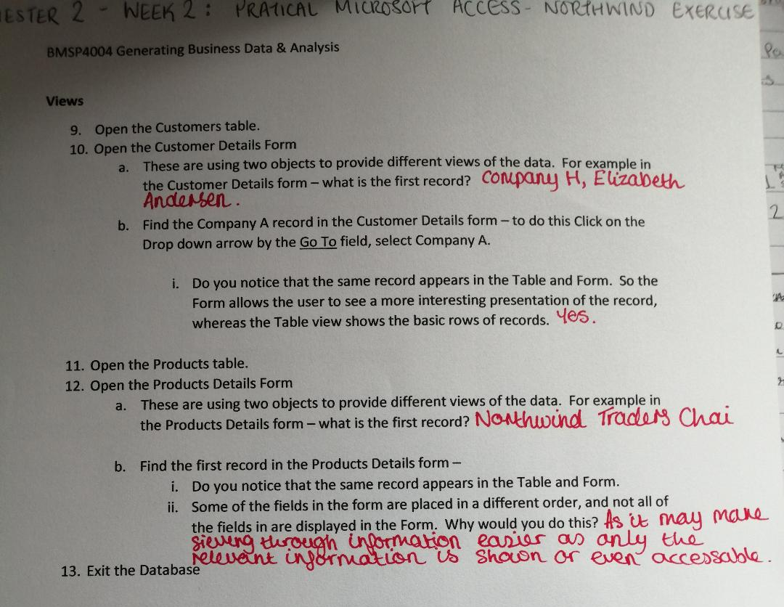
(Bragg, 2020) Available at: Own data

