
panm
Applied Computing

Wales Institute of Science and Art (WISA)

Networks and Cybersecurity Essentials (ACCA4024)

Lab 7: Tools to check on Threats and Vulnerabilities



n.kaliyamurthy@uwtsd.ac.uk 1

Objectives
Using Packet Capturing tools and network monitoring tools.
Tasks
1. Use Nmap to scan 2.
Required Resources
- PC with Ubuntu 16.0.4 LTS installed in a VirtualBox or VMware virtual machine. (Alternatively, Any Linux Platform)
- Internet Connection to refer the outcomes o References: https://nmap.org/

Task 1
- Login as User Cisco.
- Go to Terminal and Type the following commands and examine o To do that we are using Nmap.
▪ Network Mapper, or Nmap, is an open source utility used for network discovery and security auditing. Administrators also use Nmap for monitoring hosts or managing service upgrade schedules. ▪ Nmap determines
        - what hosts are available on a network,
        - what services are running,
        - what operating systems are running, • What packet filters or firewalls are running?
o So, basically if you could get all the above details using Nmap, you could get few information which could be used later in performing attacks or mitigating attacks.

- Commands to execute o Step 1:
▪ nmap localhost
(This is a scan performed to get information about the services that are bound to the localhost)
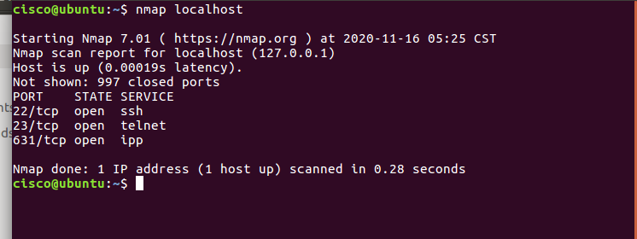

o Step 2:
▪ Replace the above command with your IP Address and other hosts (if connected/ else ignore) in your network to check the outcomes.
Type the command you used to find out your host IP Address
ifconfig
Type the command you used to scan after finding your host IP Address
nmap 10.0.2.15
Record the outcomes of the above command here
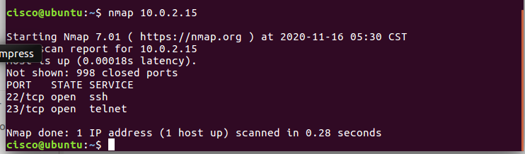

Step 3: Analyse the outputs/outcomes from Step 1 and 2 and record your reflections. (Hint: Analyse what is the difference between local host and ip address of the host, If ports displayed are different, Why is it different? etc (not limited to the hints))
Local host and ip address both 22/tcp open ssh and 23/tcp open telnet ports
However the local host also 631/tcp open ipp
Local host showed 997 closed ports and ip address showed 998 closed ports

- Step 4: Why is the nmap scan only scans the first 1000 ports? What will be the command to scan all the ports?
By default nmap scans the most common 1,000 ports for each protocol
The beginning and/or end values of a range may be omitted causing nmap to nmap to use 1 and 65535, respectively. So can specifiy -p- to scan ports from 1 through 65535
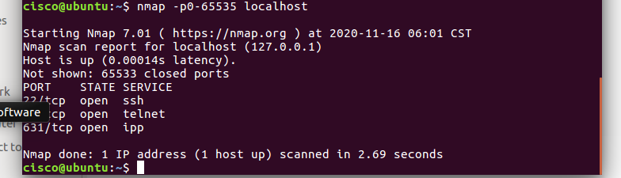

- Step 5: Scan the UDP Ports
    - nmap –sU localhost
(This is a scan performed to get information about the UDP ports and to execute this command you need root privileges. So, try)
    - sudo nmap –sU localhost
Record the outcomes of the above command here (Hint: what UDP ports could you find open through your scan)

68/udp open filtered dhcpc
631/udp open filtered ipp
5353/udp open filtered zeroconfsud

- Step 6: From the above outcomes select any ports which is open
▪ sudo nmap –p137 localhost
(Change the port number 137 to any port which you found as open in the previous step (5).)
Record the outcomes of the above command here (Hint: Is the port open or closed? Why? Also, record the use of –p command)

I used port 631 – and I can see that it is open
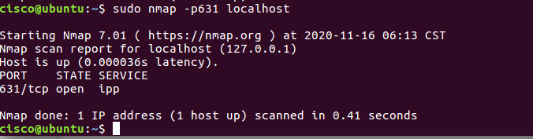

- Step 7: Try other port related commands and record its purpose.
    - sudo nmap –pportnumber host_ip
    - sudo nmap –pportnumber_startrange-portnumber_endrange host_ip
    - sudo nmap –pportnumber,portnumber host_ip
    - not limited to the above (Do a google search, refine your search and find out other port related commands, Hint:nmap.org)
Record the outcomes of the above commands here

Sudo nmap -p0-65 127.0.0.1
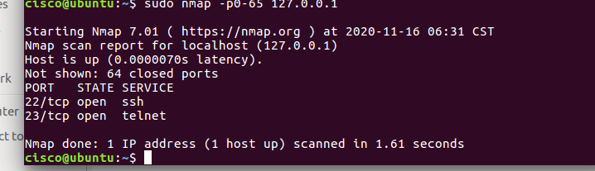

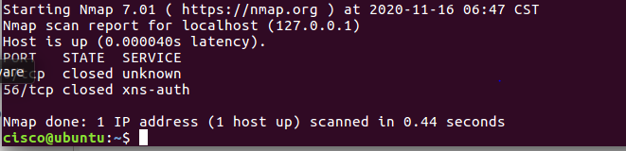
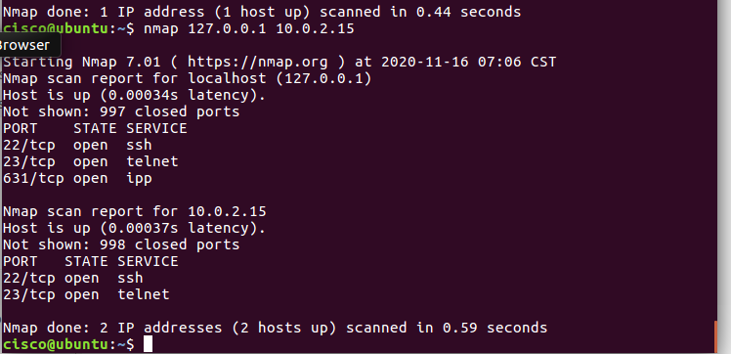
nmap 10.0.2.15 -254 (scan a range)
nmap scanme.nmap.org (scan a domain)
nmap 10.0.2.15/24 (scan using CIDR notation)
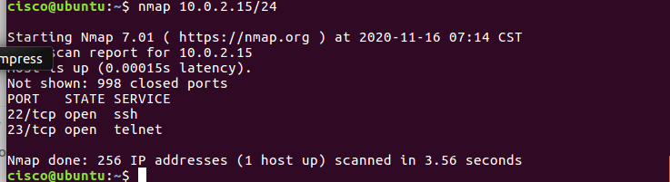

- Step 8: Detecting the version is a very important part of information gathering. Try to find out the version. ▪ nmap –sV localhost
Record the outcomes of the above commands here
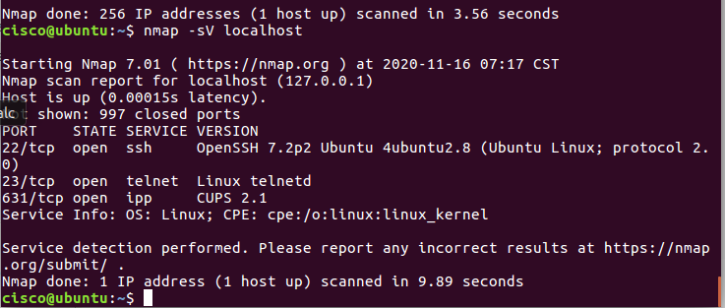

- Step 9: Try other commands to detect other versions and record its purpose.
      - Command to identify the Operating System version

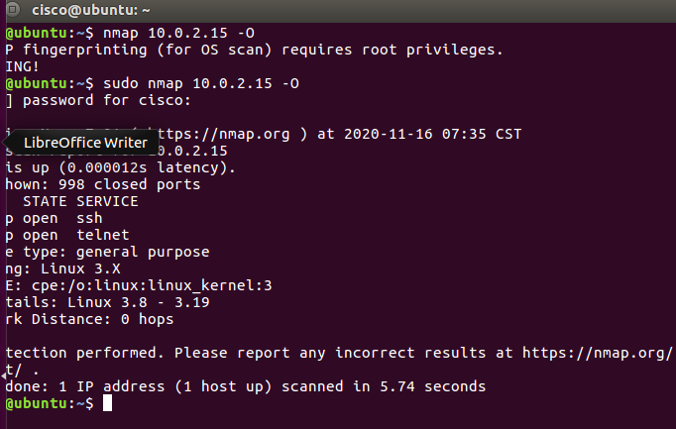
      - Command to identify the Service Version
Record the outcomes of the above commands here
nmap 10.0.2.15 -A (enables OS detection, version detection, script scanning and tracerouter)
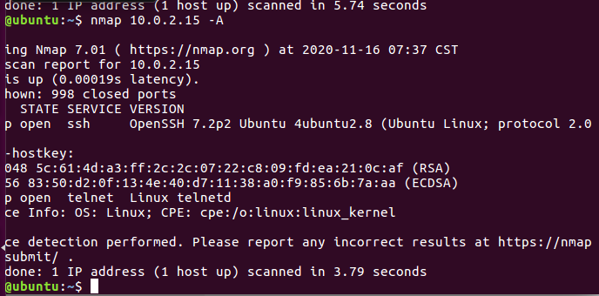

Learnings from tutorials so far:
Part 1 (Packet Tracer, Host Machines)
  - Build a home Network
  - Understand and configure IP Address
  - Use Ping/ Trace route Utility to check the connection status
  - Use ipconfig /all command to determine the MAC address of a Windows computer on an Ethernet network.
  - Analyze a MAC address to determine the manufacturer.
  - Analyze the Wired and Wireless Network connection.
  - Analyze Address Resolution Protocol (ARP).
  - Connect to a Wireless Router and configure the basic settings in a wireless router and add security features.
  - Use nslookup command to understand the url to ip conversion.
  - Configure basic connectivity settings in Intermediate devices (Switch/ Router).
  - Work with SBA Packet Tracer Files/ environment
  - Configure ftp, web, email, dns, ntp and aaa Servers Part 2
  - Set up a virtual lab environment
  - Troubleshooting the virtual lab environment
  - Working with virtual machines
  - Authentication, Authorization and Accounting
  - Threats and Vulnerabilities – Using NMAP

