Web Technologies for business
e-Commerce and e-Business Application review
Author: Damian Meewis
Lecturer: James Williams

Table of Contents
Evaluation 3
Introduction 3
Example1 – Wordpress.com 3
Example 2 - Volusion 6
Example 3 – Shopify 8
Test 10
Example 1 – Volusion 10
Example 2 - Shopify 12
Create a Website - Volusion 14
e-Business Applications 19
VoIP 19
Content management system 19
Search Engine Optimization 20
e-Commerce 20
Customer relationship management 20
Cloud Accounting 20
Works Cited 21

Evaluation

Introduction
In this part of the report =, current responsive e-Commerce site design options will be evaluated on the basis of their professional layout, response to mobile devices, product catalogue, shopping cart, payment options, updates via gui for non-technical personnel, hosting maintenance and how reasonable they are.

Example1 – Wordpress.com
Word Press have an extension called WooCommerce which is free for websites created via WordPress.

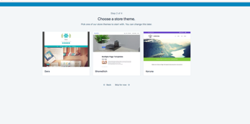
Professional Layout
WordPress offers a vast amount of themes, but only a few are able to be used for an e-commerce website but they are modifiable.

When you go through WordPress it offers three themes which is very limited even if they can be altered, the ability to customize is better for experienced developers as they see how flexible it is but for on technically gifted creators will most likely stick with the template if possible.

Response to mobile devices
Wordpress has a lot plug ins that go with the website and mobile pages comes with, the plug in allows you to choose what pages you want to show and automatically program them for mobile use with the same layout as the website. They also have word app so that you can make an application for both android and IOS, this also supports WooCommerce and comes with its own advertisement. You can then send push notification from WordPress dashboard straight to the mobile devices.

Product Catalogue
The product catalogue is very simple but efficient, it can have multiple catalogue pages and then within those pages have tags to the product. The design can also have the professional layout of the website.

Shopping Cart
The shopping cart system can be the same layout as the website or be linked to a PayPal shopping cart for ease of payment. The merchant shopping cart will show the shopping cart as the user is browsing the products

Payment options
Word press offer multiple plugins for payment options. This includes PayPal, Ready! Ecommerce Shopping Cart and Sell Digital Downloads which is for businesses selling software that the user can download straight away. They all come with Pay Pal but the easy version offers the buy now button which means a consumer can look at a product and instead of going through the basket go straight to payment and delivery.

Updates by non-technical users
WordPress will continually be rolling out updates but have got instruction pages that will help non-technical users update their website along with the e-Commerce. They do recommend using JetPack to back up the website incase things go wrong and ranges from a price of £3-25 per month. For testing the updates they also have a manual for the non-technically gifted with terms to know and with support from their Woo experts. To update the extensions as it is all run by plug ins you can see which plug ins need to be updated and their update dates with warnings not to run a live website till they have been tested on the website.

No hosting maintence
The website does offer pug ins for businesses so they do not need to do any maintenance but as the website will be running on plug ins made by the host it will need maintaining.

As reasonable as possible
WordPress offer a lot of plug ins for a website that make it frustrating to pick as they can have 20 all doing the same thing so for the non-technically gifted it makes it harder for them to choose but the creation of the website and the e-Commerce is simple enough for everyone to understand with an easy payment option.

Example 2 - Volusion
According to www.Business.com the best e-Commerce software for ease of use, they gave to Volusion [1]. They offer the user direct contact to users to help them start up their e-Commerce website. The cost of volusion is $15 per month for 100 items and 1GB bandwidth, $35 per month for 1000 items and 3GB bandwidth and $75 per month for 1000 items and 10GB bandwidth but get 10% off if you pay annually but if the website goes over the bandwidth they get charged an extra $7 per gigabyte.

Professional Layout
Volusion offers multiple templates than what WordPress offers and premium templates to. Their templates do have a similar style and less customizability as you can choose the colour best for the business and the font. Technical users can play around with the HTML and CSS files to further customize the website and will be accessible for any device.
Response to mobile devices
Volusion released their mobile storefront in fall off 2013 which they have had to continuously upgrade due to errors and falling short of what the desktop version offers but in 2014 offered the use of the volusion templates to the mobile system but this still has errors as they use the same kind of HTML code as the websites so moving it to smaller devices they just shrunk to fit the screen. Volution has now made several uprgrades and methods to make it easier to gain mobile traffic the original volusion mobile storefront which has minimal customizability but passes as mobile friendly. They also have responsive theme websites but instead of using an original template it has to be new so for an existing website can cause issues.

Shopping cart
The designing of the shopping cart is a lot easier than other solutions. It is similar to WooCommerce as it offers the same product search options and tags but Volusion allows the user to add more detail to the product as well as giving it a more modern style rather than WooCommerce generic style for its shopping cart.

Payment options [2]
Volusion offers multiple payment options including a payment gateway which will need a business to sign up with a merchant program. It also has PayPal and amazon pay for more widely known payment options that makes a customer feel safe and then an added cash option and cheque can also be set up but the payment will have to be validated by the business.

Updates by non-technical users
All of the updates are automatically made and do not need the user to do anything for extra ease, they constantly make volusion easy for non-technical users and if the user has any issues, they offer a real time chat to make it easier to find answers.

No hosting maintenance required
Volusion give instructional steps to maintain your own website so that no hosting maintenance is required.

As reasonable as possible
Volusion offers a simple to use design system where the user does not need to know any code to create a website in the design they want but also limits on how much can be done with the website. They also allow for the user to add their products to amazon and link between the two and as amazon is so popular will be free product placement for the business. It does not have a blog feature to market the product which is a downfall as it is a potent marketing chip to have.

Example 3 – Shopify
Shopify according to business.com is the best e-Commerce platform for small businesses [3]. This is because in each of the plans it includes unlimited bandwidth and storage to support an unlimited amount of products and also has 24/7 support service. The cost of Shopify is $29/79/299 per month depending on the plan that the business wants.

Professional Layout
Shopify offers 25 free templates and have additional templates that can be purchased and has a built in blog to help market the business.
The layouts are very professional and stylish which allows the business to scheme it the way they want to represent their business and unlike the other two examples offers a lot more styles for new businesses who are not as adept to designing.

Response to mobile devices
Additionally to running a desktop version Shopify also allows a free built in e-Commerce for mobile devices using HTML so that is compatible with all devices [4], As it moves on to mobile they have a separate layout but the themes will need to be changed and they offer a wide range that the user can look through to match their desktop site. Although the design might look different it will be fully integrated like the desktop version.

Product Catalogue
Shopify allows the user to make their own catalogue but also offer for an automatic catalog builder which allows the user to add items and design faster. It compromises for personal design but they offer professional layouts so if the business is not fussed on whether they want a personalized store they can bulk add all of their products and have the catalogue made straight away.

Shopping cart
The shopping cart is very simple as they show what kind of payment they will accept and then the products in the cart with their original value and total value for multiple purchases.

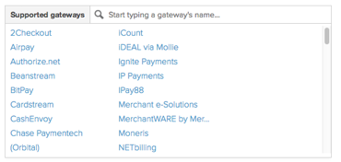
Payment options
The payment gateway integration offered by Shopify is vast including PayPal, BitPay and their own Shopify pay so that the business can find the best payment service for them.

No hosting maintenance required
All of the updates to the system are instant and have no hassle for the user so no maintenance is required from the user.

As Reasonable as required
The Shopify system is very reasonable including its price set for giving all the users unlimited product range and bandwidth, it has a lot of design features for the user to utilize and the cut is that they take 0.5 to 2% of each sale depending on the plan that the business uses.

Test

Example 1 – Volusion
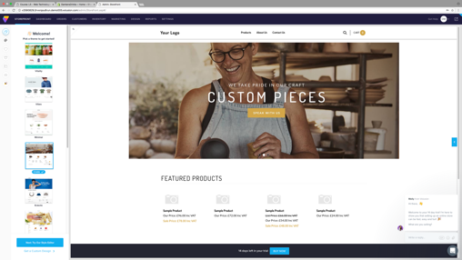

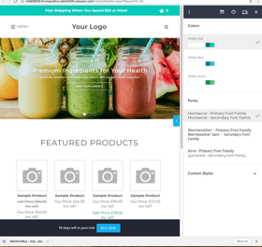
The first stage lets you pick between 10 picked layouts which you then go into style editor so the creator can go through the colour scheme and the font style. The creator can continuously check through the style on the desktop and mobile devices. But the system will only condense it to the width of the device and keep the style of the desktop version meaning there is not a separate on just for mobile use.
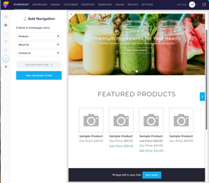

The additional add ins such as more pages to segregate items within the store or make a blog to market the blog
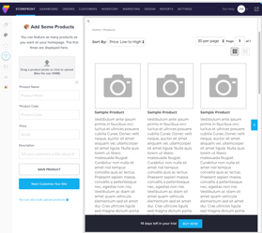
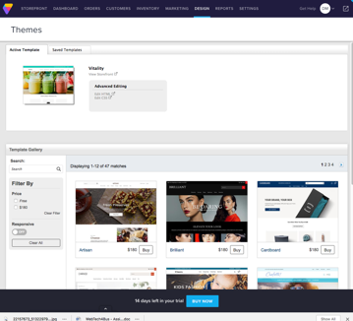
If the style is not what the business is suited for they can manually edit the HTML code or the CSS and buy premium styles.

The products can all be added easily with details and a photo then placed in the registry of products to be placed later on. The customers can choose how many products are shown and filter other options.

Example 2 - Shopify
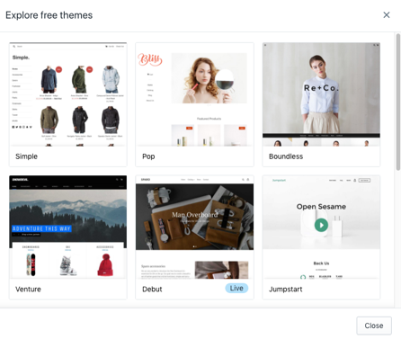

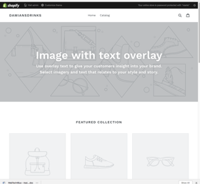

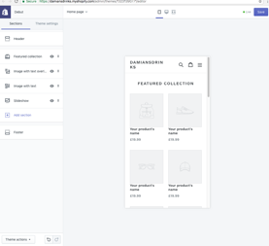
When choosing the layout for the website they give examples of other businesses using a certain template which is good as you can compare your product to what other competitors have used. I chose simple as a guideline for web design is simple is beautiful and they offer a lot of simple designs to choose from.

You can then drag and drop images and write texts into the spaces provided by the design, whilst the business is being built on the desktop version you can see the alterations on the mobile device so you can constantly check the progress of the website
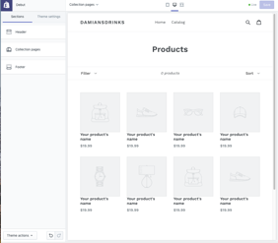
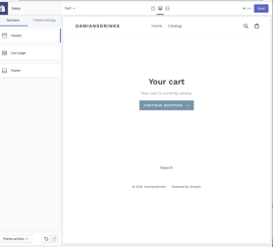
Shopify also lets you edit the shopping cart so that you can add images or logos around the basket and add the menu on the footer of the cart.

The product catalogue can be edited to show how many products can be displayed at a time and but no separate pages individualizing the items, there is only a filter section to find related items.

Create a Website - Volusion

I started with picking out a simple theme that I can add images too that kind of fit my relaxed theme with the color scheme. Colors are crucial to a website as they need to be consistent to fit the guidelines and also make sure they do not clash.
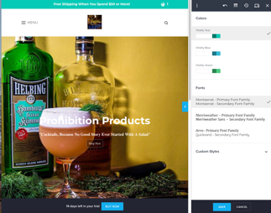
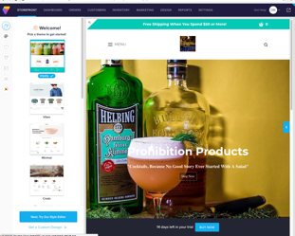

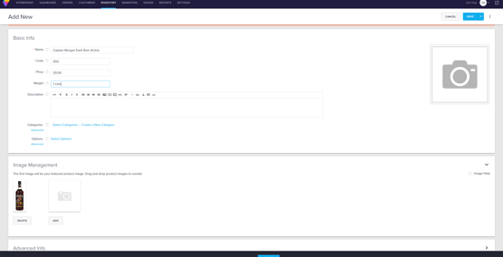
Adding a product is easy as it will place it for you, all you have to do is add the details about the product and add an image.

In the navigation section you can add multiple pages but I only added 1 as I thought 4 would be enough because navigation should be intuitive as a web design guideline as users should be able to easily navigate the website and not be sent around the world to find a product or section of the website.

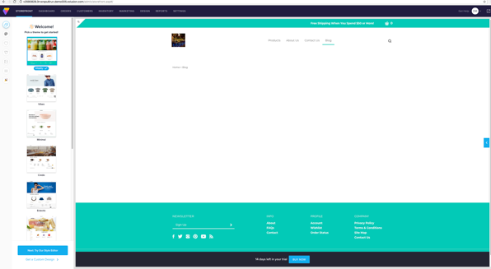
Content is also a major guideline and as you can see there is no content yet but I decided to add a blog to the commerce site so that people will be able to see the products in use and how to make the most of them and then purchase the product afterwards.
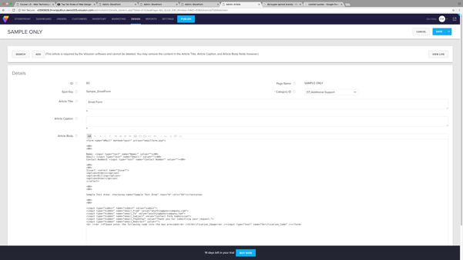
To edit the website you need to be familiar with HTML, they do have guides to show you how to create content but some parts do need editing with a bit of coding. The contact section of the website was not editable from the page you had to be redirected into the coded section to change a few bits as you can see.

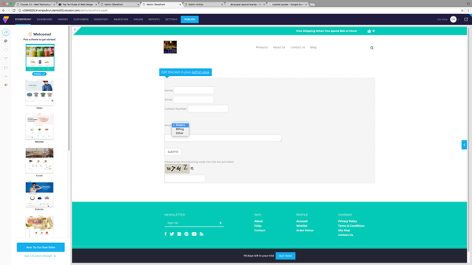
Now the contact section has a drop down section for issues that the owner can see labeled under what the issue was about.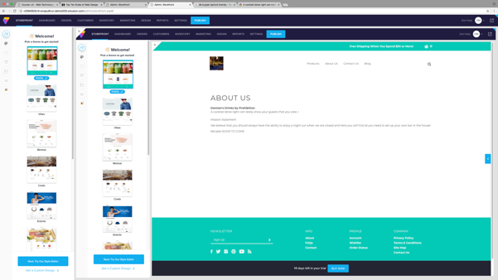
A website should always have an about page to let the consumer know a little about the business or what the business aims from selling their product.

The product page is simplified that the user can just add to cart or add multiple and then leave a review of the product on the website or linked to the product manufactures social media.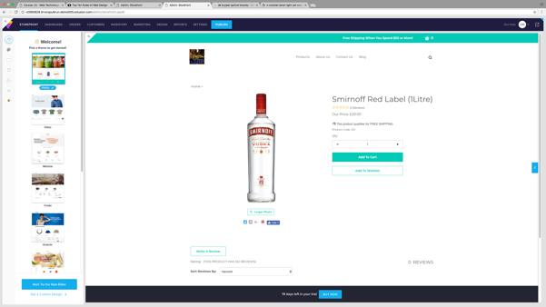

The product is then added to the cart which shows the price and quantity which can also be edited from the cart and then has a recalculate button to come up with the updated price if the consumer wants to change the amount of a product. If the business wishes to release coupons then the codes can be added below the order details.

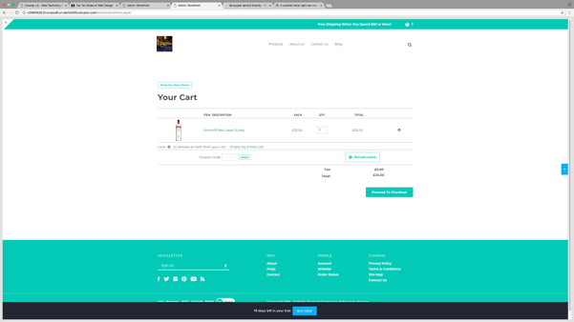

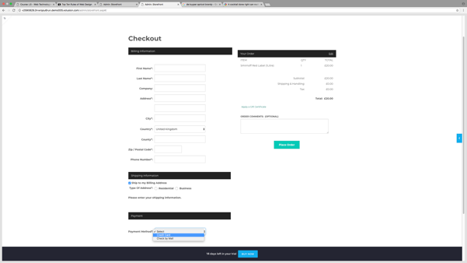

The order can then be processed through the shipping details with the order on the right, there can also be multiple payment options such as cash/PayPal or from a debit or credit card.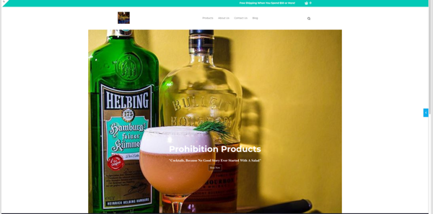

e-Business Applications

VoIP
This stands for Voice over Internet Protocol which is a piece of hardware and software that allows people to communicate using internet providers rather than traditional circuit transmissions. [5] This allows businesses to better communicate and stay leveled with bigger businesses who use telecommunication. A hosted VoIP is easy to install and inexpensive for businesses. I recommend a business to use skype because it is free and globally used by a lot of businesses.

Content management system
A content management system is a piece of software application that lets the business control all their social media sites to keep track of their work across multiple practices. [6] I recommend the use of word press as they also allow website creation and let you post website created content straight to social media and vice versa to the website.

Search Engine Optimization
SEO for short is a methodology of strategies, techniques and tactics that will increase the traffic of a website by getting higher ranking in (SERP) or search engine results page. They work with title tags and meta descriptions from a website to make people looking for those products easily directed to your website. I would recommend moz as it does weekly crawls of the website which notify the owner of any performance issues, it will also let you keep an eye on your competitors and their rankings to keep the business on the edge.

e-Commerce
Is the buying and selling of goods and the front of any e-Business, these can be business to business or business to consumer. I recommend the example I did above using for its prices and ease of use that allows the business to add all the products they want with freedom of bandwidth.

Customer relationship management
This is technology that lets a business small or large organize their customer interaction including marketing, sales, customer service and support. I recommend using SalesForce as it is used by a lot of different sized business to help a business down size or increase.

Cloud Accounting
This is similar to traditional accounting software except it is hosted on remote servers. Instead of keeping all the accounting on one system this lets you grab it from the internet rather than the hardware in front of you, this makes it a lot more safer. I recommend using SAGE for SME’s as they have the best pricing and offer financial management products that can be used on multiple devices.

Works Cited

[1] | business.com. [Online]. Available: https://www.business.com/categories/ecommerce-platforms/.
[2] | Volusion. [Online]. Available: http://helpcenter.volusion.com/get-started/getting-fancy/managing-your-payment-settings.
[3] | business.com. [Online]. Available: https://www.business.com/categories/ecommerce-platforms/.
[4] | Shopify. [Online]. Available: https://www.shopify.co.uk/tour/mobile-commerce.
[5] | WeboPedia. [Online]. Available: https://www.webopedia.com/TERM/V/VoIP.html.
[6] | [Online]. Available: http://searchcontentmanagement.techtarget.com/definition/content-management-system-CMS.
[7] | Business.com. [Online]. Available: https://www.business.com/categories/ecommerce-platforms/.
[8] | [Online]. Available: https://www.investopedia.com/terms/e/erp.asp.

