

Student Name: Varsha Garo

Student ID: 2538416

Module Name: Human Capital Management

Module Code: LCMB7023_LON

Strategic Human Capital Architecture for Organisational
Renewal at Helios Urban Mobility

Lecturer’s Name:
Dr. Gladius Kulothungan

Work Count: 2600
Term 1
Table of Contents:

1. Task A: Socialisation, Identity and Business Activism 3
1.1 Traditional Onboarding versus Strategic Organisational Socialisation 3
1.2 Psychological Contract Theory, Identity Construction and Organisational Citizenship 3
1.3 Structured Socialisation Framework for Helios 4
1.4 Organisational Identification, Ethical Professionalism and Business Activist Mindset 5
2. Task B: Innovative Job Design for Strategic Renewal 6
2.1 Application of the Job Characteristics Model 6
2.2 Job Crafting Theory and Employee Autonomy 6
2.3 Skills-Based Architecture and Internal Talent Marketplaces 7
2.4 Intrinsic Motivation, Innovation and Organisational Agility 7
3. Task C: Reflective Report 8
3.1 Use of AI as a Decision-Support Tool without Reducing Human Judgement 8
3.2 Personal Capability Development Plan for Future Employability 9
References 11

1. Task A: Socialisation, Identity and Business Activism

1.1 Traditional Onboarding versus Strategic Organisational Socialisation
Helios Urban Mobility (HUM) has difficulties beyond simply attracting new talent; they struggle with retaining need talent across their global work locations. HUM's expansion has resulted in weak socialization in their new employees with long ramp-up times, decreasing interest and high turnover within their new high-potential talent (UWTSD, 2026).
The traditional approach to onboarding new employees is very transactional and administrative. New employees are introduced to policies, job descriptions, compliance, as well as how to access company systems and procedures. While these steps are important, they will not likely lead employees to develop a sense of belonging and identity within the organization, or a desire to be actively involved in the organization. Van Maanen and Schein's (1979) socialization theory suggests that newcomers to an organization learn the values, behaviors, and expectations of the organization through Social Learning.
Socialization within a corporate framework is best suited to HUM and in particular combines the integration of employees with the long-term development of the firm’s corporate capabilities. Rather than “how we do business” in a rapidly growing corporate environment engaged with AI, the focus must be “how we do business ethically”, “how we do business with innovative stakeholder engagement” and “how we do business with technical proficiency.” The CIPD’s engagement guide says that while engagement is driven by satisfaction and short-term morale, it is also and primarily the result of motivation, connection, organizational identification and commitment (CIPD, 2025).
Helios should transition from transactional onboarding to strategic socialization. The objective should be to less apprehension and higher productivity while cultivating dedicated “organizational citizens” who embody an understanding of both the business and social facets of smart urban mobility.

1.2 Psychological Contract Theory, Identity Construction and Organisational Citizenship
Psychological Contract Theory helps us understand the graduate attrition Helios faces. Rousseau (1995) describes how employees have informal agreements that expectations of career advancement, developmental support, and fairness along with recognition and meaningful work will be provided. When these expectations are unmet, a psychological contract is breached, and employees withdraw and disengage. Helios should expect that high-potential graduates will join the company, driven by the expectations of joining an innovative company that offers mentoring, international assignments, and rapid career development. Ambiguity of roles, no constructive feedback, and a deficiency of formal onboarding will lead to high attrition, regardless of the employment contract.
Identity construction is especially critical in this case. Ashforth and Mael (1989) argue that employees develop a strong psychological contract with the company when the company membership is part of their self-concept. This means that employees of Helios have to learn their functional roles and integrate with the core identity of the company, which is a sustainable, AI-enabled urban mobility company.
This will foster a voluntary employee behavior that aids colleagues, aids knowledge sharing, and supports creativity and innovations and will also give a favorable Helios representation. Kahn (1990) suggested that socializing the new employees of Helios will also lead to an enhancement of the psychological contract. This is necessary due to the current low engagement in the company and the new employees of Helios take an unduly long time to reach full productivity, (UWTSD, 2026).

1.3 Structured Socialisation Framework for Helios
Helios should implement a three-stage employee socialization framework for the pre-boarding stage, first 90 days, and first year.
Stage 1: Socialization efforts should begin immediately after a job offer is accepted. New hires should receive initial training via a digital pre-boarding portal containing Helios’ mission, vision, values, principles of ethical AI, and advancements in corporate social responsibility. New employees should also receive additional pre-boarding support in the form of a designated mentor. This would ease pre-boarding anxiety and strengthens the psychological contract by demonstrating Helios’ active interest in its employees.
Stage 2: The first 90 days of an employee’s new role should focus on the social and professional integrations required to support positive contributions to the organization. This should include a series of manager and buddy support check-ins, role-related training, cross-department meetings, and customer case ethical decision-making workshops. The first 90 days should also include a personal development conversation, bridging the graduate’s individual career aspirations and organizational opportunities.
Stage 3: The focus of the first year on the job should support the development of a culture of citizenship around the organization and should include participation in innovation projects, international collaboration, corporate social responsibility volunteering, and the provision of internal knowledge seminars and quarterly career conversations. This addresses Helios’ organizational needs for employees to have an understanding of the organization beyond the role they fulfill.
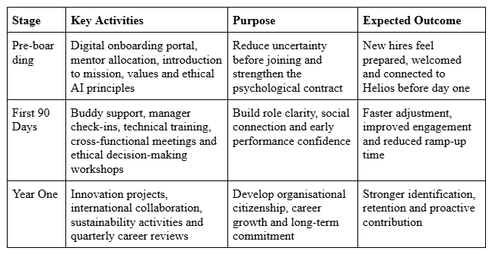

Table 1.1: Strategic Socialisation Framework for Helios Urban Mobility

1.4 Organisational Identification, Ethical Professionalism and Business Activist Mindset
Leadership storytelling, mission-based communication, and integration of employees’ work into the organization’s vision for sustainable city mobility will strengthen organizational identification at Helios. Senior leaders must become the storytellers of Helios’ vision of AI-embedded transport systems creating ‘better’ public infrastructures by removing inefficiencies and supporting environmental outcomes. Connecting the organizational purpose to the personal meaning will also be achieved by developing Helios’ systems.
Ethical professionalism must characterize the work of Helios employees as well. Because Helios works with AI mobility systems embedded in the city systems of client nations, Helios employees must receive training on responsible AI, data ethics, and the impact of bias, as well as, sustainability and stakeholder engagement. Developing complex and responsive organizational structures demands ethical HR practices and the professional behaviors of employees. The CIPD’s Profession Map emphasizes ethical practices that are evidence-based and outcome-oriented (CIPD, 2026).
Finally, Helios must develop a “business activist” philosophy. Ulrich (1997) claimed that HR must strategically contribute beyond an administrative role. Expanded, employees must be supported to identify barriers, inefficiencies, provide constructive criticism of the organization, and engage in creativity and innovation. It is an expression of stakeholder capitalism, which asserts that organizations should produce value beyond shareholders for employees, customers, communities, governments, and the environment (World Economic Forum, 2020). Helios must instill business activism by providing innovation forums, developing systems for employee voice, creating sustainability challenges, and recognition for various roles and functions.

2. Task B: Innovative Job Design for Strategic Renewal

2.1 Application of the Job Characteristics Model
Helios Urban Mobility needs a new job design strategy to tackle motivation, graduate attrition, and strategic renewal. The assignment brief cites disengagement, low socialization, and slow employee ramp-up as problems. To counter these issues, job design must go beyond allocating tasks and create meaningful roles focused on innovation and development.
Hackman and Oldham’s (1976) Job Characteristics Model provides a strong foundation to analyze issues at Helios. The model describes how five job elements affect motivation. These elements are skill variety, task identity, task significance, autonomy, and feedback. Jobs at Helios should focus on the elements of task identity and skill variety. Helios employees should be organized to work on entire smart-mobility projects like AI traffic analytics, sustainability dashboards, and client transport solutions.
In this way, Helios employees would be able to work on the entire smart-mobility project from the analytic and technical task design to client engagement and project implementation. Task significance of Helios projects would be demonstrated by employees seeing how their work supports efforts to improve the efficiency and sustainability of public transportation and citizen mobility. Helios employees should be organized into project teams, and within defined ethical and performance limits, be afforded the autonomy and responsibility to design and implement the project work. Feedback would come from supported Helios employees throughout the project and would be supplemented by user data and city government representatives (CIPD, 2025). This model aligns with the CIPD guidelines of a meaningful, quality job for the employee and a job that optimizes work processes for the employer.

2.2 Job Crafting Theory and Employee Autonomy
The Job Characteristics Model is centered on management's role in crafting jobs. In contrast, Job Crafting Theory gives recognition to the role of employees in crafting jobs. Job Crafting, as defined by Wrzesniewski and Dutton (2001), refers to changes made by employees along task boundaries, relational boundaries and cognitive boundaries. Job Crafting is vital to Helios, a rapidly developing AI-enabled mobility organization. Job Crafting will help to employ proactive and adaptive employees willing to enhance work around processes rather than focusing only on job boundaries.
Helios should encourage the three boundaries of Job Crafting. Task crafting should allow employees to adjust work to fit their strengths and relational crafting should promote the building of cross-functional relationships through the offices in London, Berlin and Singapore. Lastly, cognitive crafting should encourage employees to view their work in line with Helios' mission of promoting sustainable urban mobility.
Like any theory, job crafting should have a limit. Helios employees’ role in crafting AI-enabled Infrastructure analytic jobs should not have unrestricted freedom. Job crafting should stay within the boundaries of responsible AI, data protection and defined project goals. Managers should, therefore, employ “guided autonomy” in job crafting. This is where employees craft their jobs freely, but should remain ethically and performance-wise accountable. Job crafting would therefore be a compliment to formal job design. Job crafting would make formal job design more personalized, flexible, and innovative.

2.3 Skills-Based Architecture and Internal Talent Marketplaces
Helios must create a skill-based structure with an internal talent marketplace. The traditional job-based structure is more rigid. Because of the nature of innovation work for a fast-growing smart-transport start-up, the work may require flexible combinations of artificial intelligence, engineering, data analytics, project management, sustainability, and stakeholder engagement. A skill-based structure would allow Helios to organize work as a result of a combination of capabilities, rather than having fixed job titles.
According to Deloitte (2022), skills-based structures allow organizations to make workforce decisions with a greater emphasis on skills over jobs, and support such decisions through the usage of a skills hub to make decisions regarding work, performance, learning, and particularly workforce deployment. For Helios, this means a central skills inventory may be created consisting of the skills employees possess and the skills employees wish to acquire along with their certifications, project experience, and career aspirations.
For Helios, the internal talent marketplace may be used to post short-term innovation challenges, client projects, and assignments in differing locations. The talent marketplace would allow employees to apply for projects that excite both the employees and Helios, and may possibly decrease the rate of attrition.
The talent marketplace will require manager approval, fair access to employees, and considerations for workload before flexible resource allocation. Helios should be cautious using skills data to offer opportunities that are open and prioritized to the needs of the business.
A skills-based architecture would enable Helios deploy talent faster to close capability gaps, and build a more agile workforce.

2.4 Intrinsic Motivation, Innovation and Organisational Agility
Aims of the job design strategy would stimulate employees' intrinsic motivation, provide employees with personally meaningful work, and provide them with developmental feedback. Helios is a knowledge-based organization that focuses on the development of AI mobility solutions. Where routine work is not the case, significant benefits are derived where employees cognitively perceive their work as meaningful and developmental. These employees show greater commitment, creativity, and discretionary effort to their work.
As per the World Economic Forum (2025), the fast-emerging technologies such as AI and big data, fueled by the internet and cyberspace, coupled with technological and data literacy, are key to defining the future of work. However, paramount to future work will be analytical thinking and the ability to integrate resilience, flexibility, agility and leadership with creativity. Helios is in a position to design work in a way that incorporates these elements.
Helios would achieve greater innovation and agility by using talent marketplaces and guided job crafting to give employees the ability to work cross-functionally to test ideas, learn from customers and solve real business problems.
While Helios aims to achieve greater flexibility, there is a balance to be achieved in order to prevent employees from burnout and having a lack of clarity in their roles. Having employees work with coaching as their primary mode of supervision is necessary in this case.

3. Task C: Reflective Report

3.1 Use of AI as a Decision-Support Tool without Reducing Human Judgement
In shaping future HR practices, AI will be a partial aid and not a substitution for my professional judgment. In managing human capital, AI can assist in the analysis of large amounts of employee data, recognize patterns in workforce data, analyze possible changes in policies, and provide information for the substantiation of strategic choices. In Helios Urban Mobility, for instance, AI will be able to help in the analysis of employee data in regard to disengagement, patterns of attrition among graduates, analysis of gaps in skills, and suggestions for improvement in the process of engagement and integration. However, HR choices must be made by individuals, as those choices have an impact on career, personal wellbeing, and the trust within the organization.
The CIPD Profession Map (2026) states that people professionals work in a principled, evidenced, and outcome-based manner. This shows that AI outputs must be scrutinized for ethics and for evidence, and in the light of the organization’s values, before they can be considered. In the course of my practice, I would view AI outputs critically and would validate them through the employee voice and the voice of the managers, legal frameworks, and the context of the organization. This would be done to address the concerns of AI reproducing bias and the risk of AI providing generalized solutions to incomplete and erroneous data.
Additionally, I would practice the “human-in-the-loop” approach. AI would be permitted to aid in the articulation of diagnosis and alternatives, but the evaluation of fairness, proportionality, and impact on the stakeholders would be done my HR professionals and managers. AI in HRM provides a competitive advantage, but also a risk, when it comes to the quality of data, AI transparency, and accountability frameworks. As a result, I would use AI to promote and enhance the organization’s analytical capacity, while retaining the balance of human judgment, empathy, and ethical consideration.
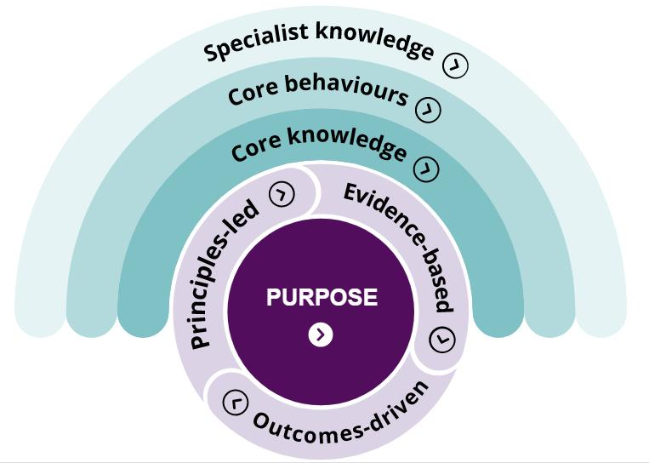
Figure 3.1: CIPD Profession Map showing purpose-led, principles-led, evidence-based and outcomes-driven HR practice.
Source: CIPD Professional Map Overview.

3.2 Personal Capability Development Plan for Future Employability
Creating capabilities at the intersection of digital fluency, strategic thinking and global consciousness will enhance my prospects for employability for roles in human capital management. The World Economic Forum (2025) focuses on technology, AI and rapid changes in the economy and demographics on the evidence of the global workforce (1,000 employers and 55 economies) to identify the most significant disruption of the labor market by 2030. In response to these challenges, HR personnel will be expected to understand the dynamics of people management along with the transformation of a technology-enabled workforce.
The first development priority is data literacy. Specifically, I will interpret HR dashboards, engagement surveys, attrition data, and workforce planning metrics so that my recommendations will be data driven rather than based on personal opinion. The second priority is 'AI as an Augmentor of HR'. I will understand how AI tools can shape HR practices in recruitment, the design of onboarding and skills, mapping and the employee experience by maintaining an ethical framework. The third priority is strategic influence. Since HR will have a more strategic focus, I should be able to articulate people-related recommendations to the executive in business terms and substantiate HR spending. The fourth priority is the awareness of global mobility, as organizations like Helios operate in multiple countries.
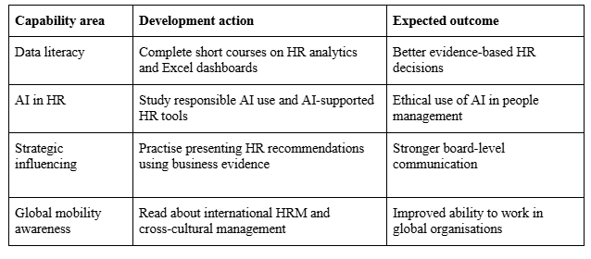
Table 3.1: Personal Capability Development Plan

References
- Ashforth, B.E. and Mael, F. (1989) ‘Social identity theory and the organization’, Academy of Management Review, 14(1), pp. 20–39.
- CIPD (2025) Employee engagement and motivation: Factsheet. London: Chartered Institute of Personnel and Development.
- CIPD (2025) Job design: Factsheet. London: Chartered Institute of Personnel and Development.
- CIPD (2026) The Profession Map. London: Chartered Institute of Personnel and Development.
- Deloitte (2022) The skills-based organization: A new operating model for work and the workforce. Deloitte Insights.
- Hackman, J.R. and Oldham, G.R. (1976) ‘Motivation through the design of work: Test of a theory’, Organizational Behavior and Human Performance, 16(2), pp. 250–279.
- Kahn, W.A. (1990) ‘Psychological conditions of personal engagement and disengagement at work’, Academy of Management Journal, 33(4), pp. 692–724.
- Rousseau, D.M. (1995) Psychological Contracts in Organizations: Understanding Written and Unwritten Agreements. Thousand Oaks, CA: Sage.
- Tambe, P., Cappelli, P. and Yakubovich, V. (2019) ‘Artificial intelligence in human resources management: Challenges and a path forward’, California Management Review, 61(4), pp. 15–42.
- Ulrich, D. (1997) Human Resource Champions: The Next Agenda for Adding Value and Delivering Results. Boston, MA: Harvard Business School Press.
- University of Wales Trinity Saint David (UWTSD) (2026) LCMB7023 Human Capital Management Assessment Specification: Component 1. University of Wales Trinity Saint David.
- Van Maanen, J. and Schein, E.H. (1979) ‘Toward a theory of organizational socialization’, Research in Organizational Behavior, 1, pp. 209–264.
- World Economic Forum (2020) Measuring Stakeholder Capitalism: Towards Common Metrics and Consistent Reporting of Sustainable Value Creation. Geneva: World Economic Forum.
- World Economic Forum (2025) The Future of Jobs Report 2025. Geneva: World Economic Forum.
- Wrzesniewski, A. and Dutton, J.E. (2001) ‘Crafting a job: Revisioning employees as active crafters of their work’, Academy of Management Review, 26(2), pp. 179–201.

