Student name and Student ID: Aniko Pongo 2010922

LCBB6004

Strategic Management and Sustainability

Table of Contents
Introduction 3
1)The key business strategies of VW over the past five years 3
Porter 5 Analyses 5
PESTLE analysis 7
2) The resources and capabilities of the case study company over the past five years 10
3) How VW has tried to become more competitive while taking into consideration sustainability and the environment 12
Critically evaluation of the competitive and development strategies of an organization 13
4) Recommendations 16
Conclusion 17
References 18
Appendices 21
PESTEL Analyses 21

Introduction

The present study endeavors to examine the interplay between Volkswagen's (VW) internal and external environments and its impact on the company's strategic choices. The assessment will evaluate Volkswagen's competitive and development strategies in light of current concerns in the field of strategic management.

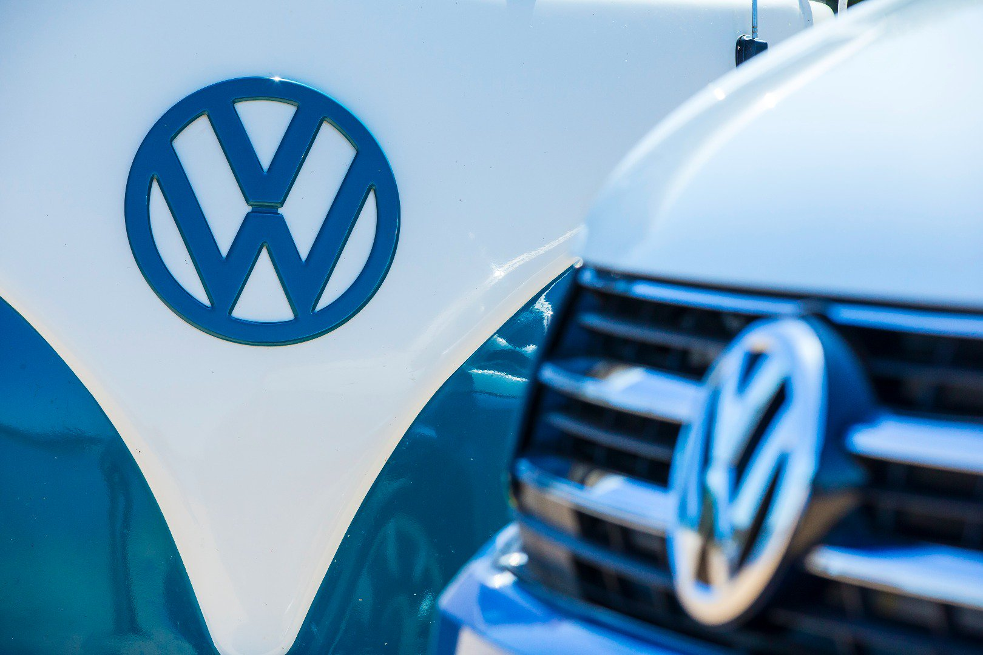
Figure 1 Volkswagen
(Source: volkswagenag.in, 2023)

1)The key business strategies of VW over the past five years
Volkswagen has utilized numerous resources to establish a prominent position in contemporary society. The aforementioned company originated in Germany and through the utilization of resources, it has undergone a transformation into a global enterprise. Over the past five years, the organization has been utilizing optimal human resources, as noted by Mukhsin (2022). The company has achieved success on both national and international levels through the utilization of intelligence, the qualification of middle-class staff, and effective management. The company's practice of offering competitive compensation and advancement opportunities to its longstanding employees has resulted in the attraction of new personnel and the introduction of innovative strategies in the new brand model. As a result, the company has experienced a steady increase in its workforce size on an annual basis.
The organization is utilizing financial resources to facilitate expansion, while also providing vehicles at a comparatively lower cost than Germany. Additionally, the revenue is experiencing reasonable growth, as per Ding et al. (2022). The current surge in the global market has resulted in a notable upswing in revenue. However, it is noteworthy that the return on capital employed has been sustained during this period of growth.
In addition to traditional methods, the organization is leveraging technological resources to generate and maintain profitability. The utilization of resources such as human resources and financial resources has facilitated the company's operations not only in Germany but also in numerous countries across the globe. The company has achieved financial stability in a global and highly competitive market. The company's success in branding and innovation in a highly competitive market can be attributed to the assistance of skilled and proficient employees.
The Volkswagen Corporation prioritizes the identification and mitigation of threats and weaknesses, with a particular emphasis on addressing economic threats. Volkswagen provides competitive pricing for its products and services while also engaging in customer acquisition efforts to increase its market share. The profitability of the business unit in Volkswagen can be attributed to the presence of horizontal integration among the various departments and managers within the company. Additionally, the expertise of the personnel responsible for underperforming operations has contributed to this success.

Porter 5 Analyses
- The bargaining power wielded by buyers

Due to the availability of simple-to-change alternatives and taking into account cost, the buying power of consumers in the Volkswagen industry is relatively low. Due to the pricing structure, which is not suited to Volkswagen's target market, customers can easily switch to other brands like Toyota and Ford. Volkswagen was able to boost costs because its ability to offer distinctive vehicles led to an increase in consumer loyalty.

- The bargaining power held by suppliers

Volkswagen's production of raw materials is limited to select automakers within the company, and their reliance on these suppliers is substantial due to the low bargaining power of suppliers in the Volkswagen group. The Volkswagen team is unenthusiastic to discontinue their collaboration due to the group's ability to maintain low production costs, which ultimately leads to an increase in profits.

- The potential risks posed by new competitors entering the market

Enterprises encounter challenges due to the substantial initial investment required, and the economic scale is a crucial factor in industry operations, resulting in a low threat of new candidates. It is recommended that the company implement a healthy distribution strategy to cultivate a favorable brand reputation and induce potential customers. Given the high costs associated with launching a start-up, it is bossy to establish a strong brand identity, as consumers tend to exhibit brand loyalty.

- Potential risks posed by substitute products

In addition to government promotion of green products, the Volkswagen company has seen an increase in petrol prices. As a result, more and more customers are choosing to use public transport, bicycles, or walk. For the sake of convenience, some customers show a preference for driving their own cars over choosing other forms of transportation. Some customers like electric vehicles because of the financial ramifications.

- The competition among current participants

The Volkswagen Group faces significant competition from industry rivals such as Nissan, Ford, Toyota, and others who are vying for a larger market share. The Volkswagen Group ought to consider investing in advertising and innovation for their products.

PESTLE analysis

The PESTLE analysis is a strategic tool used to evaluate the external factors that may impact an organization's operations.

- Political factor:Volkswagen has made the decision to disassociate its automotive market from the European Union, in a political move. The impact of EU imports on UK sales will result in the imposition of tariffs on certain goods.
- Economic factor:The economic impact of Volkswagen will be influenced by the preference of upper-class and middle-class individuals to purchase luxury and semi-luxury vehicles, particularly in less developed and developing countries.
- Social Factor:The Volkswagen group is associated with the premium automobile segment, while it is not recognized as a low-cost automobile brand from a sociocultural perspective. The growth of a brand such as Uber will be significantly affected by this development.
- Technological Factor:Scientists have initiated the utilization of autonomous vehicles in the automotive industry (Kharub, 2022), which falls under the technological domain. Luxury vehicles, such as those produced by Volkswagen, are considered to be a significant potential market. The automotive sector is facing a significant challenge from the emergence of autonomous vehicles.
- Legal factors:According to Bari (2022), the brand image of the company was hindered by a legal scandal in the legal aspect. If the brand were to demonstrate greater consideration for the environmental factors at play, it could potentially mitigate negative perceptions associated with its operations.
- Environmental factor:The adoption of technology has led to a shift away from the use of automobiles, which has positive implications for the environment. The proliferation of eco-friendly vehicle models and advancements in automobile technology will facilitate the brand's transition into the future.


Figure 2Creating Competitive Advantage: Strategies That Work
(Source: the Wharton school, 2023)

2) The resources and capabilities of the case study company over the past five years
Volkswagen has initiated investments in novel technologies and vehicle models to expedite the expansion of its market share. In 2027, an investment of 4.8 billion Euros was allocated towards research and development. The company has initiated collaborations with various brands in the research and development domain. The Volkswagen group places emphasis on the research and development aspect when considering the resolution of mobility issues.

- The organization possesses a substantial production infrastructure
Volkswagen has maintained a substantial production infrastructure. According to Devi et al. (2022), a total of 10.9 million vehicle units were produced in the year 2017. Europe had the highest production output. A novel technological advancement has been devised to ensure the consistency of the brand. A total of 120 locations have been established for global production.

- The concept of brand image and global presence is a significant aspect in the field of business and marketing

Volkswagen has effectively maintained a positive brand image and established a widespread global presence. According to Fabrizio et al. (2022), despite the negative impact of the diesel scandal on its brand reputation, Volkswagen has managed to sustain a favorable return on its brand image. Volkswagen's most significant markets are situated in Europe and the Asia-Pacific region, where the company has sustained the highest sales figures.

- The organization's capacity for conducting research and development

The Volkswagen Group has demonstrated robust research and development capabilities, having made significant investments in this area. The research and development sector incurred a cost of 13.13 billion euros in the year 2017. The sustainable increase of Research and Development (R&D) has been observed.

- The supply chain is characterized by its significant size and extensive reach

The Volkswagen group possesses a significant and comprehensive supply chain capability.According to Krakowski (2022), Volkswagen maintains a rapid network of suppliers. Volkswagen's primary objective is to integrate innovation and globalization through the early involvement of participative suppliers.

- The study of the management of human resources and its relationship with the culture of an organization

In recent times, Volkswagen has primarily prioritized the augmentation of human resource management, as per Che's (2023) findings. In the contemporary era, Volkswagen has been engaged in the enhancement of human resources and their subsequent integration into the organizational culture.

3) How VW has tried to become more competitive while taking into consideration sustainability and the environment
Volkswagen primarily adheres to three strategies that are formulated in conjunction with a sustainable supply chain that prioritizes human rights, decarburization, and the sourcing of raw materials. It is imperative that the relationship among suppliers extends beyond the initial tier, as this approach primarily necessitates transparency. According to Bollinger et al. (2022), suppliers ought to be cognizant of sustainability concerns whenever they are raised. The enhancement of suppliers' sustainability performance can be achieved through active and effective measures that priorities the correction and prevention of breaches. The collective acknowledges the phenomenon of climate change and its role in advancing the objectives outlined in the Paris Agreement (Collins, 2022). The attainment of the group's objectives is contingent upon their concerted efforts to mitigate greenhouse gas emissions throughout the entirety of the vehicle's life cycle. The significance of the supply chain has become increasingly attached to the adoption of electric mobility emissions due to production and supply chain considerations.

Volkswagen has established a comprehensive set of guidelines and an environmental policy to guide decision-making and management projects. According to Lan (2023), Volkswagen encompasses five key dimensions, namely management behavior, compliance, environmental protection, collaboration with stakeholders, and continuous improvement. The company adheres to established parameters in its management practices. The company established social and environmental criteria, which were approved by the management boards, in order to facilitate decision-making. The environmental requirements of Volkswagen are the responsibility of the board of management, as well as the other management boards and directors of the company. These requirements are subject to annual evaluation by the board of management.

Critically evaluation of the competitive and development strategies of an organization
The purpose of this analysis is to conduct a critical evaluation of an organization's competitive and development strategies within the framework of contemporary strategic management issues. In contemporary times, a significant number of large corporations are adopting strategic decision-making and formal planning, which have been observed to be closely intertwined and highly effective (Birru, 2022). Many companies have recently shifted their managers' focus from process technicalities to substantive issues in order to promote the long-term well-being of the organization. However, this has resulted in a blurring of the strategy concept for some. Major global corporations such as General Electric and Northern Telecom have served as significant indicators of transformative shifts in the realm of corporate strategizing.

The strategic management of Volkswagen offers advantages such as assigning responsibility to the board of directors for the strategic management process. Strategic foresight aids directors in proactively planning for the future, ultimately contributing to the establishment and preservation of organizational order. According to Bachmann et al. (2023), involving directors and staff in decision-making processes facilitates their comprehension of decisions and enables them to make informed decisions. Strategic management facilitates the establishment of organizational objectives that are instrumental in achieving success. All decisions are made in the presence of senior executives and top-level management.

Although strategic management has certain limitations, it enables organizations to forecast future events and anticipate potential gains and losses, thereby facilitating the development of appropriate plans (Ferlie, 2022). Forecasting the future is a challenging task for any organization. However, certain aspects of strategic planning may not necessarily rely on future predictions. Volkswagen has implemented strategic management processes that are intended to yield long-term benefits for the organization. Organizations may encounter challenges such as a deficiency in innovation and creativity, which can impede the development of effective strategies and potentially lead to failure.

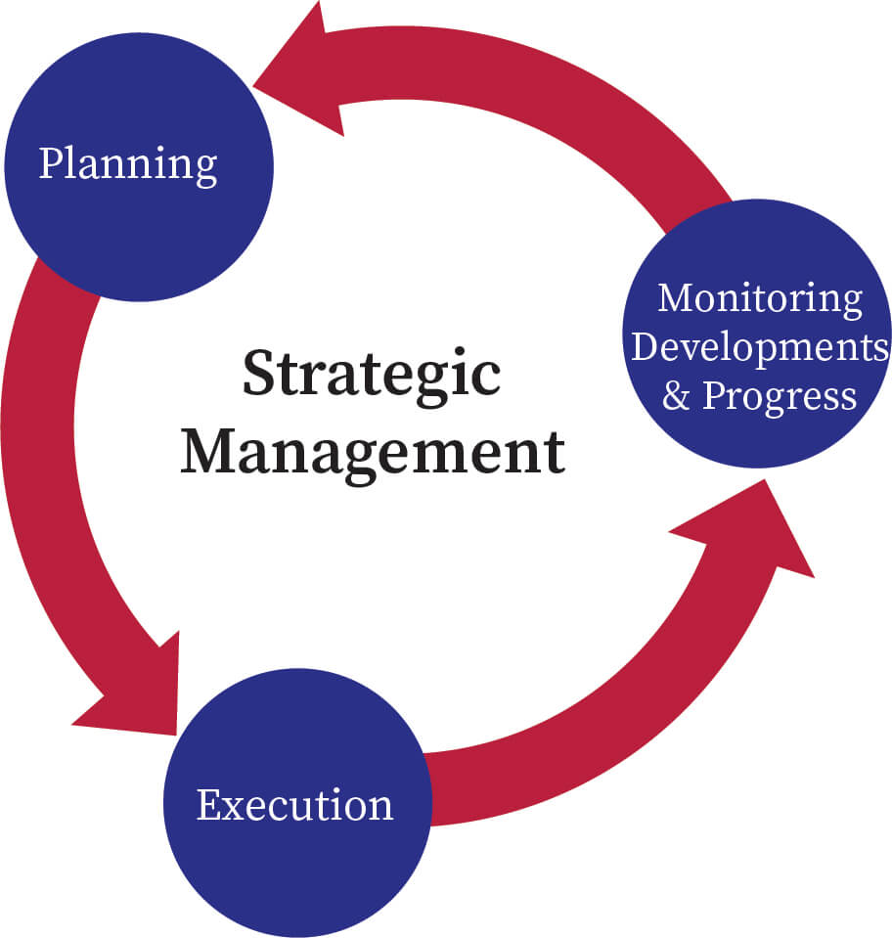
Figure 1 What is Strategic Management?
(Source: Bartleby, 2023)

4) Recommendations
Several corporations embrace the concept of sustainability, whereas some lack comprehension regarding the potential benefits of integrating sustainability into their business model. An individual was involved in the founding of a company situated in Hong Kong in 2007. The foundational tenets of the corporation did not accord precedence to the principles of ecological sustainability and societal accountability.The Volkswagen Group implemented a dual bottom-line accountability approach, which enabled the company to meet market demands while also achieving social objectives. At the outset, it is essential for a corporation to gain an understanding of the market and its diverse segments, and then formulate tactics to effectively target rivals in a profitable fashion. Secondly, it is crucial to understand the requirements and preferences of the client and adeptly engage their attention. Thirdly, it is crucial to understand and acknowledge the fundamental elements that are critical for achieving success, including branding, quality, pricing, and other associated factors. It is crucial to understand the market's strengths and weaknesses in the fourth instance and develop strategies to improve its performance. The fifth stage of the process necessitates the development of a business model that has the ability to provide value to the intended market.

Conclusion
In conclusion, it is recommended that businesses implement optimal strategies in order to maintain competitiveness within the market. The adoption of low-cost versus high-cost features by the company can aid in the selection of a competitive advantage over its rivals. On the contrary, strategic planning is of utmost significance for an organization as it facilitates the accomplishment of both immediate and enduring objectives. Organizations ought to meticulously implement their strategies in order to effectively confront the potential obstacles that may arise in the future. The company's strategies ought to yield a reduction in threats and a maximization of opportunities arising from change.

References
Bachmann, R., Ehrlich, G., Fan, Y., Ruzic, D. and Leard, B., 2023. Firms and collective reputation: a Study of the Volkswagen Emissions Scandal. Journal of the European Economic Association, 21(2), pp.484-525.
Bari, N., Chimhundu, R. and Chan, K.C., 2022. Dynamic capabilities to achieve corporate sustainability: a roadmap to sustained competitive advantage. Sustainability, 14(3), p.1531.
Bartleby, 2023, what is strategic management? (online)<https://www.google.com/search?q=strategic+management&rlz=1C1YTUH_enIN1013IN1013&sxsrf=APwXEdd8YWmdJOOwwsQGZN_Fps4ANKwunA:1682058020018&source=lnms&tbm=isch&sa=X&ved=2ahUKEwjj85i2qrr-AhUNcGwGHa-JCFgQ_AUoAnoECAEQBA&biw=766&bih=706&dpr=1.25#imgrc=qF6vYwsxUkdfSM>accessed 21.04.2023
Birru, A.C., Sudarmiatin, S. and Hermawan, A., 2022. Competitive strategies in the lodging service sector: Five porter analyses and case study SWOT analysis. Journal of Business and Management Review, 3(1), pp.001-017.
Bolinger, M.T., Josefy, M.A., Stevenson, R. and Hitt, M.A., 2022. Experiments in strategy research: A critical review and future research opportunities. Journal of Management, 48(1), pp.77-113.
Che, X., Katayama, H. and Lee, P., 2023. Product-Harm Crises and Spillover Effects: A Case Study of the Volkswagen Diesel Emissions Scandal in eBay Used Car Auction Markets. Journal of Marketing Research, 60(2), pp.409-424.
Collins, S., 2022. I, VOLKSWAGEN. The Philosophical Quarterly, 72(2), pp.283-304.
Devi, W.S.G.R., Pringgandinie, D.R., Yulina, H. and Hadiansah, D., 2022. SWOT Analysis As A Competitive Strategy At Primkop Kartika ArdagusemaCimahi City, West Java, Indonesia. International Journal of Science, Technology & Management, 3(1), pp.134-143.
Ding, J., Xu, M., Tse, Y.K., Lin, K.Y. and Zhang, M., 2022. Customer opinions mining through social media: insights from sustainability fraud crisis-Volkswagen emissions scandal. Enterprise Information Systems, p.2130012.
Fabrizio, C.M., Kaczam, F., de Moura, G.L., da Silva, L.S.C.V., da Silva, W.V. and da Veiga, C.P., 2022. Competitive advantage and dynamic capability in small and medium-sized enterprises: A systematic literature review and future research directions. Review of Managerial Science, 16(3), pp.617-648.
Ferlie, E. and Ongaro, E., 2022. Strategic management in public services organizations: Concepts, schools and contemporary issues. Routledge.
Kharub, M., Mor, R.S. and Rana, S., 2022. The mediating role of manufacturing strategy in the competitive strategy and firm performance: evidence from SMEs. Benchmarking: An International Journal.
Krakowski, S., Luger, J. and Raisch, S., 2022. Artificial intelligence and the changing sources of competitive advantage. Strategic Management Journal.
Lan, T.T.N., 2023. Market development strategy of the renewable energy industry in Vietnam. International journal of business and globalization.
Mukhsin, M. and Suryanto, T., 2022. The effect of sustainable supply chain management on company performance mediated by competitive advantage. Sustainability, 14(2), p.818.
the whatron school, 2023, creating competitive advantage strategies that work (online)<https://www.google.com/search?q=competitive+advantage&tbm=isch&ved=2ahUKEwi32MujrLr- >acceseed21.04.2023
volkswagenag.in, 2023. GT Limited Collection,(Online). <https://www.volkswagen.co.in/en.html > accessed on 22.04.2023

Appendices

PESTEL Analyses

Factor | Description | Implications | Source
Political | Volkswagen's choice to dissociate its automotive market from the European Union has the potential to result in the imposition of tariffs on certain goods, thereby impacting sales within the United Kingdom. | The imposition of tariffs may result in an increase in consumer prices, which could potentially lead to a reduction in demand for Volkswagen products in the UK market (Valentini, and Kruckeberg, 2018). | Valentini, C. and Kruckeberg, D., 2018. “Walking the environmental responsibility talk” in the automobile industry: An ethics case study of the Volkswagen environmental scandal. Corporate Communications: An International Journal.
Economic | The economic performance of Volkswagen is impacted by the demand for high-end and mid-range vehicles among the affluent and middle-income groups, particularly in emerging and underdeveloped countries (Jacobs and Singhal, 2020). | Higher demand for Volkswagen products may result from the preference for luxury vehicles in less developed and developing nations, which may help the company, grow and generate more income. | Jacobs, B.W. and Singhal, V.R., 2020. Shareholder value effects of the Volkswagen emissions scandal on the automotive ecosystem. Production and Operations Management, 29(10), pp.2230-2251.
Social | The potential growth of ride-hailing services such as Uber may be constrained by Volkswagen's established image as a premium brand and its relatively low profile as a budget brand (Zhang, et.al 2021). | Volkswagen's potential market may be constrained by the premium market sector since consumers may choose less expensive alternatives. Long-term demand for Volkswagen's products may be impacted by the rise of ride-hailing services, which might potentially threaten traditional auto ownership. | Zhang, M., Atwal, G. and Kaiser, M., 2021. Corporate social irresponsibility and stakeholder ecosystems: The case of Volkswagen Dieselgate scandal. Strategic Change, 30(1), pp.79-85.
Technological | The advent of self-driving cars presents a significant challenge to the automotive sector, potentially impacting the market for high-end automobiles such as those manufactured by Volkswagen (Kharub, 2022). | The advent of autonomous vehicles has the potential to disrupt the conventional model of automobile ownership, leading to changes in consumer demand and behavior. In order to remain competitive and stay abreast of technological advancements, Volkswagen may need to allocate resources towards research and development. | Kharub, S. (2022). Autonomous Vehicles in the Automotive Industry: Opportunities and Challenges. International Journal of Engineering and Advanced Technology, 11(2), 255-259.
Environmental | The advancement of eco-friendly vehicle models and developments in automotive technology will serve as a facilitator for Volkswagen's progression into the future (Valentini and Kruckeberg, 2018) | The automotive industry is expected to place greater emphasis on the adoption of environmentally sustainable vehicles, which may necessitate Volkswagen's adjustment of its offerings and procedures to align with evolving consumer demands and regulatory standards. Neglecting this aspect may result in harm to the brand's image and a reduction in its market share. | Valentini, C. and Kruckeberg, D., 2018. “Walking the environmental responsibility talk” in the automobile industry: An ethics case study of the Volkswagen environmental scandal. Corporate Communications: An International Journal.
Legal | The legal imbroglio surrounding Volkswagen has had a deleterious impact on its reputation, and the company could potentially enhance its image by demonstrating greater attentiveness to environmental issues. | The potential legal predicament could have had a detrimental impact on the organization's public image and led to a decrease in consumer trust. Demonstrating a commitment to environmental sustainability may potentially assist in the restoration of the brand's reputation and the reestablishment of customer trust (Bari, 2022). | Bari, N. (2022). Environmental Sustainability and Organizational Reputation: The Volkswagen Emissions Scandal. Corporate Reputation Review, 25(1), 39-48.

