DS 1 Assignment

My Screenshots/Photos

Screenshot/Photo 1
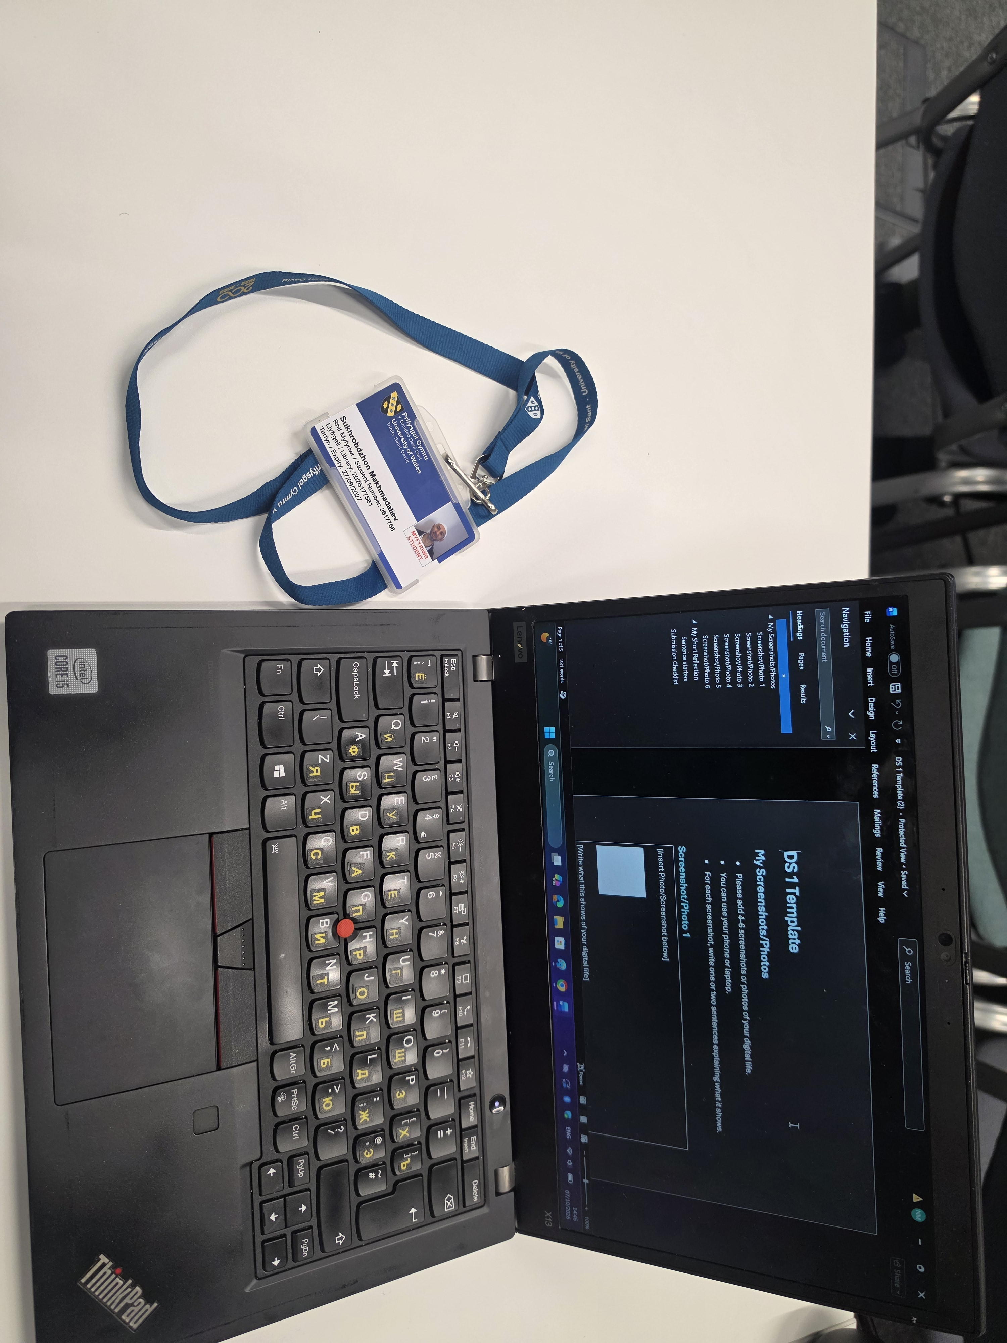
The image show abouve is the sat . studentcard which is one of my daily tools use to assist me go to inside , open the door and show am student . Give me transport discounts.

Screenshot/Photo 2
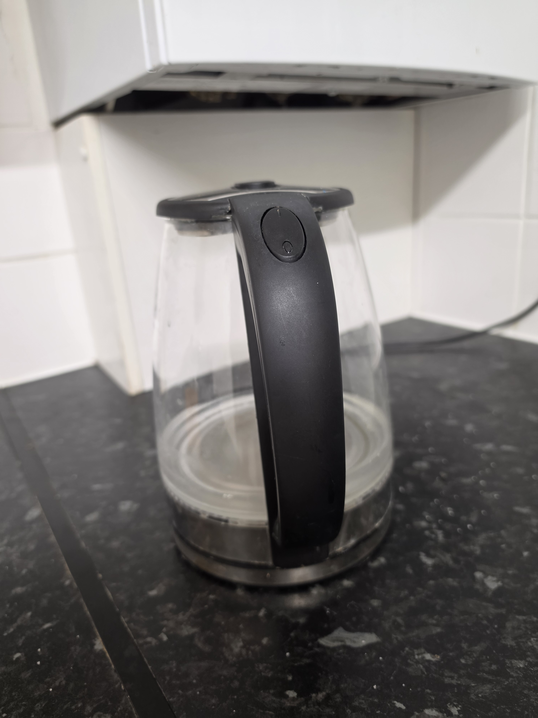
Electric Kettle
The photo shows an electric kettle. It is one of my daily tools. I use it to boil water quickly. It helps me make tea, coffee and hot food. It saves time and makes my daily life easier.

Screenshot/Photo 3
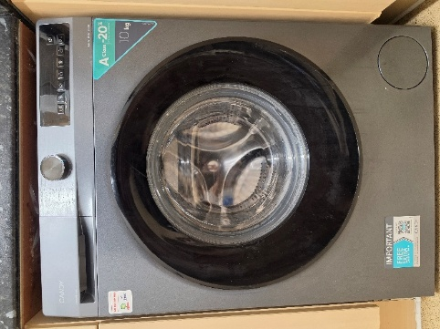
Washing Machine
The photo shows a washing machine. It is one of my daily digital tools. I use it to wash my clothes. It helps me keep my clothes clean and saves me a lot of time. It is very important for my daily life and helps me live independently.

Screenshot/Photo 4
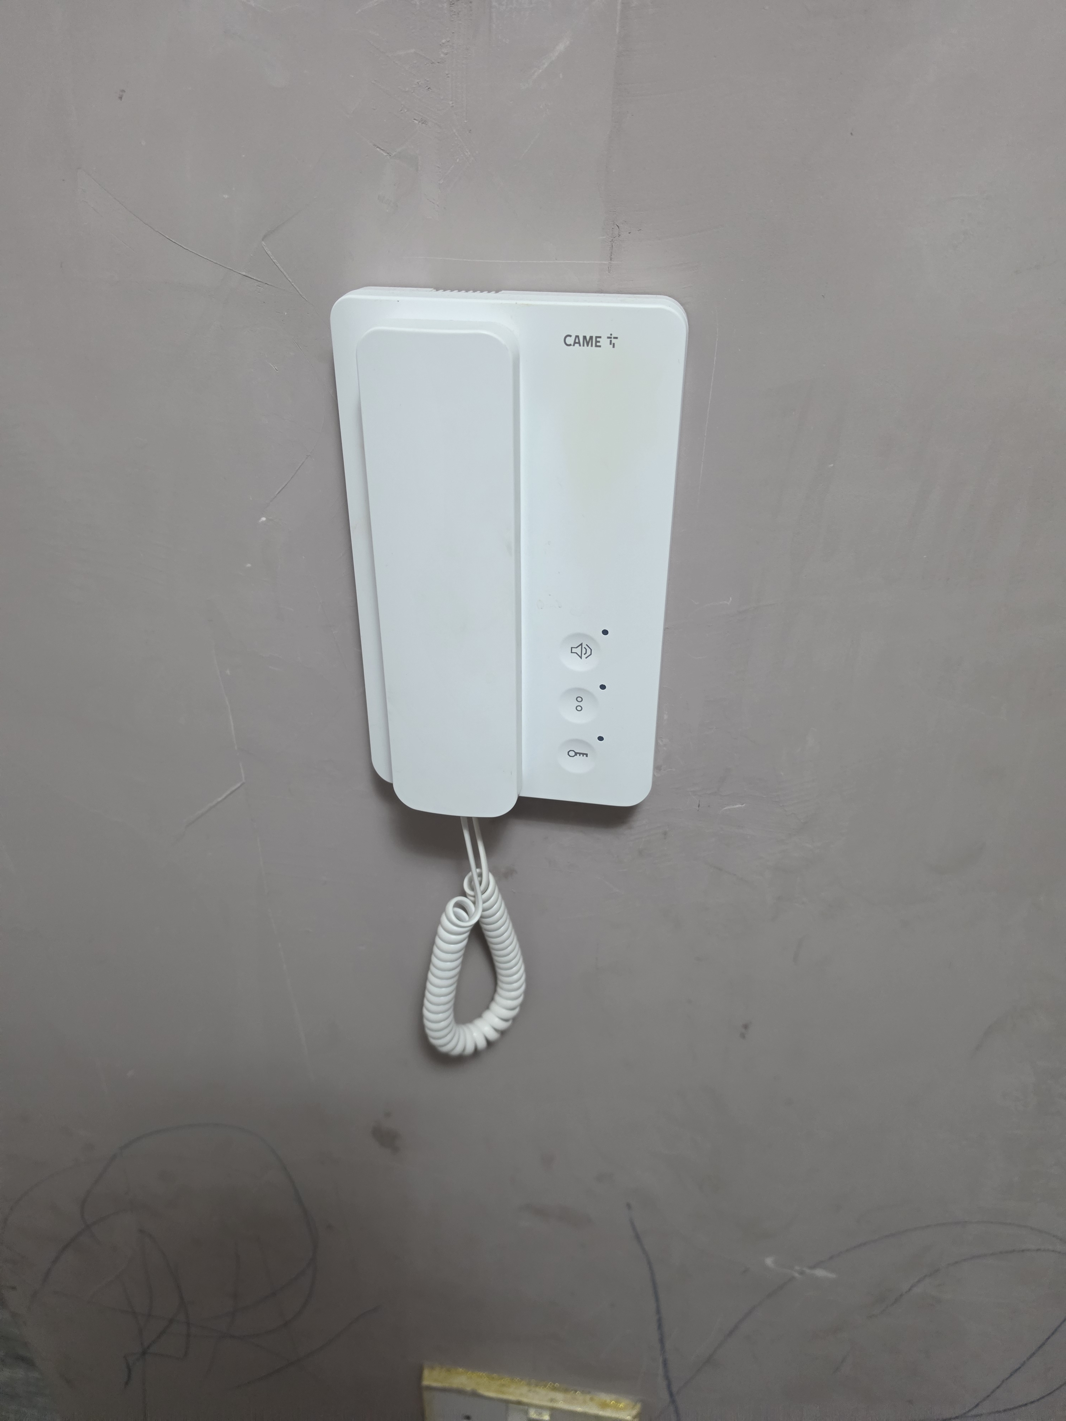
Intercom
The photo shows an intercom without a camera. It is one of my daily tools. I use it to hear who has come and to open the door remotely. It helps me feel safe, secure and independent at home.

Screenshot/Photo 5
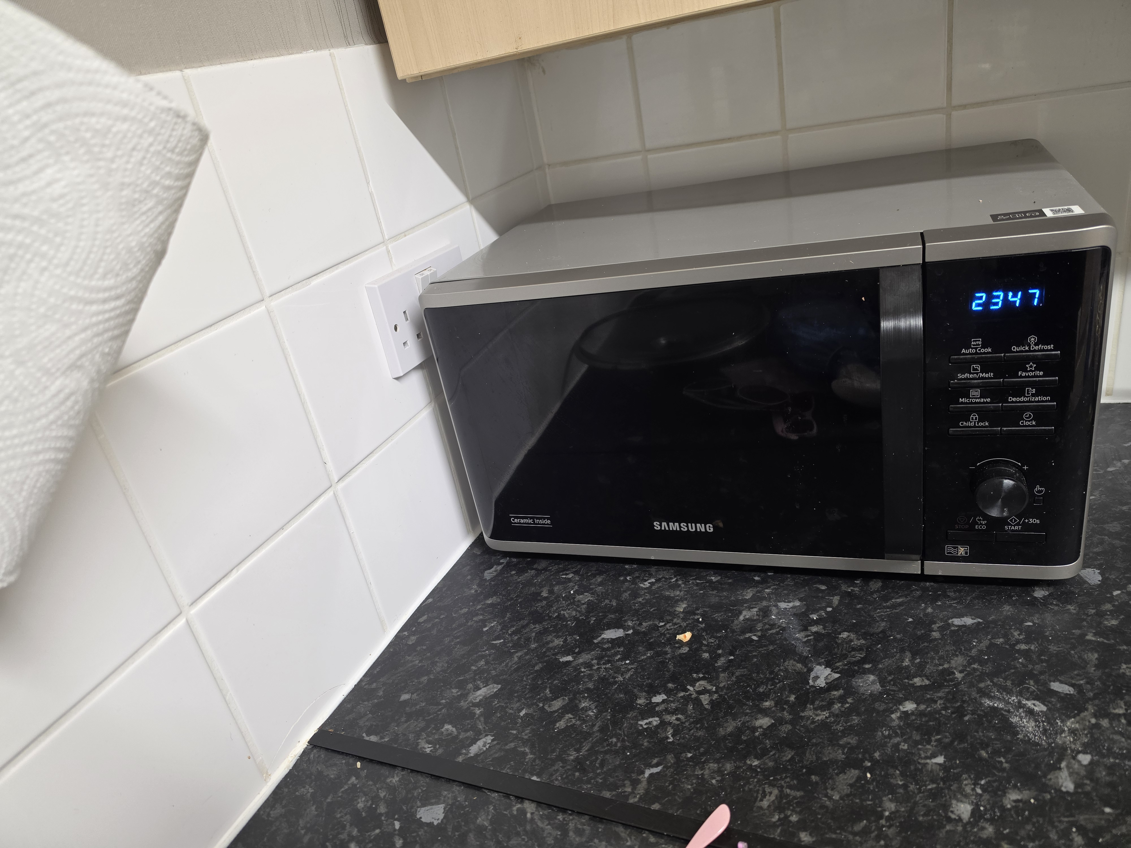

Microwave
The photo shows a microwave. It is one of my daily tools. I use it to heat my food quickly. It helps me cook and warm up meals easily. It saves time and is very useful in my daily life.

My Short Reflection
- Write 5–8 simple sentences about your digital life.
- You can use the sentence starters below if helpful.
My digital life is closely connected to my smart home devices. I control my washing machine ,microwave, and kettle using every day. It is very good because my life do easily, so I have time to do something else for my family or for my study.

Sentence starters
- I use digital tools to …
- I feel confident when I …
- I want to improve …
- I often use these tools: …
- I sometimes feel nervous about …
- I hope this module will help me …
- Digital skills are important for me because …
You can write more if you want.

Submission Checklist
Before you submit, please check:
​​​ ☐ I added 4–6 screenshots
☐ I wrote short sentences for each screenshot
☐ I wrote my short reflection
☐ My work is my own
☐ My file opens correctly
​​☐ My file opens correctly

