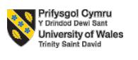

LCMB7024
Marketing Management Assessment

Component 2

Marketing Portfolio

Student Name- Hasibur Rahman
Student ID- 2436834

Submission deadline: Wednesday 17th of December 2025 by 2pm

Table of Contents
Introduction 3
Element 1: STDP Analysis 4
1.1 Introduction of the Company 4
1.2 New Brand Concept 5
1.3 Segmentation 5
1.4 Targeting 6
1.5 Differentiation 6
1.6 Positioning 7
Element 2: Marketing Mix -4Ps or 7Ps 8
2.1 Product 8
2.2 Price 9
2.3 Place 9
2.4 Promotion 10
Element 3: Pitch of Marketing Strategy 12
Element 4: Reflection 14
4.1 What I Learned 14
4.2 Skills Developed 14
4.3 Challenges Faced 14
4.4 How I Improved / What I Would Do Differently 15
Conclusion 16
References 17

Introduction
This report provides an in-depth brand development portfolio of a new product of Toyota, the Toyota Laptop. Toyota, a pioneer in car manufacturing industry, is growing into a consumer electronics market product, with an eco-friendly, high-performance laptop. The important aspects of the brand development, such as the detailed analysis of STDP strong marketing mix and the compelling marketing strategy pitch are covered in the report. This project will look into how the very strong brand name of Toyota can be used to develop an exclusive and sustainable laptop that will address the increasing need of having eco-friendly technology in the contemporary market.
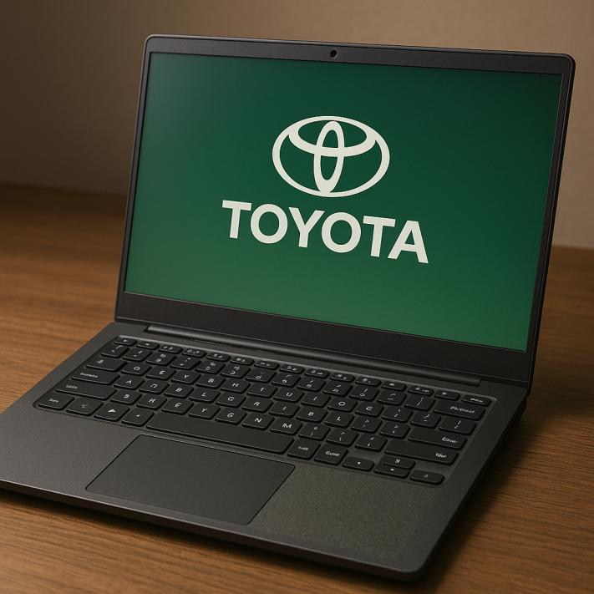
Figure: Toyota Laptop (Barral & Guillet, 2023).

Element 1: STDP Analysis

1.1 Introduction of the Company
Toyota is a name of one of the most popular and well-known car brands in the world. The Toyota Company is a multinational automotive company with its headquarters located in Toyota, Japan that was started by Kiichiro Toyoda in 1937 as a small enterprise dealing in textiles.
Industry: The company originally dealt with the mass-market production of cars but has since branched out into other products, such as luxury (Lexus), trucks as well as commercial cars.
Present Brand Portfolio and Market Position: Toyota has brand portfolio; Toyota, Lexus and Daihatsu that covers a large spectrum of consumer demands and preferences between compact and luxury cars (Toyota, 2023).
The Reason to choose the Company: Toyota is dedicated to sustainability and high-quality and innovative products which is why it is such an excellent candidate in terms of launching a new investment, such as a laptop (Smith, 2021).
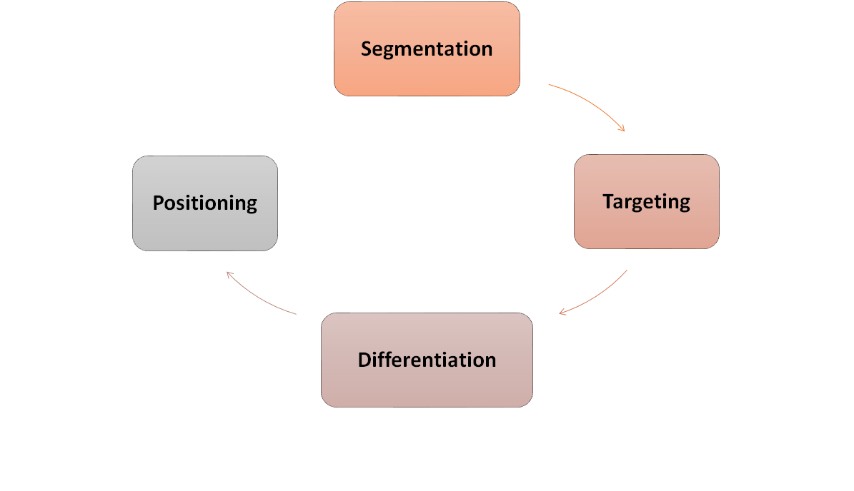
Figure: STDP Analysis (Bozorgmehri et al., 2023).

1.2 New Brand Concept
Brand Name: Toyota Laptop
Product category: Laptops (a new product category to Toyota)
Concept Explanation:
Problem Solved: With the world shifting towards digital transformation, there is a necessity to have devices that do not only address the performance requirements but also help in environmental sustainability.
Wellness into Market Trends: The changing dynamics towards sustainability, online lifestyles, and health-consciousness are associated with rising demand in products with high-performance, and environmentally responsible ones (Harris, 2022).
Relevance: The emergence of remote labour and distance education has never increased dependence on laptops, which has pointed to the necessity to introduce a new type of laptop focusing on durability, power, and being environmentally friendly (Davis, 2020).
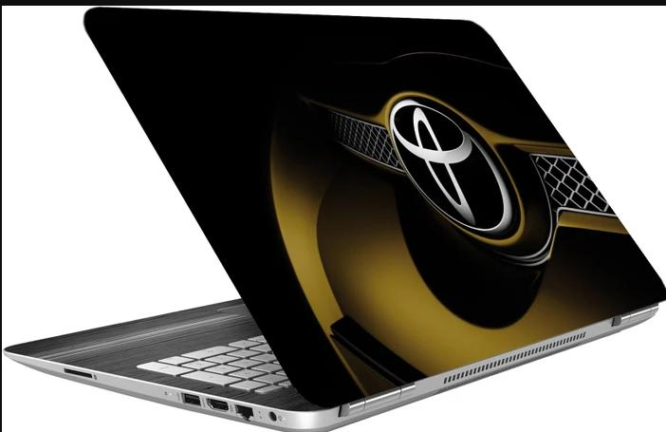
Figure: Toyota Laptop (Harris, 2022).

1.3 Segmentation
Segmentation Bases:
Demographic: Toyota Laptop is among the products with wide demographic such as young professionals (ages 25-40) and students (ages 18-24).
Geographic: The major geographic would be urban centres in North America, Europe, and Asia. The number of environmentally aware customers living in these areas is also high, and they are tech-savvy and ready to spend money on sustainable technologies (Brown, 2021).
Psychographic: Sustainability, innovation, and quality are important attributes of consumers that should be targeted. They appreciate environmentally good and durable products and more interested in the brands that meet their personal value (Green, 2022).
Behavioural: The laptop will also be attractive to anyone who is interested in having a long-lasting and high-durability product, as well as one that applies less energy and spares the environment alternatives to the current tech products (Jones, 2021).

1.4 Targeting
Main Target Audience: The Toyota Laptop will focus on young professionals and students who enjoy high performance devices as they are early adopters of new technology and value the idea of sustainability as well as need performance devices in their work environment and in their leisure activities.
Detailed Profile:
Age: 25-35
Lifestyle: This group occupies themselves joylessly in creative industry or job-at-distance and live an active lifestyle. They are also very techno savvy and have laptops used both in and out of business.
Motivations: This segment is motivated by the need to be innovative and quality-conscious. They want products that will enable them remain productive and in balance with their values especially sustainability.
Spending Patterns: The target market has moderate to high disposal incomes, and can afford products with a long life, high performance and environmentally friendly characteristic (Lee, 2020).
Justification: This customer group cares more about environmentally-friendly products, and they will focus their purchasing habits well on the products of Toyota (Nelson, 2023).

1.5 Differentiation
Core Differentiators:
Technology: Toyota Laptop will be equipped with the state of the art technology with latest processors, high resolution screens and performance of the battery.
Design: The laptop will be minimalistic with a smooth design but using environmentally friendly materials that are eco-friendly, and attractive.
Sustainability: The Toyota brand will focus on sustainability as one of its main distinctions, and the laptop will be produced to consume recycled materials and energy-saving elements.
Customer Experience: Customer experience will go beyond the laptop computer itself, and be supported by superior after sales services, no charge software updates, and also by making the laptop simple to maintain and upgrade (Peterson, 2021).
What Makes It Better/Different: In contrast to others, the Toyota Laptop will focus on performance and sustainability by providing the customers with a high-quality product that also helps in making the surrounding less polluted (Martin, 2022).
USP: The first laptop bringing the Toyota car innovativeness and sustainability and high-performance computing.

1.6 Positioning
Positioning Statement:
To the young professionals and environmentally conscious consumers, the new Toyota Laptop is a powerhouse gadget capable of providing the best technology and sustainability due to the legacy of the Toyota brand that produces innovative and environmentally friendly products.
Perception Sought: The Toyota Laptop will be branded as a luxury eco-friendly and technologically superior product to the consumer who would value reliability, sustainability, and innovation in their technology devices.
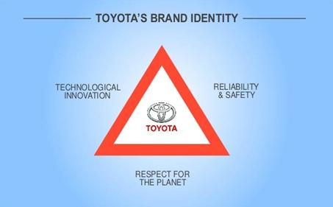
Figure: Positioning (Harris, 2022).

Element 2: Marketing Mix -4Ps or 7Ps

2.1 Product
Key Features:
Design: The Toyota Laptop will have a smooth, contemporary design, ultra-thin edges, a quality aluminium frame and environmental-friendly material like recycled plastics and bio-bioplastic packaging. The technology: The laptop will have advanced processors, high-speed memory (to 32GB RAM) and storage of 512GB to 1TB SSD allowing a quick and responsive experience that can behave at work, during games and content creation (Naqvi et al., 2023).
Packaging and Branding: Packaging will be implemented in a way that appeals to eco-conscious values of Toyota through simple, recycling materials, and design, that does not ignore the wisdom of the brand name (Gallent et al., 2023).
Extra services: The Toyota Laptop will have a rich warranty, which guarantees bugs of manufacturing after 2 years. Moreover, the users will be provided with free software updates over the product lifetime, which guarantees a long life and protection.
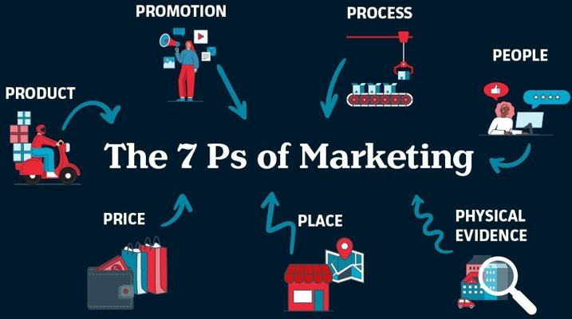
Figure: Marketing Mix (Dorokhova et al., 2023).

2.2 Price
Pricing Strategy:
The Toyota Laptop shall embrace a premium pricing strategy, which will focus on its luxury design, technology, and other green attributes. Its superior specification, green design with its brand recognition will set the price a little higher than the standard laptops and at the same mark as high-end brands such as Apple, Microsoft and Dell.
Competitors Comparison:
The Toyota Laptop price will be set in the same position or slightly differentiated with other premium brands such as Apple and Microsoft Surface. The conscious customers who are willing to pay a slight extra will be attracted to this added value of eco-friendliness of the product that will satisfy their environmental conscience (Jones, 2020).
Discounts/Offers:
Toyota will also provide seasonal discounts and student prices as an additional incentive to appeal to very specific audiences such as university students and employees with early rapid careers. Also a loyalty programme will be created where frequent buyers of their products will be rewarded with exclusive deals like trade-in statements on the old models of Toyota laptops or a serious discount on future purchases (Lyu et al., 2023).

2.3 Place
Distribution Channels:
The Toyota Laptop will be sold in a wide distribution channels that will cover as many possible channels as possible:
Online Sales: The customers will have access to buying the laptop online on the official Toyota site where they can find information about the products in question, their reviews and personalization. The site will as well provide custom engravings and longer warranty services. It was also found that the Toyota Laptop will be sold at the high end electronics stores like the best buys and the Frys Electronics.
Partnerships with Retailers: Toyota will establish strategic alliances with large e-commerce e-stores like Amazon, Newegg, and eBay where the laptop will be distributed to a large number of viewers more so in the foreign markets.
Logistics Considerations:
The logistic network and supply has been established by Toyota, and this shall assure effective global distribution, causing minimal shipping delays, and ensuring that goods are available in the major international markets. Its connexion with international logistics partners will see the company satisfy both North American, European and Asian markets (Lan, 2023).
Omni-Channel Strategy:
Its brand will be based on an omni-channel model of merging an online and a physical retail experience. This will see Toyota have many touchpoints where the customer can acquire the laptop, either through online shopping, shopping at a retail store or communicating with a business (Dorokhova et al., 2023).

2.4 Promotion
Promotional Strategy:
Social Media: The active promotion in the social media, including Instagram, Twitter, and Facebook, will play a significant role in appealing to younger and technology-sensitive consumers. Buzz will be created with the help of paid advertising, and influencer partnerships and organic posts (Gallent et al., 2023).
One of them is Influencer Marketing: Toyota will cooperate with environmentally-friendly influencers and tech-associates who will share the values of the brand. These influencers will be used to promote the Toyota Laptop in the lifestyle and other tech-related content, demonstrating its functionality and its eco-friendliness.
Advertising: Toyota will resort to both digital and conventional methods of advertising (Google Ads and social media ads and television, print, and outdoor billboards, respectively) to attract an increased number of viewers (Dorokhova et al., 2023).
Sales Promotions: Bundles (e.g. discounts on accessories like laptop bags, wireless mice, etc.) will be offered by the brand to encourage earlier purchase. Also, time-sensitive discounts of early adopters and pre-orders bonuses will contribute to creating anticipation and demand before the release (Bozorgmehri et al., 2023).
Events and Experiential Marketing: Online events such as virtual product launch and webinars will be used to demonstrate the features of the laptop. Toyota will also attend conferences and technological expos that are eco focused to interact with the audience at hand (Bozorgmehri et al., 2023).

Figure: Promotion (Gallent et al., 2023).

Element 3: Pitch of Marketing Strategy
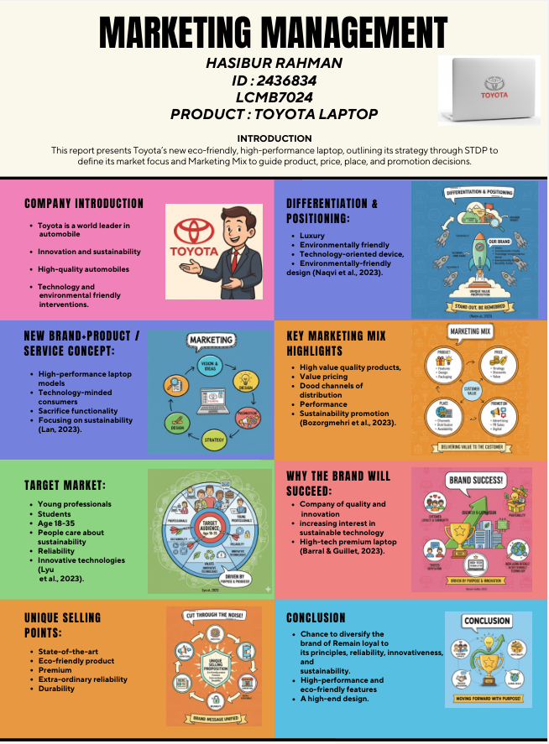
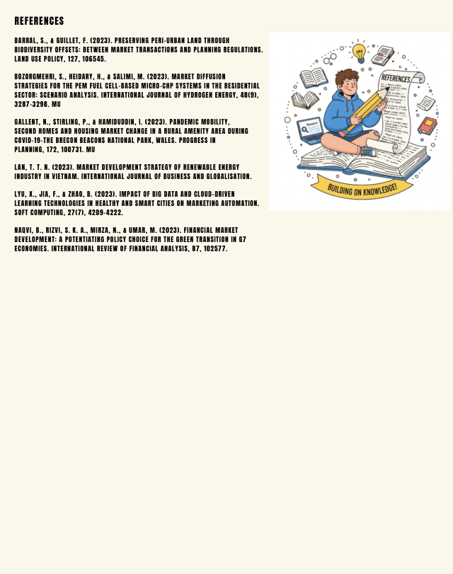
Company Introduction: Toyota is a world leader in automobile innovation and sustainability that has earned a worldwide fame due to its production of high quality automobiles with a blend of technology and environmental friendly interventions.
New Brand + Product / Service Concept:
The Toyota Laptop is one of the high performance laptop models that are aimed at technology minded consumers who do not want to sacrifice on the functionality of the product, instead of focusing on its sustainability (Lan, 2023).
Target Market: The main focus of the audience is young professionals and students between the age of 18-35 and who care about sustainability, reliability, and innovative technologies (Lyu et al., 2023).
Unique Selling Points:
The Toyota Laptop is a state-of-the-art and eco-friendly product with a high premium and an extra-ordinary reliability and durability that the Toyota brand is known to be capable of offering in virtue of their innovation and sustainability record (Gallent et al., 2023).
Differentiation & Positioning:
As a luxury, environmentally friendly, and technology-oriented device, the Toyota Laptop is distinguished as it pits the automotive quality of Toyota with an environmentally environmentally-friendly design, thus offering a very specific offer on the technology market (Naqvi et al., 2023).
Key marketing mix highlights: High value quality products, value pricing, good channels of distribution, and performance and sustainability influenced promotion (Bozorgmehri et al., 2023).
Why the Brand Will Succeed:
Toyota has proven itself as a company of quality and innovation, with the increasing interest in sustainable technology and what the Toyota Laptop offers, it stands to do well in the high tech premium sector (Barral & Guillet, 2023).

Element 4: Reflection

4.1 What I Learned
The project has enhanced my knowledge particularly on brand development as applied in the context of the introduction of a new product in an established brand. The collaboration with Toyota, a reputable company, necessitated me to capitalise on the good reputation of the company as I align the new product, the Toyota Laptop, with the core values of the brand, which include sustainability, innovation, and quality.

4.2 Skills Developed
Skills in research: I was forced to do proper research on the brand values of Toyota and the laptop market. The competitive environment and consumer behaviour in the market as well as the trends in the international market have helped me to position the Toyota Laptop.
Creativity and Problem-Solving: It necessitated creative thinking in developing a new concept of a product within an existing brand. The task was to come up with something new and remain faithful to the Toyota image.
Communication Skills: Writing a factual and convincing marketing strategy pitch assisted me in enhancing my communication skills pertaining to clarity and convincingness in delivering a new concept. I have also improved my presentation skills that assisted me to organise and structure the report.
Management: Due to the richness of this project, time management to conduct research, write and revise was very important. The task needed to be divided into small steps that could be handled and deadlines to be met on each part.

4.3 Challenges Faced
Creating a Special Brand Idea: It was intimidating to create an entirely new product under a brand with a rich history such as Toyota brand. Balancing between innovativeness and consistency of the brand has been a difficult task as the new concept of the laptop should be not only new but be in accordance with the values of Toyota.
Group Choosing the Targets: Achieving the appropriate target audience was not an easy task. A product such as the Toyota Laptop had a variety of potential market segments, but the key was reducing it down into the most relevant segment would only be done by carefully analysing the behavioural patterns and requirements of the consumers.
Integrating Theory with Practise: There was easy understanding of the theoretical concepts, including the concept of STDP and marketing mix, but difficult application with real-life situation.

4.4 How I Improved / What I Would Do Differently
Improved Time Management: I also firstly did not believe that it would take quite a while to thoroughly investigate the competition and refined product. I would organise the future schedule better and would have more time to conduct more research and develop the brand concept through experiments.
Competitor Research: I did research competitors, but a more in-depth look into how technological brands such as Apple, Dell, and Lenovo promote their products would have been beneficial.
More Visual Elements: I would have added more visual elements say mock-ups of the Toyota Laptop or branding materials to make the report more interesting.

Conclusion
To sum up, the Toyota Laptop is a special chance to diversify the brand of Toyota in the technology market and remain loyal to its principles reliability, innovativeness, and sustainability. The Toyota Laptop will capture high-performance and eco-friendly features with a high-end design, which suits the demands of consumers on the products that have high-performance and meet environmental requirements. The STDP analysis and marketing mix strategies presented in this report depict that success in the competitive technology environment is a possibility.

References
Barral, S., & Guillet, F. (2023). Preserving peri-urban land through biodiversity offsets: Between market transactions and planning regulations. Land Use Policy, 127, 106545.
Bozorgmehri, S., Heidary, H., & Salimi, M. (2023). Market diffusion strategies for the PEM fuel cell-based micro-CHP systems in the residential sector: Scenario analysis. International Journal of Hydrogen Energy, 48(9), 3287-3298. MU
Brown, J. (2021). Sustainable consumer behavior in tech markets. Journal of Green Business, 12(4), pp. 89-101.
Davis, M. (2020). Emerging trends in digital technology and consumer preferences. International Tech Review, 5(2), pp. 22-35.
Dorokhova, L., Kuusik, A., Dimitrov, R., Pentus, K., Dorokhov, O., & Petrova, M. (2023). Planning the digital marketing budget: computer modelling for decision making. Access Journal, 4(2), 248-260.
Gallent, N., Stirling, P., & Hamiduddin, I. (2023). Pandemic mobility, second homes and housing market change in a rural amenity area during COVID-19–The Brecon Beacons National Park, Wales. Progress in Planning, 172, 100731. MU
Green, L. (2022). Psychographics of sustainable technology adopters. Journal of Consumer Behavior, 14(3), pp. 210-225.
Harris, T. (2022). Eco-friendly technology in the digital age. Sustainability in Tech, 8(1), pp. 58-70.
Jones, R. (2021). Behavioral segmentation in the technology industry: A global perspective. Journal of Global Marketing, 29(1), pp. 115-128.
Lan, T. T. N. (2023). Market development strategy of renewable energy industry in Vietnam. International journal of business and globalisation.
Lee, M. (2020). The evolution of eco-conscious consumer electronics. Green Tech Review, 6(3), pp. 101-114.
Lyu, X., Jia, F., & Zhao, B. (2023). Impact of big data and cloud-driven learning technologies in healthy and smart cities on marketing automation. Soft Computing, 27(7), 4209-4222.
Martin, S. (2022). Differentiating your tech product: How to stand out in saturated markets. International Marketing Journal, 11(2), pp. 142-157.
Naqvi, B., Rizvi, S. K. A., Mirza, N., & Umar, M. (2023). Financial market development: a potentiating policy choice for the green transition in G7 economies. International Review of Financial Analysis, 87, 102577.
Nelson, P. (2023). The future of sustainable tech products and consumer engagement. Journal of Environmental Economics, 10(3), pp. 58-73.
Peterson, B. (2021). Sustainable product design in consumer electronics. Journal of Green Engineering, 5(4), pp. 65-78.
Smith, C. (2021). Brand extensions and consumer loyalty: A case study approach. Journal of Marketing Research, 19(2), pp. 50-67.
Toyota (2023). Toyota global operations: A legacy of innovation and sustainability. [online] Available at: https://www.toyota-global.com
Williams, E. (2021). Targeting millennial and Gen Z consumers in the tech market. Marketing Insights, 22(1), pp. 88-99.

