

Student name: Lourdes Cristina Fabre
Student ID: 2012080

Module name: Introduction to Physiology
Module code: BMHP5023
Lecturer name: Shaila Hussain

Assessment: Diabetes in Adults

Contents
Introduction 3
Scenario 3
Definition and Cause of Diabetes Mellitus 4
Diabetes and Endocrine Function 5
Blood Sugar Regulation 6
Glucose Homeostasis and Metabolic Regulation 6
The Rule of Insulin and Glucagon 6
Organ-Specific Roles in Glucose Regulation 7
Cellular Metabolism 7
Tracking Blood Sugar 9
The Role of Lifestyle Interventions in Diabetes Management 9
Recommendations for Patients 10
1. Medical Management & Monitoring 11
2. Nutrition & Diet 11
3. Physical Activity 12
4. Lifestyle Factors 12
Conclusion 13
References 15

Introduction

Scenario
Within a local GP surgery, an increasing number of patients are presenting with a diagnosis of Type 2 Diabetes. As a Practice Nurse, the objective is to implement early, person-centred interventions. This involves supporting patients to achieve optimal glycaemic control and empowering them with the knowledge and personalised care plans necessary to effectively manage their condition within the context of their daily lives.
The global burden of diabetes has escalated dramatically, with reported cases rising from 200 million in 1990 to 830 million in 2022, a trend disproportionately affecting developing countries (World Health Organization (WHO), 2023). The global prevalence of diabetes among adults in between 20-79 years is 589 million, or one in nine individuals. This is projected to increase to 853 million (one in eight) by 2050, with low- and middle-income countries accounting for four out of every five cases (81%). (Internation Diabetes Federation, 2025) (see Figure1).
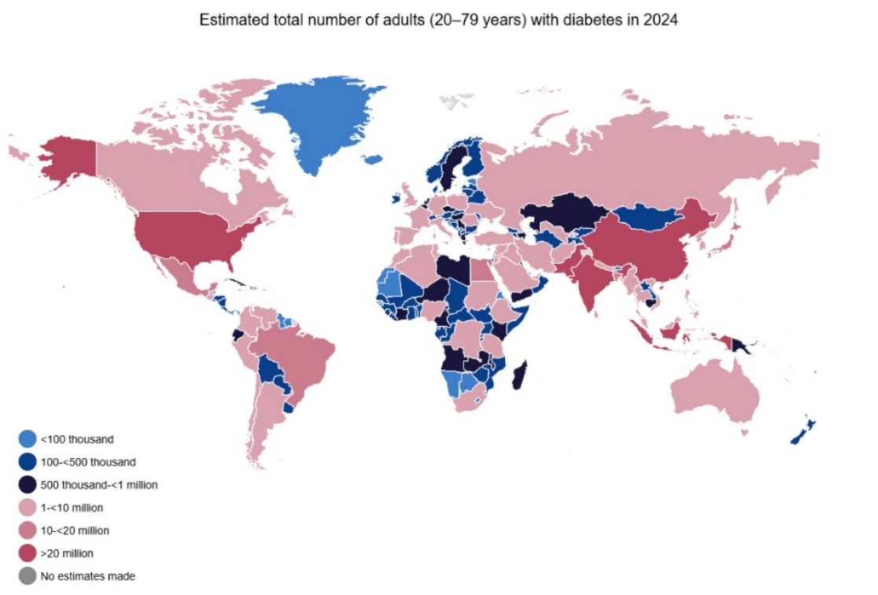
Figure 1: Global prevalence of diabetes among adults in 2024. Source: International Diabetes Federation (2025).
In the United Kingdom (UK), based on Diabetes UK (2023) data, the population at risk for or already living with dysglycaemia is substantial. Estimates indicate that 6.3 million adults have prediabetes, signifying an increased risk for Type 2 diabetes (T2D), while a further 1.3 million have undiagnosed T2D. Consequently, the aggregate figure for adults living with either diabetes or prediabetes reaches approximately 12.1 million. The prevalence continues to rise, with an increase of 185,034 cases between 2022 and 2023. Moreover, the International Diabetes Federation (2025) projects that the number of adults living with diabetes in the UK will rise from 4.5 million in 2024 to 4.9 million in 2050 (see Figure 2).
Although genetic predisposition is a significant risk factor, the development of T2D is strongly influenced by modifiable lifestyle factors, including dietary habits, physical inactivity, and obesity (Diabetes UK, 2023). Given that T2D accounts for approximately 90% of all global cases, this report will focus on analysing its implications for individuals and communities.
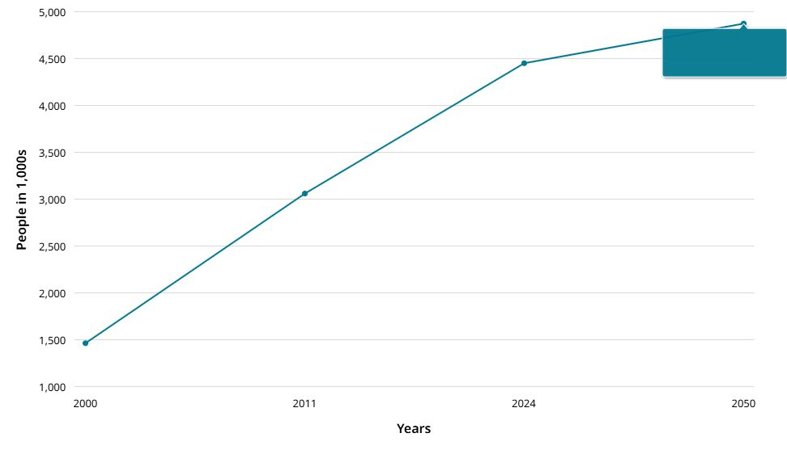
Figure 2: The estimated prevalence of diabetes among adults in the United Kingdom. Source: International Diabetes Federation (2025).

Definition and Cause of Diabetes Mellitus
Diabetes mellitus is a metabolic disorder characterised by a deficiency in insulin production or a diminished cellular response to insulin, leading to dysregulated blood glucose levels. Insulin, a hormone synthesised by the pancreas, is essential for the control of blood glucose. While several classifications of diabetes exist, Type 1 and Type 2 are the most prevalent forms (British Heart Foundation, 2018).
Type 1 Diabetes results from an autoimmune destruction of pancreatic beta-cells, causing an absolute insulin deficiency. This form is more common in developed nations, with a global prevalence estimated at nine million individuals in 2017 (British Heart Foundation, 2018).
Type 2 Diabetes arises from a combination of insulin resistance, where the body's cells fail to respond effectively to insulin, and a progressive decline in insulin secretion. It constitutes the majority of global diabetes cases (British Heart Foundation, 2018).

Diabetes and Endocrine Function

According to Endocrine Society (2025), diabetes mellitus is a chronic endocrine disorder characterized by dysregulation of blood glucose levels. This dysregulation stems from a malfunction in the insulin pathway, a hormone secreted by the pancreas that is critical for facilitating the transport of glucose from the bloodstream into the body's cells. Within the cells, glucose serves as the primary substrate for energy production, which is utilized for immediate metabolic demands or stored for future use (see Figure 3).
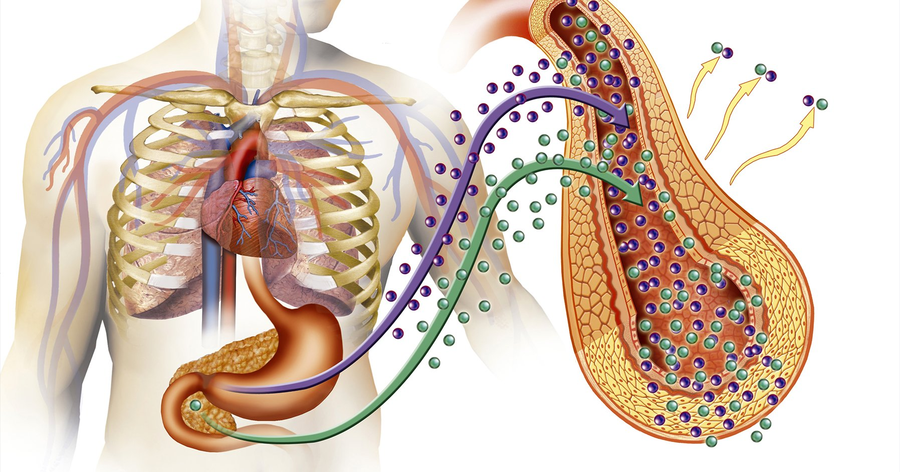
Figure 3: A schematic diagram illustrating the endocrine system's role in the pathophysiology of diabetes mellitus. Source: Endocrine Society (2025).
Furthermore, the Endocrine Society (2023) affirms that primary source of blood glucose is dietary carbohydrate intake, supplemented by hepatic glucose production during fasting states. In T2D, the physiological equilibrium is disrupted by a combination of insulin resistance, where cells fail to respond adequately to insulin, and a progressive decline in pancreatic insulin secretion. This impairment prevents the efficient cellular uptake of glucose, leading to chronic hyperglycaemia, or elevated blood sugar.
Sustained hyperglycaemia is a primary driver of macrovascular and microvascular damage, significantly increasing the risk of severe long-term health complications. These include retinopathy potentially leading to blindness, nephropathy culminating in renal failure, peripheral neuropathy which increases the risk of unnoticed injury and chronic pain, and an elevated risk of adverse cardiovascular events such as heart attack and stroke (Endocrine Society, 2025).

Blood Sugar Regulation

Glucose Homeostasis and Metabolic Regulation
According to Somjen (2023) Glucose serves as the principal metabolic substrate for energy production in the human body, essential for the maintenance of all organ systems. The preservation of physiological function is contingent upon the maintenance blood sugar level within a narrow homeostatic range (see Figure 4). The author also states that deviations from this range, manifesting as either hyperglycaemia or hypoglycaemia, are associated with significant pathologies, including diabetes mellitus, cardiovascular disease, and neurological disorders. Consequently, the body employs a sophisticated regulatory system to ensure glycaemic equilibrium.
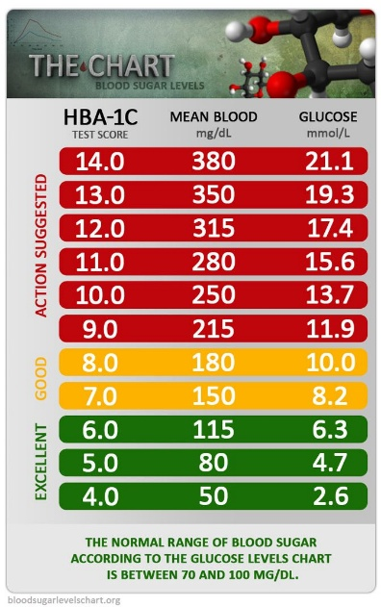
Figure 4: A traffic light colour-coded chart illustrating target, high, and low blood glucose ranges for patient education. Source: Crain, R. (2024).

The Rule of Insulin and Glucagon
According to Singh (2023), the maintenance of blood glucose levels is a dynamic process mediated by the counter-regulatory hormones insulin and glucagon. Insulin, released from pancreatic β-cells during elevated blood glucose, facilitates glucose disposal in peripheral tissues like muscle and adipose, while simultaneously promoting hepatic glucose storage as glycogen and suppressing gluconeogenesis. In opposition, glucagon is secreted from α-cells during fasting or energy demand, primarily acting on the liver to stimulate glycogen breakdown and de novo glucose synthesis from precursors like amino acids. This antagonistic relationship ensures a tightly regulated supply of glucose to meet metabolic demands (Connor et al., 2006)

Organ-Specific Roles in Glucose Regulation
Witts (2025) positions the liver as the body's central glucostat, is responsible for maintaining blood glucose balance. However, as stated by Somjen (2025) in T2D, hepatic insulin resistance disrupts this, causing aberrant glucose production that worsens hyperglycaemia (see Figure 5). The Author highlights the importance of peripheral tissues: skeletal muscle as the major site for glucose clearance, enhanced by exercise, and adipose tissue as both a storage depot and an endocrine organ that secretes insulin-sensitising adipokines.
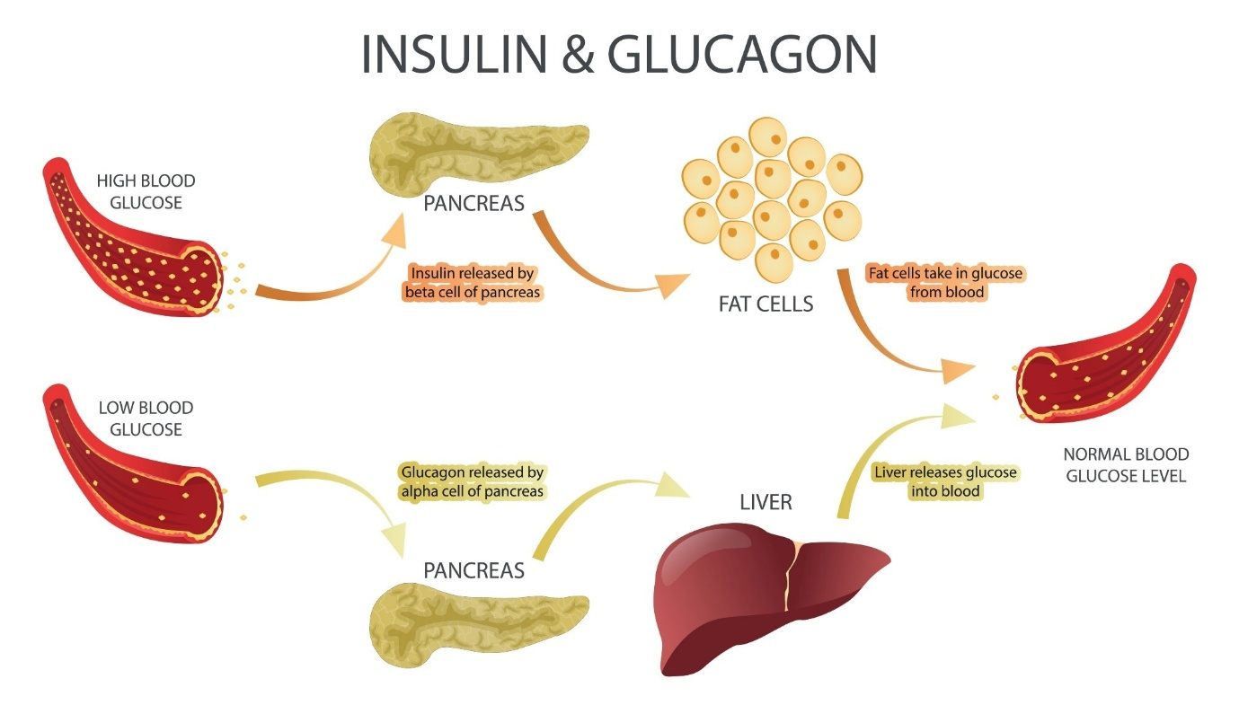
Figure 5: The role of glucagon in glycaemic regulation and its implications for diabetes pathophysiology. Source: News-Medical.net (2024)

Cellular Metabolism

According to Britannica Editors (2025) cellular respiration is a fundamental metabolic process comprising three sequential stages: glycolysis, the tricarboxylic acid (TCA) cycle, and oxidative phosphorylation (see Figure 6).
Glycolysis: This initial, anaerobic phase takes place in the cellular cytoplasm. It involves the enzymatic breakdown of one glucose molecule into two pyruvate molecules, yielding a net gain of ATP and reducing NAD⁺ to NADH.
TCA Cycle (Krebs Cycle): Occurring within the mitochondrial matrix, this cycle further oxidizes acetyl coenzyme A (derived from pyruvate). It generates high-energy electron carriers (NADH and FADH₂) and releases carbon dioxide as a metabolic byproduct.
Oxidative Phosphorylation: This final and most productive stage occurs on the inner mitochondrial membrane. It consists of the electron transport chain, where electrons from NADH and FADH₂ are passed through a series of protein complexes (cytochromes) to finally reduce oxygen, forming water. The energy released during this electron transfer powers the synthesis of the majority of the ATP.
In addition, Garcia (2020) research identifies key molecular drivers of Type 2 Diabetes Mellitus (T2DM), including impaired insulin secretion, insulin resistance, and mitochondrial dysfunction. The study further emphasises the contributory roles of inflammation, oxidative stress, and genetic factors in the disease's pathogenesis.

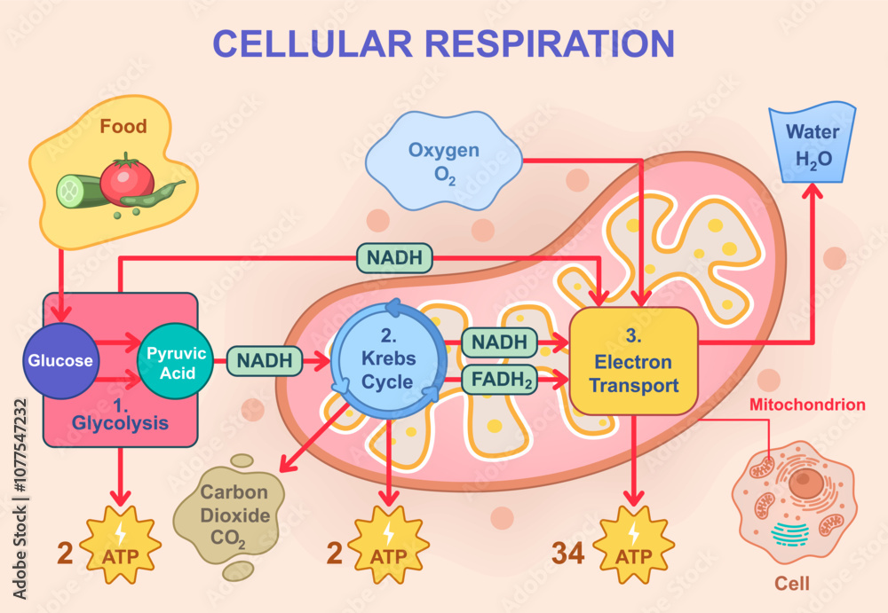
Figure 6: A vector diagram illustrating the three primary stages of cellular respiration: glycolysis, the Krebs cycle (citric acid cycle), and oxidative phosphorylation via the electron transport chain, depicting glucose catabolism, ATP synthesis, and the exchange of oxygen and carbon dioxide. Source: Britton, G.J. (2023).

Tracking Blood Sugar

According to the NHS England (2017), self-monitoring of blood glucose (SMBG) provides immediate biochemical feedback on an individual's physiological status. This process is critical as it elucidates the body's specific responses to dietary intake, physical activity, psychological stress, and pharmacological interventions, thereby guiding daily self-management decisions. However, the SMBG is available only for the T2D patient who is taking insulin. Although NICE (2022) states that the T2D patients on drug treatment have their blood sugar monitored by the HbA1c every three to six months based on individual needs.
In accordance with UK Diabetes (2023) regular monitoring is instrumental in mitigating the risks associated with glycaemic extremes. Persistent hyperglycaemia can induce microvascular and macrovascular complications, potentially leading to retinopathy, nephropathy, neuropathy, and cardiovascular disease. Conversely, acute hypoglycaemia presents an immediate danger, manifesting in adverse symptoms such as tremors, diaphoresis, and confusion, particularly for patients on insulin or certain glucose-lowering medications. SMBG facilitates the early detection and correction of these dysregulated states.
Furthermore, Diabetes UK (2023) assert that the longitudinal data generated from SMBG are indispensable for clinical decision-making, enabling healthcare professionals to optimise medication regimens, dietary plans, and exercise prescriptions in a patient-specific manner. Ultimately, this practice empowers patients by fostering insight into the causal relationships between lifestyle choices and glycaemic control, for instance, by identifying specific foods that cause after eating a meal spike or recognising the glucoregulatory benefits of postprandial exercise.

The Role of Lifestyle Interventions in Diabetes Management
According to Thompson et al. (2007), managing diabetes isn't just about medication. The patients’ daily habits are one of the most powerful tools they have. Besides, lifestyle changes can make difference for an individual leaving with T2D. Smallwood (2007) emphasises that maintaining a healthy weight is crucial for all individuals but is particularly critical for those with or at risk of diabetes. The author asserts that adhering to a balanced diet and managing one's weight are fundamental to achieving optimal glycaemic control and mitigating the long-term complications associated with the condition. In addition, for individuals with pre-diabetes, weight management and the adoption of a healthy lifestyle are identified as key strategies that can delay or even prevent the progression to T2D.
Diabetes UK (n.d) states that diet plays all the difference for people living with T2D. Dietary management of T2D is not universal. Success depends on creating a personalized and sustainable eating plan based on an individual's current diet and their specific health goals.
Another key factor for manage diabetes accordingly to Diabetes Uk (2025) is physical exercise. Exercises enhance insulin sensitivity, facilitating more effective glucose uptake by cells. This physiological effect is critical for maintaining glycaemic control and mitigating the risk of diabetic complications.
Furthermore, Smoking is a critical change. Seery (2023) asset that smoking and diabetes are both risk factors for cardiovascular disease, amplifying the likelihood of a heart attack or stroke. Both conditions damage the inner lining of arteries (the endothelium), which accelerates the formation of atherosclerotic plaques. This narrows the blood vessels, severely restricting circulation. Besides, smoking can increase insulin resistance, making diabetes harder to maintain into control (Diabetes UK 2025).
Moreover, Seery (2023) states that when this narrowing affects the coronary arteries, it can cause a heart attack; when it affects arteries supplying the brain, it can cause a stroke. Since diabetes inherently impairs blood vessel function and flow, the addition of smoking creates a profoundly dangerous combination, multiplying the risk of these life-threatening events.
In accordance with NHS University Hospitals Sussex (2025), for individuals with diabetes, alcohol consumption carries significant risks. It can cause hypoglycaemia by impairing the liver's ability to release glucose. Furthermore, regular drinking increases blood pressure and cholesterol, raising the risk of heart disease and stroke. It argues that Alcohol is also high in calories, which can hinder weight management efforts.
Diabetes UK (2025) explains that unstable blood sugar levels can interfere with sleep, and conditions like nerve damage (neuropathy) can cause pain that further prevents restful sleep.

Recommendations for Patients

According to Diabetes UK (2025) and NHS (2023) there are several recommendations for patients with T2D. They are generally categorised into lifestyle modifications and medical management, all underpinned by the goal of achieving stable blood sugar levels, preventing complications, and improving overall quality of life. These are follows:
1. Core Medical Management: This involves regular clinical engagement, strict medication adherence, consistent self-monitoring of blood glucose (especially for those on specific medications), achieving personalised HbA1c targets, and actively managing blood pressure and cholesterol to mitigate cardiovascular risks.
2. Foundational Lifestyle Modifications:
Nutrition: Adopt a balanced diet focused on complex carbohydrates, healthy fats, and reduced sugar, utilising tools like the NHS Plate Method for portion control (see Figure 7).
Physical Activity: Incorporate at least 150 minutes of moderate weekly exercise and strength training twice weekly to improve insulin sensitivity and glycaemic control.
Critical Avoidances: Smoking cessation is mandatory due to the multiplied vascular risks. Alcohol should be strictly limited and never consumed on an empty stomach. Follow NHS guidelines (no more than 14 units per week, spread over several days).
3. Holistic Self-Care & Prevention: Prioritising sleep, managing stress, and conducting daily foot checks are essential for overall wellbeing and complication prevention. Empowering oneself through structured education programmes like DESMOND and utilising NHS weight management services are key strategies for long-term success and potential remission.
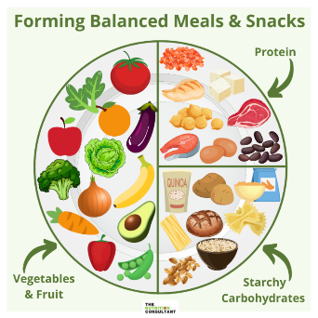

Figure 7: A visual guide to a balanced meal using the plate method. Source: NHS England (2023)

Conclusion

In summary, Type 2 Diabetes represents a profound and growing public health challenge, driven by a complex interplay of physiological dysfunction and modifiable lifestyle factors. As this report has detailed, the condition stems from a disruption of the delicate endocrine balance that maintains glucose homeostasis, primarily through insulin resistance and beta-cell dysfunction. This dysregulation initiates a cascade of metabolic consequences, from impaired cellular respiration to sustained hyperglycaemia, which in turn lays the groundwork for devastating microvascular and macrovascular complications.
However, the narrative of T2D is not one of inevitability. The evidence clearly demonstrates that its management and, in many cases, remission, are achievable through a proactive and integrated approach. Effective self-management, empowered by blood glucose monitoring, provides the critical feedback necessary for informed decision-making. Crucially, this must be coupled with foundational lifestyle modifications: a personalised, balanced diet to regulate fuel intake; regular physical activity to enhance insulin sensitivity; and the elimination of key risk factors such as smoking and harmful alcohol use.
For healthcare professionals, particularly practice nurses on the front line, the imperative is clear. The role must evolve from simply treating symptoms to actively educating, coaching, and empowering patients. By bridging the significant knowledge gap and providing structured, person-centred support—from explaining the antagonistic roles of insulin and glucagon to demonstrating the practical application of the plate method—professionals can transform patient engagement. Ultimately, conquering the diabetes epidemic requires a dual commitment: from individuals to take ownership of their health through sustainable lifestyle changes, and from healthcare systems to provide the education, resources, and supportive environment that make those changes possible. This collaborative, holistic strategy is the cornerstone for not only managing blood glucose levels but also for safeguarding long-term health and improving the quality of life for millions.

References

Britannica Editors (2025). Cellular respiration. Encyclopedia Britannica. Available at: https://www.britannica.com/science/cellular-respiration. (Accessed: 28 November 2025).
British Heart Foundation (2018) Understanding Diabetes type 2. https://www.bhf.org.uk/-/media/files/information-and-support/publications/heart-conditions/understandingseries/u001-understandingdiabetes_download0818.pdf?rev=4e3e00c6a1e74b668213496edf797795. (Accessed: 11 November 2025).
Britton, G.J. (2023) Essentials of Cellular Metabolism. 3rd edn. London: Academic Press, p. 78.
Connor, J., Harwood-Pearce, V. and Morgan, K. (2006) Anatomy and Physiology for Therapists. Oxford: Heinemann Educational Publishers.
Conor, S. (2023) Diabetes and Smoking. Available at: https://www.diabetes.co.uk/diabetes-and-smoking.html. (Accessed: 30 November 2025).
Crain, R. (2024) Glucose Level Chart for Adults. Available at: https://www.exampleblogurl.com/glucose-chart (Accessed: 26 October 2025).
Diabetes Uk (2023) Type 2 Diabetes. Available at: https//www.diabetes.org.uk/type-2-diabetes. (Accessed: 18 November 2025).
Diabetes Uk (n.d) I have type 2 diabetes – what can I eat? Available at: https://www.diabetes.org.uk/living-with-diabetes/eating/i-have-type-2-diabetes. (Accessed: 30 November 2025).
Diabetes Uk (n.d) Exercise for diabetes. Available at: https://www.diabetes.co.uk/living-with-diabetes/exercise.html. (Accessed: 30 November 2025).
Diabetes Uk (n.d) Sleep and diabetes. Available at: https://www.diabetes.org.uk/guide-to-diabetes/life-with-diabetes/sleep-and-diabetes. (Accessed: 30 November 2025).
Endocrine Society (2025) Diabetes and Endocrine Function. Available at: https://www.endocrine.org/patient-engagement/endocrine-library/diabetes-and-endocrine-function. (accessed: 17 November 2025)
Endocrine Society (2025) Endocrine Facts and Figures. Available at: https://www.endocrine.org/facts-and-figures (Accessed: 2 November 2025).
Galicia-Garcia, U., Benito-Vicente, A., Jebari, A., Larrea-Sebal, A., Siddiqi, H., Uribe, K.B., Ostolaza, H., Martín, C. (2020) ‘Pathophysiology of Type 2 Diabetes Mellitus’. International Journal of Review Molecular Sciences.
Internation Diabetes Federation (2025) United Kingdom Diabetes Country Report 2000-2050. Available at: https://diabetesatlas.org/data-by-location/country/united-kingdom/. (accessed: 30 November 2025).
Naglev (2024) Cellular Respiration Vector Illustration [Image]. Available at: https://www.istockphoto.com/ (Accessed: 26 October 2025).
News-Medical.net (2024) What is Glucagon?. Available at: https://www.news-medical.net/health/What-is-Glucagon.aspx (Accessed: 2 november 2025).
NICE (2022) Type 2 Diabetes in Adults: Management. Available at: https://www.nice.org.uk. (Accessed: 28 November 2025).
NHS England (2017) Blood Glucose Self-Monitoring Guidelines. Available at: https://www.england.nhs.uk/midlands/wp-content/uploads/sites/46/2019/05/3-guidelines-on-smbg-use.pdf. (Accessed: 28 November 2025).
NHS University Hospitals Sussex (2025). Diabetes and Alcohol. Available at: https://www.uhsussex.nhs.uk/resources/diabetes-and-alcohol/#what-is-this-information-about. (Accessed: 30 November 2025).
Singh, A. (2023) The Endocrine System. available at: https://www.diabetes.co.uk/body/endocrine-system.html. (Accessed: 16 November 2025).
Somjen, D. (2023) ‘Glucose regulation: How body keeps blood sugar levels.’ Open Access Journals. Available at: https://www.openaccessjournals.com/articles/glucose-regulation-how-body-keeps--blood-sugar-levels-balanced.pdf. (Accessed: 2 November 2025)
DOI: 10.37532/1758-1907.2023.13.441-442
Thompson, A., Govindji, A. and Suthering, J. (2007). The diabetes weight loss diet. first ed. 122 Arlington Road, London NW1 7HP: Kyle Cathie Limited.
Watts, M. (2025) The Liver and Diabetes. Available at: https://www.diabetes.co.uk/body/liver-and-diabetes.html#google_vignette. (Accessed: 16 November 2025).
Watts, M. (2023) The Kidneys and Diabetes. Available at: https://www.diabetes.co.uk/body/kidneys-and-diabetes.html#google_vignette. (Accessed: 16 November 2025).
World Health Organization (2024) Diabetes. Available at: https://www.who.int/news-room/fact-sheets/detail/diabetes. (Accessed: 1 November 2025).

