Electrical & Electronic Principles

Jacob Newman
Student number: 2515825
Electrical and Electronic
Engineering Degree Apprentice

L4 Electrical & Electronic Principles ACDA4006

Contents
List of Figures 3
List of tables 4
Abstract 5
Introduction 5
Theory of resonance 5
Simulation Setup 6
Experimental setup 8
Results 10
Discussion 12
Conclusion 14
References 15

List of Figures
Figure 1: RLC circuit setup on Proteus 8 6
Figure 2: Oscilloscope output on the simulated circuit at 100Hz 7
Figure 3: Breadboarded RLC circuit for testing 8
Figure 4: Breadboarded circuit being tested 9
Figure 5: Semi-log graph of attenuated data from the circuit simulation 11
Figure 6: Semi-log graph of attenuated data from the breadboarded circuit 12

List of tables
Table 1: Simulated circuit data recording 7
Table 2: Breadboarded circuit data recordings 9
Table 3: Simulated circuit attenuated data 10
Table 4: Attenuated data from breadboarded circuit 10

Abstract
This report investigates the resonant frequency and Q factors of RLC circuits, using Proteus 8 simulation software and practical breadboard testing. The circuit that was tested was made up of a 1 mH inductor, 1 µF capacitor and a 1 kΩ resistor. In each test a sinusoidal waveform was applied across the circuit of magnitude 2 Vpp and the frequency ranged from 100 Hz to 20 kHz. The output voltage was measured at each frequency point and then recorded. The recorded data was then converted into attenuation in decibels to help identify the resonance peak and the bandwidth of the circuit. The theoretical value of resonance for the circuit was calculated to be 5033 Hz. The obtained results closely aligned with this value; the simulated circuit resonated at approximately 5000 Hz and the breadboarded circuit resonated at approximately 5100 Hz. Despite the resonance peaks being close together the Q factors were quite different, a value of 25 for the simulated circuit compared to the value of 3.17 for the breadboarded circuit. The results show that although resonant frequencies closely matched the theory, the practical breadboarded circuit exhibited a wider and flatter resonance peak due to real-world losses and non-idealities that were not accounted for in the simulation.

Introduction
RLC circuits are a fundamental component of electronic systems and consist of resistors, inductors and capacitors. These circuits can exhibit a phenomenon known as resonance. This behavior makes RLC circuits useful for many applications, including Radio and TV tuning [10], low pass and high pass filters and transient behaviour analysis. Resonance enables circuits to filter, select and oscillate signals. They also can amplify or attenuate selected signals based on input frequency.
This report investigates the behaviour of an RLC circuit across a range of input frequencies at 2 Vpp input. A simulation is conducted to measure the output voltages over the range of 100 Hz to 20 kHz, the circuit is then practically implemented using breadboarded components and then tested across the same frequency range. The aim is to determine the resonant frequency and Q factor of the circuit. The results gathered from simulation and real-world implementation is compared and evaluated. Any variation between the results is then discussed in relation to theoretical expectations and practical limitations.

Theory of resonance
In an RLC circuit, resonance occurs when the reactance of both the inductors and capacitor in the circuit are equal in magnitude [1]. The inductor and capacitor can either be in parallel or in series. When a circuit is resonating at a frequency the reactive effects of the inductor and capacitor oppose each other. A circuit consisting of equal reactance’s behaves like a circuit consisting of only one resistor. This situation is called the resonance state of the circuit. [1]. The frequency at which a circuit resonates is entirely dependent of the size of the inductor and capacitors [1].
The resonance frequency can be found by equating equations (1) and (2) [10] [12].
$x_{l}=2πfL$ (1)
$x_{c}= \frac{1}{2πfC}$ (2)
The equated version of the equations (1) and (2) looks like equation (3) [4][10].
$f_{resonant}= \frac{1}{2π\sqrt{LC}}$ (3)
The Q factor is a dimensionless ratio between a circuit’s resonant frequency and bandwidth [1]. A higher Q Factor indicates a narrower bandwidth and a more selective circuit. A lower Q factor indicates a wider bandwidth and greater damping [3].
Q factor is calculated by dividing the peak frequency by the bandwidth (4).
$Q=\frac{Peak Frequency}{f_{2-}f_{1}}$ (4) [2]
The bandwidth is calculated by finding the -3dB point on both sides of the attenuated data identified as $f_{1}$ and $f_{2}$ in equation (2) and then subtracting them as shown in (2) [4].
The raw data collected in the experiment is attenuated by the equation (5):
$A=20×\log_{10}\left(\frac{V_{L}}{V_{In}}\right)$ (5)
Where A is attenuation in dB, VL is the peak-to-peak voltage measured across the inductor, and Vin is the peak-to-peak input voltage as set on the signal generator.

Simulation Setup
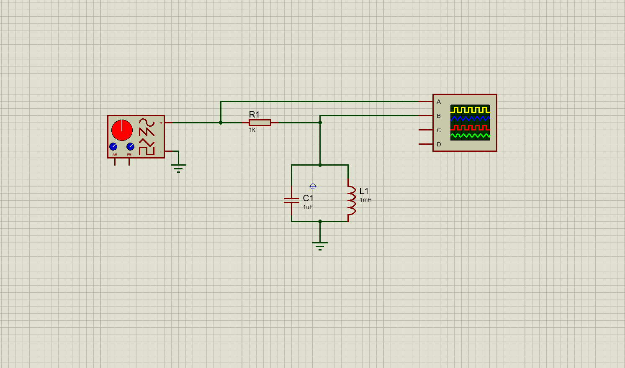
The RLC circuit was first set up using Proteus 8 simulation software. The circuit used a 1 µf capacitor, a 1 mH inductor and a 1 kΩ resistor. This is shown below in figure 1.
Figure 1: RLC circuit setup on Proteus 8

The RLC circuit was connected to a wave form generator which supplied a sinusoidal waveform input. The waveform had a magnitude of 2 Vpp and was of varying frequency, from 100 Hz to 20 kHz. The oscilloscope was connected to the circuit, before the resistor, to measure the input signal and once after the resistor to measure the change in circuit behaviour at different frequencies.
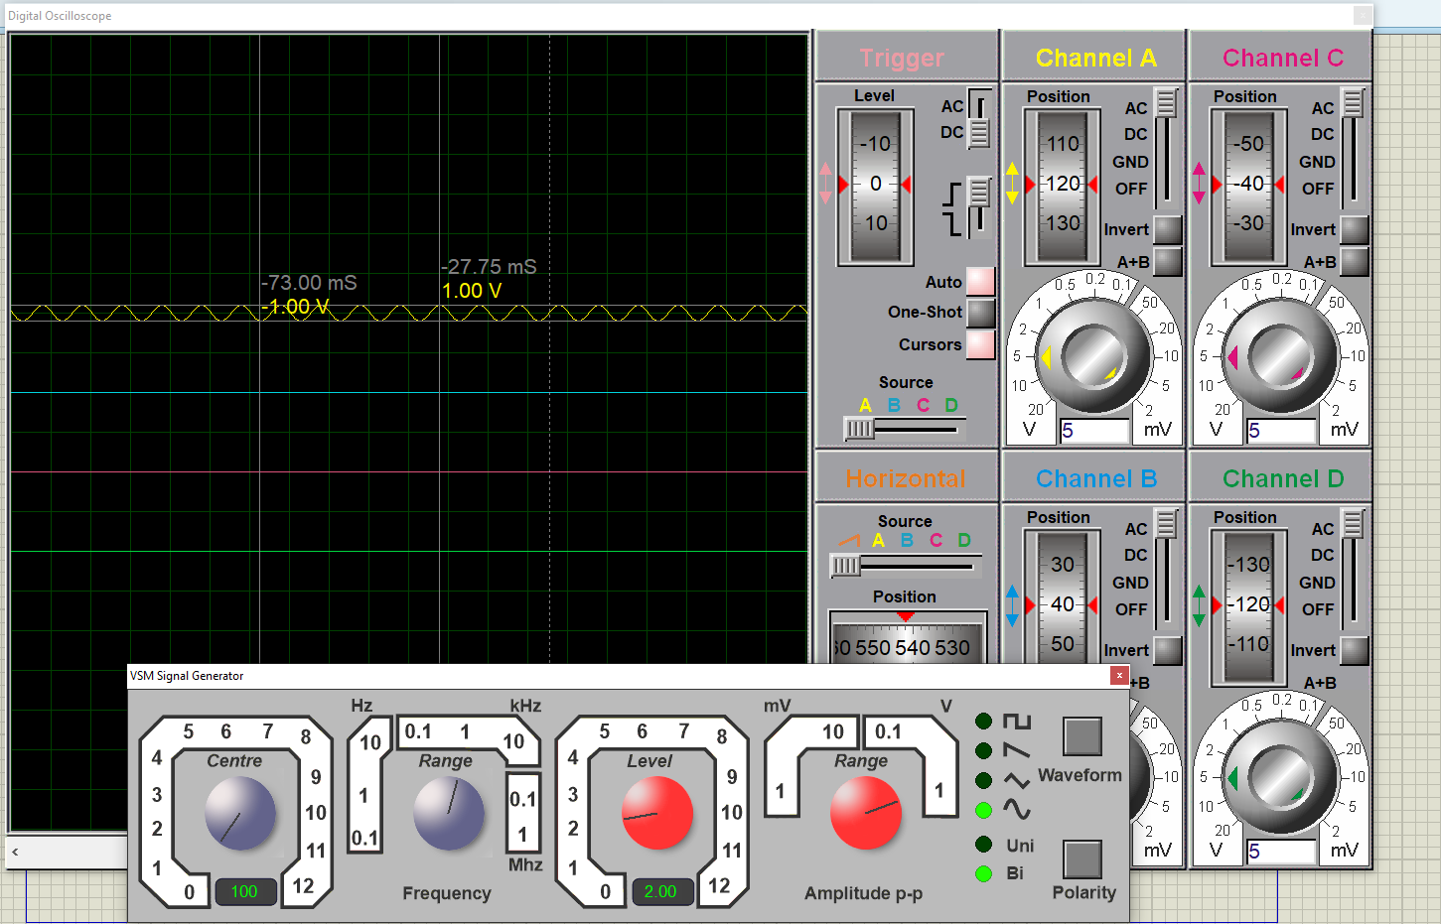
Figure 2 shows the oscilloscope output at 100Hz.
Figure 2: Oscilloscope output on the simulated circuit at 100Hz

Table 1 shows the results collected from the simulation of this circuit at different frequencies

Table 1: Simulated circuit data recording
Frequency | Vin (mV) | Vout (mV)
100 | 2000 | 0
300 | 2000 | 0
500 | 2000 | 0
1000 | 2000 | 25
2000 | 2000 | 25
3000 | 2000 | 50
3500 | 2000 | 100
4000 | 2000 | 150
4500 | 2000 | 325
4800 | 2000 | 825
4900 | 2000 | 1450
5000 | 2000 | 1600
5100 | 2000 | 950
5200 | 2000 | 625
5300 | 2000 | 450
5400 | 2000 | 375
6000 | 2000 | 175
7000 | 2000 | 100
10000 | 2000 | 50
20000 | 2000 | 25

This data shows a clear increase of output voltage leading up to 5000 Hz, after 5000 Hz the output voltage drops quickly. This suggests that resonant frequency is 5000 Hz.

Experimental setup
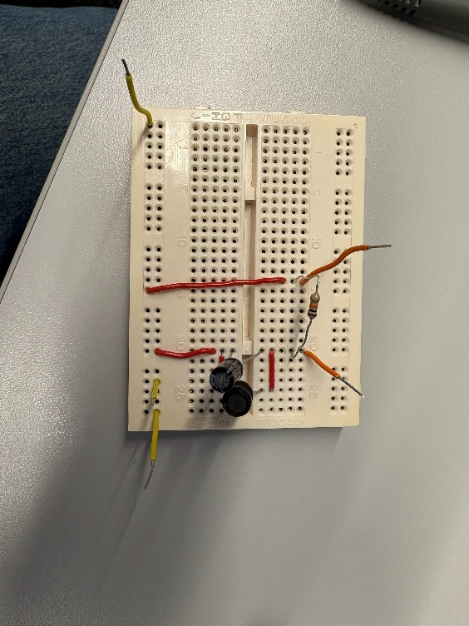
The circuit was then set up on a breadboard as shown in figure 3. Each wiring connection was checked as it was inserted and extra care taken to ensure the capacitors legs were properly inserted on both sides of the breadboard.
Figure 3: Breadboarded RLC circuit for testing

The shole circuit was then double checked for proper connections before the circuit was then connected to a waveform generator and an oscilloscope in the same manner as the simulated circuit.
This is shown in figure 4, the picture was taken when an input frequency of 1000 Hz was applied to the circuit.
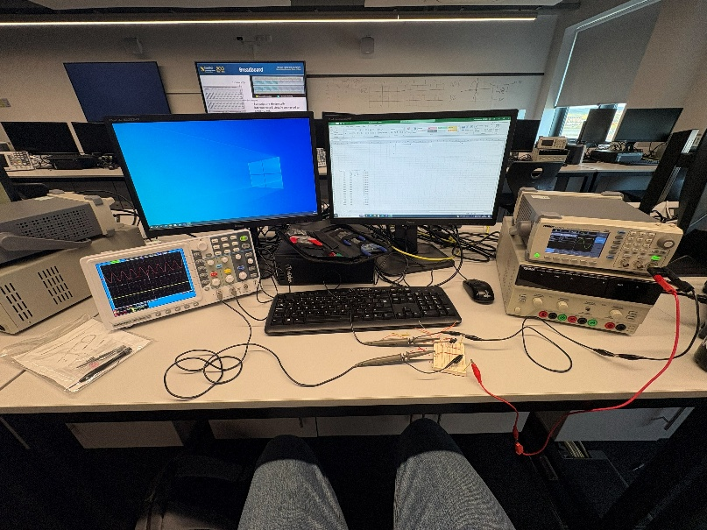
Figure 4: Breadboarded circuit being tested
Table 2 shows the results captured from the breadboarded circuit
Table 2: Breadboarded circuit data recordings
Frequency | Vin (mV) | Vout (mV)
100 | 2000 | 0
300 | 2000 | 0
500 | 2000 | 0
1000 | 2000 | 3.2
2000 | 2000 | 4
3000 | 2000 | 6.8
3500 | 2000 | 8.8
4000 | 2000 | 12
4500 | 2000 | 17.2
4800 | 2000 | 20.8
4900 | 2000 | 21.6
4950 | 2000 | 22
5000 | 2000 | 22.4
5050 | 2000 | 22.4
5100 | 2000 | 22.4
5200 | 2000 | 22.4
5300 | 2000 | 22
5400 | 2000 | 21.6
6000 | 2000 | 16
7000 | 2000 | 10.4
10000 | 2000 | 5.2
20000 | 2000 | 2.8
The data from the breadboarded circuit shows a clear increase in output voltage between 5000 Hz and 5200 Hz suggesting the resonance frequency is within this range.

Results
The attenuation was calculated from the data collected in both experiments, this is shown for the simulated circuit in table 3 and the breadboarded circuit in table 4. The data from 100 Hz to 500 Hz in both tables has been removed because the measured output voltage at these frequencies was 0 mV.
Table 3: Simulated circuit attenuated data
Frequency | dB
1000 | -38.06179974
2000 | -38.06179974
3000 | -32.04119983
3500 | -26.02059991
4000 | -22.49877473
4500 | -15.78293269
4800 | -7.691520942
4900 | -2.793239869
5000 | -1.93820026
5100 | -6.466127808
5200 | -10.10299957
5300 | -12.95634964
5400 | -14.53997456
6000 | -21.15983894
7000 | -26.02059991
10000 | -32.04119983
20000 | -38.06179974
The simulated results show a steep increase in output voltage leading up to the 5000 Hz point. After 5000 Hz the output voltage drops very quickly.
Table 4: Attenuated data from breadboarded circuit
Frequency | dB
1000 | -55.91760035
2000 | -53.97940009
3000 | -49.37042166
3500 | -47.13094647
4000 | -44.43697499
4500 | -41.31003098
4800 | -39.65933321
4900 | -39.33152489
4950 | -39.1721463
5000 | -39.01563955
5050 | -39.01563955
5100 | -39.01563955
5200 | -39.01563955
5300 | -39.1721463
5400 | -39.33152489
6000 | -41.93820026
7000 | -45.67993313
10000 | -51.70053304
20000 | -57.07743929
The breadboarded attenuated output voltage rises slowly towards 5100 Hz creating a flatter rounded peak between 5000 Hz and 5200 Hz, this suggests a wider circuit bandwidth and lower selectivity.
The data is graphically represented below in Figures 5 and 6. Figure 5 shows the simulated attenuation clearly outlining the sharp increase in the output voltage, suggesting higher selectivity and lower bandwidth. Figure 6 shows the breadboarded circuits attenuation; this clearly outlines the flatter, more rounded curve created by the breadboarded circuits output voltage.
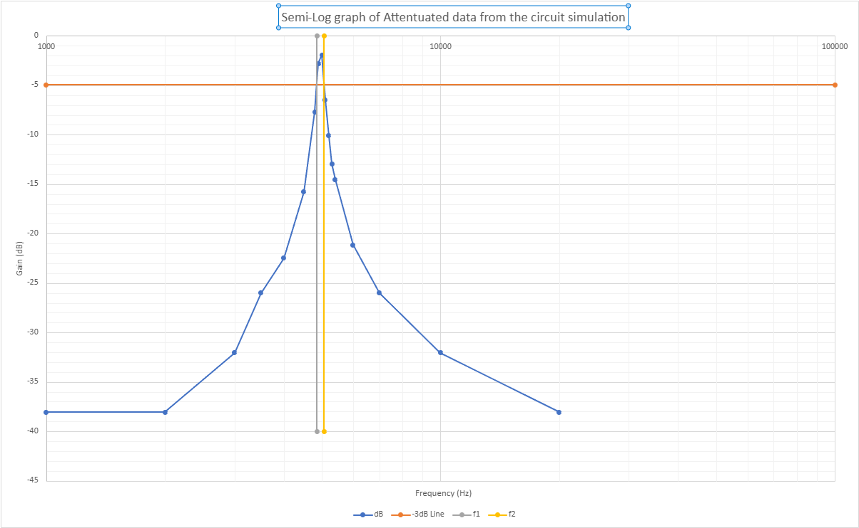
Figure 5: Semi-log graph of attenuated data from the circuit simulation

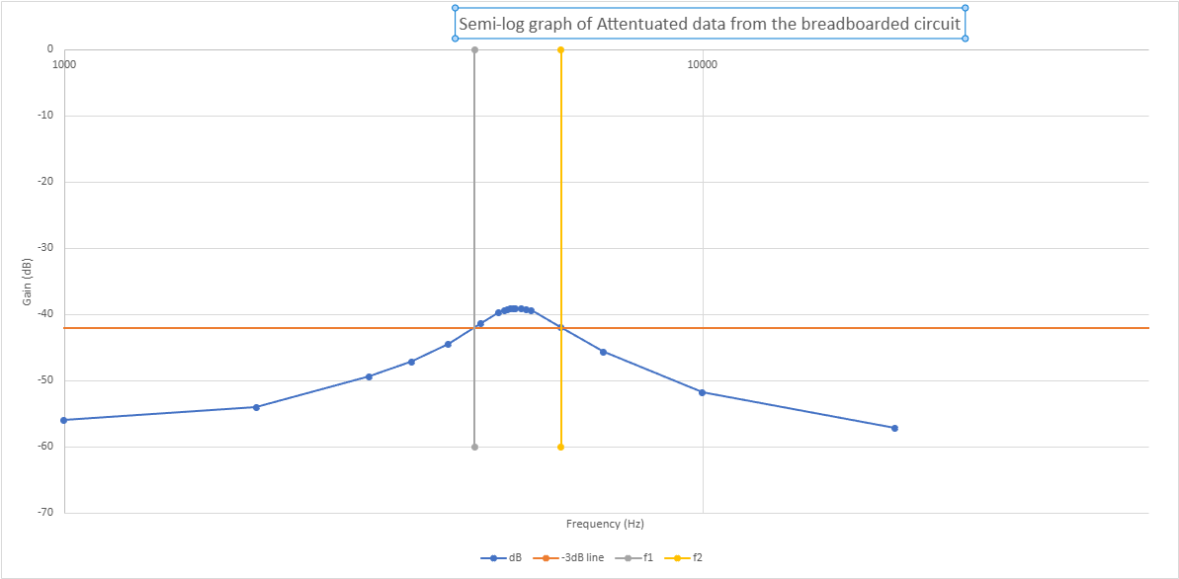
Figure 6: Semi-log graph of attenuated data from the breadboarded circuit

Discussion
The results from the simulation to the breadboarded circuit show that the resonance characteristics of each circuit are slightly different. Although, the point of resonance for both circuits is similar, in the simulation it was 5000 Hz and 5100 Hz in the breadboarded circuit. As shown by equation 6 is very close to the theoretical circuit resonance of 5033 Hz.
$f_{r}=\frac{1}{2π\sqrt{(1 ×{10}^{-3})(1 × {10}^{-6})}}=5032.92 Hz (2dp)$ (6)
The percentage error has been calculated for both circuits; the simulation has percentage error of 0.66% and the breadboarded circuit has percentage error of 1.33%. Both percentage error calculations used the equation 7 for their calculation:
$Percentage error=\left| \frac{Experimental value-actual value}{actaul value} \right|×100$ (7)
The breadboarded circuit has a much wider and flatter resonance peak compared to that of the simulated circuit which has a very sharp peak.
Although the values for both circuits are slightly different to the calculated theoretical value, the results support the basic theory that resonance occurs when inductive and capacitive reactance are equal [1].
The breadboarded circuit had -3 dB points on either side of the curve being 4400Hz and 6010 Hz respectively. This gives the breadboarded circuit a bandwidth shown in equation 8.
$6010-4400=1610 Hz$ (8)
$5060-4860=200 Hz$ (9)
This is much wider than the simulated circuit bandwidth, shown in equation 9. This indicates that the breadboarded circuit was heavily damped compared to the simulated circuit. This is highlighted further in the Q factor of each circuit. Equation 10 is the Q factor of the breadboarded circuit and equation 11 the Q factor calculation for the simulated circuit.
$Q= 5100 ÷1610=3.17 (2dp)$ (10)
Q = $5000 ÷200=25$ (11)
The simulated circuit is a more idealised version of the circuit, hence the higher Q factor and the sharper, more selective peak, which is demonstrated in the results [4]. The simulation used for this experiment does not model the real-world losses that occurred in the breadboarded circuit, this allows the simulated components to perform at their nominal values which in turn increases the Q factor.
There is a large significance in the differing Q factors as it shows the practical circuit was much less selective than the simulated circuit. The higher Q factor in the simulation showed it had a strong response over a narrow range of frequencies. To contrast the lower Q factor of the breadboarded circuit shows that the circuit was more responsive to a wider range of frequencies. The factors causing these differences have been explored.
Some of the difference between the simulated and practical results could be caused by the internal resistance of the real components [8], the inductors will have winding resistance [8], this is the natural resistance of the aluminium or copper itself within the component. Capacitors also have equivalent series resistance, which represents internal resistive losses in the capacitor, including losses from the leads, plates and dielectric material [5]. This varies under different temperatures and frequencies [6]. These losses dissipate energy from the circuit, commonly as heat [11]. This loss of energy leads to circuit damping, which widens the bandwidth as shown in Figure 6, in turn lowering the Q factor [8].
Another reason is component tolerance. Every component has a manufacturing tolerance that can affect its real-world characteristics [9]. Internal resistance, coil size and length are all things which can vary when a component is made, meaning the actual values may not be exactly 1 mH or 1µF respectively [12]. This can shift the circuits resonant frequency and could be the reason why the resonance peaks at 5100 Hz [12].
Although the experiment was carried out at much lower frequencies than those associated with very significant parasitic effects, the breadboard layout may still add small amounts of capacitance, resistance and inductance into the circuit [13]; the same phenomenon can occur with jumper wires. Jumper wires can often increase the overall resistance of the circuit [13]. In the breadboard layout, the capacitor and inductor are quite close together, this means they could have interactive forces between them, affecting the internal resistance of each component. These factors can alter the effective values of L and C and therefore shift the resonant frequency and reduce the measurement accuracy [13].
Finally, the measuring equipment can also have an effect on the results. The oscilloscope probes have an input resistance and capacitance [14] this can affect how accurately they take measurements from the circuit. Alongside that, the waveform generator has an internal resistance [7], these effects can reduce the measured voltage and can change the apparent response of the circuit as well.
These factors all contribute towards the difference seen between the simulation and practical experimentation, which saw a significant difference in peak output. This suggests that the practical losses were significant, or that the measuring point, oscilloscope scale, or circuit connection might not have been the exact equivalent to the simulation setup.
A limitation of the practical results is the resolution of the frequency measurements around the resonance peak. The breadboarded circuit produced the output measurement for the range of frequencies between 5000 Hz and 5200 Hz; this makes it difficult to identify one exact resonance frequency. Taking smaller frequency measurement steps, e.g. every 10 Hz would improve the accuracy of the peak and -3dB identification, thus improving the accuracy of the bandwidth and Q factor. The same could be applied to the simulated circuit.
Repeating the practical test several times would improve confidence in results. The results could then be averaged, giving a higher degree of certainty in the results. Doing this would eliminate any concern over the flatness and low voltage of the breadboard circuit.
Another way to improve the practical results is to measure the components values using an LCR meter before setting up the circuit. This would allow for a more accurate resonance peak to be determined and also for manufacturing tolerances to be accounted for, taking out error in the final results. With reduced error, it allows for a more reliable comparison between the simulation and the practical circuit. This extra section of method would also allow for clearer identification of the difference between the simulation and the practical lies. Whether in the measuring equipment or in the components themselves.
The simulation results could be improved by adding in another resistor which represents the inductor winding resistance and the capacitor ESR. This would more accurately recreate the circuit behaviour of the breadboarded circuit because the additional resistance would increase the damping, therefore lowering the Q factor and creating a flatter resonance peak. Allowing for a more accurate comparison between the circuits.
Overall, the results show a strong connection to theoretical calculations as to the point of resonance. However, the practical circuit had a wider bandwidth and a lower Q factor. This is indicative of the real-world losses in the circuit, including component tolerances, breadboard parasitic effects and instrument resistance and capacitance, all reducing the sharpness of the resonance peak.

Conclusion
The aim of this experiment was to investigate the resonant frequency and Q factor of simulated and practical RLC circuit. The theoretical resonant frequency is 5033 Hz; both circuits closely aligned with that value. The simulated circuit resonated at 5000 Hz and the breadboarded circuit resonated at 5100 Hz. However, the Q factors were significantly different with the simulated circuit having a Q factor of 25 and the breadboarded circuit having a Q factor of 3.17. Although the results align with the expected resonant frequency; the breadboarded circuit exhibited a much wider and flatter resonance peak. These differences are likely caused by the real-world non-idealities that were not modelled in the simulated circuit. To conclude, the experiment confirmed the expected relationship between inductance, capacitance and resonant frequency. It also demonstrated that circuit losses in a practical circuit contribute to a flatter resonance curve compared to that of a simulation which does not take into account all real-world losses.

References
[1] Dr. F. Obeidat, “Electric Circuits II Resonance.” Accessed: May 13, 2026. [Online]. Available: https://www.philadelphia.edu.jo/academics/fobeidat/uploads/Electric%20Circuits%20II%20Course2/10%20Seires%20Resonance.pdf
[2] L. Chai, J. Qi, Y. Teng, L. Hong, and L. Wang, “Experimental Study and Design of RLC Resonant Circuit,” Mar. 2024, doi: https://doi.org/10.1109/ainit61980.2024.10581674.
[3] “Resonance in Series-Parallel Circuits | Resonance | Electronics Textbook,” www.allaboutcircuits.com. https://www.allaboutcircuits.com/textbook/alternating-current/chpt-6/resonance-series-parallel-circuits/ (accessed May 13, 2026).
[4] Gupta, A.; Rahul, J.; Rahul; Tiwary, R.; Kumar, R.; and Sharma, R. (2016). Wireless power transfer by incorporation of renewable energy sources. International Journal of Engineering and Management Research, 6(1), 435-439.
[5] “Capacitors in Broadband Applications KYOCERA AVX CAPACITORS IN BROADBAND APPLICATIONS.” Accessed: May 09, 2026. [Online]. Available: https://www.kyocera-avx.com/docs/techinfo/RFMicrowaveThinFilm/Capacitors-in-Broadband-Applications.pdf
[6] “Understanding ESR In Electrolytic Capacitors | Avnet Abacus,” Avnet.com, Mar. 2017. https://my.avnet.com/abacus/resources/article/understanding-esr-in-electrolytic-capacitors/ (accessed May 09, 2026).
[7] “Experiment 2: Oscillation and Damping in the LRC Circuit Experiment 2: Oscillation and Damping in the LRC Circuit.” Accessed: May 14, 2026. [Online]. Available: https://courses.physics.ucsd.edu/2015/Summer/physics2cl/documents/Phys2CL_Exp2_2010.pdf
[8] E. coates, “Damping,” learnabout-electronics.org, Dec. 29, 2020. https://learnabout-electronics.org/ac_theory/lcr_para_104.php (accessed May 14, 2026).
[9] G. Zhai, Y. Zhou, X. Ye, and B. Hu, “A method of multi-objective reliability tolerance design for electronic circuits,” Chinese Journal of Aeronautics, vol. 26, no. 1, pp. 161–170, Feb. 2013, doi: https://doi.org/10.1016/j.cja.2012.12.005.
[10] T. Zhan, “Recommendation Of RLC Circuit and Its Uses in Electronic Devices,” Highlights in science, engineering and technology, vol. 81, pp. 281–285, Jan. 2024, doi: https://doi.org/10.54097/0yyssj09.
[11] J. E. M. Perea Martins, “Physical analysis of an electric resistor heating,” Physics Education, vol. 53, no. 3, p. 035023, Mar. 2018, doi: https://doi.org/10.1088/1361-6552/aaae80.
[12] “Resonant Frequency Formula - Keysight Technologies,” Keysight.com, 2024. https://www.keysight.com/used/rs/en/knowledge/formulas/resonant-frequency-formula (accessed May 14, 2026).
[13] C. E. Santos, A. P. Oliveira, and R. F. Costa, “Parasitic Capacitance Effects in Breadboard Circuits Operating Above 1 MHz,” International Journal of Electronics and Microcircuits, vol. 6, no. 1, pp. 19–25, Jan. 2026, doi: https://doi.org/10.22271/27084493.2026.v6.i1a.80.
[14] “Introduction to Oscilloscope Probes Instructor’s Guide Introduction to Oscilloscope Probes,” 2009. Accessed: May 14, 2026. [Online]. Available: https://www.physics.wisc.edu/courses/home/fall2022/321/lab_equipment/MSO2014_scope_tutorials/Probes/Probes-Instructors-Guide.pdf

