Student name: Gurjit Kaur
ID: 2425352
Programme: Certificate in Higher Education – Skills for the Workplace
Module: Managing Enterprise
Module Code: BMSW4011

Contents
Kings Fish & Chips – Business Plan 3
1. Product/Service Proposition & Company Name 3
2. The Story Behind Your Idea 3
3. Business Structure of Ownership. 3
4. Mission Statement, Aim, SMART Objectives and USP. 4
SMART Objectives: 4
5. Location and Rationale 4
6. Human Resources 4
7. Marketing Activities 5
8. Market Research 5
9. SWOT Analysis 6
Reflection 8
References 9

Kings Fish & Chips – Business Plan

Product/Service Proposition & Company Name
Kings Fish & Chips is a classic British take out and sit-down shop that serves freshly battered fish (cod, haddock, plaice) and golden-cut chips, served with sides, e.g. mushy peas, curry sauce, seasonal specials like fish burgers and vegan options available. The store has dynamos ingredients, ethical sourcing, and speedy and hospitable service. Besides dining and takeaway, Kings offers home delivery through an online delivery service in its website (kingsfishandchips.com). The quality, reliability, and aspiration to become the local leader in fish and chips are reflected on the name of the company, which is Kings.

The Story Behind Your Idea
This idea was born when there was a gap in the local market of the high-quality fish and chips that were of low prices. Most of the local rival’s compromise or offer high prices. The founder had a vision of a shop that would integrate quality, sustainability, and convenience with previous experience in the industry and the observation of the preferences of the customers. The competitive analysis and the survey of the local people showed that the demand was high in delivery services and ethically sourced food, which defined the brand image and business strategy.

Business Structure of Ownership.
Kings Fish & Chips will be in the form of a sole trader. This structure gives complete control on decision making, less complicated accounting and reduced administrative expenses. The owner is the one who gets all the profits, and this gives him or her a great incentive to expand the business. Nevertheless, the sole proprietors are subject to unrestrained personal liability and expansion can be restrained by individual resources. Despite such difficulties, the sole trader structure is the most appropriate in the early phase, and it can be changed to a limited company in case of expansion or capital requirement.

Mission Statement, Aim, SMART Objectives and USP.
Mission: To deliver high-quality fresh fish and chips, offer excellent services, sustainable sourcing, and affordable rates.
Goal: To be the major local fish and chicken chips supplier in 12 months.

SMART Objectives:
- Reach £4,000 of sales per week by month 6.
- Achieve customer satisfaction (90 percent) during month 9 through online survey.
- Introduce online ordering and delivery in the initial 3 months.
- Source 80% of the fish of MSC-certified suppliers in 12 months.
- Increase the number of social media followers to 2,000 Instagram followers in 12 months.
USP: Fresh and sustainable ingredients, online ordering, delivery, and family-friendly pricing are the factors that separate Kings among its competitors.

Location and Rationale
The Kings Fish and Chips have been set up at a place with a high number of people passing by 22-24 Park Way, Sketty, Swansea SA2 8JJ, access to residential zones and offices, and convenient parking and drop-off. There is no high-quality fish and chips restaurant in 5minutes, which will give Kings the best competitive edge. The site, which is a combination of commercial and residential, promotes lunch and evening business.

Human Resources
The company has five employees: one proprietor/manager, two kitchen employees, one front of house/takeaway and one delivery driver. The selection will be made of the local people who have experience in food preparation and serving customers.

As demand grows, additional drivers and an assistant manager may be added.

Marketing Activities
Multi-channel marketing to the kings will be used:
- Print: Flyers, business cards, newspaper adverts in the area.
- Digital: Instagram, Facebook, Web site, Tik Tok with specials, behind-the-scenes, and customer testimonials.
- Promotions: Opening-week offers (Buy 1 fish and chips, have mushy peas free regards) and loyalty card programmes.
- Public Relations: Community sponsorships, influencer tasting events, and press releases.
These tactics will create awareness, coaxial business, and solicit foot traffic and online orders. 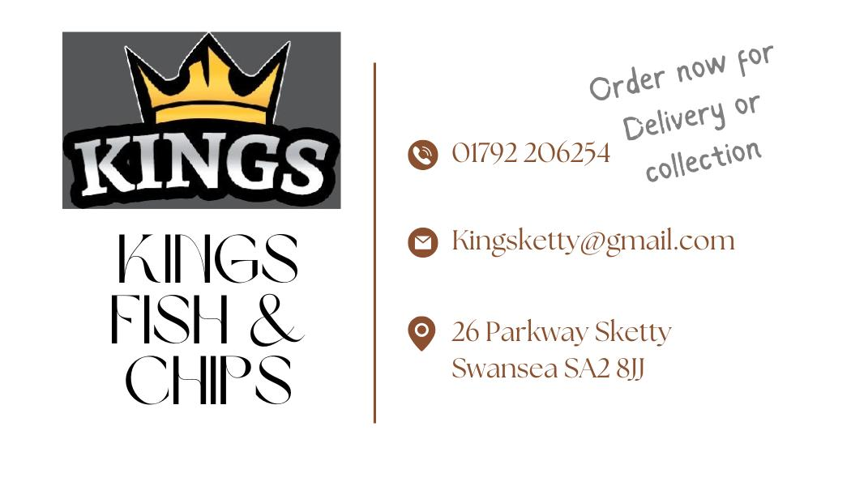 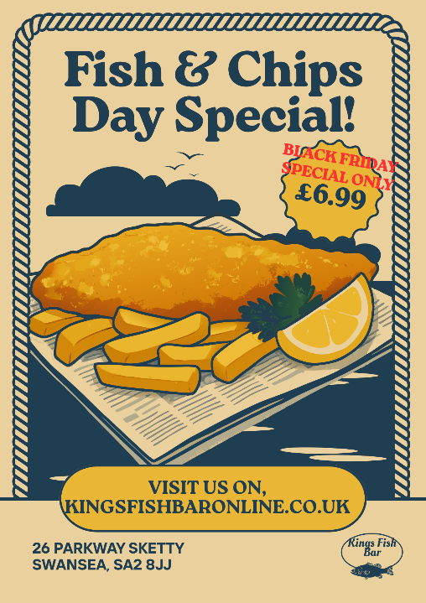

Market Research
Secondary data: According to industry reports, there is a continued interest in fish & chips and the increase in the use of delivery services in the UK (Mintel, 2023; Statista, 2024).
Primary data: A survey of 50 residents revealed that 72% of them frequent a fish and chip shop at least once a month, 65% of them would rather receive it by delivery, and 58% would be willing to pay a small premium to shop at a sustainable sourcing. The competitor analysis showed that there are no shops that offer online ordering, delivery, and a sustainability message. These discoveries influenced the orientation of Kings towards convenience, ethical sourcing and deals with the family.
Financial Resources
Estimates of initial costs: shop fitting £20,000, equipment (fryer, freezers, counters) £12,000, starting inventory £3,000, start-up advertising £2,000, three months working capital £8,000. Total start-up cost: approx. £45,000.
Sources of finance: Financing sources £20,000 personal savings £15,000 small business loan £10,000 investment by the family of the owner.
Feasibility: Under the assumption of a weekly sale of £4,000 and average gross margin, 60% monthly gross profit ≈ £9,600. Net profit each month = £3,100 after fixed costs (rent £2,000, wages £3,500, utilities/other £1,000). Break-even is therefore projected in 15 months.
12-Month Summary of Cash Flow (narrative):
- Month 1-3: ramp-up, sales will begin at £2,500/week and increase to £3,500/week at month 3; working capital will fund the deficit.
- Months 4-6: stable condition of £4,000/week; net cash flow becomes positive every month.
- Months 7-12: incremental increase (5% per quarter) due to marketing and repeat custom businesses, the sales increase to £4,400/week by the end of month 12. Repayment of £300/month loan commences at month 6 which leaves healthy net cash.
This financial plan is achievable considering the local population, pricing strategy, and marketing plan but sensitivity analysis reveals that in case the sales will not exceed £3,000/week net profit will be insignificant- therefore marketing and delivery performance will be vital.

SWOT Analysis
Strengths | Weaknesses
Sustainable quality, sustainability ingredients. | Poor brand image in the beginning.
Multi-channel provision: takeaway, delivery, dine-in. | Limited resources and sole trader liability.
Family-friendly pricing | Minimal initial team: staffing deficiency could be a service issue.
Online ordering system | Increased startup equipment and marketing expenses.

Opportunities | Threats
Growth in delivery market and loyalty programs | Rising competition and input costs
Sustainability messaging attracts ethical consumers | Regulatory changes and food hygiene risks
Largest Weakness: Minimal brand awareness in the beginning.
Actions to address:
- Establish vigorous marketing within first 3 months.
- Use referral and loyalty programmes.
- Have corporate lunch arrangements with local businesses.
- Publish and monitor reviews made on customers to gain credibility.

Reflection
Over the course of preparing and creating the business plan of Kings Fish and Chips, I have learned several skills and knowledge regarding business. To begin with, I have acquired practical skills in market research, to the extent of collecting, analysing, and interpreting primary and secondary data. The surveys among the potential customers and an analysis of competitor offerings have been able to improve my skills in defining the gaps and needs of customers in the market. I have also understood better the financial planning, such as determining start-up costs, expected revenues, estimated cash flows, and break-even points. This has enhanced my skills in making viable financial projections and analysing the commercial viability of business decisions. I have also been able to build my strategic planning and marketing capabilities, including how to develop SMART goals, a unique selling proposition (USP), multi-channel promotion strategies to acquire and maintain customers. All in all, this process has solidified my understanding of the small business operation, sustainability and the need to focus on customers in the establishment of a competitive advantage.
As a result of this process, I have also found an entrepreneurial characteristic that I will have to work on, and these are risk management and decision-making under uncertainty. Being a sole trader, I realised that I will be the final decision maker in all business decisions and any unexpected pressures like scarcity of ingredients or shortages of staff can greatly affect business. To cultivate this characteristic, I will participate in mentorship, professional development and trainings such as workshops on business risk management, scenario planning and problem-solving. I will also research on case studies of other small food companies to learn how they overcame the hurdles and the contingency measures. This skill can be practised during the real-time, by closely observing the changes in KPIs and planning the flexible working plans, which will bring me to become more confident and independent entrepreneur.
Assuming I were an angel investor, however, I would invest in Kings Fish & Chips though with reservations. I would be impressed with the good market potential, clear USP, properly researched marketing strategy, and elaborate financial planning that would break even in 15 months. The incorporation of delivery, takeaway, and dine-in services combined with their emphasis on sustainability reveal the innovation and responsiveness to the trends of customers. As an investor, I would be wary however because of the low initial brand recognition, limited team size and the use of a sole trader which raises personal liability and operation risk. Through balanced risk control, the risks involved, and a slow pace of building the brand, it can be predicted that the business has a promising growth and profitability potential hence a viable but a moderate-risk investment.

References
Anderson, E.W., Fornell, C. and Lehmann, D.R. (1994). Customer Satisfaction, Market Share, and Profitability: Findings from Sweden. Journal of Marketing, 58(3), pp.53–66. doi:https://doi.org/10.1177/002224299405800304.
Baron, R.A. (2008). The Role of Affect in the Entrepreneurial Process. Academy of Management Review, [online] 33(2), pp.328–340. doi:https://doi.org/10.5465/amr.2008.31193166.
BEIS (2022). Business Population Estimates for the UK and Regions 2022: Statistical Release (HTML). [online] GOV.UK. Available at: https://www.gov.uk/government/statistics/business-population-estimates-2022/business-population-estimates-for-the-uk-and-regions-2022-statistical-release-html.
British Takeaway Campaign (2022). 750 takeaway owners call for urgent Government support. [online] Medium. Available at: https://medium.com/@britishtakeawaycampaign/750-takeaway-owners-call-for-urgent-government-support-13658676e279 [Accessed 21 Nov. 2025].
Buss, D.M. and Foley, P. (2019). Mating and marketing. Journal of Business Research, 120. doi:https://doi.org/10.1016/j.jbusres.2019.01.034.
Cim.co.uk. (2019). Report: Impact of Marketing – Rebuilding better customer experiences | CIM. [online] Available at: https://www.cim.co.uk/content-insights/articles/report-impact-of-marketing-rebuilding-better-customer-experiences [Accessed 21 Nov. 2025].
Gary Armstrong, Kotler, P. and Opresnik, M.O. (2020). Marketing : an introduction. Editorial: Upper Saddle River: Pearson.
Hair, J.F., Ringle, C.M. and Sarstedt, M. (2011). PLS-SEM: Indeed a Silver Bullet. Journal of Marketing Theory and Practice, 19(2), pp.139–152.
Lauber, K., Hunt, D., Gilmore, A.B. and Rutter, H. (2021). Corporate Political Activity in the Context of Unhealthy Food Advertising Restrictions across Transport for London: a Qualitative Case Study. PLOS Medicine, 18(9), p.e1003695.
Nakajima, H. and Sekiguchi, T. (2025). Is Business Planning Useful for Entrepreneurs? A Review and Recommendations. Businesses, [online] 5(1), p.10. doi:https://doi.org/10.3390/businesses5010010.
Neubacher, N. (2025). Analysis of Consumer Preferences and Trends in the UK Ready Meals and Ready-to-Cook Food Market. [online] doi:https://doi.org/10.13140/RG.2.2.12327.87204.
Nfff.co.uk. (2020). Sustainability – National Federation of Fish Friers. [online] Available at: https://www.nfff.co.uk/sustainability/ [Accessed 21 Nov. 2025].
Office for National Statistics (2024). Labour Market overview, UK - Office for National Statistics. [online] Ons.gov.uk. Available at: https://www.ons.gov.uk/employmentandlabourmarket/peopleinwork/employmentandemployeetypes/bulletins/uklabourmarket/latest.
Porter, M.E. (1979). How Competitive Forces Shape Strategy. Readings in Strategic Management, [online] 57(2), pp.133–143. doi:https://doi.org/10.1007/978-1-349-20317-8_10.
Saunders, M., Lewis, P. and Thornhill, A. (2019). Saunders, Research Methods for Business Students, 8/E. [online] www.pearson.com. Available at: https://www.pearson.com/se/Nordics-Higher-Education/subject-catalogue/business-and-management/Research-methods-for-business-students-8e-saunders.html.
Statista. (2025). Topic: Restaurant delivery and takeaway in the United Kingdom. [online] Available at: https://www.statista.com/topics/4679/food-delivery-and-takeaway-market-in-the-united-kingdom-uk/?srsltid=AfmBOoonzsI3b1vZXgK52V2QrWbrMGnVsukz4vzLPIwR9nvldu-fJ7eo [Accessed 21 Nov. 2025].
Vargo, S.L. and Lusch, R.F. (2004). Evolving to a new dominant logic for marketing. Journal of Marketing, 68(1), pp.1–17. doi:https://doi.org/10.1509/jmkg.68.1.1.24036.

